SWD392 – SOFTWARE ARCHITECTURE AND DESIGN
PROJECT ASSIGNMENT / LAB
WORKER MANAGEMENT SYSTEM
Worker Information Management – LAB211 J1.S.P0056
Course Project Report
SWD392 – Worker Management System
Student: Nguyễn Xuân Đạt
Roll Number: HE181308
Class: SWD392_SE1931-NET
Lecturer: ANNV22
— Hanoi, July 2026 —

Table of Contents

Record of Changes
Date | A* / M, D | In charge | Change Description
16/07/2026 | A | Nguyễn Xuân Đạt | Initial version – Course Project Report for the Worker Management System (J1.S.P0056).
*A - Added M - Modified D - Deleted

I. Overview

I.1 Project Information
Item | Value
Project name | Worker Management System (LAB211 – J1.S.P0056)
Course | SWD392 – Software Architecture and Design
Document | Course Project Report
Architecture | MVC (Model–View–Controller) console application
Repository | https://github.com/datnx89-commits/he181308_SWD392
Date | July 2026

I.2 Project Team
# | Full Name | Roll Number | Role
1 | Nguyễn Xuân Đạt | HE181308 | Developer / Author

II. Requirement Specification

II.1 Problem Description
The Worker Management System is a console program that manages worker information for an HR staff member. The user can add a worker (with a unique code, name, age, salary and work location), increase or decrease a worker’s salary by a positive amount, and display all workers whose salary has been adjusted, sorted by worker code. Every adjustment is recorded in a salary history with the previous salary, the amount, the UP/DOWN status, the new salary and a timestamp. All business rules are validated before any state change and violations produce specific error messages.

II.2 Major Features
- Add a worker with full validation (unique non-null code, age 18–50, salary > 0).
- Increase salary for an existing worker by a positive amount.
- Decrease salary for an existing worker while keeping the salary positive.
- Salary history recording for every adjustment (before, amount, UP/DOWN, after, time).
- Adjusted salary report sorted by worker code.

II.3 Context Diagram
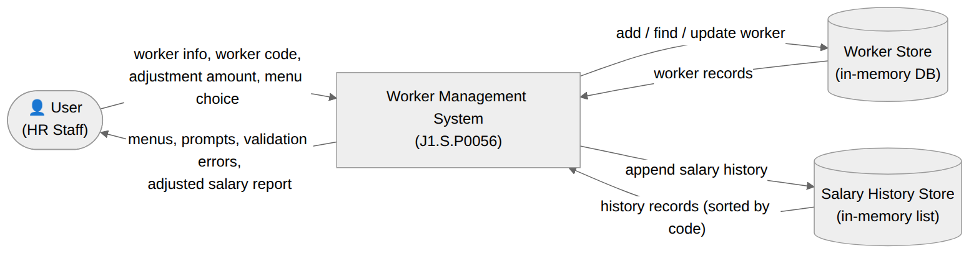
Figure 1. Context Diagram

II.4 Nonfunctional Requirements
- Usability – clear specific errors, menu always re-displayed, never crashes on invalid input.
- Performance – O(1) map operations for add/find; report sorting O(n log n).
- Data integrity – all business rules enforced by the Model before any state change; full adjustment history.
- Reliability – numeric input re-prompt loops; exceptions caught by the Controller.
- Maintainability – clean MVC separation; the Model is replaceable behind the IWorkerManagement interface.

II.5 Functional Requirements

II.5.1 Actors
# | Actor | Description
1 | User (HR Staff) | The end user who operates the console program: adds workers, increases/decreases salaries, and views the adjusted salary report.

II.5.2 Use Cases

II.5.2.1 Diagram
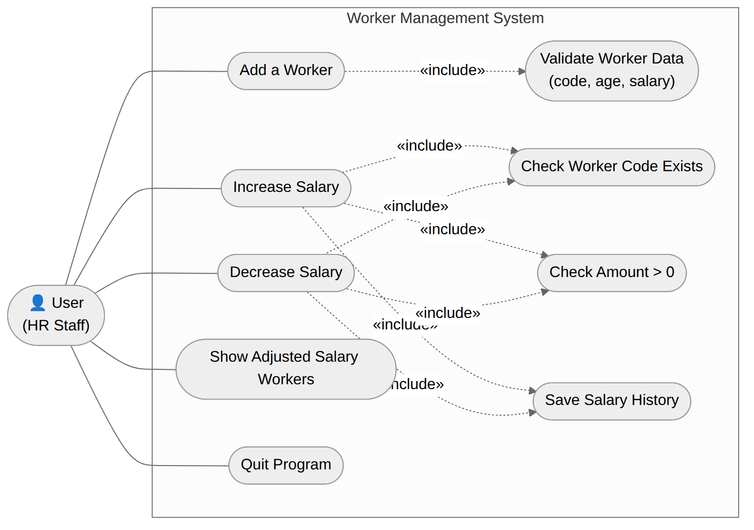
Figure 2. Use Case Diagram

II.5.2.2 Use Case Descriptions
The core use cases are Add a Worker, Increase Salary, Decrease Salary and Show Adjusted Salary Workers. The salary adjustment use cases include checking the worker code, checking the amount, and saving the salary history. The representative specification below covers the adjustment flow; the full set of specifications is provided in the SRS document.
Primary Actors | User (HR Staff) | Secondary Actors | None
Trigger | The User selects option 2 (Increase salary) from the main menu.
Description | As an HR staff member, I want to increase the salary of an existing worker by a positive amount, so that the raise takes effect and is recorded in the salary history.
Preconditions | The application is running; at least one worker should exist in the DB for the operation to succeed.
Postconditions | On success the worker’s salary is increased, a SalaryHistory record with status UP is saved, and a success message is shown. On failure an error is shown and nothing changes.
Main Sequence | 1. The User selects option 2 from the main menu.  2. The system prompts for the worker code (id).  3. The User enters the code.  4. The system prompts for the amount of money to raise.  5. The User enters the amount.  6. The system checks that the code exists in the DB. [Alt A1]  7. The system checks that the amount is greater than 0. [Alt A2]  8. The system adds the amount to the worker’s salary and saves a SalaryHistory record (before, amount, UP, after, time).  9. The system displays "Salary adjusted successfully!" and returns to the main menu.
Alternative Sequences | A1 (step 6) – Code does not exist in the DB: the system shows an error and returns to the main menu.  A2 (step 7) – Amount is not greater than 0: the system shows "Amount of money must be greater than 0." and returns to the main menu.

II.5.2.3 Business Rules
ID | Business Rule
BR-01 | A worker code (id) must not be null or empty, and must be unique in the DB.
BR-02 | A worker’s age must be in the range 18 to 50.
BR-03 | A worker’s salary must always be greater than 0 (on add and after every adjustment).
BR-04 | A salary adjustment amount must be greater than 0.
BR-05 | A salary can only be adjusted for a worker code that exists in the DB.
BR-06 | Every successful salary adjustment is saved to the salary history with time and UP/DOWN status.
BR-07 | The adjusted salary report is sorted ascending by worker code (id).

II.5.3 Activity Diagram
The activity diagram below shows the salary adjustment flow shared by options 2 and 3.
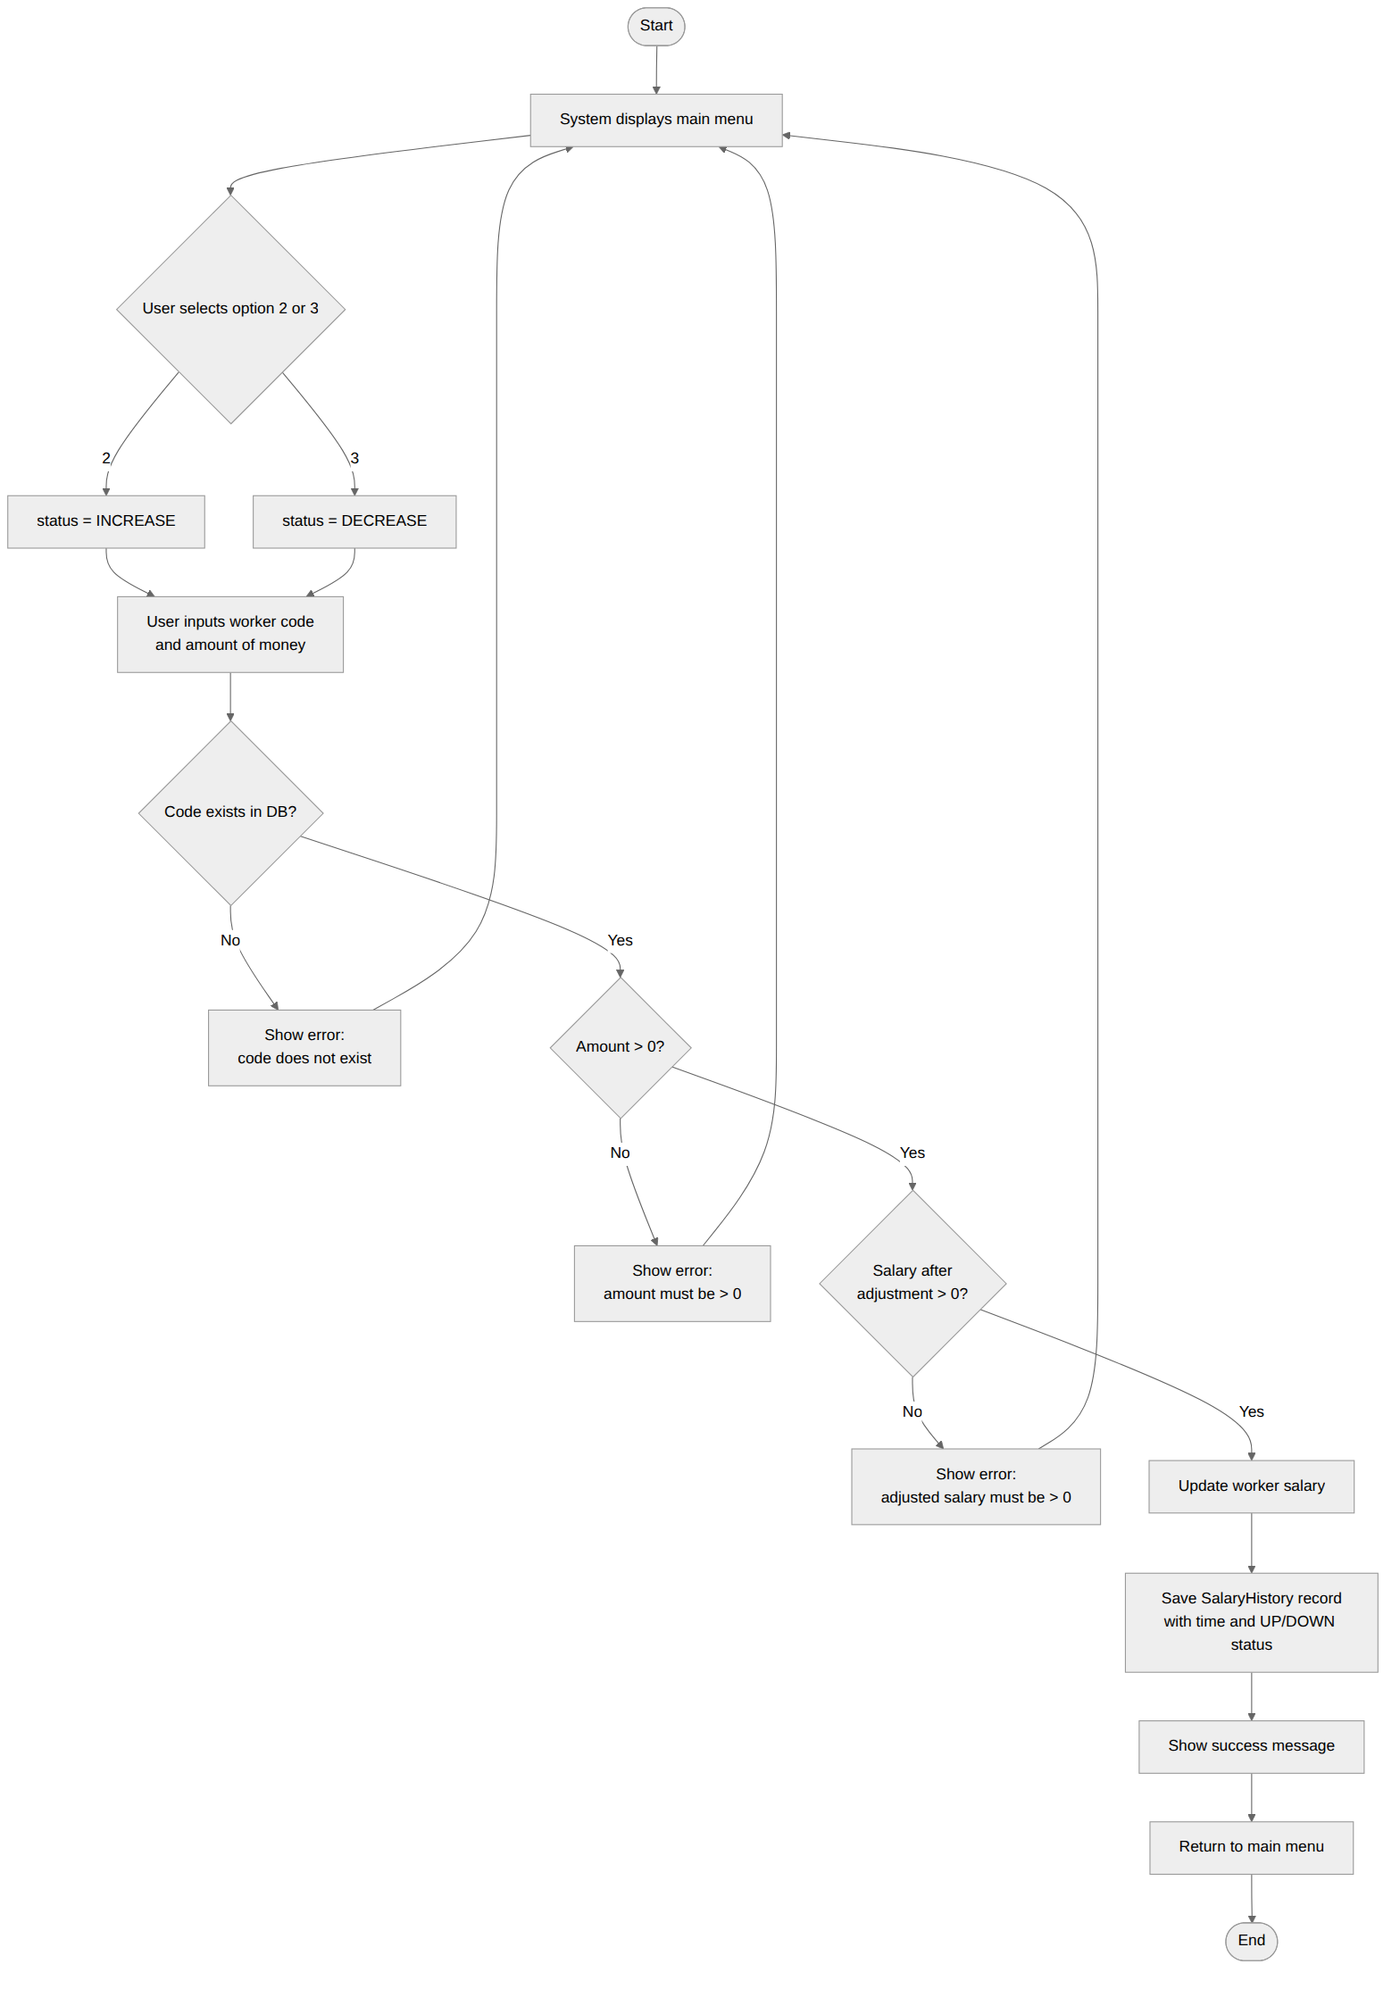
Figure 3. Activity Diagram – Adjust Salary

III. Analysis Models

III.1 Interaction Diagrams
The communication and sequence diagrams below show the objects collaborating to realize the Adjust Salary use case at the analysis level.
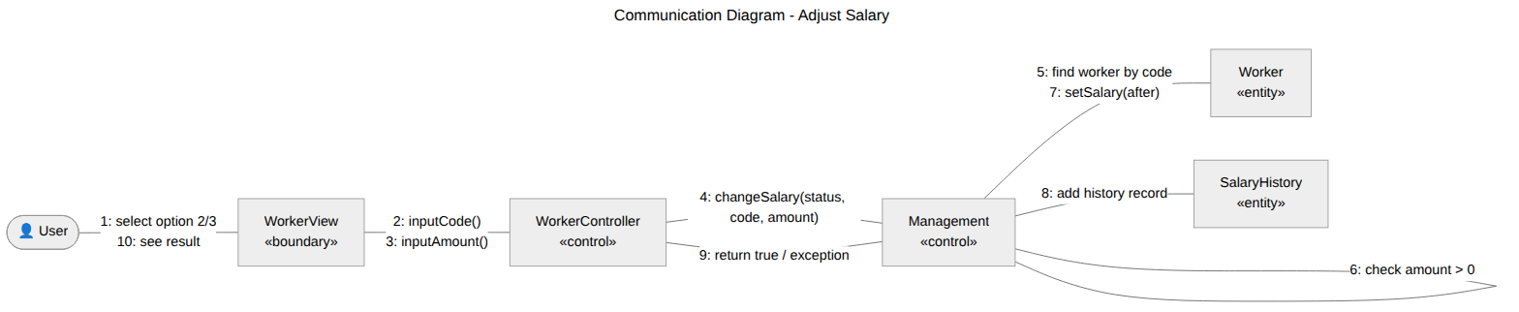
Figure 4. Communication Diagram – Adjust Salary
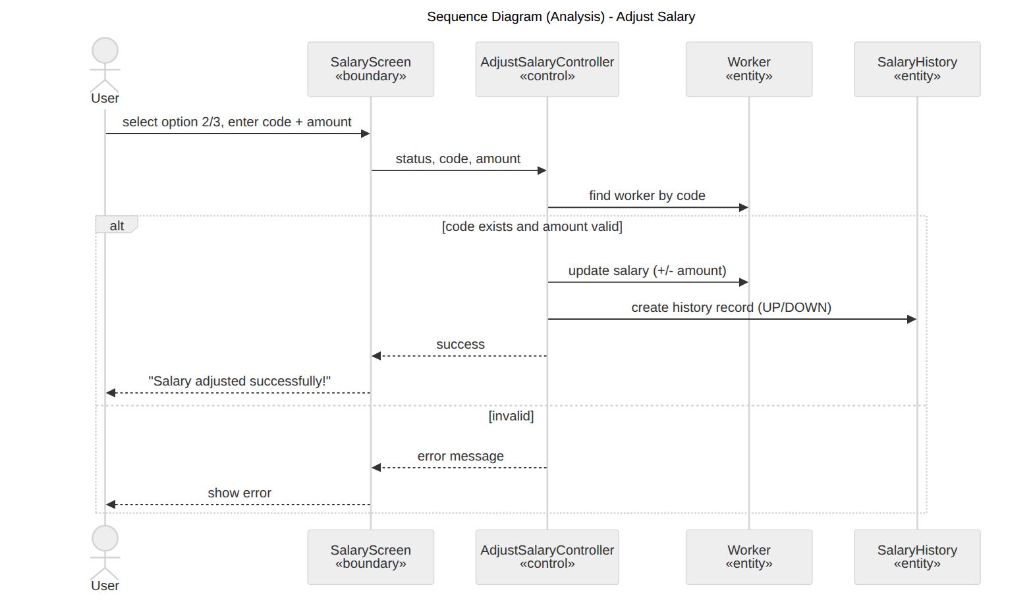
Figure 5. Sequence Diagram (Analysis) – Adjust Salary

III.2 State Diagram
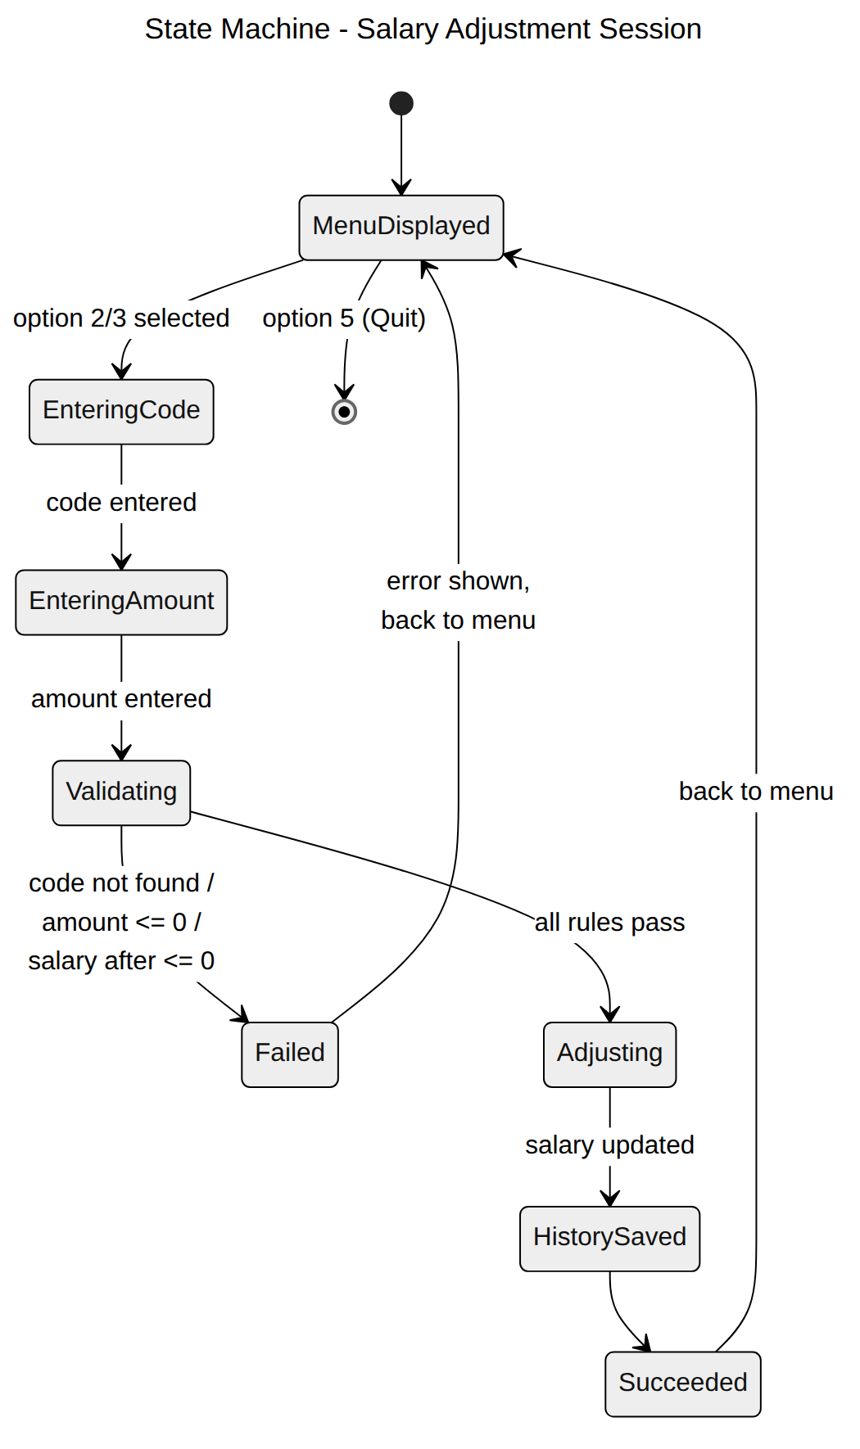
Figure 6. State Machine – Salary Adjustment Session

IV. Design Specification

IV.1 Integrated Sequence Diagram
The detailed (design-level) sequence diagram integrates all MVC roles for a complete salary adjustment.
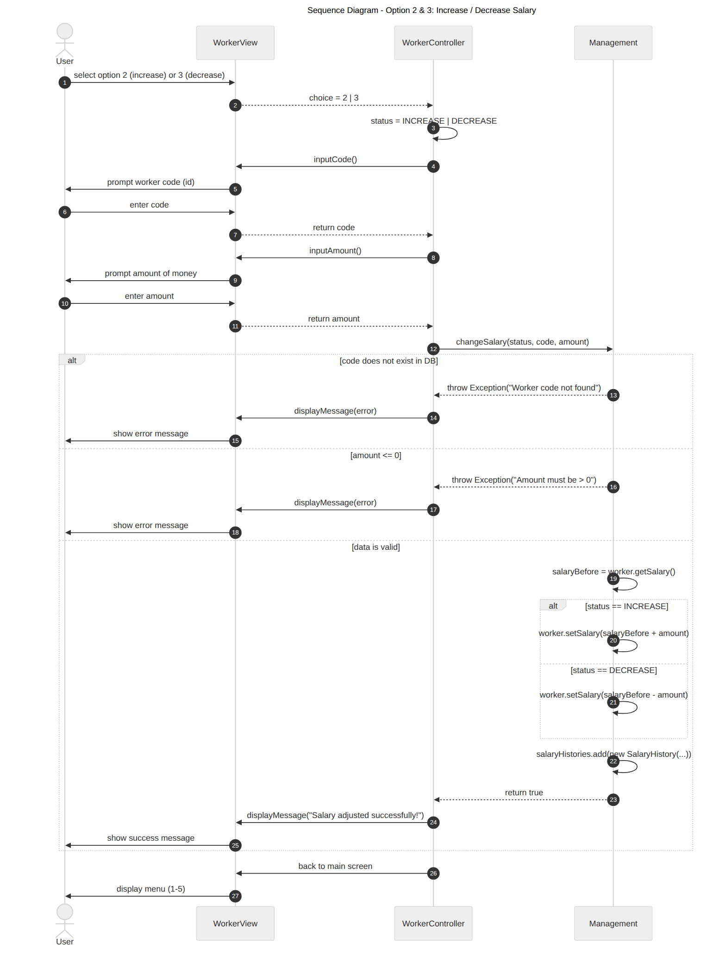
Figure 7. Sequence Diagram (Design) – Adjust Salary

IV.2 System High-Level Design
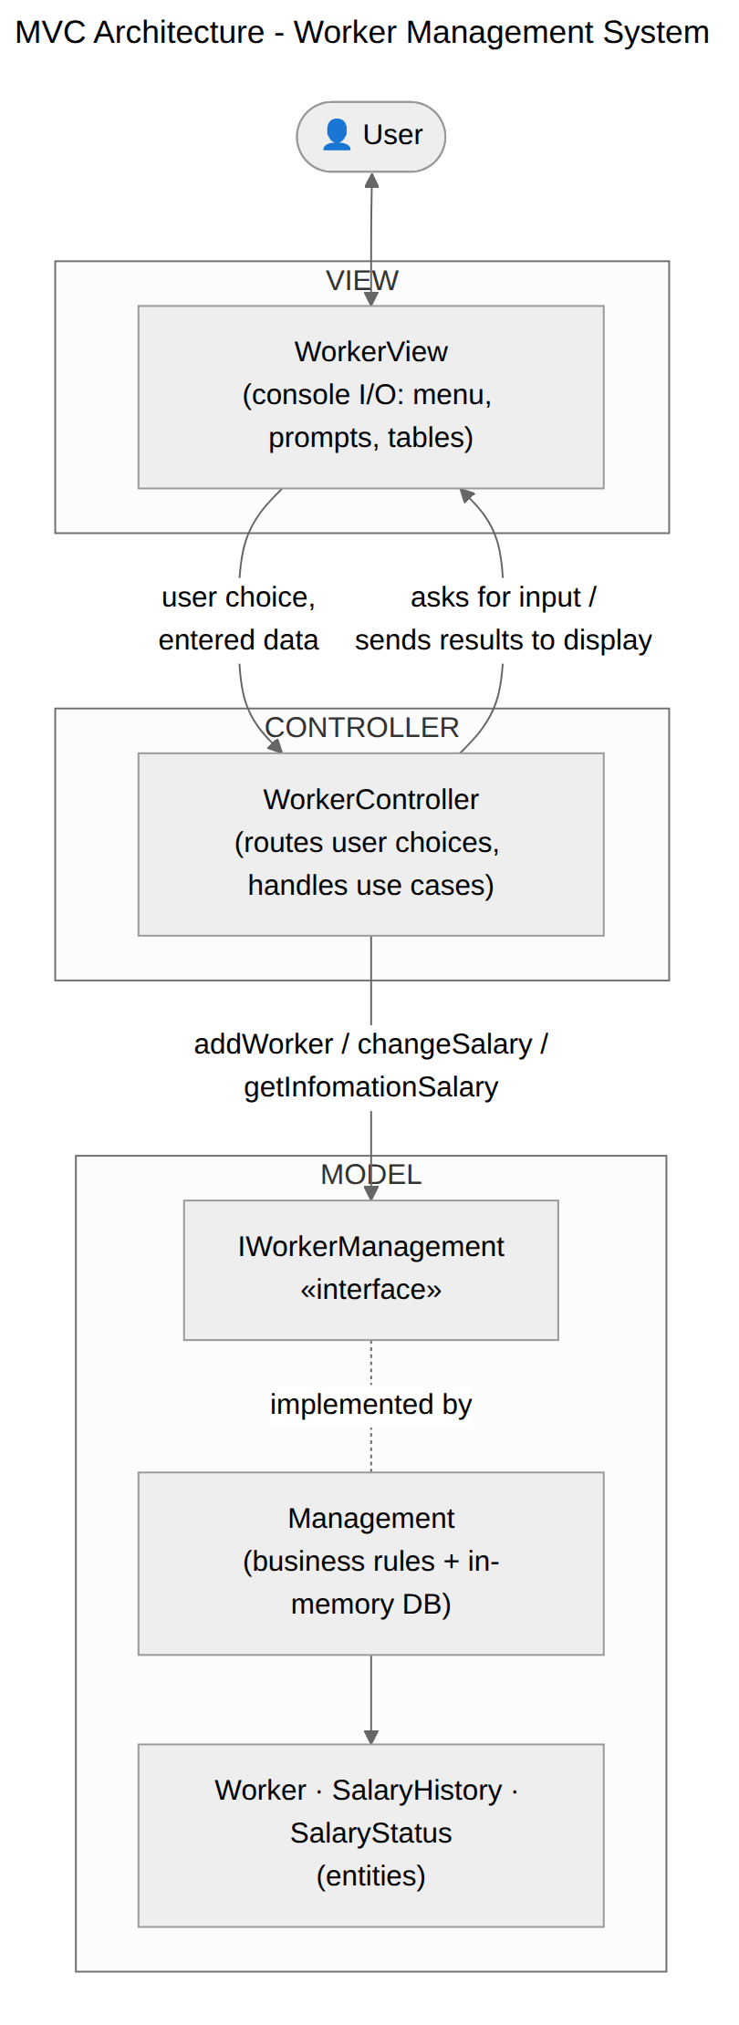
Figure 8. MVC Architecture

IV.3 Component and Package Diagram

IV.3.1 Component Diagram
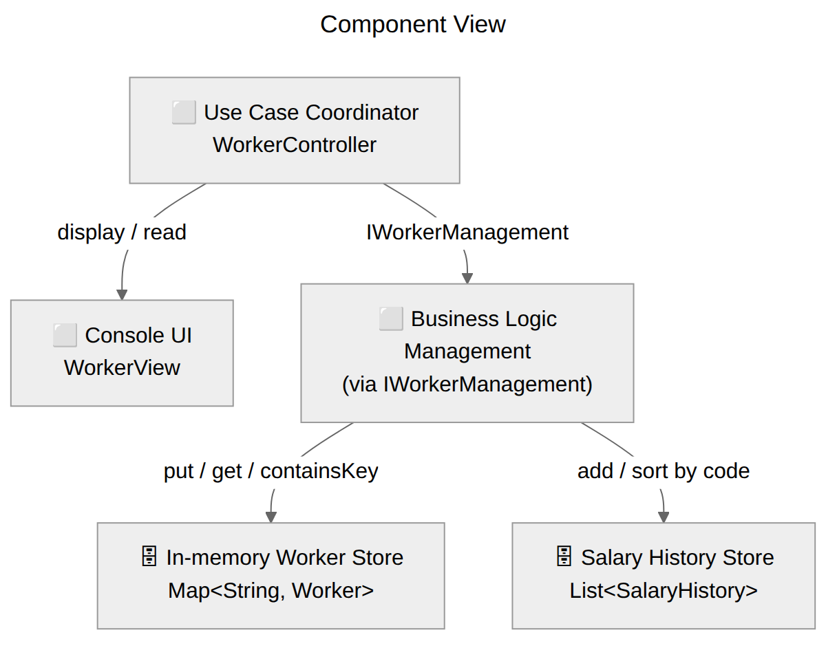
Figure 9. Component Diagram

IV.3.2 Package Diagram
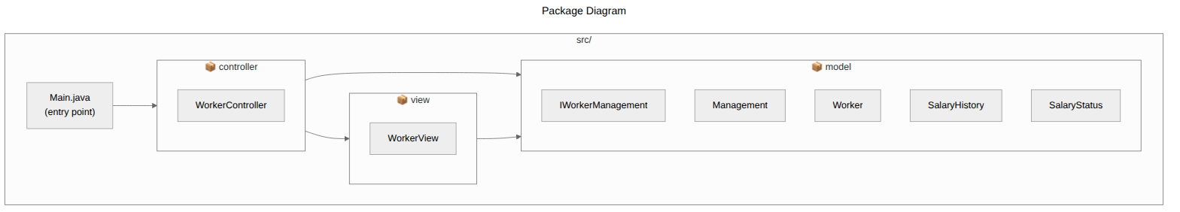
Figure 10. Package Diagram

IV.4 Class Diagram
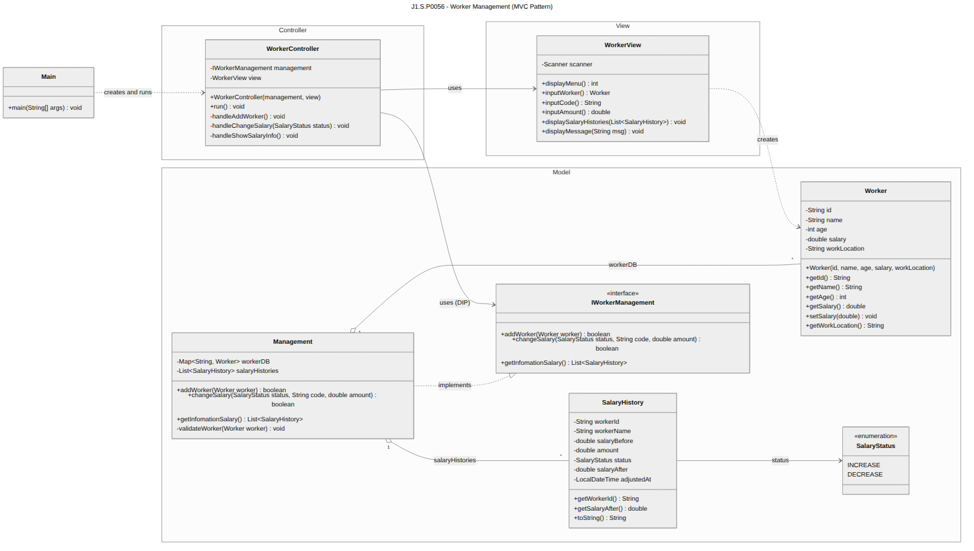
Figure 11. Design Class Diagram

IV.5 Data Design
Data is persisted in memory. The worker "table" is a Map keyed by worker code; the salary history is an append-only List sorted by code on demand.
Field | Type | Key | Description
id | String | PK | Unique worker code (map key).
name / age / salary / workLocation | String / int / double / String |  | Worker attributes; age 18–50, salary > 0.
workerId, salaryBefore, amount, status, salaryAfter, adjustedAt | history record | FK | One SalaryHistory row per adjustment (status UP/DOWN).

V. Implementation

V.1 Map Architecture to the Project Structure
Each MVC role maps to one source package; Main wires the roles together.
he181308_SWD392/
src/
controller/ -> Controller
WorkerController.java (main loop, use case handlers)
view/ -> View
WorkerView.java (menu, prompts, report table)
model/ -> Model
IWorkerManagement.java (business abstraction)
Management.java (rules + in-memory stores)
Worker.java (entity)
SalaryHistory.java (entity)
SalaryStatus.java (enum UP/DOWN)
Main.java -> entry point (wiring)
Project structure

V.2 Map Class & Interaction Diagrams to Code
Design Class | Source File | Role
Main | src/Main.java | Entry point
WorkerController | src/controller/WorkerController.java | Controller
WorkerView | src/view/WorkerView.java | View
IWorkerManagement | src/model/IWorkerManagement.java | Model
Management | src/model/Management.java | Model
Worker | src/model/Worker.java | Model
SalaryHistory | src/model/SalaryHistory.java | Model
SalaryStatus | src/model/SalaryStatus.java | Model

Example – the changeSalary(status, code, amount) message in the sequence diagram is realized by Management:
public boolean changeSalary(SalaryStatus status, String code, double amount)
throws Exception {
Worker worker = workerDB.get(code);
if (worker == null)
throw new Exception("Worker code [" + code + "] does not exist in DB.");
if (amount <= 0)
throw new Exception("Amount of money must be greater than 0.");
double salaryBefore = worker.getSalary();
double salaryAfter = (status == SalaryStatus.INCREASE)
? salaryBefore + amount : salaryBefore - amount;
if (salaryAfter <= 0)
throw new Exception("Salary after adjustment must be greater than 0.");
worker.setSalary(salaryAfter);
salaryHistories.add(new SalaryHistory(worker.getId(), worker.getName(),
salaryBefore, amount, status, salaryAfter, LocalDateTime.now()));
return true;
}
changeSalary implementation (Management.java)
Example – the worker validation rules (Add a Worker) in Management.validateWorker:
if (worker.getId() == null || worker.getId().trim().isEmpty())
throw new Exception("Worker code (id) cannot be null or empty.");
if (workerDB.containsKey(worker.getId()))
throw new Exception("Worker code [...] is duplicated in DB.");
if (worker.getAge() < 18 || worker.getAge() > 50)
throw new Exception("Age must be in range 18 to 50.");
if (worker.getSalary() <= 0)
throw new Exception("Salary must be greater than 0.");
validateWorker rules (Management.java)

VI. Applying Alternative Architecture Patterns

VI.1 Applying the Service-Oriented Architecture (SOA)
The current system is a single-process MVC console application. To support growth (web/mobile HR tools, many concurrent users, reuse by payroll or attendance systems) it can be re-architected as a Service-Oriented Architecture. The cohesive responsibilities already separated in the Model become independent, network-accessible services behind an API Gateway:
- Worker Service – add and query workers (the addWorker responsibility of Management).
- Salary Service – increase/decrease salaries (the changeSalary responsibility).
- Validation Service – the shared business rules (code, age, salary, amount).
- History Service – salary adjustment records and the sorted report (getInfomationSalary).
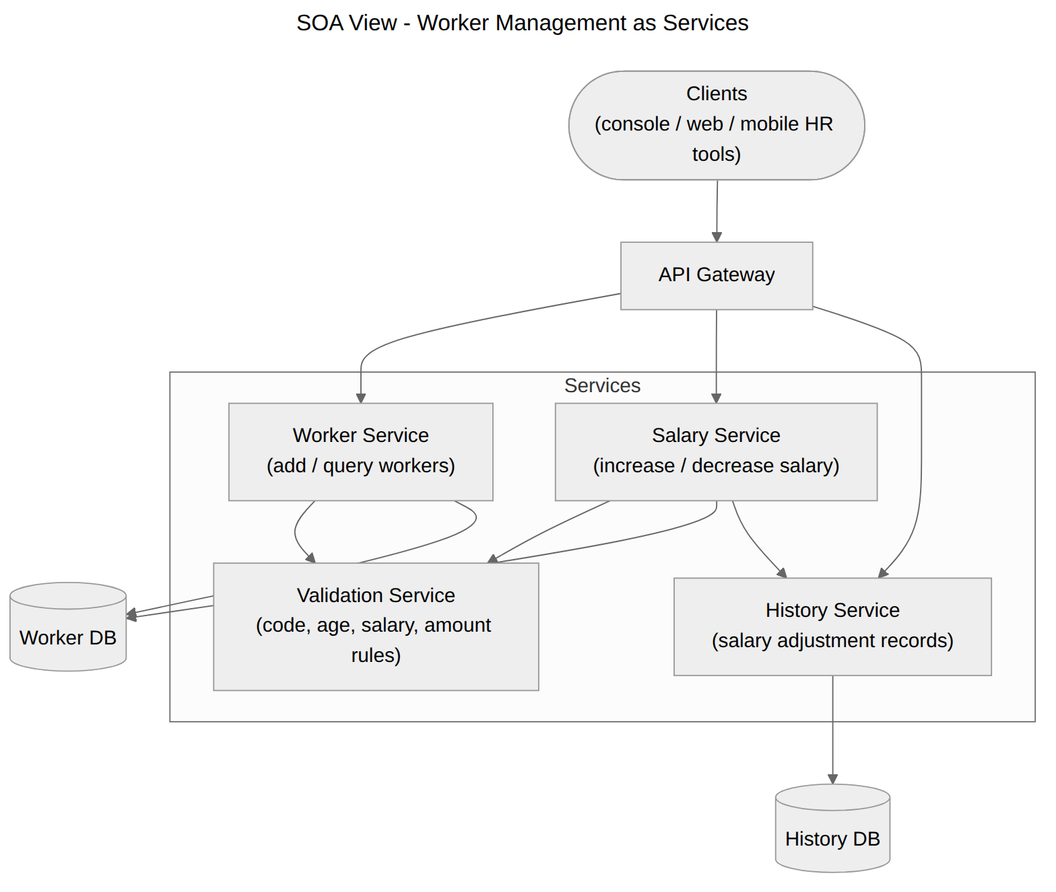
Figure 12. SOA View
Benefits: independent deployment and scaling, reuse across channels, and clear contracts. Trade-offs: added network latency, distributed-system complexity, and the need for infrastructure (gateway, monitoring, security between services).

VI.2 Applying the Service Discovery Pattern
In an SOA, each service may run as several instances whose network locations change as they scale or restart. Hard-coding addresses is brittle. The Service Discovery pattern introduces a Service Registry (for example Netflix Eureka or HashiCorp Consul): every service registers its address on startup, and clients (here, the API Gateway) look services up by logical name at runtime, then call a returned instance – enabling load balancing and resilience.
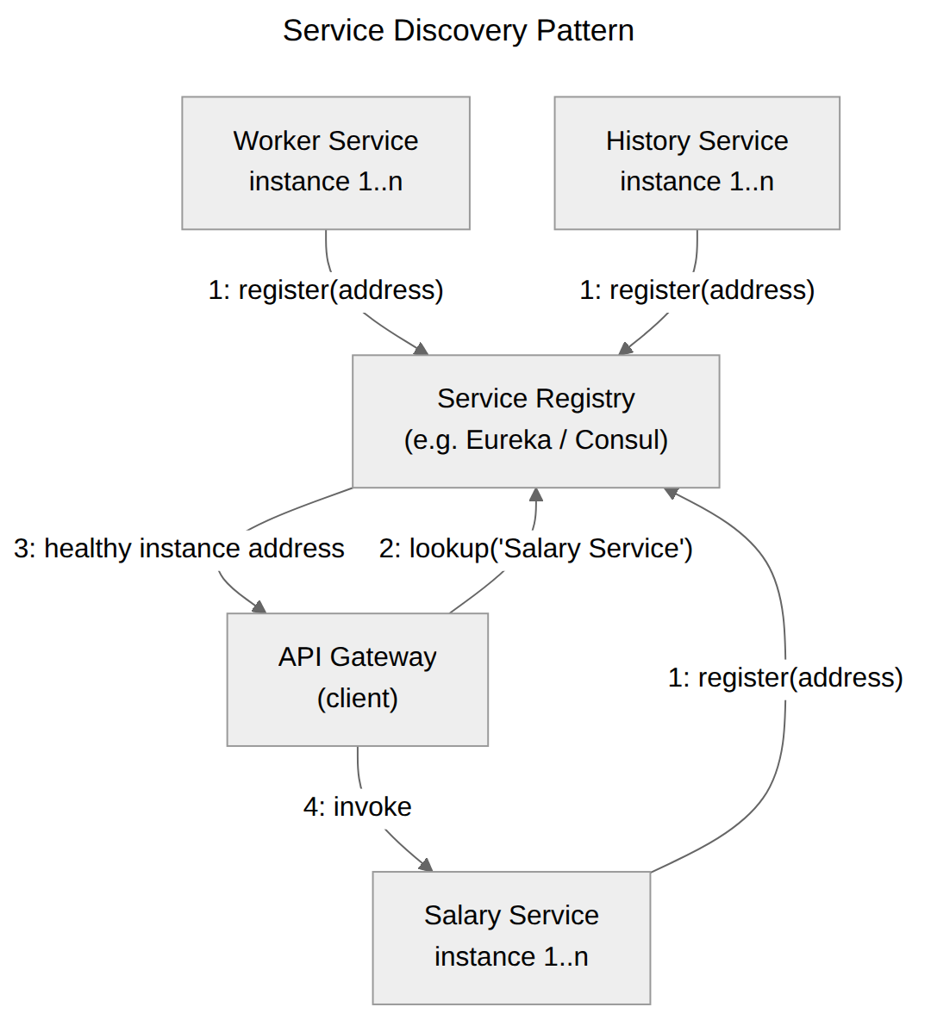
Figure 13. Service Discovery Pattern
- Registration – Worker, Salary and History services register with the registry on startup.
- Lookup – the API Gateway asks the registry for "Salary Service".
- Invocation – the registry returns a healthy instance address; the gateway invokes it.
This decouples callers from physical locations and lets the system add or remove service instances without configuration changes.

