SWD392 – SOFTWARE ARCHITECTURE AND DESIGN
PROJECT ASSIGNMENT / LAB
WORKER MANAGEMENT SYSTEM
Worker Information Management – LAB211 J1.S.P0056
Software Requirement Specification
SRS – Worker Management System
Student: Nguyễn Xuân Đạt
Roll Number: HE181308
Class: SWD392_SE1931-NET
Lecturer: ANNV22
— Hanoi, July 2026 —

Table of Contents

I. Record of Changes
Date | A* / M, D | In charge | Change Description
16/07/2026 | A | Nguyễn Xuân Đạt | Initial version – SRS for the Worker Management System (J1.S.P0056).
*A - Added M - Modified D - Deleted

II. Software Requirement Specification

1. Overall Requirements

1.1 Context Diagram
The Worker Management System is a console application for the LAB211 assignment J1.S.P0056. It lets an HR staff member add workers, adjust their salaries and review the adjustment history. The context diagram shows the actor and the internal data stores.
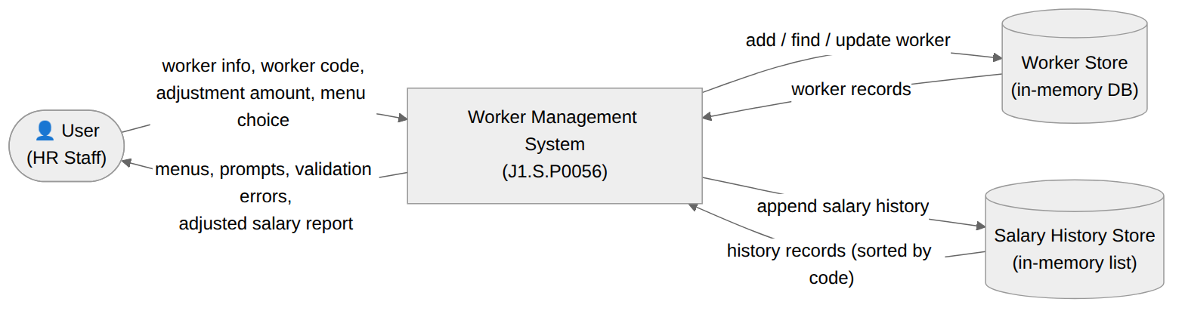
Figure 1. Context Diagram

1.2 Main Workflows

1.2.1 Add Worker Workflow
The user selects option 1 and enters the worker code, name, age, salary and work location. The system validates that the code is not null/duplicated, the age is 18–50 and the salary is positive; if all rules pass the worker is stored in the DB, otherwise a specific error is shown. The system then returns to the main menu.

1.2.2 Adjust Salary Workflow
The user selects option 2 (increase) or 3 (decrease) and enters a worker code and an amount. The system verifies the code exists and the amount is positive (and, for a decrease, that the salary stays positive), updates the salary, saves a history record with UP/DOWN status and a timestamp, and reports the result.

1.2.3 Adjusted Salary Report Workflow
The user selects option 4. The system sorts all salary history records by worker code and displays them as a table; if no adjustment has been made yet an informative message is shown instead. Option 5 terminates the program.

1.3 User Requirements

1.3.1 Actors
# | Actor | Description
1 | User (HR Staff) | The end user who operates the console program: adds workers, increases/decreases salaries, and views the adjusted salary report.

1.3.2 Use Cases
The use case diagram below lists the use cases available to the User. Add a Worker includes the data validation; Increase and Decrease Salary include the existence/amount checks and saving the salary history.
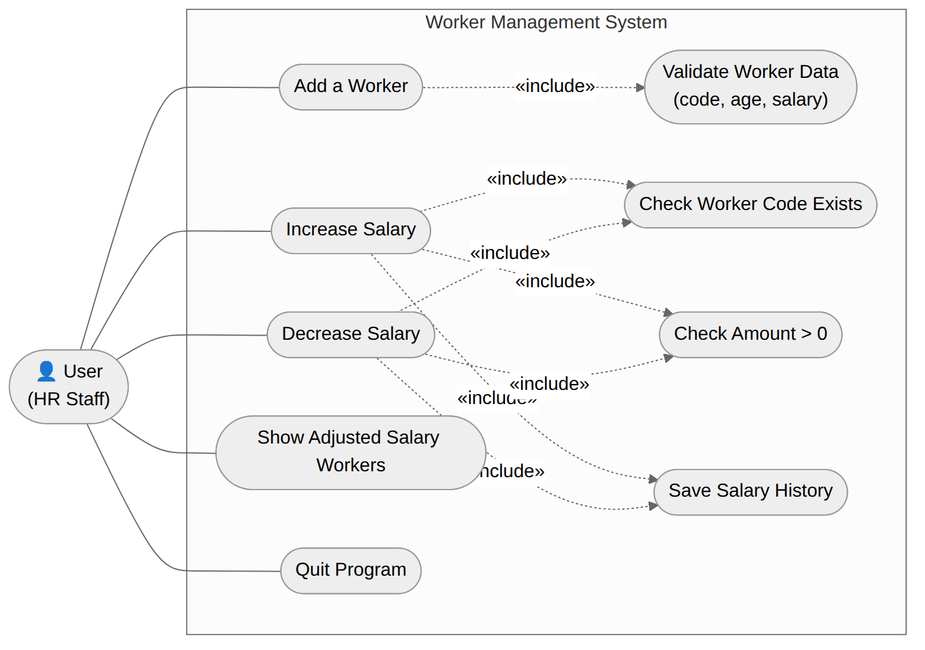
Figure 2. Use Case Diagram – User

1.4 System Functionalities

1.4.1 Screens Flow
Main Menu → (option 1) Add Worker inputs → Result → back to Main Menu. Main Menu → (option 2/3) Code + Amount inputs → Result → back to Main Menu. Main Menu → (option 4) Adjusted Salary table → back to Main Menu. Option 5 exits the program. Non-numeric input at any numeric prompt re-displays the same prompt.

1.4.2 Screen Authorization
Screen | Actor | Access
Main Menu | User | Full
Add Worker Inputs | User | Full
Adjust Salary Inputs | User | Full
Adjusted Salary Report | User | Full
The program has a single role (User); there is no administrative screen in this release.

1.4.3 Non-UI Functions
- Worker validation – code not null/duplicated, age 18–50, salary > 0.
- Adjustment validation – code must exist, amount > 0, resulting salary > 0.
- Salary computation – add or subtract the amount according to the INCREASE/DECREASE status.
- History recording – append a SalaryHistory record with a timestamp for every adjustment.
- Report sorting – order the history records ascending by worker code.

1.5 Entity Relationship Diagram
The system persists two entities in memory: Worker and SalaryHistory, in a one-to-many relationship (one worker has zero or more adjustment records).
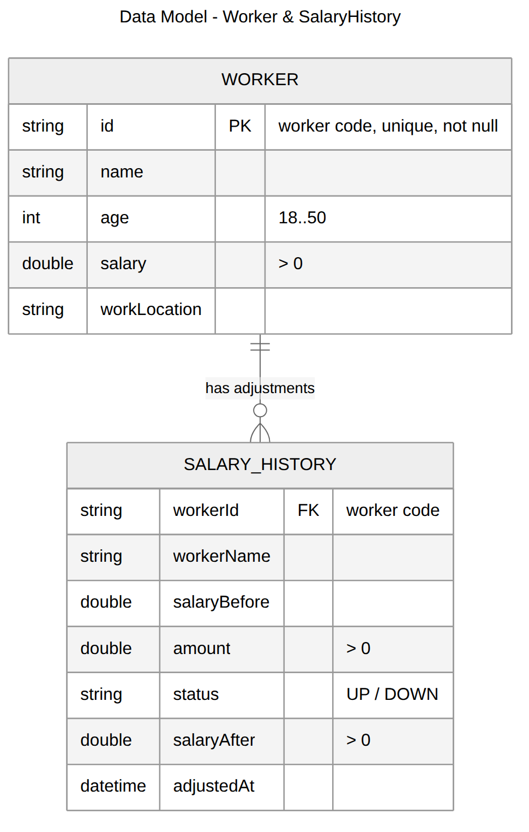
Figure 3. Data Model – Worker & SalaryHistory

2. Use Case Specifications

2.1 Worker Management

2.1.1 Add a Worker
Primary Actors | User (HR Staff) | Secondary Actors | None
Trigger | The User selects option 1 (Add a worker) from the main menu.
Description | As an HR staff member, I want to add a new worker with a unique code, name, age, salary and work location, so that the worker is stored in the system and can later receive salary adjustments.
Preconditions | The application is running and the main menu is displayed.
Postconditions | On success the Worker is stored in the in-memory DB and a success message is shown. On failure a descriptive error message is shown and nothing is stored. The system returns to the main menu.
Main Sequence | 1. The User selects option 1 from the main menu.  2. The system prompts for the worker code (id), name, age, salary and work location.  3. The User enters the worker information.  4. The system validates that the code is not null/empty and not duplicated in the DB. [Alt A1]  5. The system validates that the age is in the range 18 to 50. [Alt A2]  6. The system validates that the salary is greater than 0. [Alt A3]  7. The system adds the Worker to the DB (keyed by code).  8. The system displays "Add worker successfully!" and returns to the main menu.
Alternative Sequences | A1 (step 4) – Code is null/empty or duplicated: the system shows the corresponding error message and returns to the main menu.  A2 (step 5) – Age out of range: the system shows "Age must be in range 18 to 50." and returns to the main menu.  A3 (step 6) – Salary invalid: the system shows "Salary must be greater than 0." and returns to the main menu.

2.1.2 Increase Salary
Primary Actors | User (HR Staff) | Secondary Actors | None
Trigger | The User selects option 2 (Increase salary) from the main menu.
Description | As an HR staff member, I want to increase the salary of an existing worker by a positive amount, so that the raise takes effect and is recorded in the salary history.
Preconditions | The application is running; at least one worker should exist in the DB for the operation to succeed.
Postconditions | On success the worker’s salary is increased, a SalaryHistory record with status UP is saved, and a success message is shown. On failure an error is shown and nothing changes.
Main Sequence | 1. The User selects option 2 from the main menu.  2. The system prompts for the worker code (id).  3. The User enters the code.  4. The system prompts for the amount of money to raise.  5. The User enters the amount.  6. The system checks that the code exists in the DB. [Alt A1]  7. The system checks that the amount is greater than 0. [Alt A2]  8. The system adds the amount to the worker’s salary and saves a SalaryHistory record (before, amount, UP, after, time).  9. The system displays "Salary adjusted successfully!" and returns to the main menu.
Alternative Sequences | A1 (step 6) – Code does not exist in the DB: the system shows an error and returns to the main menu.  A2 (step 7) – Amount is not greater than 0: the system shows "Amount of money must be greater than 0." and returns to the main menu.

2.1.3 Decrease Salary
Primary Actors | User (HR Staff) | Secondary Actors | None
Trigger | The User selects option 3 (Decrease salary) from the main menu.
Description | As an HR staff member, I want to decrease the salary of an existing worker by a positive amount, so that the cut takes effect and is recorded in the salary history.
Preconditions | The application is running; at least one worker should exist in the DB for the operation to succeed.
Postconditions | On success the worker’s salary is decreased, a SalaryHistory record with status DOWN is saved, and a success message is shown. On failure an error is shown and nothing changes.
Main Sequence | 1. The User selects option 3 from the main menu.  2. The system prompts for the worker code (id).  3. The User enters the code.  4. The system prompts for the amount of money to cut.  5. The User enters the amount.  6. The system checks that the code exists in the DB. [Alt A1]  7. The system checks that the amount is greater than 0. [Alt A2]  8. The system checks that the salary after the cut is still greater than 0. [Alt A3]  9. The system subtracts the amount from the worker’s salary and saves a SalaryHistory record (before, amount, DOWN, after, time).  10. The system displays "Salary adjusted successfully!" and returns to the main menu.
Alternative Sequences | A1 (step 6) – Code does not exist in the DB: the system shows an error and returns to the main menu.  A2 (step 7) – Amount is not greater than 0: the system shows an error and returns to the main menu.  A3 (step 8) – Salary after adjustment would be ≤ 0: the system shows "Salary after adjustment must be greater than 0." and returns to the main menu.

2.1.4 Show Adjusted Salary Workers
Primary Actors | User (HR Staff) | Secondary Actors | None
Trigger | The User selects option 4 (Show adjusted salary worker information) from the main menu.
Description | As an HR staff member, I want to see the list of all salary adjustments sorted by worker code, so that I can review who has been adjusted, by how much, and when.
Preconditions | The application is running.
Postconditions | The list of SalaryHistory records, sorted by worker code, is displayed. The stored data is not modified.
Main Sequence | 1. The User selects option 4 from the main menu.  2. The system retrieves all SalaryHistory records and sorts them by worker code (id).  3. The system displays the records as a table: code, name, salary before, amount, status (UP/DOWN), salary after, time.  4. The system returns to the main menu.
Alternative Sequences | Step 3 – No adjustment has been made yet: the system shows "No worker has been adjusted salary." and returns to the main menu.

3. Functional Requirements
Each functional requirement is testable and traces back to a use case.
ID | Function | Description | UC
FR-01 | Menu display | Display a menu with 5 options and read the user’s choice; invalid choices re-display the menu. | All
FR-02 | Add worker | Accept id, name, age, salary, work location and store the worker after validation. | Add a Worker
FR-03 | Code validation | Reject a code that is null/empty or duplicated with an existing code in the DB. | Add a Worker
FR-04 | Age validation | Accept only ages in the range 18 to 50. | Add a Worker
FR-05 | Salary validation | Accept only salaries greater than 0; a decrease must keep the salary greater than 0. | Add / Decrease
FR-06 | Increase salary | Add a positive amount to the salary of an existing worker. | Increase Salary
FR-07 | Decrease salary | Subtract a positive amount from the salary of an existing worker. | Decrease Salary
FR-08 | History recording | Save a SalaryHistory record (before, amount, UP/DOWN, after, time) for every adjustment. | Increase / Decrease
FR-09 | Adjusted report | Show all salary adjustments sorted by worker code. | Show Adjusted
FR-10 | Quit | Terminate the program on option 5. | Quit

4. Non-Functional Requirements

4.1 External Interfaces
- User Interface: text console; menus, prompts and error messages in English.
- Software Interfaces: Java SE 11+; all data kept in memory (no files, no database).
- Communication Interfaces: none (standalone console application).

4.2 Quality Attributes

4.2.1 Usability
- Clear specific error messages; the menu is always re-displayed; the program never crashes on bad input.

4.2.2 Performance
- Map-based storage gives O(1) add/find; validation and adjustment complete in well under one second.

4.2.3 Data Integrity
- Unique codes, age and salary ranges, positive amounts, and positive resulting salaries are all enforced by the Model before any state change; every adjustment is recorded in the history.

4.2.4 Reliability
- Non-numeric input is caught and re-prompted; business rule violations raise exceptions that the Controller catches and reports; the program always returns to the main menu.

5. Requirement Appendix

5.1 Business Rules
ID | Business Rule
BR-01 | A worker code (id) must not be null or empty, and must be unique in the DB.
BR-02 | A worker’s age must be in the range 18 to 50.
BR-03 | A worker’s salary must always be greater than 0 (on add and after every adjustment).
BR-04 | A salary adjustment amount must be greater than 0.
BR-05 | A salary can only be adjusted for a worker code that exists in the DB.
BR-06 | Every successful salary adjustment is saved to the salary history with time and UP/DOWN status.
BR-07 | The adjusted salary report is sorted ascending by worker code (id).

5.2 System Messages
Key | Message | When shown
code.null | Worker code (id) cannot be null or empty. | Shown when the entered code is blank.
code.duplicated | Worker code [X] is duplicated in DB. | Shown when the code already exists.
age.invalid | Age must be in range 18 to 50. | Shown when the age is out of range.
salary.invalid | Salary must be greater than 0. | Shown when the entered salary is ≤ 0.
code.notfound | Worker code [X] does not exist in DB. | Shown when adjusting a non-existing worker.
amount.invalid | Amount of money must be greater than 0. | Shown when the amount is ≤ 0.
salary.after.invalid | Salary after adjustment must be greater than 0. | Shown when a cut would make the salary ≤ 0.
add.success | Add worker successfully! | Shown after a worker is stored.
adjust.success | Salary adjusted successfully! | Shown after a successful adjustment.
history.empty | No worker has been adjusted salary. | Shown when the history list is empty.

5.3 Other Requirements
- The Model is exposed through the IWorkerManagement interface, so a persistent storage implementation (file or database) can be added without changing the Controller or the View.
- Salary values are displayed with two decimal places; timestamps use the dd/MM/yyyy HH:mm:ss format.

