SWD392 – SOFTWARE ARCHITECTURE AND DESIGN
PROJECT ASSIGNMENT / LAB
WORKER MANAGEMENT SYSTEM
Worker Information Management – LAB211 J1.S.P0056
Software Design Document
SDD – Worker Management System
Student: Nguyễn Xuân Đạt
Roll Number: HE181308
Class: SWD392_SE1931-NET
Lecturer: ANNV22
— Hanoi, July 2026 —

Table of Contents

I. Record of Changes
Date | A* / M, D | In charge | Change Description
16/07/2026 | A | Nguyễn Xuân Đạt | Initial version – SDD for the Worker Management System (J1.S.P0056).
*A - Added M - Modified D - Deleted

II. Software Design Document

1. System Design

1.1 System Architecture
The Worker Management System is built on the MVC (Model–View–Controller) architectural pattern. The View (WorkerView) handles all console I/O; the Controller (WorkerController) receives the user’s menu choices and coordinates each use case; the Model (Management and the entities) holds the business rules and the in-memory data stores. Dependencies flow from Controller to View and Model only; the Model never references the View or the Controller. Three SOLID-driven decisions shape the design: SRP – input/output, coordination and business logic live in separate classes; DIP – the Controller depends on the IWorkerManagement interface rather than on the concrete Management class, and the dependency is injected through the constructor; OCP – a new storage or a new user interface can be added by writing a new implementation without modifying the existing Controller.
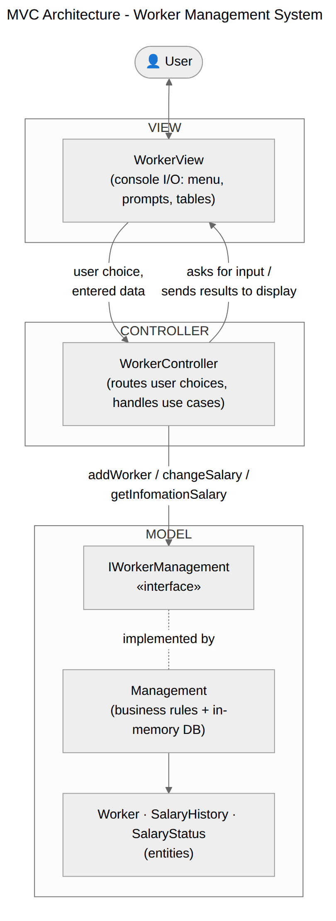
Figure 1. MVC Architecture
Role | Responsibility | Classes
View | Display menu/screens, read keyboard input (with numeric re-prompt loops), show results and the report table. | WorkerView
Controller | Main loop; route options 1–5 to the matching handler; catch business exceptions and pass messages to the View. | WorkerController, Main
Model | Validate business rules, store workers, adjust salaries, record and sort the salary history. | IWorkerManagement, Management, Worker, SalaryHistory, SalaryStatus

1.2 Package Diagram
The code is split into three packages that map one-to-one to the MVC roles, plus the Main entry point.
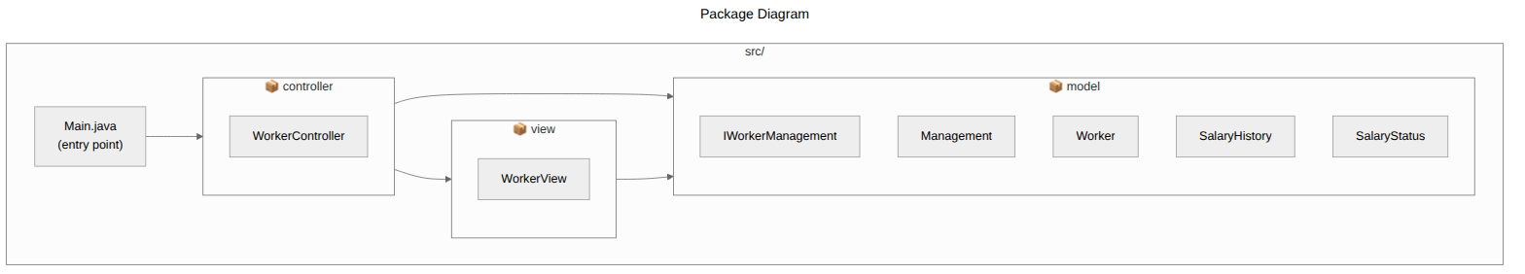
Figure 2. Package Diagram

2. Data Design
A database is not used; data is persisted in memory for the lifetime of the program. The worker "table" is realized by a Map keyed by worker code and the adjustment history by an append-only List.
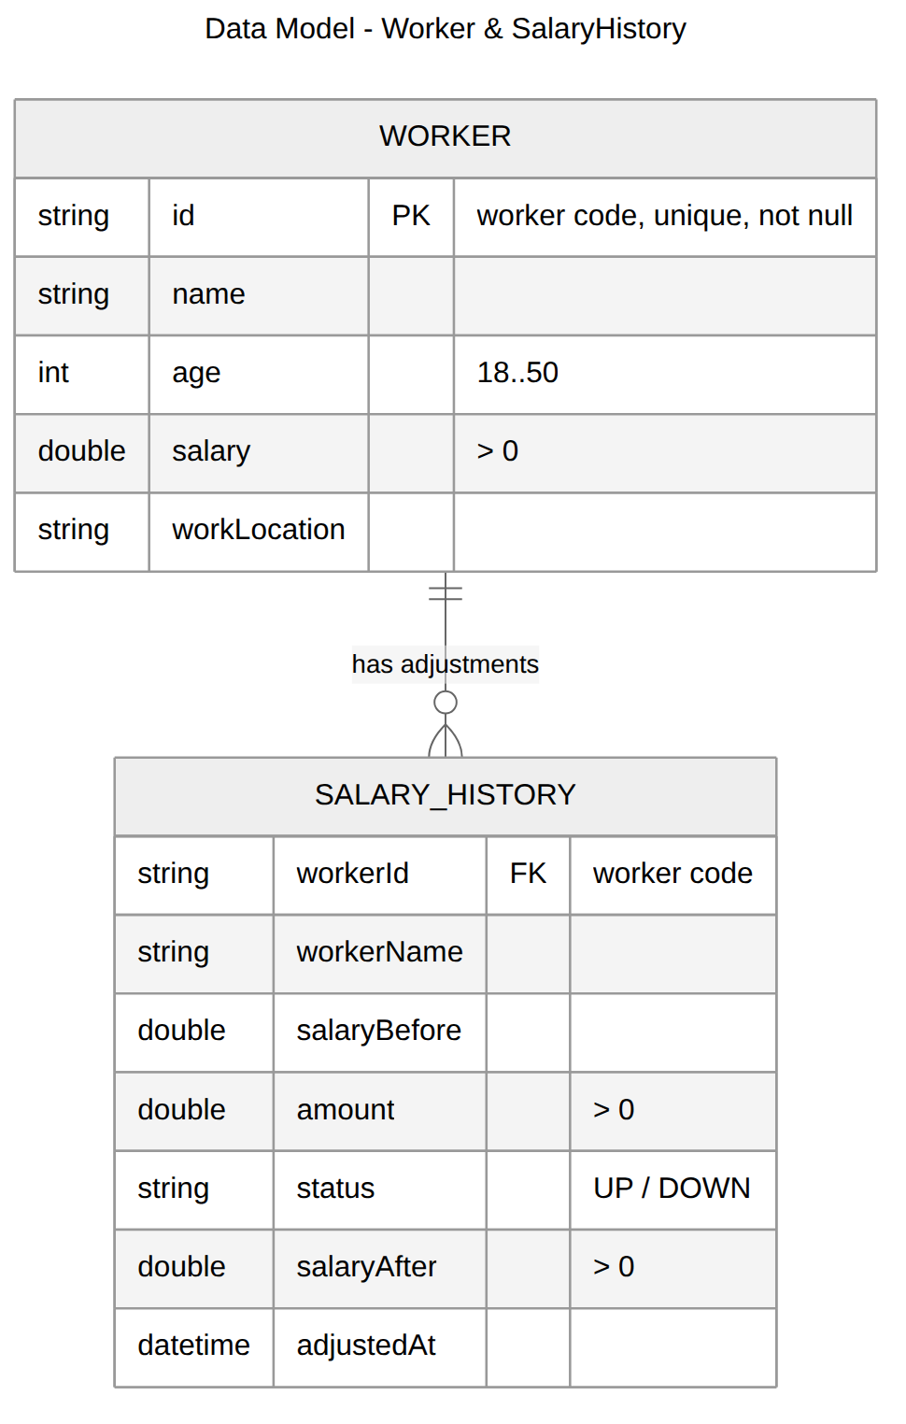
Figure 3. Data Model

2.1 Worker store (Map<String, Worker>)
Field | Type | Key | Description
id | String | PK | Unique worker code (map key); not null, not duplicated.
name | String |  | Full name.
age | int |  | 18 to 50.
salary | double |  | Greater than 0 at all times.
workLocation | String |  | Work location.

2.2 Salary history store (List<SalaryHistory>)
One record per adjustment: workerId, workerName, salaryBefore, amount, status (UP/DOWN), salaryAfter, adjustedAt. Records are returned sorted ascending by workerId when the report is requested.

III. Detailed Design

1. Class Design

1.1 Class Diagram
The design class diagram shows the full set of classes that implement the system, with attributes, operations and relationships.
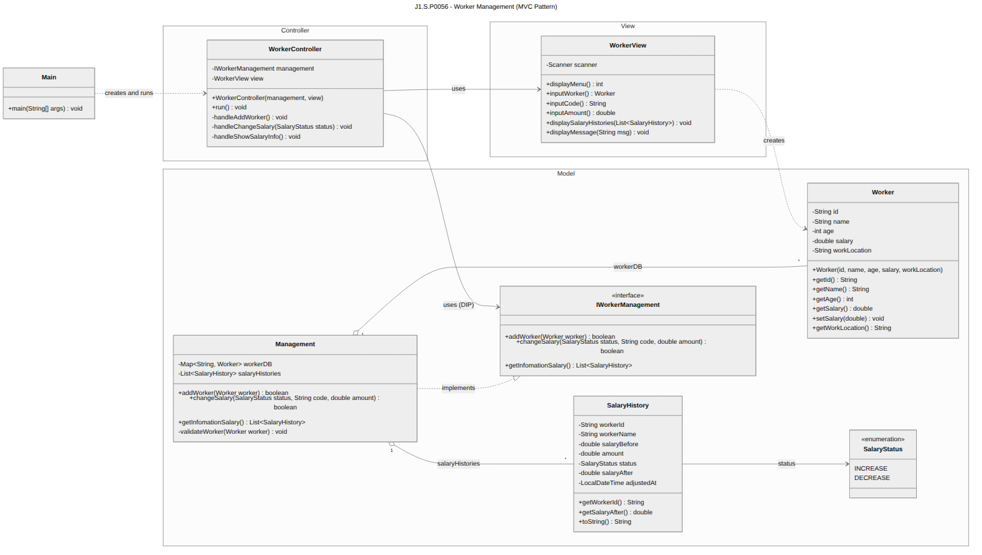
Figure 4. Design Class Diagram
Class | Role | Key Responsibilities / Methods
Main | Entry point (wiring) | main() – creates Management, WorkerView, WorkerController and starts the main loop.
WorkerController | Controller | run() – main loop; handleAddWorker(); handleChangeSalary(status); handleShowSalaryInfo(). Depends only on the IWorkerManagement abstraction (DIP).
WorkerView | View | displayMenu(); inputWorker(); inputCode(); inputAmount(); displaySalaryHistories(list); displayMessage(msg). All console I/O lives here (SRP).
IWorkerManagement | Model (abstraction) | addWorker(Worker); changeSalary(SalaryStatus, String, double); getInfomationSalary(). Contract between Controller and Model (OCP/DIP).
Management | Model (business logic) | Implements IWorkerManagement; validateWorker(worker); owns the in-memory workerDB (Map) and salaryHistories (List).
Worker | Model (entity) | id, name, age, salary, workLocation with getters; setSalary(double).
SalaryHistory | Model (entity) | One immutable adjustment record: before, amount, status, after, time.
SalaryStatus | Model (enum) | INCREASE / DECREASE with display labels UP / DOWN.

1.2 Sequence Diagram – Add a Worker
The sequence diagram details the message flow for adding a worker, including the three validation branches (duplicated/null code, age out of range, non-positive salary) and the successful path that stores the worker.
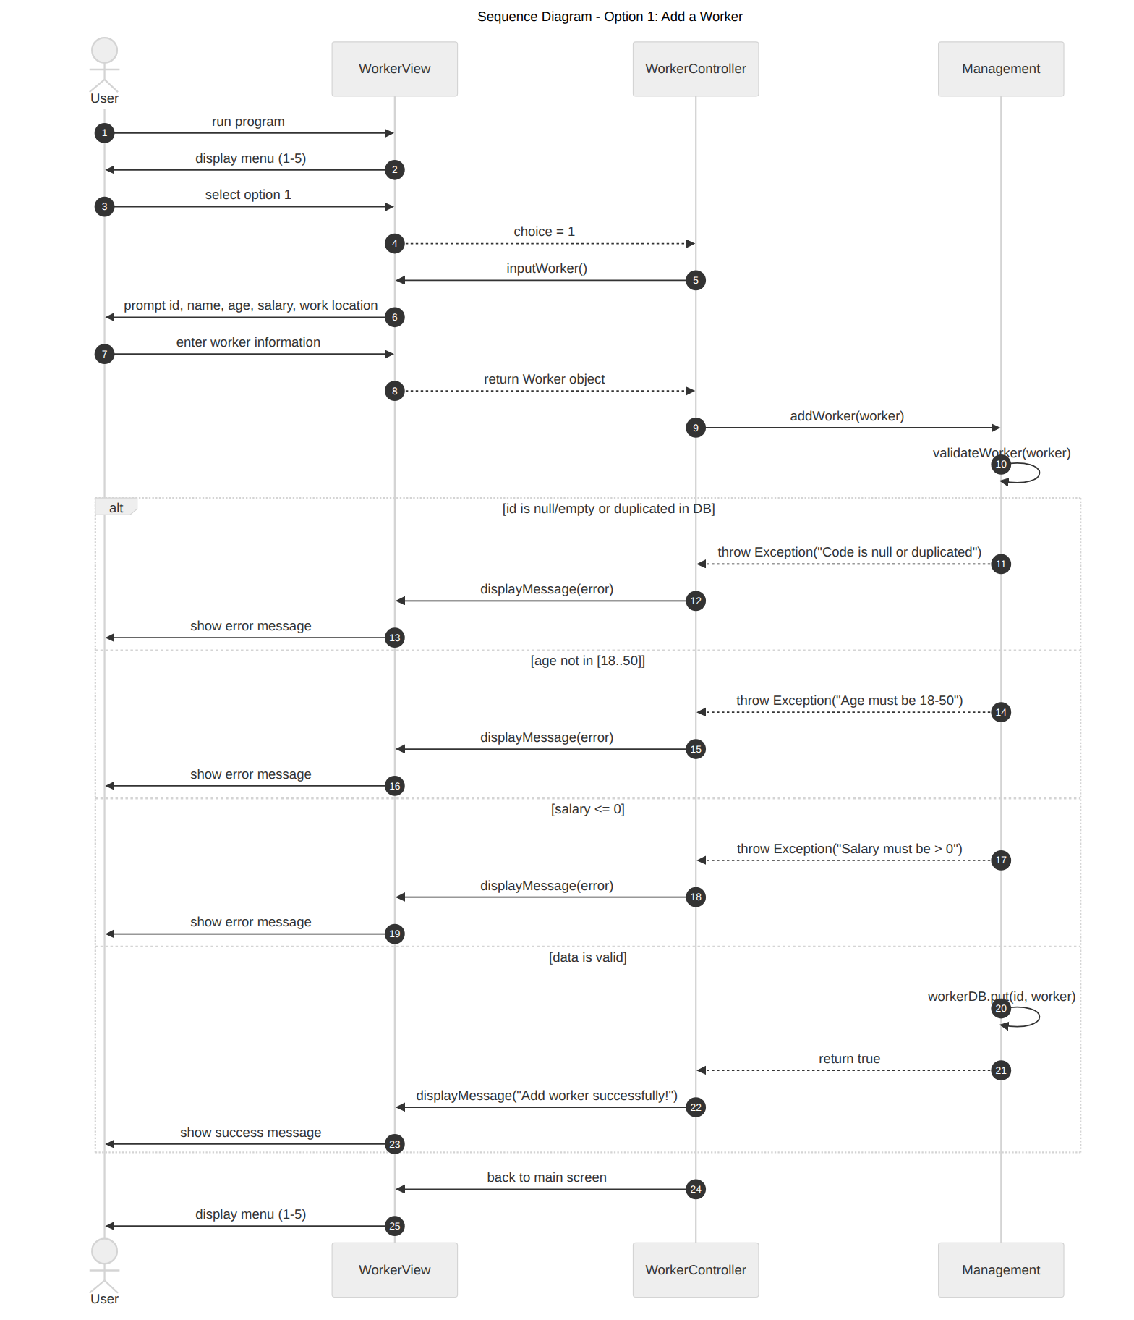
Figure 5. Sequence Diagram – Add a Worker

2. Adjust Salary

2.1 Class Diagram
Adjusting a salary uses a subset of the classes in Figure 4: WorkerController (controller) calls Management.changeSalary(status, code, amount) through IWorkerManagement; Management looks the Worker up in the map, validates the request, updates the salary and appends a SalaryHistory record.

2.2 Sequence Diagram – Increase / Decrease Salary
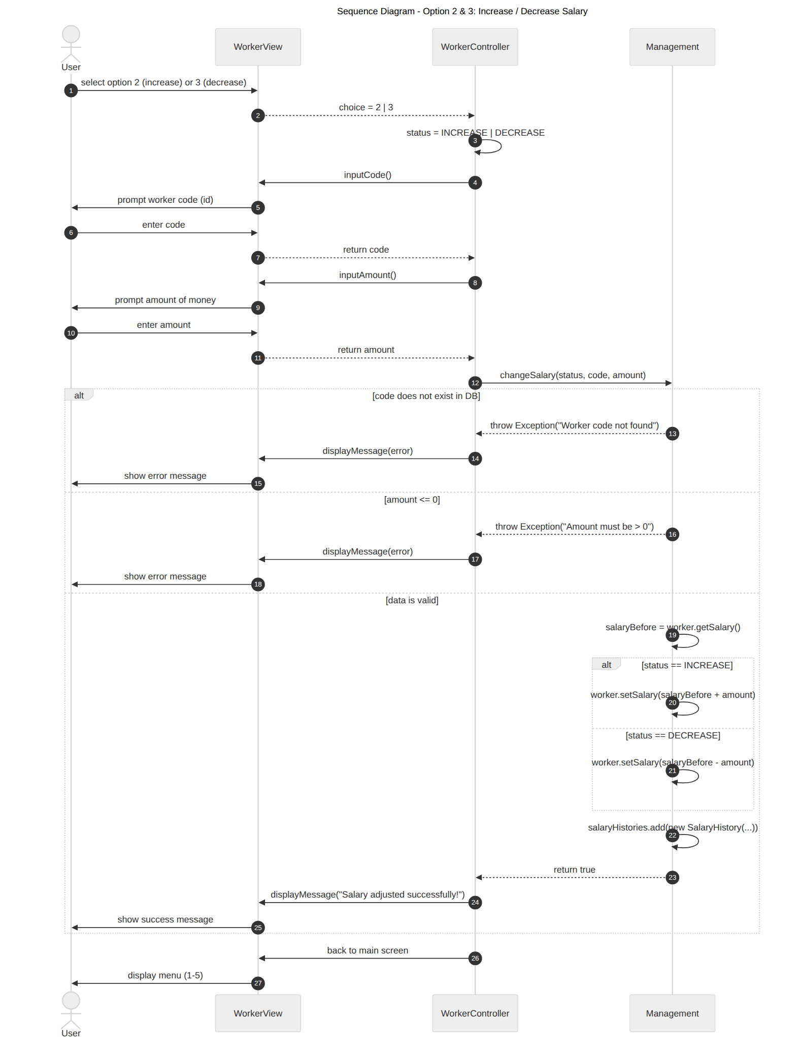
Figure 6. Sequence Diagram – Adjust Salary

3. Show Adjusted Salary Workers

3.1 Sequence Diagram
The report use case is read-only: the Controller asks the Model for the sorted history and passes it to the View for display.
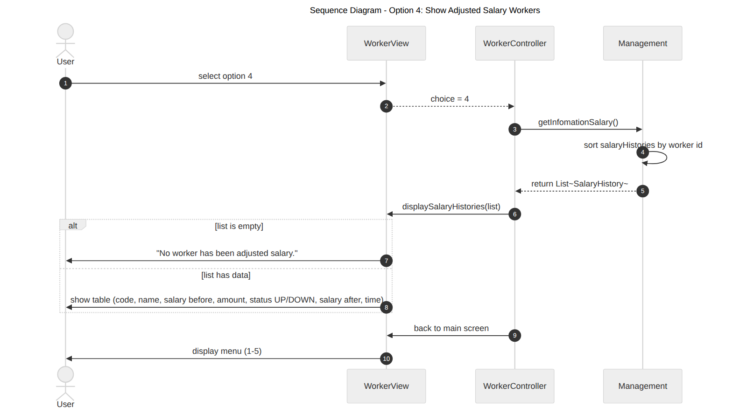
Figure 7. Sequence Diagram – Show Adjusted Salary Workers

