**Homework #7 (level 3)**

**1. Learn the New Words and IV 4**

**2. Train the Crazy Story 2.**

**3. Learn the rules of THE.**

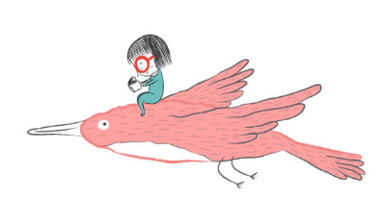**4. Write a/an, the, or --.**

1. We enjoyed our trip. **THE** A hotel was very nice.

2. Can I ask **THE a** question? Sure. What do you want to know?'

3. You look very tired. You need to go to **-** bed.

4. Where's Tom? He's in **–** the kitchen.

5. Eve is **A** interesting person. You should meet her.

6. Excuse me, can you tell me how to get to **THE** city centre?

7. Shall we go out for **-** dinner this evening? Yes, that's **THE a** good idea.

8. It’s **THE a** nice morning. Let's go for **A** walk.

9. Amanda is **A** student. When she finishes her studies, she wants to be **A** journalist. She lives with two friends in **–** an apartment near **THE** college where she is studying. **THE** apartment is small, but she likes it.

10. Peter and Mary have two children, **-** a boy and **–** a girl. **THE** boy is seven years old, and **THE** girl is three. Peter works in **THE** a factory. Mary doesn’t have **A** job at the moment.

11. What is **–the** name of **THE** director of **A** the film we saw last night?

12. Would you like to go to **THE** moon?

13. We don’t eat **A** - fish very often.

**5. Translate and answer the questions:**

1. Что ты ел на завтрак сегодня?

**What did you have for breakfast today?**

**I had a porridge for breakfast today**

2. Как ты спал прошлой ночью?

**How did you sleep last night? I slept very well last night**

3. У тебя были строгие учителя в школе?

**Did you have strict teachers at school? Yes, I had strict teaches teachers at school**

4. Что ты умел делать, когда тебе было шесть лет?

**What could you do, when you was you were 6 year? I could swim, when I was 6 year**

**Не нужно говорить years, когда мы говорим про возраст, есть два варианта:**

1) I’m 6

2) I’m 6 years old

5. Почему ты выбрал Easy School?

**Why did you choose** **Easy School? I chose Easy School, because it is very interesting**

**Not bad! ☺**