**HOMEWORK #10 (level 4)**

**1. Learn the new markers and new words.**

**2. Translate:**

1. Ты уже поужинал? Have you already dinner?

2. Они еще не уехали. They haven“t left yet

3. Я уже съел креветки, не еще не съел семгу. I have already eaten shrimps, But I haven“t eaten salmon yet

____________________________________________________________________________________________

4. Мы еще не заказали закуски. We haven“t ordered snacks yet

____________________________________________________________________________________________

5. Мэри только что сказала нам, что она едет в Австралию. Marry has just said us, that she is going to Australia

____________________________________________________________________________________________

6. Дедушка уже нашел своё пиво. Grandfa has already found him beer

7. Наш урок только что закончился. Out lesson has just finished

8. Фиона и Майк уже начали работать. Когда они начали работать? Два часа назад. Feyona and Mike have already begun work. When they have begun work? At two hour ago

____________________________________________________________________________________________

____________________________________________________________________________________________

**3. Read the situations and write sentences with just, already or yet.**

1. After lunch you go to see a friend at her house. She says, 'Would you like something to eat?' You say: No thank you. **I’ve just had** (have lunch)

2. Joe goes out. Five minutes later, the phone rings and the caller says, 'Can I speak to Joe?' You say: I'm afraid He has already gone out (go out)

3. You are eating in a restaurant. The waiter thinks you have finished and starts to take your plate away. You say: Wait a minute! We have not finished yet (not / finish)

4. You know that your friend is looking for a place to live. Maybe she has been successful.

Ask her. You say: Have you just found a place to live (find)

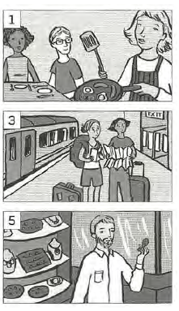**4. Extra: Write sentences for the pictures. Use Present Perfect + just.**

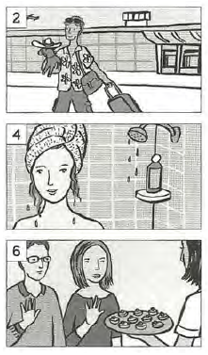

1. приготовила завтрак she has just made a breakfast

___________________________________

2. был в отпуске he has hust been in vacatiom

___________________________________

3. приехали They have just gone

___________________________________

4. помыла голову She has just washed your hair

___________________________________

5. купил кольцо he has just bought ring

___________________________________

6. пообедали _______________________

___________________________________

**5. Make up a menu for your own restaurant**

**MY RESTAURANT**

**Name: Delicious at home**

|  |  |  |
| --- | --- | --- |
| **Starters** |  | **Price** |
|  | - Fish soup  - vegetables salad  - sandwiches | 3$  2$  3.50$ |
| **Main Courses** | |  |
|  | - mashed potatoes with chicken  - buckweat with pork  - spagetti with chees | 5$  4$  7.50$ |
| **Sides** | |  |
|  | - seafood  - vegetables  - meat | 5$  5$  5$ |
| **Desserts** |  |  |
|  | - Ice-cream with chocolate  - mushrooms pie  - cheese pizza | 2$  4$  4$ |
| **Drinks** |  |  |
|  | - tea  - coffee  - Wine, champaign | 1$  2$  6$ |