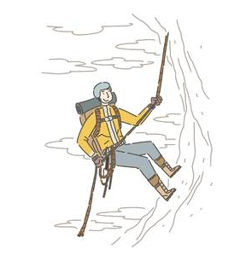**HOMEWORK #8 (level 4)**

**1. Learn the Rules of Present Perfect, new markers and the new words.**

**2. Make questions with the Present Perfect and ever. Answer them.**

**Example:** meet the President: Have you ever met the President? No, of course I haven’t.

1. fly in a helicopter

Have you ever flown in a helicopter? No,I haven’t

____________________________________________________________________________________________

2. break a leg

Have you ever broken a leg? Yes, I Have

____________________________________________________________________________________________

3. make a phone call in English

Have you ever made a phone call in enlish? No I have not haven’t

____________________________________________________________________________________________

4. spend more than a week without a phone

Have you ever spent more than a week without a phone? No, I have not haven’t

____________________________________________________________________________________________

5. do a dangerous sport

Have you ever done A dangerous sport? No, I have not haven’t

____________________________________________________________________________________________

6. study in a foreign country.

Have you ever studied in a foreign country? No, I have not haven’t

____________________________________________________________________________________________

**3. Write two more questions for your teacher.**

1. Why have you broken leg in lessons? I didn’t understand the question

2. Have you ever been trapped in an evelator? – No, I haven’t

**4. Correct mistakes in the conversation.**

A: You have ever been to Australia?

have You ever been to Australia?

B: No, I have. And you?

No, I haven’t. And you?

A: Yes, I've.

Yes, I have.

B: And have you gone to Spain too? _Have you been to…._________________________________

A: No, but l been to Portugal.

No I have been to Portugal

B: You've travel to many countries in your life…

You have traveled to many countries in your life...

A: Yes, l has. I've meeted a lot of people and I've try a lot of interesting food.

Yes, l have. I've met a lot of people and I've tried a lot of interesting food.

B: But you haven't learn to speak English perfectly!

But you haven't learned to speak English perfectly!

A: Not yet…

B: Have you ever swam in the ocean?

Have you ever swum in the ocean?

A: No, I’ve ever swim in the ocean, but I’ve swam in the sea!

No, I’ve ever never swum in the ocean, but I’ve swum in the sea!

**Good job! A-**