Software Requirement Specification

SAPP-01 for iOS TC35678 BLE

Toshiba Software Development (Vietnam) Co., Ltd

Document ID: TSDV-SAPP-01-iOS-TC35678-BLE-SRS-01
Total: 44 Page No. 1
Revision History

Rev. No.  (X.YY) | Date  (YYYY-MM-DD) | Section No. Changed | Change Description | Author | Reviewed by | Approved by
0.01 | 05/31/18 | 4.2.5, 5.2.6 | Create new | DatDN

Contents

1Introduction 7
1.1Purpose 7
1.2Scope 7
1.3Definitions, Acronyms, Abbreviations 7
1.4References 7
2Overall Description 8
2.1Product Perspective 8
2.2Technical Standards 8
2.3User characteristics/Operational Scenarios 8
2.4Operating Environment 9
3Dependencies, Constraints & Limitations 10
4Functional Requirements 11
4.1Introduction 11
4.2Use-case details 11
4.2.1Select service mode 12
4.2.2Handle GPS data 13
4.2.3Read data from SNAND via PC I/F 17
4.2.4Read GPS data by Date/Time 18
4.2.5Read GPS data by Block/Page 20
4.2.6Format SNAND 22
4.2.7User settings 22
5External Interface Requirements 24
5.1Key function 24
5.2LCD screens 24
5.2.1Mode selection screens 24
5.2.2GPS data to LCD 25
5.2.3GPS data to 3G 25
5.2.4GPS data to SNAND 28
5.2.5SNAND data to LCD (by Date/Time) 28
5.2.6SNAND data to LCD (by Block/Page) 30
5.2.7SNAND data to PC 32
5.2.8Format SNAND 33
5.2.9Setting update GPS data interval - DEPRECATED 35
5.2.10Setting update SNAND data interval - DEPRECATED 35
5.2.11Setting update 3G data interval 35
5.3PC interface command 35
5.3.1PC interface starting screen 35
5.3.2Read the Serial NAND using day and time 36
5.3.3Read the Serial NAND using block and page 36
5.3.4Go next page 36
6Non-functional Requirements 37
6.1Performance Requirements 37
6.2Memory Requirements 37
6.3Error Handling 38
6.4Other Requirements & Attributes 38
7Acceptance criteria 39
8Appendix 40

Figures

Screens

Introduction

Purpose
This document shows a detail description how to communicates between application on iOS platform and TC35678 BLE LSI board through BLE device peripheral.

Scope
This document specifies requirements including:
- Scan and connect to board in range.
- Read and display device information such as:
- Software revision.
- Firmware revision.
- Hardware revision.
- Manufacture revision.
- Read and display humidity/temperature/pressure in realtime.
- Send data string to display on demo board's LCD.

Definitions, Acronyms, Abbreviations
ID No | Acronym/ Abbreviation | Definition
1 | BLE | Bluetooth Low Energy
2 | LSI
3 | TC35678 BLE LSI | Toshiba BLE LSI TC35678 demo system

References
ID No | Reference | Version Number | Document Name/Source & Location reference | Remarks
1 | TC35678 BLE LSI Demo_board_User Manual | v0.1 | TC35678 BLE LSI Demo_board_User Manual v0.1.pdf | -
2 | SAPP-01_for_iOS_TC35678_Instructions | v0.1 | SAPP-01_for_iOS_TC35678_Instructions.pdf

Overall Description

Product Perspective
The GPS tracking system collects the position data by reading data from GPS device, filter useful data, stores the data to Serial NAND and upload data to server via 3G modem periodically. So that end users can view and get the GPS information through server.
The software also supports data read from the Serial NAND. User can read data using the user interface on the MCU board or user can also send commands via serial port (PC interface) to read data from the Serial NAND. The
TMPM3HQ MCU board shall be used to control all the devices of GPS tracker systems.
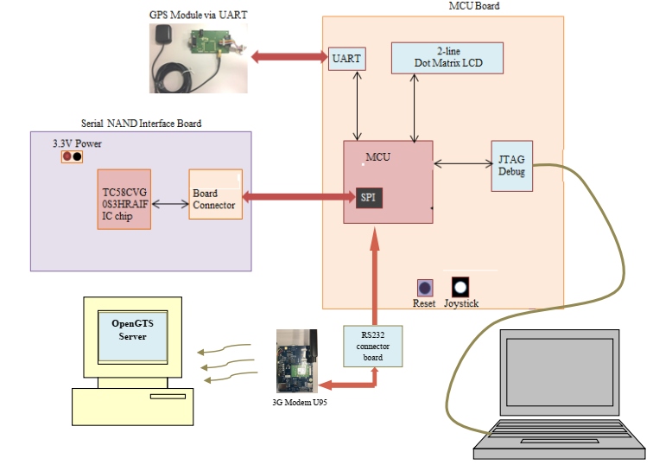
Figure 2-1: Demo iOS application overview

Technical Standards

ID No | Standard | Mandatory Specifications/ Parameters | Options considered | Options not in scope | Remarks
1 | BLE protocol | - | - | - | -

User characteristics/Operational Scenarios
N/A

Operating Environment
System development environment:
- Hardware:
- TC35678 BLE LSI board for development and demo the application.
- Software:
- Xcode 9.3
- iOS 11.3

Dependencies, Constraints & Limitations
On iOS platform don't public generic access (GA) service. So characteristics following not readable:

ID No | Name | Assigned Number | Type
1 | Device Name | 0x2A00 | org.bluetooth.characteristic.gap.device_name
2 | Appearance | 0x2A01 | org.bluetooth.characteristic.gap.appearance

Functional Requirements

Introduction
Use-cases of demo application are illustrated as following diagram:
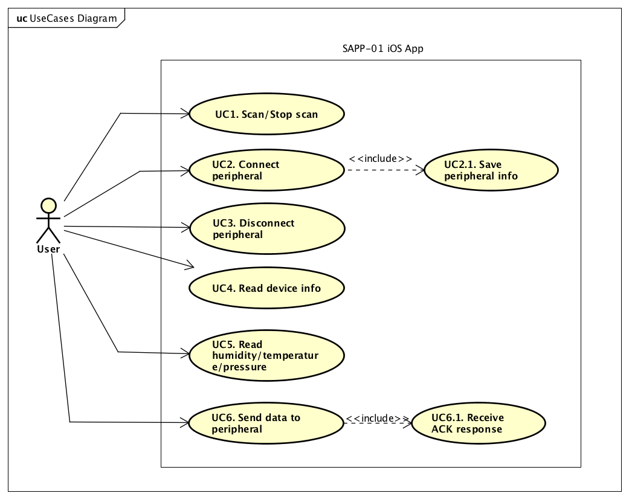
Figure 4-2: Use-case diagram
Following table lists all use-cases of application:
Table 4-1: Use-case list
Use case ID | Use case name
UC1 | Scan/Stop scan board.
UC2 | Connect to board.
UC3 | Disconnect to board.
UC4 | Read device information.
UC5 | Read humidity, temperature, pressure realtime.
UC6 | Send data to display on LCD

Use-case details

Scan board
Use-case ID | UC1
Name | Scan board.
Summary | Find board before connect.
Actor(s) | User
Pre-condition | Bluetooth power on. Board turned on. Board isn't paired to System yet.  System has launch, BLE tab is selected.
Terminate-condition for success | Found board.
Screen Design
Steps | ID | Subject | Action
Steps |  | User | Clicks to [SCAN: STOPPED] button.
Steps |  | System | Change title SCAN button = [SCAN: RUNNING]
 |  | System | Searches BLE devices
 |  | System | Displays list of BLE devices
Alternative | ID | Condition |  |  | Action
Exception | ID | Condition |  |  | Action
Exception | 2,3,4 | User close application |  |  | System cancels scan BLE devices
Exception | 2,3,4 | User change to other Tab |  |  | System cancels scan BLE devices
Exception | 2,3,4 | User turned off bluetooth |  |  | System cancels scan BLE devices  System change title [SCAN: STOPPED]

Stop scan
Use-case ID |  | UC2
Name |  | Stop scan
Summary |  | Stop scan progress
Actor(s) |  | User
Pre-condition |  | System is scan running, SCAN button title = [SCAN: RUNNING], BLE tab is selected
Terminate-condition for success |  | SCAN button title = [SCAN: STOPPED]
Screen Design
Steps |  | ID |  | Subject | Action
 |  | 1 |  | User | Clicks to [SCAN: RUNNING] button.
 |  | 2 |  | System | Stop scanning
 |  | 3 |  | System | Change title button SCAN = [SCAN: STOPPED]
Alternative |  | ID |  | Subject | Action
Exception | ID |  | Condition |  |  | Action

Connect to board
Use-case ID | UC3
Name | Connect to board.
Summary | Execute pair and connect to board
Actor(s) | User
Pre-condition | Board name is displaying in list of BLE devices.  Bluetooth's System power on, BLE tab is selected  DISCONNECT button is disabled.  Notice message title = [Choose a device to connect]
Terminate-condition for success | Board and System is paired and connect successfully  DISCONNECT button is enabled.  Notice message title = [Connected]
Screen Design
Steps | ID | Subject | Action
Steps |  | User | Click board item in list of BLE devices
Steps |  | System | Show confirm connect popup
Steps |  | User | Click OK option
Steps |  | System | Show progress dialog
Steps |  | System | Execute pair and connect
Alternative | ID | Subject | Action
Exception | ID | Condition |  |  | Action
Exception | 3 | User turned off bluetooth |  |  | Show bluetooth turned off popup
Exception | 4,5 | User turned off bluetooth |  |  | Show failure connected popup

Disconnect to board
Use-case ID | UC4
Name | Disconnect to board
Summary | Execute disconnect to board
Actor(s) | User
Pre-condition | System and board is connected, Bluetooth's System power on, BLE tab is selected  DISCONNECT button is enabled.  Notice message title = [Connected]
Terminate-condition for success | Board and System is disconnected successfully  DISCONNECT button is disabled.  Notice message title = [Choose a device to connect]
Screen Design
Steps | ID | Subject | Action
Steps |  | User | Click to DISCONNECT button
Steps |  | System | Execute disconnect
Alternative | ID | Subject | Action
Exception | ID | Condition |  | Action

Transmit GPS data to Server

Use-case ID | UC2.6
Name | Transmit GPS data to Server
Summary
Actor(s) | User
Pre-condition | Operation mode “GPS 3G – SNAND” is currently active.
Terminate-condition for success | User intentionally exits operation mode “GPS 3G – SNAND”
Screen Design
Steps | ID | Subject |  | Action
Steps |  | System |  | Send data/command to 3G module(1)
Steps |  | System |  | Send data/command messages to server(2)
Steps |  | System |  | Get response messages from server(3)
Steps |  | System |  | Display connection status to LCD(4)
Steps |  | System |  | Close connection
Alternative | ID | Condition |  |  |  | Action
Exception | ID | Condition |  |  |  | Action
Special Requirements | No |  | Description
Special Requirements | (1) |  | System may send various kind of data/command to 3G module.  - ATE0 command
Special Requirements | (2) |  | System may send various kind of data/command to server  - INIT_GSM  - INIT_CONTEXT  - CONNECT_GSM  - AT+QISEND=1
Special Requirements | (3) |  | While system send data to server, there are many responses from server each time data/command is sent.  - OK
 | (4) |  | Connection status is displayed on LCD:  - PROMT: (Screen 5.2.3-25)  - NO PROMPT: Send command failed  - RETRY ALL: Send command failed

Read data from SNAND via PC I/F
Use-case ID | U-3
Name | Read data from SNAND via PC I/F
Summary | User acquires GPS data from SNAND (able to read by day/time or block/page)
Actor(s) | User
Pre-condition | GPS Tracker system is started, current operation mode is “PC I/F SNAND”
Terminate-condition for success | User intentionally exits operation mode “PC I/F SNAND” by using [LEFT] key
Screen Design | PC interface in
Steps | ID | Subject | Action
Steps |  | User | Selected operation mode “PC I/F SNAND”
Steps |  | System | Displays current status of this mode
Steps |  | System | Waits for command from PC(1)
Steps |  | System | Command from PC is received
Steps |  | System | Checks command and executes
Steps |  | System | Sends data back to PC
Alternative | ID | Subject | Action
Exception | ID | Condition |  |  | Action
Exception | 4a | Command is not received |  |  | System continues waiting for commands from PC

Read GPS data by Date/Time

Use-case ID | U-4
Name | Select service mode
Summary | User reads GPS data from SNAND memory by date and time
Actor(s) | User
Pre-condition | GPS Tracker system is started, current operation mode is “Read NAND day”
Terminate-condition for success | User intentionally exits operation mode “Read NAND day” by using [LEFT] key
Screen Design | Error: Reference source not found, Error: Reference source not found, Error: Reference source not found, Error: Reference source not found, Error: Reference source not found, Error: Reference source not found, Error: Reference source not found and Error: Reference source not found
Steps | ID | Subject | Action
Steps |  | User | Selected “Read NAND day” mode before
Steps |  | System | Display start page Error: Reference source not found
Steps |  | User | Uses [UP] and [DOWN] button to change value of the first digit for day on Error: Reference source not found
Steps |  | User | Uses [RIGHT] button to go to next digit
Steps |  | User | Repeat the steps until user has finished selecting all 2 digits for day and all 4 digits for time
Steps |  | User | Presses [CENTER] button to start reading GPS data after day and time are selected completely
Steps |  | System | Starts reading data from from SNAND according to selected day and time from user. Reading status is displayed on Error: Reference source not found
Steps |  | System | Displays GPS data on Error: Reference source not found
Steps |  | User | Presses [DOWN] button to display latitude and longtitude for that second
Steps |  | System | Displays latitude and longtitude on LCD: Error: Reference source not found
Steps |  | User | Presses [DOWN] to display GPS data for the next 15th second
Steps |  | System | Display GPS data on LCD for the next 15th second
Steps |  | User | Continues pressing [DOWN] button to view all available GPS data in that mimute until reaching “END OF PG” message
Steps |  | System | Display “End of page” message: Error: Reference source not found
Steps |  | User | Presses [CENTER] to read next minute
Alternative | ID | Subject | Action
Alternative | 13a | User | Presses [RIGHT] to jump to the next hour instead
Alternative | 13b | User | Presses [LEFT] to return previous menu to select another day and time again
Exception | ID | Condition |  |  | Action
Exception | 4a | User enters invalid day or time |  |  | System display error message on Error: Reference source not found and gives user recommend message on Error: Reference source not found

Read GPS data by Block/Page

Use-case ID | U-5
Name | Read GPS data by Block/Page
Summary | User reads data from desired block number and page number in Serial NAND.
Actor(s) | User
Pre-condition | User selects mode “6: Read NAND BLK” from main menu
Terminate-condition for success | User presses [LEFT] key when system is displaying “Select block and page screen” screen (Error: Reference source not found and Error: Reference source not found).
Screen Design | Error: Reference source not found, Error: Reference source not found, Error: Reference source not found, Error: Reference source not found, Error: Reference source not found, Error: Reference source not found, Error: Reference source not found, Error: Reference source not found, Error: Reference source not found
Steps | ID | Subject | Action
Steps | 1 | User | User presses [LEFT] key when system is displaying “Select block and page screen” screen (Press [CENTER] key to select the “Read NAND BLK” option
Steps | 2 | System | Display “Error: Reference source not found” on LCD screen
Steps | 3 | User | Press [UP] key to increase value of current digit until the digit reaches user desired number.
Steps | 4 | System | Display the value of current digit on LCD screen (Error: Reference source not found).
Steps | 5 | User | Press [RIGHT] key to go to the next digit of block/page
Steps | 6 | System | Move adjustment position to the next digit (blink cursor to indicate which cursor is being selected)
Steps | 7 | User | Repeat steps 3 and 5 until desired number is selected
Steps | 8 | User | Press [CENTER] key to start reading data according to block/page
Steps | 9 | System | Display “Error: Reference source not found” on LCD screen
Steps | 10 | System | Read data for the selected block page
Steps | 11 | System | Display data on LCD screen “Error: Reference source not found” after read operation is finished
Steps | 12 | User | Press [DOWN] key to request next 2 lines of display data
Steps | 13 | System | Display next 2 lines of display data on LCD screen (Error: Reference source not found, Error: Reference source not found)
Steps | 14 | User | Repeat step 12 until all data of the specified block/page was displayed
Steps | 15 | System | Display “Error: Reference source not found” on LCD screen to indicates “end of page”
Steps | 16 | User | Press [CENTER] key to read the next page
Steps | 17 | System | Go to step 10.
Alternative | ID | Subject |  |  | Action
Alternative | 3a. | User |  |  | Press [DOWN] key to decrease value of current digit until the digit reaches user desired number.
Alternative | 3a.1. | System |  |  | Go to step 4
Alternative | 3b. | User |  |  | Press [LEFT] key
Alternative | 3b.1. | System |  |  | Do nothing
Alternative | 2a. | User |  |  | Press [LEFT] key
Alternative | 2a.1. | System |  |  | Leave mode “6: Read NAND BLK” and return to menu selection. (Refer to Select service mode (main function))
Exception | ID | Subject |  |  | Action
Exception | 8a. | If the block or page number is invalid (1) (2).
Exception | 8a.1. | System |  |  | Display error message (“Error: Reference source not found”) on LCD screen for a specific time before executing next step (3).
Exception | 8a.2. | System |  |  | Display “Error: Reference source not found” and waiting for a specific time before executing next step (3).
Exception | 8a.2. | System |  |  | Display “Error: Reference source not found” and waiting user to select block page again.  (Go to step 3).
Special Requirements | No |  |  | Description
Special Requirements | (1) |  |  | Default value for both block and page number is 0.  Block 0 and Page 0 are valid entries – this is the first page in the serial NAND.
Special Requirements | (2) |  |  | Number range of valid block and page number that user can enter:  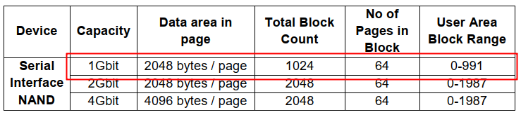
Special Requirements | (3) |  |  | Time interval for waiting while system is displaying message on LCD screen: 1s.

Format SNAND

Use-case ID | U-6
Name | Format SNAND
Summary | User requests to erased all content in Serial NAND
Actor(s) | User
Pre-condition | User selects mode “8: Format SNAND” from main menu
Terminate-condition for success | N/A
Screen Design | Error: Reference source not found, Error: Reference source not found, Error: Reference source not found, Error: Reference source not found”
Steps | ID | Subject |  | Action
Steps | 1 | User |  | Press [CENTER] key to enter the “8: Format SNAND” mode
Steps | 2 | System |  | Display “Error: Reference source not found” on LCD screen
Steps | 3 | User |  | Press [RIGHT] key to format SNAND
Steps | 4 | System |  | Display “Error: Reference source not found” on LCD screen
Steps | 5 | System |  | Start SNAND formatting operation (1).
Steps | 6 | System |  | Display “Error: Reference source not found” on LCD screen when formatting is done
Steps | 7 | System |  | Leave mode “8: Format SNAND” and return to menu selection. (Refer to Select service mode (main function))
Alternative | ID | Subject |  |  | Action
Alternative | 3a. | User |  |  | Press [LEFT] key
Alternative | 3a.1 | System |  |  | Leave mode “8: Format SNAND” and return to menu selection. (Refer to Select service mode (main function))
Exception | ID | Condition |  |  | Action
Exception | 5a. | If formatting operation is failure
Exception | 5a.1. | System |  |  | Display “Error: Reference source not found” on LCD screen and wait for a specific time (2).
Exception | 5a.2 | System |  |  | Leave mode “8: Format SNAND” and return to menu selection. (Refer to Select service mode (main function))
Special Requirements | No. |  | Description
Special Requirements | (1) |  | Formatting operation includes the following process:  - Serial NAND initialization and variables initialization  - Erase device – all pages  - Check bad blocks and get information on the bad block management
Special Requirements | (2) |  | Time interval for waiting while system is displaying message on LCD screen: 1s.

User settings

Use-case ID | U-7
Name | User settings
Summary | User changes system settings (such as 3G data upload interval)
Actor(s) | User
Pre-condition | User selects mode “10: User Setting” from main menu
Terminate-condition for success | N/A
Screen Design | Screen 4.2.7-1
Steps | ID | Subject |  | Action
Steps | 1 | User |  | Press [CENTER] key to enter the “10: User Setting” mode
Steps | 2 | System |  | Display “Screen 4.2.7-2” on LCD screen with current 3G data upload interval (Refer Special Requirements No.3)
Steps | 3 | User |  | Press [UP] key to increase 3G data upload interval
Steps | 4 | System |  | Increase 3G data upload interval by N (Refer to Special Requirements No.1)
Steps | 5 | System |  | Display “Screen 4.2.7-3” on LCD screen with new interval value
Steps | 6 | User |  | Repeat step 3 until desired number is display on LCD screen
Steps | 7 | User |  | Press [CENTER] key to write store and validate new interval
Steps | 8 | User |  | Press [LEFT] to left user settings mode and return main menu
Alternative | ID | Subject |  |  | Action
Alternative | 3a. | User |  |  | Press [DOWN] key to decrease 3G data upload interval
Alternative | 3a.1 | System |  |  | Decrase 3G data upload interval by N (Refer to Special Requirements No.1)
Alternative | 3a.2 | System |  |  | Display “Screen 4.2.7-4” on LCD screen with new interval
 | 3a.3 | User |  |  | Repeat step 3a. until desired number is display on LCD screen
 | 3a.4 | User |  |  | Go to step 7 of Basic flow
 | 4a. | System |  |  | Do nothing, in case 3G data upload interval reachs the maximum allowed number (UPLOAD_INTERVAL_MAX) (Refer to Special Requirement No.2 for UPLOAD_INTERVAL_MAX)
 | 3a.1a. | System |  |  | Do nothing, in case 3G data upload interval reachs the minimum allowed number (UPLOAD_INTERVAL_MIN) (Refer to Special Requirement No.2 for UPLOAD_INTERVAL_MIN)
Exception | ID | Condition |  |  | Action
Exception | N/A
Special Requirements | No. |  | Description
Special Requirements | (1) |  | 3G data upload interval step (N): 5 seconds
Special Requirements | (2) |  | - Maximum allowed number (UPLOAD_INTERVAL_MAX): 1800 seconds  - Minimum allowed number (UPLOAD_INTERVAL_MIN): 0 seconds
 | (3) |  | In case user has not changed the value before, The default value is used.  Default value of 3G data upload interval is 0s.

External Interface Requirements

Key function

Key name on board | Key ID | Function | Description
S4 | [UP] | Scroll Up | Show previous function or decrease number.
S5 | [DOWN] | Scroll Down | Show next function or increase number.
S6 | [SELECT] | Select | Select an option.
S7 | [BACK] | Back | Exit current function.
S9 | [ENTER] | Enter/Start | Start processing a function.

LCD screens

Mode selection screens
Screen 5.2.1-5: Mode 1 – send GPS data to SNAND and Server via 3G
S | E | L | E | C | T |  | O | P | T | I | O | N
1 | : |  | G | P | S |  | 3 | G | - |  | S | N | A | N | D

Screen 5.2.1-6: Mode 2 – read GPS data from SNAND in days
S | E | L | E | C | T |  | O | P | T | I | O | N
2 | : |  | R | E | A | D |  | N | A | N | D |  | D | A | Y

Screen 5.2.1-7: Mode 3 – read GPS data from SNAND in blocks
S | E | L | E | C | T |  | O | P | T | I | O | N
3 | : |  | R | E | A | D |  | N | A | N | D |  | B | L | K

Screen 5.2.1-8: Mode 4 – send GPS data from SNAND to PC
S | E | L | E | C | T |  | O | P | T | I | O | N
4 | : | P | C |  | I | / | F |  | S | N | A | N | D

Screen 5.2.1-9: Mode 5 – format SNAND
S | E | L | E | C | T |  | O | P | T | I | O | N
5 | : | F | O | R | M | A | T |  | S | N | A | N | D
Screen 5.2.1-10: Mode 6 – change GPS setting
S | E | L | E | C | T |  | O | P | T | I | O | N
6 | : |  | G | P | S |  | S | E | T | T | I | N | G

GPS data to LCD
Screen 5.2.2-11: Display GPS data (Latitude and MSL altitude)
A | T | E | 0
0 | 1 | 1 | 6 | . | 5 | 8 | 8 | 0 | N |  | 7 | 1 | m

Screen 5.2.2-12: Display GPS data (Longitude and Speed)
A | T | E | 0
1 | 0 | 3 | 4 | 7 | . | 9 | 1 | 1 | 3 | E |  | 0 | k

Screen 5.2.2-13: Cannot get GPS data (Latitude and MSL altitude)
A | T | E | 0
- | - | - | - | - | . | - | - | - | N |  | - | - | m

Screen 5.2.2-14: Cannot get GPS data (Longitude and Speed)
A | T | E | 0
- | - | - | - | - | . | - | - | - | - | E |  | - | k

GPS data to 3G
Screen 5.2.3-15: Sending data
1 | : |  | G | P | S |  | 3 | G | - |  | S | N | A | N | D
S | E | N | D | I | N | G | . | . | .

Screen 5.2.3-16: GPS status 1
A | T | E | 0
0 | 1 | 1 | 6 | . | 5 | 8 | 8 | 0 | N |  | 7 | 1 | m

Screen 5.2.3-17: GPS status 2
C | P | I | N |  | O | K
0 | 1 | 1 | 6 | . | 5 | 8 | 8 | 0 | N |  | 7 | 1 | m

Screen 5.2.3-18: GPS status 3
I | N | I | T | _ | G | S | M
0 | 1 | 1 | 6 | . | 5 | 8 | 8 | 0 | N |  | 7 | 1 | m

Screen 5.2.3-19: GPS status 4
I | N | I | T | _ | G | S | M | _ | O | K
0 | 1 | 1 | 6 | . | 5 | 8 | 8 | 0 | N |  | 7 | 1 | m

Screen 5.2.3-20: GPS status 5
I | N | I | T | _ | C | O | N | T | E | X | T
0 | 1 | 1 | 6 | . | 5 | 8 | 8 | 0 | N |  | 7 | 1 | m
Screen 5.2.3-21: GPS status 6
I | N | T | E | R | N | E | T |  | R | E | A | D | Y
0 | 1 | 1 | 6 | . | 5 | 8 | 8 | 0 | N |  | 7 | 1 | m

Screen 5.2.3-22: GPS status 7
C | O | N | N | E | C | T | _ | G | S | M
0 | 1 | 1 | 6 | . | 5 | 8 | 8 | 0 | N |  | 7 | 1 | m

Screen 5.2.3-23: GPS status 8
T | C | P |  | C | O | N | N |  | R | E | C | V
0 | 1 | 1 | 6 | . | 5 | 8 | 8 | 0 | N |  | 7 | 1 | m

Screen 5.2.3-24: GPS status 9
T | C | P |  | C | O | N | N | E | C | T | E | D
0 | 1 | 1 | 6 | . | 5 | 8 | 8 | 0 | N |  | 7 | 1 | m

Screen 5.2.3-25: GPS status 10
> | P | R | O | M | P | T
0 | 1 | 1 | 6 | . | 5 | 8 | 8 | 0 | N |  | 7 | 1 | m

Screen 5.2.3-26: GPS status 11
S | E | N | D |  | O | K |  | D | O | N | E
0 | 1 | 1 | 6 | . | 5 | 8 | 8 | 0 | N |  | 7 | 1 | m

Screen 5.2.3-27: GPS status 12
R | E | C | V |  | H | T | T | P |  | C | N | T
0 | 1 | 1 | 6 | . | 5 | 8 | 8 | 0 | N |  | 7 | 1 | m

Screen 5.2.3-28: GPS status 13
C | L | O | S | E |  | C | O | N | N | E | C | T | I | O | N
0 | 1 | 1 | 6 | . | 5 | 8 | 8 | 0 | N |  | 7 | 1 | m

Screen 5.2.3-29: GPS status 14
T | X |  | D | O | N | E | : |  | X | X
0 | 1 | 1 | 6 | . | 5 | 8 | 8 | 0 | N |  | 7 | 1 | m

Screen 5.2.3-30: GPS status 15
T | R | A | S | M | I | T |  | F | A | I | L
0 | 1 | 1 | 6 | . | 5 | 8 | 8 | 0 | N |  | 7 | 1 | m

GPS data to SNAND
Screen 5.2.4-31: Update NAND failed
W | R | I | T | E |  | N | A | N | D |  | E | R | R | O | R
0 | 1 | 1 | 6 | . | 5 | 8 | 8 | 0 | N |  | 7 | 1 | m

SNAND data to LCD (by Date/Time)
Screen 5.2.5-32: Read GPS information
2 | : |  | R | E | A | D |  | N | A | N | D |  | D | A | Y
D | A | Y |  | 0 | 0 |  | H | R |  | 0 | 0 | 0 | 0

Screen 5.2.5-33: Show reading status
2 | : |  | R | E | A | D |  | N | A | N | D |  | D | A | Y
N | O | W |  | R | E | A | D | I | N | G

Screen 5.2.5-34: Display GPS data: date – time - satellite
2 | : |  | R | E | A | D |  | N | A | N | D |  | D |  |  | A | Y
2 | 8 | 0 | 5 | 1 | 8 |  | 2 | 3 | 4 | 5 | 0 | 0 |  |  |  | 4
date |  |  |  |  |  |  |  | time |  |  |  |  |  | satellite

Screen 5.2.5-35: Display GPS data: MSL altitude (m) – Speed (km/h)
2 |  | : |  |  |  | R |  | E | A | D |  | N | A | N | D |  | D | A | Y
- |  | 3 |  | 8 |  | . |  | 7 | M |  | 0 | . | 6 | 7 | k
MSL altitude |  |  | speed

Screen 5.2.5-36: Display GPS data: Latitude
2 | : |  | R | E | A | D |  | N | A | N | D |  |  | D | A | Y
0 | 1 | 2 | 5 | . | 1 | 6 | 3 | 4 | , | N
Latitude

Screen 5.2.5-37: Display GPS data: Longitude
2 | : |  | R | E | A | D |  | N | A | N | D |  |  | D | A | Y
1 | 0 | 3 | 5 | 0 | . | 0 | 5 | 4 | 4 | , | E
Longitude

Screen 5.2.5-38: No SNAND error
2 | : |  | R | E | A | D |  | N | A | N | D |  | D | A | Y
N | O |  | S | N | A | N | D

Screen 5.2.5-39: Read NAND data failed
2 | : |  | R | E | A | D |  | N | A | N | D |  | D | A | Y
R | E | A | D |  | F | A | I | L | E | D

Screen 5.2.5-40: Invalid entry error
2 | : |  | R | E | A | D |  | N | A | N | D |  | D | A | Y
I | N | V | A | L | I | D |  | E | N | T | R | Y

Screen 5.2.5-41: No GPS data
2 | : |  | R | E | A | D |  | N | A | N | D |  | D | A | Y
N | O |  | G | P | S |  | D | A | T | A
Screen 5.2.5-42: GPS data format error
2 | : |  | R | E | A | D |  | N | A | N | D |  | D | A | Y
D | A | T | A |  | F | O | R | M | A | T |  | E | R | R

SNAND data to LCD (by Block/Page)
Screen 5.2.6-43: Select block and page screen (starting)
P | L | E | A | S | E |  | S | E | L | E | C | T
B | L | K | 0 | 0 | 0 | 0 |  | P | G | 0 | 0

Screen 5.2.6-44: Select block and page screen
P | L | E | A | S | E |  | S | E | L | E | C | T
B | L | K | a | b | c | d |  | P | G | m | n

Screen 5.2.6-45: Now reading status
N | O | W |  | R | E | A | D | I | N | G
B | L | K | a | b | c | d |  | P | G | m | n

Where: “abcd” and “mn” are block number and page number.

Screen 5.2.6-46: GPS data of read NAND by block and page function
Index | 0 | 1 | 2 | 3 |  | 4 |  |  | 5 | 6 | 7 | 8 |  |  | 9 | 10 | 11 | 12 | 13 | 14 | 15
Line 1 | Date |  |  |  |  |  |  |  |  |  |  |  | Time
Line 2 | Data status |  |  |  |  |  | Latitude

Example:
D | A | 2 | 8 | 0 | 5 | 1 | 7 | U | T | 2 | 3 | 3 | 9 | 0 | 0
D | S | A |  | L | A | 0 | 1 | 2 | 5 | . | 1 | 6 | 3 | 4 | ,

Screen 5.2.6-47: GPS data of read NAND by block and page function
Index | 0 | 1 | 2 | 3 | 4 |  | 5 | 6 | 7 |  | 8 |  | 9 | 10 | 11 | 12 | 13 | 14 | 15
Line 1 |  |  |  |  | Longitude
Line 2 |  |  |  |  | Satellites |  |  |  |  |  | Altitude

Example:
N |  |  |  | L | 0 | 1 | 0 | 3 | 5 | 0 | . | 0 | 5 | 4 | 4
, | E |  |  | N | S | 4 |  | A | M | - | 3 | 8 | . | 7 | M

Screen 5.2.6-48: GPS data of read NAND by block and page function
Index | 0 | 1 | 2 | 3 | 4 | 5 | 6 | 7 | 8 | 9 | 10 | 11 | 12 |  | 13 |  | 14 |  | 15
Line 1 |  |  | Speed (km/h)
Line 2

Example:
 |  | S | K | 0 | . | 6 | 7 | K | M | / | H

Screen 5.2.6-49: End of page
E | N | D |  | O | F |  | P | G | - | > | P | R | E | S | S
C | E | N | T | E | R |  | - |  | N | X | T |  | P | G

Screen 5.2.6-50: Invalid entry error
I | N | V | A | L | I | D
E | N | T | R | Y

Screen 5.2.6-51: SNAND block/page info
B | L | K |  | 0 | - | 9 | 9 | 1
P | A | G | E |  | 0 | - | 6 | 3 |  | O | N | L | Y

SNAND data to PC
Screen 5.2.7-52: PC connected status
4 | : | P | C |  | I | / | F |  | S | N | A | N | D
W | A | I | T | I | N | G |  | F | O | R |  | C | M | D

Screen 5.2.7-53: Handling command read NAND by date & time
4 | : | P | C |  | I | / | F |  | S | N | A | N | D
C | m | d |  | : |  | # | R | D | 2 | 8 | 2 | 3 | 3 | 9

Screen 5.2.7-54: Handling command read NAND by block
4 | : | P | C |  | I | / | F |  | S | N | A | N | D
C | m | d |  | : |  | # | R | B | 0 | 6 | 7 | 1 | 3 | 9

Screen 5.2.7-55: Handling command read next
4 | : | P | C |  | I | / | F |  | S | N | A | N | D
C | m | d |  | : |  | # | R | N

Screen 5.2.7-56: Exit PC interface mode message
4 | : | P | C |  | I | / | F |  | S | N | A | N | D
E | X | I | T |  | P | C | I | F |  | M | O | D | E

Screen 5.2.7-57: PC disconnected status
4 | : | P | C |  | I | / | F |  | S | N | A | N | D
R | E | A | D |  | F | A | I | L | E | D

Screen 5.2.7-58: Invalid entry of command error message
4 | : | P | C |  | I | / | F |  | S | N | A | N | D
I | N | V | A | L | I | D |  | E | N | T | R | Y

Screen 5.2.7-59: Command is not supported error message
4 | : | P | C |  | I | / | F |  | S | N | A | N | D
I | N | V | A | L | I | D |  | C | O | M | M | A | N | D

Screen 5.2.7-60: No GPS data on selected date and time.
4 | : | P | C |  | I | / | F |  | S | N | A | N | D
N | O |  | G | P | S |  | D | A | T | A

Screen 5.2.7-61: GPS data format error
4 | : | P | C |  | I | / | F |  | S | N | A | N | D
D | A | T | A |  | F | O | R | M | A | T |  | E | R | R

Format SNAND

Screen 5.2.8-62: Format NAND confirmation
F | O | R | M | A | T |  | S |  | N | A | N | D | ?
L | F | T | : | N | O |  | R | G | T | : | Y | E | S

Screen 5.2.8-63: Formatting status
F | O | R | M | A | T | T | I | N | G
S | E | R | I | A | L |  | N | A | N | D | . | .

Screen 5.2.8-64: Format operation completed
N | A | N | D |  | F | O | R | M | A | T
I | S |  | C | O | M | P | L | E | T | E | D

Screen 5.2.8-65: Format operation failed
N | A | N | D |  | F | O | R | M | A | T
F | A | I | L | E | D

Screen 5.2.8-66: Unable to format SNAND
U | N | A | B | L | E |  | T | O
F | O | R | M | A | T |  | S |  | N | A | N | D

Screen 5.2.8-67: Erasing all SNAND blocks
E | R | A | S | I | N | G |  | A | L | L |  | B | L | K | S
I | N |  | S | E | R | I | A | L |  | N | A | N | D

Screen 5.2.8-68: Cannot erase SNAND blk
C | A | N | N | O | T |  | E | R | A | S | E |  | B | L | K
I | N |  | S | E | R | I | A | L |  | N | A | N | D

Screen 5.2.8-69: Check bad block in SNAND
C | H | E | C | K |  | B | A | D |  | B | L | O | C | K
I | N |  | S | E | R | I | A | L |  | N | A | N | D

Screen 5.2.8-70: Failed to get BBM info
F | A | I | L |  | T | O |  | G | E | T
B | B | M |  | I | N | F | O

Screen 5.2.8-71: Failed to get system total bad blocks
F | A | I | L |  | T | O |  | G | E | T
S | Y | S |  | T | O | T | A | L |  | B | L | K | S

Screen 5.2.8-72: Failed to get user bad block info
F | A | I | L |  | T | O |  | G | E | T
U | S | E | R |  | B | B |  | I | N | F | O

Screen 5.2.8-73: Failed to get Bad blocks Replacement info
F | A | I | L |  | T | O |  | G | E | T
B | B |  | R | E | P | L | A | C | E |  | I | N | F | O

Screen 5.2.8-74: driver behavior is abnormal
E | R | R | O | R |  | F | O | R
S | W | A | P |  | T | A | B | L | E

Setting update GPS data interval - DEPRECATED
Screen 5.2.9-75: Setting interval for NAND saving
6 | : |  | G | P | S |  | S | E | T | T | I | N | G
N | A | N | D | : |  | 0 | 5 |  | S | E | C

Screen 5.2.9-76: Setting interval for 3G sending
6 | : |  | G | P | S |  | S | E | T | T | I | N | G
3 | G |  |  | : |  | 1 | 0 |  | S | E | C

Setting update SNAND data interval - DEPRECATED
Screen 5.2.10-77: Setting interval for NAND saving
6 | : |  | G | P | S |  | S | E | T | T | I | N | G
N | A | N | D | : |  | 0 | 5 |  | S | E | C

Setting update 3G data interval
Screen 5.2.11-78: Setting interval for 3G data upload

10 | : |  | U | S | E | R |  | S | E | T | T | I | N | G
3 | G |  |  | : |  | 1 | 0 |  | S | E | C

PC interface command

PC interface starting screen
- After PC connection is established successfully, the following screen will appear in PC terminal console.

Read the Serial NAND using day and time
- Command format: #RDDDHHMM
- Usage:
  - Data display will be shown in ASCII format
  - If there is no GPS data for the selected time, the software will start searching the serial NAND for the next available data for the rest of that day until time 23:59
  - If there is no data available, show message “No GPS data on this day”
- Example:
  - To read Day 28 and Time 2339, user has to key in #RD282339

  - If there is no data available, the following message will be shown

Read the Serial NAND using block and page
- Command format: #RBBBBBPP
- Usage:
  - Data display will be shown in hexadecimal format.
- Example:
  - For example, to read Day 28, Time 2339, this corresponds to Block 671 and Page 39; hence user has to key in #RB067139

Go next page
- Command format: #RN
- Usage:
  - In mode reading serial NAND using day and time: when #RN command is sent, GPS data is displayed for the next minute
  - In mode reading serial NAND using block and page: when #RN command is sent, GPS data is displayed for the next block
- Example:
  - In mode reading serial NAND using day and time: current time is 23:39, data in next time 23:40 will be shown
  - In mode reading serial NAND using block and page: current block is 671 page 39, next page is 40 in block 671

Non-functional Requirements

Performance Requirements
When GPS tracker system communicates with 3G and GPS modules via UART protocol, the bit rates shall be configured at 9600bps.

If error occurs during operation. GPS tracker may display corresponding status on LCD screen. In this case, system should wait for a specific time before executing next steps or trying the previous action. If timing interval is not specified, uses 1s interval timer.

Memory Requirements
Data is written to the serial NAND, with a fixed block according to the day of the month, and assigned page number according to the hour, minute and second.

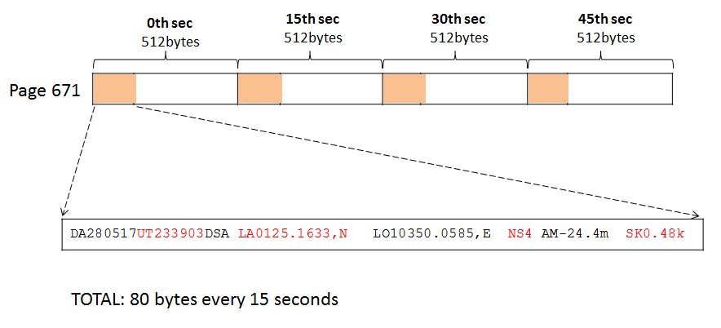
Figure 6-3: GPS data format written to each page in Serial NAND

In a 1Gbit NAND: there are a total of 1024 blocks x 64 pages = 65,536 pages

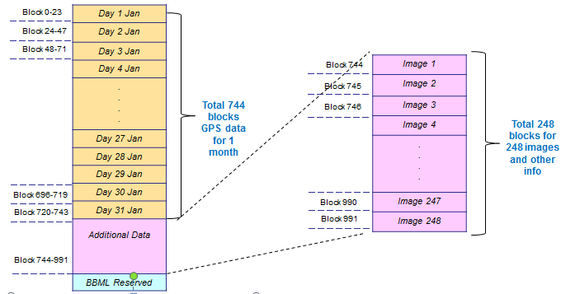
Figure 4: Illustration for fixed allocation of day, hour and minute in Serial NAND

- Block 0-23 will be assigned to DAY 1 of any month, and the rest of the blocks are assigned to the days according to the table above.
- The data for 1st February will replace the old data of 1st January and the data for 2nd February will replace the old data of 2nd February.
- If the car did not move on 3rd February, there will be no GPS data for that day. Thus, it will skip this day and proceed to 4th February - Block 72 onwards to record the data.
- For 31 days in the month of January, the GPS data will be written until it reaches the last block number 743, before it goes back to block 0 again.
- Each block will be assigned to 1 hour of data – 60 minutes.
- 1 minute corresponding to 1 page.
- For one hour, 60 pages will be used in that block -> remaining 4 pages are reserved, depending on customers’ requirement.
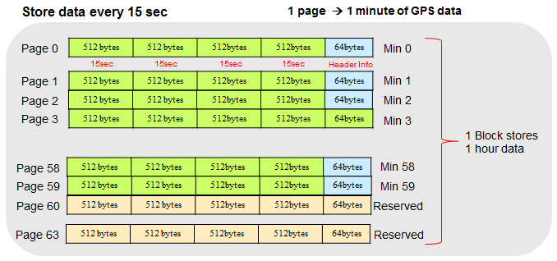
Figure 5: Illustration of 64-page layout in 1 single block

Error Handling
GPS tracker system shall have a mechanism for monitoring communication between system and Open GTS server, System and PC. The communication step should be completed within a specified time (i.e.: 1second), the monitoring timer’s interval can be considered during design phase.
Whenever error is occurred during operation, i.e.: NAND formatting operation failures. GPS tracker system may have actions to recover the state of the previous operation or bring system back to normal operation.

Other Requirements & Attributes
N/A

Acceptance criteria
N/A

Appendix
N/A
Template's Revision History

Rev. No.  (X.YY) | Date  (YYYY-MM-DD) | Section No. Changed | Change Description | Author | Reviewed by | Approved by
V2.01 | 2012-05-08 | Revision History | Fix date format | ToanDT
V3.00 | 2012-06-06 | Template's RH | Approved by manager | ToanDT |  | AnhPT
V3.01 | 2016-10-21 | 2.4 | Update guideline and example table | CucNT | TrinhNTT | Kawahara

