Software Requirement Specification

SAPP-01 for iOS TC35678 BLE

Toshiba Software Development (Vietnam) Co., Ltd

Document ID: TSDV-SAPP-01-iOS-TC35678-BLE-SRS-01
Total: 34 Page No. 1
Revision History

Rev. No.  (X.YY) | Date  (YYYY-MM-DD) | Section No. Changed | Change Description | Author | Reviewed by | Approved by
0.01 | 05/31/18 |  | Create new | DatDN

Contents

1 Introduction 6
1.1 Purpose 6
1.2 Scope 6
1.3 Definitions, Acronyms, Abbreviations 6
1.4 References 6
2 Overall Description 7
2.1 Product Perspective 7
2.2 Technical Standards 7
2.3 User characteristics/Operational Scenarios 7
2.4 Operating Environment 7
3 Dependencies, Constraints & Limitations 8
4 Functional Requirements 9
4.1 Introduction 9
4.2 Design screens 10
4.2.1 BLE screen 10
4.2.2 Device Info screen 11
4.2.3 ADC screen 12
4.2.4 Console screen 13
4.3 Use-case details 14
4.3.1 Scan board 14
4.3.2 Stop scan 16
4.3.3 Connect to board 18
4.3.4 Disconnect to board 19
4.3.5 Read Device Information 20
4.3.6 Read Humidity/Temperature/Pressure data 21
4.3.7 Send message to board 23
5 External Interface Requirements 24
6 Non-functional Requirements 25
6.1 Performance Requirements 25
6.2 Memory Requirements 25
6.3 Error Handling 25
6.4 Other Requirements & Attributes 25
7 Acceptance criteria 26
8 Appendix 27

Figures

Screens

Introduction

Purpose
This document shows a detail description how to communicates between application on iOS platform and TC35678 BLE LSI board through BLE device peripheral.

Scope
This document specifies requirements including:
- Scan and connect to board in range.
- Read and display device information such as:
- Software revision.
- Firmware revision.
- Hardware revision.
- Manufacture revision.
- Read and display humidity/temperature/pressure in realtime.
- Send data string to display on demo board's LCD.

Definitions, Acronyms, Abbreviations
ID No | Acronym/ Abbreviation | Definition
1 | BLE | Bluetooth Low Energy
2 | LSI
3 | TC35678 BLE LSI | Toshiba BLE LSI TC35678 demo system

References
ID No | Reference | Version Number | Document Name/Source & Location reference | Remarks
1 | TC35678 BLE LSI Demo_board_User Manual | v0.1 | TC35678 BLE LSI Demo_board_User Manual v0.1.pdf | -
2 | SAPP-01_for_iOS_TC35678_Instructions | v0.1 | SAPP-01_for_iOS_TC35678_Instructions.pdf

Overall Description

Product Perspective

Technical Standards

ID No | Standard | Mandatory Specifications/ Parameters | Options considered | Options not in scope | Remarks
1 | BLE protocol | - | - | - | -

User characteristics/Operational Scenarios
N/A

Operating Environment
System development environment:
- Hardware:
- TC35678 BLE LSI board for development and demo the application.
- iPhone 7 iOS 11.4
- Software:
- Xcode 9.4
- iOS 11.4
- Swift 4.1

Dependencies, Constraints & Limitations
On iOS platform don't public generic access (GA) service. So characteristics following not readable:

ID No | Name | Assigned Number | Type
1 | Device Name | 0x2A00 | org.bluetooth.characteristic.gap.device_name
2 | Appearance | 0x2A01 | org.bluetooth.characteristic.gap.appearance

Functional Requirements

Introduction
Use-cases of demo application are illustrated as following diagram:
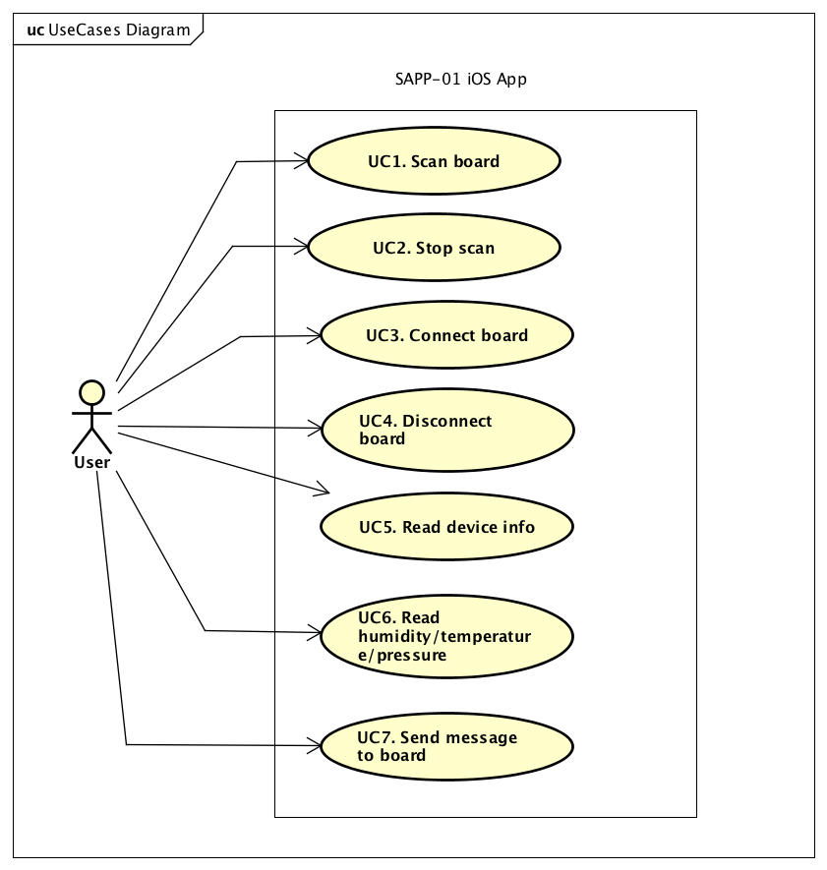
Figure 4-1: Use-case diagram
Following table lists all use-cases of application:
Table 4-1: Use-case list
Use case ID | Use case name
UC-1 | Scan board.
UC-2 | Stop scan
UC-3 | Connect to board.
UC-4 | Disconnect to board.
UC-5 | Read device information.
UC-6 | Read humidity, temperature, pressure realtime.
UC-7 | Send data to display on LCD

Design screens

BLE screen
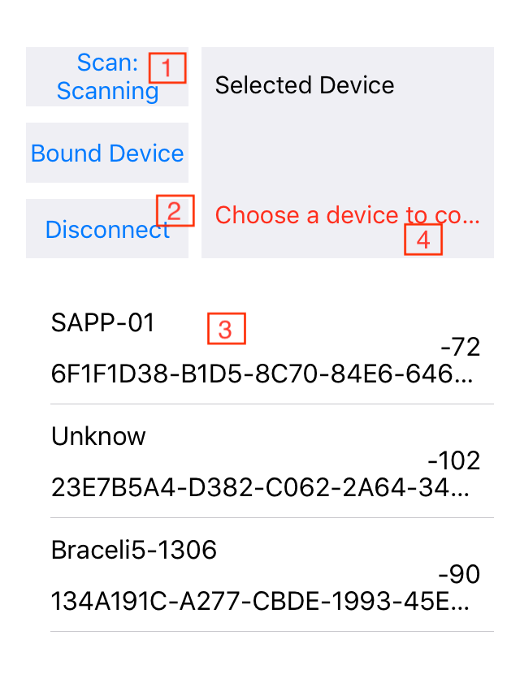Figure 4.2.1: BLE screen
ID | Description
1 | SCAN button
2 | DISCONNECT button
3 | List of BLE devices
4 | Notice message title

Device Info screen

ID | Description
1 | Software revision button
2 | Firmware revision button
3 | Hardware revision button
4 | Manufacture revision button
5 | Software revision title
6 | Firmware revision title
7 | Hardware revision title
8 | Manufacture revision title

ADC screen

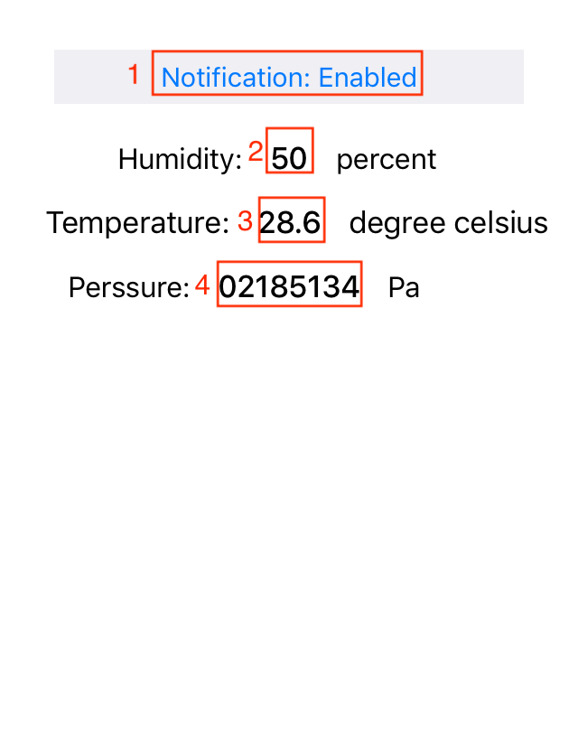Figure 4.2.3 ADC screen

ID | Description
1 | Notification button
2 | Humidity title
3 | Temperature title
4 | Pressure title

Console screen

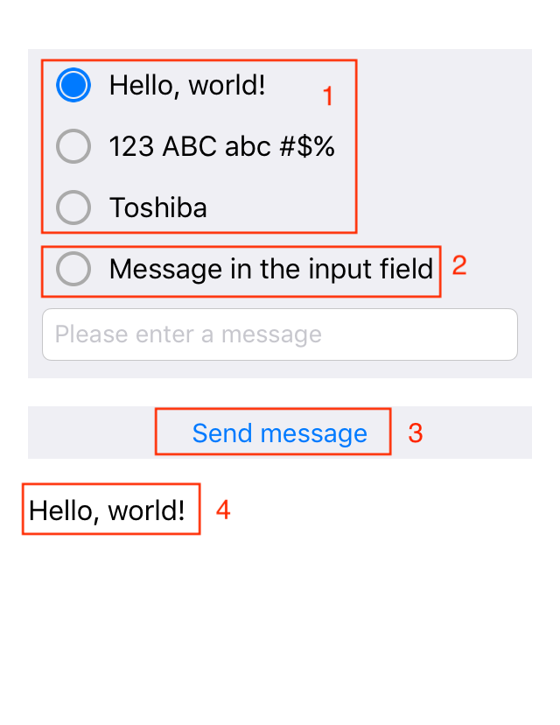Figure 4.2.4 Console screen
ID | Description
1 | Predefine message options
2 | Input message option
3 | Send message button
4 | ACK title

Use-case details

Scan board
Use-case ID | UC-1
Name | Scan board.
Summary | Find board before connect.
Actor(s) | User
Pre-condition | Bluetooth power on. Board turned on. Board isn't paired to System yet.  BLE tab is selected on System.
Terminate-condition for success | Board name appearance in list BLE devices
Screen Design | BLE screen
Steps | ID | Subject | Action
Steps |  | User | Clicks to [SCAN: STOPPED] button.
Steps |  | System | Change title SCAN button = [SCAN: RUNNING]
 |  | System | Searches BLE devices
 |  | System | Displays list of BLE devices
Alternative | ID | Condition |  | Action
Exception | ID | Condition |  | Action
Exception | 2 | User change to other Tab |  | System stop scan BLE devices  System change title [SCAN: STOPPED]
Exception | 2 | User turned off bluetooth
Exception | 2 | User click Home button

Stop scan
Use-case ID |  | UC-2
Name |  | Stop scan
Summary |  | Stop scan process
Actor(s) |  | User
Pre-condition |  | System is scan running, SCAN button title = [SCAN: RUNNING], BLE tab is selected
Terminate-condition for success |  | SCAN button title = [SCAN: STOPPED]
Screen Design |  | BLE screen
Steps |  | ID |  | Subject | Action
 |  | 1 |  | User | Clicks to [SCAN: RUNNING] button.
 |  | 2 |  | System | Stop scanning
 |  | 3 |  | System | Change title button SCAN = [SCAN: STOPPED]
Alternative |  | ID |  | Subject | Action
Exception | ID |  | Condition |  |  | Action

Connect to board
Use-case ID | UC-3
Name | Connect to board.
Summary | Execute pair and connect to board
Actor(s) | User
Pre-condition | Board name is displaying in list of BLE devices.  Bluetooth's System power on, BLE tab is selected  DISCONNECT button is disabled.  Notice message title = [Choose a device to connect]
Terminate-condition for success | Board and System is paired and connect successfully  DISCONNECT button is enabled.  Notice message title = [Connected]
Screen Design | BLE screen
Steps | ID | Subject | Action
Steps |  | User | Click board item in list of BLE devices
Steps |  | System | Show confirm connect popup
Steps |  | User | Click OK option
Steps |  | System | Close confirm connect popup
Steps |  | System | Stop scan
Steps |  | System | Show progress dialog
Steps |  | System | Execute pair and connect
Steps |  | System | Store paired device to list of bonded device
Steps |  | System | DISCONNECT button is enabled.
 |  | System | Change notice message title = [Connected]
Alternative | ID | Subject | Action
Alternative | 3a | User | Click NO option
Alternative | 4a | System | Close confirm connect popup
Exception | ID | Condition |  | Action
Exception | 7 | User turned off bluetooth |  | Show failure connected popup
 | 7 | System connected to board failure |  | Show failure connected popup

ID | Description | Value
1 | Message of confirm connect popup | Start pair and connect to {device name}
2 | Message of failure connected popup | Pair and connect to {device name} failure

Connect to boned board
Use-case ID | UC-4
Name | Connect to boned board.
Summary | Execute connect to boned board
Actor(s) | User
Pre-condition | User click BONED button  Board name is displaying in list of boned devices.  Bluetooth's System power on, BLE tab is selected  DISCONNECT button is disabled.  Notice message title = [Choose a device to connect]
Terminate-condition for success | Board and System is paired and connect successfully  DISCONNECT button is enabled.  Notice message title = [Connected]
Screen Design | BLE screen
Steps | ID | Subject | Action
Steps |  | User | Click board item in list of boned devices
Steps |  | System | Show confirm connect popup
Steps |  | User | Click OK option
Steps |  | System | Close confirm connect popup
Steps |  | System | Stop scan
Steps |  | System | Show progress dialog
Steps |  | System | Execute connect
Steps |  | System | DISCONNECT button is enabled.
Steps |  | System | Change notice message title = [Connected]
Alternative | ID | Subject | Action
Alternative | 3a | User | Click NO option
Alternative | 4a | System | Close confirm connect popup
Exception | ID | Condition |  | Action
Exception | 7 | User turned off bluetooth |  | Show failure connected popup

Disconnect to board
Use-case ID | UC-5
Name | Disconnect to board
Summary | Execute disconnect to board
Actor(s) | User
Pre-condition | System and board are connecting, BLE tab is selected  DISCONNECT button is enabled.  Notice message title = [Connected]
Terminate-condition for success | Board and System is disconnected successfully  DISCONNECT button is disabled.  Notice message title = [Choose a device to connect]
Screen Design | BLE screen
Steps | ID | Subject | Action
Steps |  | User | Click to DISCONNECT button
Steps |  | System | Execute disconnect
Alternative | ID | Subject | Action
Exception | ID | Condition |  | Action

Read Device Information

Use-case ID | UC-6
Name | Read device information
Summary | Read device information such as: Software/Firmware/Hardware/Manufacturer revision
Actor(s) | User
Pre-condition | System and board is connecting, Device Info tab is selected  Info Buttons is enabled.
Terminate-condition for success | Software revision, Firmware revision, Hardware revision is read successfully.
Screen Design | Device Info screen
Steps | ID | Subject | Action
Steps |  | User | Click Software revision button
Steps |  | System | Read Software revision info
Steps |  | System | Display Software revision title
 |  | User | Click Firmware revision button
 |  | System | Read Firmware revision info
 |  | System | Display Firmware revision title
 |  | User | Click Hardware revision button
 |  | System | Read Hardware revision info
 |  | System | Display Hardware revision title
 |  | User | Click Manufacturer revision button
 |  | System | Read Manufacturer revision info
 |  | System | Display Manufacturer revision title
Alternative | ID | Subject | Action
Exception | ID | Condition | Action
Exception | 2, 2a, 2b, 2c | User turned off bluetooth | Disable all Info Buttons

Read Humidity/Temperature/Pressure data
Use-case ID | UC-7
Name | Read Humidity/Temperature/Pressure data
Summary | Read Humidity/Temperature/Pressure data realtime
Actor(s) | User, Board
Pre-condition | System and board is connecting, ADC tab is selected  Notification button is enabled.  Notification button title = [Notification: Enabled]
Terminate-condition for success | Humidity/Temperature/Pressure data is read successfully.
Screen Design | ADC screen
Steps | ID | Subject | Action
Steps |  | User | Click notification button
Steps |  | System | Change notification button title = [Notification: Disable]
Steps |  | System | Subscribe change data characteristic notification
Steps |  | Board | Send changed data to System
Steps |  | System | Update humidity/temperature/pressure title with changed data
Alternative | ID | Subject | Action
Exception | ID | Condition |  | Action
Exception | 4 | System and board disconnect |  | Disable notification button.  Update humidity/temperature/pressure title with default title.
Exception | 4 | User change tab |  | Unsubscribe change data characteristic notification.  Change notification button title = [Notification: Enabled].
Exception | 4 | User click Home button

ID | Description | Value
1 | Humidity default title | --
2 | Temperature default title | ---
3 | Pressure default title. | ------

Send message to board

Use-case ID | UC-8
Name | Send message to board
Summary | Send limit message (<= 16 character ascii) to display on demo board's LCD and receive this message response returned.
Actor(s) | User, Board
Pre-condition | System and board is connecting, Console tab is selected  Send message button is enabled.
Terminate-condition for success | Message sent to board successfully  ACK title show message sent
Screen Design | Console screen
Steps | ID | Subject | Action
Steps |  | User | Select predefine message option
Steps |  | User | Click send message button
Steps |  | System | Execute send message
Steps |  | System | Disable send message button
Steps |  | System | Wait response
Steps |  | System | Update ACK title by message sent
Steps |  | System | Enable send message button
Alternative | ID | Subject | Action
Alternative | 1a | User | Select input message option and enter a message
Alternative | 1b | System | Check message is valid ( ascii characters and length <= 16)
Alternative | 1c | System | Show invalid popup if input message invalid
Exception | ID | Condition |  | Action
Exception | 3,5 | System and board disconnect |  | Disable send message button  Update ACK title by default title
Exception | 6 | System received response failure |  | Update ACK title by default title

ID | Description | Value
1 | ACK default title | ---
2 | Message for invalid popup | Input message must be ASCII characters

External Interface Requirements
N/A

Non-functional Requirements

Performance Requirements
N/A

Memory Requirements
N/A

Error Handling
N/A

Other Requirements & Attributes
N/A

Acceptance criteria
N/A

Appendix
N/A
Template's Revision History

Rev. No.  (X.YY) | Date  (YYYY-MM-DD) | Section No. Changed | Change Description | Author | Reviewed by | Approved by
V2.01 | 2012-05-08 | Revision History | Fix date format | ToanDT
V3.00 | 2012-06-06 | Template's RH | Approved by manager | ToanDT |  | AnhPT
V3.01 | 2016-10-21 | 2.4 | Update guideline and example table | CucNT | TrinhNTT | Kawahara

