PRD: User-Created Prediction Markets (v1)

Aster Exchange — Confidential

2026-03-25

Status | Draft
Author | Product
Feature | User-Created Prediction Markets
Version | v1

1. Feature Overview
Aster Prediction Markets v1 enables any user to create a binary (YES/NO) price-prediction market for any crypto asset covered by Aster’s oracle infrastructure. The market creator seeds initial liquidity via a CPMM AMM, sets a resolution condition and deadline, and earns a builder fee on every trade. This is Aster’s first prediction market offering — positioning the platform as a community-driven prediction exchange alongside its perpetuals and spot products.

2. Background & Motivation
Business context. Prediction markets are a high-growth category in crypto trading. Polymarket exceeded $8B in cumulative volume in 2024. Integrating user-created prediction markets directly into Aster lets traders speculate on outcomes while earning builder fees, deepening engagement without requiring central curation of every market.
Competitive landscape. The market splits into two camps: admin-created (Polymarket, Kalshi) and user-created (Augur, Manifold). Admin-created platforms offer quality control but limited market velocity — Polymarket requires users to submit suggestions via Discord and waits for a team review. Manifold and Augur demonstrate that user-created markets drive community growth and trading volume. Aster’s DEX model (wallet address = user, no account layer) is well-suited to permissionless market creation. Aster differentiates by combining CPMM liquidity with its existing orderbook infrastructure.
User pain points. Traders want to speculate on price outcomes not available on existing prediction platforms. Admin-created markets are slow to launch and don’t reflect what the community wants to bet on. Market creators want to monetize their conviction by earning fees on traffic they attract.

3. Scope

In Scope (v1)
- User creates binary (YES/NO) crypto price prediction market
- Supported asset types: any crypto asset with Aster oracle coverage
- Market parameters: title, asset, condition (≥ or <), threshold, resolution timestamp, builder fee rate, initial YES probability, seed
- CPMM AMM provides initial and ongoing liquidity using the creator’s seed
- Fee collection: basic fee (platform) + builder fee (creator) on each trade
- Resolution lifecycle: OPEN → LOCKED → oracle waterfall → RESOLVED
- Admin manual resolution fallback when oracle waterfall fails
- Settlement: winner shares = 1 USDT/share; loser shares = 0 USDT/share
- Draw resolution (manual admin only): full refund of each user’s trading capital

Out of Scope (v2+)
- Non-price markets (sports, politics, custom events) — no resolution oracle available yet
- Categorical / multi-outcome markets — requires different AMM formula
- Scalar markets (numeric range payout) — more complex settlement logic
- Community dispute resolution (Augur-style REP staking) — operational complexity for v1
- Market editing after creation — creates AMM state inconsistency
- User limit orders — AMM-only liquidity for v1
- Creator withdrawal of seed before resolution — seed locked in AMM for market integrity

4. User Stories
Role | Action | Outcome
Trader | Create a prediction market for BTC price | Market is live with CPMM AMM liquidity seeded by my deposit
Trader | Set builder fee at 0.8% when creating a market | I earn 0.8% on every trade’s USDT value in my market
Trader | Buy YES shares on a prediction market | I hold YES shares; implied probability moves up; AMM rebalances
Trader | Buy NO shares on a prediction market | I hold NO shares; implied probability moves down; AMM rebalances
Trader | Sell YES shares before resolution | I receive USDT at current AMM price; AMM rebalances
Trader | Hold YES shares when market resolves YES | Each YES share redeems for 1 USDT
Trader | Hold YES shares when market resolves NO | Each YES share redeems for 0 USDT
Trader | Hold shares when market resolves as Draw | My original purchase cost is fully refunded
Market creator | View my market’s performance | I see total volume, builder fees earned, and current implied probability
Admin | Manually resolve a market when oracle fails | I select YES, NO, or Draw; market settles accordingly

5. User Flows
5.1 Creating a Conviction
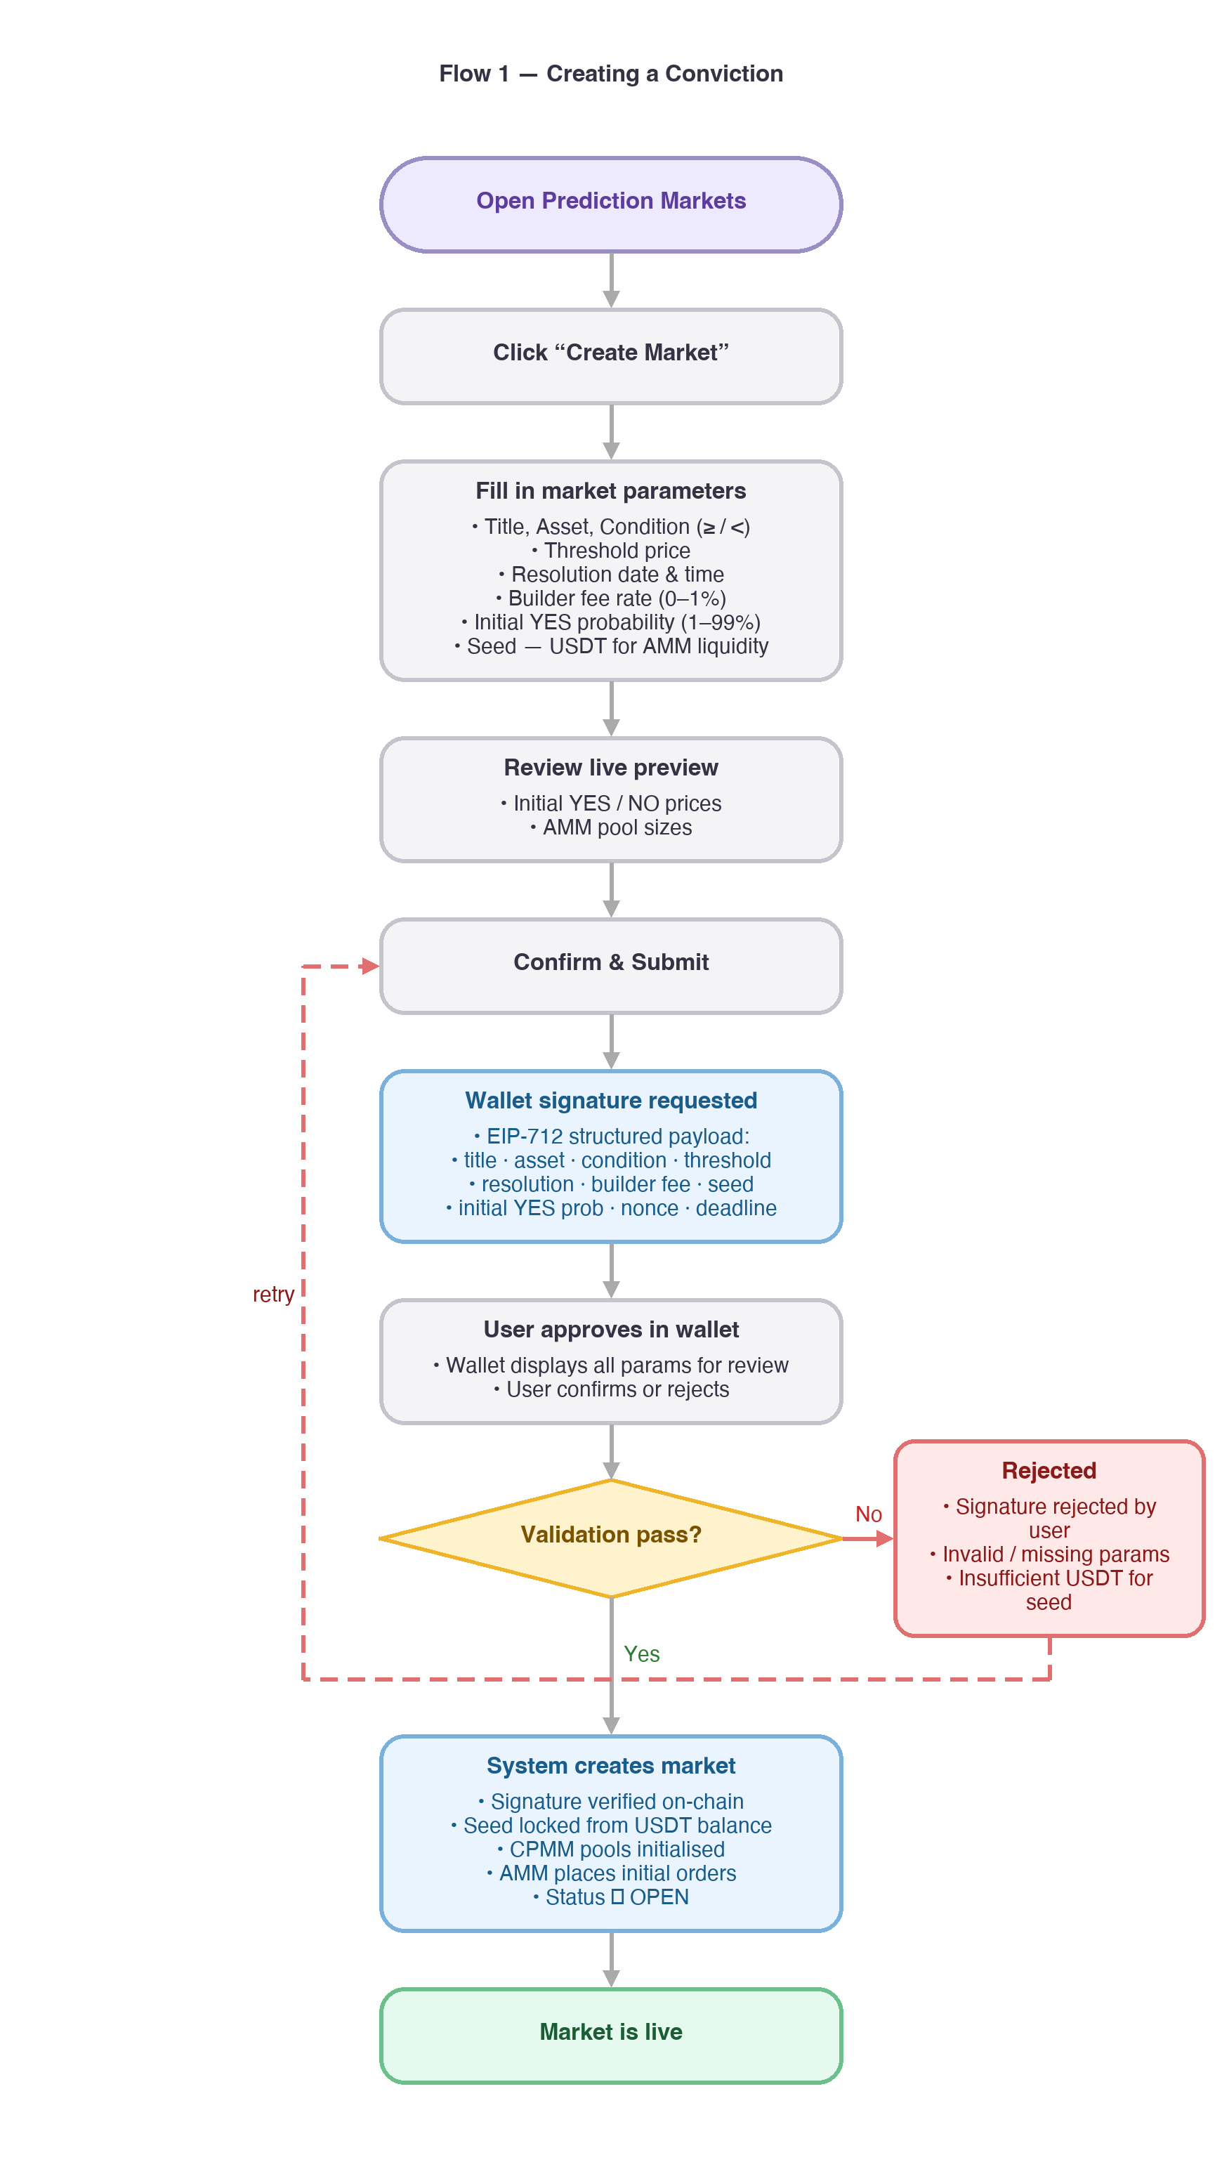
5.2 Placing an Order on a Prediction Market
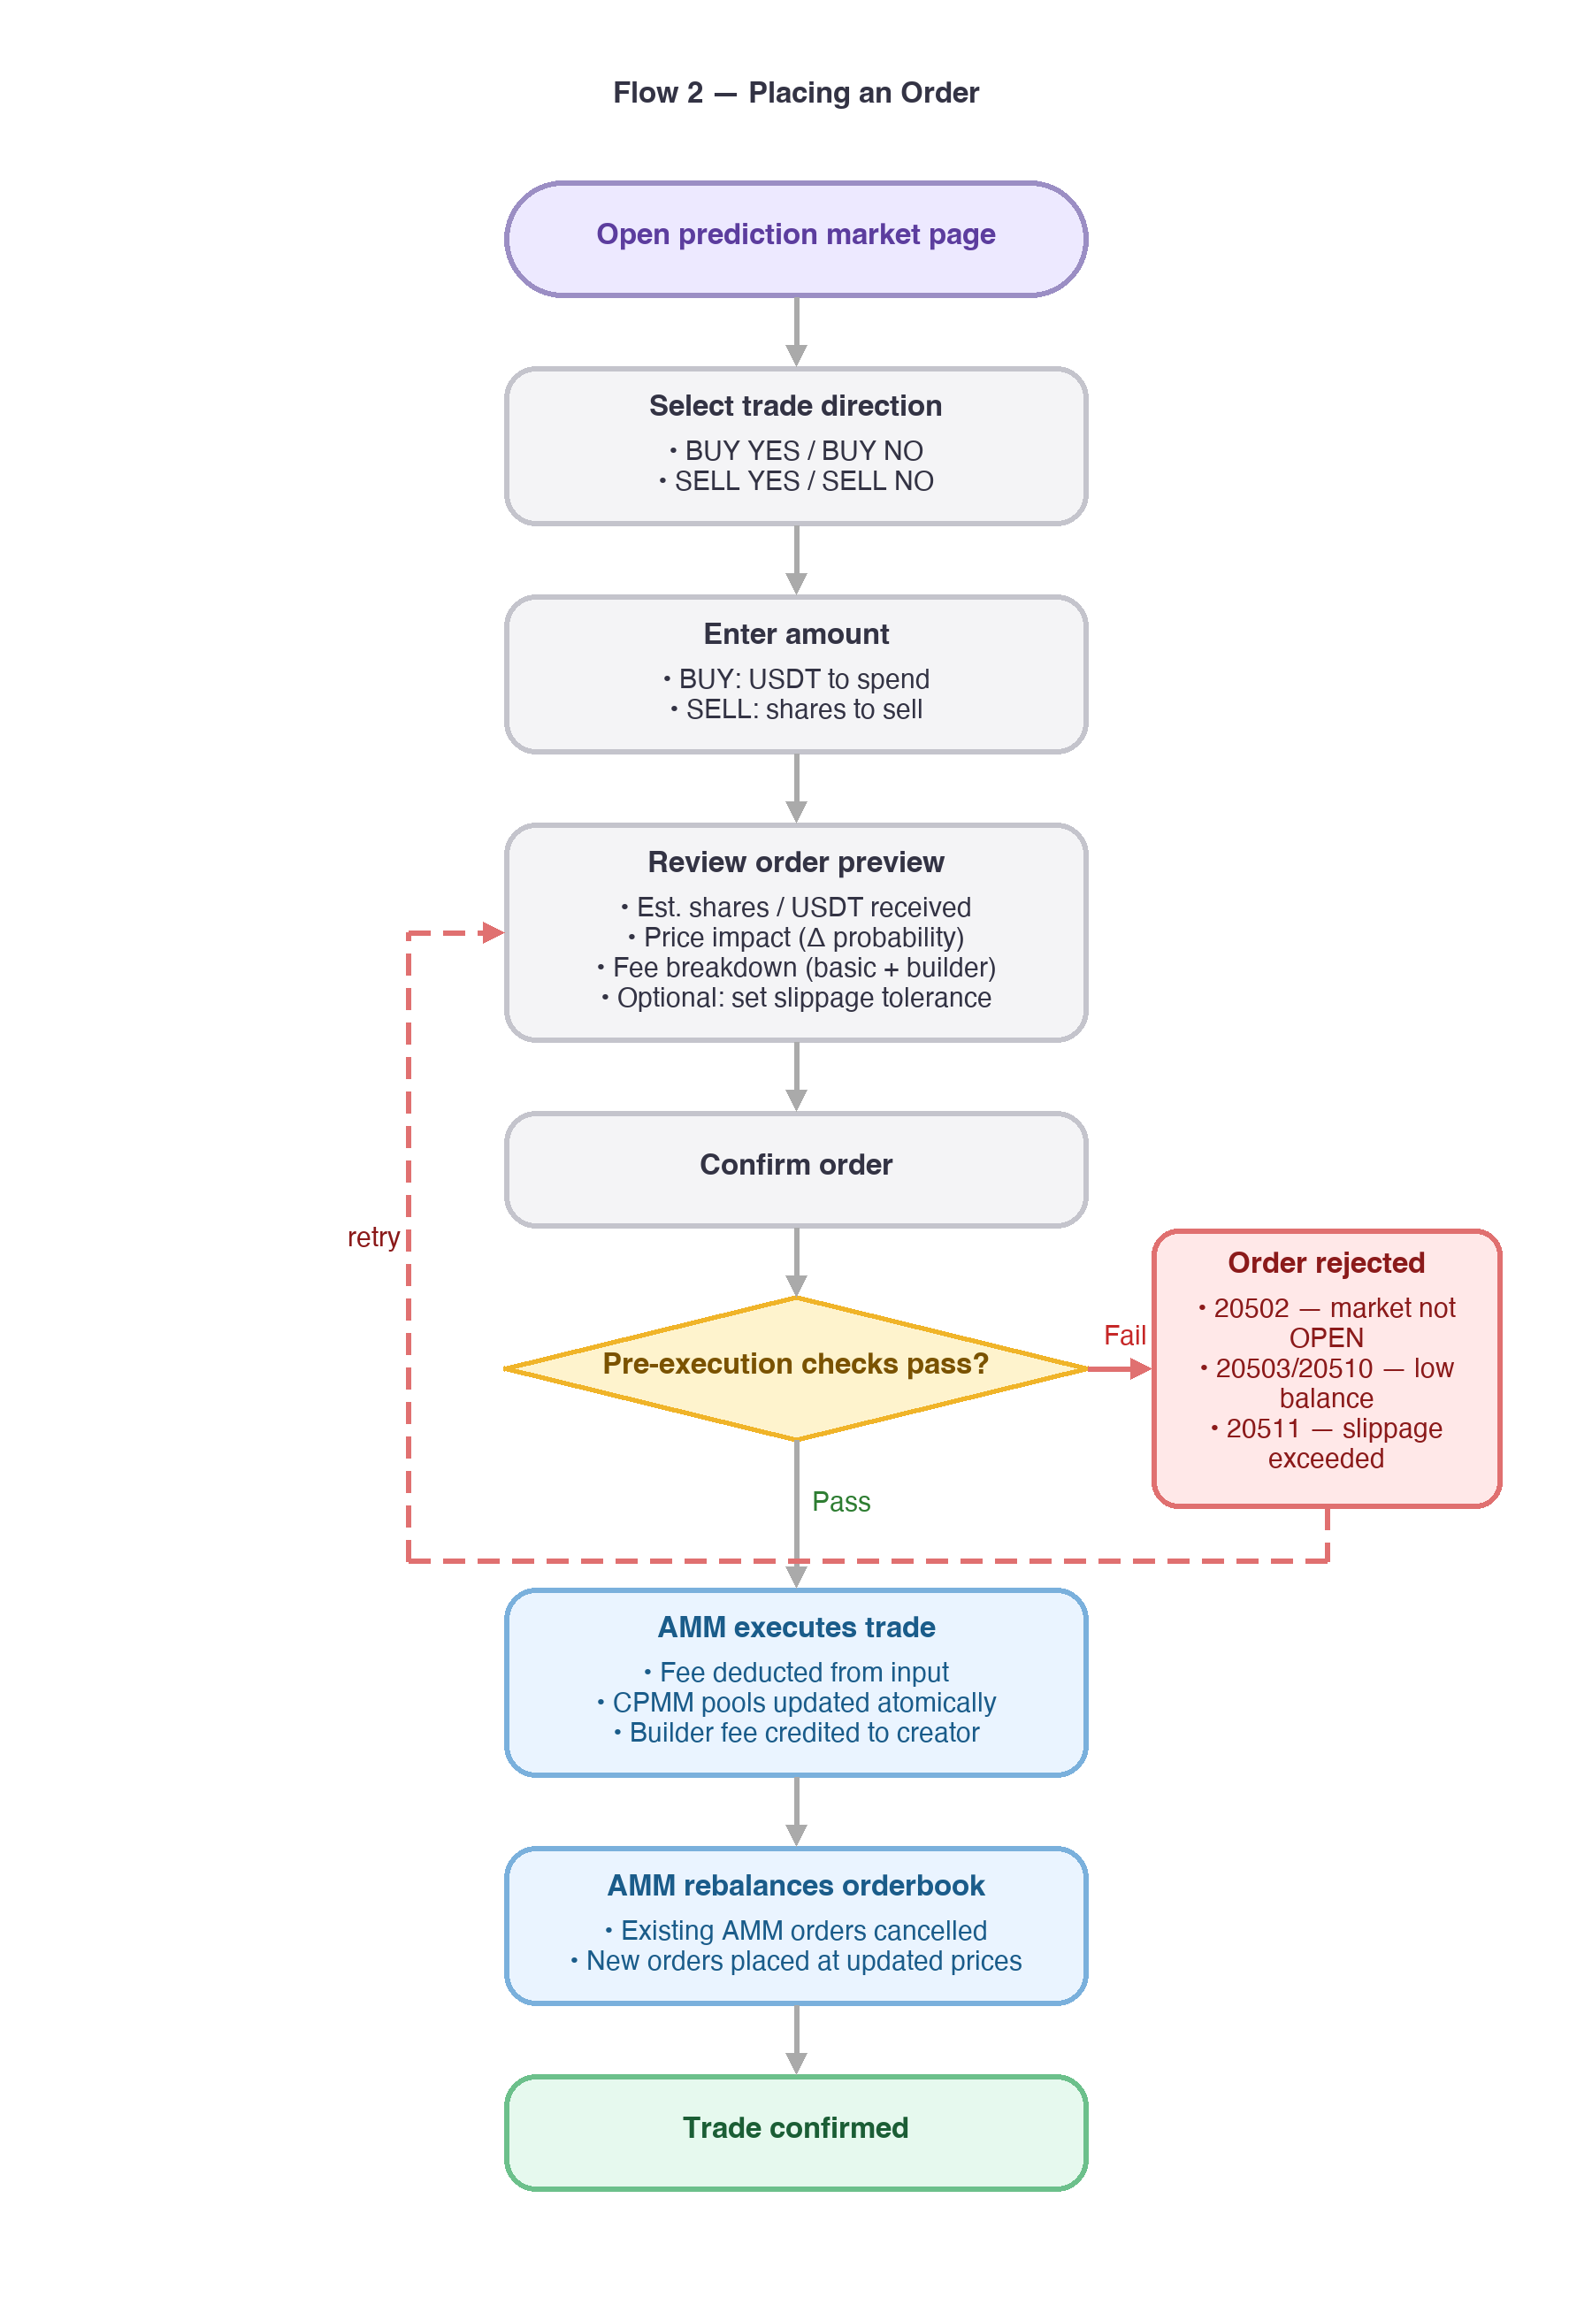

6. Functional Requirements

6.1 Market Creation
- Any authenticated user may create a prediction market. No KYC tier or balance eligibility gate applies beyond having sufficient USDT for the seed.
- The creator must supply all required parameters (see API §7.1).
- Upon submission, the system:
- a. Validates all parameters (see §8 Error Handling)
- b. Locks the seed amount from the creator’s USDT balance
- c. Initialises the CPMM AMM pools (see §6.2)
- d. Sets market status to OPEN
- e. Records created_at timestamp
- A market ID is returned immediately. The market is tradable without delay.
- The creator’s seed is deployed into the AMM pools and settles at resolution identically to any other user position.

6.2 CPMM AMM Initialisation
The prediction market uses a Constant Product Market Maker (CPMM) model for liquidity.
Why CPMM over LMSR: CPMM (xy = k) is simpler to implement and audit, works natively for binary YES/NO markets, and its pool-based model makes settlement straightforward. LMSR offers a tighter theoretical loss bound but adds implementation complexity not needed for v1.
Known trade-off. CPMM price impact scales inversely with pool depth: a thin pool (small seed) causes significant slippage on large orders. Polymarket migrated away from AMM to a CLOB model partly for this reason. For v1, the minimum seed requirement (§8) sets a floor on initial liquidity depth. If large-order UX becomes a complaint post-launch, a hybrid CLOB layer or dynamic fee scaling should be evaluated for v2.

Pool Initialisation
Given:
- S = seed (USDT)
- p = initial YES probability (e.g., 0.50)

YES_pool = S × (1 − p)
NO_pool = S × p
k = YES_pool × NO_pool = S² × p × (1 − p)
The invariant k is constant throughout the life of the market.

Price Formula
YES_price = NO_pool / (YES_pool + NO_pool) — USDT per YES share
NO_price = YES_pool / (YES_pool + NO_pool) — USDT per NO share
YES_price + NO_price = 1.0 (always)

Example
S = 500 USDT, p = 0.50
- YES_pool = 250, NO_pool = 250, k = 62,500
- Initial YES price = 0.50 USDT (50% implied probability)

6.3 Trading
Users may buy or sell YES or NO shares at any time while market status is OPEN.

Buying YES shares (user pays x USDT)
shares_received = x + YES_pool − (k / (NO_pool + x))
new_NO_pool = NO_pool + x
new_YES_pool = k / new_NO_pool

Buying NO shares (user pays x USDT)
shares_received = x + NO_pool − (k / (YES_pool + x))
new_YES_pool = YES_pool + x
new_NO_pool = k / new_YES_pool

Selling y YES shares (user receives USDT)
usdt_received = NO_pool − (k / (YES_pool + y))
new_YES_pool = YES_pool + y
new_NO_pool = k / new_YES_pool

Selling y NO shares (user receives USDT)
usdt_received = YES_pool − (k / (NO_pool + y))
new_NO_pool = NO_pool + y
new_YES_pool = k / new_NO_pool
After every trade, YES_pool × NO_pool must equal k.
Minimum trade size: [TBD — engineering to determine minimum to prevent dust attacks].

6.4 AMM Order Representation
The AMM continuously maintains limit orders on the prediction market orderbook to represent its quoted prices across different trade sizes. After each trade execution:
- AMM pools are updated per the formulas in §6.3
- AMM cancels all existing AMM orders for this market atomically
- AMM re-places orders at price levels derived from the updated pool state
- All AMM order updates are atomic with the triggering trade (same database transaction)

6.5 Fee Collection
Every executed trade incurs:
total_fee = basic_fee_amount + builder_fee_amount
basic_fee_amount = trade_usdt_value × basic_fee_rate → Aster platform
builder_fee_amount = trade_usdt_value × builder_fee_rate → market creator (immediate)
- basic_fee_rate: platform-defined, applies uniformly to all prediction markets [TBD — see Open Questions]
- builder_fee_rate: creator-defined at market creation, 0 ≤ builder_fee_rate ≤ 0.01 (max 1%). Builder fees are collected per trade and held in escrow; they are distributed to the creator only when the market reaches FINALIZED (see §6.9).
- Fees deducted before AMM calculation: effective_input = x − total_fee for buys; effective_output = usdt_received − total_fee for sells

6.6 Market Resolution Lifecycle
Market status transitions in fixed order: INIT → OPEN → LOCKED → RESOLVING → RESOLVED → FINALIZED. Exception path when oracle fails: RESOLVING → ADMIN_PENDING → RESOLVED → FINALIZED.
Status | Trigger | Tradable
INIT | System creating market | No
OPEN | Market created | Yes
LOCKED | resolution_at timestamp reached | No
RESOLVING | Oracle waterfall started | No
ADMIN_PENDING | Oracle waterfall exhausted without result | No
RESOLVED | Outcome determined | No (settlement only)
FINALIZED | Payout credited; builder fees distributed to creator | No

6.7 Oracle Waterfall
- System initiates oracle waterfall when market status transitions to RESOLVING (immediately after LOCKED). Oracle sources and their priority are [TBD — engineering to confirm].
- Each oracle source is queried with exponential backoff: 3 attempts at 10-second intervals. A source is considered failed only after all 3 attempts are exhausted.
- The first source returning a valid price for the asset at resolution_at determines the outcome.
- Outcome determination:
- Condition GTE (≥): YES wins if oracle_price ≥ threshold; NO wins otherwise
- Condition LT (<): YES wins if oracle_price < threshold; NO wins otherwise
- If any source succeeds: market transitions to RESOLVED.
- If all sources fail: market transitions to ADMIN_PENDING and an ops alert is raised. Market remains ADMIN_PENDING until an admin submits a resolution (§6.8).

6.8 Manual Admin Resolution
- An admin with PREDICTION_RESOLVE permission submits a resolution outcome.
- Admin selects one of: YES, NO, or DRAW.
- On DRAW: each share holder's original purchase cost is refunded (excluding any fees paid). Fees already collected (basic fee + builder fee) are not returned. Builder fees accumulated up to DRAW resolution are forfeited — not distributed to the creator.
- On YES or NO: standard settlement applies (§6.9).
- Market transitions to RESOLVED immediately on admin submission, then to FINALIZED once settlement and builder fee distribution are complete.

6.9 Settlement
Outcome | YES share value | NO share value
YES wins | 1.00 USDT/share | 0.00 USDT/share
NO wins | 0.00 USDT/share | 1.00 USDT/share
DRAW | Refund at cost | Refund at cost

- Settlement is credited to each holder’s USDT balance automatically.
- The creator’s seed-derived position settles identically to any other user position.
- Settlement must complete within [TBD] minutes of RESOLVED status. Once all payouts are credited, the market transitions to FINALIZED.
- Builder fee distribution: Builder fees accumulated across all trades are held in escrow throughout the market lifecycle. On FINALIZED, the total accrued builder fee is credited to the creator's USDT balance in a single transaction with type Builder fee reward (prediction). No partial distribution occurs before FINALIZED.

7. API Specification
All endpoints follow the standard Aster response envelope:
{
"code": 0,
"data": { ... },
"message": "success"
}

7.1 Create Market
POST /api/v1/prediction/markets — Authenticated

Request Fields
Field | Type | Required | Description
client_order_id | string | Yes | Idempotency key (UUID)
title | string | Yes | Market question, max 200 chars
asset | string | Yes | Oracle-covered asset symbol, e.g. "BTC"
condition | enum | Yes | "GTE" (≥) or "LT" (<)
threshold | string | Yes | Price threshold as decimal string, e.g. "200000"
resolution_at | string | Yes | ISO 8601 UTC datetime for market lock
builder_fee_rate | string | Yes | Creator fee rate, e.g. "0.008" (0.8%). Max "0.01"
initial_yes_probability | string | Yes | Initial YES probability, e.g. "0.5". Range: 0.01–0.99
seed | string | Yes | USDT seed amount. Must meet minimum

Response Fields
Field | Type | Description
market_id | string | Unique market identifier
status | enum | OPEN / LOCKED / RESOLVING / ADMIN_PENDING / RESOLVED / FINALIZED
yes_price | string | Initial YES price (= initial_yes_probability)
no_price | string | Initial NO price (= 1 − initial_yes_probability)
yes_pool | string | Initial YES pool size (USDT)
no_pool | string | Initial NO pool size (USDT)
created_at | string | ISO 8601 UTC

HTTP status codes: 201 Created / 400 Bad Request / 401 Unauthorized

Example Request
{
"client_order_id": "a1b2c3d4-e5f6-7890-abcd-ef1234567890",
"title": "Will BTC rise above 200,000 by end of 2026?",
"asset": "BTC",
"condition": "GTE",
"threshold": "200000",
"resolution_at": "2026-12-31T23:59:59Z",
"builder_fee_rate": "0.008",
"initial_yes_probability": "0.5",
"seed": "500"
}

Example Response
{
"code": 0,
"data": {
"market_id": "pm_abc123",
"status": "OPEN",
"yes_price": "0.5",
"no_price": "0.5",
"yes_pool": "250",
"no_pool": "250",
"created_at": "2026-03-25T10:00:00Z"
},
"message": "success"
}

7.2 Get Market
GET /api/v1/prediction/markets/:market_id — Public
Field | Type | Description
market_id | string | Market ID
title | string | Market question
asset | string | Asset symbol
condition | enum | "GTE" or "LT"
threshold | string | Price threshold
resolution_at | string | ISO 8601 UTC
builder_fee_rate | string | Creator fee rate
basic_fee_rate | string | Platform fee rate
yes_price | string | Current YES price
no_price | string | Current NO price
yes_pool | string | Current YES pool (USDT)
no_pool | string | Current NO pool (USDT)
status | enum | OPEN / LOCKED / RESOLVING / ADMIN_PENDING / RESOLVED / FINALIZED
outcome | enum | YES / NO / DRAW / null
oracle_price | string | Oracle price used for resolution (null if not resolved)
total_volume | string | Cumulative USDT traded
creator_uid | string | Creator’s uid
created_at | string | ISO 8601 UTC
resolved_at | string | ISO 8601 UTC, null if not resolved

7.3 List Markets
GET /api/v1/prediction/markets — Public
Query Param | Type | Required | Description
status | enum | No | Filter by market status
asset | string | No | Filter by asset symbol
creator_uid | string | No | Filter by creator uid
page | integer | No | Page number, default 1
page_size | integer | No | Results per page, default 20, max 100

Response: paginated list of market objects (same schema as §7.2).

7.4 Place Order
POST /api/v1/prediction/markets/:market_id/orders — Authenticated

Request Fields
Field | Type | Required | Description
client_order_id | string | Yes | Idempotency key (UUID)
side | enum | Yes | "BUY_YES" / "BUY_NO" / "SELL_YES" / "SELL_NO"
usdt_amount | string | Conditional | USDT to spend. Required for BUY_* sides
shares_amount | string | Conditional | Shares to sell. Required for SELL_* sides
min_shares_out | string | No | Minimum shares to receive (slippage guard for BUY)
min_usdt_out | string | No | Minimum USDT to receive (slippage guard for SELL)

Response Fields
Field | Type | Description
order_id | string | Order ID
market_id | string | Market ID
side | enum | Order side
usdt_spent | string | USDT paid (BUY orders)
shares_received | string | Shares received (BUY orders)
usdt_received | string | USDT received (SELL orders)
shares_sold | string | Shares sold (SELL orders)
basic_fee | string | Platform fee paid (USDT)
builder_fee | string | Builder fee paid (USDT)
yes_price_after | string | YES price after trade
no_price_after | string | NO price after trade
executed_at | string | ISO 8601 UTC

7.5 Get Positions
GET /api/v1/prediction/markets/:market_id/positions — Authenticated
Field | Type | Description
market_id | string | Market ID
yes_shares | string | YES shares held
no_shares | string | NO shares held
avg_yes_cost | string | Average USDT cost per YES share
avg_no_cost | string | Average USDT cost per NO share
unrealized_pnl | string | Current mark-to-market P&L (USDT)

7.6 Admin Resolve
POST /api/v1/prediction/markets/:market_id/resolve — Admin, PREDICTION_RESOLVE permission

Request Fields
Field | Type | Required | Description
outcome | enum | Yes | "YES" / "NO" / "DRAW"
note | string | No | Admin resolution note, max 500 chars

Response Fields
Field | Type | Description
market_id | string | Market ID
outcome | enum | Resolved outcome
resolved_at | string | ISO 8601 UTC
resolved_by | string | Admin uid

8. Error Handling
Code | EN | zh-Hans | zh-Hant | Trigger
20501 | Market not found | 市场不存在 | 市場不存在 | market_id invalid or not found
20502 | Market is not open for trading | 市场当前不可交易 | 市場目前不可交易 | market status ≠ OPEN
20503 | Insufficient USDT balance for seed | USDT 余额不足 | USDT 餘額不足 | balance < seed
20504 | Asset not supported by oracle | 该资产暂不支持 | 該資產暫不支援 | asset has no oracle coverage
20505 | Builder fee rate exceeds maximum (1%) | 做市费率超过上限 | 做市費率超過上限 | builder_fee_rate > 0.01
20506 | Initial YES probability out of range (1–99%) | 初始概率超出范围 | 初始機率超出範圍 | probability < 0.01 or > 0.99
20507 | Market already resolved | 市场已结算 | 市場已結算 | trade or resolve on RESOLVED market
20508 | Market is not pending admin resolution | 市场不在待处理状态 | 市場不在待處理狀態 | admin resolve on non-ADMIN_PENDING market
20509 | Seed amount below minimum | 种子资金低于最低要求 | 種子資金低於最低要求 | seed < configured minimum
20510 | Insufficient shares to sell | 持仓不足 | 持㌊不足 | shares_amount > user share balance
20511 | Slippage tolerance exceeded | 滑点超出容忍范围 | 滑點超出容忍範圍 | min_shares_out or min_usdt_out not met

9. Non-Functional Requirements
Latency: Market creation ≤ 500ms p99; order execution ≤ 200ms p99
AMM atomicity: AMM pool update and order re-quote must execute atomically in the same database transaction as the triggering trade
Oracle retry: 3 attempts per source, 10-second intervals, exponential backoff. Failure = retries exhausted, not a single failed call
Settlement SLA: All positions settled within [TBD] minutes of RESOLVED status
Precision: All USDT amounts and share quantities stored and returned with 8 decimal places
Audit log: Every state transition recorded with timestamp, actor, and trigger event
Rate limits: Market creation: 5 per user per hour; order placement: shared with existing trading rate limits

10. Open Questions
# | Question | Owner | Priority
1 | What is the basic_fee_rate for prediction markets? | Aster Product + Finance | High
2 | What is the minimum seed amount? | Engineering + Risk | High
3 | Oracle waterfall: which sources are available and in what priority order? | Engineering | High
4 | What is the minimum trade size (USDT / shares) to prevent dust attacks? | Engineering | Medium
5 | Settlement SLA: how many minutes after RESOLVED must all positions settle? | Engineering | Medium
6 | Should builder fees be withheld during ADMIN_PENDING or credited immediately on each trade? | Product | Medium
7 | What is the behaviour if resolution_at is reached while a trade is in-flight? | Engineering | Low

