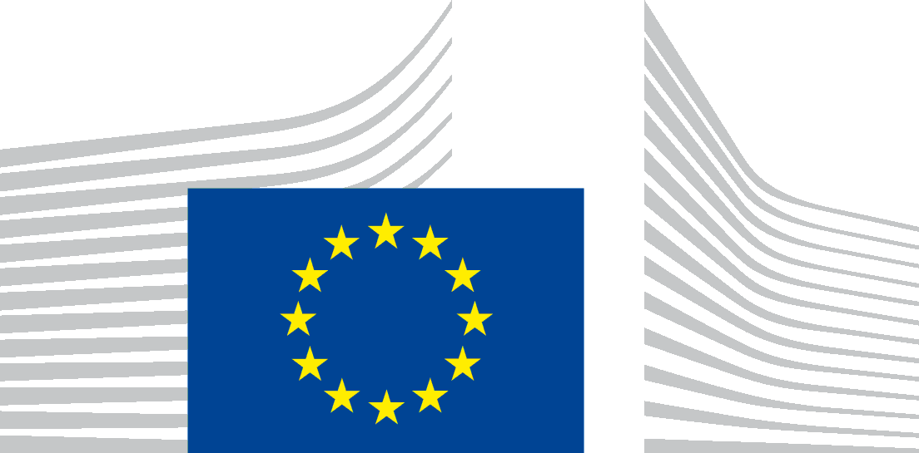 | EUROPEAN COMMISSION  Communications Networks, Content and Technology Directorate-General  Data  Data Policy and Innovation

35th Meeting of the Public Sector Information Group

Thursday, 14 December 2023
in videoconference

draft MINUTES

- Welcome and update from the European Commission
The new head of the unit G1 opened the meeting and set out the agenda. The Commission informed the participants that in line CNECT’s policy meetings of the PSI group will continue in the online form, unless physical meeting is necessary to reach an agreement on a particular file. The present meeting has mainly informative purpose, since there is new data-related legislation soon to be adopted, recently coming into application, or soon coming into application.

- Update on the status of the EU Data Strategy (Data Act, data spaces, DEP)

Firstly, the Commission updated the participants on the current state of play of the Data Act. The Data Act was formally adopted by the Council on 27 November. It aims primarily at facilitating access to data generated by the use of connected products and by promoting a fairer redistribution of the value of data among the manufacturers, users and third-party service providers. The new regulation also includes provisions of particular interest to the public sector, namely Chapter V which puts in place a mechanism for compulsory business-to-government (B2G) data sharing in exceptional situations, such as public emergencies. In addition, the Data Act may benefit public authorities directly – i.e., the new rules that ensure easy switching between the services of cloud service providers, and indirectly – thanks to enhanced data interoperability (Chapter VIII). At the same time the Data Act lays down a system of enforcement, the organisation and implementation of which will largely depend on the Member States themselves. The competent authorities to be set up under the Data Act will in the future be represented in the European Data Innovation Board (EDIB), established under the Data Governance Act.

Secondly, the Commission updated the participants on the current state of play on the Digital Europe Programme (DEP). Regarding the roll-out of Common European Data spaces, Phase 1 (preparatory actions) is ending for 8 data spaces (agriculture, financial, Green Deal, manufacturing, mobility, smart communities, skills, and tourism). Phase 2 (deployment actions) has recently started for 8 data spaces (cultural heritage, health, language, manufacturing, media, mobility, public administrations (public procurement) and smart communities). Two deployment calls of Digital Europe Programme (2023) are currently open for cultural heritage, tourism data space (Deadline: 23 January 2024). In December the Commission adopted the DEP Work Programme for 2023-204.

Thirdly, the second edition of the Commission Staff Working Document on Common European Data Spaces providing an update on state of play of Common European Data Spaces will be published by the end of January 2024.
- Update on the implementation of the Data Governance Act (DGA)
Firstly, the European Register for Protected Data held by Public Sector (ERPD) was deployed on 24 September 2023 on data.europa.eu. The ERPD harvests the national single information points (NSIPs), containing the protected data under the DGA. The ERPD is ready to accept a request for onboarding from National single information points. The ERPD metadata was translated into all EU official languages. The Commission has received so far only one harvesting request for NSIP. To get NSIP harvested by the ERPD, a Member State should check if their NSIP is suitable for harvesting by seeing the checklist in harvesting guidelines 1.3 (section 6.1.) and issuing a harvesting request via the data.europa.eu contact form.
Secondly, the EU register of data intermediation services and the EU register of data altruism organizations were published on 22 September 2024. Both registers are ready to accept the information on recognised data altruism organisations and data intermediation services from national competent authorities. As for the EU register of data intermediation services, Member State, through its national competent authority, will send the form with information on notified data intermediation service to the Commission. Regarding the EU register of data altruism organisations, Member State, through its national competent authority, will send the form with information on a notified data altruism organisation to the Commission. For registration of data intermediaries, a list of national competent bodies and authorities has been published on the register website (blue box on the right). The list is regularly updated.
Thirdly, the Commission also informed on a creation of the European Data Innovation Board (EDIB) (art 29 DGA), a Commission’s expert group that will advise and assist the Commission with effective implementation of the Data Governance Act, creation of Guidelines for common European data spaces, and development of consistent guidelines on standardization and interoperability. The first meeting of EDIB was held on 13 December.
Lastly, the Commission presented the participants the Single Notification Window, a platform that provides one central point for Member States’ notification obligations that are relevant for the single market. Member State can filter their list of notification obligations and notification procedures. (Digital => Data economy and data governance => Data Governance Act)

- Update on the High Value Datasets (HVDs) Regulation and study on extension of categories of HVDs
The Commission informed the PSI group that as at the day of the meeting four Member States were still in delay with the transposition, having been referred to the Court of Justice of the EU in early 2023. Conformity checks of notified transposition measures are ongoing, with the decision on possible infringement proceedings being expected in Q2-2024.
The Commission informed about the important dates related to the Implementing regulation on High-Value Datasets (applicable from 9 June 2024; Member States to report on their HVDs to the Commission from February 2025). The Commission also encouraged to follow the work of the recently established subgroup of MIG (expert group in charge of the INSPIRE Directive) that is focused on questions related to geospatial category of HVDs. Participants were informed about the publication of DCAT-AP for HVDs, i.e., specific version of DCAT-AP for datasets in the scope of the implementing regulation. The Commission also shared the results of the study on the extension of thematic categories of HVDs. The Commission presented replies to some of the questions that Member States asked in relation to HVDs. The working document with more Q&As will be sent to Member States together with minutes of this meeting.

- Practical questions presented for possible comments by participants
- Frequency of meetings: one per year is the pattern unless Member States call for more.
- Modality: online is CNECT’s policy.
- Structure of meetings: we may shift the point ‘Upate from the Member States’ to the end of the meeting, since it is not clear in advance, how much time it requires.
- Participation of candidate countries in the PSI Group meetings. If participants agree, we will need to change Terms of Reference to be able to invite them as observers. Such a change could be on the agenda of the next meeting of the PSI Group. Candidate countries are already involved in the Open Data Maturity report and in data.europa.eu workshops.

- Open Data Directive: transposition and practice in Member States
- Update from the Member States
Member States were asked before the meeting if they have information to share. Sweden expressed interest to share an update but due to the absence of their representative at the meeting, the contribution was eventually not presented.
Slovenia
We are happy to have organised in cooperation with data.europa.eu a successful workshop in Ljubljana in May. Together with OECD we have established a network of Open Data Stewards.

Poland
Does the Commission consider any revision of open data directive in the coming years?
Commission: The current wording of the Open Data Directive says that the Commission should evaluate the directive no sooner than 17 July 2025, so there will be no action before July 2025. There are two steps. In the evaluation and review part the Commission will look at how the Open Data Directive is working in the Member States. After that the Commission could decide to go on towards the revision of the Open Data Directive.
Slovenia
What is the scope of the data under the DGA? Examples of datasets?
The datasets belong under the category of protected data under article 3 of the DGA. It means data generated or collected by public sector bodies that are outside the scope of the Open Data Directive, i.e., commercially confidential data, data that are subject to statistical confidentiality and data protected by intellectual property rights of third parties, including trade secrets and personal data. For examples one can look at the ERPD register on data.europa.eu.
Bulgaria
How can we combine the national open data catalogue and national single information point?
The DGA recommends using the national open data infrastructure for a creation of single information point that will serve as an interface for re-users that look for protected data under the DGA. It is up to Member States how they build their national single information points. That said, the Commission recommends the following guidelines: The European Register for Protected Data held by the Public Sector harvesting guidelines 1.3, that provides information on connecting National single information point to the European Register for Protected Data held by Public Sector (ERPD). The Commission also recommends looking at the current NSIP registered in the ERPD.

- Update on Open Data activities supporting actions

- DCAT-AP and cataloguing HVDs
DIGIT presented the result of the open and inclusive process that ran throughout 2023 (3 webinars and examination of 28 issues on GitHub): the "Usage guidelines of DCAT-AP for High-Value Datasets", available at https://semiceu.github.io/DCAT-AP/releases/2.2.0-hvd/. The document is finished and ready to use for the datasets that fall into the scope of the Iimplementing Regulation on High-Value Datasets. Member States are encouraged to use the DCAT-AP-HVD in order to satisfy the requirements of Article 3(5) (Arrangements for publication) and Article 5 (Reporting).

- Data.europa.eu portal
Publications Office of the EU presented the redesign of the Portal carried out in 2023, which aligns with the New Europa design template but also brings several new functionalities (e.g., improved showing of "similar datasets", updated citation functionality. embedding of Portal datasets on third websites). The major milestones in 2023 were the November workshop for data providers in Denmark and the annual Open Data Maturity report releasing its results on the day of this meeting. Further additions to the Portal are the Data visualisation guide, the Data in Publications guide, European Register for Protected Data (mentioned above) and the collaboration channel for data providers. Data.europa.eu also recently launched the Open Data Café podcasts, with 6 episodes with experts discussing topics such as data quality, data reuse or artificial intelligence.

- Open Data Maturity Report 2023
The results of the Open Data Maturity Report 2023 were presented. The ODMR is an annual assessment of the maturity of European countries (MSs plus 3 EFTA countries and 5 candidate countries) made by data.europa.eu based on the information provided by participating countries. It focuses on four dimensions: policy, impact, portal, and quality. For the ODMR 2024, the methodology will be reviewed and the questionnaire for Member States as well as the final report will be redesigned.

- Update on the Big Data Test Infrastructure (BDTI)
DIGIT presented the Big Data Test Infrastructure (BDTI), a free, ready-to-use, cloud platform to help the European public sector derive insights from its data and accelerate transition towards data-driven decision making. From data visualisation, to search analytics passing by live dashboards, the BDTI puts at the disposal of public administrations open-source tools to experiment with data, derive insights and to accelerate transition towards data-driven decision making. All European public administrations at local, regional, and national level can apply for a BDTI pilot project. If academia and private sector entities (i.e., Geotech startups) collaborate with a public administration they can also apply. Various countries have already used the BDTI as for instance, the Norwegian Digitalization Agency, to optimize its public procurement but also Spain, to improve its management of the COVID-19 pandemic, City of Florence etc. A free BDTI Essentials Course will be available in February 2024.

- Digital Europe Programme – project Open Maps for Europe 2
The representative of Eurogeographics was invited as ad hoc expert and presented the project Open Maps for Europe 2, co-funded under the Digital Europe Programme. Eurogeographics is an organisation of over 60 European National Mapping, Cadastral and Land Registration Authorities. Building on the predecessor project Open Maps for Europe, the objective of OME2 is to provide high-value datasets from more than 40 European countries under a single open licence. The datasets are created using official map, geospatial and land information from official national sources. They include metadata under the DCAT-AP standard.

- Wrap up and conclusions
The chair thanked the participants and informed them that the Commission will continue to update MS on the initiatives related to the open data policies either directly (Open Data Directive, the HVD Implementing Regulation or the Portal) but also indirectly (the Data Governance Act and the Data Act). The Commission invited participants to share their possible feedback concerning the practical questions presented at the end of point 1. Any other update or questions from Member States are also welcome anytime during the year.

To be published with the minutes:
Presentations
HVD Q&As
DCAT-AP-HVD Guidelines

The Data Act was published on 22 December 2023 in the Official Journal of the EU, it entered into force on 11 February 2024: EUR-Lex - 32023R2854 - EN - EUR-Lex (europa.eu)
Over €760 million investment from the Digital Europe Programme for Europe’s digital transition and cybersecurity | Shaping Europe’s digital future (europa.eu)
https://data.europa.eu/data/datasets?superCatalogue=erpd&locale=en
EU register of data intermediation services | Shaping Europe’s digital future (europa.eu)
EU register of recognised data altruism organisations | Shaping Europe’s digital future (europa.eu)
https://digital-strategy.ec.europa.eu/en/library/notification-forms-member-states-recognised-data-intermediation-services
https://digital-strategy.ec.europa.eu/en/library/notification-forms-member-states-recognised-data-altruism-organisations
https://digital-strategy.ec.europa.eu/en/policies/data-intermediary-services
https://single-market-economy.ec.europa.eu/single-market/single-notification-window_en
https://data.europa.eu/data/datasets?superCatalogue=erpd&locale=en
https://data.europa.eu/sites/default/files/course/v1.3_ERPD_Technical%20recommendations%20for%20member%20states_Harvesting%20guidelines.pdf
https://data.europa.eu/en/publications/open-data-maturity/2023
https://big-data-test-infrastructure.ec.europa.eu/resources/courses-and-training/bdti-essentials-course_en

