Portfolio Personal Guide

# About Page

## About Description

This can be edited under _config.yml as well, it is under the title author_bio.

## Project Highlights

To add a project highlight, I would need many project details, this includes:

* 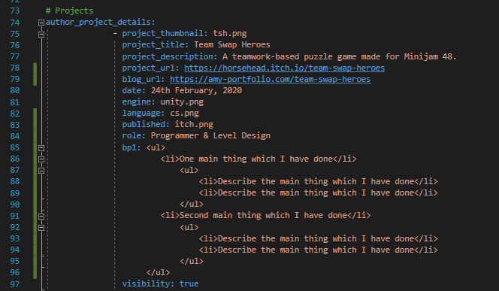Project Thumbnail (under assets/img/)
* Project Title
* Project Description
* Project URL
* Blog URL
* Date
* Engine
* Language
* Published Site
* Role
* BP (Main points about production)
* Visibility

These are all in the _config.yml file.

## Skills

This is all in the about-me.html file, and it’s a bit more difficult to find.

