Are there any duplicate ids in the records?

If yes, put screenshots of the records which are so in your answer

If no, why? Guess what information this is field represents and its implication/application

Note: There will be more than one answers and your answers don’t need to be perfect

Không có records bị trùng lặp.

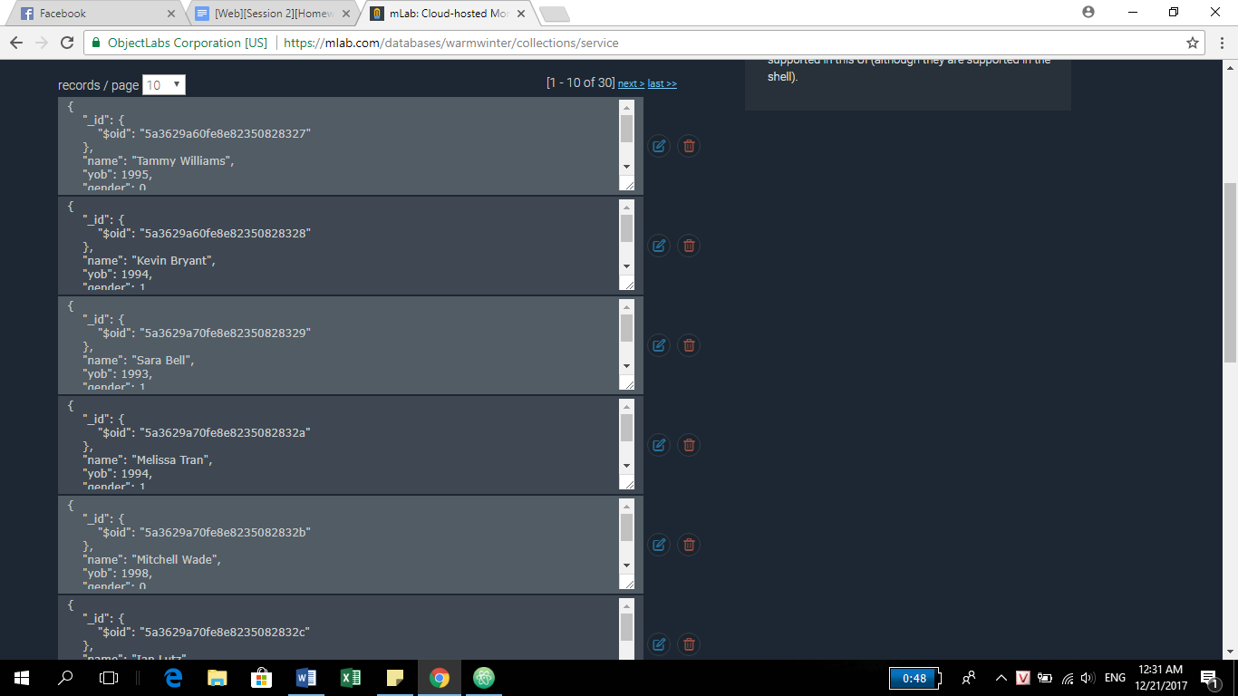

Nếu trùng thì sẽ dễ bị query sai.