VIETNAM GENERAL CONFEDERATION OF LABOR
TON DUC THANG UNIVERSITY
FACULTY OF INFORMATION TECHNOLOGY



Mai Hoang Thai – 523H0177
Phan Thanh Dat – 523H0124
Phan Tran Minh Quang – 523H0172

FINALTERM
CLOUD COMPUTING

HO CHI MINH CITY, 2026
VIETNAM GENERAL CONFEDERATION OF LABOR
TON DUC THANG UNIVERSITY
FACULTY OF INFORMATION TECHNOLOGY

Mai Hoang Thai – 523H0177
Phan Thanh Dat – 523H0124
Phan Tran Minh Quang – 523H0172

FINALTERM
CLOUD COMPUTING

Advised by
PhD Bui Quy Anh

HO CHI MINH CITY, 2026
ACKNOWLEDGEMENT

We would like to extend our profound appreciation to PhD Bui Quy Anh for his invaluable mentorship throughout the project.
During the implementation of our research, PhD Bui Quy Anh provided essential guidance.
The knowledge shared by PhD Bui Quy Anh has significantly enhanced our understanding. We are honored to have conducted this work under his expert supervision within the Faculty of Information Technology.
Ho Chi Minh city, 14th November 2026.
Author
(Signature and full name)

Thai
Mai Hoang Thai

Dat
Phan Thanh Dat

Quang
Phan Tran Minh Quang

DECLARATION OF AUTHORSHIP
We hereby declare that this is our own project and is guided by PhD Bui Quy Anh; The content research and results contained herein are central and have not been published in any form before. The data in the tables for analysis, comments and evaluation are collected by the main author from different sources, which are clearly stated in the reference section.
In addition, the project also uses some comments, assessments as well as data of other authors, other organizations with citations and annotated sources.
If something wrong happens, We’ll take full responsibility for the content of my project. Ton Duc Thang University is not related to the infringing rights, the copyrights that We give during the implementation process (if any).
Ho Chi Minh city, 14th November 2026
Author
(Signature and full name)

Thai
Mai Hoang Thai

Dat
Phan Thanh Dat

Quang
Phan Tran Minh Quang

TABLE OF CONTENTS
LIST OF FIGURES 4
LIST OF TABLES 5
CHAPTER 1. INTRODUCTION AND OBJECTIVES 5
1.1 Background and motivation 5
1.2 Project objectives 5
1.1 Scope of implementation 6
1.3 Team responsibilities 6
1.4 Report structure 7
CHAPTER 2. SYSTEM ARCHITECTURE AND DIAGRAMS 7
2.1 Components and responsibilities 7
2.2 Network, addresses and service ports 8
2.3 Web, API and data request flows 9
2.3.1 Blog request flow 9
2.3.2 Student API request flow 9
2.3.3 Authentication flow 10
2.3.4 Monitoring flow 10
2.4 Persistent storage and EC2 deployment 10
CHAPTER 3. DOCKERFILES AND INTEGRATION CONFIGURATION 11
3.1 Packaging services with Docker 11
3.1.1 Web Frontend 11
3.1.2 Application Backend 12
3.1.3 Object Storage 12
3.2 Compose, environment variables and volumes 12
3.3 Database and data contracts 13
3.4 Identity, JWT and access control 13
3.5 DNS, metrics and dashboards 14
3.6 Gateway and Round Robin 14
CHAPTER 4. DEMONSTRATION AND TESTING 14
4.1 Evidence scope and presentation of results 15
4.2 Web Frontend and blog features 15
4.3 Student APIs and database connectivity 16
4.4 Keycloak and protected resources 17
4.5 MinIO, avatar and PDF storage 18
4.6 DNS and internal connectivity 19
4.7 Prometheus and Nginx monitoring 20
4.8 Grafana dashboard 21
4.9 Gateway and load balancing 21
4.10 Trial deployment on AWS EC2 22
4.11 Summary of the ten extension items 22
CHAPTER 5. EVALUATION AND FUTURE DEVELOPMENT 24
5.1 Outcomes and learning value 24
5.2 Difficulties and diagnostic approach 24
5.3 Limitations of the model 25
5.4 Future development 25
5.5 Conclusion 25
REFERENCES 26
APPENDIX: HANDOVER INFORMATION 27
HƯỚNG DẪN CHỤP VÀ CHÈN ẢNH 28

LIST OF FIGURES
Figure 2.1. Overall architecture and communication flows in MyMiniCloud 9
Figure 2.2. EC2 instance and deployment environment information 11
Figure 2.3. Network access rules used for the EC2 demonstration 11
Figure 3.1. Web, API and MinIO Dockerfiles used in the project 13
Figure 4.1. Container status in the deployment used for testing 16
Figure 4.2. Blog home page accessed through the Gateway 17
Figure 4.3. Title search and category filtering on the article list 17
Figure 4.4. Article content, illustrations and suggested reading 17
Figure 4.5. Student API JSON responses and the Gateway alias 18
Figure 4.6. Student schema, records and results read from the database 18
Figure 4.7. Keycloak realm, two users and the flask-app client 19
Figure 4.8. Acceptance of valid tokens and rejection of invalid tokens 19
Figure 4.9. The three buckets and required objects for MinIO acceptance testing 20
Figure 4.10. Anonymous access to the avatar through the S3 endpoint 20
Figure 4.11. Report PDF in the documents bucket and download verification 20
Figure 4.12. Resolution of four records and web access through internal DNS 21
Figure 4.13. Prometheus node and web scrape targets 21
Figure 4.14. The nginx_up metric and Nginx request counter 21
Figure 4.15. Team dashboard showing CPU, memory and network traffic 22
Figure 4.16. Student API and alias route through the Gateway 22
Figure 4.17. Gateway request sequence showing the two Round Robin upstreams 23
Figure 4.18. Web and service functions verified in the EC2 environment 23

LIST OF TABLES
Table 1.1. Responsibilities by functional area 7
Table 2.1. The nine roles in MyMiniCloud 8
Table 2.2. Addresses and ports in the integrated deployment 9
Table 4.1. Extension results from the local integration record 23
Table 5.1. Technical issues and lessons learned 25

INTRODUCTION AND OBJECTIVES

Background and motivation
Cloud applications combine services that deliver interfaces, process data, authenticate users, store files and monitor operations. Studying each technology separately does not fully explain how a request moves through a system or how its services depend on one another.
MyMiniCloud uses Docker Compose and widely used software to simulate nine server roles in a small cloud environment. The system supports experimentation on a personal computer and deployment to an Ubuntu instance on Amazon EC2. The project focuses on understanding the mechanisms, integrating the services and verifying their behaviour through observable results.

Project objectives
  - Separate the interface, API, data and infrastructure services into containers with clear responsibilities.
  - Establish communication within cloud-net, provide consistent access paths and retain data throughout the container lifecycle.
  - Extend the system with a personal blog, student APIs, JWT authentication, object storage, internal DNS, monitoring and load balancing.
  - Distinguish local test results from EC2 results and identify both verified functions and outstanding evidence.

Scope of implementation
The basic system consists of a Web Frontend, Application Backend, MariaDB, Keycloak, MinIO, BIND9, Prometheus, Grafana and an Nginx Gateway. Node Exporter and Nginx Exporter support monitoring. With a second web instance and the web exporter enabled, the integrated deployment contains 12 containers while retaining the same nine architectural roles.
The assignment defines ten extension items, each worth up to 0.5 points. The Flask connection to the database is tracked separately as APP-02 for integration purposes; it is not an eleventh graded extension. The blog also provides title search, category filtering for Travel, Sports and Technology, and links to other articles. Search and filtering run in the browser using JavaScript.
Each environment runs its services on one host. The two web instances distribute requests, but this arrangement does not provide multiple hosts, automatic scaling or resilience to a regional failure. The blog is publicly accessible, while the JWT protected resource is the /secure API endpoint.

Team responsibilities
Table 1.1. Responsibilities by functional area
Team member | Assigned tasks | Main deliverables
Mai Hoàng Thái, 523H0177, Egew | WEB-01, OBJ-01, LB-01 | Blog, MinIO, two web instances and Round Robin; supporting evidence and report sections.
Phan Thanh Đạt, 523H0124, Newton | APP-01, DB-01, APP-02, AUTH-01, GW-01 | APIs, SQL, JWT and student routing; coordination of integration and deployment.
Phan Trần Minh Quang, 523H0172, Demonwan | DNS-01, MON-01, GRAF-01 | DNS, exporters, Prometheus, dashboards and monitoring evidence.

Report structure
The five chapters cover objectives and scope, architecture and data flows, Dockerfiles and configuration, demonstrations and test results, and evaluation with future development. The appendix provides handover links and instructions for screenshots captured through the AWS Console.

SYSTEM ARCHITECTURE AND DIAGRAMS

Components and responsibilities
Table 2.1. The nine roles in MyMiniCloud
Role | Technology | Function
Web | Nginx | Serves blog HTML, CSS, JavaScript and images.
Application | Flask and Gunicorn | Reads JSON and MariaDB data and verifies access tokens.
Database | MariaDB | Stores the basic notes data and the students table.
Identity | Keycloak | Manages realms, clients, users, tokens and public keys.
Object Storage | MinIO | Stores buckets, objects, the avatar and PDF files.
DNS | BIND9 | Provides the cloud.local zone and internal IPv4 records.
Monitoring | Prometheus and exporters | Collects operating system and Nginx metrics.
Visualization | Grafana | Displays CPU, memory and network traffic metrics.
Gateway | Nginx | Routes URLs and distributes requests between two web instances.

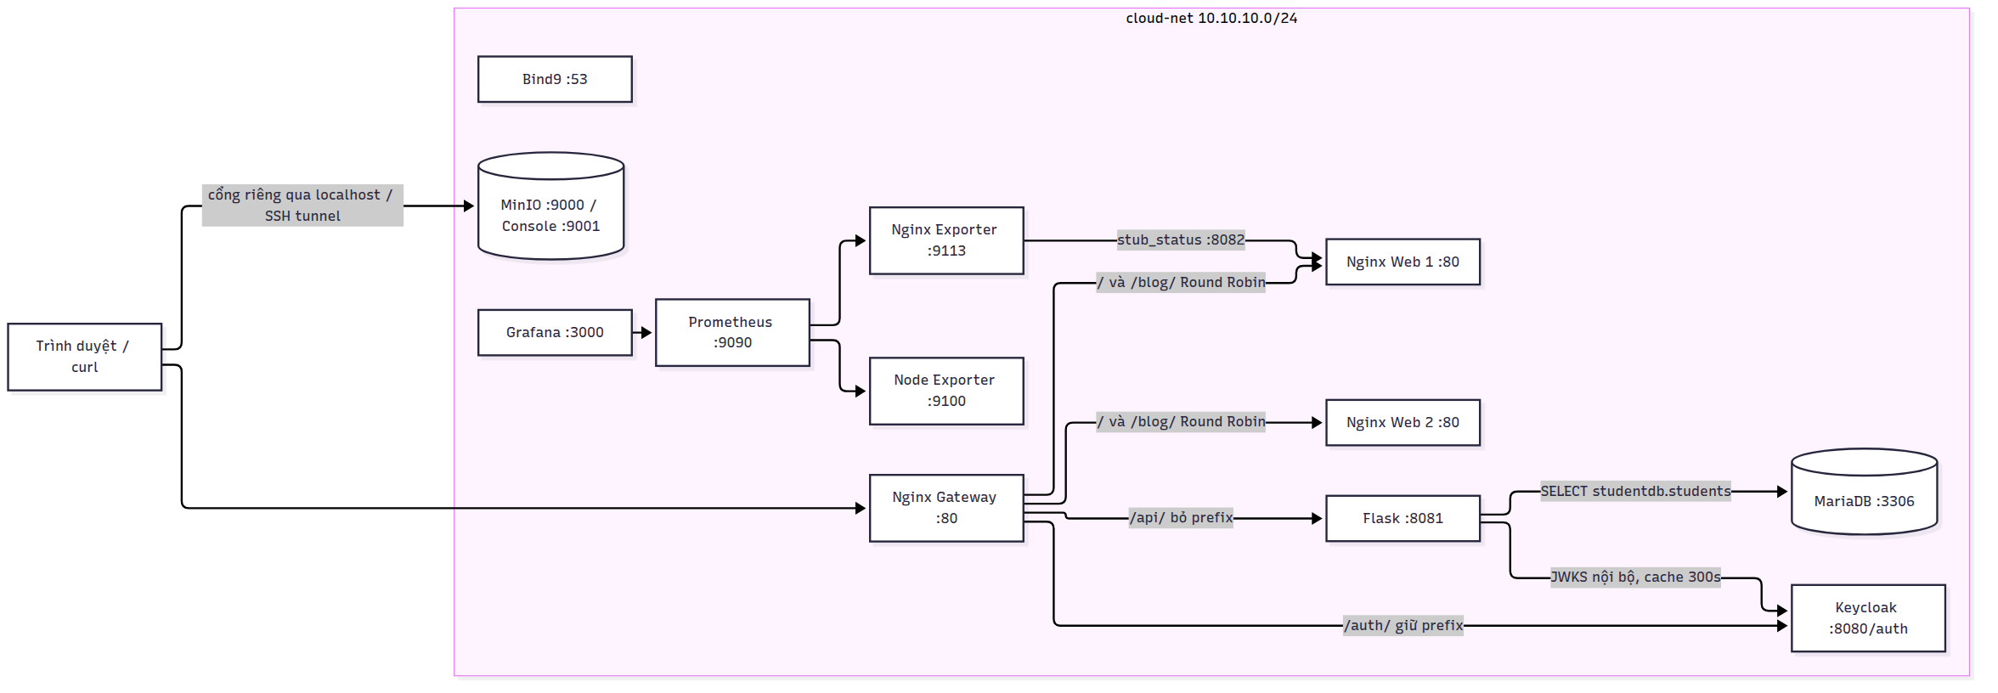
Figure 2.1. Overall architecture and communication flows in MyMiniCloud

Network, addresses and service ports
The containers share cloud-net with the subnet 10.10.10.0/24. Static IP addresses support verification of the lab DNS records, while application connections generally use service names. A container port differs from a port published on the host. For example, the API listens on port 8081 inside the Docker network and is directly accessible through host port 8085.
Table 2.2. Addresses and ports in the integrated deployment
Service | Internal IP | Container and host ports
Web 1 | 10.10.10.10 | 80; host 8080. Internal stub_status on 8082.
Web 2 | 10.10.10.11 | 80; host 8086 for direct instance access.
API | 10.10.10.20 | 8081; host 8085.
MariaDB | 10.10.10.21 | 3306; host port set by DB_HOST_PORT.
Keycloak | 10.10.10.30 | 8080 with the /auth context; host 8081.
MinIO | 10.10.10.40 | 9000 for the S3 API; 9001 for the Console.
BIND9 | 10.10.10.53 | 53 TCP/UDP; host 1053.
Prometheus | 10.10.10.60 | 9090.
Node Exporter | 10.10.10.61 | 9100.
Nginx Exporter | 10.10.10.62 | 9113, internal only.
Grafana | 10.10.10.70 | 3000.
Gateway | 10.10.10.80 | 80; host port set by GATEWAY_PORT.

Docker embedded DNS resolves service names and aliases. BIND9 separately manages the cloud.local zone. Adding a DNS server to the network does not automatically make every container use it. On EC2, the instance private address and public IP belong to a different addressing layer from the container addresses in 10.10.10.x.

Web, API and data request flows

Blog request flow
The browser sends a request to the Gateway, which forwards web requests to an Nginx Web instance. HTML references CSS, JavaScript and images, so loading one page can produce several separate requests. Both web instances use the same image. Only their home pages are replaced through bind mounts with versions carrying different instance labels.

Student API request flow
The Gateway maps /api/student to /student in Flask. The API reads students.json, validates its structure and returns five objects. The /student/ path is a Gateway alias for the same data source. The /students-db API queries studentdb.students with the application database account, converts dates of birth to ISO format and returns JSON.

Authentication flow
Keycloak issues an access token for the flask-app client in the team realm. The client sends the Bearer token to /api/secure. The backend verifies the RS256 signature, issuer, audience, expiry and subject. Public keys are retrieved through an internal JWKS endpoint, while the issuer remains the public identity exposed through the Gateway. The static blog does not currently provide a login interface connected to this flow.

Monitoring flow
Prometheus scrapes both exporters every 15 seconds. Nginx Exporter converts web1 stub_status output into metrics. Grafana queries Prometheus with PromQL to draw panels. Node Exporter network metrics reflect its configured network namespace rather than the combined traffic of all containers.

Persistent storage and EC2 deployment
MariaDB, Keycloak, MinIO, Prometheus and Grafana use named volumes. File mounts supply Nginx configuration, the DNS zone and dashboards. Volumes retain data across container recreation but do not replace backups.
Each EC2 environment has separate source, images, environment variables and data. Accessibility depends on Security Groups, host bind addresses and application permissions. Even a public MinIO object remains inaccessible when network rules block its S3 API port.
[CHÈN ẢNH EC2_INSTANCE]
Figure 2.2. EC2 instance and deployment environment information
Vị trí ảnh được căn giữa. Cách chụp minh chứng EC2_INSTANCE được trình bày trong phụ lục hướng dẫn chụp ảnh.
[CHÈN ẢNH EC2_SECURITY]
Figure 2.3. Network access rules used for the EC2 demonstration
Vị trí ảnh được căn giữa. Cách chụp minh chứng EC2_SECURITY được trình bày trong phụ lục hướng dẫn chụp ảnh.

DOCKERFILES AND INTEGRATION CONFIGURATION

Packaging services with Docker

Web Frontend
The Web Dockerfile uses Nginx Alpine and copies the server configuration and HTML directory into the image. Nginx uses root for general content and alias for /blog/. The /health endpoint provides a liveness response. CSS rules are scoped to the home page, article list and article pages to limit unintended effects on other views.
Title search converts text to lowercase, normalizes Unicode and removes diacritics before matching. Filtering combines the title and category conditions. Article links remain available as HTML links when JavaScript is disabled. Suggestions at the end of each article are static links to the other two articles rather than a personalized recommendation system.

Application Backend
The API Dockerfile uses Python slim and installs dependencies with pinned versions. Gunicorn serves the WSGI application with two workers. The JSON file path is resolved relative to the module, avoiding dependence on the working directory. SQL connections use finite timeouts, and database failures return a generic 503 response without exposing driver details.

Object Storage
The MinIO image is built in multiple stages from the upstream source at the tag selected for the lab. The build stage uses Go, and the runtime stage receives the compiled binary on Alpine. This keeps compilation tools out of the runtime image. A local image name does not establish that the image has been published on Docker Hub.
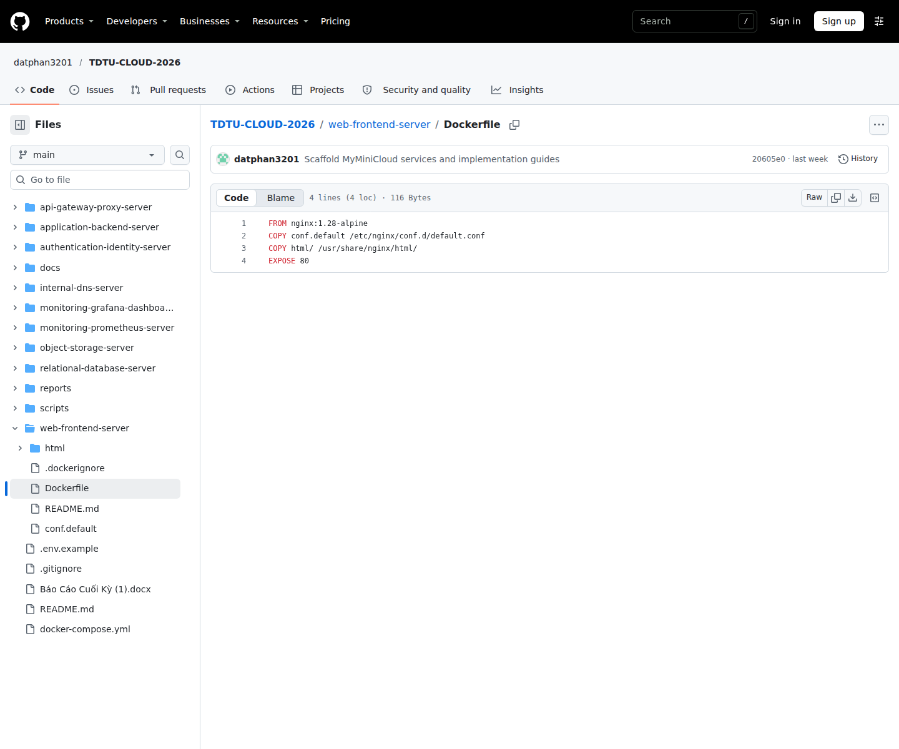
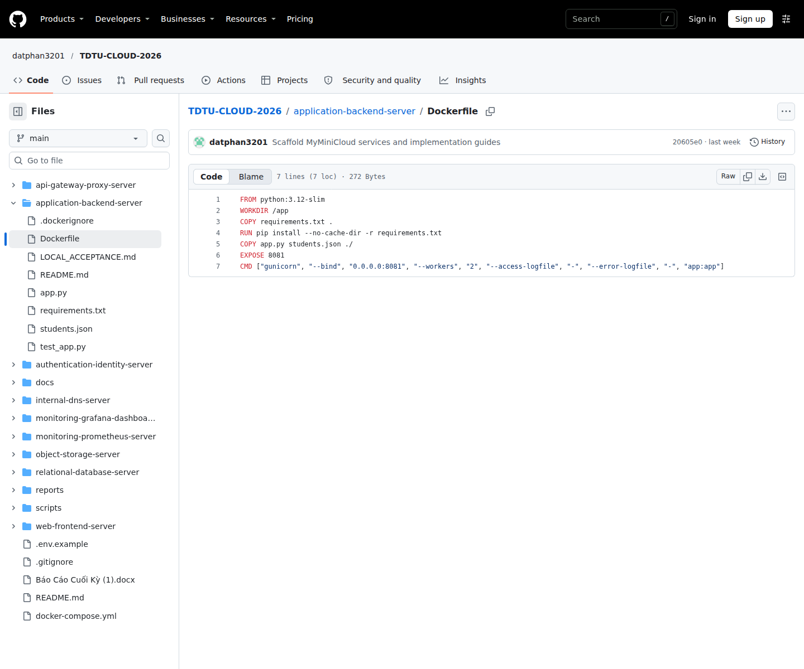
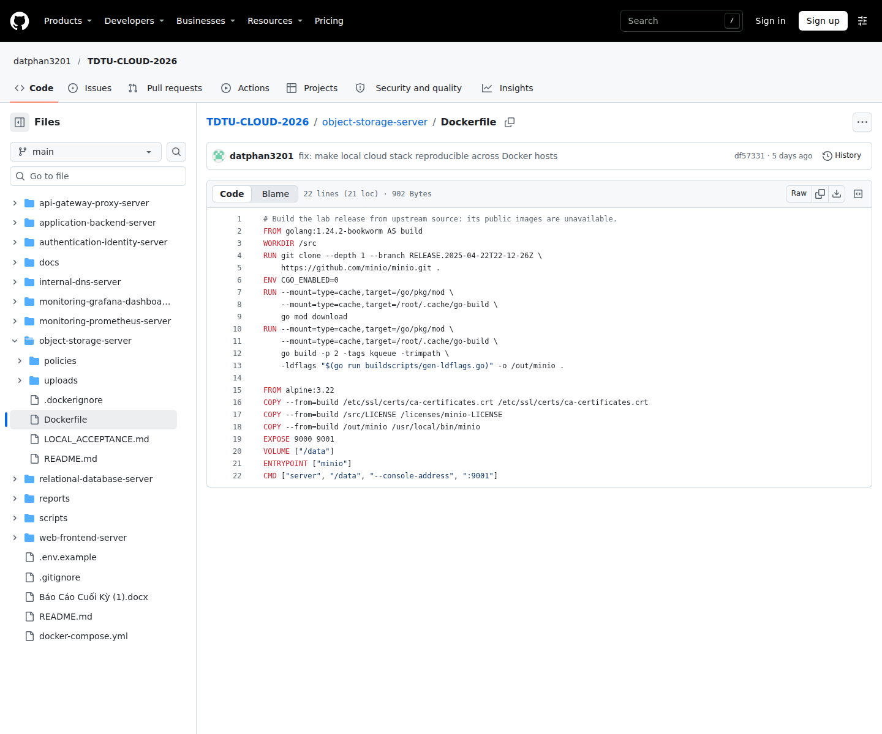
Figure 3.1. Web, API and MinIO Dockerfiles used in the project

Compose, environment variables and volumes
The base Compose file defines the services and shared resources. The load balancing override adds web2 and replaces the Gateway configuration file. The monitoring override adds Nginx Exporter and the web scrape configuration. Together, the merged files define one integrated deployment.
Environment variables separate configuration from images. PUBLIC_BASE_URL defines the canonical URL, and GATEWAY_BIND_ADDRESS controls the address on which the Gateway port is published. Defining a variable in .env does not automatically pass it to every container. Changing a value in that file also does not automatically update account state already stored in the database or Keycloak.
Healthchecks and depends_on help control startup order. The service_started condition alone does not establish that a service is ready for application requests. A restart policy can produce a restart loop when credentials or application configuration are invalid; the underlying cause still needs to be identified from logs.

Database and data contracts
The notes table belongs to the minicloud database. A migration creates studentdb.students and three sample records. The id column is an automatically incremented primary key. The student_id column stores a student identifier but does not itself carry a UNIQUE constraint. The migration checks whether a record exists before inserting it, avoiding replacement of existing data during sequential executions.
The application account has SELECT permission on the students table. Static JSON records contain id, name, major and gpa, while SQL records contain id, student_id, fullname, dob and major. These schemas serve different exercises and are not automatically synchronized.

Identity, JWT and access control
The realm template declares the public client flask-app and two users, sv01 and sv02. An audience mapper includes flask-app in the access token. Provisioning scripts manage configuration and environment specific passwords without embedding real passwords in the template. The Direct Access Grants flow supports token testing with an HTTP client in the lab.
PyJWT accepts only RS256, requires the exp, iss, aud and sub claims, and uses JWKS from a trusted endpoint. The key set is cached for 300 seconds and can be refreshed when a new key is needed. Forged tokens and tokens with invalid claims are rejected with 401. A failure of the JWKS dependency can produce 503. Reading a token payload alone does not verify its signature.

DNS, metrics and dashboards
BIND9 provides A records for web, app-backend, minio and keycloak within cloud.local. The SOA serial identifies the zone version, and TTL controls how long records may be cached. DNS is available over both TCP and UDP. A correct DNS record does not establish that the process at the destination address is serving requests.
Prometheus stores time series identified by metric names and labels. A counter is cumulative, while rate calculates its rate of change over a time window. The CPU panel subtracts the idle ratio from one. The memory panel uses MemAvailable relative to MemTotal, and the network panel uses the rates of received and transmitted bytes. Grafana provisioning connects the dashboard to a stable data source UID.

Gateway and Round Robin
Both the base and load balancing configurations define an exact /student/ route to the Flask /student endpoint and preserve the query string. The /api/ route removes its prefix, while /auth/ retains its prefix. Forwarded headers help upstream services generate redirects and canonical URLs that match the address used by the client.
The web pool contains two upstream servers with equal weights. Nginx uses Round Robin by default. The Web service generates X-Web-Instance, and the Gateway generates X-Upstream-Addr. Repeated browser refreshes can show the same label because requests for HTML, CSS and images are interleaved. Direct access to the two instance ports confirms that both instances have distinct labels, while a sequence of requests through the Gateway demonstrates load distribution.
Docker healthchecks do not automatically become active upstream health checks in Nginx. This configuration also does not provide sticky sessions or automatic scaling. Failover behaviour requires its own verification and cannot be inferred from a Round Robin sequence alone.

DEMONSTRATION AND TESTING

Evidence scope and presentation of results
This chapter distinguishes implemented source code, tests supported by logs and positions reserved for screenshots. LOCAL_INTEGRATION dated 14 November 2026 provides the basis for the local integration results. Items awaiting evidence are not treated as successful EC2 verification.
The local integration record reports 12 running containers, with the services that define healthchecks reporting healthy. The smoke test passed all 11 checks, and the network checks for the ten base services passed. These results apply to the recorded checks rather than every user interface operation or every function of each service.
[CHÈN ẢNH STACK_STATUS]
Figure 4.1. Container status in the deployment used for testing
Vị trí ảnh được căn giữa. Cách chụp minh chứng STACK_STATUS được trình bày trong phụ lục hướng dẫn chụp ảnh.

Web Frontend and blog features
The web checks cover access to the home page, article list, three articles and their assets through web1, web2 and the Gateway. The local integration record reports HTTP 200 for the corresponding URLs. Browser screenshots are still required to demonstrate title search, category filtering and links to other articles.
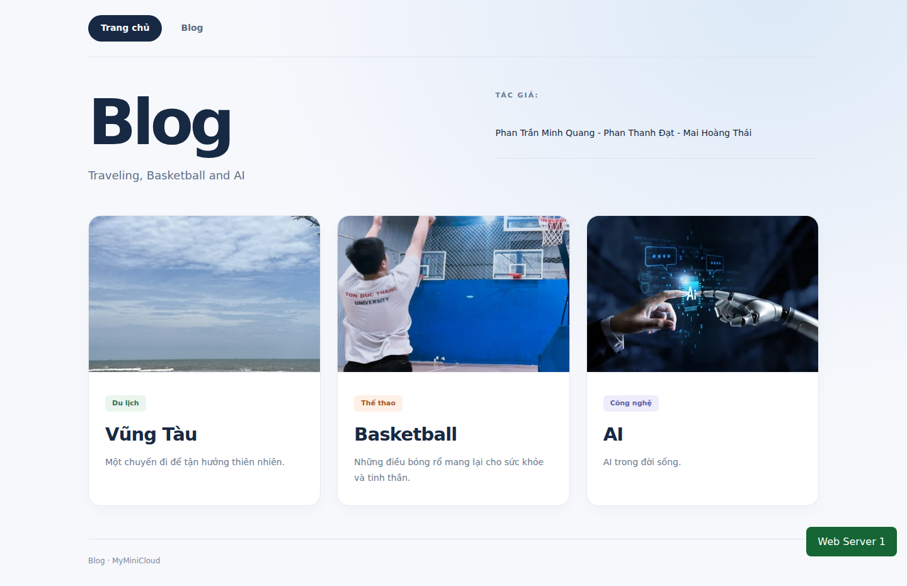
Figure 4.2. Blog home page accessed through the Gateway
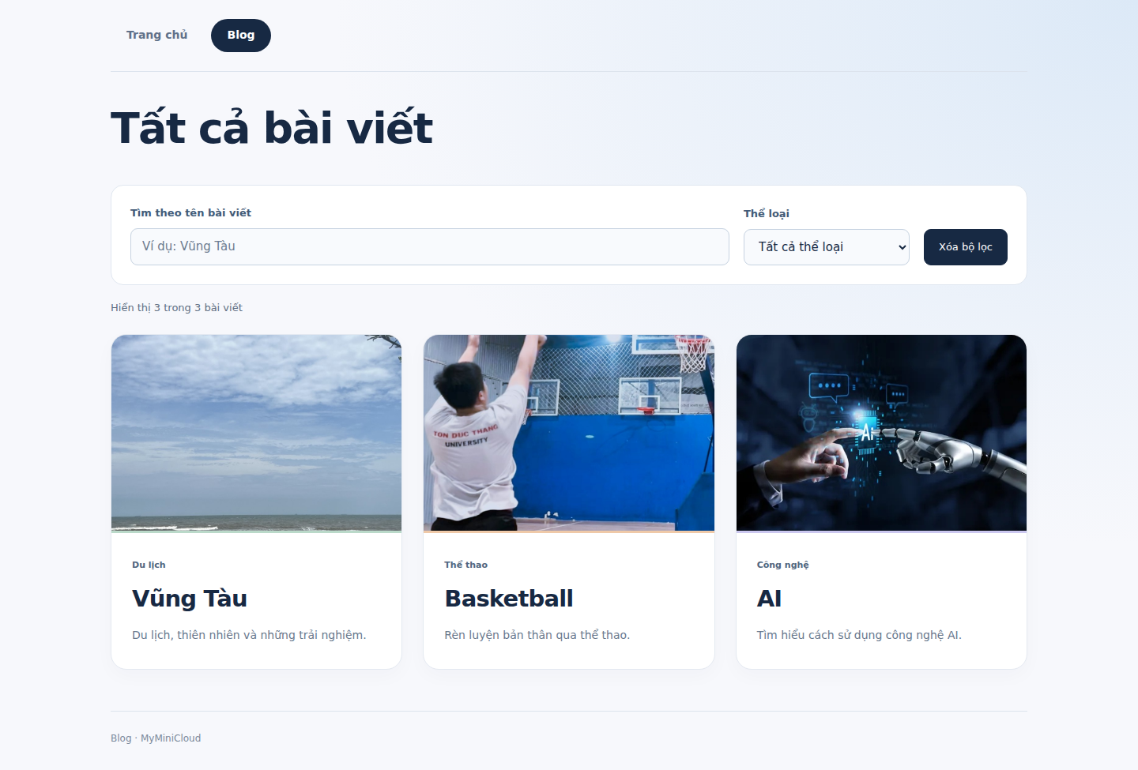
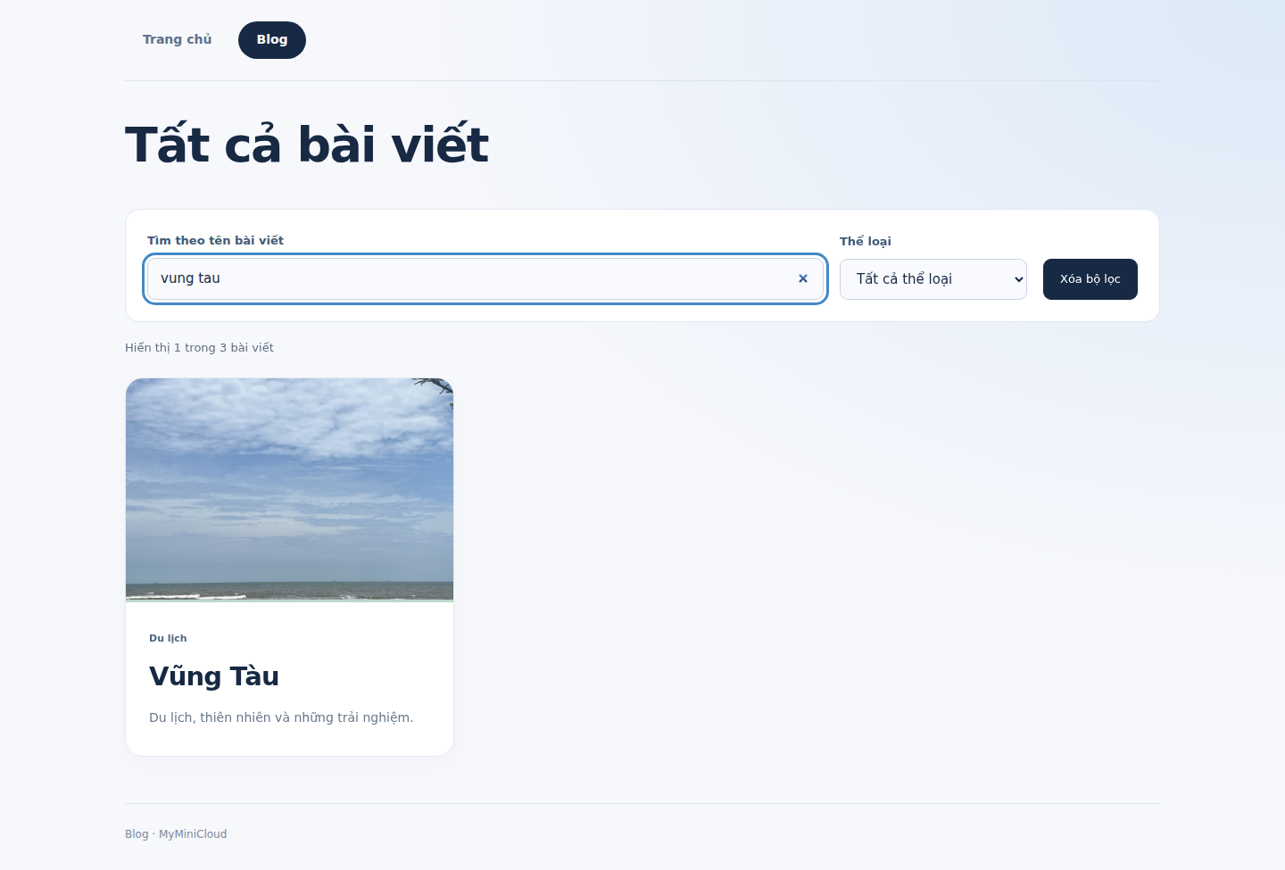
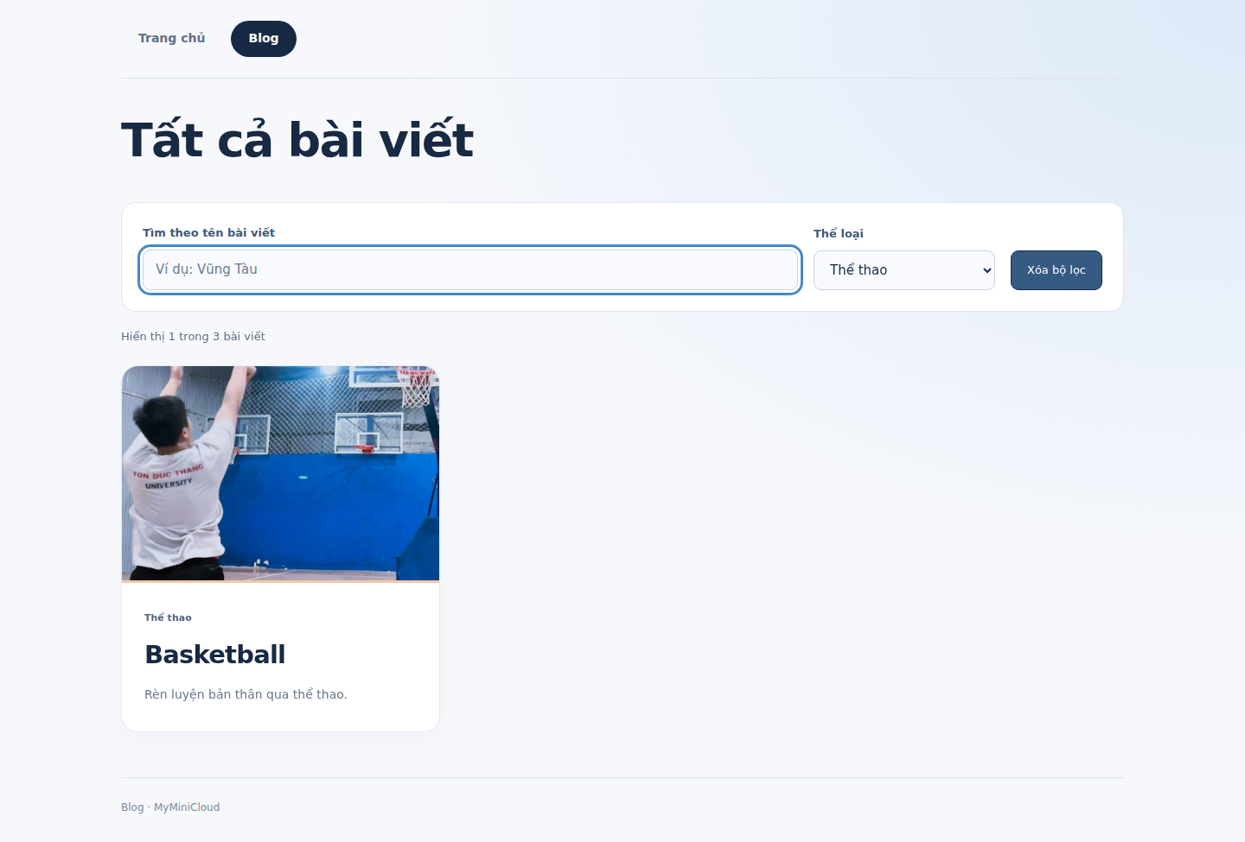
Figure 4.3. Title search and category filtering on the article list
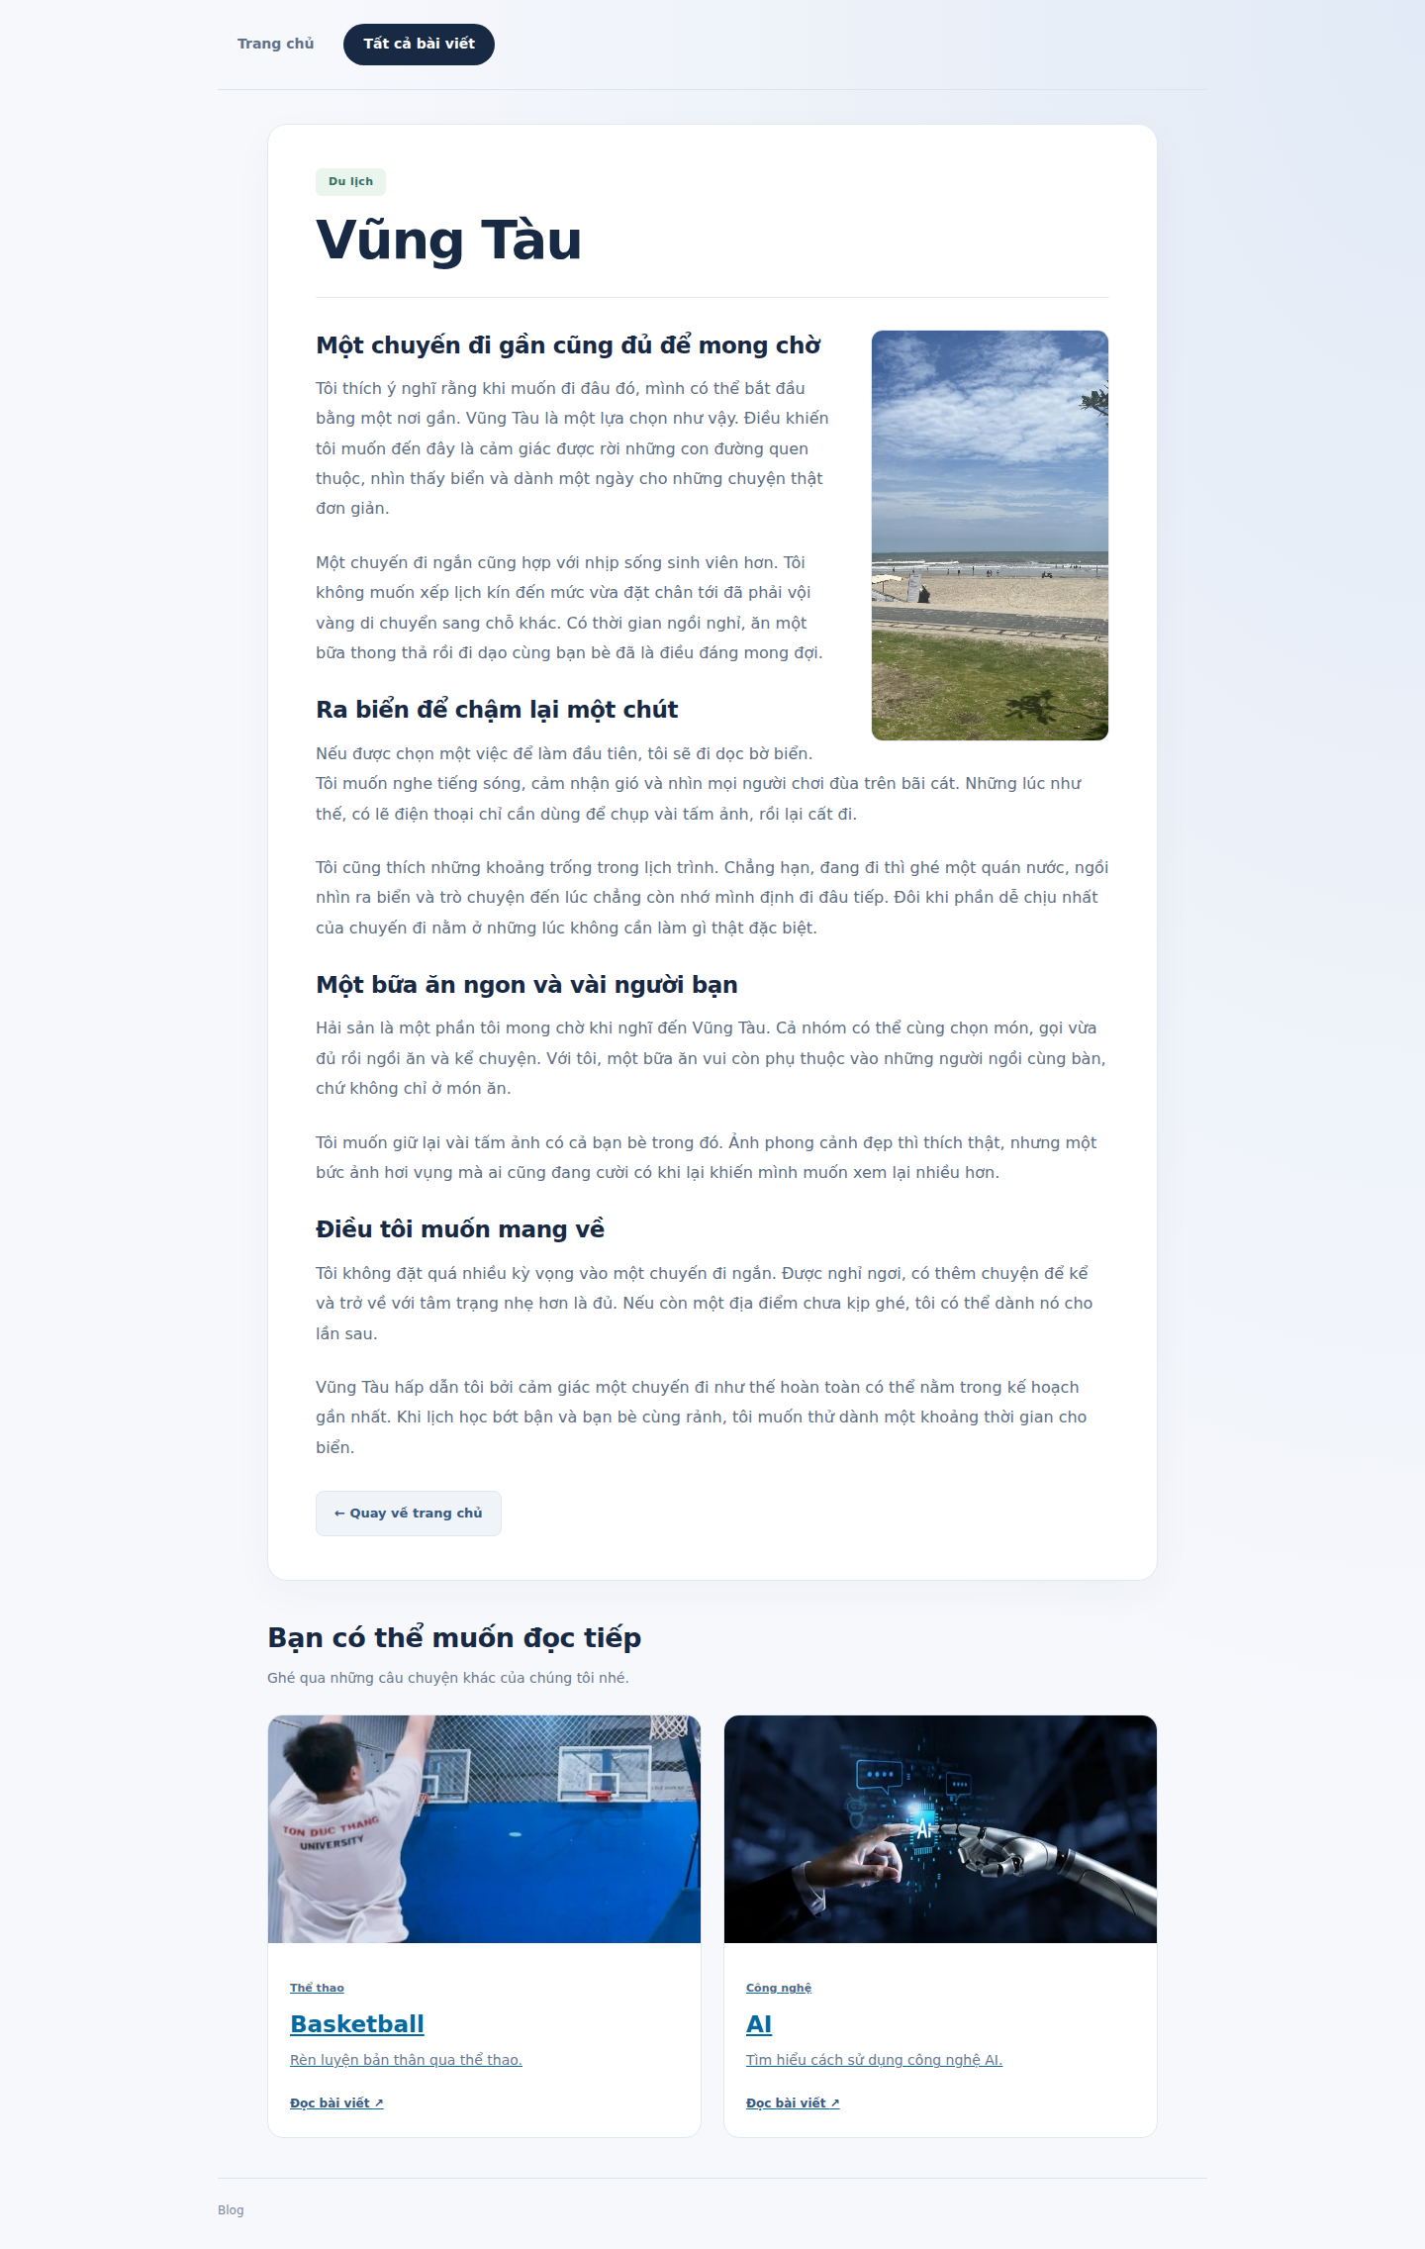
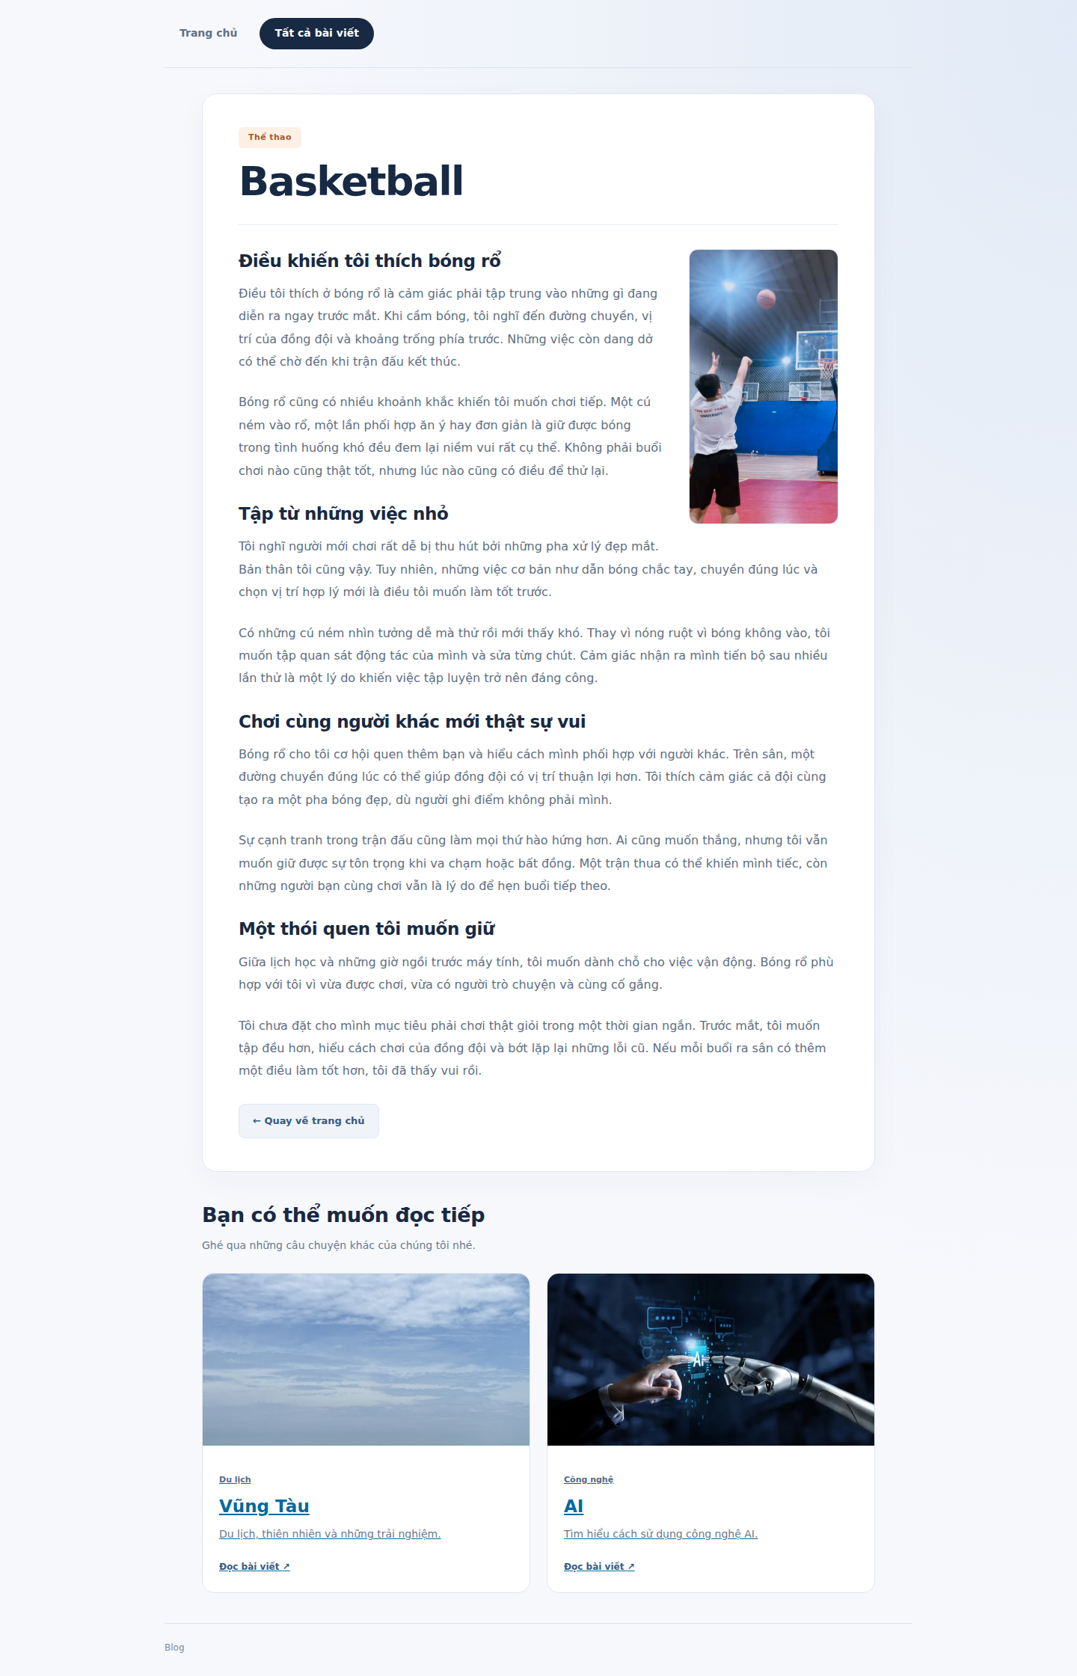
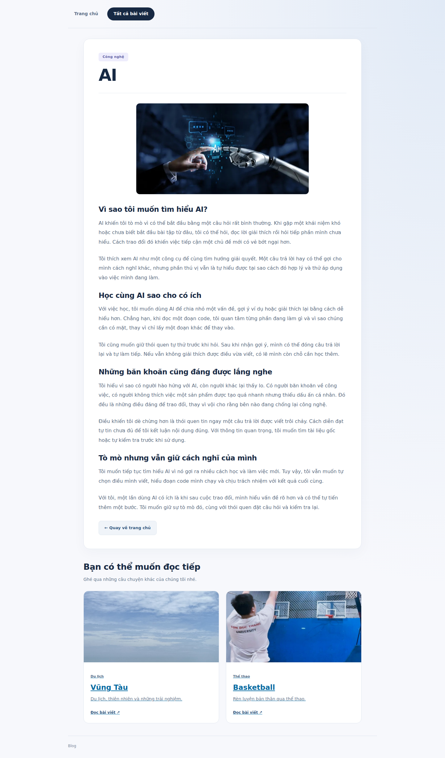
Figure 4.4. Article content, illustrations and suggested reading

Student APIs and database connectivity
APP-01 was checked against a list of five students, including field names and data types. Direct responses were compared with responses through the Gateway. APP-02 was compared with SQL executed using the application account, with at least three rows and dates in ISO format. The local record reports that the Newton integration suite passed all 18 checks.
An earlier database failure test recorded a controlled 503 response and API recovery after the database became available again. This is a recorded local result, not a recovery time guarantee or an EC2 load test.
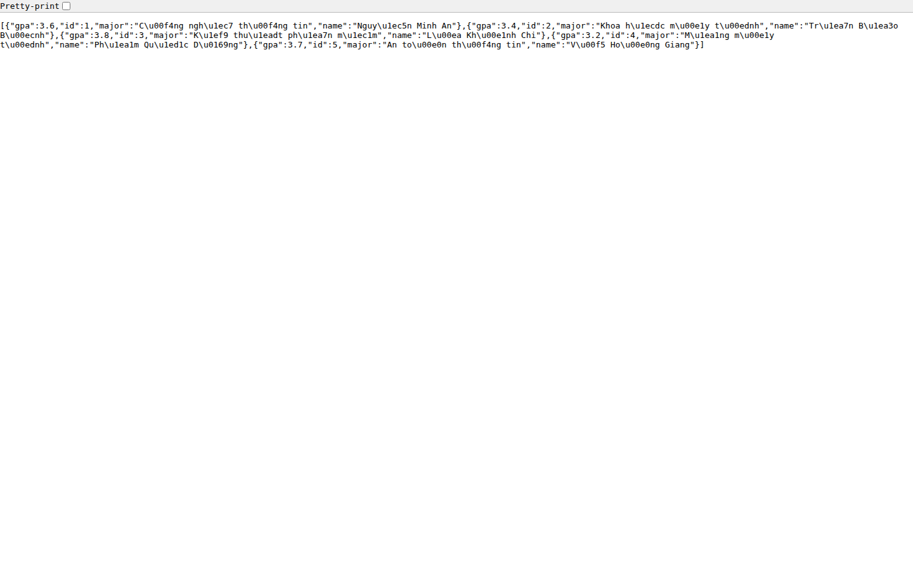
Figure 4.5. Student API JSON responses and the Gateway alias
[CHÈN ẢNH DB_STUDENTS]
Figure 4.6. Student schema, records and results read from the database
Vị trí ảnh được căn giữa. Cách chụp minh chứng DB_STUDENTS được trình bày trong phụ lục hướng dẫn chụp ảnh.

Keycloak and protected resources
AUTH-01 obtains real tokens from Keycloak for both users and uses them to access the API. Valid tokens return 200 and the corresponding username. A token with a modified signature returns 401. Unit tests cover invalid issuers, audiences, algorithms and expiry, together with key rotation scenarios using RSA keys and an HTTP JWKS fixture.
[CHÈN ẢNH AUTH_REALM]
Figure 4.7. Keycloak realm, two users and the flask-app client
Vị trí ảnh được căn giữa. Cách chụp minh chứng AUTH_REALM được trình bày trong phụ lục hướng dẫn chụp ảnh.
[CHÈN ẢNH AUTH_TOKEN]
Figure 4.8. Acceptance of valid tokens and rejection of invalid tokens
Vị trí ảnh được căn giữa. Cách chụp minh chứng AUTH_TOKEN được trình bày trong phụ lục hướng dẫn chụp ảnh.

MinIO, avatar and PDF storage
OBJ-01 requires anonymous access to profile-pics/avatar.jpg and a report PDF in documents that can be downloaded according to the selected permissions. Earlier results from 10 November recorded the required data in a previous environment. However, the integration record from 14 November states that the local environment under test contained only the demo bucket and lacked the avatar and PDF. This report uses the newer result to avoid combining the states of different environments.
The underlying storage service was verified by uploading and downloading a temporary object. OBJ-01 in the integrated environment still requires the missing data and another acceptance test. The old demo/index.html object also needs to be compared with the current web source. Bucket state on EC2 requires separate screenshots and logs; it cannot be inferred from policy files stored in Git.
[CHÈN ẢNH STORAGE_BUCKETS]
Figure 4.9. The three buckets and required objects for MinIO acceptance testing
Vị trí ảnh được căn giữa. Cách chụp minh chứng STORAGE_BUCKETS được trình bày trong phụ lục hướng dẫn chụp ảnh.
[CHÈN ẢNH STORAGE_AVATAR]
Figure 4.10. Anonymous access to the avatar through the S3 endpoint
Vị trí ảnh được căn giữa. Cách chụp minh chứng STORAGE_AVATAR được trình bày trong phụ lục hướng dẫn chụp ảnh.
[CHÈN ẢNH STORAGE_PDF]
Figure 4.11. Report PDF in the documents bucket and download verification
Vị trí ảnh được căn giữa. Cách chụp minh chứng STORAGE_PDF được trình bày trong phụ lục hướng dẫn chụp ảnh.

DNS and internal connectivity
DNS-01 was checked using four domain names that returned the expected IP addresses over UDP and TCP. This was supplemented by a web request from a container configured to use the lab DNS resolver. Pinging a service checks part of the network path. Accessing HTTP content through the DNS name provides additional evidence that application access works with that resolver.
[CHÈN ẢNH DNS_RECORDS]
Figure 4.12. Resolution of four records and web access through internal DNS
Vị trí ảnh được căn giữa. Cách chụp minh chứng DNS_RECORDS được trình bày trong phụ lục hướng dẫn chụp ảnh.

Prometheus and Nginx monitoring
The local record reports up equal to 1 for the node and web jobs, with nginx_up also equal to 1. The web request counter increased after requests were generated. The increase may include healthchecks and background traffic, so it is not expected to equal exactly the number of requests issued by the tester. The exporter currently reads web1 and does not represent the combined traffic of both web instances.
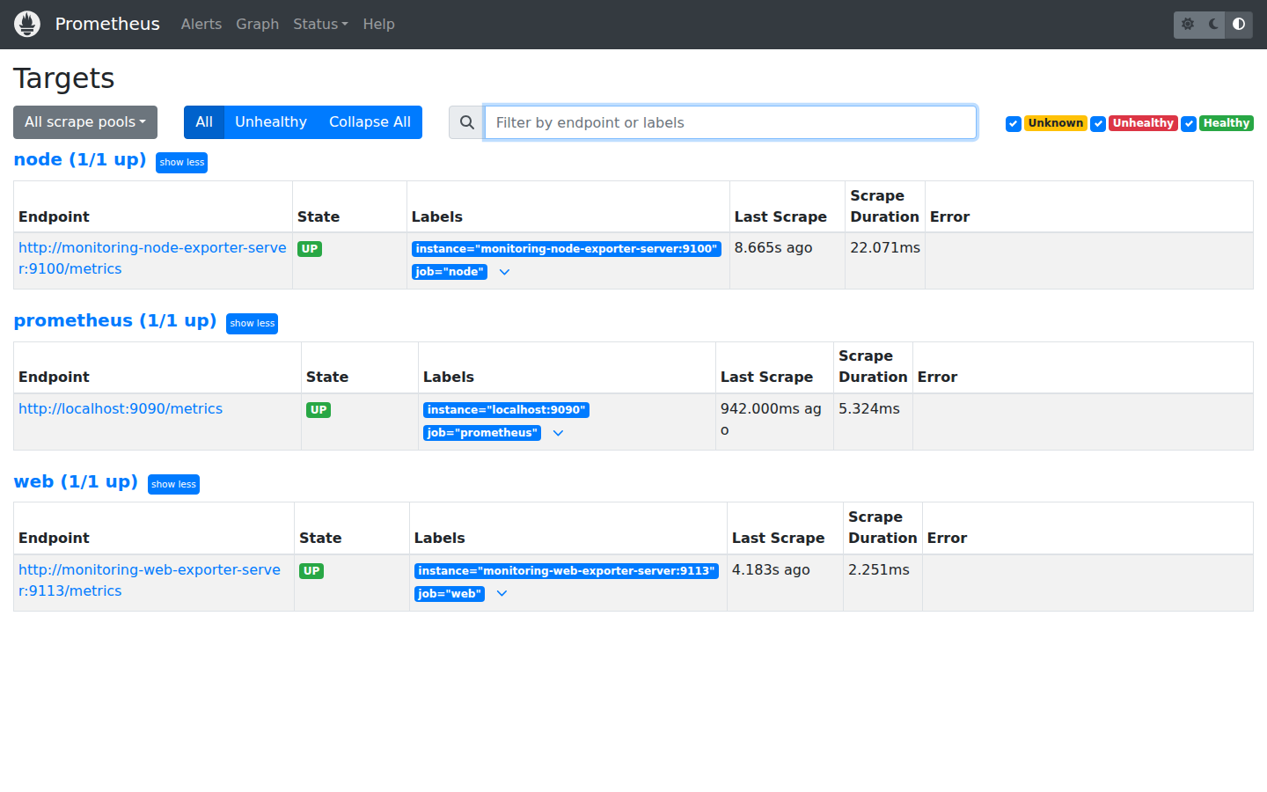
Figure 4.13. Prometheus node and web scrape targets
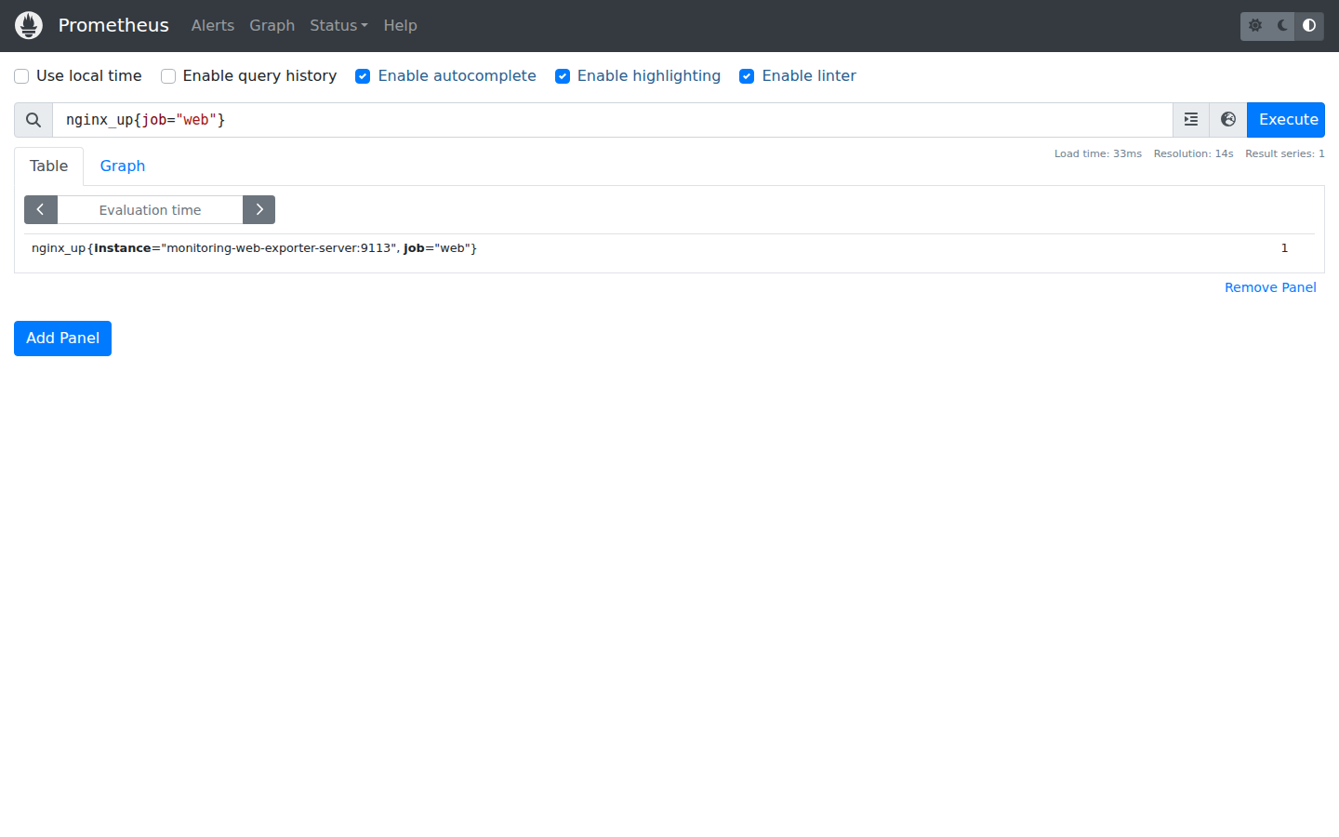
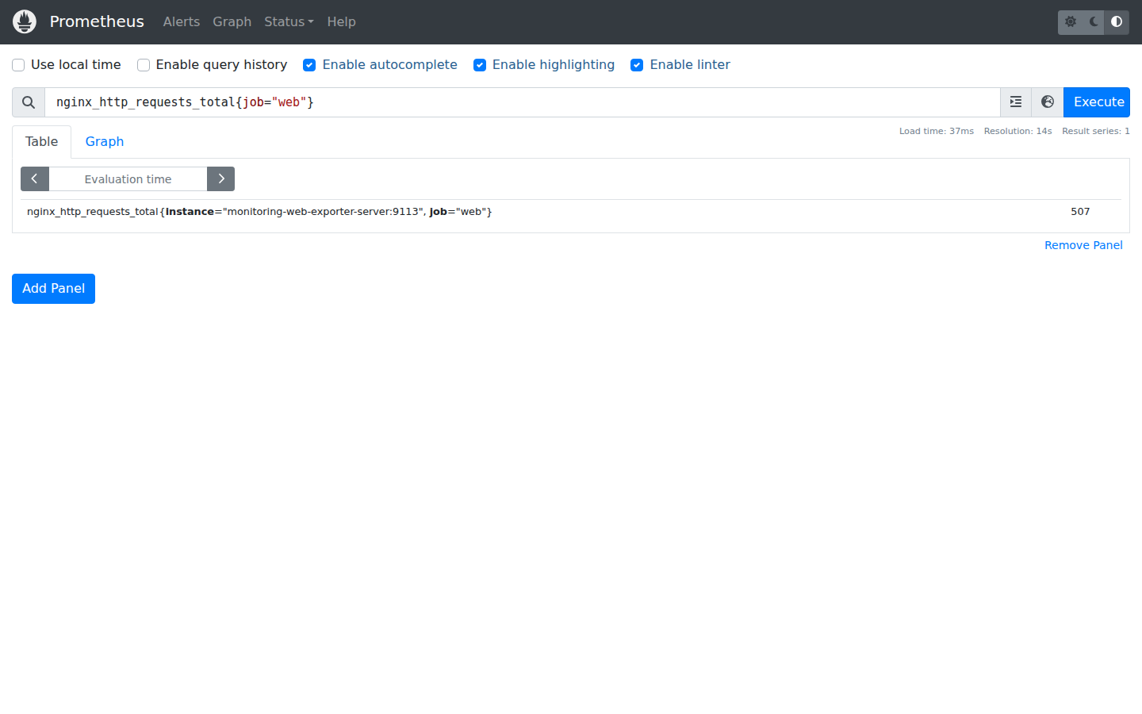
Figure 4.14. The nginx_up metric and Nginx request counter

Grafana dashboard
The dashboard is defined in JSON with Prometheus as its data source, panels for CPU, memory and network traffic, a 15 minute display window and a 30 second refresh interval. The integration record confirms that all three queries returned data. A dashboard screenshot must include panel titles, units and the time range so the results can be interpreted correctly.
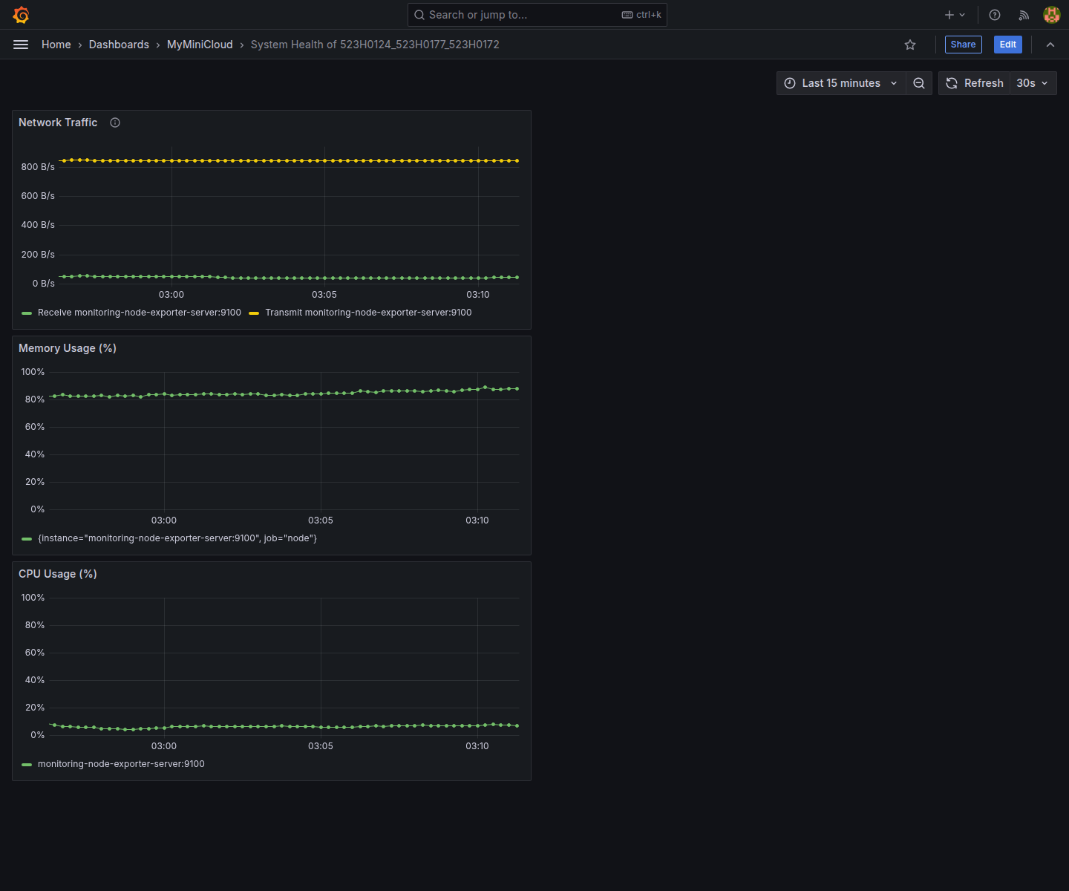
Figure 4.15. Team dashboard showing CPU, memory and network traffic

Gateway and load balancing
GW-01 was verified by confirming that /student/ returned the same data as /api/student with both overrides enabled. LB-01 recorded 12 HTML requests distributed equally between the two web instances, with six requests per instance. HTML labels and upstream headers identify the instances. These results describe the local test and do not replace EC2 logs.
Figure 4.16. Student API and alias route through the Gateway
[CHÈN ẢNH LB_ROUNDROBIN]
Figure 4.17. Gateway request sequence showing the two Round Robin upstreams
Vị trí ảnh được căn giữa. Cách chụp minh chứng LB_ROUNDROBIN được trình bày trong phụ lục hướng dẫn chụp ảnh.

Trial deployment on AWS EC2
During the EC2 deployment session for Egew, the home page became accessible through the public IP after the HTTP IPv4 rule was corrected. MinIO previously entered a restart loop because its credentials did not meet the length requirements. Logs identified the cause, and the corrective procedure was to update the environment and recreate the container while retaining its volume.
The available screenshots and logs do not yet establish acceptance of all three Egew components on EC2. Separate DNS, monitoring and Grafana confirmations from other team members do not replace an integrated test of the full team deployment in one environment. The test time, active public URL and actual results must be recorded before submission.
[CHÈN ẢNH EC2_FUNCTIONS]
Figure 4.18. Web and service functions verified in the EC2 environment
Vị trí ảnh được căn giữa. Cách chụp minh chứng EC2_FUNCTIONS được trình bày trong phụ lục hướng dẫn chụp ảnh.

Summary of the ten extension items
Table 4.1. Extension results from the local integration record
Item | Documented local result | Evidence or outstanding work
WEB-01 | Passed; local check on 14 November. | Bổ sung ảnh Home, danh sách, bài viết và thao tác tìm kiếm, lọc.
APP-01 | Passed; five JSON records; API responses match. | Provide the final logs and evidence for the relevant environment.
DB-01 | Passed; three rows; app account can read. | Retain SQL output and the corresponding persistence evidence.
AUTH-01 | Passed; real tokens and rejection cases. | Bổ sung ảnh cấu hình realm, client và hai user.
OBJ-01 | Pending locally; avatar and PDF are missing. | Restore the missing avatar and PDF, then repeat the checks.
DNS-01 | Passed; four DNS records and resolver checks. | Provide the final DNS outputs and supporting logs.
MON-01 | Passed; targets, nginx_up and request counter. | Bổ sung ảnh Targets, query và phạm vi metric được đo.
GRAF-01 | Passed; all three queries returned data. | Chèn ảnh dashboard đủ CPU, RAM, Network.
GW-01 | Passed with the integrated configuration. | Retain the response comparison for both URLs.
LB-01 | Passed; 12 requests split equally, six per instance. | Bổ sung ảnh, log Round Robin trên local và EC2.

Local checks on 14 November recorded nine of ten extensions and optional APP-02 as functionally passed. Final evidence, Docker Hub publication, full EC2 acceptance, the report and video still require confirmation. These results do not establish an official score.

EVALUATION AND FUTURE DEVELOPMENT

Outcomes and learning value
The system demonstrates how an application platform can be assembled from services with clearly defined contracts. The team practised application packaging and examined the relationships between routes, hostnames, schemas, tokens, storage permissions and metrics. Separating runtime data from source code explains why the same repository can start successfully in a new environment while still lacking the data required for its demonstration.

Difficulties and diagnostic approach
Table 5.1. Technical issues and lessons learned
Issue | Cause and lesson
MinIO image could not be pulled | Build from source at the selected tag and distinguish registry availability from application failures.
MinIO repeatedly restarted on EC2 | Invalid credentials; inspect logs before changing Security Groups or removing data.
Website requests timed out from the Internet | Check the running process, bind address, Docker port mapping and IPv4/IPv6 rules separately.
Browser repeatedly showed the same web label | Inspect Gateway requests; asset requests also participate in load distribution.
Bucket contents differed between machines | Git does not transfer volumes; declared configuration and runtime data are separate.
Web monitoring returned an unsuitable format | Use an exporter rather than treating the HTML response on port 80 as Prometheus metrics.

Limitations of the model
  - A single host and a single Gateway remain a shared failure domain. Two web replicas do not provide resilience to the loss of that host.
  - Keycloak runs in a lab configuration, and token acquisition is used for testing. The blog does not have an integrated login flow.
  - Node Exporter does not report separate resource usage for each container, and the web exporter currently reads only one instance.
  - Grafana visualizes metrics in the current deployment. A centralized logging pipeline and distributed tracing are not implemented.
  - Volumes preserve data across container recreation, but they are not a backup or disaster recovery solution.
  - Local results and isolated EC2 trials are insufficient to establish acceptance of the full deployment in the cloud.

Future development
The first priority is to complete the data and evidence for the selected source version and repeat the integrated checks on EC2. Further improvements include HTTPS with a stable domain, appropriate secret management, backups, monitoring of both web instances and individual containers, and a controlled deployment pipeline. Expanding to multiple hosts would require shared state, service discovery and failure handling, rather than simply increasing the number of containers on the current machine.

Conclusion
MyMiniCloud connects Docker, web applications, data services and infrastructure concepts in an observable deployment. The report records results against specific evidence and identifies the limits of those results. Outstanding data and acceptance evidence must be completed before the report is submitted.

REFERENCES
[1] Cloud Computing final project assignment. The lecturer provided the document “Báo Cáo Cuối Kỳ (1).docx”.
[2] Docker Documentation. Docker Engine, Compose and storage. https://docs.docker.com/
[3] Flask Documentation. Deploying to Production. https://flask.palletsprojects.com/en/stable/deploying/
[4] MariaDB Documentation. Server and SQL. https://mariadb.com/docs/server/
[5] Keycloak Documentation. Server Administration and reverse proxy configuration. https://www.keycloak.org/documentation
[6] MinIO. Source code for the version used in the lab. https://github.com/minio/minio/tree/RELEASE.2025-04-22T22-12-26Z
[7] ISC BIND 9 Administrator Reference Manual. https://bind9.readthedocs.io/
[8] Prometheus Documentation. Overview and query functions. https://prometheus.io/docs/introduction/overview/
[9] Grafana Documentation. Provisioning. https://grafana.com/docs/grafana/latest/administration/provisioning/
[10] AWS Documentation. Amazon EC2 User Guide. https://docs.aws.amazon.com/AWSEC2/latest/UserGuide/
[11] Project team. MyMiniCloud repository. https://github.com/datphan3201/TDTU-CLOUD-2026. ARCHITECTURE, LOCAL_INTEGRATION and the source code provide the basis for the implementation and result descriptions in this report.

APPENDIX: HANDOVER INFORMATION
The following links identify the source version, published image, deployment and demonstration evidence used for final acceptance. Entries remain open until the corresponding deliverable has been verified.
Deliverable | Information
Source code | https://github.com/datphan3201/TDTU-CLOUD-2026
Source version for the final demonstration | [ENTER THE VERIFIED COMMIT OR TAG]
Docker Hub | [ENTER THE IMAGE LINK, TAG AND DIGEST AFTER PUBLICATION]
EC2 public URL | [ENTER THE URL AND TEST DATE]
Demonstration video | [ENTER THE VIDEO LINK]
Screenshots and logs | [ENTER THE LOCATION OF THE LOCAL AND EC2 EVIDENCE]

HƯỚNG DẪN CHỤP VÀ CHÈN ẢNH
PHẦN HƯỚNG DẪN TẠM: XÓA TRƯỚC KHI NỘP BÁO CÁO
Phần này được giữ bằng tiếng Việt theo yêu cầu để bạn hoàn thiện ảnh. Sau khi chèn đủ ảnh và kiểm tra chú thích, bạn có thể xóa toàn bộ phần hướng dẫn này cùng các ghi chú chèn ảnh trong nội dung báo cáo. Giữ lại chú thích tiếng Anh dưới mỗi hình và cập nhật mục lục, danh mục hình, danh mục bảng.
Phụ lục hướng dẫn chụp dành cho người sử dụng AWS Console và EC2 Instance Connect trên trình duyệt. Đây là phần hỗ trợ hoàn thiện báo cáo. Không đánh dấu một kết quả là đạt chỉ vì đã có vị trí để chèn ảnh.
Các tên IP_PUBLIC_EC2, MSSV và đường dẫn dữ liệu trong hướng dẫn là ký hiệu cần thay bằng giá trị của môi trường đang chụp. Không chụp mật khẩu, access token, file .env, private key hoặc màn hình có thông tin xác thực chưa che.
Cách mở đúng Terminal và lưu ảnh
- Trong AWS Console chọn đúng Region, vào EC2, Instances, chọn máy của nhóm đang Running rồi nhấn Connect.
- Chọn EC2 Instance Connect, kết nối bằng public IP và username ubuntu. Terminal đúng máy thường có dấu nhắc ubuntu@ip…; CloudShell là môi trường khác.
- Trong Terminal vào thư mục TDTU-CLOUD-2026. Chỉ thực hiện phép kiểm tra trên môi trường đã được cấu hình, không chạy script có gián đoạn khi đang demo.
- Mở URL ứng dụng trong một tab trình duyệt khác. Giữ thanh địa chỉ khi chụp giao diện để phân biệt local với EC2.
- Trên Windows dùng Win + Shift + S để chụp vùng cần thiết, lưu PNG với tiền tố ec2 và mã minh chứng. Với Terminal, giữ cả lệnh đã chạy và kết quả; không chỉ chụp một chữ PASS.
- Trong Word, chọn đoạn [CHÈN ẢNH …], dùng Insert, Pictures, This Device để chèn ảnh. Đặt Wrap Text là In Line with Text và căn giữa đoạn ảnh. Giữ chú thích tự động ngay dưới; không gõ lại số hình bằng tay.
Bộ cấu hình dùng chung khi chụp
Các phép kiểm tra có Compose phải dùng cùng mô hình đang chạy. Với cụm có LB và monitoring, giữ đủ file nền, api-gateway-proxy-server/compose.lb.yml và monitoring-prometheus-server/compose.web-metrics.yml. Nếu máy EC2 dùng compose.ec2.yml riêng, cần tính cả override đó khi vận hành; không chụp hoặc công bố secret khi xem cấu hình đã nội suy.
sudo docker ps --format "table {{.Names}} {{.Status}} {{.Ports}}"
Lệnh trên dùng để chụp trạng thái container mà không in environment. Trước khi chụp, kiểm tra không có container ngoài phạm vi bài làm gây nhầm lẫn.
Mở Prometheus và Grafana khi chỉ thao tác trên AWS web
Nếu hai giao diện đang bind loopback và chưa có tunnel, có thể chuẩn bị cổng quản trị chỉ cho IP người chụp trong môi trường demo. Cần thống nhất với thành viên vận hành trước khi đổi cấu hình. Các bước dưới đây là hướng dẫn, không phải kết quả đã thực hiện trên EC2.
- Trong EC2 chọn đúng instance, vào Security, mở Security Group đang gắn với máy và chọn Edit inbound rules.
- Thêm Custom TCP 9090 với Source là My IP cho Prometheus và Custom TCP 3000 với Source là My IP cho Grafana, rồi Save rules. Khi đổi mạng hoặc VPN, cần kiểm tra lại địa chỉ nguồn.
- Trong EC2 Instance Connect mở compose.ec2.yml bằng nano. Giữ nguyên các service đã có; dưới services bổ sung port override cho hai service monitoring như mẫu bên dưới. Không đặt LOCAL_BIND_ADDRESS chung thành 0.0.0.0 vì điều đó có thể publish cả database và các console khác.
- Kiểm tra cấu hình hợp nhất bằng config --quiet trước, rồi tạo lại riêng hai service bằng cùng bộ file Compose. Nếu bước kiểm tra báo lỗi, sửa cấu trúc YAML trước khi chạy service.
- Mở http://IP_PUBLIC_EC2:9090/targets và http://IP_PUBLIC_EC2:3000 trong tab trình duyệt trên cùng mạng đã được cấp My IP. Đăng nhập Grafana trước khi chụp; không đưa password vào ảnh.
- Khi chụp xong, giữ hoặc thu hẹp endpoint quản trị theo kế hoạch nhóm. Chỉ mô tả những gì thực sự quan sát được trên máy này.
services:
monitoring-prometheus-server:
ports: !override
- "0.0.0.0:9090:9090"
monitoring-grafana-dashboard-server:
ports: !override
- "0.0.0.0:3000:3000"
Trong file hiện có chỉ có một khóa services ở cấp gốc; mẫu trên thể hiện cấu trúc, không dán thêm một khóa services trùng lặp. Giữ nguyên các mapping MinIO đã có nếu đang dùng chúng.
sudo docker compose -f docker-compose.yml -f api-gateway-proxy-server/compose.lb.yml -f monitoring-prometheus-server/compose.web-metrics.yml -f compose.ec2.yml config --quiet
sudo docker compose -f docker-compose.yml -f api-gateway-proxy-server/compose.lb.yml -f monitoring-prometheus-server/compose.web-metrics.yml -f compose.ec2.yml up -d --no-build monitoring-prometheus-server monitoring-grafana-dashboard-server
Minh chứng ARCH_OVERVIEW: Sơ đồ tổng thể và các luồng giao tiếp của MyMiniCloud
- Mở repository trên GitHub trong trình duyệt, vào docs/ARCHITECTURE.md và xem sơ đồ Mermaid hiện hành. Dùng sơ đồ khớp cấu hình cuối, có hai web và hai exporter nếu đã tích hợp.
- Chụp trọn các nút và mũi tên, đủ đọc luồng Web, API, DB, JWKS, MinIO và monitoring. Không dùng một sơ đồ snapshot cũ có route hoặc trạng thái chưa cập nhật.
Minh chứng EC2_INSTANCE: Máy EC2 và thông tin môi trường triển khai của nhóm
- Trong AWS Console mở EC2, Instances và chọn máy đang demo. Mở phần Details để thấy Name, trạng thái Running, loại máy, hệ điều hành theo thông tin AMI và public IP.
- Chụp phần thông tin cần thiết; che account ID nếu xuất hiện. Ghi thời điểm ảnh được chụp trong ghi chú báo cáo. Không khẳng định loại máy nếu ảnh chưa thể hiện.
Minh chứng EC2_SECURITY: Các quy tắc truy cập mạng phục vụ demo trên EC2
- Từ tab Security của instance, mở Security Group thực sự đang gắn với máy rồi xem Inbound rules.
- Chụp các cổng liên quan với loại nguồn đúng: HTTP 80, SSH theo cơ chế kết nối và 9000/9001 nếu đã publish MinIO. Ảnh chỉ mô tả cấu hình thực tế, không cần mở thêm cổng để giống một ví dụ.
Minh chứng DOCKERFILES: Dockerfile Web, API và MinIO dùng trong dự án
- Mở repo trên GitHub, lần lượt xem web-frontend-server/Dockerfile, application-backend-server/Dockerfile và object-storage-server/Dockerfile.
- Chụp rõ FROM, COPY, CMD hoặc ENTRYPOINT. Có thể ghép ba ảnh trong cùng vùng chèn, giữ nguyên tỷ lệ và chữ đọc được. Không chụp .env.
Minh chứng STACK_STATUS: Trạng thái các container của cụm dùng cho lần kiểm thử
- Trong EC2 Instance Connect chạy lệnh docker ps theo mẫu định dạng ở trên với sudo. Chụp tên container, trạng thái và cổng.
- Ghi rõ đây là cụm đầy đủ hay chỉ một nhóm dịch vụ. Chỉ mô tả 12 container nếu kết quả thực sự có đủ 12 container của dự án.
Minh chứng WEB_HOME: Trang chủ blog được truy cập qua Gateway
- Mở http://IP_PUBLIC_EC2/ trên tab trình duyệt. Kiểm tra tiêu đề, danh sách ba bài và ảnh đã tải.
- Chụp thanh địa chỉ cùng nội dung Home. Cuộn hoặc chụp thêm nếu ảnh đầu không thấy phần liên kết tới bài.
Minh chứng WEB_FILTER: Tìm kiếm tên và lọc thể loại trên trang danh sách blog
- Mở http://IP_PUBLIC_EC2/blog/. Chụp trạng thái ban đầu có đủ ba bài và bộ lọc.
- Nhập vung tau để thể hiện tìm không dấu; sau đó xóa bộ lọc và chọn Thể thao để thấy Basketball. Có thể ghép hai ảnh kết quả trong cùng vùng minh chứng.
- Thử tên không có kết quả để kiểm tra thông báo rỗng; chỉ đưa ảnh nếu đã quan sát thực tế.
Minh chứng WEB_POSTS: Nội dung bài viết, ảnh minh họa và gợi ý đọc tiếp
- Mở lần lượt /blog/blog1.html, /blog/blog2.html và /blog/blog3.html qua IP public.
- Với mỗi bài, chụp phần có tiêu đề và ảnh; cuộn xuống chụp gợi ý đọc tiếp cùng link về Home. Ghép các ảnh có nhãn bài tương ứng, tránh chữ quá nhỏ.
Minh chứng API_JSON: Response JSON của API sinh viên và alias Gateway
- Mở http://IP_PUBLIC_EC2/api/student trong trình duyệt để thấy JSON, hoặc dùng Terminal EC2 để đọc response rồi trình bày bằng jq nếu công cụ đã có.
- Chụp đủ năm object cùng tên trường; đọc thêm /student/ để đối chiếu. Không thay JSON bằng nội dung tự nhập vào một file để chụp.
Minh chứng DB_STUDENTS: Schema, bản ghi sinh viên và kết quả đọc từ database
- Trên Terminal EC2, khi DB đã có migration, dùng MariaDB client trong container để xem schema và SELECT bằng user ứng dụng. Dùng biến môi trường bên trong container thay vì gõ mật khẩu trực tiếp.
- Chụp tên cột và ít nhất ba dòng. Kiểm tra thêm /api/students-db để đối chiếu tên, ngành và ngày sinh. Nếu database trên EC2 chưa được chuẩn bị thì giữ mục này là chờ minh chứng.
sudo docker exec relational-database-server sh -lc 'mariadb -u"$MARIADB_USER" -p"$MARIADB_PASSWORD" -e "DESCRIBE studentdb.students; SELECT * FROM studentdb.students;"'
Minh chứng AUTH_REALM: Realm, hai user và client flask-app trong Keycloak
- Mở http://IP_PUBLIC_EC2/auth/admin/, đăng nhập quản trị trước khi chụp. Chọn realm_<MSSV> đã được cấu hình.
- Chụp Users có sv01/sv02, Clients có flask-app và cấu hình audience mapper. Không chụp trang nhập mật khẩu hoặc tab token có giá trị thật.
Minh chứng AUTH_TOKEN: Kết quả xác thực token hợp lệ và từ chối token không hợp lệ
- Trong Terminal EC2 dùng bộ kiểm tra scripts/check-newton.py sau khi DB, realm, user và environment đã sẵn sàng. Script này không in raw token theo thiết kế.
- Chụp các dòng phản ánh user lấy token thành công, /secure hợp lệ trả 200 và token bị sửa bị từ chối. Không dùng ảnh 401 đơn lẻ làm bằng chứng cho cả flow hợp lệ.
sudo python3 scripts/check-newton.py
Minh chứng STORAGE_BUCKETS: Ba bucket và các object cần có trong môi trường nghiệm thu MinIO
- Mở http://IP_PUBLIC_EC2:9001, đăng nhập trước khi chụp và mở danh sách bucket.
- Chụp demo, profile-pics, documents rồi chụp object trong từng bucket. Nếu cổng Console giữ loopback, dùng phương thức truy cập được nhóm cấu hình; không suy ra lỗi dữ liệu chỉ từ lỗi kết nối mạng.
Minh chứng STORAGE_AVATAR: Avatar truy cập không đăng nhập qua endpoint S3
- Mở cửa sổ ẩn danh và truy cập http://IP_PUBLIC_EC2:9000/profile-pics/avatar.jpg bằng mạng được Security Group cho phép.
- Chụp thanh địa chỉ cùng ảnh đã hiển thị. Có thể bổ sung HTTP 200 trong Terminal. Public object không bắt buộc Security Group mở mọi IP; ghi rõ phạm vi truy cập của môi trường.
curl -I http://127.0.0.1:9000/profile-pics/avatar.jpg
Minh chứng STORAGE_PDF: PDF báo cáo trong bucket documents và kết quả tải lại
- Trong Console mở documents, chọn PDF báo cáo rồi Download. Mở file tải về để kiểm tra nội dung báo cáo thật.
- Chụp tên object và trang đầu PDF; xác nhận bucket private theo policy thực tế. Không chụp URL presigned còn hiệu lực nếu có thông tin cấp quyền trong URL.
Minh chứng DNS_RECORDS: Kết quả phân giải bốn bản ghi và truy cập web qua DNS nội bộ
- Trong Terminal EC2 dùng dig tại 127.0.0.1, cổng 1053 để truy vấn web-frontend-server.cloud.local, app-backend.cloud.local, minio.cloud.local và keycloak.cloud.local.
- Chụp kết quả đúng IP qua UDP và TCP. Kèm phép tải web của container thực sự dùng resolver 10.10.10.53, theo README DNS; bản ghi đúng chưa đủ chứng minh truy cập theo DNS lab.
dig @127.0.0.1 -p 1053 web-frontend-server.cloud.local +short
dig +tcp @127.0.0.1 -p 1053 web-frontend-server.cloud.local +short
Minh chứng PROM_TARGETS: Các target node và web của Prometheus
- Mở Prometheus bằng endpoint hoặc tunnel mà nhóm đã cấu hình, rồi vào trang Targets.
- Chụp job node và web có trạng thái UP và tên target. Khi cổng 9090 còn bind loopback, không gõ public IP:9090 rồi coi timeout là lỗi Prometheus; cần đường truy cập quản trị được cấu hình trước.
Minh chứng PROM_NGINX: Metric nginx_up và bộ đếm request của Nginx
- Trong giao diện Prometheus, truy vấn nginx_up của job web và chụp giá trị 1.
- Ghi nhận nginx_http_requests_total trước và sau khi có request web. Nếu dùng HTTP API tại Terminal, chỉ chụp kết quả truy vấn; không in credentials.
- Chú thích ảnh nêu counter của web1 theo cấu hình exporter hiện tại, không gọi là tổng hai replica.
Minh chứng GRAFANA_HEALTH: Dashboard CPU, RAM và Network của nhóm
- Mở Grafana bằng endpoint quản trị của nhóm, đăng nhập rồi chọn dashboard System Health of nhóm.
- Chọn khoảng 15 phút hoặc khoảng đã có đủ mẫu; đợi dữ liệu hiển thị. Chụp đủ CPU, Memory và Network, giữ tiêu đề, đơn vị, khoảng thời gian và tên dashboard.
- Nếu chỉ có Terminal EC2, kiểm tra dữ liệu qua API chưa thay được ảnh dashboard. Cần cấu hình endpoint hoặc tunnel của Grafana trước khi chụp giao diện.
Minh chứng GATEWAY_ROUTES: API sinh viên và route alias qua Gateway
- Trong Terminal EC2 gọi /api/student và /student/ qua Gateway đang chạy với override LB. Chụp cùng một khung kết quả để thấy hai URL trả cùng danh sách.
- Khi chụp ở trình duyệt có thể dùng hai tab; giữ URL đọc được. Không dùng cổng backend trực tiếp thay cho phép kiểm tra alias Gateway.
Minh chứng LB_ROUNDROBIN: Chuỗi request qua Gateway thể hiện hai upstream Round Robin
- Trong Terminal EC2 gửi sáu request chỉ lấy header từ Gateway rồi lọc X-Web-Instance và X-Upstream-Addr. Chụp cả vòng lặp và kết quả có hai hostname/IP.
- Bổ sung hai ảnh Home có nhãn Web Server 1 và Web Server 2 nếu đã có đường truy cập riêng. Ảnh từng web không thay log phân phối qua Gateway.
for attempt in 1 2 3 4 5 6; do curl -sSI http://127.0.0.1/ | tr -d "\r" | grep -iE "x-web-instance|x-upstream-addr"; done
Minh chứng EC2_FUNCTIONS: Các chức năng Web và dịch vụ được nghiệm thu trên EC2
- Chụp thao tác Web, MinIO và LB thật trên EC2, giữ dấu hiệu môi trường như IP public hoặc Terminal đúng hostname máy.
- Đối chiếu từng kết quả với mục tương ứng trước khi cập nhật bảng tổng hợp; ghi ngày kiểm thử, phiên bản source và phần chưa đạt. Không dùng ảnh local làm ảnh Cloud.
Thông tin cần bổ sung trước bản chính thức
- Ảnh và log đúng môi trường ở các vị trí chèn; kết quả nghiệm thu lại OBJ-01 trên cụm hiện hành.
- Public URL và thời điểm demo, commit/tag source, link Docker Hub kèm tag/digest và link video.
- Kết quả tích hợp toàn cụm EC2, ảnh dashboard ba panel và xác nhận PDF báo cáo cuối cùng.
- Sau khi hoàn thiện ảnh, xóa phần hướng dẫn tạm và các ghi chú chèn ảnh; giữ chú thích tiếng Anh, cập nhật các trường tự động trong Word và giữ nguyên bốn trang đầu.

