|  |  |
| --- | --- |
|  | **CASE STUDY 2**  Create 2 extraction criteria using the Toolkit and then use it in the GUI: 1.    The position criteria TKT_POSITION_CRT should categorize the positions based on the first letter of the instrument reference and displaying the buckets A, B, C, etc. 2.    The transaction criteria TKT_TRADE_CRT should categorize the transactions based on the trade quantity: a.    Bucket 1: less than 15K b.    Bucket 2: between 15K and 100K c.    Bucket 3: more than 100K |

## Implementation:

* FCIExtractionCrtTrade
* FCIExtractionCrtPosition

**Two buckets sets are defined**

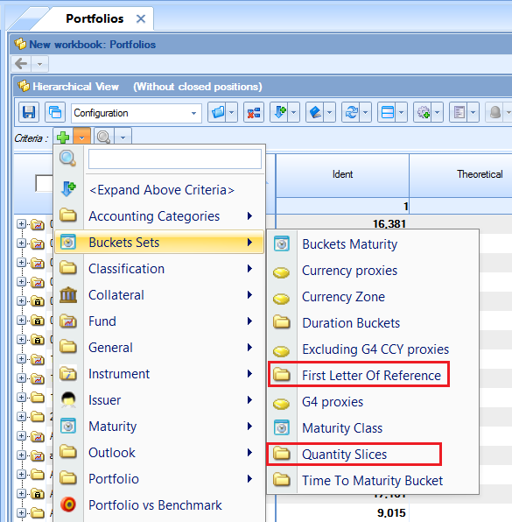

**When applied:**

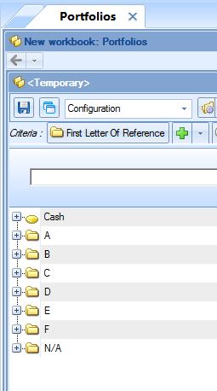 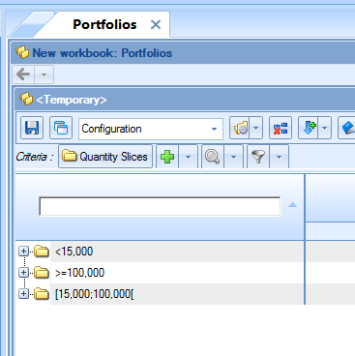

**They are defined in the menu Portfolio/Bucket Sets**

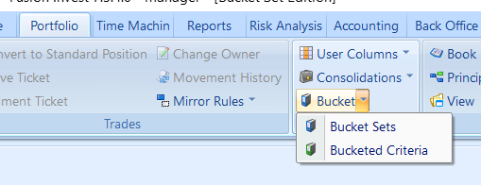

**Bucket Set “First Letter Of Reference” is defined as below:**

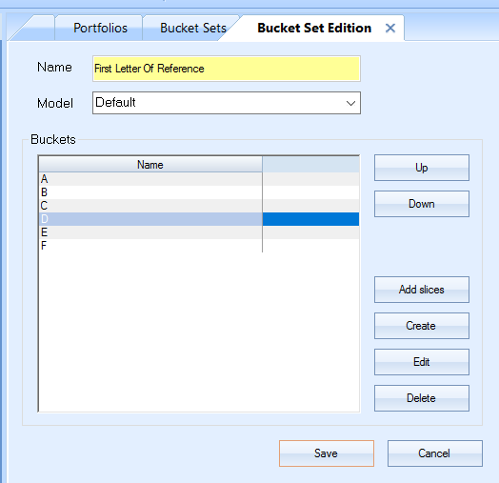

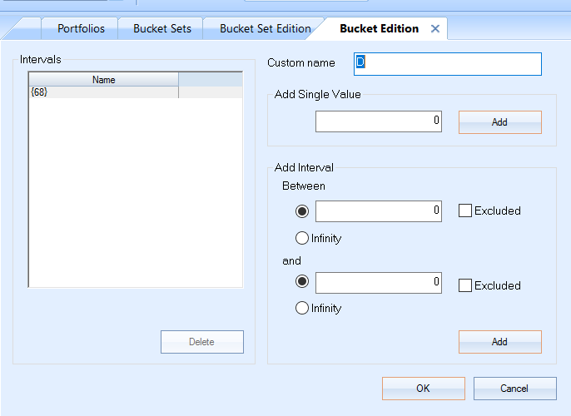

**Bucket Set “Quality Slices” is defined as below:**

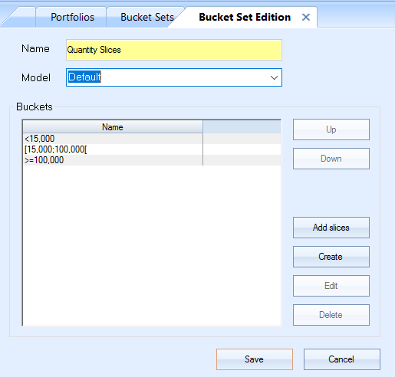

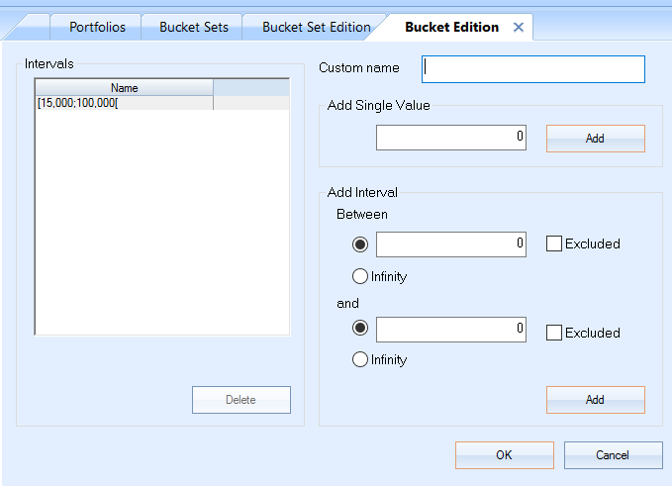

# CASE STUDY 4

# Create a new field “new quantity” in the Deal Input using the toolkit and use it while creating a new Deal: The field should receive the value of 1/quantity (e.g. if quantity is 100, the new quantity will be 0.01).  The new field should be stored on the database.  In case the field is modified, it should trigger the change of the quantity field and recalculate it accordingly;

## Implementation:

* FCIDealInput

To create a new column in Histomvts:

* Execute the store procedure: TK_ADD_HISTOMVTS_COLUMN

Links:

* <https://misyslive.force.com/SupportCommunity/apex/community_KnowledgeArticle?Id=kA020000000Prfi&articleType=Troubleshooting>
* <https://misyslive.force.com/SupportCommunity/apex/community_KnowledgeArticle?Id=kA020000000fxaU&articleType=Troubleshooting>

# CASE STUDY 5

Create a new deal action condition on the workflow of the BO using the toolkit:  
The deal action has to verify if the new quantity field created on the previous step is smaller than a threshold defined on a new Risk.config Custom Parameter entry called TKT_TRESHOLD

## Implementation:

* FCIKernelConditionNewQuantity

Note: the case study ask to write a TransactionAction with the same logic.

# CASE STUDY 6

Create a new portfolio column “Toolkit” in the position:  
As a pre-requisite it has to:  
1.    For interest rate swaps, retrieve the first cashflow from the interest rate leg and calculate the Present Value (PV) with the instrument currency color;  
2.    For the fixed bond and floating, retrieve the current rate value and multiply by the Notional with the instrument currency color;  
3.    For Shares, retrieve the instrument external reference “ISIN” (make sure it is setup properly in External and Universal Reference)  with a black color;  
4.    For all the other types of instruments, retrieve the Theoretical column value and display in the global currency from the users preference with the global currency color;

## Implementation:

* FCIColumnToolkit

