|  |
| --- |
| Beji, Hichem  October 16, 2017 |

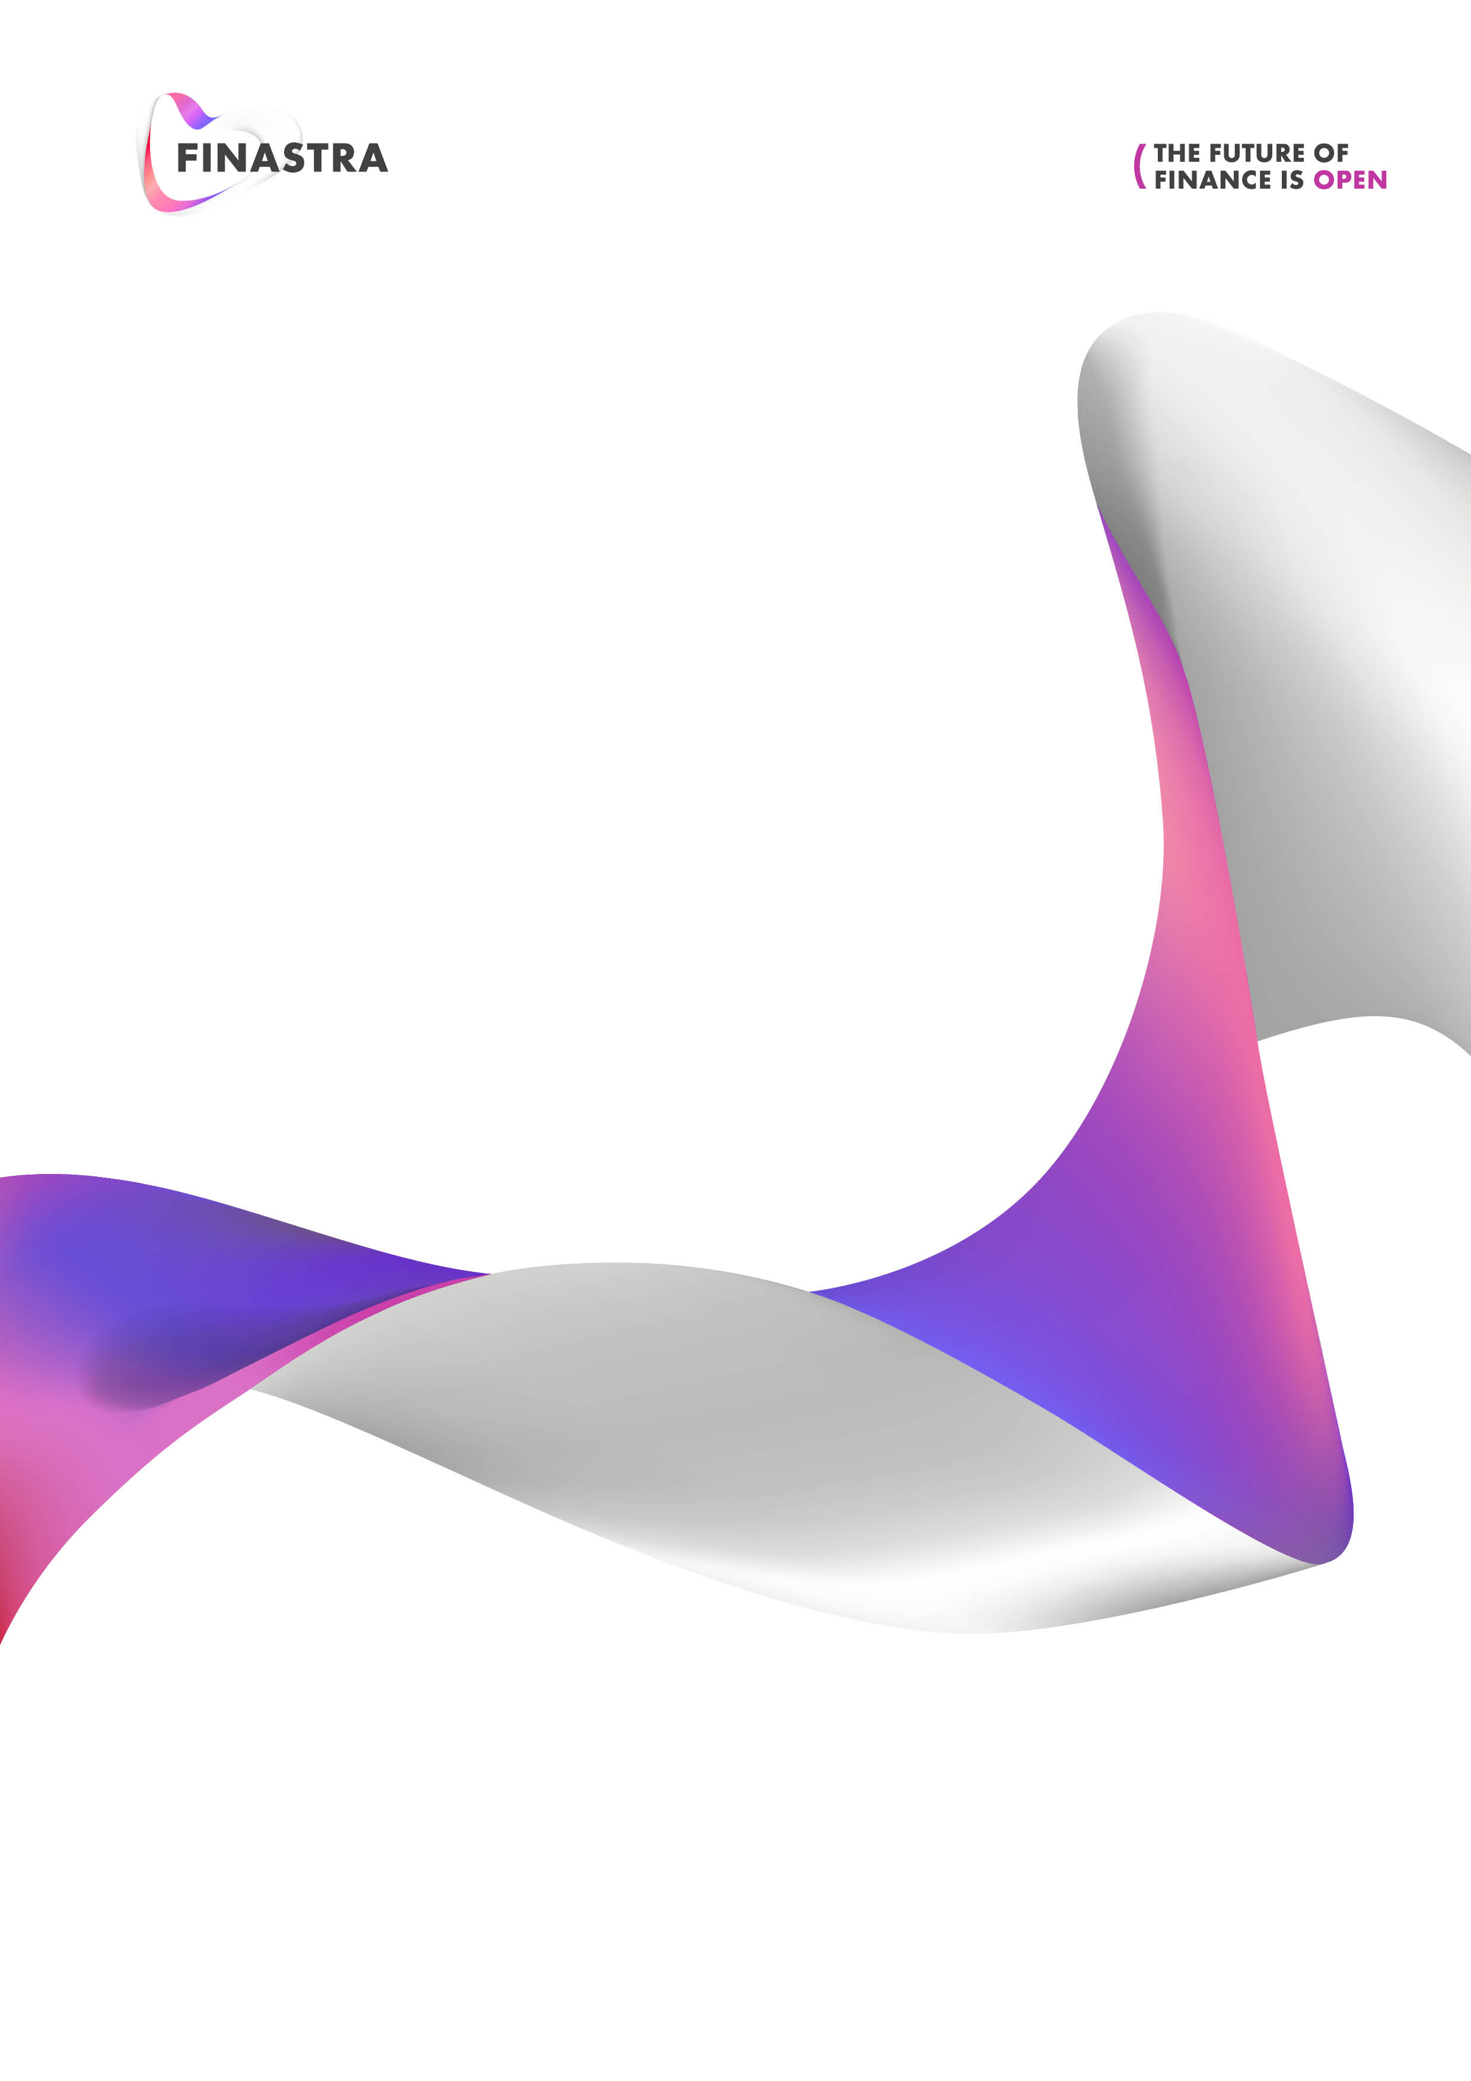

|  |
| --- |
| FusionInvest |
| Fully Executed Kernel Action |
| Toolkit Team |

CONTENTS

Purpose 3

Document Control 3

Fully Executed Kernel Action 3

BackOffice Setup modifications 3



Purpose

The purpose of this document is to specify the technical requirements for a development that allows to successfully activate ‘deal aggregation’ and ‘deal allocation’ in Sophis Fusion Invest.

Document Control

|  |  |  |  |
| --- | --- | --- | --- |
| Date | Version | Author | Comments |
| 09/10/2017 | 1.0 | Finastra | Document Creation |

Fully Executed Kernel Action

A toolkit development creates a new ‘Kernel Action’ named FullyExecutedAction.

This action is selected on the BackOffice transition Checked FO to Checked FO via MO Creation.

When the FullyExecutedAction is run, the code checks if the trade is fully executed or not.

To do so it uses the SQL request:

select islast from EXTERNAL_EXECUTIONS where pk_sophisexecid in (select SOPHISEXECID from EXTERNAL_EXECUTIONS_TO_TRADES where tradeid =  YourTradeId)

If the trade is fully executed, then a new workflow transition is run on the trade:

Checked FM to Checked FM via Fully Executed event (the name of the event is a configuration).

BackOffice Setup modifications

Configuration should include :

* One kernel action that generates our FullyExecutedAction

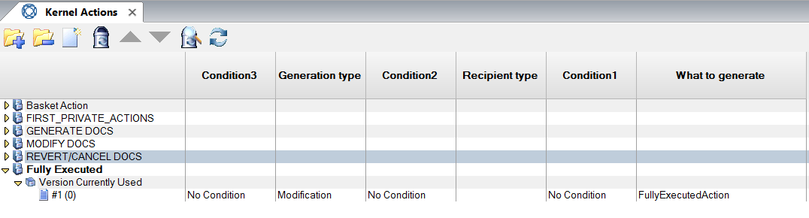

* Adding a Kernel Event (let’s say **Fully Executed Event**) that will be targeted by the Kernel Action.

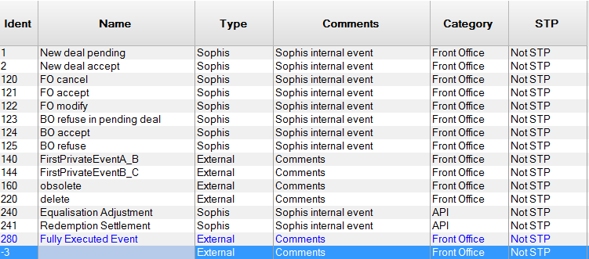

* Two workflow transitions in Back Office parameters :
  + First transition is the initial one (Checked FM to Checked FM via MO Creation in our example). Which target the Kernel action “Fully Executed”.
  + Second Transition which will be called via the toolkit and having **the Fully Executed Event** as the event name



* This Event “Fully Executed Event” in the example is configured via the config file :

<add Section="MEDIO_BACKOFFICE_DEALACTION" Entry="AfterFinalExecution_EventName" Value="FullyExecuted " />



|  |  |
| --- | --- |
| **About Finastra** Finastra unlocks the potential of people and businesses in finance, creating a platform for open innovation. Formed in 2017 by the combination of Misys and D+H, we provide the broadest portfolio of financial services software in the world today –spanning retail banking, transaction banking, lending, and treasury and capital markets. Our solutions enable customers to deploy mission critical technology on premises or in the cloud. Our scale and geographical reach means that we can serve customers effectively, regardless of their size or geographic location – from global financial institutions, to community banks and credit unions. Through our open, secure and reliable solutions, customers are empowered to accelerate growth, optimize cost, mitigate risk and continually evolve to meet the changing needs of their customers. 48 of the world’s top 50 banks use Finastra technology. Please visit [**finastra.com**](http://www.finastra.com)  Finastra and the Finastra ‘ribbon’ mark are trademarks of the Finastra group companies.  © 2017 Finastra. All rights reserved. | **Corporate Headquarters** One Kingdom Street Paddington London W2 6BL United Kingdom  T +44 20 3320 5000 |