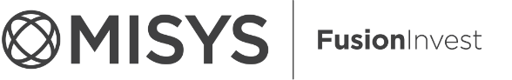

|  |
| --- |
| FusionInvest 7.1.3 |
| Matching Workflow Selector Toolkit Condition |
| As prepared for Mediolanum |

|  |
| --- |
| Mac Aodha, Sean  [Date] |



Contents

Document Control 2

Purpose 2

Version 2

Business Requirement 3

Current Workflow Selector 3

Counterparty Profiles 3

Implementation Requirement 4

Toolkit Parameters 4

Logic Mapping 4

Omgeo Condition 4

MarkitTM Condition 4

**© Misys Limited   
All rights reserved**

**Registered in   
England & Wales**

No. 01360027

**Registered Office:**One Kingdom Street Paddington   
London W2 6BL  
United Kingdom

Document Control

Purpose

The purpose of this document is to outline the requirement and implementation of a Back Office Workflow Selector condition toolkit to facilitate the routing of trades to the correct workflow for trade matching.

Version

|  |  |  |  |
| --- | --- | --- | --- |
| Version | Date | Author | Comment |
| 1.0 | July 2016 | Seán Mac AODHA | Initial Version |

Business Requirement

Mediolanum uses three Trade Matching processes for Off-Market trades:- Two electronic platforms Omgeo and MarkitTM for capable counterparties and manual matching for all other counterparties.

A requirement for a simple workflow selector condition has become apparent as the profile of counterparty support across the three methods is becoming complex. Maintaining standard workflow selector lines for each counterparty profile would be problematic to support.

Current Workflow Selector

The current workflow selector routes all Off-Market trades to an Electronic platform based on the allotment group.

Off-Market trades are defined as trades where the counterparty is known and defined. Otherwise matching is done on Exchange.

Trades on Listed Products (Equity, Fixed Income, ETF etc.) are routed to the Omgeo Workflow. Trades on supported OTC Products are routed to the MarkitTM workflow.

Trades on instruments not supported, either by the electronic platform or the counterparty profile, are to be routed to a Paper Confirmation workflow for Manual Matching

Counterparty Profiles

Counterparty profiles are to be built mapping counterparty acceptance of electronic matching per allotment configured on the system.

Currently there are a number of exceptions to the generalisation that counterparties would accept all available instruments on the relevant electronic platform.

**Example**

*SOCIETE GENERAL*

Contractually approved trading Equities and Fixed Income.

Only accepts Shares and Convertible Bonds on Omgeo.

Everything else (Corporate Bonds, Government Bonds, ETF etc.) must be Paper matched.

Implementation Requirement

It is proposed to use a BO Kernel Workflow Selector condition to help route trades to the correct workflow. It would be required to develop conditionals for each non-paper workflow. Where the trade fails the condition, it should drop into the Paper workflow.

The configuration for mapping the counterparty to the electronic platform can be done using the Agreement Tab on the third party definition.

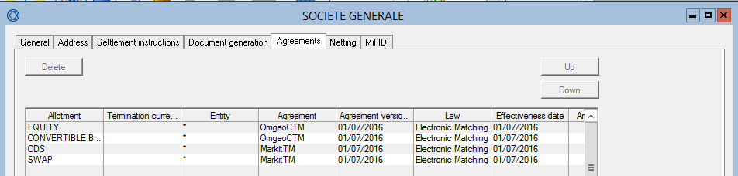

Toolkit Parameters

As the toolkit is on the BO Trade Kernel, it should be supplied the Transaction object entering the workflow selector.

The relevant fields for the Toolkit are

* Trade Instrument Allotment
* Counterparty

Logic Mapping

Taking the input parameters of Allotment and Counterparty the condition can return a true/false value should an SQL query on the Counterparty’s Agreement setup return a result set.

Omgeo Condition

Where the trade is an Equity Share trade against Societe General as Counterparty

Allotment = 1; Code = 10005129

SELECT count(*) FROM tiersagreement WHERE agreement = 'OmgeoCTM' AND code = 10005129 AND allotment = 1

Returns 1, Therefore condition returns **true**

**[TODO]** The allotment criteria should also take into account that the configuration could specify an allotment group. Mapping this correctly should be considered

MarkitTM Condition

Where the trade is a Credit Default Swap trade against Societe General as Counterparty

Allotment = 28; Code = 10005129

SELECT count(*) FROM tiersagreement WHERE agreement = 'MarkitTM' AND code = 10005129 AND allotment = 1

Returns 1, Therefore condition returns **true**

**[TODO]** The allotment criteria should also take into account that the configuration could specify an allotment group. Mapping this correctly should be considered 