

|  |
| --- |
| Misys |
| Compliance - Counterparty Sector grouping |
| FusionInvest Toolkit |

|  |
| --- |
| Su, Yuanjia |



Contents

Purpose 2

Business requirement 3

1.1 Sector credit 3

1.2 Counterparty rating 3

2.1 Counterparty user property set up 3

2.2 Toolkit criteria 3

**© Misys Limited   
All rights reserved**

**Registered in   
England & Wales**

No. 01360027

**Registered Office:**One Kingdom Street Paddington   
London W2 6BL  
United Kingdom

Document Control

Purpose

This document defines the client requirements in which additional filtering on counterparties are needed for pre-trade compliance checks.

|  |  |  |  |  |
| --- | --- | --- | --- | --- |
| ACTION | VERSION | NAME | DATE | COMMENTS |
| Creation | 0.01 | Yuanjia Su | 12-DEC-2016 | Beta version, internal distribution |

1. Functional details

Business requirement

Mediolanum would like to add additional user properties on counterparties, and this will allow toolkit criteria to pick up the user defined values and group trades accordingly. Eventually this development will give accessibility of these criteria to the compliance checks.

1.1 Sector credit

(TBC) Basically, a flag (Yes/No) is introduced to segregate credit institutions from other types of counterparties

1.2 Counterparty rating

Possible values are A++, A+, etc.

2 Technical details

2.1 Counterparty user property set up

In the *Set up Back Office/General/Back Office Parameter* tab, add two names, namely: MEDIO_Credit, and MEDIO_Rating:

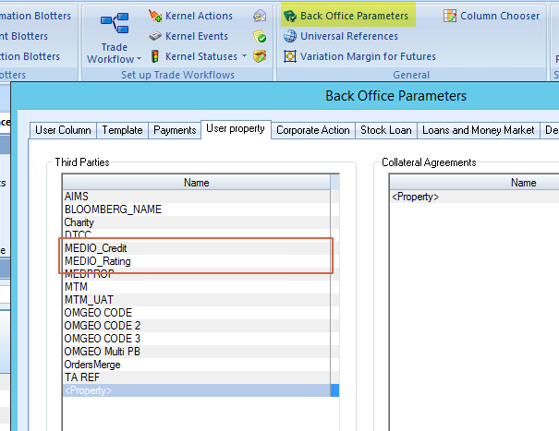

Add/modify the values in the counterparty dialog:

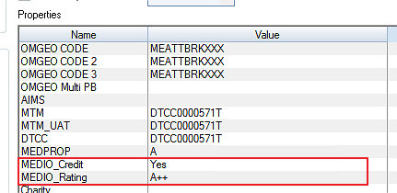

2.2 Toolkit criteria

Two criteria (Medio Thirdparty Rating/Credit) can be found in the extraction criterion list as well as in the compliance rules dialog:

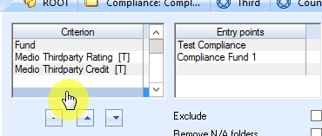

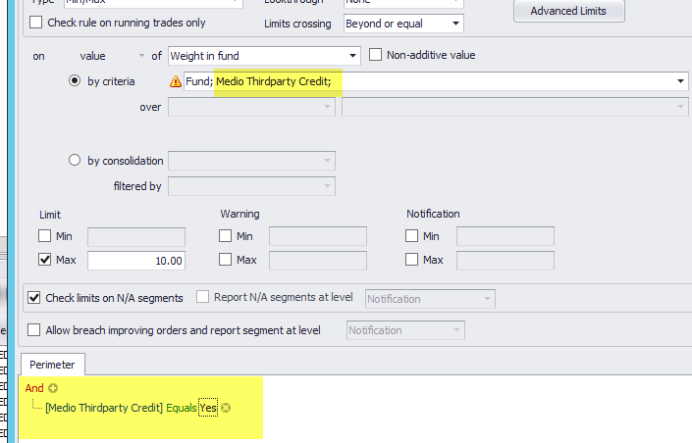

Take an example of the rating criteria, the group-by structure are populated identically in FusionInvest client vs in compliance GUI:

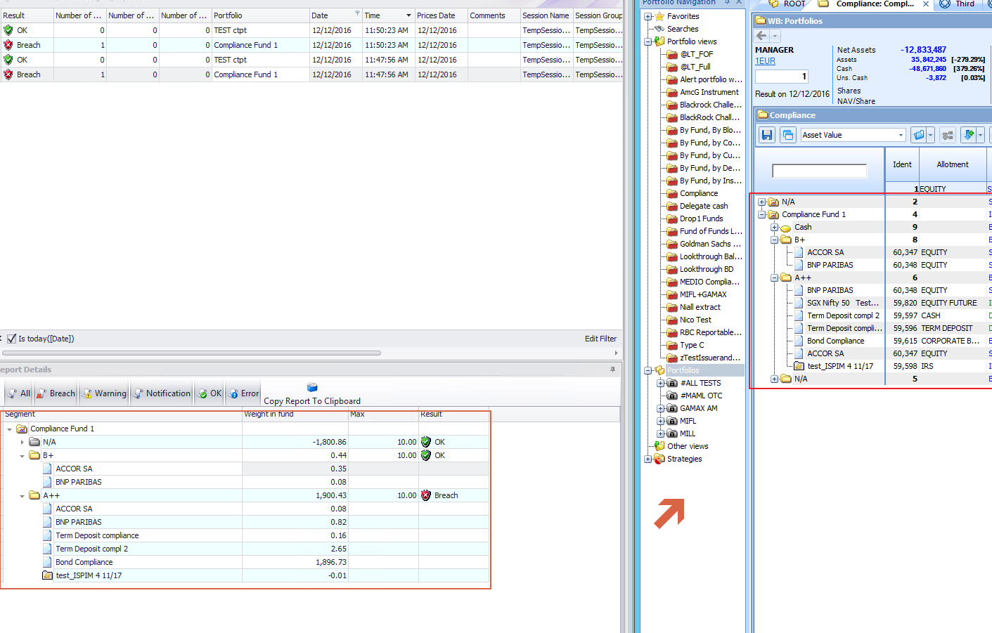

Furthermore, user will be able to put restrictions on the rules by certain conditions (Rating equals to A+ for instance).

Sign-off

|  |  |  |  |
| --- | --- | --- | --- |
| *Date* |  | *Date* |  |
| *Authorized Mediolanum Signature(s)* |  | *Authorized MISYS Signature(s)* |  |

