

|  |
| --- |
| FusionCapital |
| Mediolanum  New Weight for DOB |
|  |

|  |
| --- |
| Misys  2 Jun 2015 |



# Table of Contents

**© Misys Limited**

All rights reserved

Registered in England & Wales

No. 01360027

Registered Office:

One Kingdom Street Paddington

London W2 6BL

United Kingdom

Table of Contents 1

1 Purpose 2

2 The standard DOB weight 3

3 New weight for Index Futures and Spot 4

3.1 Index Futures 4

3.2 FX Spot and Forwards 5

# Purpose

The purpose of this document is to describe development done to satisfy the need of Mediolanum to raise order on Index Futures and FX Spot/Forwards.

# The standard DOB weight

In standard Sophis, the “weight” used by the Dynamic Order Builder depends on Dynamic Order Builder functionality, by default at Mediolanum we use:

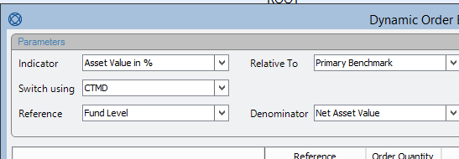

Sophis will therefore use the column “Asset Value”

So the “Initial Exposure in%” is the same as the weight in fund, and the “Initial Exposure” is the same as Asset Value:

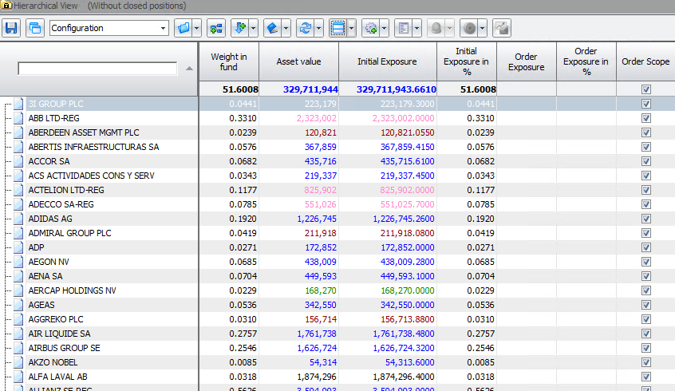

The issue is that Index Futures have an Asset value very close (or Equal) to zero. Indeed every day you can either make or lose money on the future.

Same thing with FX, the Asset value in Sophis is in the cash lines so a FX spot has no Asset value, therefor no weight.

# New weight for Index Futures and Spot

We developed a new toolkit indicator to be selected as part of the dynamic order builder;

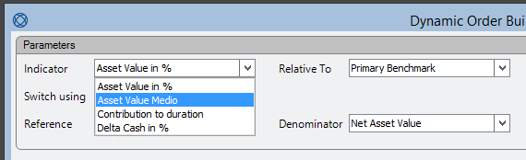

It only impacts the numerator for the definition of the weight.

## Index Futures

For Index Futures, the Exposure is set to:

Future Price * Contract Size * Number of Contracts

It is expressed in Future currency, then converted to Fund currency to compute the weight in %.

The initial Exposure 5 should be in line with the user column “Medio Weight in Fund”

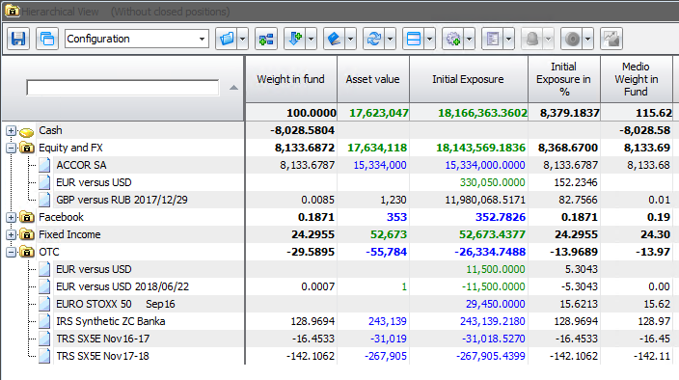

In term of how the order columns relates to each other:

For an order with Quantity = 1 you have

Order Exposure = Future Last Price * Contract Size

Order Exposure in % =

100 * Future Last Price * Contract Size * FX[Future CCY, Fund CCY] / (FUND NAV)

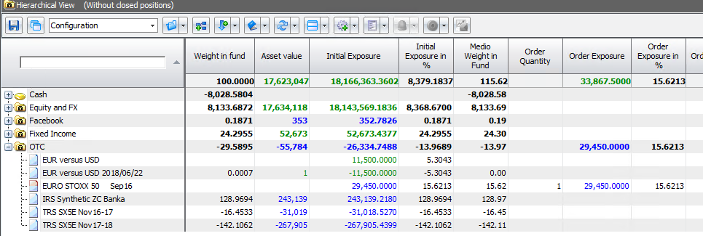

## FX Spot and Forwards

Here, the Exposure is the Nominal of the first currency, expressed in the second currency (using current spot rate)

So for an Order with quantity 1, it means you want to buy 1 CCY1

The Order Exposure will be the Equivalent in CCY2

The Order Exosure in % will be this amount, expressed in fund currency, then in % of the NAV.

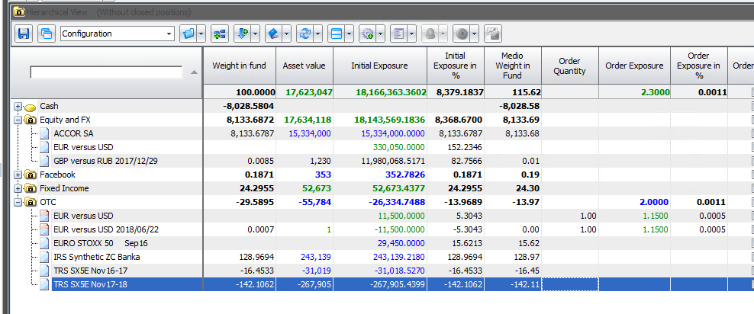

Reporting Source

For Other Asset classes we keep the same behavior as described in Chapter 2, ie we base the Exposure on the column “Asset Value” and the weight on the column “Weight in Fund”

