**Food Order Android Mobile Application**

1. **Member**
2. [**QuynhNVHE130061@fpt.edu.vn**](mailto:QuynhNVHE130061@fpt.edu.vn)
3. **N**[**amHVHE130474@fpt.edu.vn**](mailto:namhvhe130474@fpt.edu.vn)
4. **T**[**hanhNDTHE130488@fpt.edu.vn**](mailto:thanhndthe130488@fpt.edu.vn)
5. **TuanNMHE130452@fpt.edu.vn**
6. **Requirements**

**Introduction:** App is used to help the customers to order the foods online.

1. **UseCase**

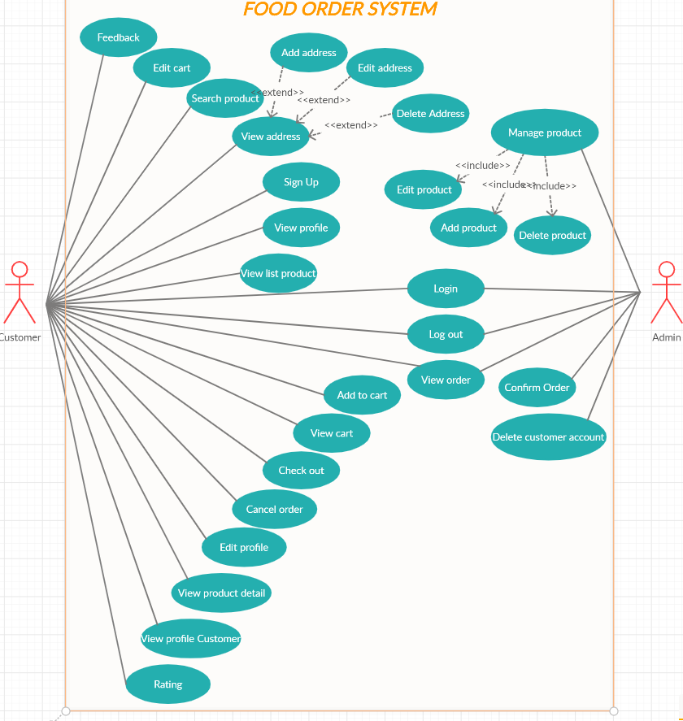

1. **Database**

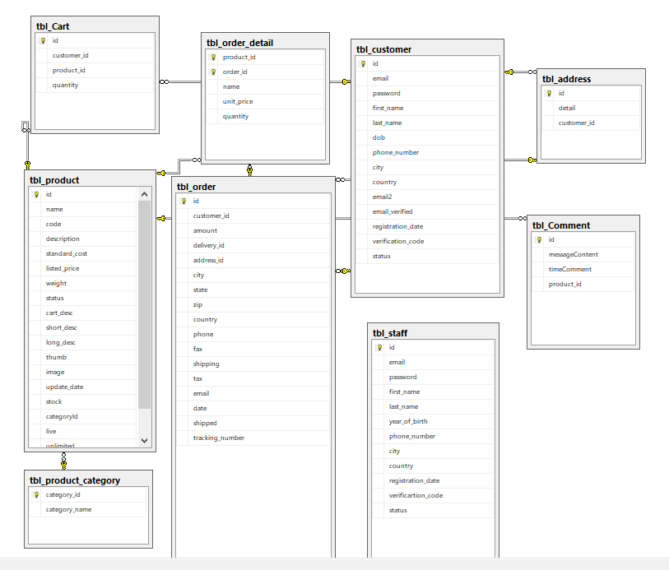

**3. Function**

|  |  |  |  |
| --- | --- | --- | --- |
| **ID** | **Actor** | **Name** | **Description** |
| UC-1 | Admin,Customer | Login | User(Include seller and buyer) enter username and password to login the system |
| UC-2 | Admin,Customer | Logout | User(include seller and buyer) logout of system |
| UC-3 | Customer | Sign up | Allow new user use app to register account to have ability to buy item |
| UC-4 | Customer | View profile | Allow buyer to view their profile |
| UC-5 | Customer | Edit Profile | User can modify their profile |
| UC-6 | Customer | View list product | Allow user who have owned or haven’t account to view the product of shop |
| UC-7 | Customer | Add to cart | App’s user can add the product to cart |
| UC-8 | Customer | View cart | App’s user can view the product of the cart |
| UC-9 | Customer | Edit cart | Buyer can modify amount of product |
| UC-10 | Customer | Search product(filter) | Allow user to search the product followed by the attribute |
| UC-11 | Customer | Check out | After the dish is chose, buyer will pay to order successful |
| UC-12 | Customer | View product detail | User chooses 1 product to view the detail of that product |
| UC-13 | Customer | Cancel order | User can cancel order which is not delivered |
| UC-14 | Admin | Edit product | Admin can modify the information of product which is selling insystem |
| UC-15 | Admin | Add product | Admin adds the wanted product insystem |
| UC-16 | Admin | Delete product | Admin deletes product in system |
| UC-17 | Admin | Confirm order | Admin confirms order of buyer |
| UC-18 | Admin, Customer | View order | Admin can view the order which is ordered by buyer |
| UC-19 | Admin | View profile customer | Admin can view the accounts of buyers |
| UC-20 | Admin | Delete customer account | Admin can delete the account of buyer |
| UC-21 | Customer | Feedback | User comments to evaluate the product |
| UC-22 | Customer | Rating | User evaluates the product through to choose the stars. |
| UC-23 | Customer | Edit address | User modifies address |
| UC-24 | Customer | Add address | User adds more address |
| UC-25 | Customer | Delete address | User deletes address |
| UC-26 | Customer | View address | User views the entered addresses |
| UC-27 | Admin | Manage product | Admin manage function(add,edit,delete) |

1. **Mockup Screen**

UC-1: Login

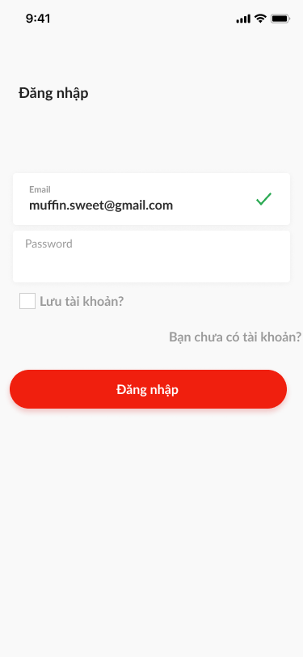

UC-2: Logout

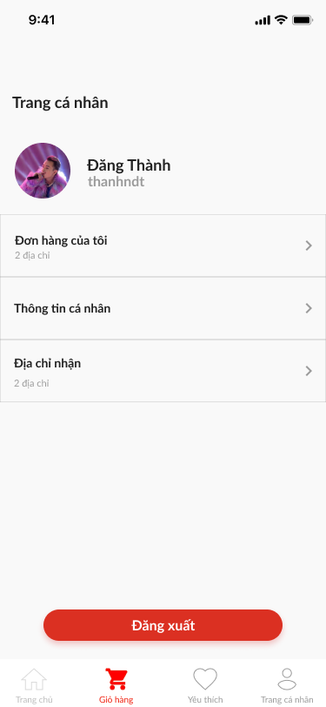

UC-3: Sign up

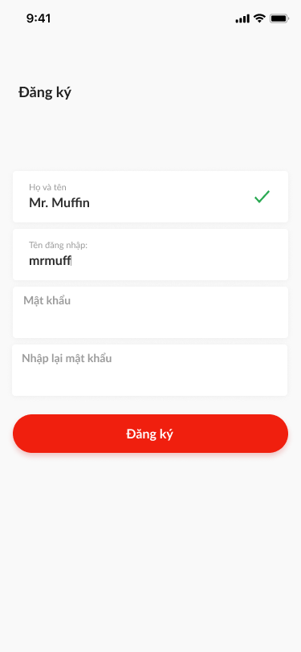

UC-4: View profile

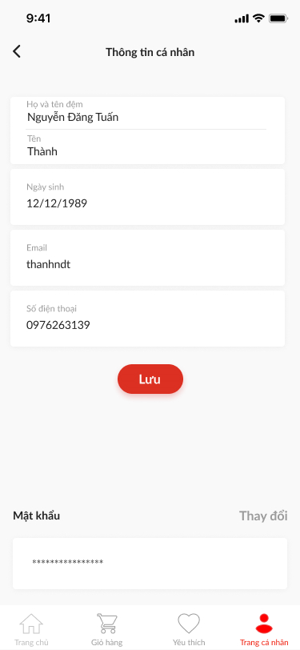

UC-5: Edit profile



UC-6: View list product

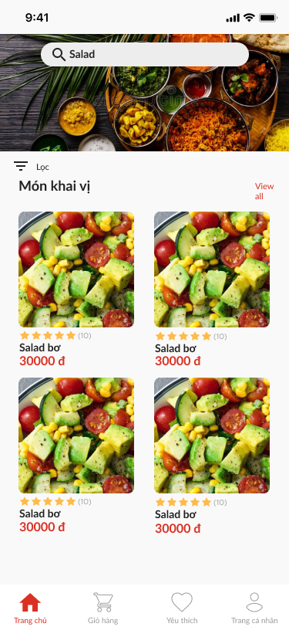

UC-7: Add to cart

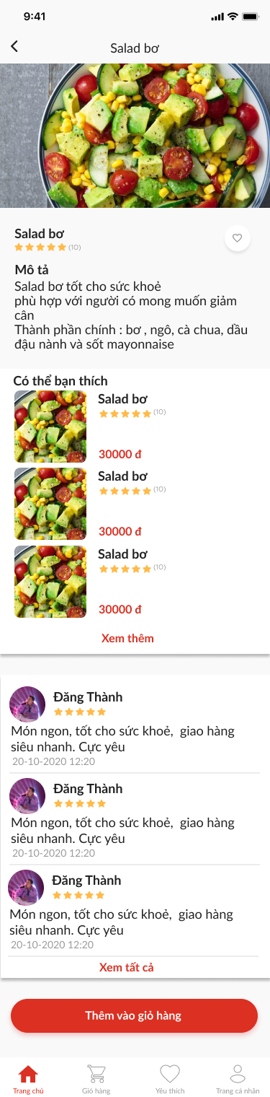

UC-8: View cart

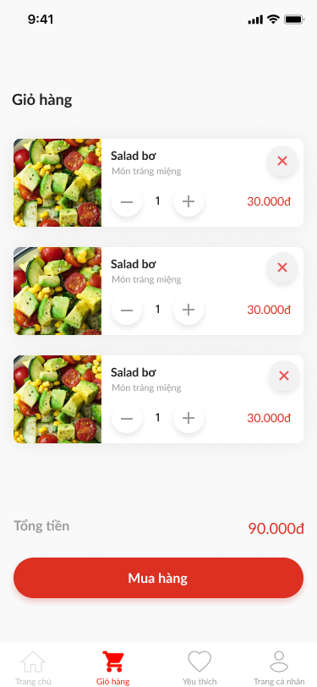

UC-9: Edit cart



UC-10: Search product ( filter )

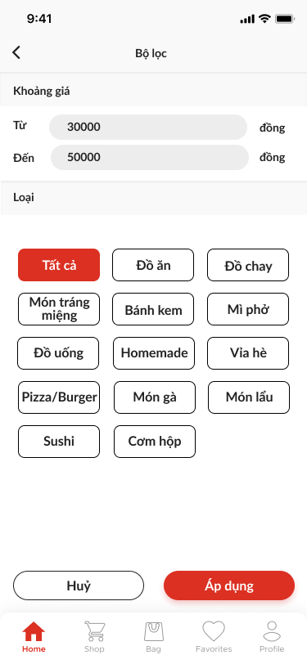

UC-11: Check out

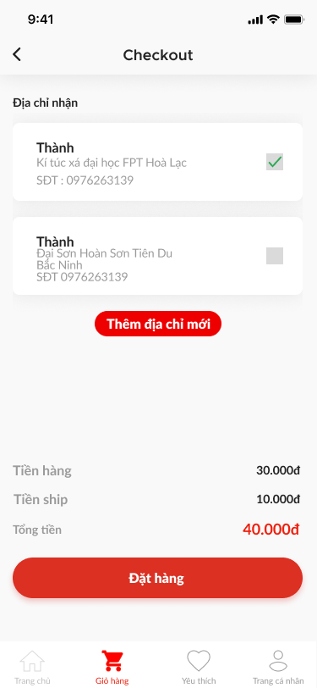

UC-12: View product detail



UC-13: Cancel order

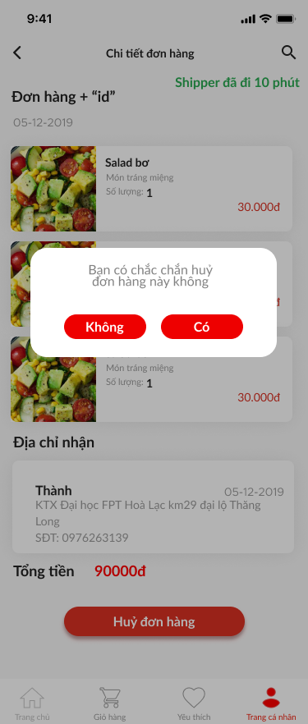;

UC-14: Edit product

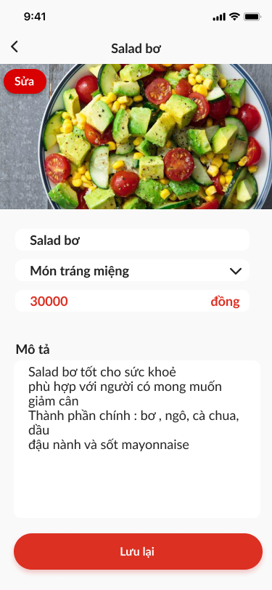

UC-15: Add product

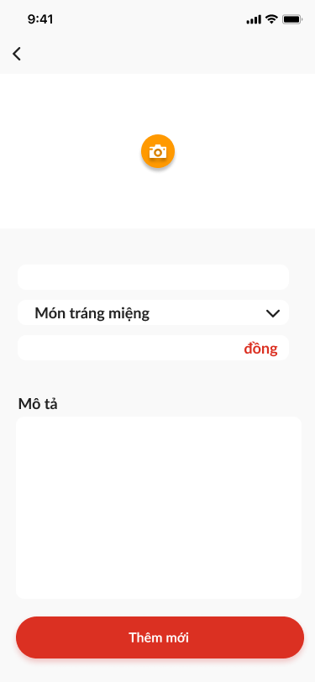

UC-16: Delete product

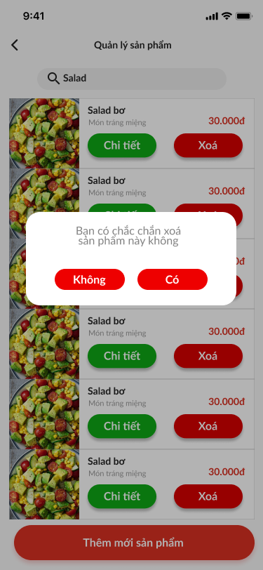

UC-17: Confirm order

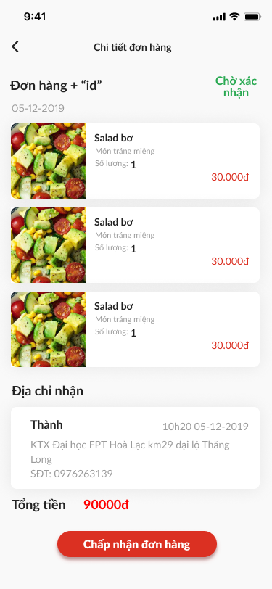

UC-18: View order

* Người mua

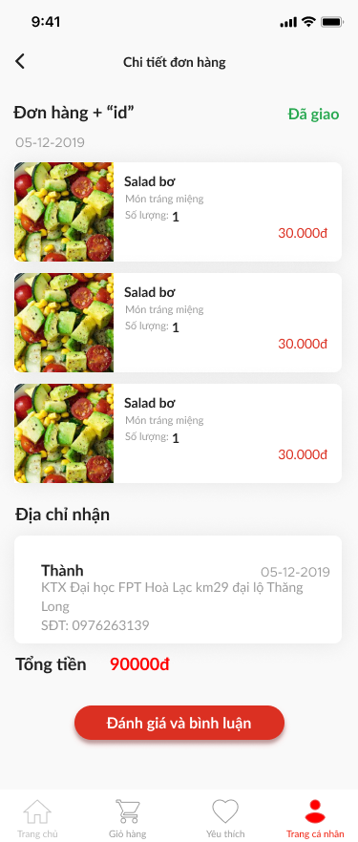

* Admin

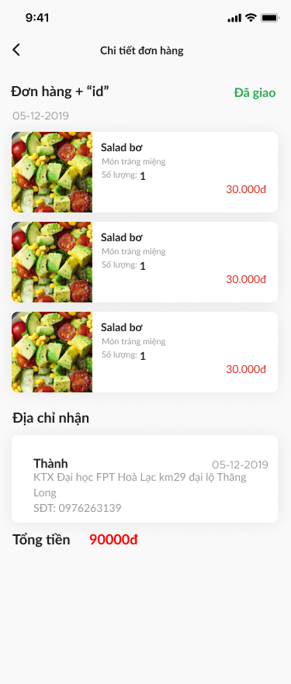

UC-19: View profile customer

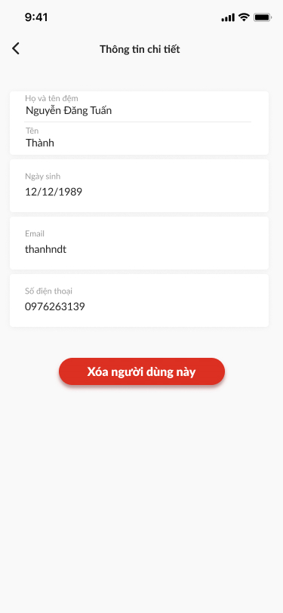

UC-20: Delete customer account

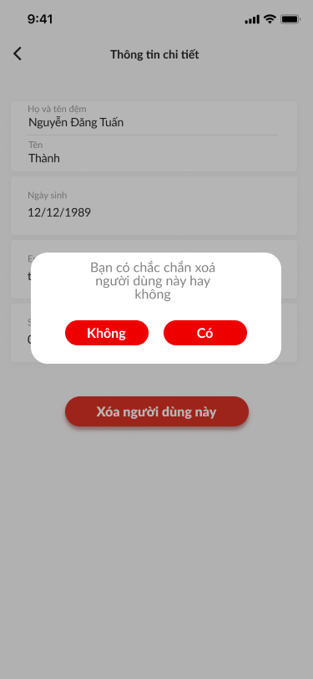

UC-21: Feedback

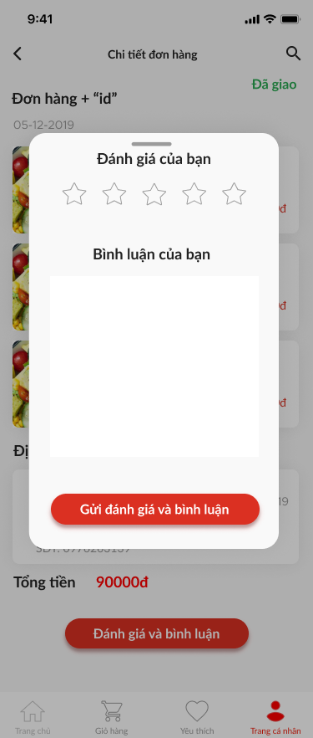

UC-22: Rating



UC-23: Edit address

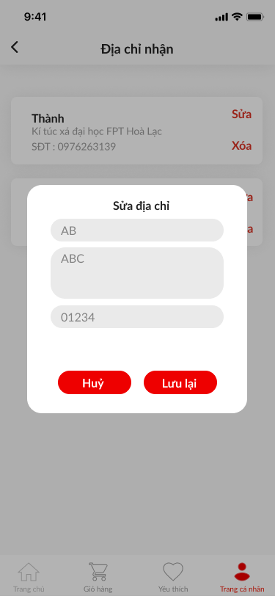

UC-24: Add address

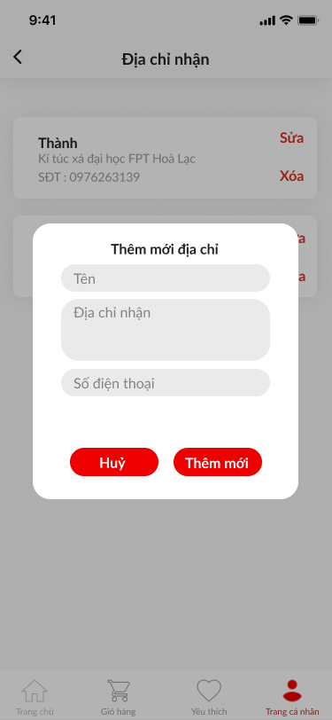

UC-25: Delete address

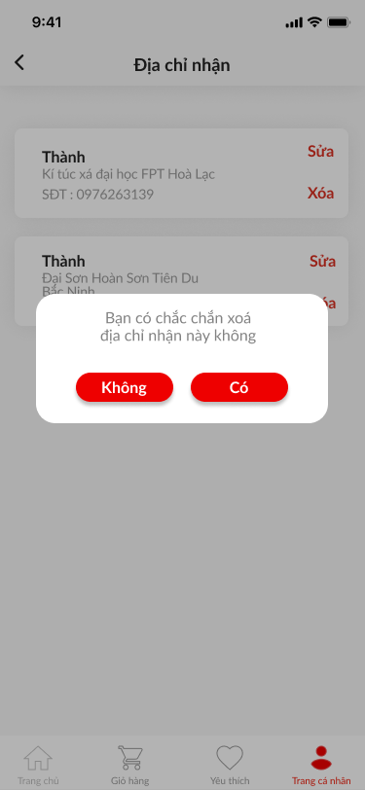

UC-26: View address

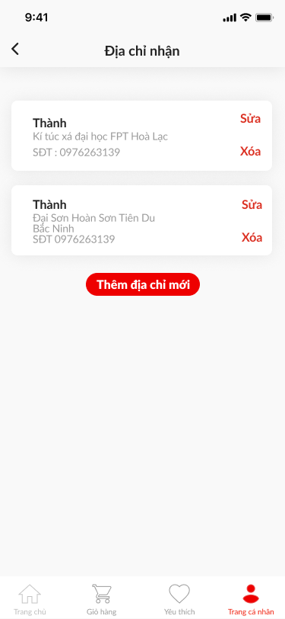

UC-27: Manage product

