**ASSIGNMENT – 3**

**Group 43:**

**Lalitha Devi Pulagam 105159977**

**Nikhitha Inturi 110008508**

**Quoc Dat Lam 105190512**

**SCREENSHOTS**

* A new Application “myapp” under the Project “mysiteS20” is shown along with settings.py and urls.py

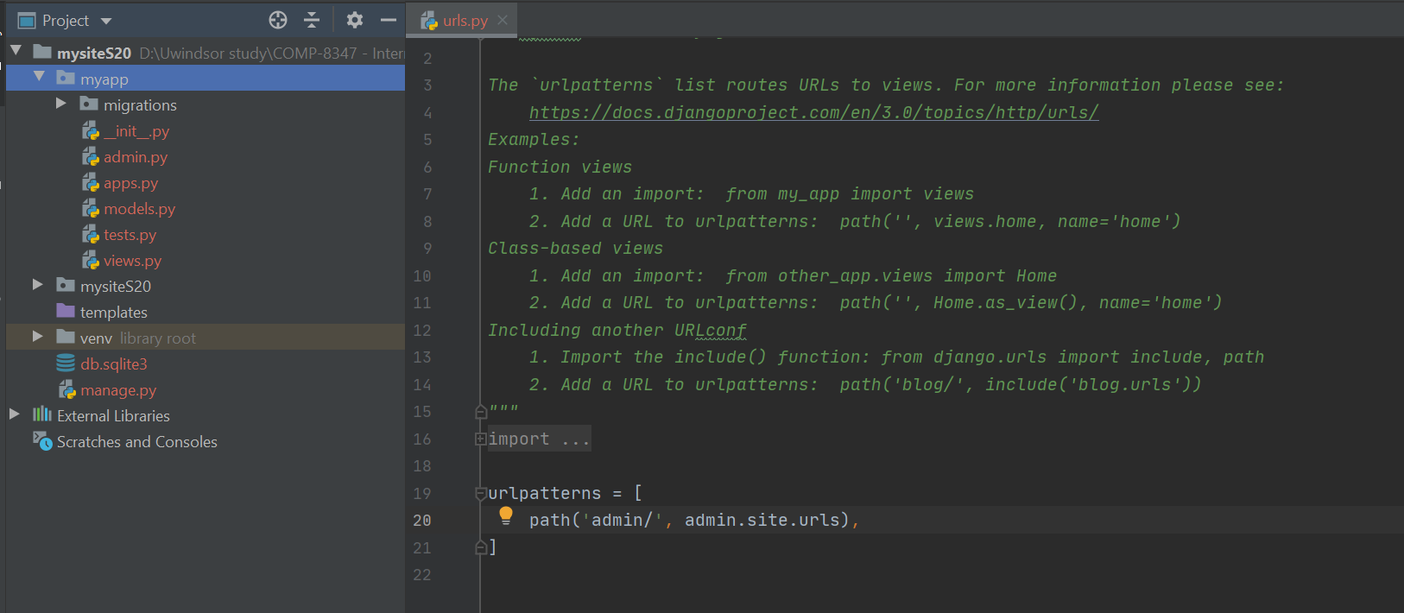

* Migrate creates necessary db tables for each app listed under INSTALLED_APPS

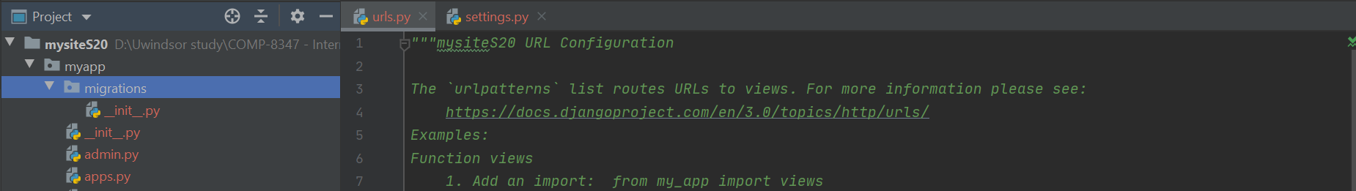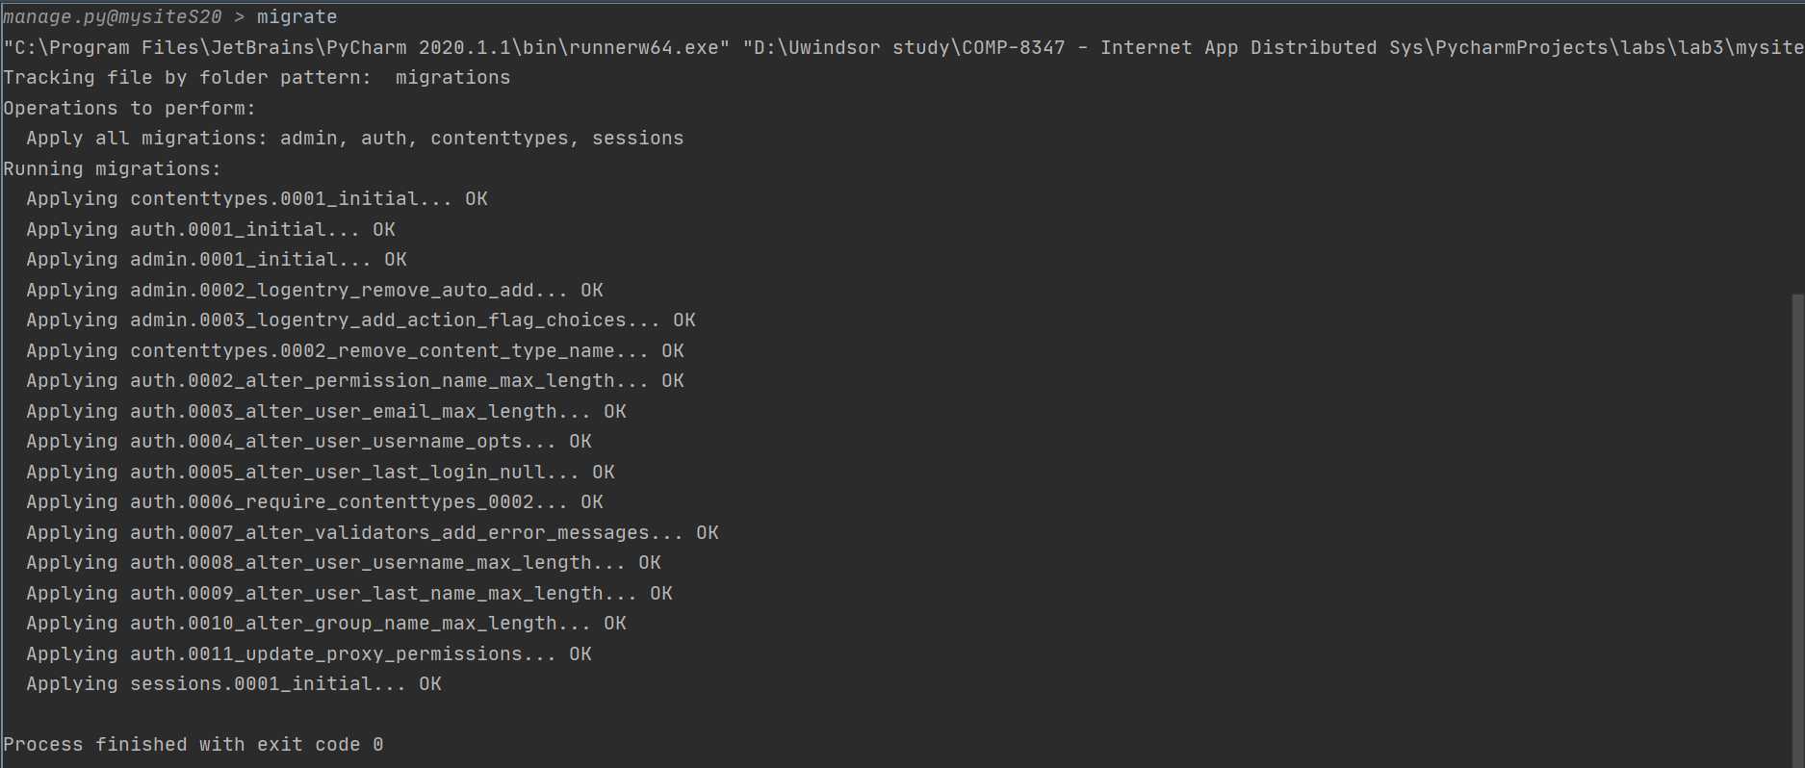

* A successful run on the project with admin login redirects to the following Django site admin interface

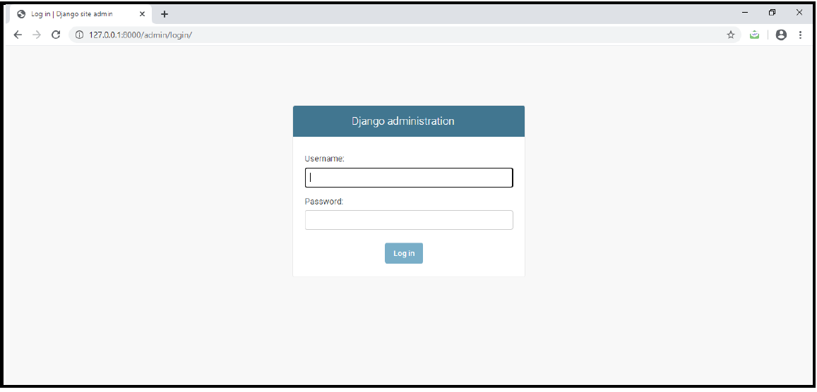

* The Django admin page after login

