**LAB-4**

**Group 43:**

**Lalitha Devi Pulagam 105159977**

**Nikhitha Inturi 110008508**

**Quoc Dat Lam 105190512**

**Part 2.**

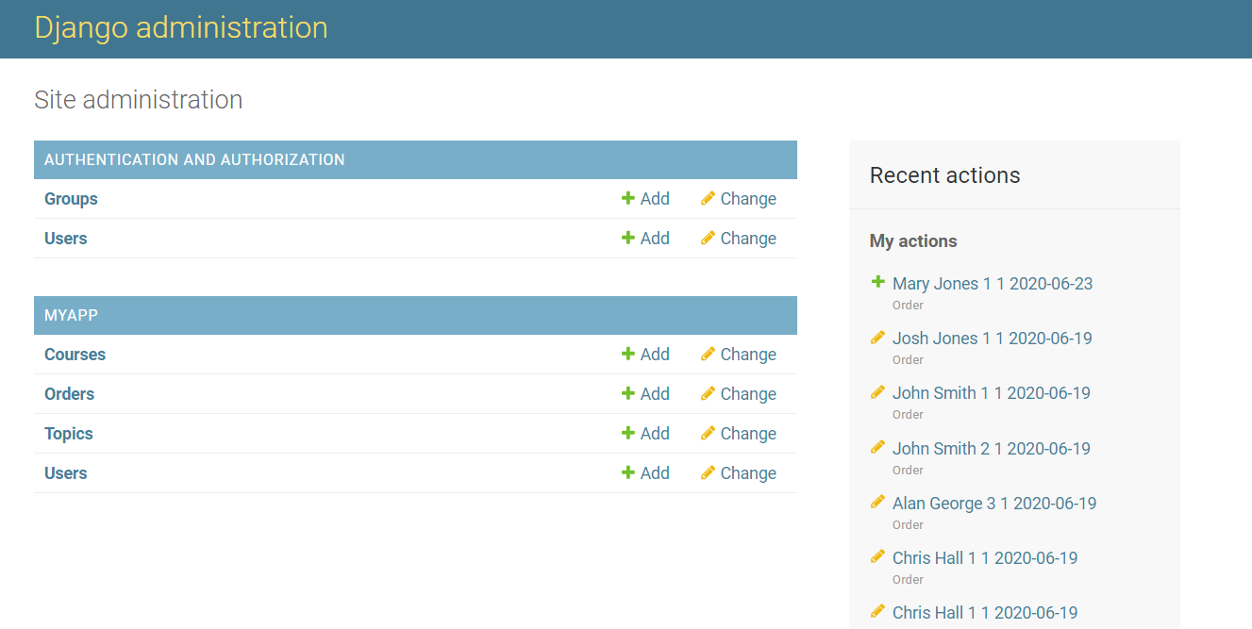

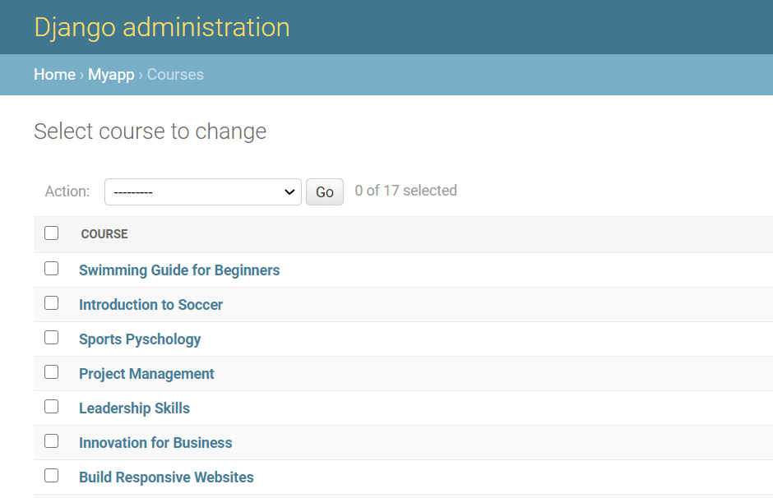

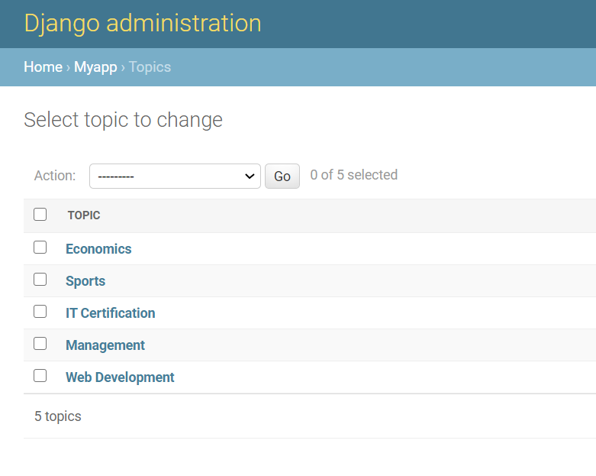

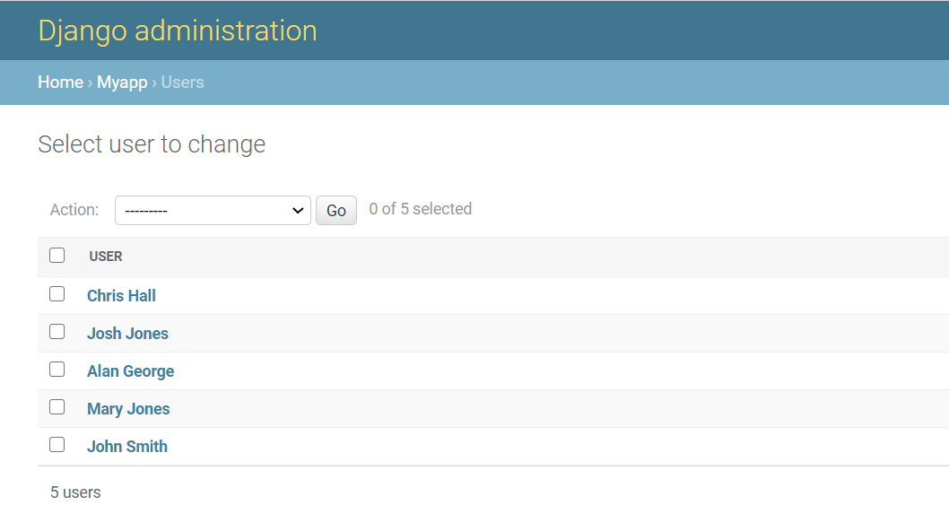

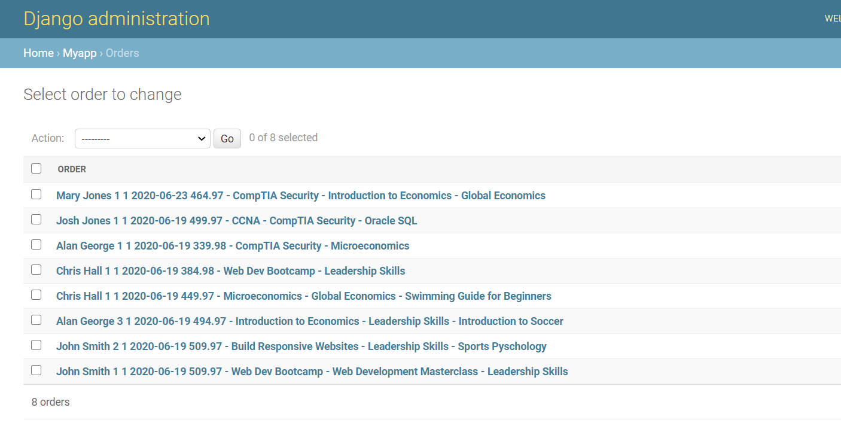

Displayed values returned from the **__str__** functions. It’s always useful to add more information for displaying purpose

**Part 3.**

**a. List all the courses in the db.**

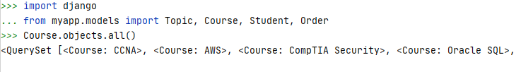

**b. List all the students in the db.**

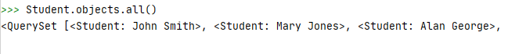

**c. List all the orders in the db.**



**2.**

**a. List all students whose last name is ‘Jones’**



**b. List all courses that for Topic ‘Management’**

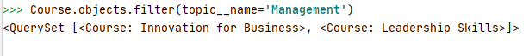

**c. List all students that live on ‘Sunset Avenue’.**

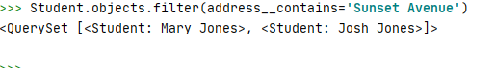

**d. List all students that live on an ‘Avenue’ and live in ‘Windsor’ city.**

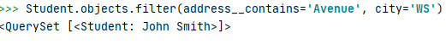

**e. List all the students that are interested in Topic 'Health & Fitness'**



**f. List the courses that cost more than $150.00**



**g. List the students that do NOT live in Windsor.**



**h. List the Orders placed by a student whose first_name is ‘Chris’.**



**i. List the courses that are currently NOT for_everyone.**



**j. Get the first name of the student of the Order with pk=1.**

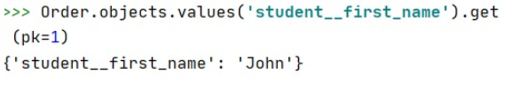

**k. List all topics that the student with username ‘john’ is interested_in.**



**l. List all the courses with a price < $150 and is for_everyone.**



**m. List the categories that the students who ordered a Web Dev Bootcamp is interested_in.**



**n. List the category of the topic that ‘alan’ is interested in. (You may assume that ‘alan’ is interested in exactly one topic.)**