Equity Research · Vietnam · IT
FPT Corporation (HOSE: FPT)
2Q26 review: growth held, and the AI line started paying
5 August 2026 · Quan Ton, quan.td@miraeasset.com.vn
Rating | Target price | Current price (04/08/26) | Expected return | Market cap
BUY (Update) | VND87,950 | VND71,700 | +22.7% | VND122,141bn

1H26 revenue rose 12.6% and PBT 18.1% on FPT’s own restated base, lifting the group PBT margin to 21.8% from 20.7%. We keep our FY26F NPATMI at VND10,944bn (+15.6% YoY) and our DCF target price at VND87,950 (BUY, 23% upside). The quarter’s most useful datapoint is not the headline: AI and data analytics revenue grew 55% to VND1,842bn and both AI Factories turned profitable, which is the first hard evidence that AI is adding to FPT’s revenue faster than it is compressing the headcount-based pricing it threatens.
2Q26 and 1H26 earnings overview
All comparatives here are FPT’s restated 1H25 figures. FPT Telecom moved to the equity method from FY26, so the previously published 1H25 revenue of VND32,683bn and PBT of VND6,166bn are not comparable with the 1H26 print; the restated base is VND23,326bn and VND4,838bn.
Table 1. 1H26 P&L (VNDbn) | 1H26 | 1H25R | YoY | 2Q26 | 1Q26 | QoQ
Net revenue | 26,269 | 23,326 | +12.6% | 13,789 | 12,480 | +10.5%
Profit before tax | 5,714 | 4,838 | +18.1% | 2,910 | 2,804 | +3.8%
PBT margin | 21.8% | 20.7% | +1.0%p | 21.1% | 22.5% | -1.4%p
NPATMI | 5,055 | n.a. | n.a. | 2,568 | 2,487 | +3.3%
o/w Technology revenue | 23,138 | 20,126 | +15.0%
o/w Technology PBT | 3,314 | 2,835 | +16.9%
o/w Education, investment & others revenue | 3,131 | 3,198 | -2.1%
o/w Education, investment & others PBT | 2,400 | 2,003 | +19.8%
Associate income | 1,423 | 1,011 | +40.8%
Note: 1H25R is FPT’s restated comparative. 1Q26 revenue and PBT are derived as 1H26 less the 2Q26 print. FPT restated 1H25 revenue, PBT and PAT but we have no restated 1H25 NPATMI, so no YoY is shown on that line; the 2Q26 print alone was +14% YoY. Source: FPT, Mirae Asset Vietnam Research
Revenue growth was carried by the technology segment. Technology revenue reached VND23,138bn (+15.0% YoY), 88% of the group, on PBT of VND3,314bn (+16.9%). Within it, Global IT grew 13.4% to VND18,902bn and Domestic IT 22.5% to VND4,236bn — the fastest-growing line in the group, on national digital-transformation awards. Domestic IT’s PBT doubled to VND308bn, though its 7.3% margin still dilutes the segment blend. Education, investment and others fell 2.1% to VND3,131bn but lifted PBT 19.8% to VND2,400bn, contributing 42% of group PBT on a margin near 77%.
Figure 1. 1H26 revenue by segment  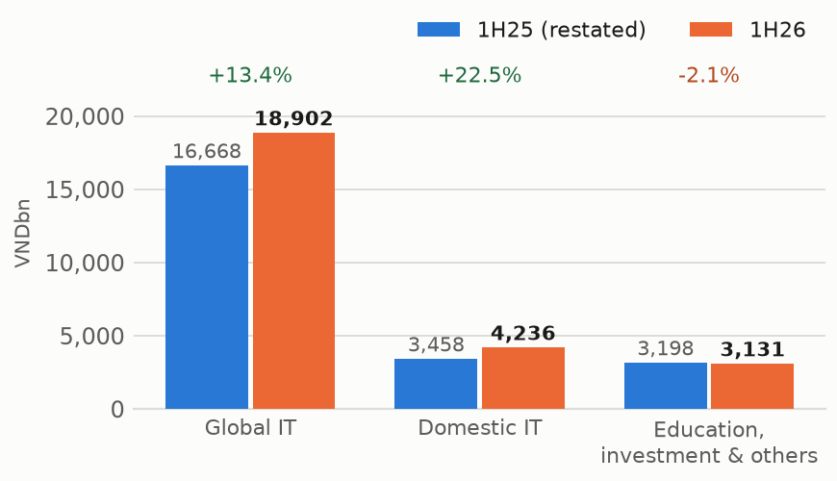  Source: FPT, Mirae Asset Vietnam Research | Figure 2. 1H26 PBT by segment  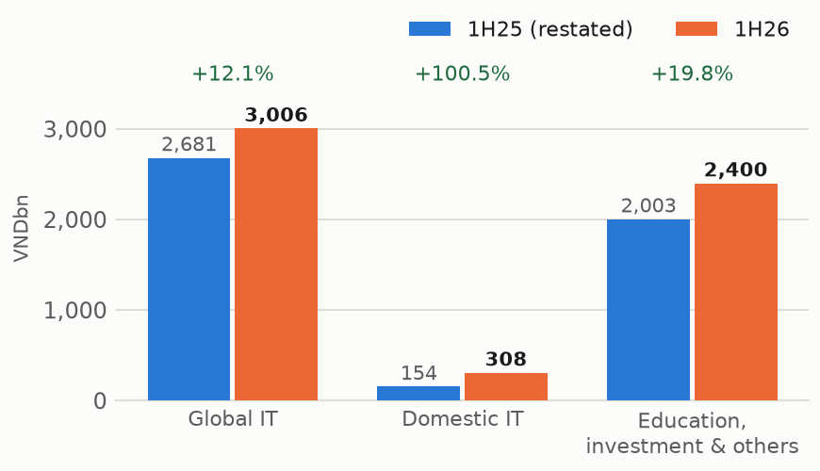  Source: FPT, Mirae Asset Vietnam Research

Associate income is now a material line. With FPT Telecom (45.66%) equity-accounted alongside FPT Retail (46.5%), Synnex FPT (48%) and FPT Online (49.5%), associate income reached VND1,423bn in 1H26, up 40.8% YoY. That is 25% of group PBT, against a line that was immaterial two years ago, and it is the single largest reason group PBT growth (+18.1%) outpaced revenue growth (+12.6%).

The AI question, answered in FPT’s own numbers
The bear case on FPT is that AI compresses per-hour billing faster than it expands demand. 1H26 is the first period with enough disclosure to test that, and it cuts the other way.
AI and data analytics revenue reached VND1,842bn, +55% YoY against +15% for Technology as a whole, lifting its share of the segment to 8.0% from 5.9%. That single line contributed roughly a fifth of Technology’s growth; strip it out and the segment grew 12.5%. Both AI Factories — Vietnam and Japan — ran above 90% utilisation and turned profitable in 2Q26, about a year after launch, which is faster than we assumed. The caveat: 8% of one segment cannot yet offset pricing pressure on the other 92%, and the margin disclosure is not granular enough to see whether AI work is being priced at a premium or simply substituting for headcount. We treat this as directional evidence, not proof.
Figure 3. AI & data analytics revenue  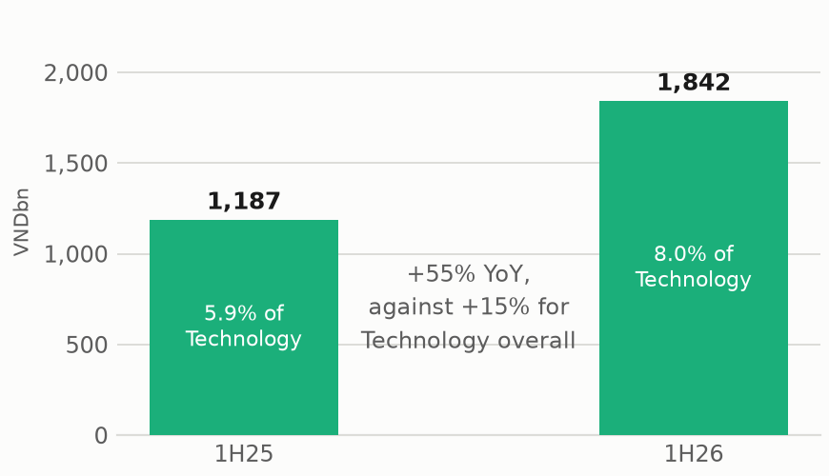  Source: FPT, Mirae Asset Vietnam Research | Figure 4. NPATMI and growth  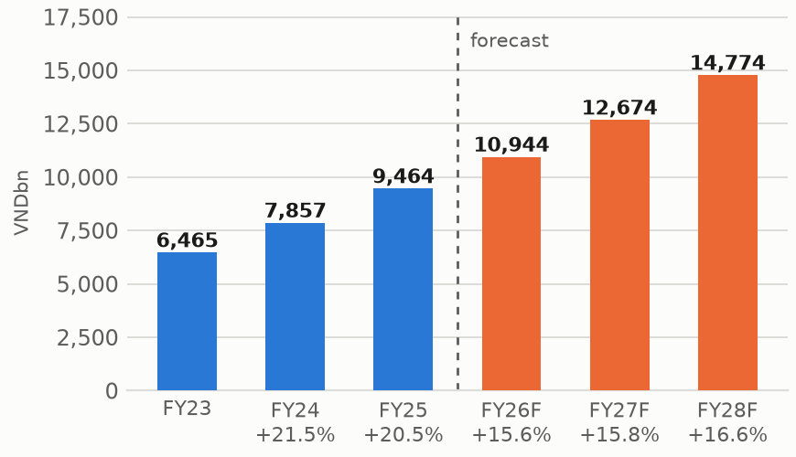  Source: FPT, Mirae Asset Vietnam Research

The order book supports a Global IT reacceleration. Signed contract value for Global IT reached VND26,338bn in 1H26, +32.3% YoY, including 14 deals above USD10mn. That is a book-to-bill of 1.39x against 1.07–1.22x through FY21–25 — the widest gap between orders and revenue in five years. On that basis we look for Global IT to grow 14.7% in FY26F and reaccelerate to 16.7% in FY27F and 17.7% in FY28F, from 13.4% delivered in 1H26. The US book is the exception, cut to +5.9% on price competition and tariff-related deal slippage.
Forecast and valuation
Table 2. Forecast summary (VNDbn) | FY25 | FY26F | FY27F | FY28F
Revenue | 70,208 | 57,284 | 66,048 | 76,654
% YoY | +11.7% | n.m.* | +15.3% | +16.1%
Operating profit | 11,079 | 9,807 | 11,044 | 13,053
Profit before tax | 13,134 | 13,070 | 15,159 | 17,671
Associate income | 658 | 2,608 | 2,999 | 3,449
NPATMI | 9,464 | 10,944 | 12,674 | 14,774
% YoY | +20.5% | +15.6% | +15.8% | +16.6%
EPS (VND) | 5,073 | 6,424 | 7,440 | 8,673
ROE (%) | 28.6 | 27.6 | 27.1 | 26.5
P/E at target price (x) | 17.3 | 13.7 | 11.8 | 10.1
* FY26F revenue is not comparable with FY25 as reported: FPT Telecom is equity-accounted from FY26F. Against a restated FY25 revenue of VND50,607bn the change is +13.2%. NPATMI is unaffected by the change of basis. P/E is struck on the target price of VND87,950. Source: Company data, Mirae Asset Vietnam Research
We keep FY26F NPATMI at VND10,944bn (+15.6% YoY), FY27F at VND12,674bn (+15.8%) and FY28F at VND14,774bn (+16.6%). Two things carry the forecast. Associate income rises to VND2,608bn in FY26F and VND3,449bn by FY28F, and grew 40.8% in 1H26. Operating leverage carries the rest: SG&A falls from 17.6% of sales to 16.5% by FY28F on an unchanged gross margin. ROE holds near 27% on net cash of around 60% of equity and a maintained DPS of VND2,000.
Valuation. Our DCF (FCFF) target price is VND87,950. The equity risk premium stays at 9% and long-term growth is held at 1.5% — deliberately below what the order book alone would justify, to carry the risk that AI lowers IT services pricing over time. At VND71,700 the stock trades at 11.2x FY26F earnings against a five-year median above 18x; at the target price, 13.7x FY26F and 11.8x FY27F, implying 23% upside. We maintain BUY.
Risks. (1) AI-driven price deflation outpacing our long-term growth assumption; (2) subdued US and global IT spending and tariff-related contract delays; (3) JPY/USD volatility, which moves both the translated Japanese revenue base and the FX line in financial income.
Analyst certification and important disclosures follow the house template and are omitted from this working draft.

