DEF-RS-004-001

After applying a venue type filter and refreshing the page, the filter menu only displays "All results" and the previously selected filter option. All other filter options are missing.

After applying “Grocery” filter and saving it:

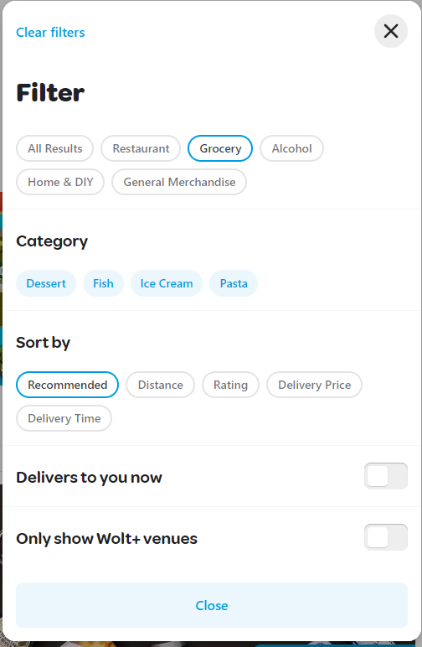

After refreshing the page:

