# Loading and processing data

##### Load packages  
require(knitr)

## Loading required package: knitr

## Warning: package 'knitr' was built under R version 3.2.4

require(markdown)

## Loading required package: markdown

## Warning: package 'markdown' was built under R version 3.2.4

setwd('C:/Users/GWANG1/Documents/GitHub/RepData_PeerAssessment1')  
dat <- read.csv("activity.csv")  
  
#### convert date to date data type  
dat$date <- as.Date(dat$date)  
  
library(ggplot2)

## Warning: package 'ggplot2' was built under R version 3.2.4

#### Mean of total number of steps taken per day  
datc <- na.omit(dat)   
steps.total <-tapply(datc$steps, datc$date,FUN=sum, na.rm=TRUE)  
dim(steps.total)

## [1] 53

hist(steps.total,breaks=10,xlab="Total Number of Steps Taken per Day", col="grey",main="Histogram of Total Steps")

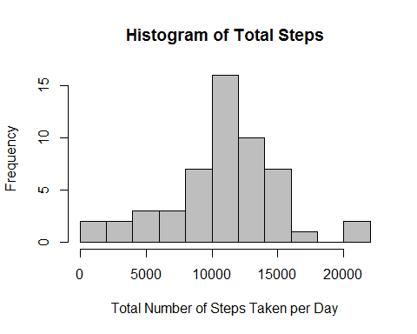

print("Mean of Total number of steps taken per day")

## [1] "Mean of Total number of steps taken per day"

mean(steps.total,na.rm=T)

## [1] 10766.19

print("Median of Total number of steps taken per day")

## [1] "Median of Total number of steps taken per day"

median(steps.total,na.rm=T)

## [1] 10765

# Average daily activity

head(dat[!is.na(dat$steps),])

## steps date interval  
## 289 0 2012-10-02 0  
## 290 0 2012-10-02 5  
## 291 0 2012-10-02 10  
## 292 0 2012-10-02 15  
## 293 0 2012-10-02 20  
## 294 0 2012-10-02 25

avg <- aggregate(x=list(steps=dat$steps),by=list(interval=dat$interval), FUN=mean, na.rm=T)  
ggplot(data=avg, aes(x=interval, y=steps))+geom_line(color="blue",size=1)+xlab("5-minute Interval")+ylab("Average Number of Steps Taken")

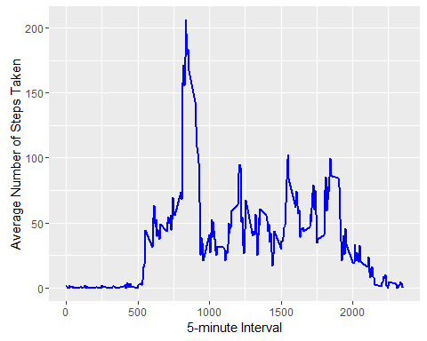

print("Maximum number of Steps in 5-minute Interval")

## [1] "Maximum number of Steps in 5-minute Interval"

avg[which.max(avg$steps),]

## interval steps  
## 104 835 206.1698

# Imputing missing values

#### 1. total number of missing values in dataset  
sum(is.na(dat$steps))

## [1] 2304

##### 2. Replace missing value with mean for that 5-minute interval  
dat.impmiss <- dat  
nas<- is.na(dat.impmiss$steps)  
avg_int<- tapply(dat.impmiss$steps, dat.impmiss$interval, mean, na.rm=TRUE, simplify = TRUE)  
dat.impmiss$steps[nas] <- avg_int[as.character(dat.impmiss$interval[nas])]  
names(dat.impmiss)

## [1] "steps" "date" "interval"

print("#Missing")

## [1] "#Missing"

sum(is.na(dat.impmiss))

## [1] 0

#### Histogram  
steps.imp <-tapply(dat.impmiss$steps, dat.impmiss$date,FUN=sum, na.rm=TRUE)  
dim(steps.imp)

## [1] 61

hist(steps.imp,breaks=10,xlab="Total Number of Steps Taken per Day", col="green",main="Total Steps including Imputing Value")

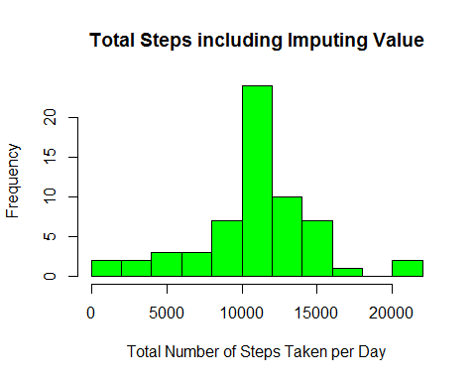

mean(steps.imp)

## [1] 10766.19

median(steps.imp)

## [1] 10766.19

# Difference in activity patterns between weekdays and weekends

#### Function: wwdat  
wwdat <- function(date){  
 day <-weekdays(date)  
 if(day %in% c("Monday","Tuesday","Wednesday","Thursday","Friday"))  
 return("Weekday")  
 else if( day %in% c("Saturday","Sunday"))  
 return("Weekend")  
 else  
 stop("Invalid Date")  
}  
  
dat.impmiss$weektype <- as.Date(dat.impmiss$date)  
dat.impmiss$weektype <- sapply(dat.impmiss$weektype, FUN=wwdat)  
  
#### Plot  
avg.imp <- aggregate(steps~interval+weektype, data=dat.impmiss, mean)  
  
library("lattice")  
xyplot(steps ~ interval|factor(weektype), data=avg.imp,   
 type = 'l',  
 main="Averaged Across All Weekday Days or Weekend Days",  
 xlab="Interval",  
 ylab="Number of Steps",layout=c(1,2))

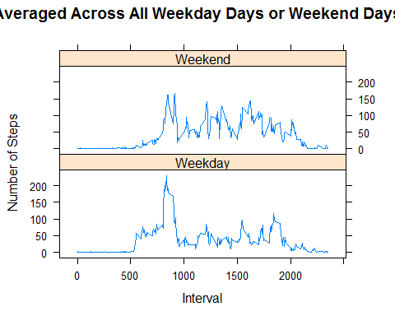

#transform the .Rmd to a markdown (.md) file.  
#knit('PA1_template.Rmd')  
  
#transform the .md to HTML format  
markdownToHTML("PA1_template.Rmd", "PA1_template.html",fragment.only = TRUE)

## Warning in readLines(con): incomplete final line found on  
## 'PA1_template.Rmd'

#transform the HTML to .md format  
markdownToHTML("PA1_template.html","PA1_template.md", fragment.only = TRUE)  
  
knit2html("PA1_template.html","PA1_template.md")

##   
##   
## processing file: PA1_template.html

##   
 |   
 | | 0%  
 |   
 |.................................................................| 100%  
## ordinary text without R code

## output file: PA1_template.txt

##### Create .md, .html, and .pdf files  
#knit2html  
#rmarkdown::render('PA1_template.Rmd', 'PA1_template.html') #, options=c("use_xhml")  
#rmarkdown::render('PA1_template.Rmd', 'PA1_template.md') #, options=c("use_xhml")