**Digital Marketing Case Study: Clique Bait**

**Topics to be Covered in this Module**

1. Introduction

2. Project Overview

3. Objective

4. Approach

5. Analysis Overview

- Campaign Analysis

- Event Analysis

- Product Analysis

- Page Analysis

- User Behavior Analysis

6. Insights and Recommendations

7. Conclusion

**INTRODUCTION**

**Clique Bait**, an esteemed online seafood emporium, helmed by its visionary Founder and CEO, Danny, extends an invitation for collaboration to delve into the depths of data analysis within the seafood industry. In this case study, your mission is to navigate the dataset intricacies and craft innovative strategies to compute funnel fallout rates, thereby bolstering Clique Bait's online presence and market position.

**PROJECT OVERVIEW**

This SQL-driven endeavor is dedicated to assisting Danny, the luminary behind Clique Bait, in harnessing the power of data analysis to propel his digital seafood empire to new heights. Armed with a wealth of experience in digital analytics, Danny aspires to revolutionize the seafood industry's landscape through astute insights derived from data scrutiny. The project encompasses a multifaceted approach, encompassing **Digital Analysis, Page Analysis Product Funnel Analysis, Campaign Performance Analysis, User Behavior Analysis, and Product Recommendation Analysis.**

**OBJECTIVE**

Through meticulous examination of the dataset, we aim to unearth innovative and data-driven solutions that resonate with Danny's aspiration to fuse digital analytics expertise with the nuances of the seafood industry. The resulting insights will serve as guiding beacons, steering decision-making processes, streamlining business operations, and charting a course for exponential growth for **Clique Bait**.

**SCOPE**

The scope of the SQL Clique Bait Analysis Project on Analyzing Marketing Engagement encompasses various analytical techniques applied to authentic datasets. Through comprehensive SQL analysis, the project seeks to reveal valuable business insights, providing practical examples of optimizing marketing strategies within the seafood industry.

**METHODOLOGIES EMPLOYED**

This project employs a range of SQL methodologies to analyze campaign performance and user engagement metrics. Techniques include aggregating data using SQL queries, computing campaign performance indicators, and extracting data on initiative durations, visitor engagements, user interactions, and product affiliations. By leveraging SQL analysis, insights are gained into campaign effectiveness and user behavior, enabling informed decision-making for marketing optimization.

**APPROACH**

Leveraging the prowess of SQL queries, advanced data analysis techniques, and sophisticated SQL functions, the project embarks on a journey to unveil latent patterns within the dataset. By peering into these data-driven narratives, we strive to extract actionable insights that will fortify various facets of Clique Bait's operational framework, fostering resilience and adaptability in an ever-evolving digital landscape.

**SQL Functions Utilized 💻**

The analysis employs a diverse array of SQL functions to extract meaningful insights, leveraging advanced techniques and methodologies. This versatile mix allows us to explore data from multiple angles, enriching our understanding of complex relationships. By harnessing such a diverse toolkit, we're equipped to extract even deeper insights, driving impactful outcomes and informed strategies. Additionally, this approach enables us to adapt dynamically to evolving data landscapes, ensuring relevance and accuracy in our analyses. Moreover, by continually refining our methodologies, we strive to uncover new perspectives and refine our decision-making processes.

|  |  |
| --- | --- |
| Function | Description |
| Data Aggregation | Utilizing functions like COUNT, SUM, AVG, MIN, MAX, and GROUP BY for summarizing data. |
| Data Ordering | Employing HAVING and ORDER BY clauses to sort and filter data based on specific criteria. |
| Data Manipulation | Using functions like JOIN (Right, Left, Inner), UNION, and DISTINCT for combining and restructuring datasets. |
| Window Functions | Leveraging functions such as LEAD, LAG, ROW_NUMBER, and RANK for analyzing data in a specified sequence. |
| Subqueries | Extracting subsets of data for deeper analysis within the context of larger queries. |
| Logical Functions | Employing CASE WHEN for data categorization and conditional operations based on specified conditions. |
| Date and Time Functions | Utilizing DATE_FORMAT, TIMESTAMPDIFF, and DATEDIFF for manipulating and analyzing temporal data. |
| Common Table Expressions (CTEs) | Creating temporary result sets for complex queries, enhancing readability, and simplifying complex logic. |
| Data Formatting and Transformation | Utilizing functions like CONCAT, SUBSTRING, and REPLACE for formatting and modifying data values. |
| Dimensional Aggregation | Aggregating data across multiple dimensions with functions such as GROUP_CONCAT for concatenated string aggregation. |
| Alias Usage | Enhancing query clarity and readability by assigning aliases to tables and columns. |
| Query Performance Optimization | Implementing indexing and query tuning techniques to improve query execution speed and efficiency. |

**Data description - ERD Diagram**

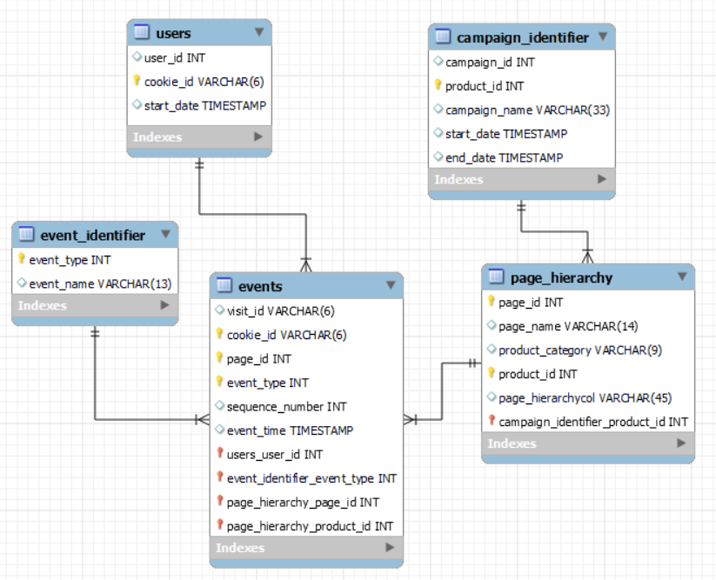

**Clique Bait Funnel Flow**

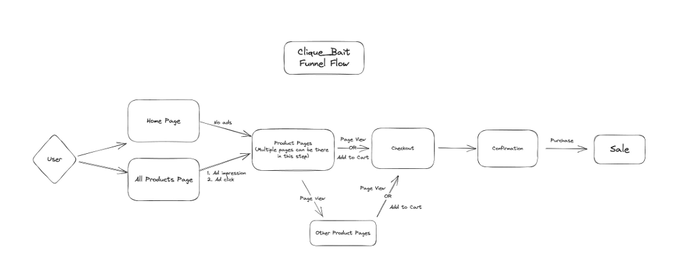

**ANALYSIS OVERVIEW**

**1. CAMPAIGN ANALYSIS**

* Conducted an in-depth examination of marketing campaign effectiveness and impact using sophisticated SQL queries and data analysis techniques, analyzing metrics such as user engagement, conversion rates, and campaign performance.
* Demonstrated SQL's capabilities in uncovering valuable business insights within the realm of marketing and advertising, providing insights into campaign performance metrics and user behavior.
* Offered a holistic approach to enhancing campaign effectiveness and driving business growth through data-driven decision-making, providing insights into campaign performance trends and factors contributing to successful campaigns.
* Analyzed the performance of various marketing campaigns in terms of user engagement and conversion rates, identifying key drivers of campaign success and areas for improvement.
* Explored trends in campaign performance over time and identified factors contributing to successful campaigns, providing actionable recommendations for optimizing marketing strategies and maximizing ROI.

**2. EVENT ANALYSIS**

* Leveraged a diverse set of SQL techniques to comprehensively explore user engagement dynamics, analyzing various event types and their distribution.
* Uncovered insights into the distribution of event types and prevalent activities such as page views, cart additions, and purchases, providing a holistic view of user interactions.
* Provided a multifaceted approach for a thorough exploration of user behavior, enabling effective optimization strategies in the digital landscape, such as identifying conversion bottlenecks and optimizing content placement.
* Analyzed temporal variations in user activities and event frequencies, discerning peak activity periods and identifying trends in user behavior over time.
* Identified peak activity periods and trends in user interaction across different time intervals, enabling businesses to optimize resource allocation and scheduling.

**3. PRODUCT ANALYSIS**

* Harnessed a range of SQL functions and queries to extract crucial insights into user interactions and product performance, including metrics such as conversion rates, cart abandonment rates, and product popularity.
* Offered actionable guidance for optimizing product presentation and marketing efforts, identifying high-performing products, and recommending strategies for cross-selling and upselling.
* Served as a vital resource for data-driven decision-making, empowering businesses to refine strategies and drive growth by providing insights into product engagement metrics and user behavior.
* Analyzed user preferences and behavior towards different product categories, identifying trends and patterns in product interactions and informing inventory management decisions.
* Examined the impact of promotional activities on product engagement and sales, providing insights into the effectiveness of marketing campaigns and promotions.

**4. PAGE ANALYSIS**

* Provided in-depth insights into user engagement, event sequences, and conversion rates across website pages, enabling businesses to optimize content placement and user experience.
* Empowered businesses to optimize content effectively and improve user experience by analyzing bounce rates, exit points, and session durations to identify areas for website improvement and optimization.
* Offered a roadmap for data-driven decision-making and continuous optimization to achieve business objectives efficiently, providing insights into page performance metrics and user engagement trends.
* Evaluated the effectiveness of different web pages in driving user engagement and conversion, identifying high-performing pages, and recommending strategies for content optimization.
* Analyzed the bounce rates and exit points to identify areas for website improvement and optimization, providing actionable insights for enhancing user experience and driving higher conversion rates.

**5. USER BEHAVIOR ANALYSIS**

* Explored user engagement dynamics using SQL functions like concatenation, logical operations, and date formatting, allowing for a granular understanding of user behavior.
* Facilitated a thorough exploration of user behavior across different stages of the user journey, uncovering insights into user preferences and interaction patterns.
* Empowered data-driven decision-making and optimization strategies for enhanced platform performance by providing actionable insights into user engagement metrics.
* Identified trends in user interactions and engagement patterns, including peak activity periods, common event sequences, and session durations.
* Extracted insights into user preferences and behaviors through rigorous data scrutiny, enabling personalized marketing approaches and tailored user experiences.

**INSIGHTS AND RECOMMENDATIONS:**

In light of the comprehensive analysis conducted across multiple dimensions of Clique Bait's digital marketing landscape, several key insights have emerged, paving the way for targeted strategies to optimize performance and drive growth. Moving forward, the following recommendations are proposed to capitalize on these insights and propel Clique Bait towards sustained success:

**Campaign Optimization**

* Refine targeting strategies based on demographic and behavioral analysis.
* Experiment with A/B testing to identify high-performing campaign elements.
* Utilize retargeting techniques to re-engage users and drive conversions.

**User Experience Enhancement**

* Streamline the checkout process to reduce cart abandonment rates.
* Implement personalized product recommendations based on user preferences.
* Optimize website navigation for a seamless user journey across pages.

**Product Portfolio Expansion**

* Introduce new product categories based on demand and market trends.
* Collaborate with suppliers to diversify product offerings and cater to varied preferences.
* Promote seasonal specials and limited-time offers to entice customers.

**Content Strategy Refinement**

* Create engaging content tailored to different stages of the customer journey.
* Incorporate multimedia elements such as videos and interactive features to enhance user engagement.
* Leverage user-generated content and testimonials to build trust and credibility.

**Data-Driven Decision-Making**

* Continuously monitor key performance indicators and adjust strategies accordingly.
* Invest in advanced analytics tools and technologies for deeper insights and predictive modeling.
* Foster a culture of data literacy and experimentation within the organization to drive innovation.

These recommendations aim to leverage the insights gleaned from the analysis to optimize marketing strategies, enhance user experiences, and drive conversions for Clique Bait. By embracing a data-driven approach and implementing targeted initiatives, Clique Bait can position itself as a leader in the digital seafood industry, poised for sustainable growth and market dominance.

**CONCLUSION:**

In conclusion, the culmination of rigorous data analysis and strategic insights has positioned Clique Bait on the cusp of transformative growth within the digital seafood industry. With a clear roadmap delineated by actionable recommendations, Clique Bait is poised to not only enhance its online presence but also redefine the standards of excellence within its niche. By harnessing the power of data-driven decision-making, Clique Bait stands ready to navigate the complexities of the digital landscape with precision and agility, capitalizing on emerging opportunities and mitigating potential challenges.

*As Clique Bait embarks on this journey of innovation and expansion, it does so with a firm commitment to excellence and customer satisfaction. By embracing change, fostering a culture of continuous improvement, and leveraging the insights gleaned from this comprehensive analysis, Clique Bait is primed to usher in a new era of success and dominance in the digital realm. With unwavering dedication and a strategic vision, the future of Clique Bait shines bright, promising unparalleled growth and prosperity in the dynamic world of digital marketing.*

**We extend our gratitude for the opportunity to undertake this thorough analysis. Thank you for considering our findings.**