Kabadiwala Connect 2.0: A Role-Based Household E-Waste Collection Platform with YOLOv8 Item Detection and Gradient-Boosted Price Estimation

[TO FILL: Student author – full name]
[TO FILL: Department of Computer Applications]
[TO FILL: Institution name]
[TO FILL: City, India]
[TO FILL: email or ORCID]
[TO FILL: Project guide – full name]
[TO FILL: Department of Computer Applications]
[TO FILL: Institution name]
[TO FILL: City, India]
[TO FILL: email or ORCID]

Abstract—Household e-waste in Indian cities is usually handed to informal collectors, and after it leaves the house there is little record of where it goes or what it was worth. Kabadiwala Connect 2.0 keeps the collector in the chain but records each step in one FastAPI backend with a MongoDB Atlas database. A home user photographs an item in a Flutter app; a YOLOv8n detector fine-tuned on 37 device classes suggests the item type, and a histogram-based gradient boosting regressor gives an indicative price. A collector from the same ward accepts the pickup, and the handover counts as collected only if the collector’s GPS reading is within 150 m of the household and within 48 hours of the request. Collected items are listed for recycler bidding, and a database index allows only one accepted bid per lot. On a held-out test split of 758 images the detector reached a precision of 0.868, a recall of 0.822 and an mAP@0.5 of 0.876. The price model reached an R-squared value of 0.952 on a later time period. Because its 6,000 training records are synthetic, this result does not measure real market accuracy. During evaluation we found that lot data sent to recyclers exposed household-linked fields; after an allow-list correction, all 412 backend tests passed, and the mobile app passed 153 tests. Mismatched input vocabularies between the detector, the mobile form and the price model remain unresolved, and no field study has been carried out yet.
Keywords—e-waste collection, informal sector, object detection, YOLOv8, gradient boosting, price estimation, geo-tag verification, FastAPI, MongoDB

Introduction
The world generated a record 62 million tonnes of e-waste in 2022, and generation is rising faster than documented recycling [1]. In India most of this material is collected, dismantled and recycled by informal workers, often with methods such as open burning and acid dumping that harm workers and the environment [2]. The E-Waste (Management) Rules, 2022 place recycling obligations on producers and registered recyclers [3], but a household that wants to dispose of one old phone still has no simple channel that records where the phone ends up.
The door-to-door kabadiwala (scrap collector) is a common channel. In a survey reported by Sengupta et al., about 45% of respondents preferred to give e-waste to kabadiwalas, and the informal sector was reported to handle over 90% of India’s e-waste [4]. The same group argues for bringing such collectors into formal schemes rather than bypassing them [5]. Our project follows this idea. Its first version, Kabadiwala Connect 1.0, tried to digitise the channel, but the project’s design notes record three faults: the apps and the server disagreed about an item’s state, state changes were applied inconsistently, and some actions were not properly authorised. Version 2.0 was rebuilt around a single backend that owns every rule, and it adds automatic item identification and pricing.
The contributions of this paper are:
- a role-based platform for five actors in which changes to an item’s, lot’s and bid’s state are made only by the backend through allow-listed state machines;
- integration of a YOLOv8n detector into the photo upload step, with a confidence threshold that sends uncertain results back to the user or to manual classification;
- a gradient-boosted price estimator chosen by a time-ordered comparison of five regressors, reported with the limits of its synthetic training data;
- an evaluation that combines held-out detection results, automated tests and a code-level review, including a privacy defect that was found and corrected.
Section II reviews related work and Section III states the problem. Section IV describes the method, Section V the architecture and data design, and Section VI the results. Section VII concludes.

Literature Review

E-Waste Collection and the Informal Sector
Kumar et al. review how e-waste is generated, collected, regulated and recycled [6]. Wath et al. describe the composition of e-waste and the Indian situation in detail; they report that collection, dismantling and recycling in India were carried out mostly by unorganised workers, and they list practices such as open burning of plastics and dumping of acids [2]. The 2022 Rules, which replaced the 2016 rules, make producers responsible for recycling targets that are met through certificates generated by registered recyclers [3]. Sengupta et al. propose a modified extended producer responsibility model that includes informal collectors [5]. In a follow-up study they surveyed households and tracked collectors’ routes with GPS, finding that kabadiwalas cover roughly 20–30 km a day [4]. These studies explain why collectors should be integrated; they do not describe software for doing it.

Vision-Based Waste Identification
YOLO treats object detection as one regression from an image to box coordinates and class probabilities, so a single network pass produces all detections [7]. Ultralytics YOLOv8 offers five model sizes, from nano to extra-large, with an anchor-free detection head [8], and its released weights are pre-trained on the COCO dataset [9]. Majchrowska et al. combined an EfficientDet-D2 detector with an EfficientNet-B2 classifier to find and sort litter in natural and urban photographs [10]. Voskergian and Ishaq compared YOLOv5s, YOLOv7-tiny and YOLOv8s for e-waste detection within an Internet-of-Things management system and reported the best result, 72% mAP@50, for YOLOv8s [11]. Their dataset and classes differ from ours, so the numbers are not directly comparable.

Price Estimation for Tabular Data
Gradient boosting fits an additive model of regression trees, each new tree correcting the error left by the previous ones [12]. LightGBM speeds up training by finding splits on histograms of binned feature values and adds gradient-based sampling and feature bundling [13]. Scikit-learn’s histogram-based estimator follows the same idea: it first bins every input feature into at most 256 integer bins and then searches for splits over those bins [14]. We used scikit-learn [15] for all preprocessing and model comparison. For Indian-language interfaces, IndicTrans2 provides open translation models for the 22 scheduled languages [16].

Research Gap
Within the works reviewed above, the policy and field studies explain why the collector should be formalised, and the vision studies show that devices can be recognised from images taken at a bin or a sorting site. None of them combines recognition at the household, an indicative price, a verified collector handover and a traceable sale to a recycler in one workflow. We do not claim that no such system exists elsewhere; this paper describes our attempt to build and test one.

Problem Statement
Given a household that wants to dispose of a small electronic item, and a set of ward-based collectors, RRR (resource recovery and recycling) centres and authorised recyclers, the problem is to build a system that (i) identifies the item from a photograph and gives an indicative price before pickup, (ii) treats a pickup as collected only when location and time evidence show that the collector met the household, (iii) sells collected items to recyclers through bidding in which exactly one bid can win, (iv) rewards the household once per verified item, (v) keeps every actor consistent by enforcing the rules on the server, and (vi) does not reveal household identity or location to recyclers.

Proposed Methodology and System

Actors and Workflow
Table I lists what each role may do. Home users register themselves; collector accounts are created by the administrator, with the employee ID as the user name and a fixed ward; RRR centres and recyclers register and wait for approval. Fig. 1 shows the main flow. A collector sees only pending pickups in his or her own ward. After a verified handover, the backend lists the item as a single-item lot owned by that collector, provided the submission carries a category; otherwise the item waits for an RRR centre to classify it and build a lot.
- Role Permissions Enforced by the Backend
Role | Main permitted actions
Home user | photo upload and detection, price estimate, submission, own rewards and redemption
Collector | ward pickup queue, accept pickup, handover, choose winning bid on own lot
RRR centre | receive, classify (AI or manual), create and publish lots, accept bids on own lots (API only)
Recycler | browse listed lots, bid, book logistics, pay (mock gateway)
Admin | approvals, collector accounts, wards, reward computation, lot completion, audit logs

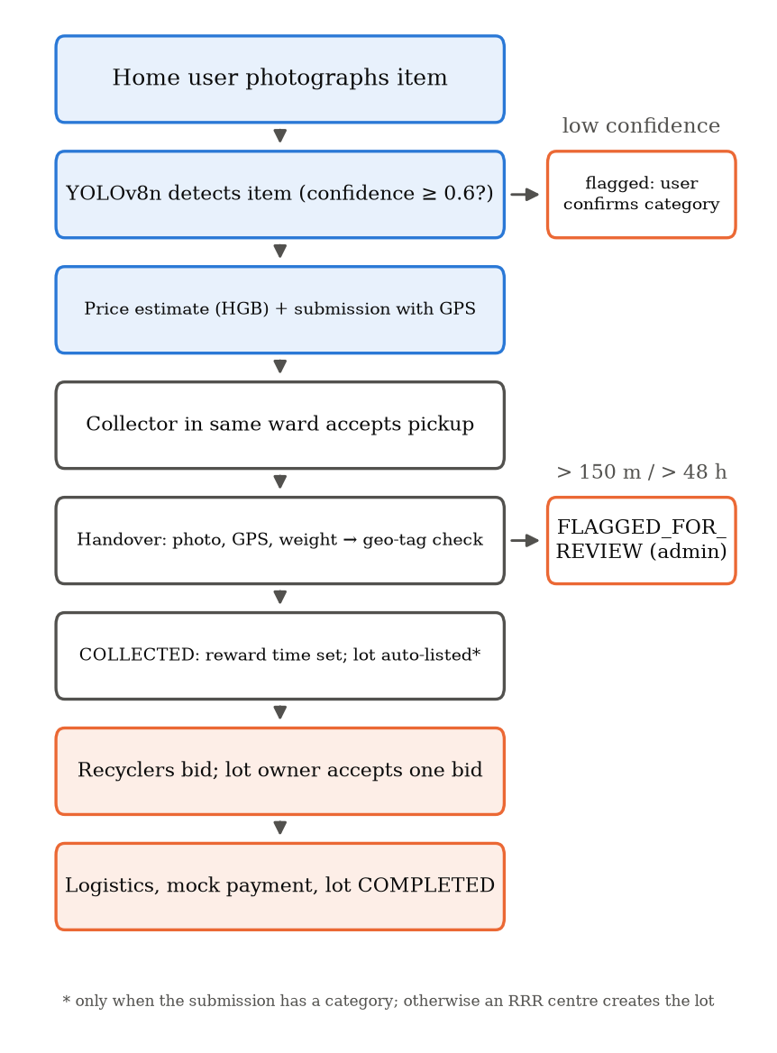
- Main workflow from photograph to sale, with the two review branches.

Item Detection Model
We fine-tuned YOLOv8n [8] on version 3 of the Roboflow “Balanced E-Waste Dataset” [17] (licence CC BY 4.0), which has bounding boxes for 37 device classes. The cleaned copy used for training holds 7,163 images (4,990 training, 1,415 validation and 758 test) with 8,044 boxes. We chose detection over whole-image classification because the boxes were already available and 8.2% of the images contain more than one device. The project notes state that 104 cross-split duplicates in the raw export were removed. Our own MD5 check of the cleaned files found no test image identical to a training image, but five test images identical to validation images and 83 duplicate files overall, 71 of them inside the training split; near-duplicates were not checked.
YOLOv8n uses a backbone of strided convolutions and C2f blocks ending in a spatial pyramid pooling layer, a neck that merges features from different depths by upsampling and concatenation, and an anchor-free head that predicts boxes at strides of 8, 16 and 32 pixels [8]. After layer fusion the trained model has 3,012,863 parameters and needs 8.1 GFLOPs for a 640 × 640 image. Table II gives the training settings, read from the training script and the saved run arguments.
- YOLOv8n Training Configuration
Setting | Value
Initial weights | yolov8n.pt (COCO pre-trained)
Epochs / image size / batch | 20 / 640 px / 16; patience 10 (not reached)
Optimizer | “auto” (chosen by Ultralytics)
Augmentation | mosaic 1.0 (off in last 10 epochs), mixup 0.1, rotation ±10°, scale 0.5, shear 2.0, flip 0.5, HSV jitter
Software | Ultralytics 8.3.40, PyTorch 2.11 (CUDA), mixed precision, seed 0
Hardware / time | NVIDIA GeForce RTX 3050 Laptop GPU (4 GB); 57.7 min

When a photo is uploaded, the backend runs the model, keeps the detection with the highest confidence and maps its label to a coarse lot category; at present only batteries and printed circuit boards have their own categories, and every other label is mapped to small appliances. If nothing is detected, the classifier fails or the confidence is below 0.6, the result is flagged and the user confirms or types the category. Detection results at upload time are returned to the app but not stored. When an RRR centre runs AI classification on a received item, every attempt and every manual decision is stored in an append-only collection, so the predicted and the confirmed category can both be audited.

Price Estimation Model
The price model predicts the collector price per kilogram from material (20 values), condition (4 values: working, partially working, non-working, damaged), city (11 values), quantity and total weight. A weight-per-item feature is added, text fields are one-hot encoded and missing values are imputed. The 6,000 records span 1 January 2024 to 1 September 2026 and every record is labelled as synthetic demonstration data. Because prices change over time, the unique dates are split in order into 60% training, 20% validation and 20% final test (3,593, 1,228 and 1,179 records), so each evaluation uses later dates than the training data. Five scikit-learn regressors were compared on the validation period and ranked by the sum of their MAE, RMSE and R² ranks. The selected HistGradientBoostingRegressor [12], [14] (250 iterations, learning rate 0.05, L2 regularisation 1.0) was refitted on the training and validation periods and evaluated once on the final test period.
The application multiplies the per-kilogram prediction by the weight and shows a fixed band of ±10% around it. This band is a configuration setting, not a statistical interval. Separately, the training project computed a 90% prediction interval from forward-chaining out-of-fold residuals; that interval is reported in Section VI but is not used by the application.

Geo-Tag Based Handover Verification
When a collector records a handover, the server compares the household’s submission coordinates (φ₁, λ₁) with the collector’s coordinates (φ₂, λ₂) using the haversine great-circle distance [18]:
d = 2R·arcsin√(sin²(Δφ/2) + cos φ₁ cos φ₂ sin²(Δλ/2)) (1)
where R = 6,371 km. The handover is accepted only if both readings are valid (missing, out-of-range and (0, 0) values are rejected), the collector’s timestamp is after the submission and no more than 48 hours later, and d ≤ 150 m. Otherwise the item moves to a review state and the reasons are stored. The collector’s coordinates and timestamp come from the device, and the server uses its own clock only when no timestamp is sent, so we describe this as geo-tag based verification rather than proof.

Lots, Bidding, Rewards and Translation
Lots accept bids for seven days, and bids after the deadline are rejected. A partial unique index allows at most one ACCEPTED bid per lot. The lot owner may cancel an acceptance only within 24 hours and before the lot moves on to logistics and payment. Recyclers book a collection slot and pay through a deliberately labelled mock gateway, and the administrator marks the sale complete. When an item first becomes COLLECTED, a reward-eligibility timestamp is written once; the administrator triggers reward computation for a calendar month at 10 points per eligible item and ₹0.50 per point, and households redeem rewards through a mock UPI payout.
The backend also has translation endpoints that load the distilled 200M-parameter IndicTrans2 English-to-Indic model [16] on first use and support 25 target languages. The mobile app does not call them yet: it switches between English and a built-in Kannada string table. The translation tests replace the model with a stub, so translation quality was not measured.

System Architecture and Design

Layered Architecture
Fig. 2 shows the architecture. We chose a modular monolith: one FastAPI backend with 19 domain modules and 86 API endpoints, each module split into a router (HTTP only), a service (business rules) and repositories (database access only). The clients are a Flutter app for home users and collectors and React web apps for recyclers and the administrator. Keeping one backend was a response to version 1.0: all clients depend on the same state machines, role checks and idempotency rules, and copying those rules into several services would bring back the mismatch problem. The RRR-centre web app was removed in this version, so that role currently works only through the API.
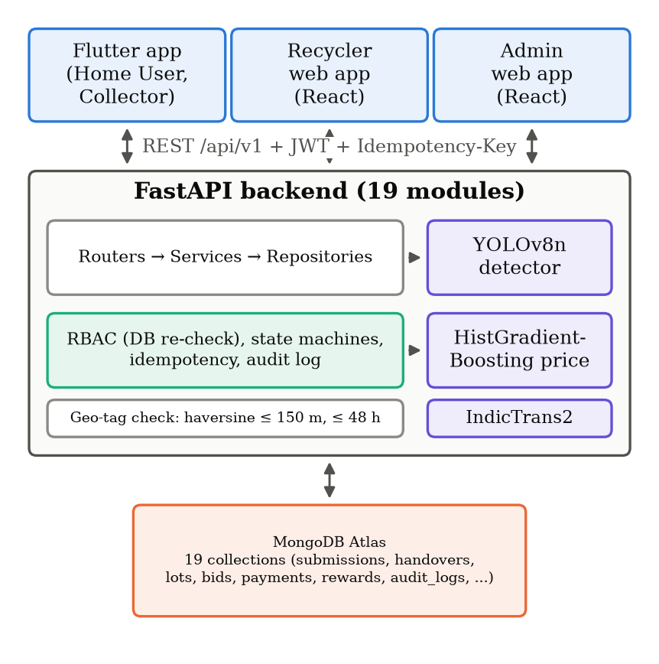
- Architecture of Kabadiwala Connect 2.0.

Database Design
Data is stored in 19 MongoDB collections, including users and role profiles, wards, e_waste_submissions, collection_handovers, ai_classifications, lots, bids, logistics_bookings, payments, rewards, reward_transactions, complaints, notifications, audit_logs and idempotency_keys. Several rules are enforced by indexes: one handover per submission (unique), at most one ACCEPTED bid per lot (partial unique) and one reward per home user per month (unique). Bid amounts are stored as 128-bit decimals rather than floating-point numbers.

Consistency and Security
State changes for items, lots, bids and complaints go through allow-listed transition functions; the item lifecycle has 22 states and 26 permitted transitions, and any other change raises an error. Account approval and reward statuses are simpler and are set directly by their services. Passwords are hashed with bcrypt; JWT access tokens last 15 minutes and refresh tokens seven days. On every request the user’s role and status are read again from the database, so a disabled account loses access at once. Of the 45 state-changing operations, the 17 that drive the main workflow (submission, acceptance, handover, receipt, classification, lot, bid, logistics, payment, redemption and completion) require an idempotency key; a repeated key returns the first response, which lets the mobile app replay its offline queue safely. Registration, profile updates, approvals and notification reads do not use keys.

Protecting Household Data
A code review during evaluation showed that the two recycler endpoints for lots (the list of open lots and a lot’s details) returned each item’s full record: the home user’s identifier, the collector’s identifier, and the GPS point, time and photo reference of the handover, which is taken within 150 m of the household. This broke requirement (vi). We corrected it with an allow-list: recyclers now receive only each item’s submission identifier and measured weight, while lot owners and the administrator still see the full handover evidence. Four regression tests were added; the two recycler tests failed before the change and passed after it.

Initial Results and Findings

Item Detection
The weights used by the backend have the same MD5 hash as the best checkpoint of training run ewaste_yolov8n5, so the results describe the deployed model. Fig. 3 shows validation mAP during training. The best checkpoint is the last epoch, and both curves were still rising slowly at epoch 20, so a longer run might help. Table III gives the validation result at epoch 20 from the training log and the result on the 758-image test split, which was used neither for training nor for checkpoint selection. The test evaluation was run on 12 October 2026 with Ultralytics 8.4.157 on a CPU using its default validation settings. P and R are precision and recall; mAP50 and mAP50-95 are mean average precision at an intersection-over-union threshold of 0.5 and averaged over thresholds from 0.5 to 0.95, as defined for COCO [9].
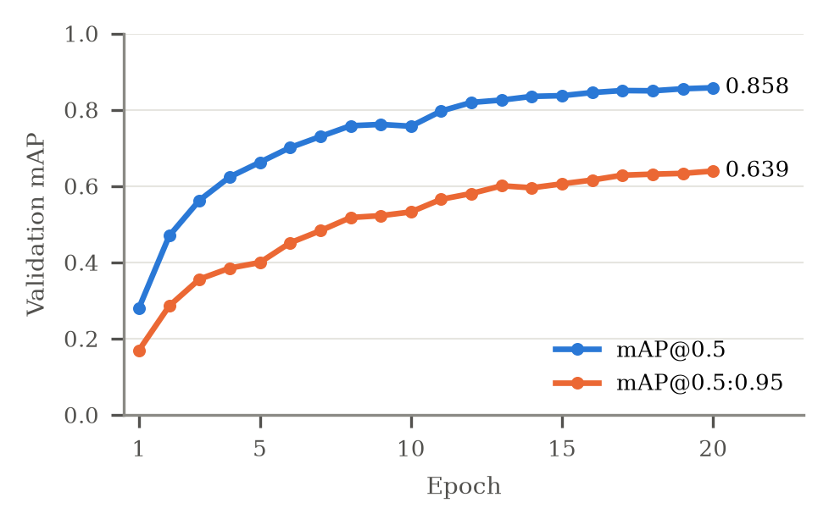
- Validation mAP of YOLOv8n over 20 epochs.
- Detection Results
Split | Images | P | R | mAP50 | mAP50-95
Validation | 1,415 | 0.850 | 0.813 | 0.858 | 0.639
Test | 758 | 0.868 | 0.822 | 0.876 | 0.653

Per-class AP@0.5 on the 849 test boxes ranged from 0.637 to 0.995. The weakest classes were straight-tube fluorescent lamps (0.637), boilers (0.695) and computer mice (0.699). Lamp boxes are small and elongated (median area 10.6% of the image, median length-to-width ratio 2.0), and boiler boxes are also small (16.4%), against a median of 29.2% for all boxes. Mouse boxes are not small (34.4%), so their low recall of 0.451 is not explained by size; we have not yet studied its cause. On an AMD Ryzen 7 7445HS laptop CPU, with batches of 16 images, preprocessing took 2.2 ms, the model 59.1 ms and post-processing 0.8 ms per image. These figures exclude upload time and the model loading that the backend currently repeats on every request, so end-to-end response time remains to be measured. A saved run on 11 photographs taken outside the dataset produced at least one box for 8 of them; the photographs have no ground-truth labels. [TO FILL: one sentence describing what the detector got right or wrong on these 11 photographs, or delete this sentence].

Price Estimation
Fig. 4 compares the five candidate models on the validation period. Linear regression had an MAE of ₹34.15/kg, 2.4 times that of the selected model and 1.7 times that of the weakest tree ensemble, so a linear model fits these data poorly. Table IV gives the selected model’s results on the validation period and on the later final-test period.
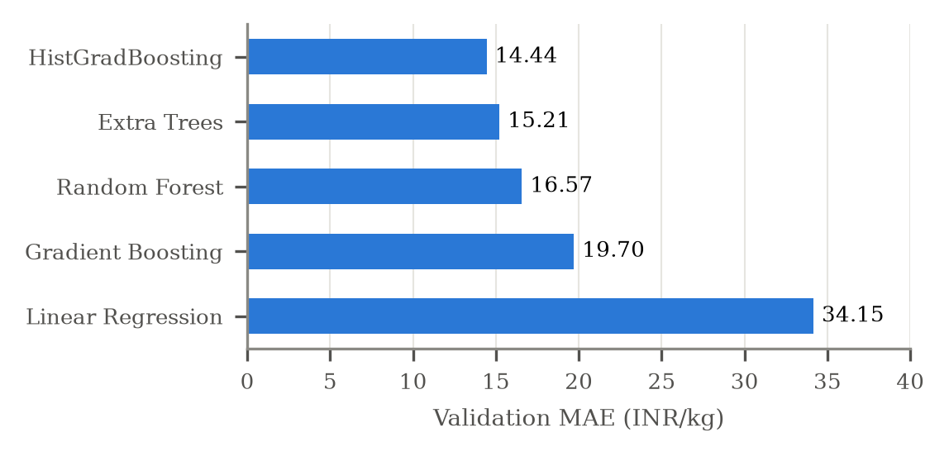
- Validation MAE of the five candidate price models.
- Price Model (HistGradientBoosting) Results
Period | Rows | MAE (₹/kg) | RMSE (₹/kg) | R²
Validation | 1,228 | 14.44 | 23.13 | 0.970
Final test | 1,179 | 21.85 | 32.20 | 0.952

Error grows on the final period, whose dates lie further from the training data. Because the data are synthetic, the high R² shows that the pipeline recovers the pattern built into the data, not that it predicts real scrap prices. The 90% interval from the training project covered 93.1% of validation records but only 86.9% of final-test records, below its target, which is a further reason not to present it as calibrated for real use.

Integration Findings
The code review also found problems that remain open. Only three of the 37 detector labels (battery, laptop and router) match a material known to the price model, the mobile form offers conditions (new, like new, good, used, damaged, non-working) that differ from the four used in training, and the app sends a place name or ward identifier where the model expects one of 11 city names. The encoder silently ignores unknown values. With one item of 2 kg in Bengaluru, a working smartphone and a working refrigerator both received ₹199.48/kg, and a laptop in “good” condition received ₹222.51/kg against ₹475.09/kg for “working”. In addition, the detector weights are loaded again on every classification request. A label-mapping table, aligned form values and loading the model once at start-up would address these issues; until then, price estimates for most detected items should not be relied on.

Software Testing
Table V summarises the automated tests. The backend suite uses an in-memory MongoDB substitute and covers every API module, cross-role isolation, input validation, idempotency, a reward redemption race and a full flow from registration to a redeemed reward. The AI-related API tests replace the detector with a deterministic mock and the translation tests use a stub, so these tests check the surrounding logic; the detector itself was evaluated separately.
- Automated Test Results
Suite | Passed / run | Date
Backend (pytest), after privacy fix | 412 / 412 | 12 Oct 2026
Backend (pytest), before fix | 408 / 408 | 12 Oct 2026
Mobile (Flutter) | 153 / 153 | 12 Oct 2026
Recycler web (Vitest)* | 45 / 45 | by 15 Sep 2026
Admin web (Vitest)* | 50 / 50 | by 15 Sep 2026

* The web results come from the project’s status log, last modified on 15 September 2026. They could not be re-run because the evaluation machine’s Node.js 20 is older than the installed test environment requires, and the web code has changed since then; it now contains 48 and 42 test cases respectively.

Completed and Pending Evaluation
Completed: detector evaluation on a held-out split, price-model comparison on later dates of synthetic data, automated functional and security tests, and the household-data correction with regression tests. Pending: labelled photographs from real households, price evaluation on real market records, load tests of the database rules on MongoDB Atlas, timing on physical Android phones, re-running the web tests, and a usability study with collectors and households. No user study has been carried out.

Conclusion
Kabadiwala Connect 2.0 keeps the informal collector at the centre of household e-waste collection while one backend records and checks every step. A small YOLOv8n detector reached an mAP@0.5 of 0.876 on held-out test images and runs on a laptop CPU. The price pipeline works on synthetic data but has not been tested on real prices, and its inputs do not yet match the detector’s labels or the mobile form. Geo-tag verification, database-enforced bidding, idempotent workflow requests and the corrected protection of household data are covered by 412 backend tests. The next steps are to align the input vocabularies, load the detector once, collect real price records, and run a field study with real photographs and users.

Acknowledgment
[TO FILL: names of your project guide and department to acknowledge, or delete this section]

References
- C. P. Baldé, R. Kuehr, T. Yamamoto, R. McDonald, E. D’Angelo, S. Althaf, G. Bel, O. Deubzer, E. Fernandez-Cubillo, V. Forti, V. Gray, S. Herat, S. Honda, G. Iattoni, D. S. Khetriwal, V. Luda di Cortemiglia, Y. Lobuntsova, I. Nnorom, N. Pralat, and M. Wagner, The Global E-waste Monitor 2024. Geneva/Bonn: International Telecommunication Union (ITU) and United Nations Institute for Training and Research (UNITAR), 2024. [Online]. Available: https://ewastemonitor.info/the-global-e-waste-monitor-2024/
- S. B. Wath, P. S. Dutt, and T. Chakrabarti, “E-waste scenario in India, its management and implications,” Environmental Monitoring and Assessment, vol. 172, pp. 249–262, 2011, doi: 10.1007/s10661-010-1331-9.
- Ministry of Environment, Forest and Climate Change, Government of India, “E-Waste (Management) Rules, 2022,” Notification G.S.R. 801(E), Gazette of India, Nov. 2, 2022.
- D. Sengupta, I. M. S. K. Ilankoon, K. D. Kang, and M. N. Chong, “Circular economy and household e-waste management in India. Part II: A case study on informal e-waste collectors (Kabadiwalas) in India,” Minerals Engineering, vol. 200, Art. no. 108154, 2023, doi: 10.1016/j.mineng.2023.108154.
- D. Sengupta, I. M. S. K. Ilankoon, K. D. Kang, and M. N. Chong, “Circular economy and household e-waste management in India: Integration of formal and informal sectors,” Minerals Engineering, vol. 184, Art. no. 107661, 2022, doi: 10.1016/j.mineng.2022.107661.
- A. Kumar, M. Holuszko, and D. C. R. Espinosa, “E-waste: An overview on generation, collection, legislation and recycling practices,” Resources, Conservation and Recycling, vol. 122, pp. 32–42, 2017, doi: 10.1016/j.resconrec.2017.01.018.
- J. Redmon, S. Divvala, R. Girshick, and A. Farhadi, “You only look once: Unified, real-time object detection,” in Proc. IEEE Conf. Computer Vision and Pattern Recognition (CVPR), Las Vegas, NV, USA, 2016, pp. 779–788, doi: 10.1109/CVPR.2016.91.
- G. Jocher, A. Chaurasia, and J. Qiu, “Ultralytics YOLOv8,” version 8.0.0, 2023. [Online]. Available: https://github.com/ultralytics/ultralytics
- T.-Y. Lin, M. Maire, S. Belongie, J. Hays, P. Perona, D. Ramanan, P. Dollár, and C. L. Zitnick, “Microsoft COCO: Common objects in context,” in Computer Vision – ECCV 2014, Lecture Notes in Computer Science, vol. 8693. Cham: Springer, 2014, pp. 740–755, doi: 10.1007/978-3-319-10602-1_48.
- S. Majchrowska, A. Mikołajczyk, M. Ferlin, Z. Klawikowska, M. A. Plantykow, A. Kwasigroch, and K. Majek, “Deep learning-based waste detection in natural and urban environments,” Waste Management, vol. 138, pp. 274–284, 2022, doi: 10.1016/j.wasman.2021.12.001.
- D. Voskergian and I. Ishaq, “Smart e-waste management system utilizing Internet of Things and deep learning approaches,” Journal of Smart Cities and Society, vol. 2, no. 2, pp. 77–98, 2023, doi: 10.3233/SCS-230007.
- J. H. Friedman, “Greedy function approximation: A gradient boosting machine,” The Annals of Statistics, vol. 29, no. 5, pp. 1189–1232, 2001, doi: 10.1214/aos/1013203451.
- G. Ke, Q. Meng, T. Finley, T. Wang, W. Chen, W. Ma, Q. Ye, and T.-Y. Liu, “LightGBM: A highly efficient gradient boosting decision tree,” in Advances in Neural Information Processing Systems 30 (NeurIPS 2017), 2017, pp. 3146–3154.
- scikit-learn developers, “Ensembles: Gradient boosting, random forests, bagging, voting, stacking” (Section: Histogram-based gradient boosting), scikit-learn User Guide. [Online]. Available: https://scikit-learn.org/stable/modules/ensemble.html (accessed Oct. 12, 2026).
- F. Pedregosa, G. Varoquaux, A. Gramfort, V. Michel, B. Thirion, O. Grisel, M. Blondel, P. Prettenhofer, R. Weiss, V. Dubourg, J. Vanderplas, A. Passos, D. Cournapeau, M. Brucher, M. Perrot, and E. Duchesnay, “Scikit-learn: Machine learning in Python,” Journal of Machine Learning Research, vol. 12, pp. 2825–2830, 2011.
- J. Gala et al., “IndicTrans2: Towards high-quality and accessible machine translation models for all 22 scheduled Indian languages,” Transactions on Machine Learning Research, Dec. 2023. [Online]. Available: https://arxiv.org/abs/2305.16307
- Electronic Waste Detection, “Balanced E-Waste Dataset,” version 3, Roboflow Universe, CC BY 4.0. [Online]. Available: https://universe.roboflow.com/electronic-waste-detection/balanced-e-waste-dataset/dataset/3
- R. W. Sinnott, “Virtues of the haversine,” Sky and Telescope, vol. 68, no. 2, p. 159, Aug. 1984.

