MCA MINI PROJECT – SECOND REVIEW REPORT
Kabadiwala Connect 2.0
A role-based digital platform for household e-waste collection with image-based item detection, machine-learning price estimation and transparent recycler bidding
Field | Details
Student name | [TO FILL: your full name]
Register / USN number | [TO FILL]
Programme / semester | [TO FILL: e.g. MCA, Semester __]
Project guide (supervisor) | [TO FILL: guide name and designation]
Department and institution | [TO FILL]
Supervisor review | 21.10.2026 – 23.10.2026 (as per review notice)
Examiner review | 24.10.2026 (Saturday)
Report prepared on | 12 October 2026, from the project repository and evidence listed in Appendix B

How to read this report. Every implementation claim in this report was checked against the source code, model files and test runs in the project folder. Text shown like [TO FILL: ...] marks information that cannot be found in the repository (for example your personal details, your First Review feedback, or screenshots). Please complete or delete every highlighted item before submission.

Contents
Summary of Progress 4
Progress Since the First Review 4
1. Refined Problem Statement and Objectives 5
1.1 Background 5
1.2 Refined Problem Statement 5
1.3 Objectives 6
1.4 Scope of the Current Version 6
2. Literature Review and Existing System Study 6
2.1 Existing System 6
2.2 Literature Survey 7
2.3 Limitations of the Existing System and Proposed Improvements 7
3. System Architecture and Design Models 8
3.1 Architecture 8
3.2 Functional Requirements 9
3.3 Non-Functional Requirements 9
3.4 Use-Case Diagram 10
3.5 Data Flow Diagrams 11
3.6 E-Waste Item Lifecycle (State Machine) 12
3.7 Role and Permission Matrix 13
3.8 Key Design Decisions 13
4. Module-Wise Development Progress 14
4.1 Backend (FastAPI) 14
4.2 Client Applications 15
4.3 AI and ML Modules 15
5. Database Design and Backend Integration 18
5.1 Collections 18
5.2 Integrity Mechanisms 19
5.3 API Summary 20
5.4 End-to-End Integration Flow 20
6. Quality of Initial Deliverables 21
6.1 Testing Evidence 21
6.2 Issues Found During This Review 21
6.3 Deliverables Available 22
6.4 Screenshots to Capture 22
7. Limitations, Pending Work and Next Steps 24
7.1 Limitations 24
7.2 Plan Until the Final Review 24
8. Simple Explanation for the Presentation 25
9. Research Paper Rough Draft 25
Appendix A – Review Requirements Checklist 26
Appendix B – Evidence Files 26
References 26

(Right-click the table of contents in Word and choose “Update Field” to refresh page numbers.)

Summary of Progress
Kabadiwala Connect 2.0 connects four groups who handle household e-waste: home users who want to dispose of old devices, collectors (kabadiwalas) who pick them up, Resource Recovery and Recycling (RRR) centres, and authorised recyclers who buy the collected material. A Government Admin oversees the whole chain. The project replaces an earlier version (1.0) whose design document records three recurring failures: frontend/backend state mismatches, inconsistent state transitions and authorisation gaps. Version 2.0 was rebuilt around a single FastAPI backend that owns every rule, so the apps only display what the server decides.
At this review the following is working and has test evidence:
- A FastAPI backend with 19 domain modules, JWT authentication, role checks that re-read the user from the database on every request, idempotency keys on the 17 main workflow calls (17 of 45 state-changing calls; coverage is partial), an append-only audit log, and four explicit state machines (e-waste item, lot, bid, complaint). It is configured to use MongoDB Atlas.
- A Flutter mobile app that serves both the Home User and the Collector role, with separate navigation per role, an offline submission queue and an English/Kannada interface.
- Two React + TypeScript web apps: one for recyclers (browse lots, bid, book logistics, pay) and one for the Government Admin (approvals, wards, collectors, monitoring, rewards, complaints, audit logs).
- An image detection model (YOLOv8n, trained on 37 e-waste classes) that is integrated into the photo upload step. On the held-out test split it reached mAP@0.5 = 0.876.
- A price estimation model (HistGradientBoosting regressor) that gives an estimated price range to home users. It was trained on a synthetic demonstration dataset, so its accuracy figures describe the method, not real market accuracy.
- A privacy defect found during this review has been fixed and verified: recyclers no longer receive the home user ID or the GPS point, time and photo reference recorded at handover (Section 6.2, issue 7).
- Fresh test runs on 12 October 2026: backend 408 of 408 tests passed before the privacy fix and 412 of 412 after it (the 4 extra tests are the new privacy regression tests); Flutter 153 of 153 tests passed.
The main open items are: real-device testing of the APK, re-running the web test suites on Node.js 22, aligning the vocabulary of the detection model, the mobile form and the price model, and replacing the synthetic price data with real market data. These are explained in Section 7.

Progress Since the First Review
The review notice asks students to show substantial progress from the First Review. The repository does not contain a record of what was shown at the First Review, so the left column below must be filled in by you. The right column is verified from the code and test logs.
Table 1. Progress comparison (left column to be completed by the student).
Area | Status at First Review | Status at Second Review (verified)
Problem statement / objectives | [TO FILL] | Refined; Section 1
Architecture and design | [TO FILL] | Final modular-monolith design implemented; Section 3
Backend modules | [TO FILL] | 19 modules implemented; 412/412 tests pass (after privacy fix)
Mobile app (Home User + Collector) | [TO FILL] | Implemented; 153/153 Flutter tests pass
Recycler and Admin web apps | [TO FILL] | Implemented and built (dist/ present); tests need re-run on Node 22
Image detection model | [TO FILL] | YOLOv8n trained and integrated; test mAP@0.5 0.876
Price estimation model | [TO FILL] | Trained on synthetic data and integrated; final-test R² 0.952
Research paper | [TO FILL] | Rough draft prepared (separate file)
Supervisor feedback from First Review and how it was addressed | [TO FILL] | [TO FILL]

1. Refined Problem Statement and Objectives

1.1 Background
The Global E-waste Monitor 2024 reports that the world generated a record 62 million tonnes of e-waste in 2022, and that generation is growing about five times faster than documented recycling [1]. Reviews of e-waste management describe the same weak point in many developing countries: collection happens mostly through informal channels, so material leaves the formal recycling system early [2]. In India, informal collectors and recyclers handle a large share of discarded electronics, often with unsafe methods for recovering metals [3]. The E-Waste (Management) Rules, 2022 place collection and recycling obligations on producers and registered recyclers [4], but they do not by themselves give a household an easy, traceable way to hand over a single old phone or keyboard.
Studies of household e-waste in India suggest that the kabadiwala is not the problem to be removed but the link to be formalised. Sengupta et al. argue for integrating informal collectors into formal schemes [5], and their follow-up survey found that about 45% of respondents prefer to give e-waste to kabadiwalas [6]. Kabadiwala Connect 2.0 takes this position: it keeps the collector at the centre of the flow but records every step digitally.

1.2 Refined Problem Statement
Households in Indian cities have no simple and trustworthy channel to dispose of small electronic items. The household does not know what an item is worth, has no proof of where it went, and gets no benefit for handing it over properly. Collectors work without a record of what they picked up and from whom. Recyclers cannot see verified, ward-level supply. Version 1.0 of this project attempted a digital channel but suffered from state mismatches between apps and weak authorisation. The refined problem is therefore:
To design and build a role-based platform that lets a household photograph and submit an e-waste item, receive an automatic item identification and an indicative price, have the pickup verified by geo-tagged evidence, and see the item move through a transparent lot-and-bid process to an authorised recycler – with all business rules enforced in one backend so that every app shows the same, correct state.

1.3 Objectives
Table 2. Project objectives and their measurable status.
# | Objective | How it is measured / current status
O1 | Let home users submit e-waste with a photo, GPS location and item details from a mobile app, even with poor connectivity. | Implemented: photo upload, GPS capture, offline queue with idempotent replay. Flutter tests pass.
O2 | Identify the item in the photo automatically and suggest a category. | YOLOv8n detector, 37 classes. Test-split mAP@0.5 = 0.876, precision 0.868, recall 0.822.
O3 | Give the household an indicative price before pickup. | HistGradientBoosting regressor, final-test R² 0.952 on synthetic data; shown as a ±10% range.
O4 | Verify that the collector actually met the household. | Haversine distance ≤ 150 m and time window ≤ 48 h; failures go to FLAGGED_FOR_REVIEW. Unit and API tests pass.
O5 | Sell collected items to authorised recyclers through transparent bidding with exactly one winner per lot. | Lot/bid state machines; partial unique index allows only one ACCEPTED bid per lot. Tests pass.
O6 | Reward households for verified handovers without double payment. | reward_eligible_at set once at COLLECTED; unique (home_user_id, period); idempotent redemption. Tests pass.
O7 | Give the Government Admin full oversight and an audit trail. | Admin web app with 11 pages; append-only audit_logs collection. Admin tests reported as 50/50 (unverified historical evidence: reported in PROJECT_STATUS.md; no run log and no run date recorded).
O8 | Keep every rule in one backend so all apps agree. | All status writes go through state-machine allow-lists; role and ownership checked server-side.

1.4 Scope of the Current Version
In scope: the Home User and Collector mobile roles, the Recycler and Admin web apps, the RRR-centre workflow through the API, image detection, price estimation, price trend from accepted bids, geo-tag verification, bidding, logistics booking, mock payment, rewards with a mock UPI payout, complaints, notifications and English/Kannada UI text.
Out of scope or not present in this version: real payment and UPI integration (both are deliberately mocked and labelled MOCK_PAYMENT_GATEWAY), a separate RRR-centre web app (removed; the RRR workflow is API-only), a “Smart Match” recommendation engine, and food-rescue/NGO matching. No code for Smart Match or food rescue exists in this repository. If these were mentioned in your First Review, explain at this review that they were dropped or deferred, and why: [TO FILL: your reason].

2. Literature Review and Existing System Study

2.1 Existing System
Today a household usually sells old electronics to a door-to-door kabadiwala for a price fixed on the spot, or stores them at home. The kabadiwala sells to an aggregator, who may pass the material to an informal dismantler. No record links the household, the collector and the final recycler, so neither the household nor the municipality can check whether the item reached an authorised facility. Prices depend on bargaining, and the household has no reference value.
Kabadiwala Connect 1.0, the earlier version of this project, tried to digitise this chain. Its design notes (docs/ARCHITECTURE.md) list the problems that motivated a rebuild: frontend and backend disagreed about an item’s state, state transitions were applied inconsistently, and some actions were not properly authorised. [TO FILL: if you have 1.0 screenshots or a 1.0 report, cite one concrete example here].

2.2 Literature Survey
The survey below groups the sources by the part of the project they inform. Object detection with YOLO treats detection as a single regression from image pixels to boxes and class scores, which makes it fast enough for interactive use [7]. The project uses the Ultralytics YOLOv8 implementation [8], starting from weights pre-trained on the COCO dataset [9]. Majchrowska et al. showed that deep learning can localise and classify litter in real outdoor photographs [10], and Voskergian and Ishaq compared YOLOv5s, YOLOv7-tiny and YOLOv8s for e-waste detection inside an IoT-based smart bin [11]. For pricing, the project relies on gradient boosting [12]; scikit-learn’s histogram-based variant follows the binning idea used in LightGBM [13] and is part of the scikit-learn library [14]. Multilingual support is based on IndicTrans2 [15], and handover distance uses the haversine formula [16].
Table 3. Summary of literature reviewed.
Ref. | Work | Key point | Relevance / gap addressed by this project
[1] | Global E-waste Monitor 2024 | 62 Mt generated in 2022; recycling not keeping pace | Motivation; scale of the problem
[2] | Kumar et al., 2017 | Overview of generation, collection, legislation and recycling | Collection is the weak link; we digitise collection
[3] | Wath et al., 2011 | Indian e-waste scenario and informal recycling hazards | Need for traceable hand-over to formal recyclers
[4] | E-Waste (Management) Rules, 2022 | EPR obligations for producers and recyclers | Platform records which recycler received each lot
[5] | Sengupta et al., 2022 | Integrate formal and informal sectors | Collector role kept central and formalised
[6] | Sengupta et al., 2023 | Kabadiwala case study; ~45% prefer kabadiwalas | Supports collector-centred design
[10] | Majchrowska et al., 2022 | Deep-learning waste detection in real scenes | Shows feasibility of photo-based identification
[11] | Voskergian & Ishaq, 2023 | YOLO models for e-waste in a smart-bin system | We use detection at the household, not at a bin
[7], [8] | YOLO / Ultralytics YOLOv8 | One-stage real-time detection | Detector used in this project
[12], [13] | Gradient boosting / LightGBM | Boosted trees for tabular regression | Basis of the price model
[15] | IndicTrans2 | Open translation models for 22 Indian languages | Backend translation endpoint

2.3 Limitations of the Existing System and Proposed Improvements
Table 4. Existing-system limitations and the corresponding improvements.
Limitation in existing practice / version 1.0 | Improvement in Kabadiwala Connect 2.0
No record of who handed over what to whom | Every submission, handover, lot, bid and payment is a document with an audit-log entry
Household has no idea of item value | ML price estimate (range) before pickup; trend from real accepted bids
Item type is described in free text, often wrongly | YOLOv8n detects the item in the photo and pre-fills the category
No proof that the collector visited the household | Geo-tag verification: haversine distance and time window checked on the server
Opaque pricing between collector and recycler | Lots are listed for bidding; exactly one bid can be accepted per lot
No incentive for the household | Points per verified item (10 points = ₹5.00 by default), redeemable to UPI (mocked)
Version 1.0: apps disagreed about item state | Only the backend changes status, through allow-listed state machines
Version 1.0: weak authorisation | Role re-checked from the database on every request, plus ownership checks per record
Retries could create duplicates | Idempotency-Key header on 17 of 45 state-changing requests (the main workflow: submission, handover, lots, bids, logistics, payment, redemption); unique indexes. Remaining operations not yet covered (open)

3. System Architecture and Design Models

3.1 Architecture
The system follows a modular-monolith design: one FastAPI backend organised by domain module, and separate client apps for each role group. The design document explains the choice: all clients share the same rules (state machine, role checks, idempotency, audit), and splitting the backend per client would bring back the 1.0 mismatch problem. Inside the backend each module has a router (HTTP only), a service (business rules) and repositories (database access only).
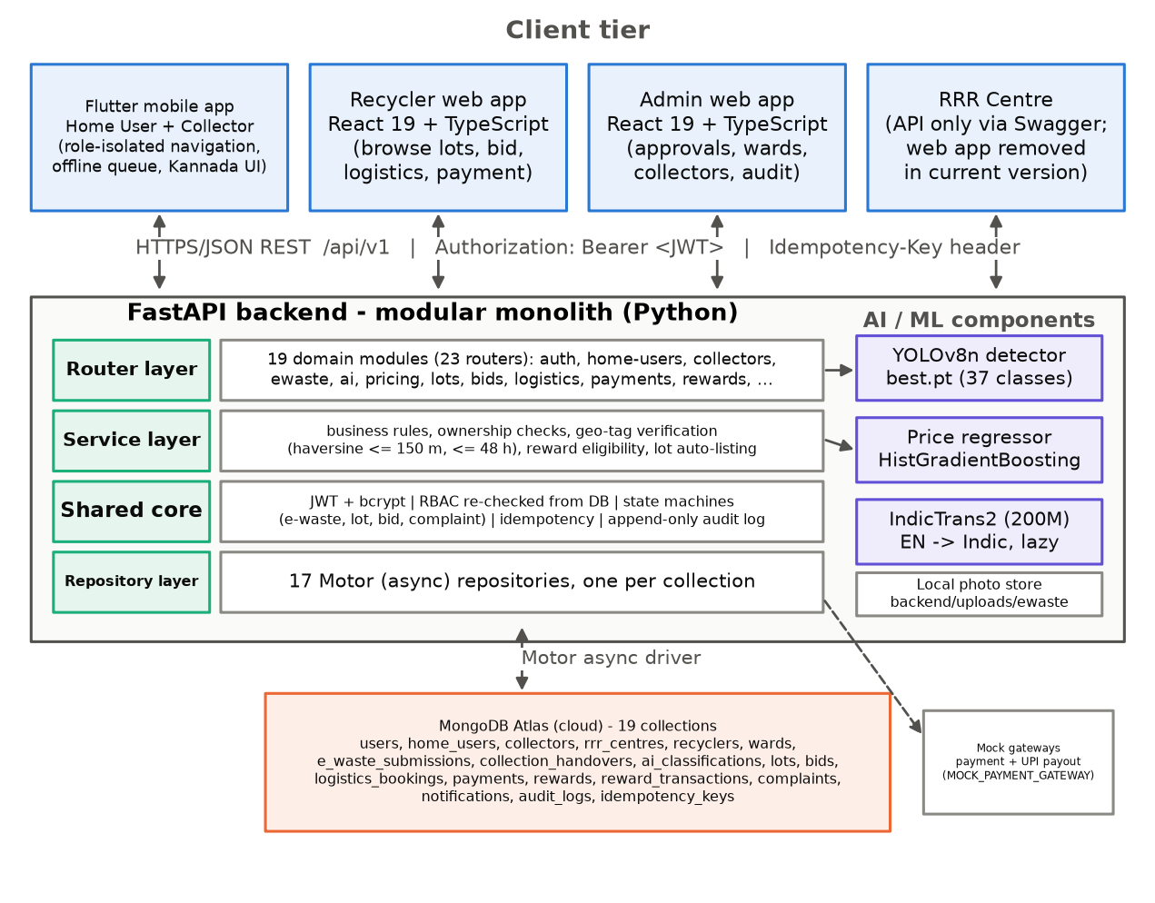
Fig. 1. System architecture of Kabadiwala Connect 2.0.

3.2 Functional Requirements
Table 5. Functional requirements and implementation status.
ID | Requirement | Role(s) | Status
FR1 | Register (home user, RRR centre, recycler) and log in with JWT access and refresh tokens | All | Done
FR2 | Admin creates collector accounts (employee ID as username) and assigns RRR and ward | Admin | Done
FR3 | Upload an item photo (JPEG/PNG/WebP, ≤ 10 MB) and get an AI-detected category | Home User, Collector | Done
FR4 | Get a price estimate from product type, condition, quantity, weight and location | Home User | Done
FR5 | Create a pickup submission with GPS location; queue it offline when the network fails | Home User | Done
FR6 | View the ward pickup queue, accept a pickup and record a geo-tagged handover with actual weight | Collector | Done
FR7 | Automatically list a verified item as a single-item lot owned by the collector | System | Done
FR8 | Receive items, classify (AI or manual) and create/publish lots | RRR Centre (API) | Done (no web UI)
FR9 | Browse listed lots, place and cancel bids | Recycler | Done
FR10 | Accept one bid per lot; cancel acceptance within 24 h and before payment | RRR Centre, Collector (own lot) | Done
FR11 | Book a logistics slot, confirm collection and pay through the mock gateway | Recycler | Done
FR12 | Compute monthly rewards and redeem to UPI through a mock payout | Admin, Home User | Done
FR13 | File complaints and review them | All / Admin | Done
FR14 | In-app notifications (list, unread count, mark read) | Home User, Collector, Recycler | Done
FR15 | View price trend for an item from accepted bids (90-day window) | Home User, Collector | Done
FR16 | Approve or reject RRR centres and recyclers; manage wards; view audit logs and dashboards | Admin | Done
FR17 | Translate interface text (English → Indian languages) | Home User | API done; mobile uses a static Kannada table

3.3 Non-Functional Requirements
Table 6. Non-functional requirements.
Category | Requirement | How it is met
Security | Passwords never stored in plain text; tokens expire | bcrypt hashing; access token 15 min, refresh 7 days (HS256 JWT)
Security | A changed or disabled account must lose access at once | RBAC dependency re-reads role and status from the database on each request
Security | Secrets kept out of code | Read from environment (.env, git-ignored); startup warns if demo defaults are active
Reliability | Retries must not duplicate submissions, bids or payments | Partly met: Idempotency-Key header + cached response per user and scope on 17 of 45 state-changing operations, including submissions, bids and payments; the other 28 (e.g. registration, profile updates, approvals, complaints, notification reads) take no key (open)
Data integrity | Only valid status changes | Allow-list state machines; invalid pairs raise INVALID_STATE_TRANSITION
Data integrity | Money without rounding drift | Decimal arithmetic for money and estimate totals
Availability | AI failure must not block the workflow | Classifier errors or low confidence route to NEEDS_REVIEW; manual path stays open
Usability | Works with weak mobile connectivity | Offline submission queue in the Flutter app, replayed with the same idempotency key
Usability | Local language | Kannada UI strings in the app; IndicTrans2 endpoint in the backend
Privacy | Household location not exposed to recyclers | Met since 12 Oct 2026: recycler lot responses now pass through an allow-list that keeps only submission_id and actual_weight_kg for each item; 4 regression tests (Section 6.2, issue 7)
Maintainability | Clear layering and tests | Router/service/repository layers; 412 backend tests
Performance | Interactive item detection | YOLOv8n: about 59 ms per image on a laptop CPU (measured)

3.4 Use-Case Diagram
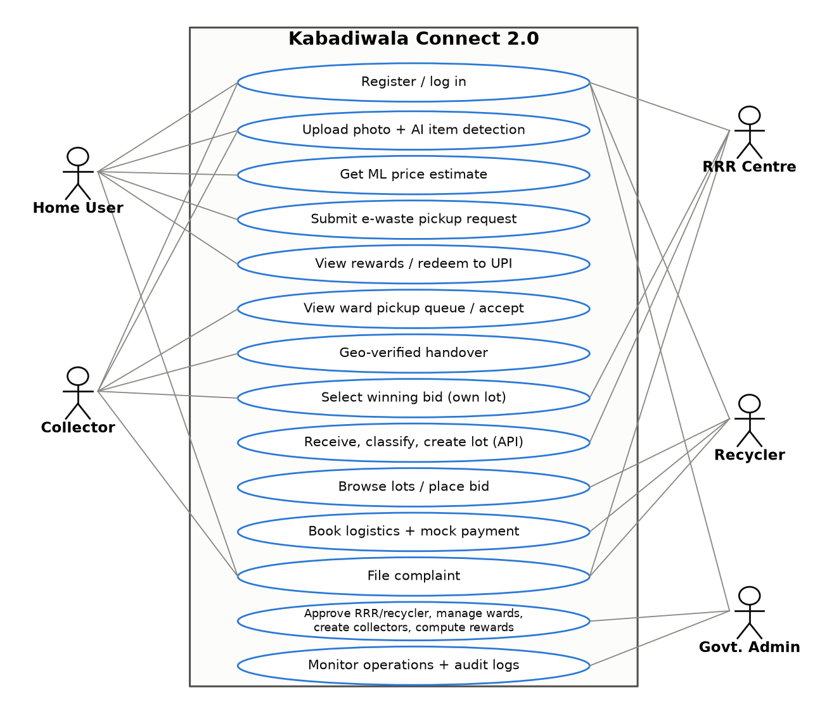
Fig. 2. Use-case diagram showing the five actors and their main use cases.

3.5 Data Flow Diagrams
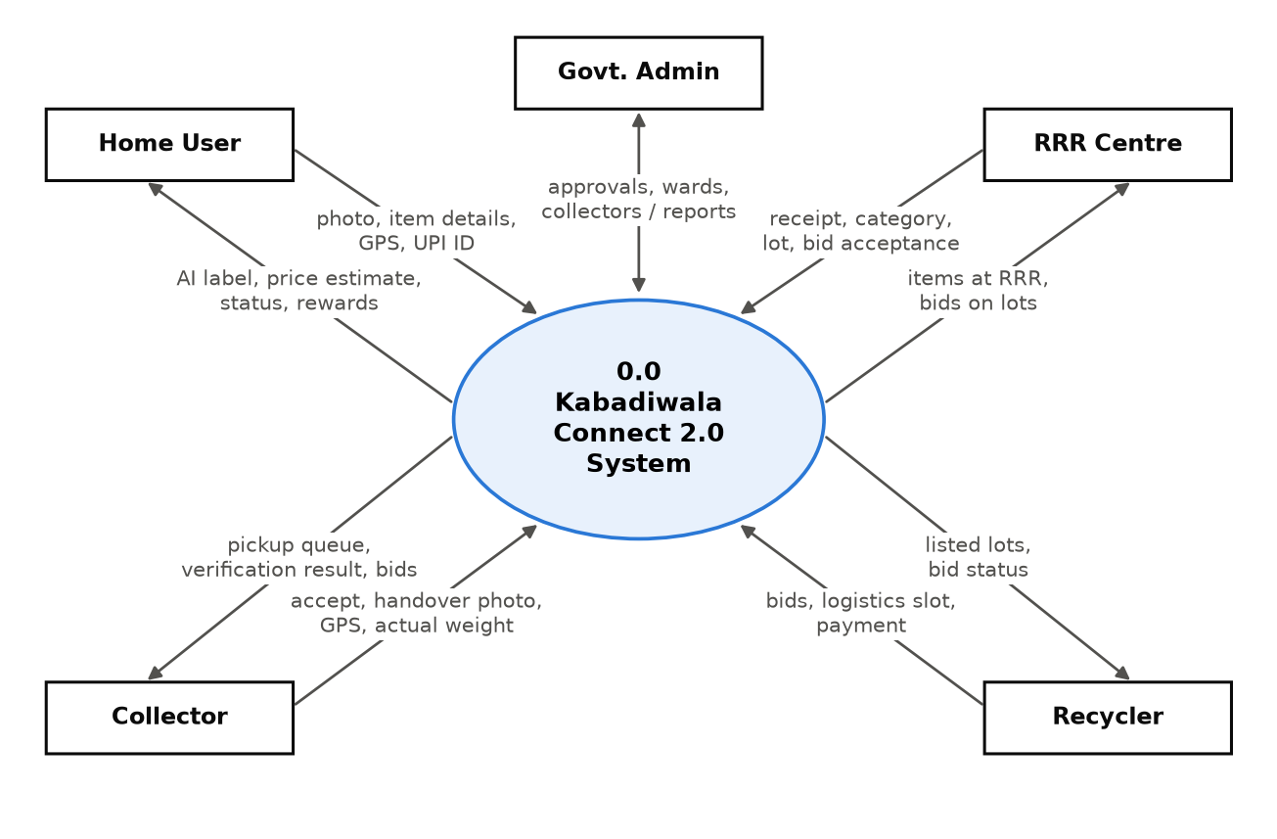
Fig. 3. Data flow diagram, Level 0 (context diagram).
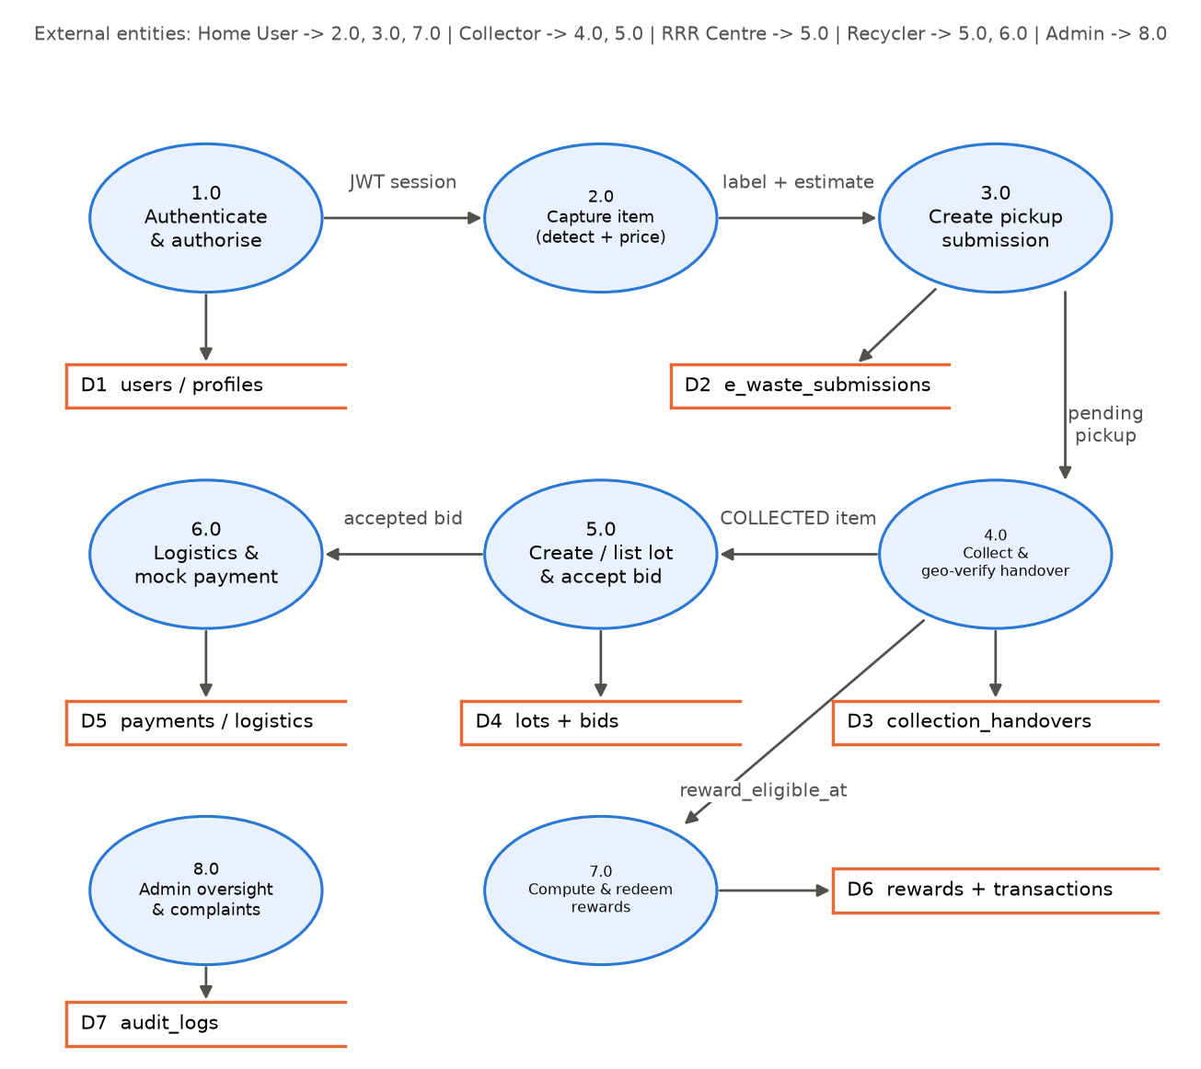
Fig. 4. Data flow diagram, Level 1.

3.6 E-Waste Item Lifecycle (State Machine)
Every e-waste item follows the states below. The backend file app/state_machines/ewaste_states.py holds the full allow-list of 26 permitted transitions; any other change is rejected. The two side branches matter most at review: a failed geo check goes to FLAGGED_FOR_REVIEW, and a low-confidence AI result goes to NEEDS_REVIEW.
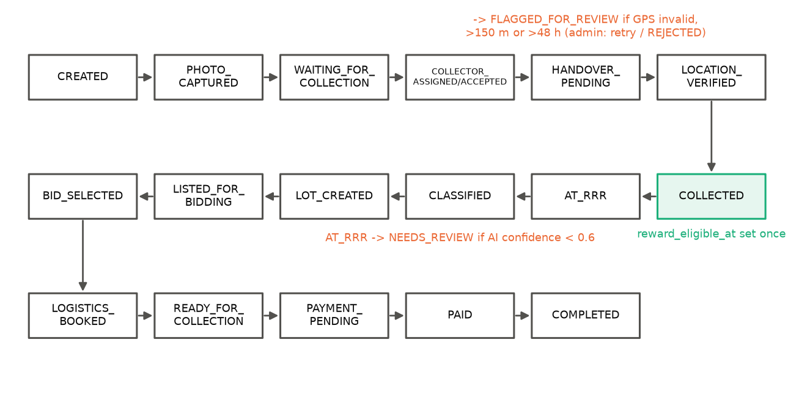
Fig. 5. Main path of the e-waste item state machine with its two review branches.

3.7 Role and Permission Matrix
Table 7. Role and permission matrix (“own” is enforced by ownership checks in the service layer).
Action | Home User | Collector | RRR Centre | Recycler | Admin
Submit e-waste / get estimate | Own | – | – | – | –
Upload photo + AI detection | Yes | Yes | – | – | –
Accept pickup, record handover | – | Own ward | – | – | –
Receive / classify / create lot | – | – | Own ward | – | –
Accept bid on a lot | – | Own auto-lot | Own lot | – | –
Place / cancel bid | – | – | – | Own bids | –
Book logistics / pay | – | – | – | Own accepted lot | –
View / redeem rewards | Own | – | – | – | Compute
Approvals, wards, collectors, audit logs | – | – | – | – | Yes

3.8 Key Design Decisions
- Object detection instead of whole-image classification. The training dataset ships with bounding boxes and about 8% of its images contain more than one device (ewaste_ml/README.md). A detector uses that information, and its highest-confidence box still gives a single category for the common one-item photo.
- HistGradientBoosting for price. Five regressors were compared on a time-ordered validation split; this model had the lowest MAE and RMSE and the highest R² (Section 4.3).
- Database-enforced rules where a race is possible. For example, a partial unique index on bids.lot_id for status ACCEPTED means two acceptances for the same lot cannot both succeed, whatever the application code does.
- Mocks that say they are mocks. Payment and UPI payout are deterministic hash-based mocks, labelled MOCK_PAYMENT_GATEWAY in every record and response, so the demo never pretends to move real money.

4. Module-Wise Development Progress
Status meanings: Complete – implemented and covered by passing tests run on 12 Oct 2026; Complete* – implemented, last test record older than the latest code; Partial – works but with a known gap; Not started.
Table 8. Module-wise implementation status.
Module | What it contains | Status | Evidence
Auth & RBAC | Login, refresh, logout, /me; bcrypt; JWT; DB re-check of role | Complete | test_auth_api, test_security*, test_rbac_core
Wards, Home users, Collectors | Registration, profiles, preferences, admin-created collectors | Complete | test_wards/home_users/collectors_api
RRR centres, Recyclers | Registration, admin approval/rejection | Complete | test_rrr_centres_api, test_recyclers_api
E-waste submission & handover | Photo upload, submission, accept, geo-verified handover, receive | Complete | test_ewaste_api (35 tests), test_geo
Collector auto-lot | Verified handover becomes a listed single-item lot | Complete | test_collector_lot_workflow
AI classification | YOLOv8n detector, classify-photo and RRR classify endpoints | Complete (integration) | test_classification_api (mock classifier); model metrics in 4.3
Pricing | ML estimate, RRR predict endpoint, price trend | Partial | test_pricing_*, test_price_*; vocabulary gap (Section 6.3)
Lots & bids | Create, publish, place, cancel, accept, cancel-acceptance; household data filtered from recycler views | Complete | test_lots_api, test_bids_api, test_lot_recycler_privacy, state tests
Logistics & payments | Booking, collection confirmation, mock gateway | Complete | test_logistics_api, test_payments_api
Rewards | Monthly compute, ledger, mock UPI redemption | Complete | test_rewards_api, reward race test
Complaints, notifications, audit | Complaint workflow, in-app notifications, append-only log | Complete | test_complaints/notifications_api
Translation (backend) | IndicTrans2 endpoints, lazy model load | Partial | API tests use a fake model; real model not run in this review
Flutter mobile app | Home User and Collector screens, offline queue, Kannada | Complete | flutter test 153/153 (12 Oct 2026)
Recycler web app | Login, register, dashboard, browse lots, lot detail, my bids | Complete* | Vitest 45/45 (unverified historical evidence: reported in PROJECT_STATUS.md; no run log and no run date recorded); build present
Admin web app | Dashboard, RRR, recyclers, collectors, wards, operations, lots & bids, rewards, complaints, audit logs | Complete* | Vitest 50/50 (unverified historical evidence: reported in PROJECT_STATUS.md; no run log and no run date recorded); build present
RRR-centre web app | Removed in this version; workflow available through API/Swagger | Removed | docs/ARCHITECTURE.md folder note
APK / deployment | Debug APK built 26 Sep 2026; deployment and APK guides | Partial | Not yet installed and run on a real device

4.1 Backend (FastAPI)
The backend is written in Python with FastAPI 0.115, Pydantic 2 and the Motor 3.5 async MongoDB driver. It exposes 86 endpoints under /api/v1, grouped into 19 modules. Errors follow one structured format (success, error_code, message), so every client can show a clear reason. Swagger UI is available for testing and is also how the RRR-centre workflow is demonstrated in this version.
The handover check is the core of trust in the system. When a collector records a handover, the service checks that both GPS readings are valid (missing, out-of-range and (0, 0) values are rejected), that the collector’s timestamp is after the submission and within 48 hours, and that the haversine distance between household and collector is at most 150 m. If all checks pass, the item becomes COLLECTED and its reward_eligible_at time is written once. If any check fails, the item becomes FLAGGED_FOR_REVIEW and the reasons are stored for the admin.

4.2 Client Applications
Flutter mobile app. One code base serves both mobile roles, but the role decides which screens are built after login, and the backend independently rejects calls from the wrong role. Home-user screens: register, login, home, submit e-waste (photo, AI detection, price estimate), submissions list and detail, rewards, financial history, notifications, profile and settings. Collector screens: home, pending queue, accepted collections, handover, and lot detail (to choose the winning bid on an auto-listed lot). Packages used include geolocator, image_picker, flutter_secure_storage, connectivity_plus and provider.
Recycler web app (React 19, TypeScript, Vite): login, registration, dashboard, browse listed lots, lot detail (bid, logistics booking, payment) and my bids. Admin web app: dashboard summary, RRR centres, recyclers, collectors, wards, operations (submissions and handovers), lots and bids, rewards, complaints and audit logs.

4.3 AI and ML Modules
The project uses three AI/ML components. It is important to describe them correctly at the review:
Table 9. AI/ML components in the project.
Component | Type | Trained by the team? | Where it is used
YOLOv8n e-waste detector | Deep learning (convolutional object detector) | Yes – fine-tuned on 37 classes | Photo upload (Home User, Collector); RRR AI classify
Collector price model | Classical machine learning (gradient-boosted decision trees) | Yes – on a synthetic dataset | Price estimate (Home User); RRR price prediction
IndicTrans2 (200M distilled) | Deep learning (pre-trained transformer) | No – used as published | Backend translation endpoints

4.3.1 Image detection model
The detector was trained in a separate project folder (ewaste_ml) and copied into backend/ai/detection/weights/best.pt. The two files have the same MD5 hash, so the metrics below belong to the model that the app actually uses. Training used the Roboflow “Balanced E-Waste Dataset”, version 3 [17], licensed CC BY 4.0. After 104 images duplicated across splits were removed, 7,163 images remained (4,990 train, 1,415 validation, 758 test), all 640×640, covering 37 device classes with roughly 200 images each.
Table 10. YOLOv8n training configuration.
Setting | Value (from train.py and args.yaml of run ewaste_yolov8n5)
Base model | yolov8n.pt (pre-trained on COCO), 3,012,863 parameters after fusion, 8.1 GFLOPs
Epochs / image size / batch | 20 / 640 / 16, early-stopping patience 10, mixed precision (AMP)
Augmentation | rotation ±10°, translate 0.1, scale 0.5, shear 2.0, horizontal flip 0.5, mosaic 1.0, mixup 0.1, HSV jitter
Hardware | GPU device 0 (model not recorded) [TO FILL: GPU name]; total training time about 58 min (results.csv)

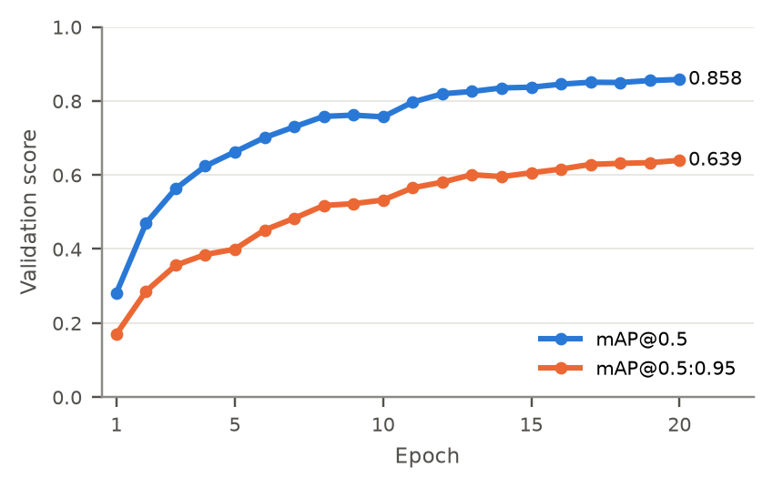
Fig. 6. Validation mAP of the YOLOv8n detector over 20 training epochs (run ewaste_yolov8n5).
The curves are still rising slightly at epoch 20, so a longer run may improve the model. The project capped training at 20 epochs.
Table 11. Detection results of the integrated model.
Split | Images | Precision | Recall | mAP@0.5 | mAP@0.5:0.95 | Source
Validation (epoch 20) | 1,415 | 0.850 | 0.813 | 0.858 | 0.639 | results.csv from training
Test (held out) | 758 | 0.868 | 0.822 | 0.876 | 0.653 | Evaluated 12 Oct 2026 (evidence folder)

The test-split numbers were produced during preparation of this report by running Ultralytics validation on a copy of the 758 test images (script and log in evidence/). Please re-run the script once yourself so you can show the output live if the examiner asks.

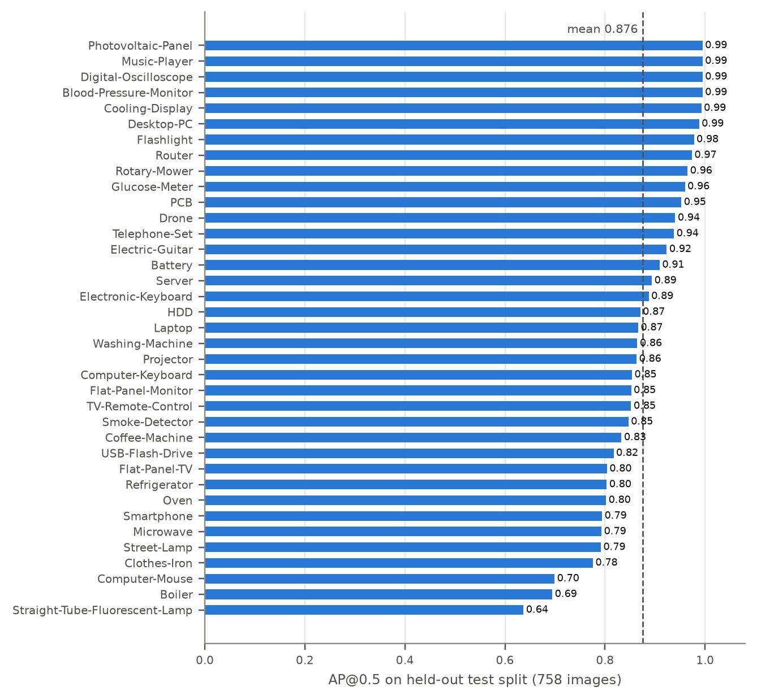
Fig. 7. Per-class AP@0.5 on the held-out test split. The dashed line is the mean.
Weak classes are long thin objects and small or low-contrast items: straight-tube fluorescent lamp (0.64), boiler (0.69) and computer mouse (0.70, recall only 0.45). These are honest limitations to mention.
How the detector is used in the app. The backend runs the model on the uploaded photo, takes the detection with the highest confidence and maps its label to a coarse category (batteries, circuit-boards, otherwise e-waste-small-appliances). If no object is found or the confidence is below 0.6, the result is marked “needs review” and the user or RRR staff confirms the category manually. The mobile app shows the detected item name and pre-fills the category field, which the user can still edit. Eleven real photos in ai/detection/test_image were run through the model (outputs in runs/detect/predict); no ground-truth labels exist for them, so they are a qualitative check only. [TO FILL: one or two sentences on what you observed in those real photos].

4.3.2 Price estimation model
The price model predicts the collector price per kilogram from five inputs: material, condition, quantity, weight and location. A feature weight_per_item is derived, categorical inputs are one-hot encoded, and five regressors were compared [14]. The data are split by date (60% train, 20% validation, 20% final test), so the model is always tested on later dates than it was trained on. The selected model is a HistGradientBoostingRegressor (250 iterations, learning rate 0.05, L2 regularisation 1.0), a gradient-boosted tree ensemble [12], [13]. After selection it was refitted on train + validation data and evaluated once on the final test period.
Important: all 6,000 rows in price_training_demo_dataset.csv are labelled SYNTHETIC_DEMO_DATA. The results below show that the pipeline learns the pattern in that data; they do not show accuracy against real scrap prices. Say this clearly at the review.

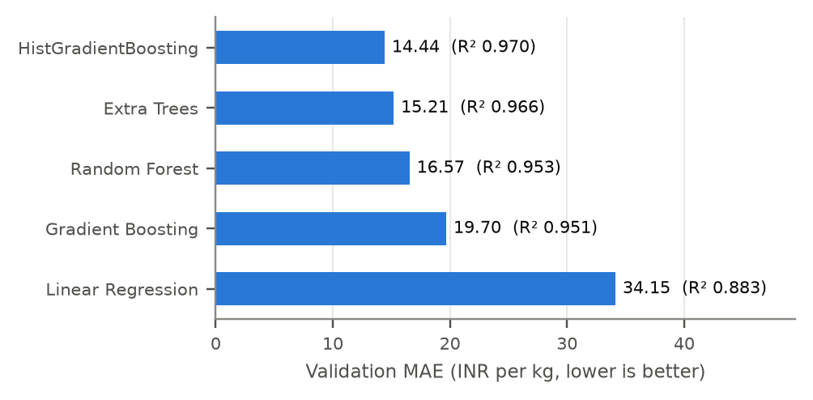
Fig. 8. Validation MAE of the five candidate price models (R² in brackets).
Table 12. Selected price model (HistGradientBoosting) on synthetic data.
Partition | Rows | Date range | MAE (₹/kg) | RMSE (₹/kg) | R²
Validation | 1,228 | 2025-08-08 to 2026-02-18 | 14.44 | 23.13 | 0.970
Final test | 1,179 | 2026-02-19 to 2026-09-01 | 21.85 | 32.20 | 0.952

A 90% prediction interval was also calibrated in the training project using out-of-fold residuals (validation coverage 0.931, final-test coverage 0.869). This interval is not used by the backend yet; the app currently shows a fixed ±10% band around the prediction. Separately, the price-trend feature does not use the ML model at all: it averages real accepted bid prices (₹/kg) per day over the last 90 days and reports “increasing”, “decreasing”, “stable” (change under 5%) or “insufficient data” (fewer than 4 days).

4.3.3 Translation
The backend exposes /api/v1/translation endpoints that lazily load the ai4bharat/indictrans2-en-indic-dist-200M model [15] and list 25 target languages. The mobile app does not call this API; it switches between English and a built-in Kannada string table. The translation tests replace the model with a fake, so real translation quality has not been measured in this project.

5. Database Design and Backend Integration

5.1 Collections
The backend uses one MongoDB database with 19 collections. The connection string is read from the environment and points to a MongoDB Atlas cluster (mongodb+srv scheme); credentials are not reproduced in this report. All indexes are created at start-up by app/db/mongo.py.
Table 13. MongoDB collections.
Collection | Purpose | Important keys and indexes
users | Login identity for every role | username unique; role
home_users, collectors, rrr_centres, recyclers | Role profiles | user_id unique; employee_id, rrr_id, tender_id, license_id unique
wards | Municipal wards | ward_id unique; one RRR centre per ward
e_waste_submissions | Household submission and item lifecycle | submission_id unique; (home_user_id, status); (ward_id, status)
collection_handovers | Geo-tagged handover evidence | submission_id unique (one handover per item)
ai_classifications | Every AI or manual classification attempt (append-only) | item_id; classification_id partial unique
lots | Sellable lots (RRR- or collector-owned) | lot_id unique; (rrr_id, status)
bids | Recycler bids | bid_id unique; partial unique on lot_id where status = ACCEPTED
logistics_bookings | Collection slot per lot | booking_id unique; lot_id unique
payments | Mock payments | payment_id unique; idempotency_key unique
rewards, reward_transactions | Monthly rewards and ledger | (home_user_id, period) unique; txn_id unique
complaints, notifications | Complaints and in-app messages | complaint_id unique; (user_id, read)
audit_logs | Append-only event log | (entity_type, entity_id); timestamp
idempotency_keys | Cached responses for retried requests | per user, key and scope

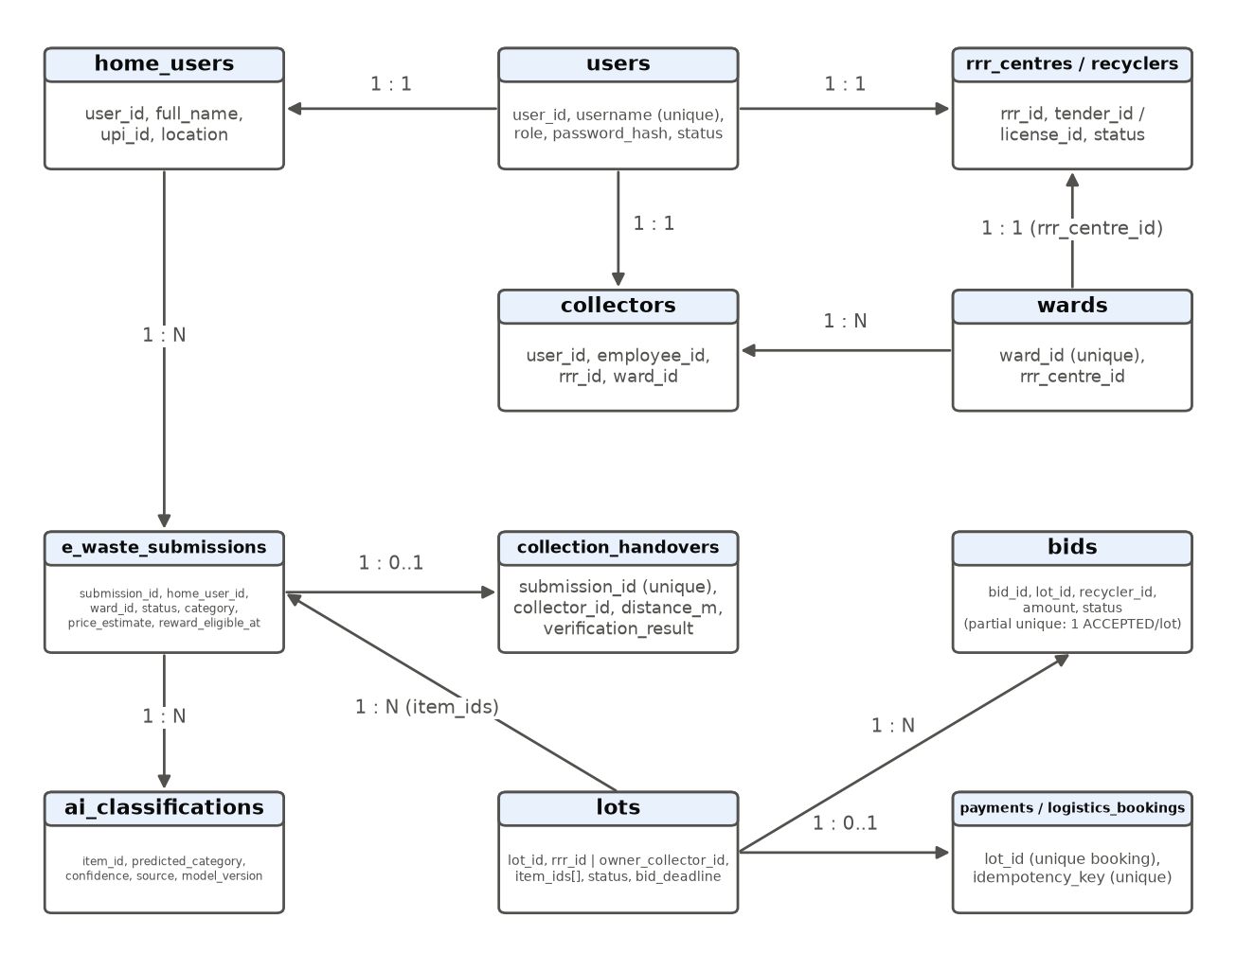
Fig. 9. Main collections and their relationships.

5.2 Integrity Mechanisms
- One handover per item: unique index on collection_handovers.submission_id; a duplicate returns DUPLICATE_HANDOVER.
- One winner per lot: partial unique index on bids.lot_id for ACCEPTED bids; the losing request gets LOT_ALREADY_ACCEPTED.
- Household data hidden from recyclers (added 12 Oct 2026): recycler lot responses now pass through an allow-list that keeps only submission_id and actual_weight_kg for each item; lot owners and the admin still see the full handover evidence.
- No double reward: unique (home_user_id, period) on rewards, and reward_eligible_at can only be written when empty.
- No duplicate payments: unique payments.idempotency_key; replaying the same key returns the original result.
- History is kept: classifications and audit logs are inserted, never overwritten; no API exists to delete audit logs.

5.3 API Summary
Table 14. API summary (full list in Swagger at /docs).
Module (prefix /api/v1) | Main endpoints | Roles
auth | POST login, refresh, logout; GET me | All
home-users | POST register; GET/PATCH me; PATCH me/preferences; POST me/deactivate | Home User
ewaste | POST photos, submissions; GET submissions (+ pending, assigned, handed-over, awaiting-receipt, ...); POST {id}/accept, handover, receive, classify | Home User, Collector, RRR
ai | POST classify-photo; POST classify/{submission_id} | Home User, Collector / RRR
pricing | POST estimate; POST predict; GET trend | Home User / RRR / Home User, Collector
lots, bids | POST lots, {id}/publish; GET listed, {id}, {id}/bids; POST bids, {id}/cancel, accept, cancel-acceptance | RRR, Recycler, Collector
logistics, payments | POST {lot}/book, {booking}/confirm-collection; POST {lot}/initiate; GET lot/{lot} | Recycler, Admin
rewards | GET mine, transactions/mine, summary; POST {id}/redeem; admin compute and list | Home User, Admin
admin, wards, audit-logs | dashboard summary; approvals; collector create/update/status; wards; audit logs | Admin
complaints, notifications, translation | create/list/review complaints; list/read notifications; translate | Various

5.4 End-to-End Integration Flow
1. Home user uploads a photo (POST /ewaste/photos), then calls POST /ai/classify-photo; YOLOv8n returns the detected item.
2. The user optionally asks for a price (POST /pricing/estimate) and submits the pickup with GPS (POST /ewaste/submissions).
3. A collector of the same ward sees it in the pending queue, accepts it, and records the handover with photo, GPS and actual weight.
4. The backend verifies distance and time. If verified, the item becomes COLLECTED, the reward eligibility time is stored, and the item is auto-listed as a lot for bidding.
5. Recyclers bid on the lot in the recycler web app; the lot owner accepts one bid.
6. The recycler books logistics, confirms collection and pays through the mock gateway; the admin marks the lot COMPLETED.
7. At month end the admin computes rewards; the home user redeems them to UPI through the mock payout.
This chain is covered by tests/integration/test_end_to_end_flow.py (home-user registration to a redeemed reward), which passed in the 12 October 2026 run.

6. Quality of Initial Deliverables

6.1 Testing Evidence
Table 15. Test evidence. Logs are in the evidence folder; the two web rows have no log and are unverified.
Suite | Tests | Result | Date | Notes
Backend pytest, before privacy fix | 408 | 408 passed | 12 Oct 2026 | In-memory mongomock database; 6 min 58 s
Backend pytest, after privacy fix | 412 | 412 passed | 12 Oct 2026 | Includes 4 new privacy tests; run on a copy of the patched source; 4 min 23 s
Flutter (unit + widget) | 153 | 153 passed | 12 Oct 2026 | Run on a copy of mobile/lib and mobile/test
recycler-web (Vitest) | 45 reported (48 test cases in code now) | 45/45 passed (reported) | Not recorded | Unverified historical evidence from PROJECT_STATUS.md; could not re-run on 12 Oct: Node 20 vs jsdom 30
admin-web (Vitest) | 50 reported (42 test cases in code now) | 50/50 passed (reported) | Not recorded | Unverified historical evidence from PROJECT_STATUS.md; same environment issue
YOLOv8n test split | 758 images | mAP@0.5 0.876 | 12 Oct 2026 | Ultralytics validation, CPU
Price model final test | 1,179 rows | R² 0.952 | Training run | Synthetic data

Backend test files cover the areas examiners usually ask about: role isolation across all roles (test_cross_role_isolation, test_security_rbac_matrix), input validation, idempotency scoping, a reward-redemption race, state-machine tables and the full lifecycle. Note that the AI integration tests use a deterministic mock classifier, so they test the workflow around the model, not the model itself; the model is evaluated separately (Section 4.3).

6.2 Issues Found During This Review
Inspecting the code for this report revealed issues that are not caught by the tests. Reporting them openly is better than having the examiner find them. Issue 7 has since been fixed and verified; issues 1–6 and 8 are still open.
Table 16. Integration issues identified (evidence: price_model_input_probe in the evidence folder). Issue 7 fixed; issues 1–6 and 8 open.
# | Issue | Effect | Suggested fix / status
1 | Only 3 of the 37 detector labels (Battery, Laptop, Router) match a material name known to the price model | Unknown materials are ignored by the encoder; e.g. “Smartphone” and “Refrigerator” both get ₹199.48/kg | Add a mapping table from detector labels to price-model materials
2 | Mobile condition options (New, Like New, Good, Used, Damaged, Non-Working) differ from training values (Working, Partially-Working, Non-Working, Damaged) | “Good” laptop gets ₹222.51/kg while “Working” gets ₹475.09/kg | Use the four training values in the dropdown, or map them
3 | Location sent to the price model is a geocoded place name or ward ID, while the model knows 11 city names | Location usually has no effect on the estimate | Send the city name; retrain with ward-level data later
4 | get_classifier() loads the YOLO weights on every request | Slower responses under load | Load the model once at start-up
5 | Detector labels other than battery/PCB all map to one category | Lots for large appliances share a category with small items | Extend the category mapping
6 | Calibrated 90% price interval not used in backend | Displayed range is a fixed ±10% | Load price_range_calibration.joblib
7 | Recycler lot endpoints (GET /lots/listed, GET /lots/{id}) return item_details with home_user_id and the collector’s GPS taken within 150 m of the house | Recyclers can infer the household’s approximate location; contradicts the design’s privacy rule | FIXED 12 Oct 2026: allow-list in lots/service.py keeps only submission_id and actual_weight_kg for recyclers; 4 regression tests; full suite 412/412
8 | Only 17 of 45 state-changing operations require an Idempotency-Key (verified from the OpenAPI schema; list in evidence/idempotency_coverage_2026-10-12.txt) | Retried calls such as registration, profile updates, approvals, complaint creation or notification reads are not protected by the key mechanism; whether each is otherwise safe to repeat has not been reviewed | Review the 28 remaining operations; add keys where a repeat could cause harm (open)

Verification of the issue 7 fix. The change is limited to backend/app/modules/lots/service.py: a new _recycler_view() function is applied to GET /api/v1/lots/listed and, for the RECYCLER role, to GET /api/v1/lots/{lot_id}. The new test file tests/integration/test_lot_recycler_privacy.py has four tests: the two recycler tests failed before the change (they reported home_user_id, collector_id, collector_lat, collector_lng, collection_ts and collection_photo_file_id as leaked) and passed after it, and two further tests confirm that the collector who owns the lot and the admin still receive the full handover evidence. The full suite then passed 412 of 412. The handover verification itself was not changed. Recyclers still see the lot’s ward, category, weights, deadline and the owning collector’s internal ID. The recycler web app’s TypeScript type still lists the removed fields; this has no runtime effect because the page only counts the items. Evidence and a copy of the original file are in second_review_deliverables/privacy_fix_proposal/.

6.3 Deliverables Available
- Source code: backend, mobile (Flutter), recycler-web, admin-web; ML training projects ewaste_ml and price_ml.
- Built artefacts: debug APK (mobile/build/app/outputs/flutter-apk/app-debug.apk, built 26 Sep 2026); production builds in recycler-web/dist and admin-web/dist.
- Documentation: ARCHITECTURE.md, SETUP_GUIDE.md, TESTING_GUIDE.md, DEPLOYMENT_GUIDE.md, APK_BUILD_GUIDE.md, PROJECT_STATUS.md.
- This report, the viva preparation document and the research paper rough draft.

6.4 Screenshots to Capture
Screenshots cannot be generated from the repository. Capture the following from the running system and paste them into the boxes below (or into your slides). Use demo accounts only and blur any real phone numbers or UPI IDs.
[SCREENSHOT TO INSERT: capture login_screen.dart]
Fig. 10. Mobile – login screen with Home User / Collector selector
[SCREENSHOT TO INSERT: capture submit_ewaste_screen.dart after AI detection]
Fig. 11. Mobile – submit e-waste: photo with detected item name and confidence
[SCREENSHOT TO INSERT: capture submit_ewaste_screen.dart after 'Estimate price']
Fig. 12. Mobile – price estimate card (range and total)
[SCREENSHOT TO INSERT: capture collector_pending_queue_screen.dart / collector_handover_screen.dart]
Fig. 13. Mobile – Collector pending queue and handover screen
[SCREENSHOT TO INSERT: capture rewards_screen.dart with Kannada selected]
Fig. 14. Mobile – rewards screen and Kannada interface
[SCREENSHOT TO INSERT: capture recycler-web /lots and /lots/:lotId]
Fig. 15. Recycler web – browse lots and lot detail with bid form
[SCREENSHOT TO INSERT: capture admin-web / and /audit-logs]
Fig. 16. Admin web – dashboard summary and audit log page
[SCREENSHOT TO INSERT: capture http://localhost:8000/docs]
Fig. 17. Swagger UI – list of API modules
[SCREENSHOT TO INSERT: capture Atlas Data Explorer]
Fig. 18. MongoDB Atlas – collections list (hide the connection string)

7. Limitations, Pending Work and Next Steps

7.1 Limitations
- The price model is trained only on synthetic data; real price accuracy is unknown.
- Payments and UPI payouts are mocks; no real money moves.
- GPS-based verification can be fooled by location-spoofing apps; the system calls it “geo-tag based verification” and sends doubtful cases to human review rather than claiming it is tamper-proof.
- Detector accuracy is lower on lamps, boilers and computer mice, and real-world photos have not been labelled for a proper field test.
- The RRR-centre role has no web interface in this version.
- The household-data fix (Section 6.2, issue 7) has been verified only against the in-memory test database, not a running deployment on MongoDB Atlas.
- The tests run on an in-memory database (mongomock); behaviour of unique indexes under true concurrency on Atlas has not been load-tested.
- The APK has been built but not yet installed and run on a physical phone.

7.2 Plan Until the Final Review
Table 17. Pending work.
# | Task | Priority | Target date
1 | Fix the three vocabulary mismatches (Section 6.2, issues 1–3) and add tests for them | High | [TO FILL]
2 | Remove item_details (home_user_id, GPS) from recycler lot responses and add tests – done (4 tests; 412/412) | Done | 12 Oct 2026
3 | Load the YOLO model once at start-up | High | [TO FILL]
4 | Install the APK on a real Android phone and test the full flow on the same Wi-Fi as the backend | High | [TO FILL]
5 | Re-run web tests with Node.js 22 and record the results | Medium | [TO FILL]
6 | Collect a small set of real scrap prices (with source and date) to evaluate or retrain the price model | Medium | [TO FILL]
7 | Label 50–100 real phone photos to measure detector accuracy outside the dataset | Medium | [TO FILL]
8 | Use the calibrated price interval instead of the fixed ±10% band | Low | [TO FILL]
9 | Complete the research paper (results, author details) and submit | High | [TO FILL]
10 | Review the 28 state-changing operations without an Idempotency-Key and add keys where needed (Section 6.2, issue 8) | Medium | [TO FILL]

8. Simple Explanation for the Presentation
Use the explanation below as the spoken outline for a 7–10 minute presentation. It avoids jargon on purpose.
1. The problem. Old phones, chargers and keyboards pile up at home. When people sell them to a kabadiwala, nobody knows where they end up, and the seller does not know the right price.
2. Our idea. Keep the kabadiwala, but make every step digital and checkable. The household takes a photo in our app; the app recognises the item and suggests a price; a collector picks it up; the system checks that the collector really was at the house; then recyclers bid for it in an open auction.
3. How it is built. One backend server (FastAPI, Python) holds all the rules and talks to a MongoDB Atlas database. A Flutter mobile app is used by households and collectors. Recyclers and the Government Admin use web apps built in React.
4. The AI part. For photos we trained a YOLOv8n object detector on 37 types of e-waste. On 758 test photos it found the right item with mAP@0.5 of 0.876. For price we trained a gradient-boosting model. It works well on our demo data, but that data is synthetic, so we treat the price as an estimate only.
5. Trust and safety. Distance and time are checked when the collector hands over the item. Only one bid can win a lot, enforced by the database. Every important action is logged. Recyclers do not receive the household’s ID or location; a leak of this data found during the review was fixed and is covered by tests.
6. Testing. 412 backend tests (including 4 new privacy tests) and 153 mobile tests passed on 12 October 2026.
7. What is left. Real-phone testing, matching the item names between the detector and the price model, real price data, and finishing the research paper.

9. Research Paper Rough Draft
Item 7 of the review notice asks for a research paper rough draft. It has been prepared separately as Kabadiwala_Connect_Research_Paper_Rough_Draft.docx using the supplied IEEE template, and contains all eleven required sections from Title to References.

Appendix A – Review Requirements Checklist
Table 18. Mapping of review requirements to this report.
Requirement in review notice | Where it is addressed
1. Refinement of problem statement & objectives | Section 1
2. Literature review / existing system study | Section 2
3. System architecture & design models | Section 3 (architecture, use case, DFD L0/L1, state machine, role matrix)
4. Module-wise development progress | Section 4
5. Database design / backend integration | Section 5
6. Quality of initial deliverables | Section 6
7. Research paper – rough draft | Section 9 and separate file
Substantial progress from first review | “Progress Since the First Review” table (left column to be completed)

Appendix B – Evidence Files
Table 19. Evidence used in this report.
File (second_review_deliverables/evidence) | Content
backend_pytest_2026-10-12.txt | Backend test run before the privacy fix: 408 passed
../privacy_fix_proposal/backend_pytest_after_fix_2026-10-12.txt | Backend test run after the privacy fix: 412 passed
../privacy_fix_proposal/validation_results.txt, lots_service_privacy.diff, test_lot_recycler_privacy.py | Privacy fix: before/after test results, code change and new tests
flutter_test_2026-10-12.txt | Flutter test run: 153 passed
web_vitest_attempt_2026-10-12.txt | Why the web tests could not start (Node version)
yolo_test_split_eval_2026-10-12.txt / .json | Test-split detection metrics, per class
yolo_test_eval_script.py | Script used for the detection evaluation
price_model_input_probe_2026-10-12.txt | Price predictions for known and unseen inputs
idempotency_coverage_2026-10-12.txt | Which of the 45 state-changing operations require an Idempotency-Key (17)
ewaste_ml/runs/detect/ewaste_yolov8n5/results.csv | Training and validation curves (original location)
price_ml(working)/outputs/*.csv | Price model comparison, evaluation and calibration reports (original location)

References
[1] C. P. Baldé, R. Kuehr, T. Yamamoto, R. McDonald, E. D’Angelo, S. Althaf, G. Bel, O. Deubzer, E. Fernandez-Cubillo, V. Forti, V. Gray, S. Herat, S. Honda, G. Iattoni, D. S. Khetriwal, V. Luda di Cortemiglia, Y. Lobuntsova, I. Nnorom, N. Pralat, and M. Wagner, The Global E-waste Monitor 2024. Geneva/Bonn: International Telecommunication Union (ITU) and United Nations Institute for Training and Research (UNITAR), 2024.
[2] A. Kumar, M. Holuszko, and D. C. R. Espinosa, “E-waste: An overview on generation, collection, legislation and recycling practices,” Resources, Conservation and Recycling, vol. 122, pp. 32–42, 2017, doi: 10.1016/j.resconrec.2017.01.018.
[3] S. B. Wath, P. S. Dutt, and T. Chakrabarti, “E-waste scenario in India, its management and implications,” Environmental Monitoring and Assessment, vol. 172, pp. 249–262, 2011, doi: 10.1007/s10661-010-1331-9.
[4] Ministry of Environment, Forest and Climate Change, Government of India, “E-Waste (Management) Rules, 2022,” Notification G.S.R. 801(E), Gazette of India, Nov. 2, 2022.
[5] D. Sengupta, I. M. S. K. Ilankoon, K. D. Kang, and M. N. Chong, “Circular economy and household e-waste management in India: Integration of formal and informal sectors,” Minerals Engineering, vol. 184, Art. no. 107661, 2022, doi: 10.1016/j.mineng.2022.107661.
[6] D. Sengupta, I. M. S. K. Ilankoon, K. D. Kang, and M. N. Chong, “Circular economy and household e-waste management in India. Part II: A case study on informal e-waste collectors (Kabadiwalas) in India,” Minerals Engineering, vol. 200, Art. no. 108154, 2023, doi: 10.1016/j.mineng.2023.108154.
[7] J. Redmon, S. Divvala, R. Girshick, and A. Farhadi, “You only look once: Unified, real-time object detection,” in Proc. IEEE Conf. Computer Vision and Pattern Recognition (CVPR), Las Vegas, NV, USA, 2016, pp. 779–788, doi: 10.1109/CVPR.2016.91.
[8] G. Jocher, A. Chaurasia, and J. Qiu, “Ultralytics YOLOv8,” version 8.0.0, 2023. [Online]. Available: https://github.com/ultralytics/ultralytics
[9] T.-Y. Lin, M. Maire, S. Belongie, J. Hays, P. Perona, D. Ramanan, P. Dollár, and C. L. Zitnick, “Microsoft COCO: Common objects in context,” in Computer Vision – ECCV 2014, Lecture Notes in Computer Science, vol. 8693. Cham: Springer, 2014, pp. 740–755, doi: 10.1007/978-3-319-10602-1_48.
[10] S. Majchrowska, A. Mikołajczyk, M. Ferlin, Z. Klawikowska, M. A. Plantykow, A. Kwasigroch, and K. Majek, “Deep learning-based waste detection in natural and urban environments,” Waste Management, vol. 138, pp. 274–284, 2022, doi: 10.1016/j.wasman.2021.12.001.
[11] D. Voskergian and I. Ishaq, “Smart e-waste management system utilizing Internet of Things and deep learning approaches,” Journal of Smart Cities and Society, vol. 2, no. 2, pp. 77–98, 2023, doi: 10.3233/SCS-230007.
[12] J. H. Friedman, “Greedy function approximation: A gradient boosting machine,” The Annals of Statistics, vol. 29, no. 5, pp. 1189–1232, 2001, doi: 10.1214/aos/1013203451.
[13] G. Ke, Q. Meng, T. Finley, T. Wang, W. Chen, W. Ma, Q. Ye, and T.-Y. Liu, “LightGBM: A highly efficient gradient boosting decision tree,” in Advances in Neural Information Processing Systems 30 (NeurIPS 2017), 2017, pp. 3146–3154.
[14] F. Pedregosa, G. Varoquaux, A. Gramfort, V. Michel, B. Thirion, O. Grisel, M. Blondel, P. Prettenhofer, R. Weiss, V. Dubourg, J. Vanderplas, A. Passos, D. Cournapeau, M. Brucher, M. Perrot, and E. Duchesnay, “Scikit-learn: Machine learning in Python,” Journal of Machine Learning Research, vol. 12, pp. 2825–2830, 2011.
[15] J. Gala et al., “IndicTrans2: Towards high-quality and accessible machine translation models for all 22 scheduled Indian languages,” Transactions on Machine Learning Research, Dec. 2023. [Online]. Available: https://arxiv.org/abs/2305.16307
[16] R. W. Sinnott, “Virtues of the haversine,” Sky and Telescope, vol. 68, no. 2, p. 159, Aug. 1984.
[17] Electronic Waste Detection, “Balanced E-Waste Dataset,” version 3, Roboflow Universe, CC BY 4.0. [Online]. Available: https://universe.roboflow.com/electronic-waste-detection/balanced-e-waste-dataset/dataset/3

