CIS 9665 - Applied Natural Language Processing
Instructor - Chaoqun Deng
Student: Apu Datta

An NLP Analysis of Linguistic Patterns in Netflix User Reviews

Introduction & Background:

Natural Language Processing (NLP) enables the efficient analysis of large volumes of user reviews, allowing companies to understand customer sentiment beyond simple star ratings. For streaming platforms like Netflix, app store reviews offer valuable insight into user satisfaction, usability, and content quality. NLP makes it possible to systematically identify sentiment trends and recurring themes that would be impractical to analyze manually.

Motivation:

Analyzing Netflix reviews with NLP helps uncover the specific factors driving user satisfaction or frustration, such as content quality or technical issues—information not fully captured by ratings alone. Understanding linguistic differences between positive and negative reviews supports data-driven improvements, early issue detection, and better user-experience planning.

Dataset Description:

The analysis uses the Kaggle dataset “Netflix Reviews with NLP,” containing 113,068 mobile app reviews with review text, 1–5 star ratings, and metadata. The primary variables are review text and star rating. Duplicate review IDs were removed during preprocessing. The dataset is highly imbalanced, with one-star (≈39%) and five-star (≈28%) reviews dominating, indicating polarized user sentiment and motivating deeper linguistic analysis across rating levels.

Data Exploration & Linguistic Patterns:

Distribution of Ratings:

The distribution of review ratings is highly skewed, with 1-star and 5-star reviews dominating the dataset. The most frequent category is 1-star reviews, reflecting a large volume of dissatisfied users reporting negative experiences. In contrast, 5-star reviews form the second-largest group, representing a substantial population of highly satisfied users. The mid-range ratings (2, 3, and 4 stars) occur far less frequently, resulting in a noticeably imbalanced dataset. While this imbalance does not prevent multi-class classification, it creates challenges for predictive modeling especially when distinguishing between the middle categories. This pattern also reveals an important behavioral insight: Users tend to write reviews primarily when they feel very frustrated (1 star) or very satisfied (5 stars). Because of this, the linguistic signals in the dataset often reflect strong emotional polarity, with fewer neutral or mixed reviews available for analysis. This imbalance directly influences sentiment trends, word-choice patterns, and model performance later in the project.
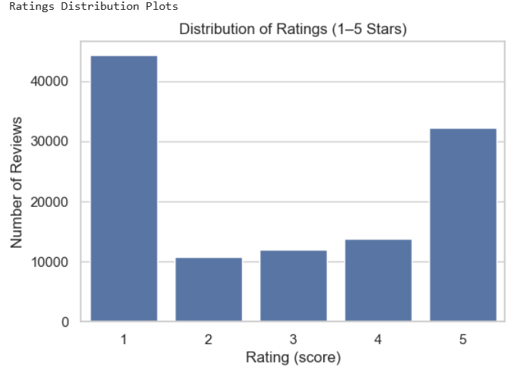
Review Length Patterns:

An analysis of review length revealed clear differences in how users express their experiences depending on their rating. Reviews with 1–2 stars tend to be short, abrupt, and emotionally charged, often reflecting frustration or dissatisfaction. In contrast, 4–5-star reviews are generally longer and more descriptive, with users providing detailed explanations of what they enjoyed. These length patterns appear consistently across both word count and character count distributions (shown in the boxplots below). Although outliers exist such as unusually long reviews within the mid-range categories the overall trend shows that the amount of detail in a review itself is a linguistic cue for user satisfaction. Longer reviews often contain richer descriptions, narrative elements, and positive language, while shorter reviews rely more on direct emotional expressions. This reinforces the idea that linguistic structure beyond just word choice plays an important role in signaling sentiment and perceived quality.
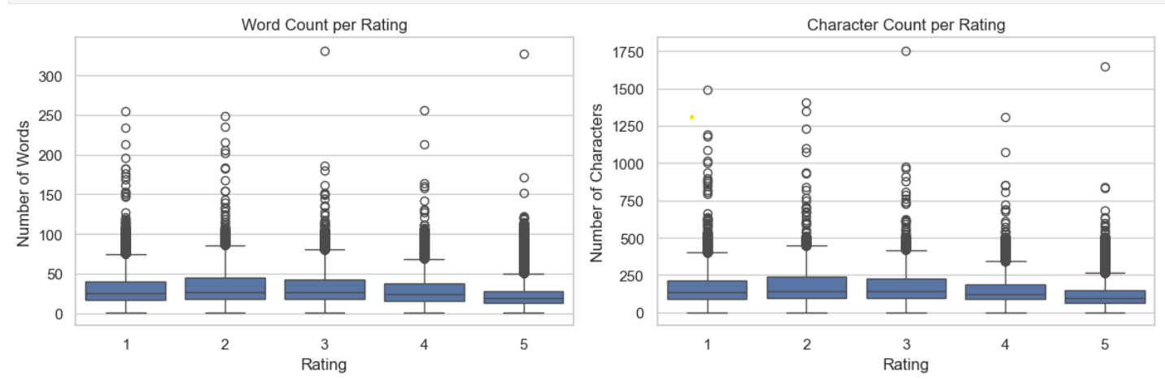

Vocabulary & Word Frequency Patterns:

The overall distribution of word frequencies shows that the top 20 most common words across all reviews are dominated by standard English stopwords such as “the,” “i,” “to,” “and,” and “it.” While this is typical in natural language text, these words provide little value for sentiment or rating prediction. Their prevalence reinforces the importance of stopword removal during preprocessing. A few domain-related words such as “netflix,” “app,” and “watch” also appear, confirming that the dataset is contextually consistent.
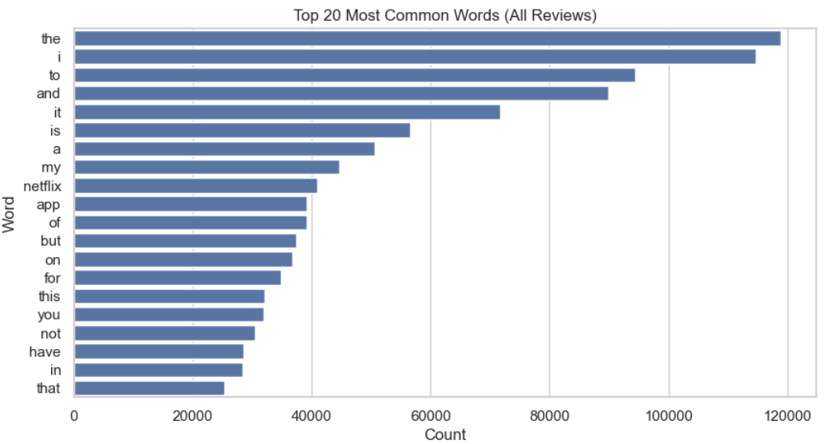
To better understand how language differs between satisfied and dissatisfied users, We analyzed the most frequent words within 1-star and 5-star reviews separately. Although both groups include expected stopwords, their meaningful vocabulary diverges sharply:
- 1-star reviews contain more negation and frustration markers, such as “not,” “no,” “bad,” “worst,” and expressions describing technical failures (“app,” “not working,” “won’t load”).
- 5-star reviews feature positive emotion words like “love,” “great,” “amazing,” “movies,” “watch,” and “best.”

These vocabulary differences provide early and strong evidence that linguistic patterns vary significantly with user sentiment. Negative reviews rely more on blunt, emotionally charged wording, while positive reviews include richer, descriptive language tied to enjoyment or satisfaction. This contrast directly supports the research question: Yes, linguistic patterns differ strongly by sentiment level, and these differences are measurable and predictive.

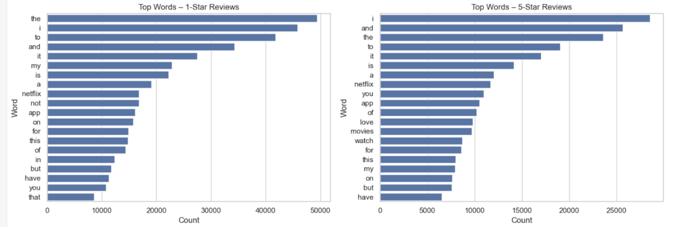

Findings on Dataset:

The dataset revealed a pronounced imbalance, with 1-star and 5-star reviews making up the majority of all entries. This pattern indicates that users are more likely to leave reviews when they feel either very dissatisfied or highly satisfied, while moderate experiences tend to generate fewer comments.
The linguistic analysis further reflected this polarization:
- Negative reviews frequently contained strong emotional and negation markers such as “not,” “bad,” “worst,” and direct expressions of frustration.
- Positive reviews included affirming and praise-oriented vocabulary such as “love,” “great,” “amazing,” and terms related to content enjoyment.
Review length patterns showed a similar contrast:
- Lower-rated reviews were typically short, abrupt, and emotionally charged.
- Higher-rated reviews tended to be longer, more descriptive, and more detailed.
Together, these findings demonstrate that linguistic patterns both in vocabulary and structure strongly correlate with user sentiment. The clear differences between negative and positive reviews make the dataset highly suitable for sentiment analysis and rating prediction tasks.

Sentiment Analysis (VADER):

The VADER sentiment results show a strong and consistent alignment between the emotional tone of a review and its assigned star rating. Reviews labeled as positive overwhelmingly correspond to higher ratings, while negative sentiment labels dominate the lower ratings, particularly 1-star reviews. Neutral sentiment appears mostly in the mid-range ratings, reflecting mixed or ambiguous user experiences.
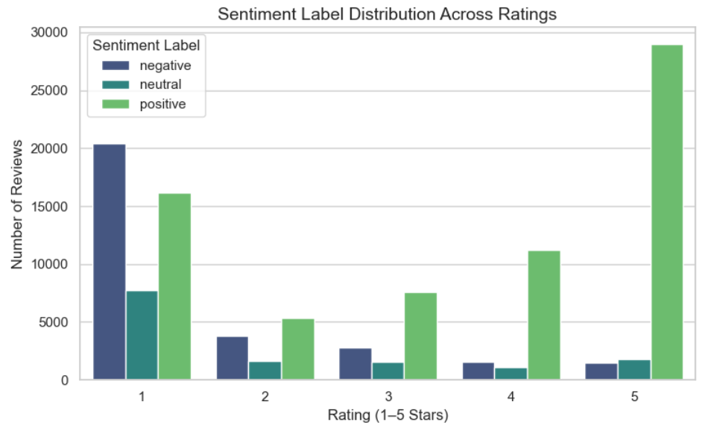
The average sentiment scores reveal a clear upward progression:
- Negative sentiment → ~1.66 average rating
- Neutral sentiment → ~2.08 average rating
- Positive sentiment → ~3.46 average rating
This near-linear relationship is also supported by the correlation heatmap, which shows a strong positive correlation between VADER sentiment scores and user ratings. In other words, as sentiment becomes more positive, the rating increases accordingly.
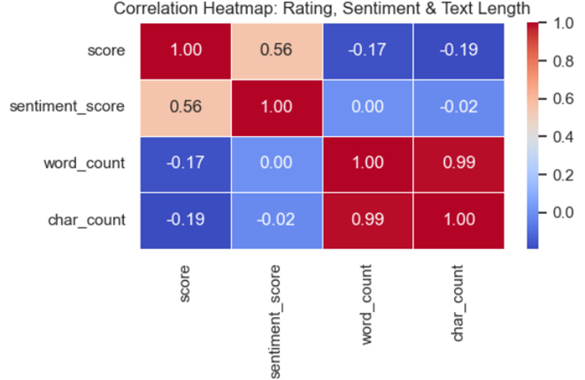
One notable observation is that mid-range ratings (2–4 stars) often contain mixed or conflicting language, which can reduce the clarity of sentiment signals. This contributes to the difficulty of accurately predicting these classes in later modeling stages.
Average Sentiment Score Table:
- Overall, sentiment analysis strongly supports the research question:
- linguistic tone is a reliable indicator of perceived content quality, and emotional polarity in text closely reflects user satisfaction.
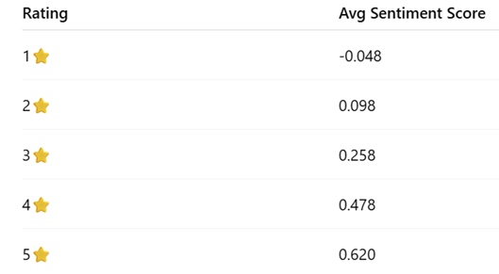

Text Preprocessing:

Before analysis, the raw review text was cleaned using standard NLP preprocessing steps, including lowercasing, removing punctuation and stopwords, and lemmatizing words. This produced a simplified clean_text version that is easier for models to interpret. The example below shows how noisy, unstructured text is transformed into a more uniform and meaningful representation. These preprocessing decisions were made to improve both interpretability and model performance. Lowercasing and removing punctuation reduce superficial variation that does not carry sentiment, while stopword removal helps the models focus on content-bearing words such as adjectives, verbs, and domain-specific nouns. Lemmatization was used instead of stemming so that words like “loved,” “loving,” and “loves” are mapped to the same base form “love,” preserving meaning while reducing vocabulary size and sparsity in the TF-IDF features.

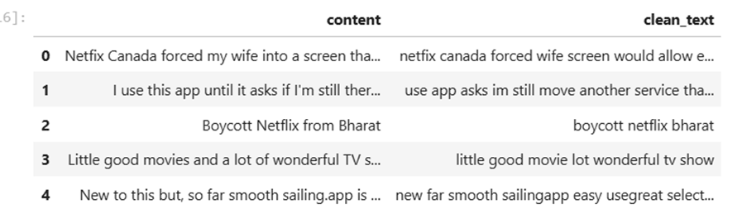

Topic Modeling (LDA):

The LDA model uncovered six dominant themes across the dataset, each representing different types of user concerns or experiences. The topics can be summarized as follows:
  - App crashes & technical issues (e.g., error, fix, problem, update)
  - Positive reactions to movies/series (e.g., love, great, amazing, best)
  - Billing and subscription problems (e.g., payment, money, account, subscription)
  - Content availability & streaming use (e.g., content, use, streaming, price)
  - Device-related playback issues (e.g., screen, brightness, episode, season)
  - App not opening or functioning (e.g., open, work, error, problem, download)
The topic counts show that technical and playback-related issues (Topics 1 and 5) are the most common themes overall, followed by general app usage and subscription concerns.
When topics were compared to their average user rating, a clear pattern emerged:

- Content enjoyment topics produced the highest ratings (e.g., Topic 1 avg rating ≈ 4.22).
- Billing, app crashes, or technical issues produced the lowest ratings (e.g., Topic 5 avg rating ≈ 1.74; Topic 3 ≈ 1.98).
- Neutral or mixed topics fell into the mid-range.

These results show that user satisfaction is strongly tied to the type of issue being discussed. Users give low ratings when they face technical or account problems, whereas high ratings are associated with positive reactions to movies, shows, or features. LDA therefore provides meaningful insight into why users rate the app the way they do, linking themes directly to satisfaction levels.

Specific Question: Can We Accurately Predict a Reviewer’s Rating Based Solely on Their Written Text?
This section focuses on the predictive component of the project, examining whether the written content of a Netflix review contains sufficient linguistic and emotional information to accurately infer the reviewer’s final star rating. While the group level analysis explores sentiment trends, topic distributions, and descriptive patterns, my individual contribution builds and evaluates a full supervised learning pipeline to directly answer this specific question.
Using a combination of classical machine learning models and deep learning architectures, we evaluate how effectively review text alone can predict ratings on a 1–5 star scale.
Supervised Learning Setup and Feature Definition:
This task is formulated as a multi-class supervised classification problem that predicts a reviewer’s 1–5 star rating using only the written review text. The input feature (X) consists of cleaned Netflix reviews, and the target variable (y) is the corresponding numerical star rating.
This formulation directly links linguistic expression to perceived content quality, and validation checks confirm that each cleaned review is correctly paired with its rating label. The same feature-target definition supports both classical machine learning models and deep learning architectures used in the analysis.
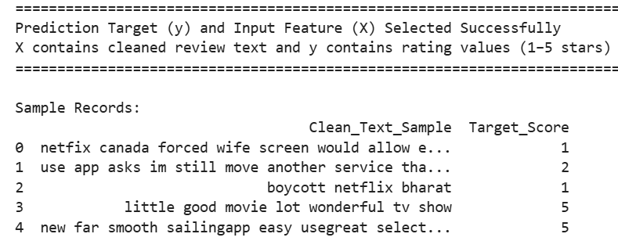

Train–Test Split Strategy:
The dataset is split into 80% training and 20% testing sets to ensure reliable evaluation of model performance. Stratified sampling is used so that the distribution of star ratings (1★–5★) remains consistent across both sets, which is important given the class imbalance favoring extreme ratings. The training set is used for model learning, while the test set contains unseen reviews and is used solely to assess generalization performance.
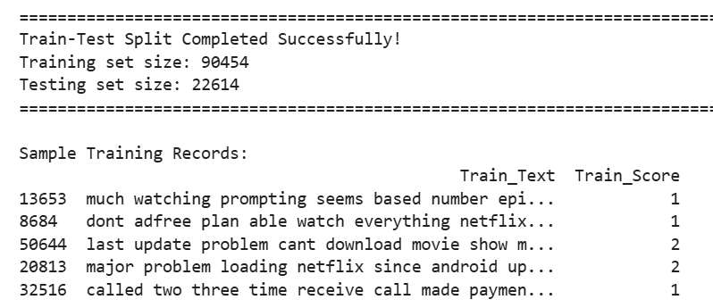

Supervised Machine Learning Models (TF-IDF Baselines)
Review text is converted into numerical features using TF-IDF vectorization with a 20,000-word vocabulary, incorporating unigrams and bigrams and applying stopword removal. This representation captures both term importance and frequency, providing an efficient and effective baseline for text-based classification in large-scale datasets.
Several classical supervised machine learning models were trained and evaluated using TF-IDF features on the original, imbalanced test set. Model performance was assessed using accuracy, precision, recall, F1-score, and confusion matrix analysis, allowing both overall and class-level evaluation.
Classical Supervised Models: TF-IDF Baselines:
Logistic Regression is the strongest classical baseline, achieving the highest accuracy (0.645). It performs very well on extreme ratings, with 92% recall for 1★ and 83% recall for 5★, reflecting strong detection of polarized sentiment. Performance drops sharply for mid-range ratings, especially 2★ reviews (4% recall), due to ambiguous and mixed language. The macro-averaged F1-score (0.42) highlights this class imbalance, while the weighted F1-score (0.59) reflects strong performance on dominant classes.
The Linear SVM achieves an accuracy of 0.622 and shows similar behavior, with strong recall for 1★ (86%) and 5★ (81%) reviews but declining performance for 2★–4★ ratings. This confirms that TF-IDF features effectively capture polarized sentiment but struggle with overlapping mid-range classes.
Multinomial Naive Bayes reaches 0.627 accuracy, demonstrating very high recall for extreme ratings (92% for 1★, 85% for 5★) but near-zero recall for 2★ reviews. Its independence assumption limits its ability to model nuanced language, resulting in the lowest macro-average F1-score (0.36).
XGBoost achieves 0.618 accuracy and performs reasonably well on extreme ratings but shows weak recall for mid-range classes. Despite its complexity, it does not outperform linear models on sparse TF-IDF features, suggesting linear classifiers are better suited for this representation.
Summary of Classical Model Performance: Across all classical models, several consistent patterns emerge:
- Extreme ratings (1★ and 5★) are predicted with high precision and recall due to strong, polarized emotional language.
- Mid-range ratings (2★–4★) are difficult to classify, exhibiting low recall and significant overlap in linguistic features.
- Logistic Regression with TF-IDF provides the strongest and most stable baseline performance.
- Weighted metrics appear relatively strong due to class imbalance, while macro-averaged metrics reveal substantial performance gaps across classes.
These results demonstrate that text alone contains sufficient information to reliably predict strong sentiment but accurately distinguishing subtle or mixed sentiment remains challenging for classical supervised models.
Addressing Class Imbalance: Random Oversampling:
The training dataset is highly imbalanced, with most reviews concentrated in the 1★ and 5★ categories and far fewer samples in the mid-range ratings (2★–4★). Models trained on this skewed distribution tend to over-predict extreme classes and exhibit low recall for minority ratings. To address this issue, Random Oversampling was applied only to the training set, balancing all five rating classes to 35,474 samples each. The test set was left unchanged to ensure fair and realistic evaluation. This approach allows the model to better learn decision boundaries for underrepresented rating categories.
Impact on Model Performance and Evaluation Metrics:
Overall accuracy decreased after balancing (0.561 vs. 0.645), reflecting the removal of bias toward dominant classes. However, class-level evaluation metrics show improved fairness across ratings.
- Accuracy: Decreased as dominance of 1★ and 5★ predictions was reduced
- Precision: Became more evenly distributed across rating categories
- Recall: Improved notably for mid-range ratings (2★–4★)
- F1-score: Macro-averaged F1 increased, indicating fairer class-level performance
- Extreme ratings: Recall for 1★ and 5★ remained relatively strong
Deep Learning Model:
The Bi-LSTM model is used to capture sequential and contextual information beyond TF-IDF representations. It is trained on tokenized and padded review text using a 20,000-word vocabulary, 150-token sequence length, and early stopping to prevent overfitting. The model achieves a test accuracy of 0.646, closely matching the best classical baseline. It performs strongly on extreme ratings (90% recall for 1★ and 82% for 5★) but struggles with mid-range ratings, particularly 2★ reviews, due to linguistic ambiguity. This indicates that deeper contextual modeling improves representation but does not fully resolve mixed-sentiment overlap.
A BERT-based model was prepared for the same 5-class prediction task; however, training could not be completed due to a framework compatibility issue. Despite the lack of results, this attempt demonstrates the use of state-of-the-art transformer methods, which would likely outperform TF-IDF and Bi-LSTM models in a properly configured GPU environment.
Final Model Performance Summary:
Across both classical machine learning and deep learning approaches, models consistently perform best on extreme ratings (1★ and 5★) and struggle with mid-range ratings (2★–4★). This confirms that review text alone is a strong indicator of polarized sentiment, while subtle or mixed sentiment remains challenging even for advanced neural models.
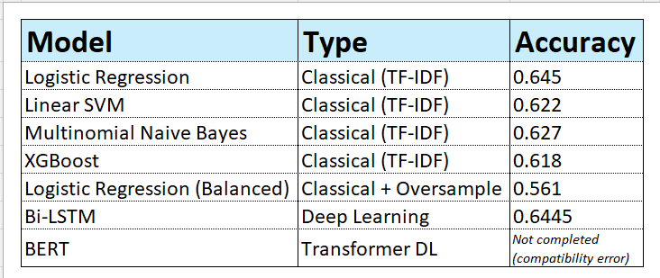

Confusion Matrix Analysis: Logistic Regression vs. Bi-LSTM:
Confusion matrix analysis shows that both Logistic Regression and Bi-LSTM accurately classify extreme ratings. Logistic Regression correctly identifies over 8,136 one-star and 5,349 five-star reviews, while the Bi-LSTM demonstrates comparable performance, correctly classifying more than 8,322 one-star and 5,254 five-star reviews.
In contrast, mid-range ratings (2★–4★) are frequently misclassified, often being pushed toward extreme categories. This occurs because these reviews tend to contain mixed or neutral language with weaker sentiment cues. Overall, the confusion matrices confirm that text-based rating prediction is highly reliable for polarized sentiment, but substantially less precise for subtle or ambiguous sentiment distinctions.

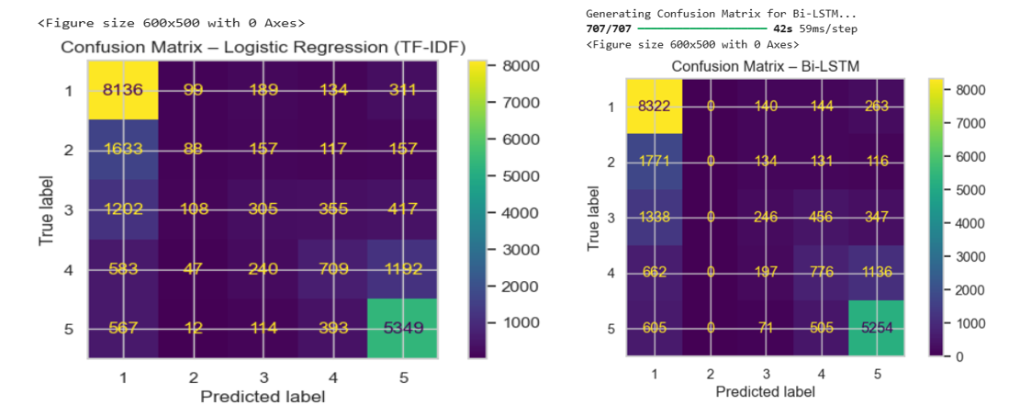

Interactive Review Prediction Demo:
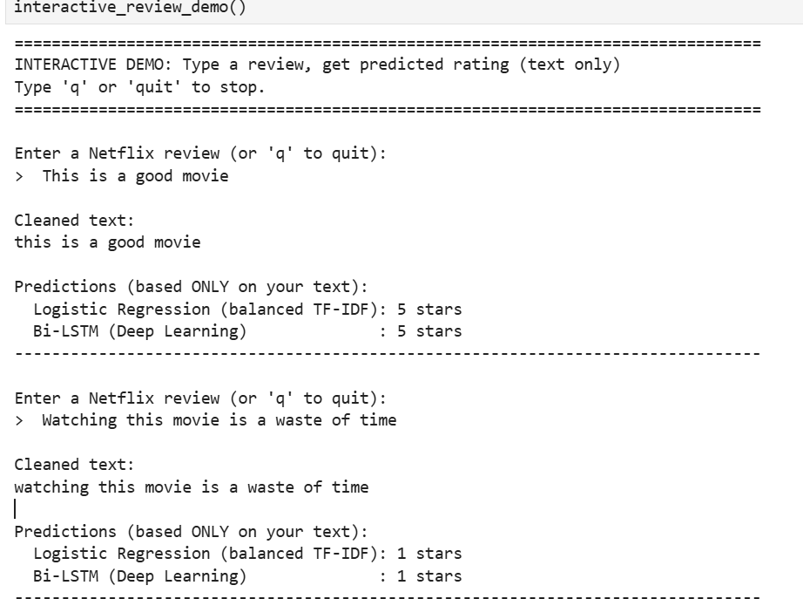
To demonstrate real-world applicability, an interactive demo was developed in which users can input arbitrary review text. Both the Logistic Regression (TF-IDF) and Bi-LSTM models instantly generate a predicted star rating based solely on the written text, providing an intuitive validation of model behavior.

Interpretation and Connection to the Overarching Research Question:
The results demonstrate that linguistic patterns in Netflix reviews strongly reflect user sentiment and perceived content quality. Reviews containing clearly positive language consistently correspond to higher star ratings, while expressions of frustration or dissatisfaction align with lower ratings. This confirms that how users describe their viewing experience in text closely mirrors how they evaluate content numerically.
At the same time, reviews with mixed or neutral language, typically associated with mid-range ratings (2★–4★), are more difficult to classify accurately due to overlapping and ambiguous sentiment cues. Overall, the findings show that review text alone is a reliable indicator of polarized sentiment and perceived quality, while accurately distinguishing subtle evaluations remains a key limitation of text-based rating prediction.
Limitations:
- The dataset is highly imbalanced, favoring 1★ and 5★ reviews
- Middle ratings (2★–4★) are inherently ambiguous
- Lexicon-based sentiment methods may miss sarcasm or informal language
- Deep learning models require more data and computational resources to yield larger gains.

