- Title of Project: SkillPath AI

Name of students:
  - Mr. Babar Athrav Sunil
  - Mr.Ingole Dattatray Jyotiba
  - Mr.Jadhav Shivam Vinayak

- Name of the guide: Mrs. S. B.Thorat
- Name of Department : Computer Science and Engineering
- Name of college : AGTI’s Dr.Daulatrao Aher College of Engineering Karad.
- Academic Year:2026-2027

Introduction:
SkillPath AI is an AI-powered adaptive learning platform designed to help students develop technical skills through personalized career-oriented learning roadmaps. Unlike traditional learning platforms that provide the same learning path to every student, SkillPath AI analyzes student performance, study activity, quiz scores, coding performance and roadmap progress to provide personalized recommendations.
The platform integrates learning roadmaps, interactive quizzes, coding challenges, AI tutoring, analytics, gamification, resume building, mock interviews and placement readiness features into a single system.
This project is relevant because:
1. Personalized Learning:
The system provides career-specific and student-specific learning paths. AI recommendations help students identify what topic they should learn or revise next.
2. Adaptive Learning:
Topics are progressively unlocked based on learning and assessment performance. Quiz and coding results can be used to determine whether a student is ready to proceed to the next topic.
3. AI-Based Assistance:
Google Gemini AI is integrated to provide coding assistance, learning recommendations, resume analysis, mock interviews, assignment evaluation and
other educational support.
4. Real-World Application:
The platform provides a practical solution for students, teachers and colleges by combining learning management, assessment, analytics and artificial intelligence in one system.
- Motivation for work:
The motivation behind developing SkillPath AI – AI-Powered Adaptive Learning Roadmap Platform is to help students improve their technical skills through personalized learning paths and AI-based guidance. Traditional learning platforms often provide fixed learning content without considering individual student performance and learning requirements.
SkillPath AI aims to provide a single platform for career-based roadmaps, quizzes, coding challenges, AI assistance and performance tracking. It uses student progress and assessment results to recommend suitable topics, practice activities and learning resources.
The project also motivates students to learn consistently through gamification features such as points, badges, streaks and leaderboards. Additionally, features such as resume building, mock interviews and placement-readiness analysis help students prepare for their future careers.
- Problem Statement:
To develop SkillPath AI, an AI-powered adaptive learning platform that provides personalized career-oriented roadmaps, interactive quizzes, coding challenges and performance tracking. The system aims to overcome the limitations of traditional learning platforms by analyzing student performance and providing suitable learning recommendations. It also integrates AI tutoring, resume building, mock interviews and placement preparation to help students improve their technical skills and career readiness through a single platform.
- Objective & Scope Of Project:
Objectives:
The main objectives of SkillPath AI are:
1. Personalized Learning: To provide career-oriented learning roadmaps based on students' interests and learning goals.
2. Adaptive Learning: To track student performance and unlock topics based on quiz and coding challenge results.
3. AI-Based Assistance: To provide personalized recommendations, technical guidance and doubt-solving support using Google Gemini AI.
4. Performance Tracking: To monitor study hours, quiz scores, coding performance and completed topics.
5. Skill Development: To improve programming skills through interactive quizzes and coding challenges.
6. Career Preparation: To provide resume building, resume analysis, mock interviews and placement-readiness assessment.
7. Student Engagement: To encourage consistent learning through points, badges, streaks and leaderboards.
Scope of Project:
SkillPath AI provides an integrated platform for students, teachers, HODs, principals and super administrators. It includes career roadmaps, learning resources, quizzes, coding challenges, AI recommendations, analytics, gamification and certificate generation.
The system also supports assignment management, student performance monitoring, college administration and career preparation. It is developed using Python, FastAPI, SQLAlchemy, HTML, CSS, JavaScript, Bootstrap, MySQL/SQLite and Google Gemini AI.
The project aims to simplify the learning process, improve technical skill development and help students prepare for future career opportunities through a single web-based platform.
- Literature Review:
The proposed SkillPath AI project is an AI-powered adaptive learning roadmap platform designed to provide personalized learning paths, assessments, coding practice and career guidance to students. A literature survey for this project involves researching adaptive learning systems, learning management platforms, artificial intelligence in education, coding assessment systems and personalized recommendation techniques.

Below are key areas to explore:
Investigate the development of learning management systems and adaptive learning platforms, focusing on student learning paths, progress tracking, online assessments and personalized education. Research how educational platforms manage student performance, learning activities, quiz results and skill development using digital technologies.
Explore artificial intelligence and machine learning techniques used in education for personalized learning and recommendation systems. Study how AI can analyze student performance, learning time, quiz scores and coding results to recommend suitable topics, revision activities and learning resources.
Research web application development technologies such as Python, FastAPI, SQLAlchemy, Jinja2 and Bootstrap for developing secure and scalable educational platforms. Investigate best practices for database management, REST APIs, authentication, role-based access control and secure storage of student information..
Investigate gamification techniques used in educational applications, including points, badges, ranks, streaks and leaderboards. Study how these mechanisms can improve student engagement, encourage regular learning and motivate students to complete learning activities.
Search for similar AI-based education and career guidance platforms. Analyze different approaches for AI tutoring, resume analysis, mock interviews, project recommendations and placement-readiness systems. Study how these features can be integrated with an adaptive learning roadmap to provide a complete student development platform.
By conducting a literature survey in these areas, a deeper understanding of the technical, educational, AI and design aspects relevant to SkillPath AI can be gained. This will help in refining the adaptive learning system, improving personalized recommendations and expanding the platform's learning and career-oriented functionalities.
- Proposed System :
The proposed SkillPath AI is an AI-powered learning platform that provides personalized career-based learning roadmaps for students. Traditional learning platforms generally provide fixed learning paths and do not consider individual student performance.
Students also use separate platforms for learning, quizzes, coding practice, resume preparation and interview preparation.
SkillPath AI solves these problems by integrating adaptive roadmaps, quizzes, coding challenges, AI recommendations, performance analytics and career preparation into one platform. The system tracks quiz scores, coding performance, study time and completed topics to provide suitable learning recommendation

System Architecture:
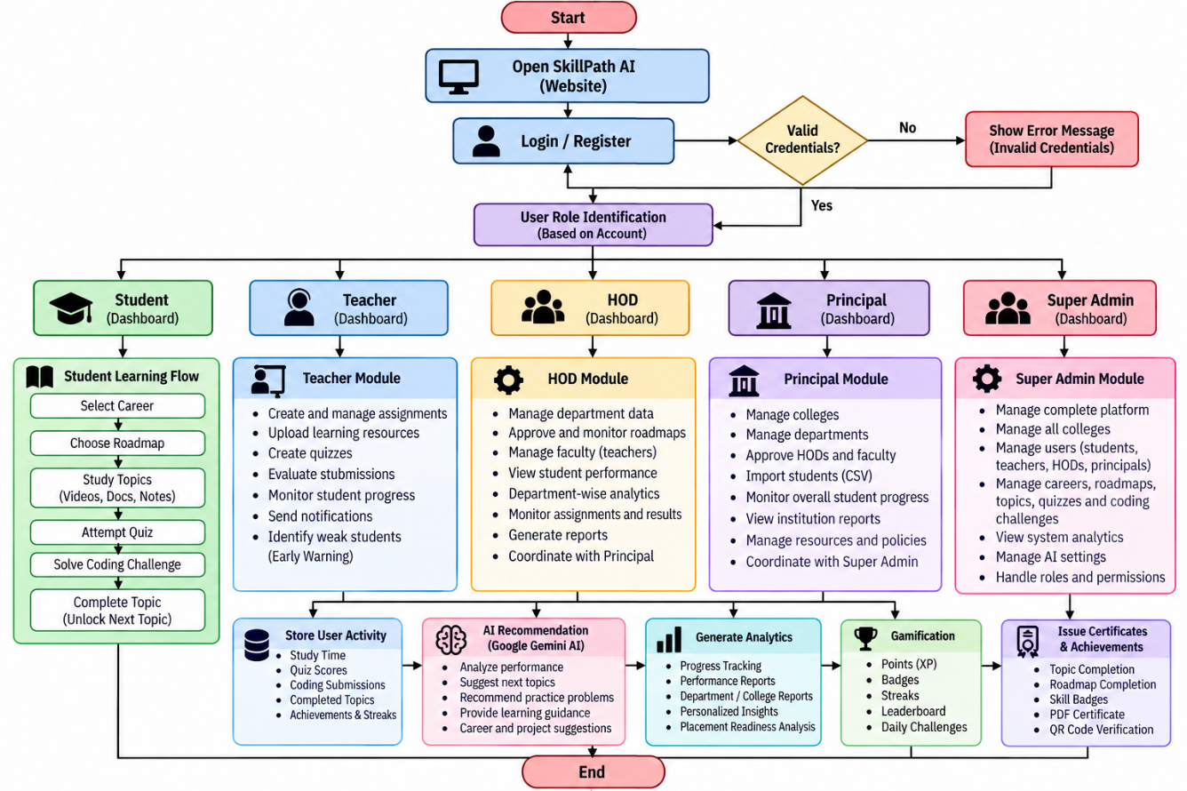
- Expected Outcome:
The expected outcome of SkillPath AI – AI-Powered Adaptive Learning Roadmap Platform is to develop a user-friendly web application that helps students learn technical skills through personalized roadmaps and AI-based guidance.
1. Personalized Learning: Students can follow career-oriented roadmaps according to their learning goals.
2. Improved Technical Skills: Quizzes and coding challenges help students practice and evaluate their programming knowledge.
3. AI-Based Recommendations: Google Gemini AI provides learning suggestions, technical assistance and personalized guidance.
4. Performance Tracking: Students and teachers can monitor study hours, quiz scores, coding performance and learning progress.
5. Career Development: Resume building, resume analysis, mock interviews and project recommendations help students prepare for placements.
6. Student Engagement: Gamification features such as points, badges, streaks and leaderboards encourage regular learning.
7. Teacher and College Management: Teachers and college administrators can manage assignments, monitor student performance and generate reports.
8. Certificate Generation: Students who complete their career roadmaps can receive PDF certificates with QR-code verification.
Overall, SkillPath AI aims to provide an integrated learning environment that improves students' technical skills, tracks their progress and supports their career preparation.

Expected Date Completion

Approximate Expendature:
The approximate expenditure required for the development of SkillPath AI – AI-Powered Adaptive Learning Roadmap Platform is given below.

- SDG aligned with Project:
SkillPath AI – AI-Powered Adaptive Learning Roadmap Platform aligns with the following United Nations Sustainable Development Goals (SDGs):
1. SDG 4 – Quality Education: The project provides personalized learning roadmaps, interactive quizzes, coding challenges and AI-based guidance to improve access to quality technical education and support continuous learning.
2. SDG 8 – Decent Work and Economic Growth: The platform supports career development through resume building, mock interviews, project recommendations and placement-readiness assessment, helping students prepare for employment opportunities.
3. SDG 9 – Industry, Innovation and Infrastructure: The project uses artificial intelligence and modern web technologies to develop an innovative digital learning platform that supports technical skill development and technological advancement.

References:

https://www.studytonight.com/c-projects/quiz-game-project-using-c-language

https://www.geeksforgeeks.org/c-multiple-choice-questions/

https://en.m.wikipedia.org/wiki/Quiz

Place: Karad

Date:

Roll No. | Name of Student | Signature
22054 | Jadhav Vaishnavi Lalasaheb
22040 | Pisal Sheya Sandip
22038 | Pawar Vedika Mohan

