Information-Retrieval Bonus

Daniel Attali, Sapir Bashan, Noam Benisho

2025-02-05

Table of Contents

1 Part A: Human Validation on Ex4 2

1.1 Results and Discussion 2

1.1.1 Results Summary 2

1.1.2 Explanation of the Results 4

2 Part B: Vector Based Model 6

2.1 Data Preparation 6

2.1.1 Basic Data Preparation 6

2.1.2 Basic Logical Classification 7

2.1.3 Vectorization of the Sentences 8

2.1.4 Filtering the Data 8

2.1.5 Train and Test Split 9

2.2 Model Preparation 10

2.2.1 SVM 10

2.2.2 Logistic Regression 11

2.2.3 ANN 11

2.3 Model Implementation 12

2.4 Testing and Evaluation 13

2.4.1 SVM 13

2.4.2 Logistic Regression 14

2.4.3 ANN 15

2.5 Results Documentation 18

2.5.1 SVM & LoR 18

2.5.2 ANN 19

2.6 Conclusion 20

# 1 Part A: Human Validation on Ex4

In this part we took 35 sentence from each class that could have been classified by a human to more than one class and then tried to see how our model from Ex4 was compared to the human classifier.

## 1.1 Results and Discussion

### 1.1.1 Results Summary

On a new test dataset (with a total support of 246 samples), one set of results for a model run was:

* **Overall Accuracy:** 21.14%
* **Classification Report:**

| Class | Precision | Recall | F1-Score | Support |
| --- | --- | --- | --- | --- |
| **pi** (Pro-Israel) | 0.12 | 0.03 | 0.05 | 59 |
| **pp** (Pro-Palestinian) | 0.35 | 0.09 | 0.15 | 65 |
| **n** (Neutral) | 0.50 | 0.11 | 0.19 | 35 |
| **ai** (Anti-Israel) | 0.24 | 0.73 | 0.36 | 52 |
| **ap** (Anti-Palestinian) | 0.04 | 0.06 | 0.05 | 35 |

* **Macro Average:**
  + Precision: 0.25
  + Recall: 0.21
  + F1-Score: 0.16
* 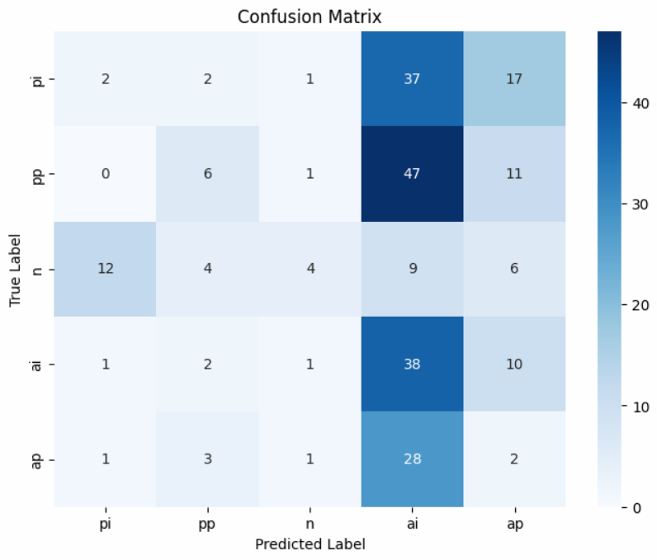 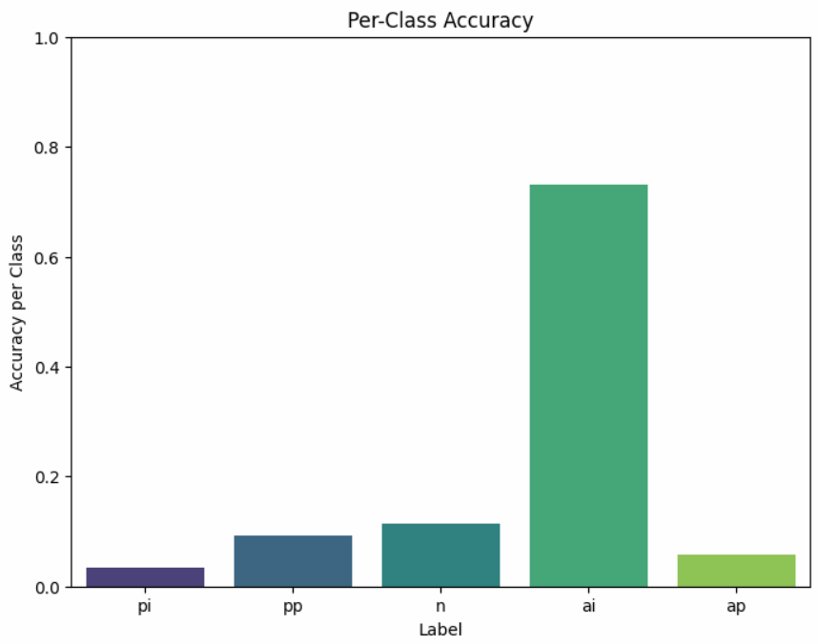

### 1.1.2 Explanation of the Results

The overall accuracy of **21.14%** is only marginally better than random guessing in a five-class classification problem (where chance performance is around 20%). Below are several factors that likely contributed to these results:

1. **Data Representation and Feature Quality:**
   * **Subtle Linguistic Cues:**  
     Political bias is often expressed through nuanced language. While BERT and SBERT embeddings capture many aspects of language, the subtleties that distinguish one bias from another might not be sufficiently prominent in the resulting vectors.
   * **Domain Specificity:**  
     The new test data might use a slightly different vocabulary or style than the training data, leading to a drop in performance as the model struggles to generalize.
2. **Labeling and Overlap Between Classes:**
   * **Noisy Labels:**  
     Our initial labeling was based on a rule-based approach using keyword matching. Such labels can be noisy or ambiguous, as sentences might contain elements of more than one bias, leading to overlapping class characteristics.
   * **Ambiguous Class Boundaries:**  
     For example, a sentence with subtle cues might be misclassified between “pro-” and “anti-” categories. This ambiguity negatively affects both recall and precision for several classes.
3. **Class Imbalance and Sample Size:**
   * **Imbalanced Data Distribution:**  
     Although we balanced the training set by sampling an equal number of examples per class, the inherent complexity and distinctiveness of each class vary. Classes like neutral or anti-palestinian have fewer distinct features in the text, making them harder to learn.
   * **Limited Support in Test Set:**  
     With some classes having a relatively small support (e.g., 35 samples for neutral and anti-palestinian), even a few misclassifications can dramatically lower the metrics.
4. **Model Complexity and Training:**
   * **Underfitting vs. Overfitting:**  
     The modest overall improvement above chance (only ~1.14% above 20%) suggests that the models might not have been complex enough to capture the nuanced patterns in the data—or that they overfitted the training data and thus failed to generalize.
   * **Hyperparameter Tuning:**  
     The hyperparameters chosen (or the network architecture in the ANN) might not be optimal for this complex task, resulting in low precision for some classes and a tendency to over-predict others (e.g., the anti-Israel class shows high recall but very low precision).
5. **Bias in Feature Extraction:**
   * **Distinct Features for “ai” Class:**  
     The anti-Israel (ai) class shows a high recall (73%), indicating that the features associated with this class might be more prominent or consistent in the text. However, the low precision (24%) suggests that many sentences not belonging to this class are misclassified as anti-Israel, likely due to overlapping vocabulary or insufficient discriminative features.

# 2 Part B: Vector Based Model

In this part we are tasked to create a new model based on vectors (BERT and SBERT) and then use 3 different classifiers to classify the sentences into 5 categories. So the work we did was as follows:

1. **Prepare the data** - Get the original article data and prepare it for vectorization, meaning separte into sentences and clean the text etc.
2. **Create the vectors** - Create the vectors using BERT and SBERT methods.
3. **Prepare the data** - Create a base classifier using simple logic.
4. **Separte the data into test and train** - Split the data into test and train + validation.
5. **Create the classifiers** - Create the 3 classifiers as mentioned in the assignment.
6. **Train the classifiers** - Train the classifiers on the data.
7. **Test the classifiers** - Test the classifiers on the test data.
8. **Show the results** - Show the results in with graph and matrices.

## 2.1 Data Preparation

### 2.1.1 Basic Data Preparation

In order to save time we took the output from the first assignment (meaning the articles after basic processing) meaning we have for each of our 4 journals (NYT, JP, AJ, BBC) a csv file (stored in our GitHub repo for the course) that contains the following columns:

* id - the id of the article in the following format aj_1 meaning it is the first article from AJ.
* document - the text body of the article.

Then we have a function called extract_all_sentences that will read through an article and extract all the sentences and then clean them. The cleaning process is as follows:

import spacy  
  
nlp = spacy.load("en_core_web_sm")  
  
def extract_all_sentences(df):  
 all_sentences = []  
 for index, row in df.iterrows():  
 doc = nlp(row["document"])  
 for sent in doc.sents:  
 # Optionally clean text  
 sentence = clean_text(sent.text.strip())  
 all_sentences.append({"id": row["id"], "document": sentence})  
 return all_sentences

The clean_text function make sure that we have a clean text that contain only UTF-8 characters and no special characters.

After applying this function for each of our 4 journals we have a new dataframe that contains the following columns:

* id - the id of the article of the sentence.
* sentence - the text body of the article.

Now we concat all the dataframe into 1 big dataframe that contains all the sentences from all the journals. This new dataframe contains $46242$ sentences.

### 2.1.2 Basic Logical Classification

Now we will use a simple logical classification of our data. We have 4 files pro-israel.txt, pro-palestine.txt, anti-israel.txt, anti-palestine.txt those file contains $≈20$ words with clear bias towards the mentioned group. We will use those words to classify our sentences.

The idea of the classifier is simple if a sentence contains a word from a certain group we classify it as that group. But this time we can have a multi-calss classification meaning a sentence can be classified as two or more classes at the same time, We did this by adding to our dataframe for each sentence 5 columns one for each class, and we put a 1 if the sentence contains a word from that class and 0 otherwise. For the neutral class we classify a sentence as neutral if it doesn’t contain a word from any of the classes.

def classify_sentence(sentence):  
 # Tokenize and stem the sentence  
 tokens = word_tokenize(sentence.lower())  
  
 # Initialize the one-hot encoded vector  
 # [pro-israel, pro-palestine, neutral, anti-israel, anti-palestine]  
 vector = [0, 0, 0, 0, 0]  
 # Check for each class  
 if stemmed_tokens & pro_israel_words:  
 vector[0] = 1 # pro-israel  
 if stemmed_tokens & pro_palestine_words:  
 vector[1] = 1 # pro-palestine  
 if stemmed_tokens & anti_israel_words:  
 vector[3] = 1 # anti-israel  
 if stemmed_tokens & anti_palestine_words:  
 vector[4] = 1 # anti-palestine  
 # Check if the sentence is neutral (no words from any class)  
 if not any(vector):  
 vector[2] = 1 # neutral  
 return vector

Now we have a dataframe that contains the following columns:

* id - the id of the article of the sentence.
* sentence - the text body of the article.
* pro-israel
* pro-palestine
* neutral
* anti-israel
* anti-palestine

### 2.1.3 Vectorization of the Sentences

Now that we have the sentences and their basic classification we can start the vectorization process. We will use the sentence-transformers library to create the vectors for our sentences. We will use two methods:

1. BERT - We will use the bert-base-uncased model to create the vectors.
2. SBERT - We will use the paraphrase-MiniLM-L6-v2 model to create the vectors.

# Load BERT model and tokenizer  
bert_tokenizer = BertTokenizer.from_pretrained('bert-base-uncased')  
bert_model = BertModel.from_pretrained('bert-base-uncased')  
  
# Load SBERT model  
sbert_model = SentenceTransformer('all-MiniLM-L6-v2')

Now we have 2 functions to convert each sentence into a vector:

def get_bert_embedding(sentence):  
 device = torch.device("cuda" if torch.cuda.is_available() else "cpu")  
 bert_model.to(device)  
 inputs = bert_tokenizer(sentence, return_tensors='pt',  
 truncation=True, padding=True).to(device)  
 with torch.no_grad():  
 outputs = bert_model(**inputs)  
 embeddings = outputs.last_hidden_state.sum(dim=1).squeeze().cpu().numpy()  
 return embeddings

def get_sbert_embedding(sentence):  
 device = "cuda" if torch.cuda.is_available() else "cpu"  
 return sbert_model.encode(sentence, device=device)

Then we converted each sentence into both the BERT and SBERT vectors and added them to our dataframe.

### 2.1.4 Filtering the Data

Now we needed to take a subset of the data for the training process. We did some analilysis on the data to find out what kind is the distribution of the data. We took only the data that only had 1 class and printed the amount for each class:

pro_israel: 2523,  
pro_palestine: 3380,  
neutral: 30222,  
anti_israel: 1495,  
anti_palestine: 1255

Meaning if we want each class to have the same amount of samples to train on we need to take at most 1255 samples from each class. So we took a random sample of 1255 samples from each class.

pro_israel_sample = pro_israel_df.sample(n=num_samples, random_state=42)  
pro_palestine_sample = pro_palestine_df.sample(n=num_samples, random_state=42)  
neutral_sample = neutral_df.sample(n=num_samples, random_state=42)  
anti_israel_sample = anti_israel.sample(n=num_samples, random_state=42)  
anti_palestine_sample = anti_palestine_df.sample(n=num_samples,  
 random_state=42)

### 2.1.5 Train and Test Split

For the train and test data we needed to take only the vectors (BERT, SBERT) and their class:

pro_palestine_bert_data = df_pro_palestine["bert_embedding"]  
pro_palestine_sbert_data = df_pro_palestine["sbert_embedding"]  
  
pro_palestine_bert_data = np.array([eval(instance) for instance in  
 pro_palestine_bert_data])  
pro_palestine_sbert_data = np.array([eval(instance) for instance in  
 pro_palestine_sbert_data])  
  
print(pro_palestine_bert_data.shape)  
print(pro_palestine_sbert_data.shape)

(1255, 768) (1255, 384)

And it was the same for all the classes.

Now we needed to create our data:

X_bert = np.vstack([  
 pro_israel_bert_data,  
 pro_palestine_bert_data,  
 neutral_bert_data,  
 anti_palestine_bert_data,  
 anti_israel_bert_data  
])  
  
y_bert = np.array(  
 [0] * len(pro_israel_bert_data) + # 0s for pro-israel  
 [1] * len(pro_palestine_bert_data) + # 1s for pro-palestinian  
 [2] * len(neutral_bert_data) + # 2s for neutral  
 [3] * len(anti_palestine_bert_data) + # 3s for anti-palestinian  
 [4] * len(anti_israel_bert_data) # 4s for anti-israel  
)  
  
y_bert_onehot = to_categorical(y_bert)

Same for the SBERT data.

Then we split the data into train and test:

# Split the data (80% train, 20% test)  
X_bert_train, X_bert_test, y_bert_train, y_bert_test = train_test_split(  
 X_bert, y_bert_onehot, test_size=0.2, random_state=42  
)  
  
# Further split training data to create validation set (10% of original data)  
X_bert_train, X_bert_val, y_bert_train, y_bert_val = train_test_split(  
 X_bert_train, y_bert_train, test_size=0.125, random_state=42  
 # 0.125 of 80% is 10% of total  
)

Same for the SBERT data.

Now we have the data ready for training.

## 2.2 Model Preparation

Now we will show the implementation of the 3 models:

1. SVM
2. Logistic Regression
3. ANN

### 2.2.1 SVM

from sklearn.svm import SVC  
from sklearn.linear_model import LogisticRegression  
from sklearn.model_selection import cross_val_score, GridSearchCV  
from sklearn.metrics import classification_report, confusion_matrix  
import numpy as np  
  
# SVM for BERT  
svm_bert = SVC(probability=True)  
svm_bert_params = {  
 'C': [0.1, 1, 10],  
 'kernel': ['linear', 'rbf'],  
 'class_weight': [None, 'balanced']  
}  
grid_svm_bert = GridSearchCV(svm_bert, svm_bert_params, cv=10,  
 scoring='accuracy')  
grid_svm_bert.fit(X_bert_train, np.argmax(y_bert_train, axis=1))  
best_svm_bert = grid_svm_bert.best_estimator_

What we did is we created an SVM model, and then we used GridSearchCV to find the best parameters for the model.

### 2.2.2 Logistic Regression

# Logistic Regression for SBERT  
lor_sbert = LogisticRegression(multi_class='multinomial', max_iter=1000)  
lor_sbert_params = {  
 'C': [0.1, 1, 10],  
 'solver': ['lbfgs', 'newton-cg'],  
 'class_weight': [None, 'balanced']  
}  
  
grid_lor_sbert = GridSearchCV(lor_sbert, lor_sbert_params, cv=10, scoring='accuracy')  
grid_lor_sbert.fit(X_sbert_train, np.argmax(y_sbert_train, axis=1))  
best_lor_sbert = grid_lor_sbert.best_estimator_

Same as the SVM model we used GridSearchCV to find the best parameters for the model.

### 2.2.3 ANN

The ANN had to be created with the following requirements:

* Data split: 80% training (with 10% validation), 20% testing
* Maximum 15 epochs
* Batch size of 32
* Specific architecture requirements:
  + 4 hidden layers (3×32 nodes, 1×16 nodes)
  + ReLU activation for hidden layers
  + Softmax for output layer
  + Include callbacks:
    - Early stopping after 5 iterations without improvement
    - Model checkpoint for best accuracy

**Callbacks**

# Callbacks  
early_stopping = EarlyStopping(  
 monitor='val_accuracy',  
 patience=5,  
 restore_best_weights=True  
)  
  
  
  
# Create separate checkpoints for BERT and SBERT models  
bert_checkpoint = ModelCheckpoint(  
 'best_bert_model.h5',  
 monitor='val_accuracy',  
 save_best_only=True,  
)  
  
...

**Model Creation + Compilation**

# BERT Model (input dimension 768)  
bert_model = Sequential([  
 Dense(32, activation='relu', input_dim=768),  
 Dense(32, activation='relu'),  
 Dense(32, activation='relu'),  
 Dense(16, activation='relu'),  
 Dense(5, activation='softmax') # 5 classes  
])  
  
sbert_model = ...  
  
# Compile models  
bert_model.compile(  
 optimizer='adam',  
 loss='categorical_crossentropy',  
 metrics=['accuracy']  
)  
  
...

## 2.3 Model Implementation

**Model Training**

# Train BERT model  
bert_history = bert_model.fit(  
 X_bert_train,  
 y_bert_train,  
 batch_size=32,  
 epochs=15,  
 validation_data=(X_bert_val, y_bert_val),  
 callbacks=[early_stopping, bert_checkpoint],  
 verbose=1  
)

We have this for the training process:

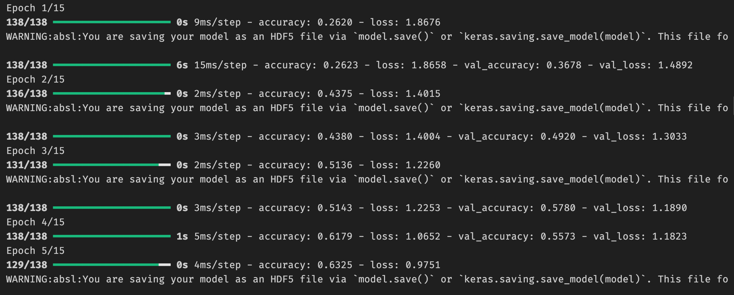

## 2.4 Testing and Evaluation

### 2.4.1 SVM

def evaluate_model(model, X_test, y_test, class_names):  
 y_pred = model.predict(X_test)  
 print("Classification Report:")  
 print(classification_report(np.argmax(y_test, axis=1),  
 y_pred, target_names=class_names))  
 # Confusion Matrix  
 cm = confusion_matrix(np.argmax(y_test, axis=1), y_pred)  
 print("\nConfusion Matrix:")  
 print(cm)  
 return model.predict_proba(X_test)

# Evaluate models (assuming class_names is already defined)  
print("\nSVM BERT:")  
svm_bert_proba = evaluate_model(best_svm_bert, X_bert_test,  
 y_bert_test, class_names)  
  
print("\nSVM SBERT:")  
svm_sbert_proba = evaluate_model(best_svm_sbert, X_sbert_test,  
 y_sbert_test, class_names)

SVM BERT:  
  
Classification Report:   
  
 precision recall f1-score support   
pro_israel 0.80 0.43 0.56 28   
pro_palestine 0.53 0.71 0.61 14   
neutral 0.26 0.50 0.34 10   
anti_israel 0.60 0.50 0.55 24   
anti_palestine 0.44 0.50 0.47 24   
  
accuracy 0.51 100   
macro avg 0.53 0.53 0.51 100   
weighted avg 0.57 0.51 0.52 100   
  
Confusion Matrix:   
 [[12 3 2 5 6]   
 [ 1 10 3 0 0]   
 [ 1 0 5 1 3]   
 [ 1 3 2 12 6]   
 [ 0 3 7 2 12]]

SVM SBERT:   
  
Classification Report:   
  
 precision recall f1-score support   
pro_israel 0.78 0.50 0.61 28   
pro_palestine 0.56 0.71 0.62 14   
neutral 0.33 0.70 0.45 10   
anti_israel 0.73 0.67 0.70 24   
anti_palestine 0.71 0.62 0.67 24   
  
accuracy 0.62 100   
macro avg 0.62 0.64 0.61 100   
weighted avg 0.67 0.62 0.63 100   
  
Confusion Matrix:   
  
[[14 3 7 3 1]   
[ 1 10 2 1 0]   
[ 1 1 7 0 1]   
[ 0 1 3 16 4]  
[ 2 3 2 2 15]]

### 2.4.2 Logistic Regression

The testing method is the same as for the SVM model:

print("\nLogistic Regression BERT:")  
lor_bert_proba = evaluate_model(best_lor_bert, X_bert_test,  
 y_bert_test, class_names)  
  
  
  
print("\nLogistic Regression SBERT:")  
lor_sbert_proba = evaluate_model(best_lor_sbert, X_sbert_test,  
 y_sbert_test, class_names)

Logistic Regression BERT:  
  
Classification Report:   
 precision recall f1-score support   
pro_israel 0.68 0.46 0.55 28  
pro_palestine 0.47 0.57 0.52 14   
neutral 0.25 0.50 0.33 10   
anti_israel 0.61 0.58 0.60 24   
anti_palestine 0.43 0.38 0.40 24   
  
accuracy 0.49 100   
macro avg 0.49 0.50 0.48 100   
weighted avg 0.53 0.49 0.50 100   
  
Confusion Matrix:   
  
 [[13 4 3 4 4]   
 [ 1 8 3 0 2]   
 [ 1 0 5 1 3]   
 [ 2 1 4 14 3]   
 [ 2 4 5 4 9]]

Logistic Regression SBERT:   
  
Classification Report:   
 precision recall f1-score support   
pro_israel 0.79 0.54 0.64 28   
pro_palestine 0.56 0.71 0.62 14   
neutral 0.28 0.50 0.36 10   
anti_israel 0.70 0.58 0.64 24   
anti_palestine 0.64 0.67 0.65 24   
  
accuracy 0.60 100   
macro avg 0.59 0.60 0.58 100   
weighted avg 0.65 0.60 0.61 100   
  
Confusion Matrix:   
  
 [[15 3 6 2 2]   
 [ 1 10 2 1 0]   
 [ 1 1 5 1 2]   
 [ 1 1 3 14 5]   
 [ 1 3 2 2 16]]

### 2.4.3 ANN

The testing process for the ANN is a bit different:

def get_metrics(y_true, y_pred, class_names):  
 # Convert one-hot encoded labels back to class indices  
 if len(y_true.shape) > 1: # if one-hot encoded  
 y_true = np.argmax(y_true, axis=1)  
 if len(y_pred.shape) > 1: # if one-hot encoded  
 y_pred = np.argmax(y_pred, axis=1)  
   
 # Calculate metrics  
 accuracy = accuracy_score(y_true, y_pred)  
 precision, recall, f1, _ = precision_recall_fscore_support(y_true,  
 y_pred, average=None)  
   
 # Print detailed results  
 print("Overall Accuracy:", accuracy)  
 print("\nPer-class metrics:")  
 for i, class_name in enumerate(class_names):  
 print(f"\n{class_name}:")  
 print(f"Precision: {precision[i]:.4f}")  
 print(f"Recall: {recall[i]:.4f}")  
 print(f"F1-score: {f1[i]:.4f}")  
   
 # Return metrics for further use if needed  
 return {  
 'accuracy': accuracy,  
 'precision': precision,  
 'recall': recall,  
 'f1': f1  
 }

BERT Model Metrics:   
==================   
Overall Accuracy: 0.6597609561752988   
Per-class metrics:   
 Pro-Israel:   
 Precision: 0.6992   
 Recall: 0.6300  
 F1-score: 0.6628   
 Pro-Palestinian:   
 Precision: 0.5831  
 Recall: 0.7511   
 F1-score: 0.6565   
 Neutral:   
 Precision: 0.6545   
 Recall: 0.5000   
 F1-score: 0.5669   
 Anti-Palestinian:   
 Precision: 0.6850  
 Recall: 0.7016   
 F1-score: 0.6932   
 Anti-Israel:   
 Precision: 0.6877  
 Recall: 0.7255  
 F1-score: 0.7061  
  
BERT Confusion Matrix:   
  
 Confusion Matrix:  
 ----------------   
 True\Pred Pro- Pro- Neut Anti Anti   
 Pro- 172 32 30 22 17   
 Pro- 15 172 19 8 15   
 Neut 29 45 125 23 28   
 Anti 16 23 11 174 24   
 Anti 14 23 6 27 185

SBERT Model Metrics:   
===================   
Overall Accuracy: 0.7450199203187251  
  
Per-class metrics:   
 Pro-Israel:   
 Precision: 0.8376  
 Recall: 0.7179  
 F1-score: 0.7732   
 Pro-Palestinian:   
 Precision: 0.7040  
 Recall: 0.8515  
 F1-score: 0.7708   
 Neutral:   
 Precision: 0.7015  
 Recall: 0.5640  
 F1-score: 0.6253   
 Anti-Palestinian:   
 Precision: 0.7385  
 Recall: 0.7742  
 F1-score: 0.7559   
 Anti-Israel:   
 Precision: 0.7456   
 Recall: 0.8275   
 F1-score: 0.7844  
  
SBERT Confusion Matrix:   
  
 Confusion Matrix:  
 ----------------   
 True\Pred Pro- Pro- Neut Anti Anti   
 Pro- 196 14 24 13 26   
 Pro- 8 195 10 9 7   
 Neut 21 43 141 25 20   
 Anti 4 17 16 192 19   
 Anti 5 8 10 21 211

## 2.5 Results Documentation

We will show graphs and metrics for each of the model

### 2.5.1 SVM & LoR

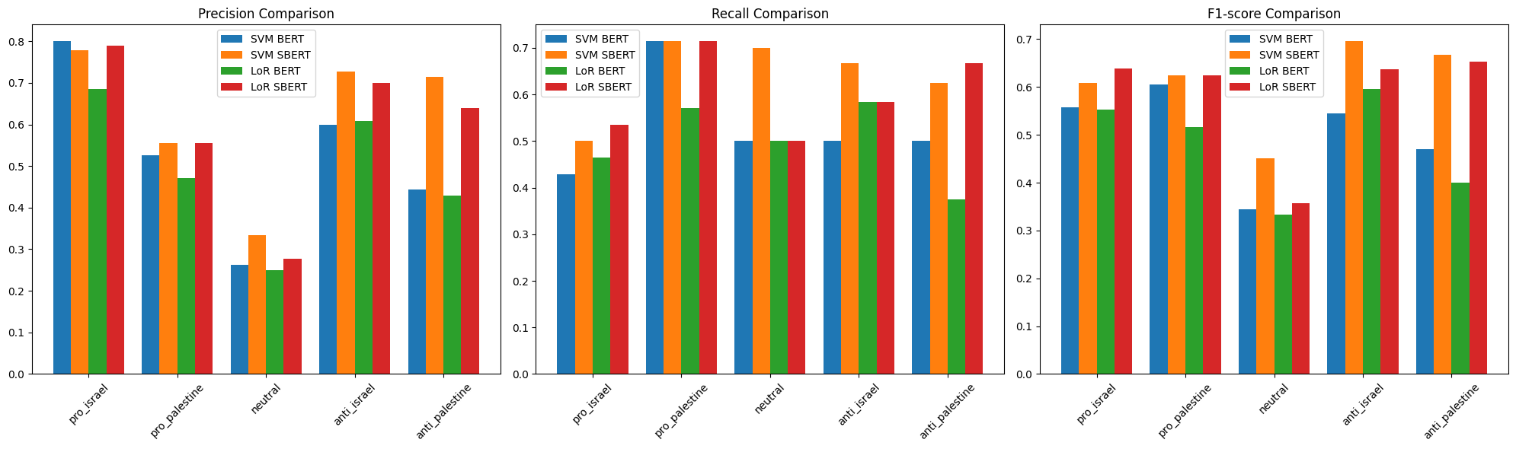

LoR and SVM

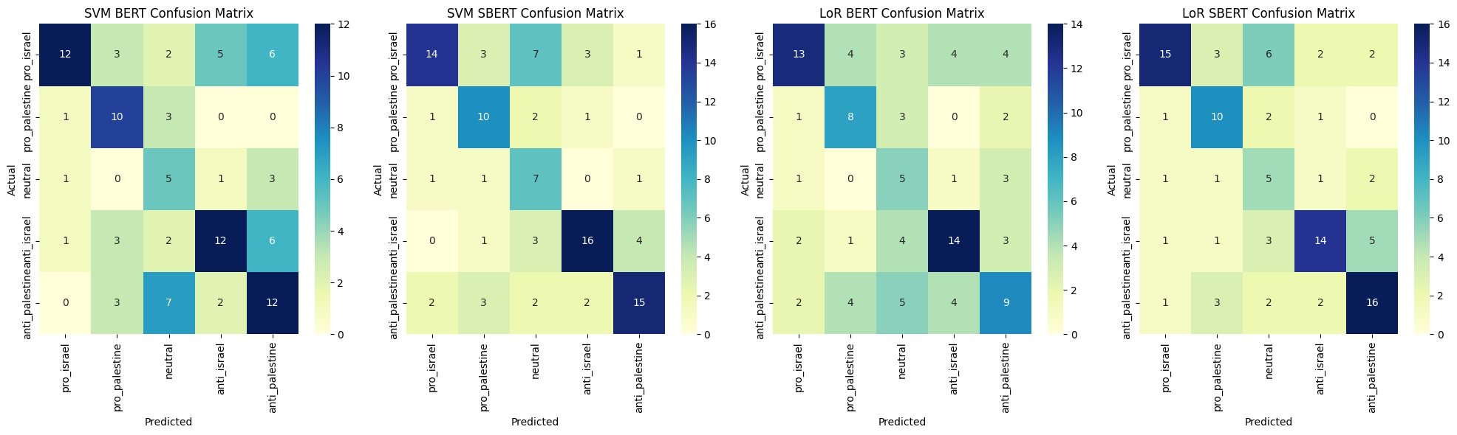

LoR and SVM CM

### 2.5.2 ANN

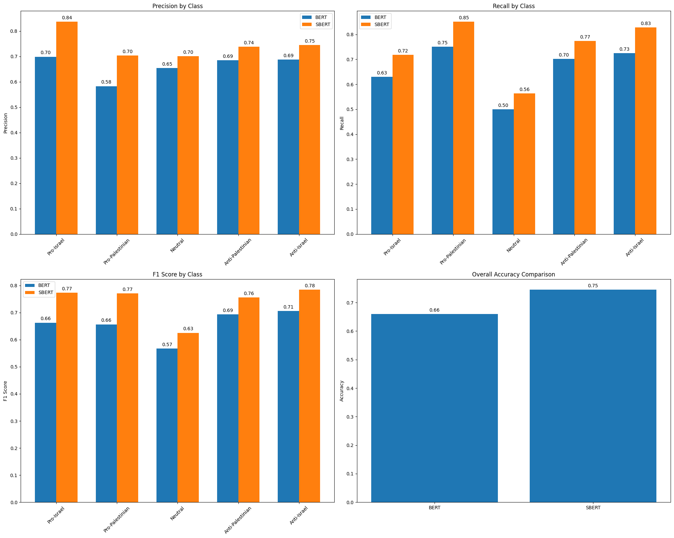

metric_ann

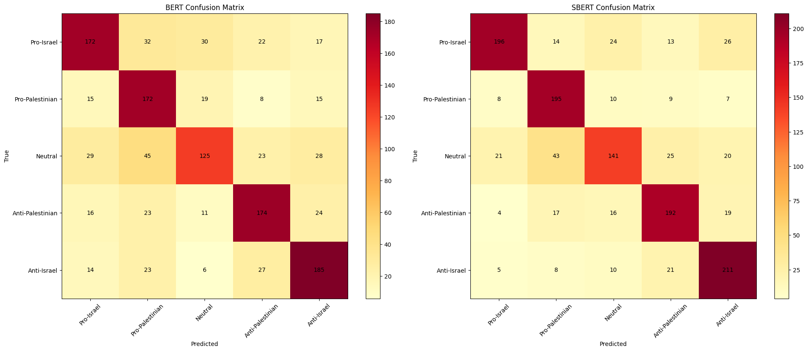

cm_ann

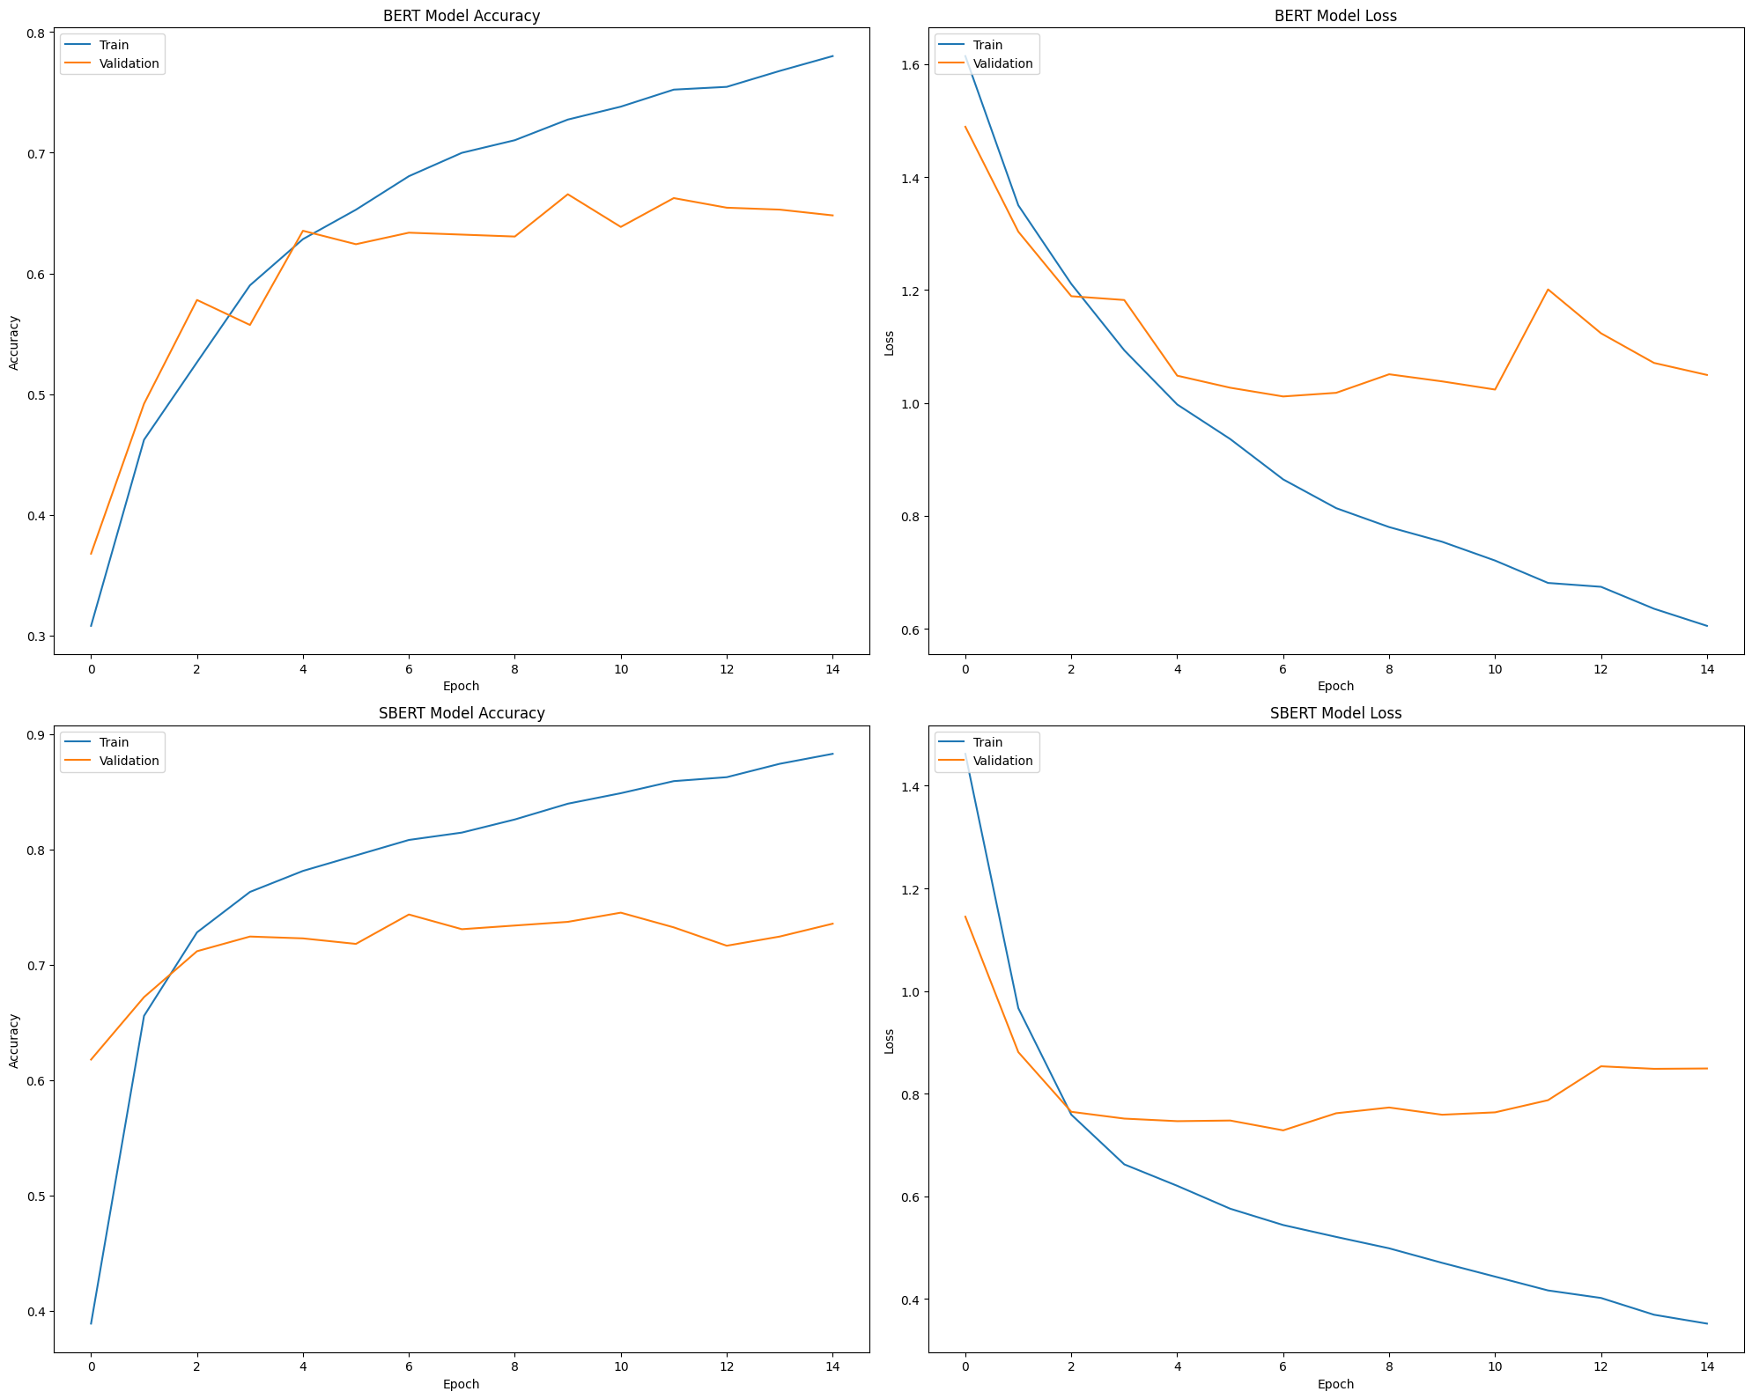

training_ann

## 2.6 Conclusion

We have shown that the ANN model is the best model for this task, and we have shown the results for the other models. We have also shown the training process for the ANN model.

The best model was the ANN model with a test accuracy of $0.64$. For the other models the accuracy was $0.59$ for the SVM model and $0.57$ for the LoR model.

The low accuracy of those model compared to our $95\%$ in the last assignment is due to the complexity of the data natural-language and understanding the sentiment of the text is not an easy task.