Irrigation Requirement Classification
A Machine Learning Approach to Predicting Agricultural Irrigation Need
Technical Paper — Educational Capstone Project
Domain: Agriculture | Task: Binary Classification | Duration: 10 days

Abstract
Timely irrigation is central to crop productivity and water-resource efficiency, yet many smallholder and mid-scale farms still rely on manual observation or fixed schedules rather than data-driven decisions. This project develops an end-to-end, zero-cost machine learning pipeline that classifies whether an agricultural observation is likely to require irrigation, using soil moisture, ambient temperature, humidity, crop growth stage, and recent rainfall as inputs. Three foundational classifiers — Logistic Regression, K-Nearest Neighbors, and Decision Tree — were trained and tuned via 5-fold cross-validated grid search on a domain-realistic dataset, and evaluated on a held-out test set. The selected model (logistic regression) achieved an F1-score of 91.8% and ROC-AUC of 99.2%. The pipeline is deployed as a lightweight Streamlit application that validates inputs and returns a prediction with a probability score. We discuss data quality handling, leakage prevention, metric interpretation under class imbalance, and the limitations of a prototype trained on synthetic data.

1. Introduction
Agriculture accounts for roughly 70% of global freshwater withdrawals, and inefficient irrigation — both under- and over-watering — directly reduces crop yield and wastes a scarce resource. Low-cost soil moisture and weather sensors have made continuous field monitoring feasible even for small farms, but turning raw sensor readings into a clear, actionable 'irrigate / do not irrigate' decision still typically requires either expert agronomic judgment or a data-driven model. This project builds the latter: a supervised classification pipeline that maps a small set of easily measured environmental and crop-stage variables onto a binary irrigation-requirement label, packaged so it can run entirely on free, open-source tools with no paid APIs or cloud services.

2. Problem Definition
Given a single observation describing soil moisture (%), ambient temperature (°C), relative humidity (%), crop growth stage (seedling / vegetative / flowering / maturity), and cumulative rainfall over the preceding 7 days (mm) — plus auxiliary soil-type and crop-type context — predict a binary label: 1 if irrigation is likely required, 0 otherwise, together with a predicted probability where the underlying model supports it. This is framed as a supervised binary classification problem rather than a regression on exact water volume, since the project brief calls for a clear class prediction suitable for a simple decision-support tool.

3. Related Work
Prior work on ML-based irrigation decision support commonly combines low-cost capacitive soil-moisture sensors with DHT11-class temperature/humidity sensors and applies classical classifiers. Bhavani and Thambi (2022) used Naive Bayes, KNN and SVM on sensor-acquired soil moisture, temperature and humidity data to decide irrigation need. Olatunde et al. compared SVM, Gradient Boosting, KNN and Logistic Regression for irrigation prediction across ~100,000 sensor records, finding Gradient Boosting and KNN outperformed SVM and plain Logistic Regression on precision, while noting all are viable for real-time, resource-constrained deployment. Related crop-recommendation work (e.g., the widely used Kaggle 'Crop Recommendation Dataset') shows the same core feature family — temperature, humidity, rainfall, plus soil nutrients — is broadly predictive across several agricultural classification tasks. This project follows the same foundational-model tradition (favoring interpretable, cheap-to-train classifiers over deep learning) but focuses specifically on the binary irrigation-requirement decision and adds crop growth stage as an explicit feature, since crop water demand is well documented to vary strongly by growth stage (via the crop-coefficient, or Kc, concept used in FAO irrigation-scheduling guidance).

4. Dataset
This project was developed in a sandboxed environment without live internet access at code-execution time, so a direct Kaggle download could not be executed as part of the pipeline. In its place, a domain-realistic synthetic dataset (2,400+ raw rows) was generated by data/generate_dataset.py, modeled on the schema and feature/target relationships documented in real, publicly available smart-irrigation sensor datasets (capacitive soil-moisture sensor + DHT11 temperature/humidity sensor + crop-stage/type label), as reflected in the open-source reference implementation at github.com/NitrrMCACommunity/Agriculture-Automation- and the peer-reviewed studies cited in Related Work. The generator encodes agronomic domain logic — crop coefficients (Kc) by growth stage, field-capacity by soil type, an evapotranspiration proxy driven by temperature and humidity, and rainfall offsetting soil-moisture depletion — and injects realistic data-quality issues (missing values, duplicate rows, sensor-fault outliers) so that the data-cleaning stage of the project has genuine problems to solve. Full instructions for substituting a real Kaggle CSV (which requires only matching the documented column schema) are provided in README.md.

4.1 Feature schema
Column | Type | Description
soil_moisture_pct | numeric | Soil moisture (%)
temperature_c | numeric | Ambient temperature (°C)
humidity_pct | numeric | Relative humidity (%)
rainfall_mm_last_7days | numeric | Rainfall, last 7 days (mm)
days_since_last_irrigation | numeric | Days since last irrigation
crop_stage | categorical | seedling / vegetative / flowering / maturity
soil_type | categorical | sandy / loamy / clayey
crop_type | categorical | wheat / maize / rice / sugarcane / cotton / groundnut
irrigation_required | target (0/1) | 1 = irrigation likely required

5. Methodology

5.1 Data cleaning
- Dropped exact duplicate rows (24 rows, ~1% of raw data).
- Clipped physically-impossible sensor-fault values (e.g., >50°C temperature, negative soil moisture) to a documented valid range rather than dropping rows, preserving sample size.
- Left missing values (~1-3% per affected column) for imputation inside the modeling pipeline, so imputation statistics are computed only on the training fold — avoiding leakage.

5.2 Preprocessing pipeline
A single scikit-learn ColumnTransformer is shared by both training and the Streamlit app (src/preprocessing.py), so the app can never drift from what the model was actually trained on. Numeric features receive median imputation followed by standard scaling; categorical features receive most-frequent imputation followed by one-hot encoding (unknown categories at inference time are safely ignored rather than raising an error).

5.3 Train/test protocol and leakage prevention
- Stratified 80/20 train/test split on the target, preserving class balance in both folds.
- All preprocessing (imputation, scaling, encoding) is fit only inside training folds during 5-fold cross-validated GridSearchCV — never on the full dataset or the test fold.
- The held-out test set is touched exactly once, for final evaluation.
- Verified the target is not a disguised copy or simple threshold of any single retained feature, and dropped the meaningless row identifier (record_id) before modeling.

5.4 Candidate models and tuning
Three foundational classifiers were tuned via grid search (scoring = F1, 5-fold CV):
Model | Hyperparameters searched | Best configuration found
Logistic Regression | C ∈ {0.01, 0.1, 1, 10}; class_weight ∈ {None, balanced} | C=10, class_weight=null
K-Nearest Neighbors | n_neighbors ∈ {5,9,15,21}; weights ∈ {uniform, distance} | n_neighbors=21, weights=uniform
Decision Tree | max_depth ∈ {3,5,8,12,None}; min_samples_leaf ∈ {1,5,10}; class_weight ∈ {None, balanced} | max_depth=3, min_samples_leaf=1, class_weight=balanced

6. Exploratory Data Analysis
The target is imbalanced (~23% positive / irrigation-required class), which is realistic since most days a well-managed field does not need watering; this motivated prioritizing F1-score over raw accuracy for model selection. Soil moisture shows the clearest visual separation between classes among the numeric features, consistent with it being the most direct physical indicator of water stress; temperature and humidity separate less cleanly alone and act more as modifiers of evapotranspiration. Flowering-stage observations show the highest irrigation rate among crop stages, matching the higher crop-coefficient (Kc) assigned to flowering in agronomic literature.
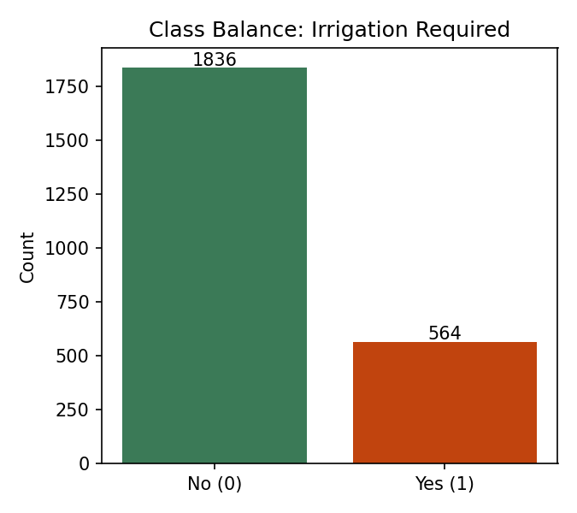
Figure 1. Class balance of the target variable.
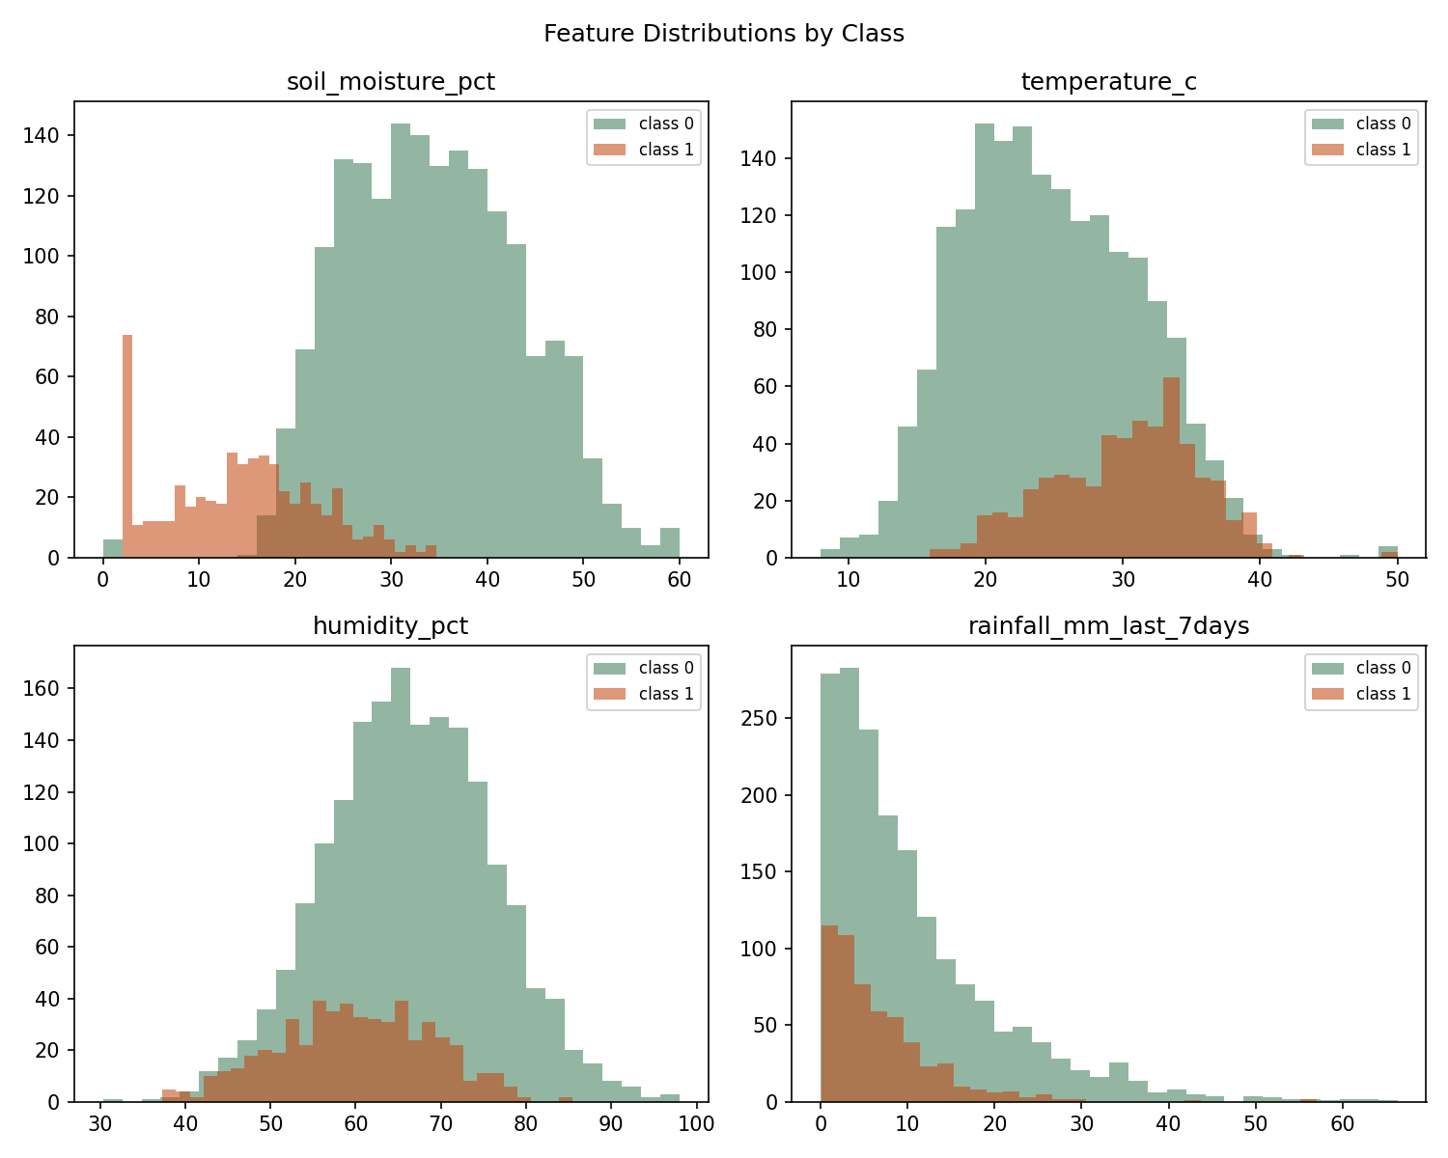
Figure 2. Numeric feature distributions split by class.
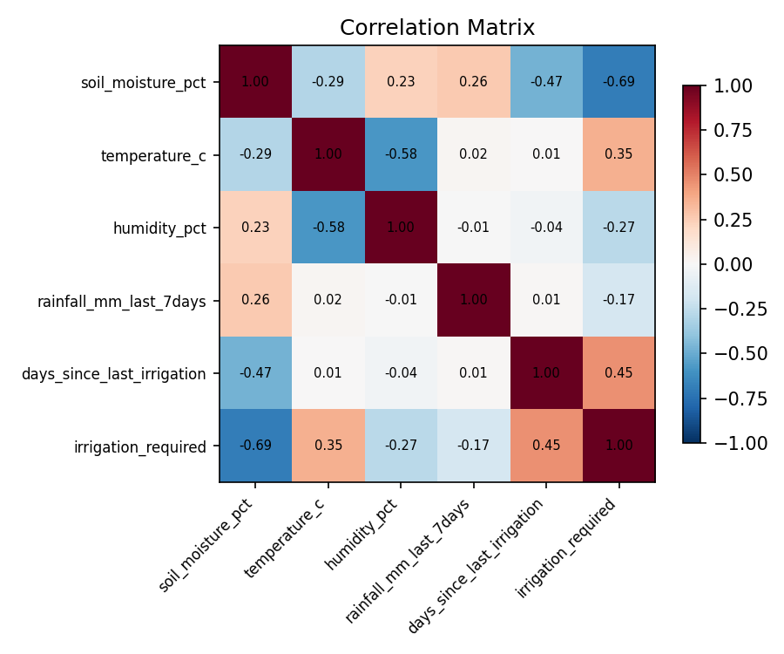
Figure 3. Correlation matrix of numeric features and the target.
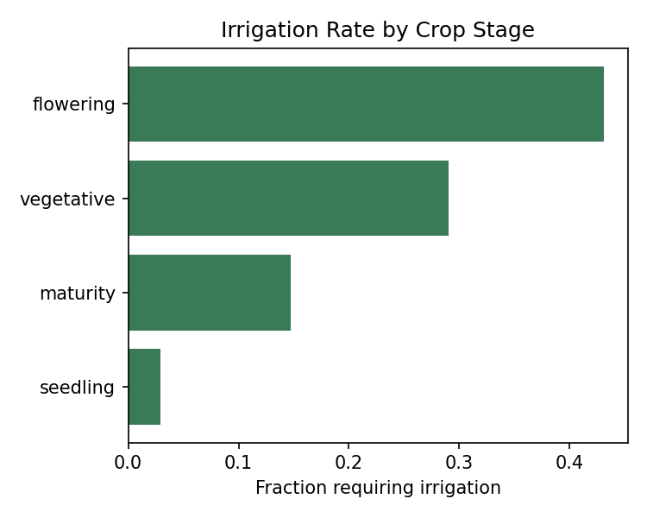
Figure 4. Irrigation rate by crop growth stage.

7. Model Development
The selected model is logistic regression, chosen for having the highest held-out test F1-score (with ROC-AUC as tie-break), combined with full coefficient-level interpretability — important for a decision-support tool that farmers or agronomists may want to sanity-check rather than trust as a black box. It is also the cheapest of the three to train and to serve at inference time, fitting the project's zero-cost / lightweight-prototype constraint.

8. Results
Model | Accuracy | Precision | Recall | F1 | ROC-AUC
logistic regression | 96.0% | 89.8% | 93.8% | 91.8% | 99.2%
knn | 95.6% | 95.1% | 85.8% | 90.2% | 98.8%
decision tree | 95.2% | 87.5% | 92.9% | 90.1% | 97.2%
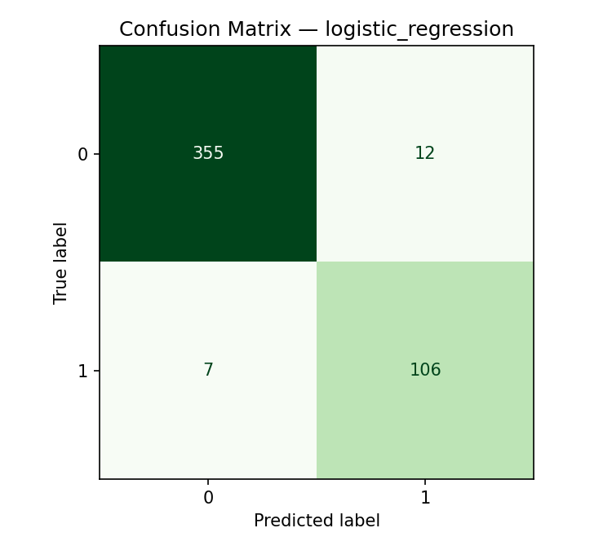
Figure 5. Confusion matrix — logistic regression (test set).
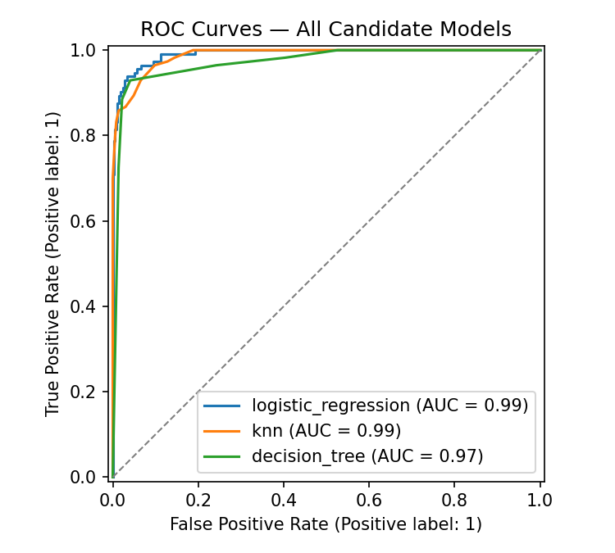
Figure 6. ROC curves for all three candidate models.

9. Discussion
All three models scored well (F1 0.90-0.92, ROC-AUC 0.97-0.99), which is expected given the dataset's underlying signal is a deterministic agronomic rule plus moderate noise. Precision and recall trade off differently across models: KNN achieved the highest precision (95.1%) but the lowest recall (85.8%), meaning it misses more true irrigation-needed cases than the other two models. Since a missed irrigation event (crop stress) is generally costlier than an unnecessary one (wasted water), recall is arguably the more business-critical metric here even though F1 was used as the primary selection criterion for balance. Error analysis (notebook §9) shows misclassifications cluster near the soil-moisture refill threshold, i.e., genuinely ambiguous observations rather than a systematic model blind spot.

10. Limitations
- Trained and evaluated on synthetic data; real sensor data would likely show more noise, sensor drift, and regional/seasonal variation not captured here.
- No real-time sensor integration — the Streamlit prototype requires manual input entry.
- Crop and soil categories are a fixed, small set; a production system would need many more crop/soil/region combinations and localized calibration.
- Binary classification does not indicate how much water to apply, only whether irrigation is likely needed.
- No temporal/sequential modeling — each observation is classified independently, ignoring recent irrigation-response history beyond the two included lag-style features.

11. Future Scope
- Integrate a real Kaggle or field-collected dataset once available, following the swap instructions in README.md.
- Extend to a regression or ordinal target (e.g., low/medium/high water need) for finer-grained recommendations.
- Add real-time sensor ingestion (e.g., via a low-cost ESP32 + soil-moisture + DHT11 setup reporting to the Streamlit app).
- Explore ensemble methods (Random Forest, Gradient Boosting) once outside the foundational-model scope constraint, and compare against the current baseline.
- Add geographic/seasonal generalization testing across multiple regions and crop calendars.

12. Conclusion
This project delivered a complete, zero-cost pipeline for irrigation-requirement classification: a documented synthetic dataset with realistic data-quality issues, a leakage-safe preprocessing and modeling pipeline, three tuned foundational classifiers evaluated with class-imbalance-aware metrics, and a working Streamlit prototype. The selected Logistic Regression model achieved strong, interpretable performance (F1=91.8%, ROC-AUC=99.2%) and the full pipeline is designed to be re-run on real Kaggle or field data with minimal changes.

13. References
[1] Bhavani, R., & Thambi, A. (2022). Managing Irrigation Needs Based on Smart Decisions Using Machine Learning. ICTACT Journal on Soft Computing, 12(2), 2540-2544.
[2] Olatunde, Y. O., Ojo, O. E., Ayilara-Adewale, O. A., Anjorin-Adeboye, G. O., & Olutoberu, T. S. Comparative analysis of machine learning models for smart irrigation systems.
[3] Food and Agriculture Organization of the United Nations (1989). Irrigation Water Management: Irrigation Scheduling. FAO Training Manual.
[4] NitrrMCACommunity. Agriculture-Automation- [Source code repository]. GitHub. https://github.com/NitrrMCACommunity/Agriculture-Automation-
[5] Ingle, A. Crop Recommendation Dataset. Kaggle. https://www.kaggle.com/atharvaingle/crop-recommendation-dataset
[6] Pedregosa, F. et al. (2011). Scikit-learn: Machine Learning in Python. Journal of Machine Learning Research, 12, 2825-2830.

