6.1 **Component Architecture Diagram**

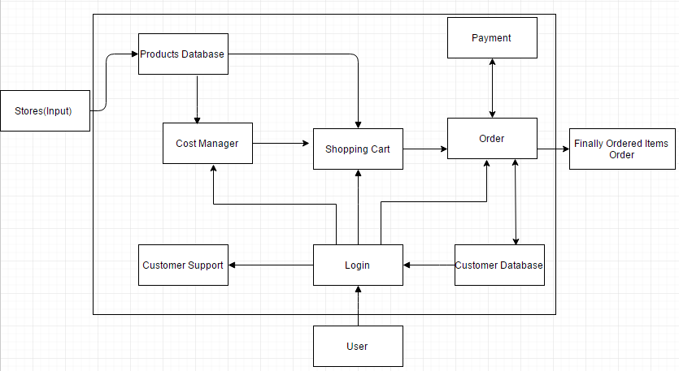

6.2 **Component Descriptions**

https://lh5.googleusercontent.com/w6viKNVnH3Qa-fRsofC3oJHP4EDOGThvBJulHUpXIdL0OAK-8kbfgfDTKQ92gsJ8sSFJpwbRQ9LV6nd0I0C-LpgV4TwPVgr4x24OjnBllb9kbJUsGME_QoCBIDGZdzWPYmjYs1o6qG8mHonUxA

This system/block will have all the stores in a selected geographical area initially and then spread all over the country as the product is used by several users.

https://lh5.googleusercontent.com/C0UhMSIoRLU8ss9zpGrs257mtsn2J8eS8MZolQlSFkVQ2a3XkMks7RxYMamAko4erwIR8P1YZbqkt8hzpM1D9JUv4PH-x3J15H1S86L0si-A015VVJ4vkbl9LZqPdrykaLmIwGcFIh5gqper-Q

This system/block consists of all the stores’ product details which include product name, product id, quantity and other technical details of products.  Shopping by a user or searching of different products from the cost manager done by the algorithm.

https://lh4.googleusercontent.com/07pEzlFTiny3I8R2sCjX_u0StUW3ClG1HTUkoeOcGeqHnlnJGtcO2s2adj_YD8ijnUA2MNN_QVcvpiCjebfnWeyXyw1PUtmlaVGS7xmZszmgGFHMCFLc4HdVVAk716UfMgar4A_HQjSwLosPAw

This system/block takes a list of products from the user as input.  The list of items will be chosen economically from the locality by user the user’s location taken during the login process.  The items will be searched from the Products Database and then added into the cart

https://lh4.googleusercontent.com/OWGsiXrF_QXWq2hMDfhnkFD94ZeQwY29X6i0CbUNcZt68zi_FizVsAIox08Crce0CVtex57wdyAH63hgOmYINnyjQWvSKd1DdaSAL3oXf3S_Ow4N6eC_LTCOUCNAax_HUPzF24BA26505e2UpQ

Customer Support is a system which can be used once the user logins to his account he can interact with the customer service agents.

https://lh6.googleusercontent.com/7onvZzEIKA7uBfTAC8XriYCRKpvtsZs9N5kERS9pshQYSIZ73K1SasrGeHqZ2ezB8s90GFw7WF-tOwY-jGCho0r9E0yuI7s9J7QZuJh9W53IGRV_PQ_ZSbSQA2spWsJ6m3hRCOwj3RVxc90QSQ

Shopping Cart is a block which can is used to input all the products and their quantities.  This block will also carry all the necessary data of the products which is carted to be bought.  This block will let us update the quantities of the item carted or to add or delete a product from the cart.  This block will help is checkout process too.

https://lh6.googleusercontent.com/Gv8-gf-FlBOlVBLuDKTD71oYGthVZNqItJtMWAJm9pi7-6WzLISbqGy_rLXIarTFhXWyeN9I2ljladb942vpEHO9-VGeycnRAByEpFi0_DzOvgfSRe9wXixwcIlrVuHNg_hUdoqf_CjvcoCdhA

The Login block will serve as a normal login interface which asks the user to enter his user name and password.  This block will also provide the user to create an account, if he is using this application for the first time.  This block will also detect the current location of the user.

https://lh6.googleusercontent.com/SGhoH04c77IWXCx6gZ_1t_R-jOJUAEAypq_sHfANkra3OlnIFemXhgS-9sv9CYDEKR1wJ5wgBFDKH_CdfF_uw23JqAyM8T5ydh5TGP37o0Z4niRXwyD2vFUcw7PV8Vd_PnQdqyOT2fFWhQmIVw

This block represent the user, who is using the application.

https://lh6.googleusercontent.com/Ff0lcuOPUdx2SAgflc-xxmonokFo_S4Md1I3IcI89S6YF4488MIryBDNzm58vDWl0H-UeglwUMAC4Hq3qHSP4hRHIsjpEElTsijIGTEKjmMw9l63s3qWM2g8ODZ2eTCFiesOv-q6HjH7p7ZzHAv

Payment block is represents the payment gateway through which a user is allowed to make payments using various modes like credit card, debit card, Paypal etc.

https://lh6.googleusercontent.com/SaQjLucOq7D-Wg5CwJYhsPUx89QXpuQT2G52TKIaIBFIBuqKb_Ht07CdVYYJVZDeWCvmzi6VpZ6BX2PL5RvimLoRaZvJTNJs6nld62YRj_XNmzMwCoxc14GPmqvLVFTaRGimLI_FaGP20mbjHg

This is the most important block which takes the shipping information from the customer database (if there is no shipping address in the customer database, then it asks the user to input here), has all the details regarding the products about their prices, quantities, and delivery dates.  The user can login into his account and check all of his current and past orders in this system.

https://lh3.googleusercontent.com/m4xuLH__u1fECKyqBiwSR1DWpOeQJMtQpC76fiG6r_MqRYY6sYInnQqgPMgkK32HXstU55OZ42RQRtA6kbL-Cbogj_5yx1hPi9vSJHzV_IcpXozOh8G2mSIHh1sp7y4S0wNJfMn_qpgZ4T22Jg

This system/block consists of user information like customer name, customer address, shipping addresses, phone number, emailed, credit card information. This block will also have his wish list item too.

https://lh6.googleusercontent.com/ZmCgj2icS1Mg0LAwk6pJ0HXvBb2eqc3_6QeotDn8naNf8zuJgVN_17nvUVXa0vCHxQ4yBLH7rgya7wo1_oGmOtYGxN9rXt67-BBd6Hs-tHs4nl_Ztbh2htoAdjZejvoeWfDJoNynXso9jK2MkQ

Finally Ordered Items (order) is the output of the system which contains the order item details and their quantities and shipping details which is emailed to the user for his reference.

6.3 **Class Diagrams**

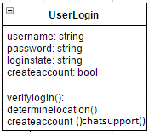

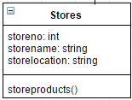

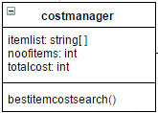

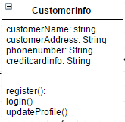

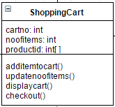

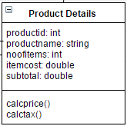

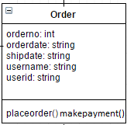

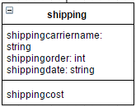

6.4 **Class Relationship/Interaction Diagrams**

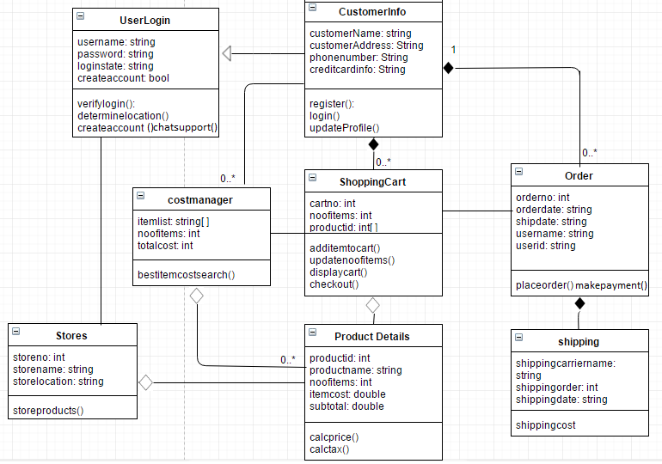

**Events:**

1. UserLogin: The system asks the user to login into his/her account by providing the correct username and password. If the user enters correct username and password then login is successful, otherwise the user is again asked for correct username and password. For the first time users, there is an option for creating a new account.
2. CustomerInfo: For the first time users, there is an option for creating a new account which asks for all user details like name, address, contact information and payment method.
3. User Verification: For the users entering usernme and password, if the details entered are correct, the verification is successful, otherwise it fails and user is asked to enter the details again.
4. CostManager/ List Creation: It involves the user to enter the list of items that he/she needs and the quantity of each item. Based on the list of items entered by the user a total cost (minimum based on the system algorithm) is generated and offers and discounts of each item is also displayed to the user.
5. ShoppingCart: After selecting all the items to purchase and availing all the discounts and offers applicable to items purchased, the user must add all the items to the shopping cart. Each customer is assigned a unique cart number and all products have a unique product identification number. The customer can view his/her account and also remove the items that are not required and after confirming all the items the customer is directed to checkout.
6. Order: After payment of the product is completed, each order is assigned a unique order number, order date, an estimated shipping/ delivery date, customer’s name and user id.
7. Stores: When the user enter’s the list of items to be purchased by him/ her, the system checks for all the stores and the products in the database and based on the prices of that product, it chooses the least amount that is available for that product and at the same time it also checks the availability of the product and location of the store and based on that, it selects that product for the user. Each store has a unique store number, store name and store location.
8. ProductDetails: Each product selected by the system for the user has a unique product id, product name, quantity present in different stores and cost at different stores.
9. Shipping: For the customers who select shipping or are premium customers are given a shipping carrier name, shipping order number and an estimated shipping/ delivery date. For non-premium customers who opt for delivery are charged an extra amount for shipping depending on the shipping address.

**Motives:**

1. UserLogin: The motive of user login is successful login of the user into the system and for the new customers the motive is to successfully create an account.
2. CustomerInfo: For the new user’s the motive is to correctly provide their details like name, address, contact information and payment method and successfully create a new account.
3. CostManager: The motive of the cost manager is to provide the most economic price of the product entered by the customer and at the same time it also checks the availability of the product and location of the store and based on that, it selects that product for the user. Also, to notify the user of all the offers and discounts that can be availed on the selected products.
4. ShoppingCart: The motive is to add all the items and also the quantity of each item into the cart and proceed to checkout.
5. Order: The motive is to successfully make the payment and then to get a unique order number and shipping or pickup details correctly.
6. Stores: The motive is to display the correct list and quantity of all the items present in the store and update them regularly based on the purchases made by the users.
7. ProductDetails: The motive is to display the correct product details and at the same time update the quantity in the system as per the requests made by the users.
8. Shipping: For all the customers who have opted for shipping or for the premium customers, the motive is to get correct details of the shipping order and also the estimated delivery date.

**Activity/ State Diagram:**

C:\Users\Harsh Yadav\AppData\Local\Microsoft\Windows\INetCacheContent.Word\Untitled Diagram (1).png

C:\Users\Harsh Yadav\AppData\Local\Microsoft\Windows\INetCacheContent.Word\Untitled Diagram (2).png

**6.8 Behavior Diagram**

**6.8.1: Sequence Diagram**

**(Generic Sequence)**

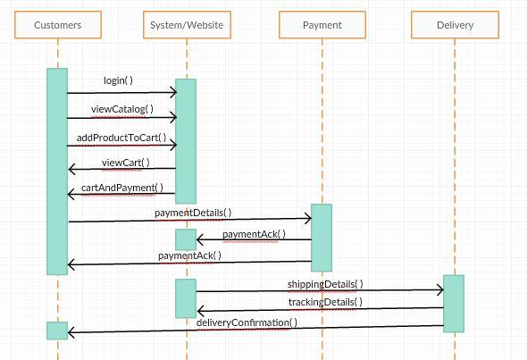

Between Store Manager and System

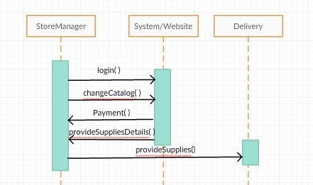

6.8.2: Collaboration Diagram

//Like object oriented diagram

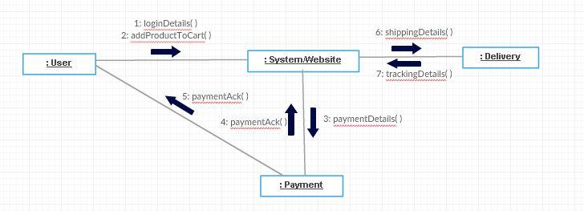

**Event Diagram:**