Twitter Bot Detection

# Datta Sainath Dwarampudi

Computer Science,

New York University

New York, USA

dsd298@nyu.edu

# Madhu Kiran Gudivada

Computer Science,

New York University

New York, USA

mg5309@nyu.edu

***Abstract*—** **In recent years, social media accounts are not only controlled by humans but also by bots. Recent literature has focused primarily on detection of bot in social networks. These bots act as a double-edged sword for a common social media user. Few bots generate large amount of data about news and updating feeds, while other bots spread spam or malicious data through tweets, which is of major concern. In this project, we are trying to design, analyze and implement classifiers to detect the probability of a given user account as a bot or not. We shall use 2 classifiers based on Naïve Bayes and Logistic regression for tweet analysis. We shall compare the classifiers and try to improve the better classifier till we get satisfied accuracy.**

***Keywords—machine learning, bots, Naïve Bayes, logistic regression, twitter, Natural Language Processing***

**I.INTRODUCTION**

Our project proposal is to determine a user account as a legitimate user account or a bot. There is tremendous work been done in this domain. Bots can be used to generate live scores, weather and news. They can also be used to distribute malicious tweets which have huge consequence on society. There are. According to Emilio Ferrara, a computer scientist and assistant professor at the University of Southern California (USC) has said that online bots which influence the political discourse on social media as never. We shall employ two algorithms based on Naïve Bayes and logistic regression for tweet analysis and then hone one of the algorithm of the above two which gives a better accuracy for bot detection. We shall modify and enhance the code to get better accuracy. Online marketers on twitter are also affected due to huge number of bot in the twitter ecosystem.

**II.MOTIVATION**

Twitter is one of the most popular social media platforms, it has been plagued by many bots during recent years. This has been a major problem to deal with. A recent publication states that more than half of the twitter accounts are not human. Few other optimistic studies states that 5-9% of the overall population is a bot and these bots generate 24% of all the tweets produced on twitter. In a case, a bot campaign created fake “buzz” about a tech company: automated stock trading algorithms acted on this chatter, resulting in a spurious 200-fold increase in market price. This has motivated us to actively deal with this issue by designing good classifiers using naïve Bayes and logistic regression for tweet analysis.

**III.RELATED WORK**

We are referring a lot of published papers and websites to complete this project successfully. We tried to refer papers which dealt with how twitter was in the in initial phase [1],[2], to better understand about the community of social media and its usage statistics. Krishnamurthy et al. [1] has studied and segregated twitter into 3 groups: 1) broadcasters, which have a large number of followers; 2) acquaintances, which have about the same number on either followers or folling; and 3) miscreants and spammers, which follow a large number of follower but have few followers. Twitter has attracted spammers to post spam content, due to its popularity and openness. Fighting against spam on Twitter has been investigated in recent works [2],[3]&[4]. Yardi et al. [2] dated spam on twitter. His observations, include that spammer ssend more messages than legitimate users, and more likely to follow other spammers than legitimate users. Thus, a high follower-to-following ratio is a sign of spamming behavior. We are also mainly referring from papers recommended by professors [5],[6] & [7].

**IV.DATA**

We have gathered 50 bot accounts and 50 user accounts from various sources. It was very tough to gather data for bot accounts. We gathered bot data primarily from major websites which have detailed bot accounts listed in its websites. We even obtained data for bots from news website like CNN and other major websites which increased the number of followers of prominent politicians in United States of America. We tried searching for bots from various other websites, which helped people to build bots and some bot accounts were listed as the work performed by the previously. Some of the statuses contained symbols like emoticons, which were converted to UTF-8 format.

**V.ALGORITHM(S)**

The major part of any analysis for twitter data would be the tweets. The way a bot tweets and a human tweet plays a major part in the classification of the accounts. So, for the initial part of the project would be to gather the last 200 tweets and clean them. Then these are fed to the selected classifiers.

**V.I. CLEANING DATA**

The data received from the twitter API is crude and contains a lot of unwanted symbols(emoticons) and hex values. We used the NLTK package to remove these symbols. Once cleaned the tweets were tokenized from which stop words are removed to improve the vocabulary of the classifier. The remaining words are stemmed to ensure that the count vectorizer identifies the similar words properly.

**V.II. DATA COVERSION**

The cleaned data is then labelled properly to distinguish between bot and user data. Since the algorithms require numerical data we use CountVectorizer() fuction from sklearn to covert the text data into numerical data.

# **V.III TRAINING DATA**

The data is spilt into Training data and Test data for a 10-fold cross validation using the StratifiedKFold technique.

**V.IV. ALGORITHMS USED**

One the best methods to classify text data is Naïve Bayes. As Wikipedia states that “Naïve Bayes is a popular (baseline) method for text categorization, the problem of judging documents as belonging to one category or the other (such as spam or legitimate, sports or politics, etc.) with word frequencies as the features”. For discrete features like the ones encountered in document classification (include spam filtering), Multinomial and Bernoulli distributions are very popular.

**V.IV.I. Multinomial Naïve Bayes.**

Wikipedia defines Multinomial Naïve Bayes as “A multinomial event model, samples (feature vectors) that represent the frequencies with which certain events have been generated by a multinomial where the probability that event occurs”. A feature vector is represented as a histogram, by counting the number of times event was observed for an instance. This is the event model typically is used for document classification, with events representing the occurrence of a word in a single document (see bag of words assumption).

**V.IV. II. Bernoulli Naïve Bayes.**

In the multivariate Bernoulli event model, features are independent booleans (binary variables) describing inputs. Like the multinomial model, this model is popular for document classification tasks where binary term occurrence features are used rather than term frequencies. This event model is especially popular for classifying short texts. It has the benefit of explicitly modelling the absence of terms.

A Naive Bayes classifier with a Bernoulli event model is not the same as a multinomial NB classifier with frequency counts truncated to one.

**V.IV.III. Logistic Regression**

We also used another popular method to classify the data i.e. by

regression. Logistic regression is defined as “a regression model where the dependent variable (DV) is categorical. This article covers the case of a binary dependent variable—that is, where it can take only two values, "0" and "1", which represent outcomes such as pass/fail, win/lose, alive/dead or healthy/sick.” Since our dependent variable has only two values i.e. bot or not bot we need not use multinomial Logistic Regression. Logistic regression measures the relationship between the categorical dependent variable and one or more independent variables by estimating probabilities using a logistic function, which is the cumulative logistic distribution. Thus, it treats the same set of problems as probity regression using similar techniques, with the latter using a cumulative normal distribution curve instead.

**V.V. Our NEW Algorithm**

We used Naïve Bayes algorithms like Multinomial Naïve Bayes and Bernoulli Naïve Bayes and Logistic regression in the mid report. Later, we tried to use sentimental analysis and worked on the behavior features of a twitter account like the followers count, friends count, location, favorites count and many other parameters. The results which we obtained were very disappointing. We then realized that the training bot data is corrupted. They were huge number of user accounts in the training bot data. Then, our plan of action was to completely clean the bot data and then implement our own algorithm.

To clean up the bot data, first we needed to come up with an algorithm to recognize user accounts. The best user data we had was our own 50 user data. We wanted to first try our cleaning algorithm on our own data sets and then work on cleaning the data sets

**Recognizing the user accounts as well as bot accounts:**

**First Step:** Finding whether ‘bot words’ is present in the screen names, names or description of a user account. Most of the times, we can observe that if it is a bot, then there is bot word attached to description or name or screen name. There can be a circumstance where ‘bot’ phrase can be used in a legitimate user. But, we will not pay much attention to it because in our user data and training user data there is very less probability of such an event occurring.

In this step, when ever we will recognize a bot phrase in the account, we will change the value of account to 2.

When the first step is applied on our user accounts has led to 0 accounts which had a bot in its screen names, names or description.

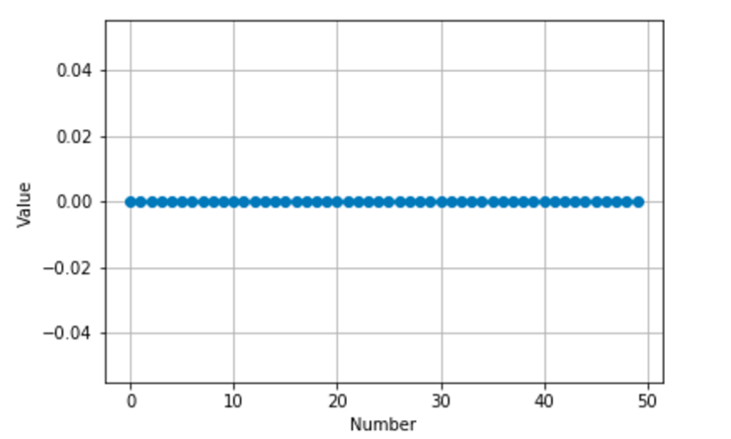

We can clearly observe that all the values are zero and no detection of ‘bot’ term in any one of the 50 accounts.

When we apply this step on training user data, we get the following graph.

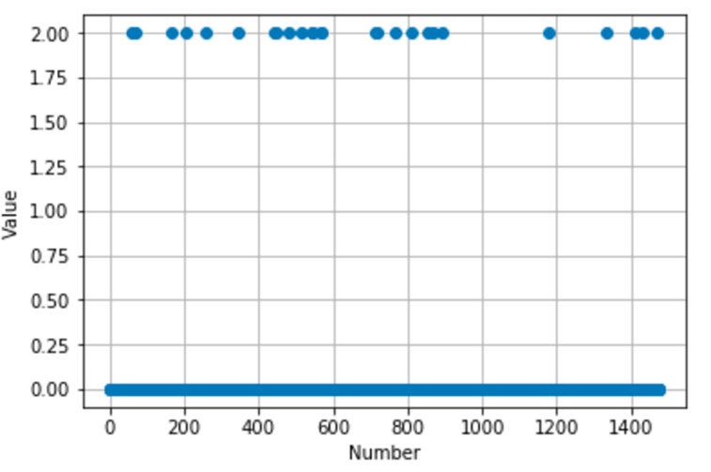

We can observe there are few instances where there is ‘bot’ phrase in the screen name, name or description of the user account. But, it should be noted that we could flush out only 21 accounts out of 1477 accounts that led to decrease of accuracy by 0.01423. This decrease of accuracy can be tolerated because this step is vital for filtering out bot accounts.

When this step was applied on our bot data we could get the following result.

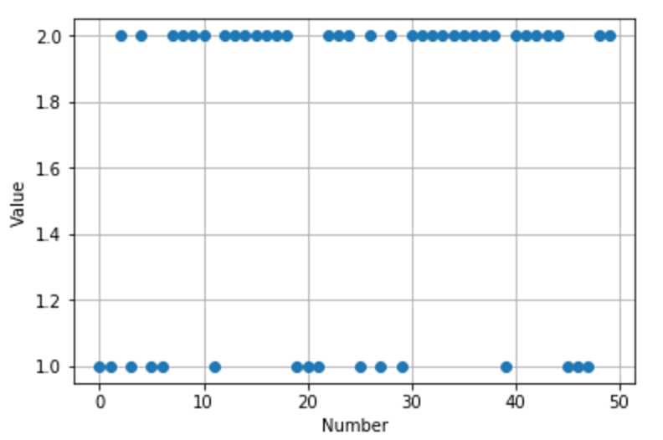

Here we could see that most of the bot accounts were filtered directly. Precisely, 29 of the 50 accounts can be directly categorized as bot leading to increase in accuracy of 58%.

When this step was applied on the bot analysis data, we could achieve the following plot.

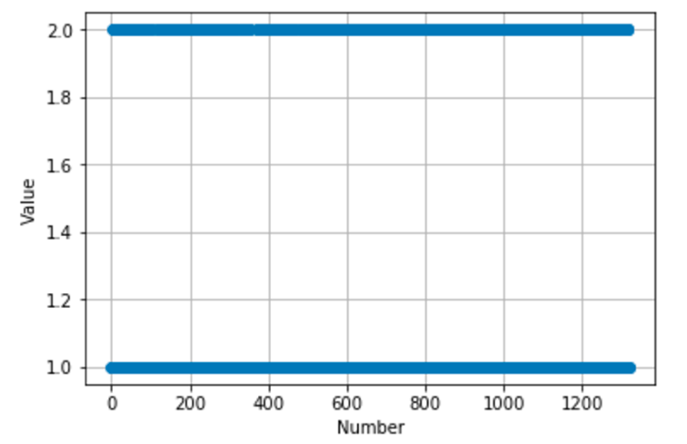

We could recognize 388 accounts as bots and led to an increase of 29.3999 % out of the uncleaned data.

**Second Step:** Finding whether there are accounts with zero followers, zero friends or zero tweets. If there are any such accounts, we shall consider these types of accounts as users and not bots because bots are usually made with a motive to either follow many people or make friends or tweet a lot of stuff.

When we applied this step on our user data, we could find that no account satisfied this condition.

When we applied this step on training user data, we could find 24 accounts which satisfied this condition. This can improve our accuracy by 1.626%

When we applied this step on our bot data, we could find 4 account which satisfied this condition. This could deteriorate our assumption and lead to a decrease in accuracy of 8%

When we applied this step on training bot data, we could find that several accounts around 250 were discovered with condition leading to a accuracy change of 19%.

**Third Step**: Finding whether there are accounts which have tweets to friends ratio less than 12 or tweets to followers ratio less than 12. If any such account we will regard such accounts as user accounts. (We have concluded this assumption by seeing the following observations)

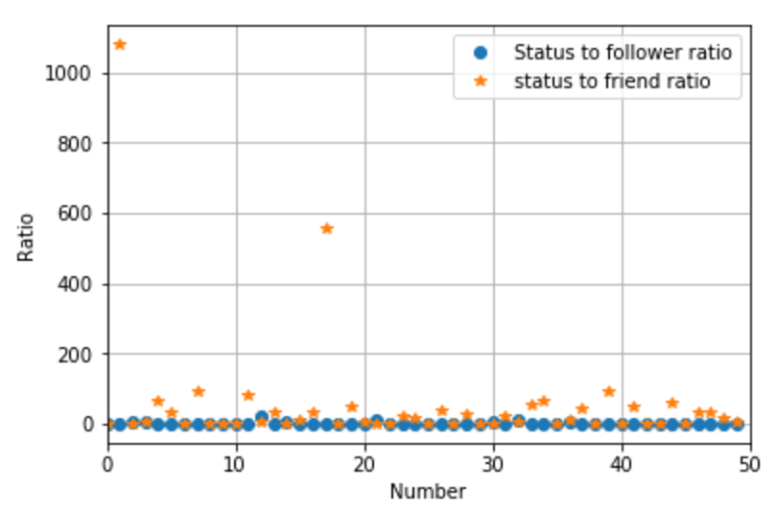

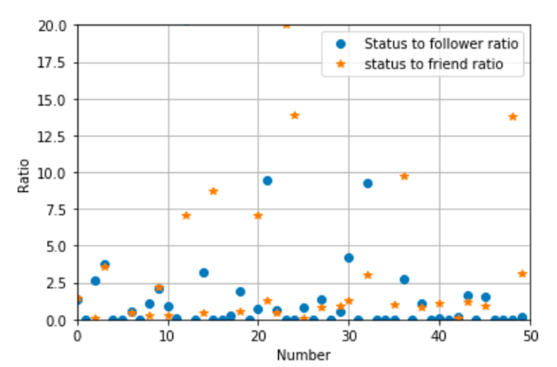

When we apply this step on our user data the following plots was produced. We could plot the second graph by limiting the y axis to 20. We could clearly observe the fact the user accounts clearly showed that either of tweets to followers ratio or tweets to friends ratio were below 12. We could achieve 100 accuracy on our user data.

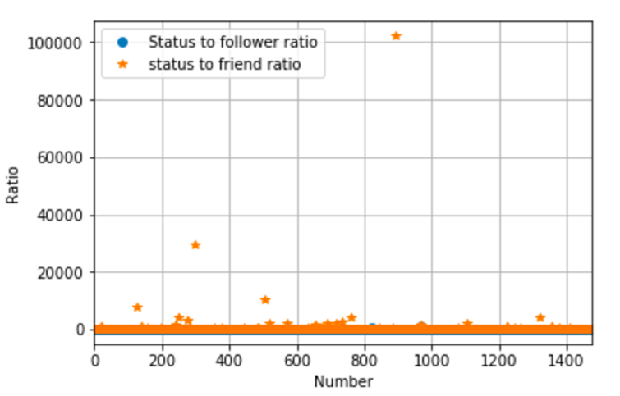

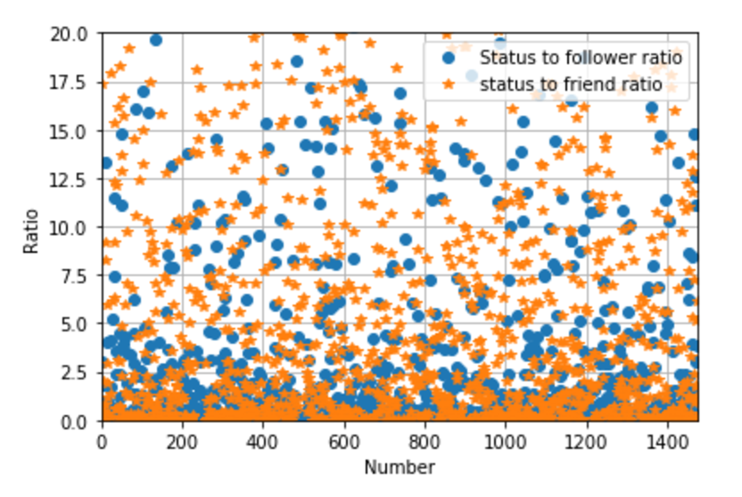

When we apply this step on train user data the following plots was produced. We could clearly observe the fact the user accounts clearly showed that either of tweets to followers ratio or tweets to friends ratio were below 12. We could achieve 89.77% accuracy on our user data.

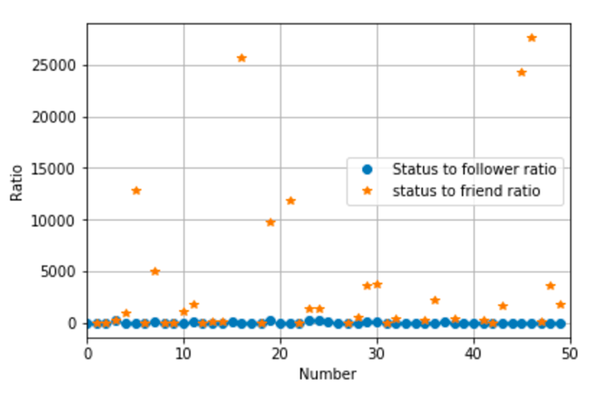

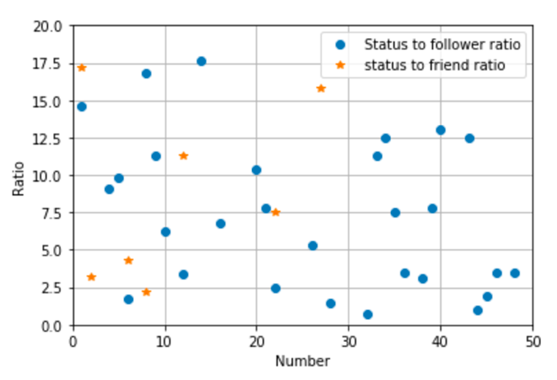

When we apply this step on our bot data the following plots was produced. We could clearly observe the fact the bot accounts clearly showed that not both of tweets to followers ratio or tweets to friends ratio were below 12. (In the context of bots we try to change the condition of this stop from either to both the ration under 12). So, we could see that only 1 account was recognized here.

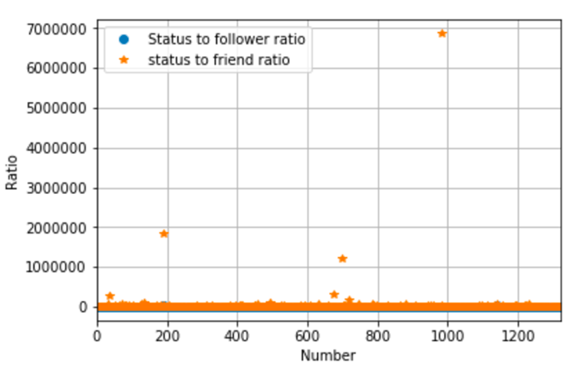

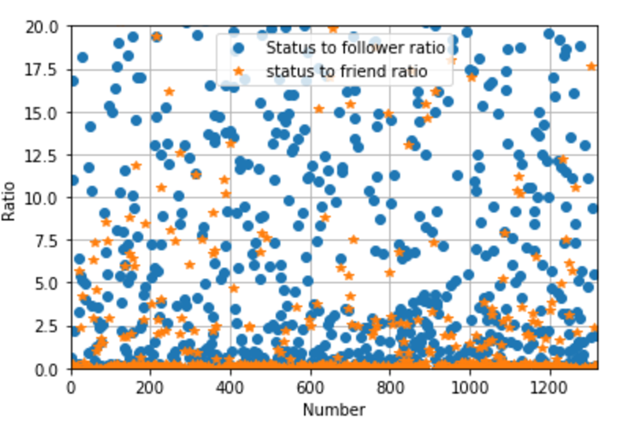

When we apply this step on train bot data the following plots was produced. We could clearly observe the fact the bot accounts clearly showed that not both of tweets to followers ratio or tweets to friends ratio were below 12. (In the context of bots we try to change the condition of this stop from either to both the ration under 12). So, we could see that only 220 accounts were recognized here. (This is actually lots of noise present in the given bot data)

**Fourth Step**: Finding whether there are any accounts are verified are not. If an account is verified then we shall assume it to be a user account because twitter usually verifies users/humans rather than bots. (We change the value of account to 1 when it is verified)

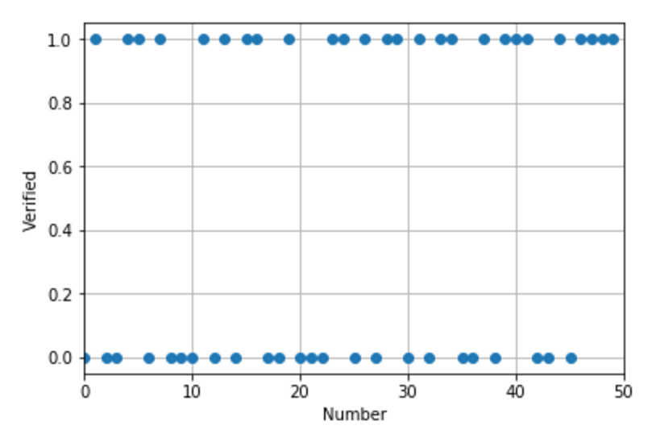

When we applied this step on our user data. We could find the around 26 accounts to be verified. That leads to an accuracy of 52%.

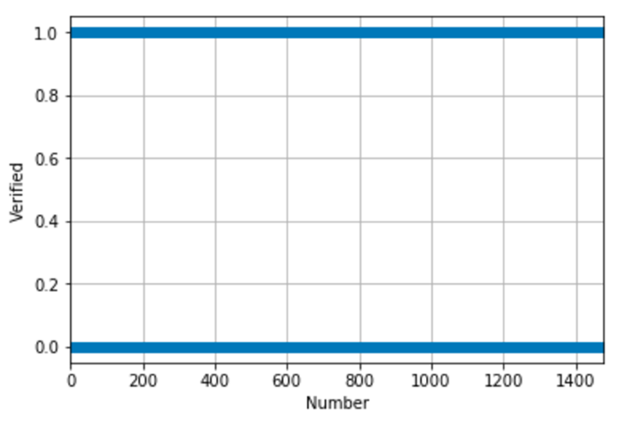

When we applied this step on train user data. We could find that 645 accounts were verified. That leads to an accuracy of 43.7%

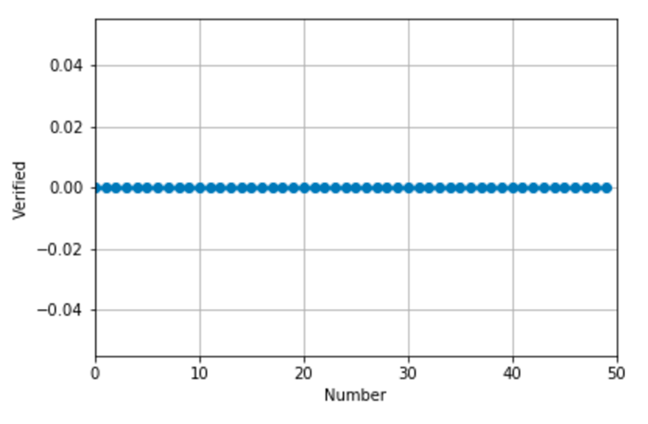

When we applied this step on our bot data. We could find that 0 accounts were verified. That leads to an accuracy of 0%.

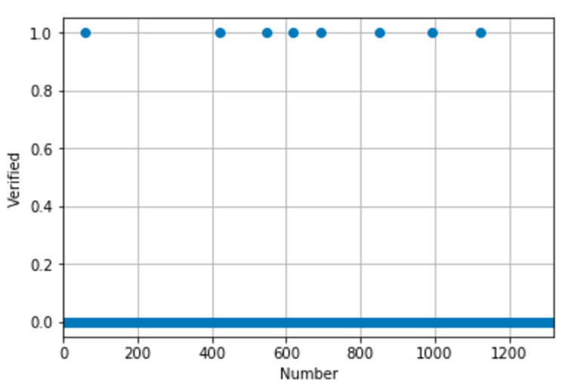

When we applied this step on train bot data. We could find that 8 accounts were verified in a bot data. Which leads to an accuracy of 0.6%. This step strengthens our claim that the given bot training data is not so accurate.

**Fifth Step:** This step is used for finding the clever bots. We define clear bot which were clever enough not to mention that they were bots in screen names, names or description but they follow huge no of user or they tweet a lot. We will try to find the bots which have tweets to status ratio greater than 10 or tweets to followers ratio greater than 10.

When we applied this condition on our user data. We recognized zero accounts satisfying this condition. This is a huge positive point for us.

Similar results were obtained when we tried on train user data, our bot data, train bot data.

**Calculation of the accuracy of the all the above steps:**

**In case of user accounts:**

Initially we assume the value of Value array to be 0. We change its value to 2 in the first and fifth step. Change its value to 3 in second, third and fourth step.

So, during calculation of accuracy, we shall consider value 2 as 0 and rest of the values as a positive value for users.

The accuracy scores achieved on our user data was 100% and on user train data was 98.3%.

**In case of bot accounts:**

Initially we assume the value of Value array to be 1. We change its value to 2 in first and fifth step. Change its value to 3 in second, third and fourth step.

So, during calculation of accuracy, we shall consider value 3 as 0 and rest of the valueas as a positive value for bots.

The accuracy scores achieved on our bot data was 90% and on bot train data was 64%. We achieved 64% on train bot data because it had lots of accounts which were legitimate users. We can use the same algorithm for cleaning of the bot train data.

**VI.PEFORMANCE AND RESULTS**

We calculated the average accuracy, recall, precision, f1 and roc_auc(area under curve) scores for the 10-fold values and plotted an ROC curve by using the tpr and fpr values.

The average values are in the following table:

|  |  |  |  |
| --- | --- | --- | --- |
|  | MultinoialNB | BernoulliNB | LogisticReg |
| accuracy | 0.7128 | 0.7227 | 0.7295 |
| precision | 0.8344 | 0.8159 | 0.7814 |
| recall | 0.6435 | 0.6878 | 0.7547 |
| f1 score | 0.7230 | 0.7436 | 0.7666 |
| roc_auc | 0.8139 | 0.8145 | 0.8055 |

|  |  |  |
| --- | --- | --- |
|  | New Algorithm | LogisticReg |
| Accuracy | 0.857 | 0.729 |
| Precision | 0.789 | 0.7814 |
| Recall | 0.859 | 0.7547 |
| f1_score | 0.818 | 0.7666 |
| Roc_auc | 0.849 | 0.8055 |

The ROC graph is:

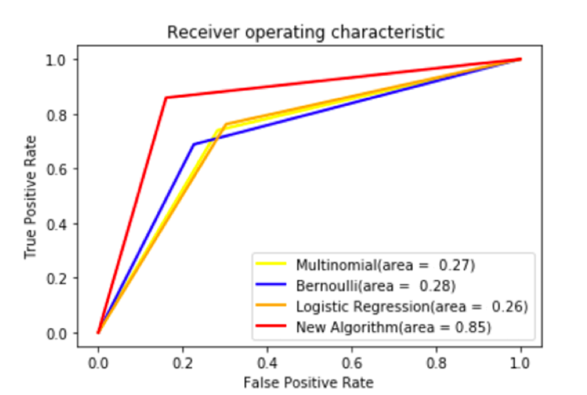

To estimate the error rate of the classifier we used Mean Squared Error and the values are

|  |  |  |  |
| --- | --- | --- | --- |
|  | MultinoialNB | BernoulliNB | LogisticReg |
| MSE | 0.2871 | 0.2772 | 0.2704 |

|  |  |  |
| --- | --- | --- |
|  | New Algorithm | LogisticReg |
| MSE | 0.153 | 0.2704 |

**VII.CODE**

Code Link: <https://github.com/dattasainathd/TwitterBot3>

**VIII. Future Work**

The future work can be focused on the following parameters.

1)**Sentimental Analysis**: We would add Twitter specific sentiment analysis algorithms, including happiness, arousal-dominance-valence, and emoticon scores.

2) **Friends Hierarchy** that include an account’s social contacts, such as the median, moments, and entropy of the distributions of their number of followers, posts, and so on

3)**User metadata** which include the language, time of creation, locations etc.

4)**Behavior Features** like when a user posts a tweet and time between tweets and length of tweets etc.

**IX.REFERENCES**

[1] B. Krishnamurthy, P. Gill, and M. Arlitt, “A Few Chirps about Twitter,” Proc. First Workshop Online Social Networks, 2008.

[2] S. Yardi, D. Romero, G. Schoenebeck, and D. Boyd, “Detecting Spam in a Twitter Network,” First Monday, vol. 15, no. 1, Jan. 2010.

[3] C. Grier, K. Thomas, V. Paxson, and M. Zhang, “@spam: The Underground on 140 Characters or Less,” Proc. 17th ACM Conf. Computer and Comm. Security, pp. 27-37, 2010.

[4] K. Thomas, C. Grier, D. Song, and V. Paxson, “Suspended Accounts in Retrospect: An Analysis of Twitter Spam,” Proc. ACM SIGCOMM Conf. Internet Measurement Conf., pp. 243-258, 2011.

[5] Emilio Ferrara, Onur Varol, Clayton Davis, Flippo Menczer, Allessandro Flammini, “The Rise of Social Bots”, Communications of ACM 59 (70, 96-104, 2016

[6] Lee, et al. Who Will Retweet This? Automatically Identifying and Engaging Strangers on Twitter to Spread Information.

[7] Erin Shellman, http://www.erinshellman.com/bot-or-not/.