AUTOMATED AUDIO MINUTES SYSTEM
A MINI - PROJECT REPORT
Submitted by
PRASANNA RAMKUMAR M | Reg. No.: 9517202404109
PRAVEEN B | Reg. No.: 9517202404110
for the Course
23CS553 – MINI PROJECT - III

DEPARTMENT OF COMPUTER SCIENCE AND ENGINEERING
MEPCO SCHLENK ENGINEERING COLLEGE, SIVAKASI
(An Autonomous Institution affiliated to Anna University Chennai)
November 2026

BONAFIDE CERTIFICATE
This is to certify that it is the Bonafide work titled “AUTOMATED AUDIO MINUTES SYSTEM” carried out by PRASANNA RAMKUMAR M (Reg. No.: 9517202404109) and PRAVEEN B (Reg. No.: 9517202404110) for the course 23CS553 - Mini Project – III, Mepco Schlenk Engineering College (Autonomous), Sivakasi during Semester - V in the academic year 2026 – 2027.
Project Guide Head of the Department
Submitted for the Practical Examination held at Mepco Schlenk Engineering College (Autonomous), Sivakasi on ....../....../ 20.......
Internal Examiner - I Internal Examiner - II

ABSTRACT
Meetings, lectures and recorded discussions produce large amounts of audio and document content in which the important information is difficult to find and expensive to review manually. This project presents the Automated Audio Minutes System (AAMS), also called MeetInsight, a locally hosted web application that analyses audio, TXT and PDF files. Audio is converted into text using faster-whisper, text is read directly from TXT files and text is extracted from PDF files.
The system automatically detects whether the content is a meeting, study material or a general document. For meetings it produces a concise summary, topics and keywords, action items, decisions and sentiment. For study material it produces key concepts, keywords, important points, definitions, programs and exam questions. For general documents it produces a summary and key topics. Text preprocessing uses spaCy, extractive summarization uses Sumy, keywords are extracted with YAKE, and action items are detected by a Logistic Regression model trained on TF-IDF features of labelled meeting sentences.
The application is built with Flask and SQLite. All analyses are stored locally so that users can view their history, search previous records and export reports, and no meeting content leaves the user’s computer. The design is informed by a review of automatic text summarization techniques and by recent work on consensus-focused and agenda-aware meeting summarization.

ACKNOWLEDGEMENT
First and foremost, we thank the LORD ALMIGHTY for his abundant blessings that is showered upon our past, present and future successful endeavors.
We extend our sincere gratitude to our college management and Principal Dr.S.Arivazhagan, M.E., Ph.D., for providing sufficient working environment such as systems and library facilities. We also thank him very much for providing us with adequate lab facilities, which enable us to complete our mini-project.
We would like to extend our heartfelt gratitude to Dr.J.Raja Sekar, M.E., Ph.D., Senior Professor and Head, Department of Computer Science and Engineering, Mepco Schlenk Engineering College for giving us the golden opportunity to undertake a mini-project of this nature and for his most valuable guidance given at every phase of our work.
We would also like to extend our gratitude to Mr.N.Umakanth, M.E., (Ph.D.,) Assistant Professor (Sl. Grade), and Dr.K.Kamala Devi, M.E., Ph.D., Assistant Professor, Department of Computer Science and Engineering, for being our mini-project in-charges and directing us throughout our project.
We express our sincere thanks to our project guide Mrs.T.Bhuvaneshwari, Department of Computer Science and Engineering, Mepco Schlenk Engineering College, for her valuable experience, expertise, direction, suggestions and support throughout the mini-project.
Our sincere thanks to our revered faculty members and lab technicians for their help over this mini-project work.
Last but not least, we extend our indebtedness towards our beloved family and our friends for their support which made the mini-project a successful one.
TABLE OF CONTENTS
ABSTRACT ii
ACKNOWLEDGEMENT ii
LIST OF TABLES ii
LIST OF FIGURES ii
LIST OF ABBREVIATIONS ii
INTRODUCTION 1
1.1 PERSPECTIVE 1
1.2 OBJECTIVE 1
1.3 SCOPE 1
1.4 PROBLEM STATEMENT 1
1.5 LITERATURE SURVEY 1
1.6 ORGANIZATION OF THE REPORT 1
REQUIREMENTS DESCRIPTION 1
2.1 FUNCTIONAL REQUIREMENTS 1
2.2 NON-FUNCTIONAL REQUIREMENTS 1
SYSTEM DESIGN 1
3.1 ARCHITECTURE DESIGN 1
3.2 DESIGN COMPONENTS 1
3.3 DATABASE DESCRIPTION 1
3.4 LOW LEVEL DESIGN 1
3.5 DATASET AND MODEL DESCRIPTION 1
3.6 USER INTERFACE DESIGN 1
3.7 CHAPTER CONCLUSION 1
SYSTEM IMPLEMENTATION 1
4.1 LOGIN IMPLEMENTATION 1
4.2 FILE UPLOAD IMPLEMENTATION 1
4.3 SPEECH-TO-TEXT IMPLEMENTATION 1
4.4 TEXT PREPROCESSING IMPLEMENTATION 1
4.5 MODE DETECTION IMPLEMENTATION 1
4.6 MEETING ANALYSIS IMPLEMENTATION 1
4.7 STUDY MATERIAL ANALYSIS IMPLEMENTATION 1
4.8 GENERAL DOCUMENT ANALYSIS IMPLEMENTATION 1
4.9 STORAGE, HISTORY AND SEARCH IMPLEMENTATION 1
4.10 REPORT EXPORT IMPLEMENTATION 1
4.11 ACTION ITEM MODEL TRAINING 1
RESULTS AND DISCUSSION 1
5.1 TEST CASES AND RESULTS 1
5.2 DISCUSSION 1
CONCLUSION AND FUTURE ENHANCEMENT(S) 1
SYSTEM REQUIREMENTS 1
SOURCE CODE 1
REFERENCES 1

LIST OF TABLES
TABLE NO. | TABLE CAPTION | PAGE NO.
1.1 | Comparison of Reference Papers with AAMS
3.1 | User Description
3.2 | Meeting Record Description
3.3 | Action Item Description
3.4 | Decision Description
3.5 | Login Details
3.6 | File Upload Details
3.7 | Speech-to-Text Details
3.8 | Mode Detection Details
3.9 | Meeting Analysis Details
3.10 | Study Material Analysis Details
3.11 | Report Export Details
3.12 | Action Item Dataset and Model Configuration
5.1 | Positive Test Case and result for Login
5.2 | Negative Test Case and result for Login
5.3 | Test Case and result for Audio Upload
5.4 | Test Case and result for PDF Upload
5.5 | Test Case and result for Unsupported File
5.6 | Test Case and result for Meeting Mode Detection
5.7 | Test Case and result for Study Material Mode Detection
5.8 | Test Case and result for Action Item Detection
5.9 | Test Case and result for Decision Detection
5.10 | Test Case and result for Search
5.11 | Test Case and result for Report Export
5.12 | Performance of the Action Item Detection Model

LIST OF FIGURES
FIGURE NO. | FIGURE CAPTION | PAGE NO.
3.1 | Architecture Diagram of Automated Audio Minutes System
3.2 | ER Diagram of Automated Audio Minutes System
3.3 | Database Schema Diagram
3.4 | Use Case Diagram
3.5 | Class Diagram
3.6 | Sequence Diagram
3.7 | Activity Diagram
3.8 | Dashboard
3.9 | New Meeting Upload Page
3.10 | Analysis Progress and Status
3.11 | Analysis Results – Summary and Keywords
3.12 | Analysis Results – Action Items and Decisions
3.13 | Meeting History
3.14 | Search Filter
3.15 | Settings Page

LIST OF ABBREVIATIONS
ABBREVIATION | DESCRIPTION
AAMS | Automated Audio Minutes System
API | Application Programming Interface
ASR | Automatic Speech Recognition
CFAS | Consensus-Focused Abstractive Summarization
CSS | Cascading Style Sheets
ER | Entity Relationship
HTML | HyperText Markup Language
LLM | Large Language Model
NER | Named Entity Recognition
NLP | Natural Language Processing
PDF | Portable Document Format
ROUGE | Recall-Oriented Understudy for Gisting Evaluation
SQL | Structured Query Language
SRS | Software Requirements Specification
TF-IDF | Term Frequency – Inverse Document Frequency
TXT | Plain Text File
UI | User Interface
UML | Unified Modeling Language
YAKE | Yet Another Keyword Extractor

CHAPTER 1

INTRODUCTION

1.1 PERSPECTIVE
The purpose of this project is to introduce the Automated Audio Minutes System (AAMS), which is presented to the user under the name MeetInsight. AAMS is a locally hosted web application that analyses audio recordings and document-based content and converts them into organized, easily readable information. The system accepts audio, TXT and PDF files as input. Audio files are first converted into text using automatic speech recognition, text files are processed directly, and text is extracted from PDF files before analysis.
After the text is prepared, the system automatically detects the most suitable analysis mode from the uploaded content. Three modes are supported. In Meeting mode the system produces a concise summary, important topics and keywords, action items, decisions and the overall sentiment of the discussion. In Study Material mode it produces key concepts, keywords, important points, definitions, programs and exam-oriented questions. In General Document mode it produces a summary and the key topics of the document. All analysis results are stored in a local SQLite database so that users can revisit them through a history section, search through them and export them as a report.
The system is designed for a single type of user:
- User – A person who needs to review and organize information from meetings, lectures or documents. The user logs in, uploads a file, starts the analysis, views the results, searches previously analysed records and exports reports.

1.2 OBJECTIVE
The main objective of the project is to reduce the time and effort spent in manually reviewing long recordings and documents by providing a single system that automatically extracts the information that matters. The specific objectives are:
- To develop a system for processing audio, TXT and PDF files.
- To convert audio content into text using speech recognition.
- To automatically identify the appropriate analysis mode from the uploaded content.
- To provide separate analysis for Meeting, Study Material and General Document modes.
- To generate concise summaries and extract important information from the input.
- To identify action items, decisions and sentiment from meeting content.
- To extract concepts, definitions, programs and exam questions from study materials.
- To store the analysis locally and provide history, search and report export.

1.3 SCOPE
The scope of the project covers the analysis of uploaded meeting recordings, study materials and general documents. The system works offline after installation and keeps all data on the user’s computer, which protects the privacy of confidential meeting content. The current version processes content after it has been uploaded; it does not analyse a meeting while it is still in progress. Advanced features such as real-time analysis, agenda tracking, speaker diarization and advanced consensus analysis are outside the scope of this version and are listed as future enhancements.

1.4 PROBLEM STATEMENT
Important information is often buried inside long audio recordings and documents. Manually reviewing and organizing large amounts of content requires considerable time and effort. Different types of content also require different kinds of analysis: meeting transcripts require identification of action items and decisions, study material requires concepts, definitions and exam-oriented information, and general documents require key topics and important points. Existing workflows do not provide a single system that supports multi-format input, mode-aware analysis and organized, searchable results.

1.5 LITERATURE SURVEY
Three research papers were studied to understand the techniques used in text and meeting summarization and to decide which ideas could be applied in a lightweight, offline system.

1.5.1 Review of automatic text summarization techniques and methods
Widyassari et al. (2022) present a systematic literature review of 85 journal and conference papers on text summarization published between 2008 and 2019. The review classifies research into extractive and abstractive summarization, single-document and multi-document summarization and real-time summarization. It reports that machine learning is the most commonly used approach technique, that statistical methods such as TF-IDF are easily combined with other approaches to score words and sentences, and that ROUGE is the most widely used evaluation measure. It also points out that extractive summarization is comparatively simpler and still an active research area, while abstractive summarization is more complex because it requires deeper language processing. This review motivated the choice of an extractive summarization approach and TF-IDF based features in AAMS.

1.5.2 CFAS: consensus-focused abstractive meeting summarization
Jin et al. (2025) propose CFAS, a framework that models a meeting in three stages: topic segmentation, consensus identification and consensus-aware summarization. The framework identifies the utterances in which participants reach an agreement or decision and gives them higher priority in the summary, so that the summary states the outcome of a discussion and not just the topics discussed. The authors evaluate the approach on the AMI, ICSI and QMSum datasets using ROUGE and BERTScore and report improvements over several baseline models. The idea that a meeting summary must explicitly capture decisions and agreements is the basis of the decision detection module in AAMS. Because CFAS uses a neural abstractive model, AAMS adopts only the underlying idea and implements decision detection with lightweight language patterns.

1.5.3 Dynamic agenda-aware real-time meeting summarization
Liu et al. (2025) define the task of dynamic agenda-aware real-time meeting summarization. Their Agenda-LLM Summarizer tracks which agenda item is being discussed, produces summaries incrementally as the meeting progresses and is evaluated on the AMI, ICSI and MeetingBank datasets. The paper shows the value of structuring a meeting summary by topic and of updating summaries as new content arrives. These ideas are not implemented in the present version of AAMS, but they form the basis for the planned real-time analysis and agenda tracking enhancements. The reported results should be read with some caution, since the ICSI test set contains only 14 meetings and some metrics are favourable by design.

1.5.4 Summary of the survey
Table 1.1 summarizes how each reference paper relates to the present work.
Table 1.1: Comparison of Reference Papers with AAMS
Reference | Main idea | Used in AAMS for
Widyassari et al. (2022) | Systematic review of summarization techniques, features, datasets and evaluation | Choice of extractive summarization, TF-IDF features and evaluation metrics
Jin et al. (2025) – CFAS | Topic segmentation and consensus identification for meeting summaries | Decision detection and topic identification
Liu et al. (2025) – Agenda-LLM | Agenda tracking and real-time incremental meeting summaries | Future enhancements: real-time analysis and agenda tracking

1.6 ORGANIZATION OF THE REPORT
Chapter 1 introduces the project, its objectives, scope and literature survey. Chapter 2 describes the functional and non-functional requirements. Chapter 3 presents the system design, including the architecture, database, low level design, dataset and user interface. Chapter 4 describes the implementation of the main modules. Chapter 5 presents the test cases, results and discussion. Chapter 6 concludes the report and lists the future enhancements. The appendices give the system requirements and the source code.
CHAPTER 2

REQUIREMENTS DESCRIPTION

2.1 FUNCTIONAL REQUIREMENTS
The functional requirements describe the operations that the Automated Audio Minutes System must provide.
- User authentication: The system shall provide a login mechanism so that only authorized users can access the application and their own analysis records.
- File upload: The system shall allow the user to upload audio, TXT and PDF files and shall validate the file type before the analysis starts.
- Speech-to-text: The system shall convert uploaded audio into a transcript using speech recognition.
- Text extraction: The system shall extract readable text from PDF files and shall read TXT files directly.
- Text preprocessing: The system shall clean the text, split it into sentences and recognise named entities before analysis.
- Mode detection: The system shall automatically identify whether the content is a Meeting, Study Material or General Document.
- Meeting analysis: For meeting content the system shall generate a concise summary, topics and keywords, action items, decisions and sentiment.
- Action item details: Where the information is available, the system shall identify the task description, the person responsible and the deadline of each action item.
- Study material analysis: For study material the system shall extract key concepts, keywords, important points, definitions, programs and exam questions.
- General document analysis: For general documents the system shall generate a summary and the key topics.
- Result display: The system shall show the results in separate, clearly labelled sections.
- Record storage: The system shall store each analysis in a local database.
- History and search: The system shall list previously analysed records and allow the user to search them by title or content.
- Report export: The system shall allow the user to export the analysis results as a report.
- Status and errors: The system shall show the current stage of the analysis (file uploaded, content extraction, text processing, analysis, completed) and shall display a clear message when an error occurs.

2.2 NON-FUNCTIONAL REQUIREMENTS
The non-functional requirements describe the quality attributes and the platform and physical resources required for building the system.
- Performance: Files should be analysed within a reasonable time and results should be displayed quickly. Processing time grows with the length of the recording or document.
- Reliability: The system should give consistent results and should handle invalid or unsupported files by showing an error message instead of failing.
- Security and privacy: All data is stored only in the local SQLite database and no meeting content is sent to external servers.
- Usability: The user interface should be simple and clean so that users with basic computer knowledge can upload files and read results without technical help.
- Availability: Since the system is an offline application, it should work without an internet connection after installation.
- Maintainability: The application should follow a modular design so that new libraries or features can be added without affecting existing modules.
- Scalability: The system should store many analysis records efficiently and allow future support for additional file formats and features.
- Portability: The application should run on supported operating systems such as Windows and Linux when the required Python libraries are installed.
CHAPTER 3

SYSTEM DESIGN

3.1 ARCHITECTURE DESIGN
The architecture diagram in Figure 3.1 shows the flow of the system. The user first logs in and uploads an audio, TXT or PDF file. The file type is validated. Audio is passed to the speech-to-text module, which produces a transcript, while text is read directly from TXT files and extracted from PDF files. The text is then cleaned and prepared by the text processing module. The mode detection module decides whether the content is a meeting, study material or a general document, and the content is sent to the matching analysis module. The results are stored in the SQLite database and displayed to the user, who can later search the history or export a report.
<< INSERT ARCHITECTURE DIAGRAM HERE >>
Figure 3.1: Architecture Diagram of Automated Audio Minutes System

3.2 DESIGN COMPONENTS

3.2.1 Front End:
The front end is a web interface built with HTML, CSS and JavaScript. It contains the login page, dashboard, new meeting upload page, results page, meeting history, search filter and settings page.

3.2.2 Back End:
The back end is written in Python using the Flask framework. It receives the uploaded files, calls the processing and analysis modules and reads and writes the SQLite database.

3.2.3 Processing Libraries:
The language processing functions use the following libraries:
- Speech recognition: faster-whisper (Whisper base or a lighter model) converts audio into text on the local machine.
- Text preprocessing: spaCy performs text cleaning, sentence segmentation and named entity recognition.
- Summarization: Sumy generates the extractive summary.
- Keyword extraction: YAKE extracts the keywords and key topics.
- Action item detection: A TF-IDF and Logistic Regression classifier, supported by spaCy and Python regular expressions, finds action items and extracts task, person and deadline.
- Report generation: A report library produces the exported report file.

3.3 DATABASE DESCRIPTION
The entity relationship diagram is shown in Figure 3.2 and the database schema diagram in Figure 3.3. The database is stored locally in SQLite. The document schemas used by the system are described below.

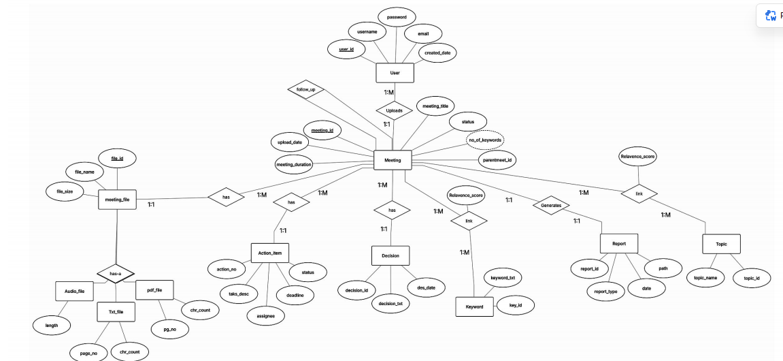
Figure 3.2: ER Diagram of Automated Audio Minutes System

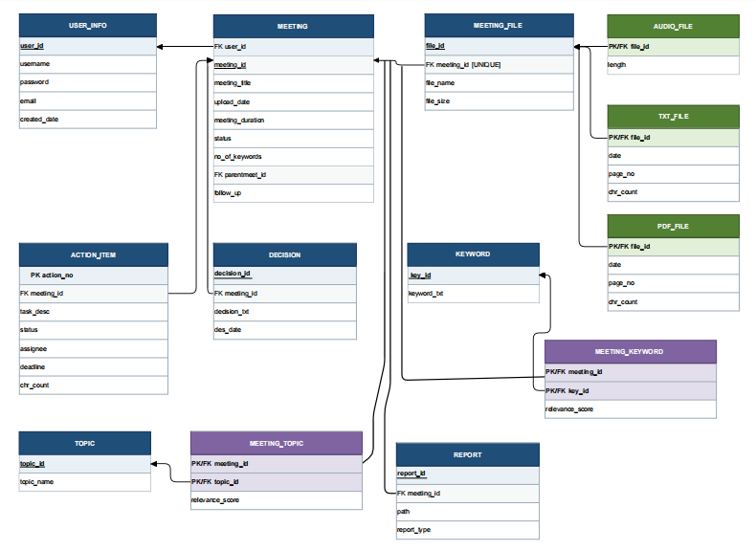
Figure 3.3: Database Schema Diagram

3.3.1 User Structure
As shown in Table 3.1, the user structure contains the login details of the users.
Table 3.1: User Description
Attribute Name | Type | Width | Constraint(s) | Description
user_id | Integer | – | Primary key | Unique identifier of the user
username | String | 50 | Unique, not null | Name used to log in
password | String | 255 | Not null | Password of the user (stored as a hash)
created_at | DateTime | – | Default current time | Date and time of registration

3.3.2 Meeting Record Structure
Table 3.2 shows the structure that stores one analysed file.
Table 3.2: Meeting Record Description
Attribute Name | Type | Width | Constraint(s) | Description
meeting_id | Integer | – | Primary key | Unique identifier of the record
user_id | Integer | – | Foreign key | Owner of the record
title | String | 150 | Not null | Title of the meeting or document
file_name | String | 255 | – | Name of the uploaded file
file_type | String | 10 | – | Audio, TXT or PDF
analysis_mode | String | 20 | – | Meeting, Study Material or General Document
transcript | Text | – | – | Transcript or extracted text
summary | Text | – | – | Generated summary
keywords | Text | – | – | Keywords and topics
sentiment | String | 20 | – | Overall sentiment of a meeting
mode_results | Text | – | – | Mode-specific results such as concepts, definitions, programs and exam questions
created_at | DateTime | – | Default current time | Date and time of analysis

3.3.3 Action Item Structure
Table 3.3 shows the structure of the action items found in a meeting.
Table 3.3: Action Item Description
Attribute Name | Type | Width | Constraint(s) | Description
item_id | Integer | – | Primary key | Unique identifier of the action item
meeting_id | Integer | – | Foreign key | Meeting to which the item belongs
task | Text | – | Not null | Description of the task
person | String | 100 | Nullable | Person responsible, if mentioned
deadline | String | 50 | Nullable | Deadline, if mentioned

3.3.4 Decision Structure
Table 3.4 shows the structure of the decisions identified in a meeting.
Table 3.4: Decision Description
Attribute Name | Type | Width | Constraint(s) | Description
decision_id | Integer | – | Primary key | Unique identifier of the decision
meeting_id | Integer | – | Foreign key | Meeting to which the decision belongs
decision_text | Text | – | Not null | Sentence stating the decision or agreement

3.4 LOW LEVEL DESIGN
The following section illustrates the design of the system using UML diagrams and describes the functionality of its main modules.

3.4.1 Use Case Diagram
Figure 3.4 shows the actions available to the user: login, upload a file, start the analysis, view results, view history, search records, export a report and change settings.
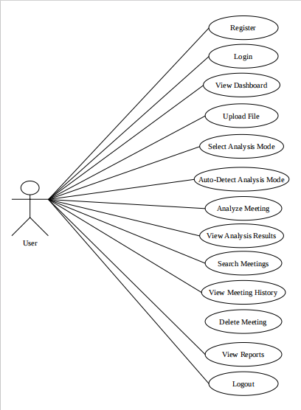
Figure 3.4: Use Case Diagram

3.4.2 Class Diagram
Figure 3.5 shows the main classes of the system and the relationships between them.
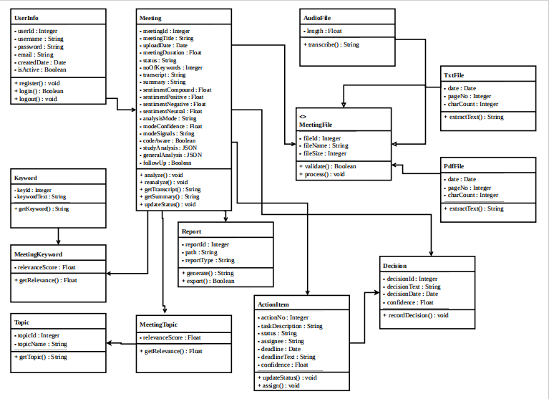

3.4.3 Sequence Diagram
Figure 3.6 shows the order of interaction between the user, the web interface, the processing modules and the database during one analysis.
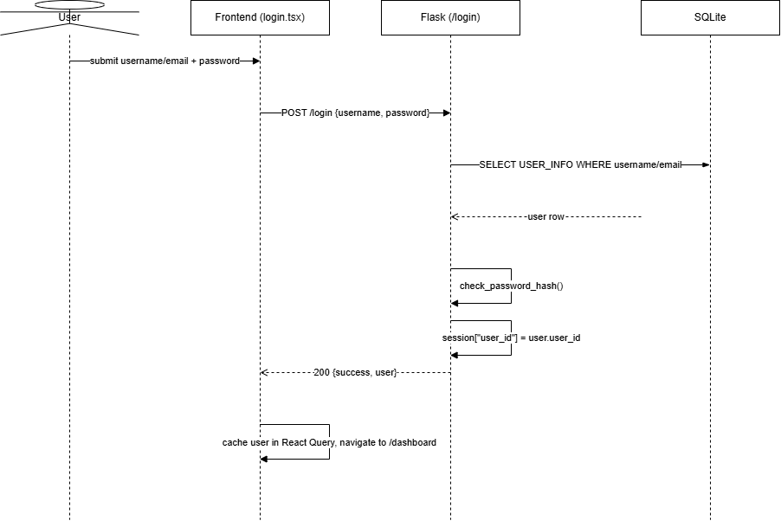
Figure 3.6: Sequence Diagram

3.4.4 Activity Diagram
Figure 3.7 shows the flow of activities from file upload to the display of results.

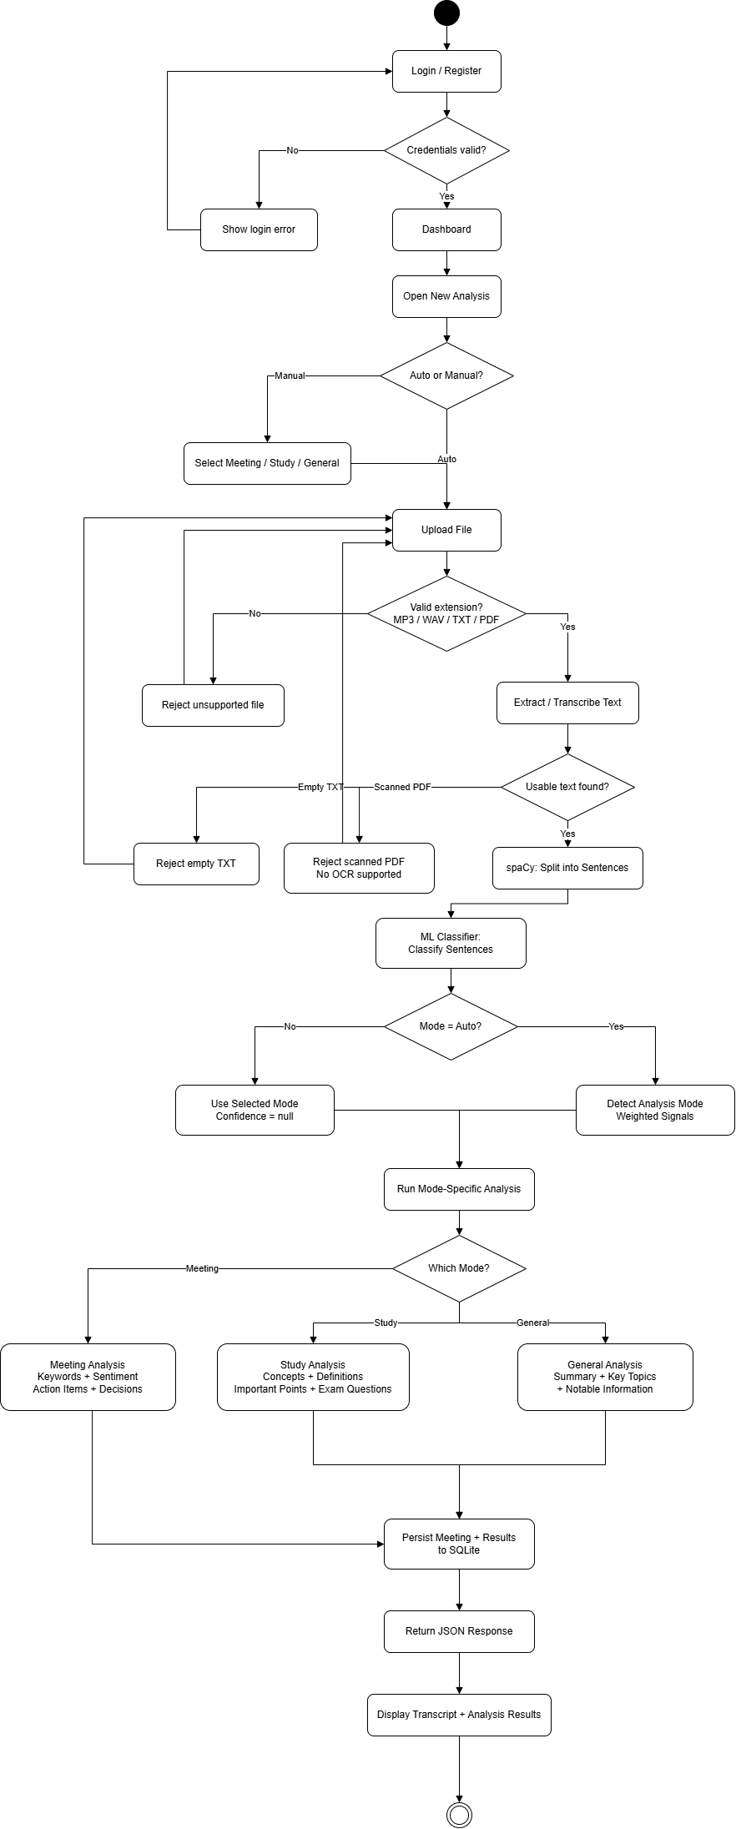

Figure 3.7: Activity Diagram

3.4.5 Login
Table 3.5 shows the login details of the application.
Table 3.5: Login Details
Files used | [auth module, e.g., app.py / auth.py]
Short Description | Allows the user to log in to the application
Arguments | Username, Password
Return | Success / Failure in login
Pre-Condition | The user must have an account
Post-Condition | The dashboard is displayed
Exception | Invalid username or password
Actor | User

3.4.6 File Upload and Text Extraction
Table 3.6 shows the details of the upload module.
Table 3.6: File Upload Details
Files used | [upload module, e.g., upload.py]
Short Description | Accepts the file, validates its type and obtains the text (direct read for TXT, extraction for PDF, speech-to-text for audio)
Arguments | Uploaded file, Title
Return | Text of the file
Pre-Condition | The user is logged in and a supported file is selected
Post-Condition | The text is passed to the text processing module
Exception | Unsupported file type, empty file, unreadable PDF
Actor | User

3.4.7 Speech-to-Text
Table 3.7 shows the details of the speech-to-text module.
Table 3.7: Speech-to-Text Details
Files used | [speech module, e.g., transcribe.py]
Short Description | Converts the speech in an audio file into a transcript using faster-whisper
Arguments | Audio file path
Return | Transcript text
Pre-Condition | A valid audio file has been uploaded
Post-Condition | The transcript is available for processing
Exception | Corrupted audio file or no speech detected
Actor | System

3.4.8 Mode Detection
Table 3.8 shows the details of the mode detection module.
Table 3.8: Mode Detection Details
Files used | [mode detection module, e.g., mode.py]
Short Description | Identifies whether the processed text is a Meeting, Study Material or General Document
Arguments | Processed text
Return | Analysis mode
Pre-Condition | Text preprocessing is completed
Post-Condition | The matching analysis module is selected
Exception | Insufficient text – General Document mode is used
Actor | System

3.4.9 Meeting Analysis
Table 3.9 shows the details of the meeting analysis module.
Table 3.9: Meeting Analysis Details
Files used | [meeting analysis module, e.g., meeting_analysis.py]
Short Description | Generates the summary, topics and keywords, action items, decisions and sentiment of a meeting
Arguments | Processed meeting text
Return | Summary, keywords, action items, decisions, sentiment
Pre-Condition | Mode detection has selected Meeting mode
Post-Condition | Results are stored in the database and displayed
Exception | No action item or decision found – the section is shown as empty
Actor | System

3.4.10 Study Material Analysis
Table 3.10 shows the details of the study material analysis module.
Table 3.10: Study Material Analysis Details
Files used | [study analysis module, e.g., study_analysis.py]
Short Description | Extracts key concepts, keywords, important points, definitions, programs and exam questions
Arguments | Processed study material text
Return | Concepts, keywords, important points, definitions, programs, exam questions
Pre-Condition | Mode detection has selected Study Material mode
Post-Condition | Results are stored in the database and displayed
Exception | No definitions or programs found – the section is shown as empty
Actor | System

3.4.11 Report Export
Table 3.11 shows the details of the report export module.
Table 3.11: Report Export Details
Files used | [report module, e.g., report.py]
Short Description | Exports the stored analysis of a selected record as a report
Arguments | Meeting record id
Return | Report file
Pre-Condition | The record exists in the database
Post-Condition | The report is downloaded by the user
Exception | Record not found
Actor | User

3.5 DATASET AND MODEL DESCRIPTION
The action item detection module uses a supervised model. Table 3.12 summarizes the dataset and the model configuration.
Table 3.12: Action Item Dataset and Model Configuration
Item | Description
Purpose | To train the action item detection model
Data | Meeting-related sentences with labels [state source and number of sentences]
Class 1 | Action Item
Class 0 | Not Action Item
Split | 80% training and 20% testing
Feature extraction | TF-IDF
Model | Logistic Regression
Evaluation | Accuracy, Precision, Recall and F1-score

Each sentence is converted into a TF-IDF vector, which gives higher weight to words that are frequent in a sentence but rare across the dataset. Logistic Regression is then trained on 80% of the labelled sentences to separate action items from other sentences and is evaluated on the remaining 20%. Once trained, the model is saved and loaded by the application during meeting analysis. The details of the task, person and deadline of a detected action item are then extracted with spaCy and regular expressions.

3.6 USER INTERFACE DESIGN

3.6.1 Dashboard
Figure 3.8 provides the interface for the dashboard, which is the home page shown after login.
<< INSERT DASHBOARD SCREENSHOT HERE >>
Figure 3.8: Dashboard

3.6.2 New Meeting Upload
Figure 3.9 provides the interface in which the user enters a title, selects an audio, TXT or PDF file and starts the analysis.
<< INSERT NEW MEETING UPLOAD SCREENSHOT HERE >>
Figure 3.9: New Meeting Upload Page

3.6.3 Analysis Status
Figure 3.10 shows the current stage of the analysis.
<< INSERT ANALYSIS STATUS SCREENSHOT HERE >>
Figure 3.10: Analysis Progress and Status

3.6.4 Analysis Results
Figure 3.11 shows the generated summary, topics and keywords.
<< INSERT RESULTS SCREENSHOT HERE >>
Figure 3.11: Analysis Results – Summary and Keywords

3.6.5 Action Items and Decisions
Figure 3.12 shows the action items and decisions in separate sections.
<< INSERT ACTION ITEMS / DECISIONS SCREENSHOT HERE >>
Figure 3.12: Analysis Results – Action Items and Decisions

3.6.6 Meeting History
Figure 3.13 lists all previously analysed records.
<< INSERT MEETING HISTORY SCREENSHOT HERE >>
Figure 3.13: Meeting History

3.6.7 Search Filter
Figure 3.14 lets the user search the stored records.
<< INSERT SEARCH FILTER SCREENSHOT HERE >>
Figure 3.14: Search Filter

3.6.8 Settings
Figure 3.15 provides the application settings.
<< INSERT SETTINGS SCREENSHOT HERE >>
Figure 3.15: Settings Page

3.7 CHAPTER CONCLUSION
This chapter described the architecture, database, low level design, dataset and user interface of the Automated Audio Minutes System. The modular design separates input handling, text processing, mode detection, analysis, storage and reporting, so that each part can be developed, tested and improved independently.
CHAPTER 4

SYSTEM IMPLEMENTATION
This chapter describes how the main modules of the system are implemented. Each module is presented as pseudo code.

4.1 LOGIN IMPLEMENTATION
The login credentials are obtained. If the credentials are valid, the user is redirected to the dashboard.
GET username, password
IF username and password valid
RETURN dashboard
ELSE
SHOW "Invalid Credential"

4.2 FILE UPLOAD IMPLEMENTATION
The uploaded file is checked against the supported types. Audio is transcribed, PDF text is extracted and TXT is read directly.
GET file, title
IF file type NOT IN (audio, txt, pdf)
SHOW "Unsupported file type"
RETURN
IF file type is audio
text = TRANSCRIBE(file)
ELSE IF file type is pdf
text = EXTRACT_PDF_TEXT(file)
ELSE
text = READ_TEXT(file)
IF text is empty
SHOW "No readable content found"
ELSE
RETURN text

4.3 SPEECH-TO-TEXT IMPLEMENTATION
The audio file is given to the faster-whisper model, which returns the recognised speech as text segments. The segments are joined to form the transcript.
LOAD faster-whisper model
GET audioPath
segments = MODEL.TRANSCRIBE(audioPath)
transcript = JOIN(text of each segment)
RETURN transcript

4.4 TEXT PREPROCESSING IMPLEMENTATION
The text is cleaned and divided into sentences, and named entities such as people, dates and organizations are recognised with spaCy.
GET text
text = REMOVE extra spaces, fillers and noise from text
sentences = SPACY.SEGMENT(text)
entities = SPACY.NER(text)
RETURN sentences, entities

4.5 MODE DETECTION IMPLEMENTATION
The text is scored against the typical vocabulary and structure of each mode. The mode with the highest score is selected; if no mode scores high enough the content is treated as a general document.
GET sentences
meetingScore = COUNT meeting cues (speaker turns, "agenda", "action", "decided")
studyScore = COUNT study cues ("definition", "example", "syntax", "unit")
IF max(meetingScore, studyScore) < threshold
RETURN "General Document"
ELSE IF meetingScore >= studyScore
RETURN "Meeting"
ELSE
RETURN "Study Material"

4.6 MEETING ANALYSIS IMPLEMENTATION

4.6.1 Summary and Keywords
Sumy selects the most important sentences to form the extractive summary, and YAKE extracts the keywords and key topics.
GET sentences
summary = SUMY.SUMMARIZE(sentences, sentenceCount)
keywords = YAKE.EXTRACT(text, topN)
RETURN summary, keywords

4.6.2 Action Item Detection
Every sentence is converted into a TF-IDF vector and classified by the trained Logistic Regression model. For each sentence classified as an action item, the person and deadline are extracted using spaCy entities and regular expressions.
LOAD trained model, TF-IDF vectorizer
FOR each sentence IN sentences
vector = VECTORIZER.TRANSFORM(sentence)
IF MODEL.PREDICT(vector) == 1
person = ENTITY of type PERSON, or "Not specified"
deadline = DATE entity or deadline pattern, or "Not specified"
ADD (task = sentence, person, deadline) to actionItems
RETURN actionItems

4.6.3 Decision Detection
Following the consensus idea of the CFAS paper, sentences that state an agreement or a final decision are identified by decision and agreement patterns, such as "we decided", "it was agreed" and "let us go with".
FOR each sentence IN sentences
IF sentence MATCHES decision or agreement pattern
ADD sentence to decisions
RETURN decisions

4.6.4 Sentiment Analysis
A sentiment score is calculated for the meeting text and mapped to a positive, neutral or negative label.
score = SENTIMENT_SCORE(text)
IF score > positiveLimit RETURN "Positive"
ELSE IF score < negativeLimit RETURN "Negative"
ELSE RETURN "Neutral"

4.7 STUDY MATERIAL ANALYSIS IMPLEMENTATION
For study material, the system extracts key concepts and keywords, important points, sentences that define terms, program code segments and exam-oriented questions.
GET sentences
concepts, keywords = YAKE.EXTRACT(text, topN)
importantPoints = TOP ranked sentences
definitions = sentences MATCHING definition patterns
programs = blocks MATCHING code patterns
questions = FORM questions from concepts and definitions
RETURN concepts, keywords, importantPoints, definitions, programs, questions

4.8 GENERAL DOCUMENT ANALYSIS IMPLEMENTATION
GET sentences
summary = SUMY.SUMMARIZE(sentences, sentenceCount)
topics = YAKE.EXTRACT(text, topN)
RETURN summary, topics

4.9 STORAGE, HISTORY AND SEARCH IMPLEMENTATION
After the analysis, the record is written to the SQLite database. The history page reads the stored records, and the search function matches the entered text against the title and stored content.
GET analysis results
INSERT record into meetings table
INSERT each action item into action_items table
INSERT each decision into decisions table

GET searchText
records = SELECT FROM meetings WHERE title OR content LIKE searchText
RETURN records

4.10 REPORT EXPORT IMPLEMENTATION
GET meetingId
record = SELECT record, action items, decisions for meetingId
IF record exists
report = BUILD report (details, summary, keywords, action items, decisions)
RETURN report file
ELSE
SHOW "Record not found"

4.11 ACTION ITEM MODEL TRAINING
LOAD labelled sentences (label 1 = action item, 0 = not action item)
SPLIT data into 80% training and 20% testing
vectorizer = TF-IDF fitted on training sentences
model = LOGISTIC_REGRESSION trained on training vectors
predictions = model predicts testing vectors
COMPUTE accuracy, precision, recall, F1-score
SAVE model and vectorizer

CHAPTER 5

RESULTS AND DISCUSSION

5.1 TEST CASES AND RESULTS
The system was tested with both positive and negative test cases for each major function. The test data below are examples; the Result column is to be completed with the outcome observed when the test is run.

5.1.1 Test Cases and Results for Login Function:
The test case in Table 5.1 checks a login with valid details; the expected output is true.
Table 5.1: Positive Test Case and result for Login
Test Case ID | TC1
Test Case Description | It tests whether the given login details are valid or not
Test Data | [valid username], [valid password]
Expected Output | TRUE
Result | [PASS / FAIL – fill after execution]

The test case in Table 5.2 checks a login with an incorrect password; the expected output is false.
Table 5.2: Negative Test Case and result for Login
Test Case ID | TC2
Test Case Description | It tests whether the given login details are valid or not
Test Data | [valid username], [wrong password]
Expected Output | FALSE
Result | [PASS / FAIL – fill after execution]

5.1.2 Test Cases and Results for File Upload and Text Extraction:
Table 5.3 tests the speech-to-text path.
Table 5.3: Test Case and result for Audio Upload
Test Case ID | TC3
Test Case Description | It tests whether an uploaded audio file is converted into text
Test Data | Sample meeting recording (.wav / .mp3)
Expected Output | Transcript is generated and the analysis continues
Result | [PASS / FAIL – fill after execution]

Table 5.4 tests the PDF extraction path.
Table 5.4: Test Case and result for PDF Upload
Test Case ID | TC4
Test Case Description | It tests whether text is extracted from a PDF file
Test Data | Sample PDF with readable text
Expected Output | Extracted text is displayed and analysed
Result | [PASS / FAIL – fill after execution]

Table 5.5 tests the file validation.
Table 5.5: Test Case and result for Unsupported File
Test Case ID | TC5
Test Case Description | It tests whether an unsupported file type is rejected
Test Data | File of an unsupported type (for example .exe)
Expected Output | Error message “Unsupported file type” is shown; no analysis starts
Result | [PASS / FAIL – fill after execution]

5.1.3 Test Cases and Results for Mode Detection:
Table 5.6 tests detection of meeting content.
Table 5.6: Test Case and result for Meeting Mode Detection
Test Case ID | TC6
Test Case Description | It tests whether a meeting transcript is detected as Meeting mode
Test Data | Transcript containing discussion, tasks and decisions
Expected Output | Mode = Meeting
Result | [PASS / FAIL – fill after execution]

Table 5.7 tests detection of study material.
Table 5.7: Test Case and result for Study Material Mode Detection
Test Case ID | TC7
Test Case Description | It tests whether lecture notes are detected as Study Material mode
Test Data | PDF of lecture notes with definitions and programs
Expected Output | Mode = Study Material
Result | [PASS / FAIL – fill after execution]

5.1.4 Test Cases and Results for Meeting Analysis:
Table 5.8 tests action item detection.
Table 5.8: Test Case and result for Action Item Detection
Test Case ID | TC8
Test Case Description | It tests whether an action item with person and deadline is identified
Test Data | “Ravi will submit the report by Friday.”
Expected Output | Action item detected; Person = Ravi; Deadline = Friday
Result | [PASS / FAIL – fill after execution]

Table 5.9 tests decision detection.
Table 5.9: Test Case and result for Decision Detection
Test Case ID | TC9
Test Case Description | It tests whether a decision sentence is identified
Test Data | “We agreed to postpone the release to next month.”
Expected Output | Sentence listed under Decisions
Result | [PASS / FAIL – fill after execution]

5.1.5 Test Cases and Results for History, Search and Report:
Table 5.10 tests the search function.
Table 5.10: Test Case and result for Search
Test Case ID | TC10
Test Case Description | It tests whether stored meetings can be searched
Test Data | Search text: [keyword from a stored meeting]
Expected Output | Matching records are listed
Result | [PASS / FAIL – fill after execution]

Table 5.11 tests the report export.
Table 5.11: Test Case and result for Report Export
Test Case ID | TC11
Test Case Description | It tests whether a report is generated for a stored record
Test Data | Record selected from history
Expected Output | Report file is downloaded with details, summary, keywords, action items and decisions
Result | [PASS / FAIL – fill after execution]

5.1.6 Performance of the Action Item Model:
Table 5.12 gives the evaluation of the Logistic Regression model on the 20% test data.
Table 5.12: Performance of the Action Item Detection Model
Metric | Value
Accuracy | [value]
Precision | [value]
Recall | [value]
F1-score | [value]

5.2 DISCUSSION
The system met its main objective of turning audio recordings and documents into organized information. A single upload leads to a transcript or extracted text, an automatically selected analysis mode, structured results, and a stored record that can be searched and exported.
Compared with the approaches reviewed in the literature survey, AAMS makes a deliberate trade-off. The reference papers by Jin et al. and Liu et al. use neural abstractive models, which can write fluent new sentences but need considerable computing resources and trained models. AAMS uses an extractive summarizer, keyword extraction and a small classifier, so it runs offline on an ordinary computer and keeps all data local. The cost is that its summaries are made of sentences taken from the source and are therefore less fluent than abstractive summaries, and its decision detection depends on language patterns rather than a learned discourse model.
The following limitations were observed:
- The accuracy of the transcript depends on the quality of the audio, and errors in the transcript carry over into the later analysis.
- Processing time increases with the length of the recording or document.
- Mode detection and decision detection are based on cue words and patterns and can fail on content that does not use the usual wording.
- Speakers are not identified, so action items can be attributed to a person only when the person is named in the text.
- The system analyses completed recordings and does not support real-time analysis or agenda tracking.
CHAPTER 6

CONCLUSION AND FUTURE ENHANCEMENT(S)
The Automated Audio Minutes System is an application that helps users to quickly understand long recordings and documents. It accepts audio, TXT and PDF files, converts speech into text, detects whether the content is a meeting, study material or a general document, and produces the matching analysis: summaries, keywords, action items, decisions and sentiment for meetings, and concepts, definitions, programs and exam questions for study material. The results are stored locally, so users can view their history, search previous analyses and export reports without sending any data outside their computer.
In future, the system can be extended in the following ways:
- Real-time meeting analysis: produce summaries while a meeting is in progress, as studied by Liu et al. (2025).
- Agenda tracking: align the summary with the items of a meeting agenda.
- Speaker diarization and identification: attribute statements and action items to the correct speaker.
- Advanced consensus analysis: detect agreement and disagreement more accurately, following Jin et al. (2025).
- Abstractive summarization: generate more fluent summaries using a language model.
- Automatic meeting title generation: suggest a title for each analysed meeting.
- Integration with online meeting platforms: import recordings and transcripts directly from meeting tools.
- Cloud synchronization and additional file formats: allow access from multiple devices while keeping user control of data.
APPENDIX – A

SYSTEM REQUIREMENTS
HARDWARE REQUIREMENT:
- Processor: [fill in]
- RAM: minimum 8 GB recommended
- Storage: sufficient local storage for audio files and the database
- GPU: optional
SOFTWARE REQUIREMENT:
Item | Details
Operating System | Windows
Programming Language | Python
Framework | Flask
DBMS | SQLite
Front End | HTML, CSS, JavaScript
Speech Recognition | faster-whisper
NLP Libraries | spaCy, Sumy, YAKE, scikit-learn
APPENDIX – B

SOURCE CODE
<< Paste the source code here, one file at a time, with the file name as an underlined heading, as in the template. Suggested files: >>
- Flask application and routes (login, upload, results, history, search, report)
- Speech-to-text module
- Text preprocessing module
- Mode detection module
- Meeting analysis module (summary, keywords, action items, decisions, sentiment)
- Study material and general document analysis modules
- Action item model training script
- Database module
- HTML templates, CSS and JavaScript

REFERENCES
1. A. P. Widyassari, S. Rustad, G. F. Shidik, E. Noersasongko, A. Syukur, A. Affandy and D. R. I. M. Setiadi, “Review of automatic text summarization techniques & methods,” Journal of King Saud University – Computer and Information Sciences, vol. 34, no. 4, pp. 1029–1046, 2022. https://doi.org/10.1016/j.jksuci.2020.05.006
2. Y. Jin, Q. Shi and Q. Liu, “CFAS: consensus-focused abstractive meeting summarization through multi-party discourse modeling,” Journal of King Saud University – Computer and Information Sciences, vol. 37, article 187, 2025. https://doi.org/10.1007/s44443-025-00210-3
3. X. Liu, J. Lu and A. Xu, “Dynamic agenda-aware real-time meeting summarization with large language models,” Journal of King Saud University – Computer and Information Sciences, vol. 37, article 275, 2025. https://doi.org/10.1007/s44443-025-00304-y
4. A. Radford, J. W. Kim, T. Xu, G. Brockman, C. McLeavey and I. Sutskever, “Robust speech recognition via large-scale weak supervision,” in Proc. International Conference on Machine Learning (ICML), 2023.
5. R. Campos, V. Mangaravite, A. Pasquali, A. Jorge, C. Nunes and A. Jatowt, “YAKE! Keyword extraction from single documents using multiple local features,” Information Sciences, vol. 509, pp. 257–289, 2020.
6. faster-whisper: https://github.com/SYSTRAN/faster-whisper
7. spaCy documentation: https://spacy.io
8. Sumy documentation: https://github.com/miso-belica/sumy
9. scikit-learn documentation: https://scikit-learn.org
10. Flask documentation: https://flask.palletsprojects.com
11. SQLite documentation: https://www.sqlite.org/docs.html

