1. **Solving problems using array functions on rest countries data.**
2. **Get all the countries from Asia continent /region using Filter function**

**// set up for our HTTP request**

**var xhr = new XMLHttpRequest();**

**//create and send some request to API server**

**// we required one is request type and another is url type**

**xhr.open("GET", "https://restcountries.com/v3.1/all");**

**// we will send a instruction by applying on load**

**xhr.onload = function () {**

**var t = JSON.parse(this.response);**

**console.log(**

**"1 (a) Get all the countries from Asia continent /region using Filter function"**

**);**

**// first filtering the asia content by region next doing map on that and printing the output.**

**console.log("\n");**

**t.filter((x) => x.region === "Asia").map((x) => console.log(x.name.common));**

**};**

**xhr.onerror = function () {**

**console.log("Error", this.statusText);**

**};**

**xhr.send();**

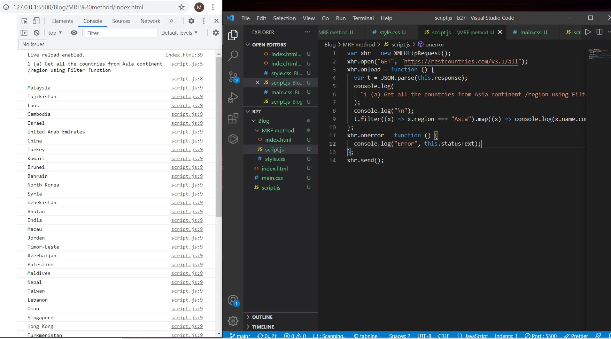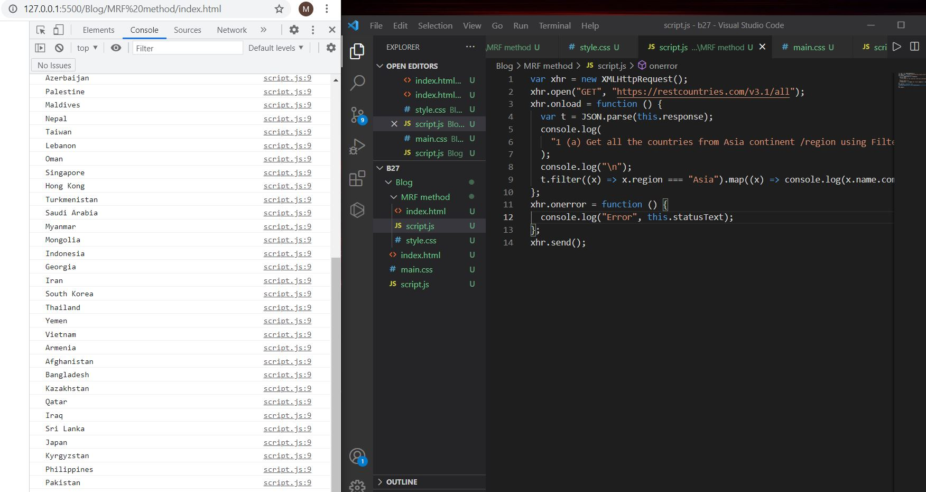

**b. Get all the countries with a population of less than 2 lakhs using Filter function**

**// set up for our HTTP request**

**var xhr = new XMLHttpRequest();**

**//create and send some request to API server**

**// we required one is request type and another is url type**

**xhr.open("GET", "https://restcountries.com/v3.1/all");**

**// we will send a instruction by applying on load**

**xhr.onload = function () {**

**var t = JSON.parse(this.response);**

**console.log(**

**"1 (b) Get all the countries with a population of less than 2 lakhs using Filter function"**

**);**

**// first filtering the population who are less than 2 lakh and next by doing mapping printing the country name**

**console.log("\n");**

**t.filter((x) => x.population < 200000).map((y) => console.log(y.name.common));**

**}**

**xhr.onerror = function () {**

**console.log("Error", this.statusText);**

**};**

**xhr.send();**

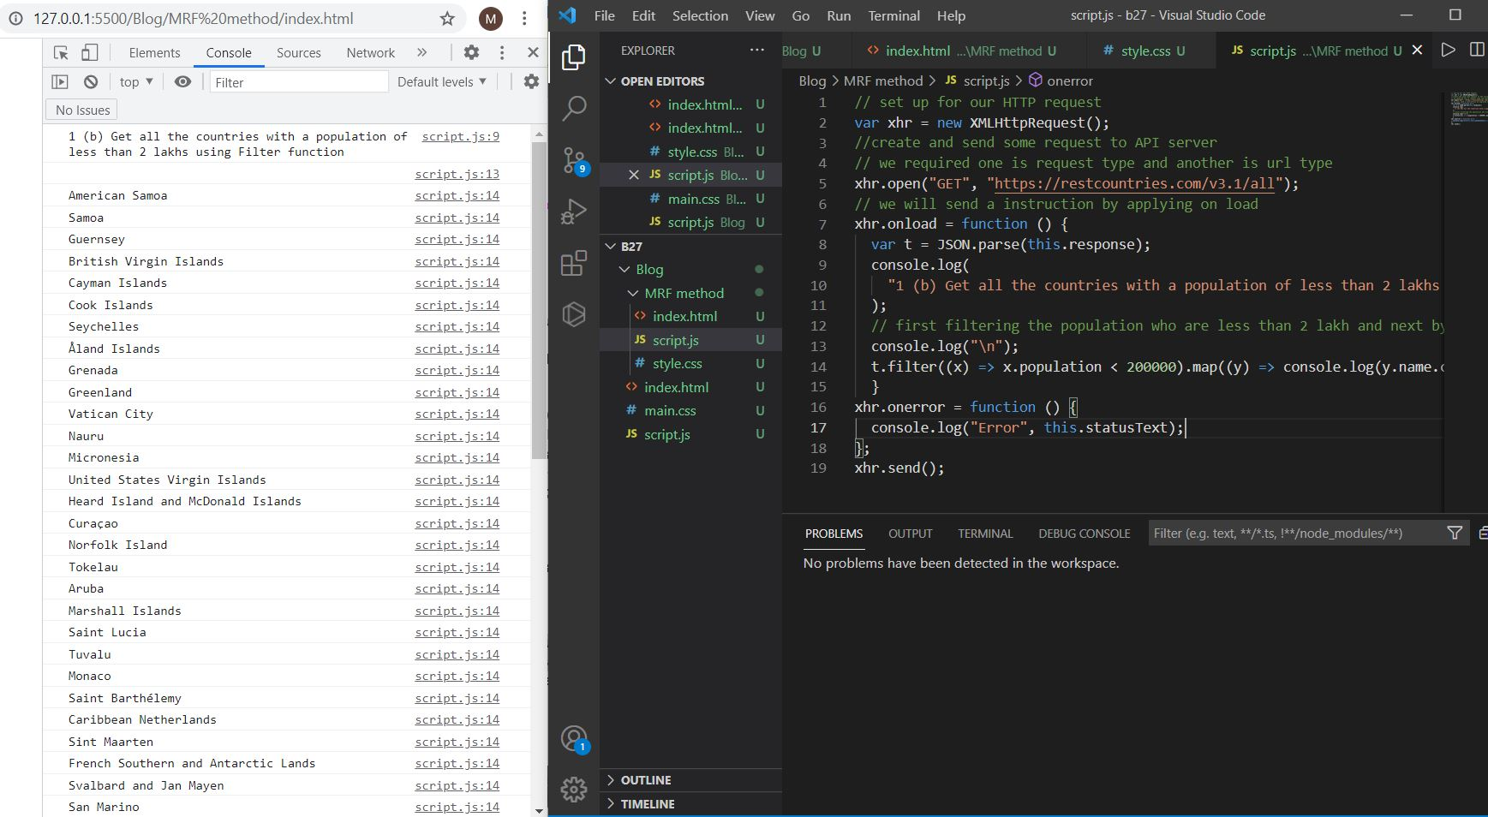



**c. Print the following details name, capital, flag using forEach function**

**// set up for our HTTP request**

**var xhr = new XMLHttpRequest();**

**//create and send some request to API server**

**// we required one is request type and another is url type**

**xhr.open("GET", "https://restcountries.com/v3.1/all");**

**// we will send a instruction by applying on load**

**xhr.onload = function () {**

**var t = JSON.parse(this.response);**

**console.log(**

**"1 (c) Print the following details name, capital, flag using forEach function"**

**);**

**console.log("\n");**

**//by using for each loop we are printing the name and capital anf flag in png format**

**t.forEach((element) => {**

**console.log("\n", element.name.common, element.capital, element.flags.png);**

**});**

**}**

**xhr.onerror = function () {**

**console.log("Error", this.statusText);**

**};**

**xhr.send();**



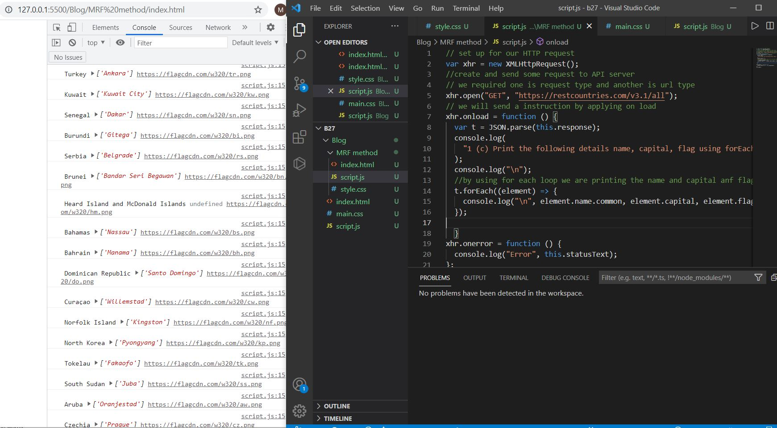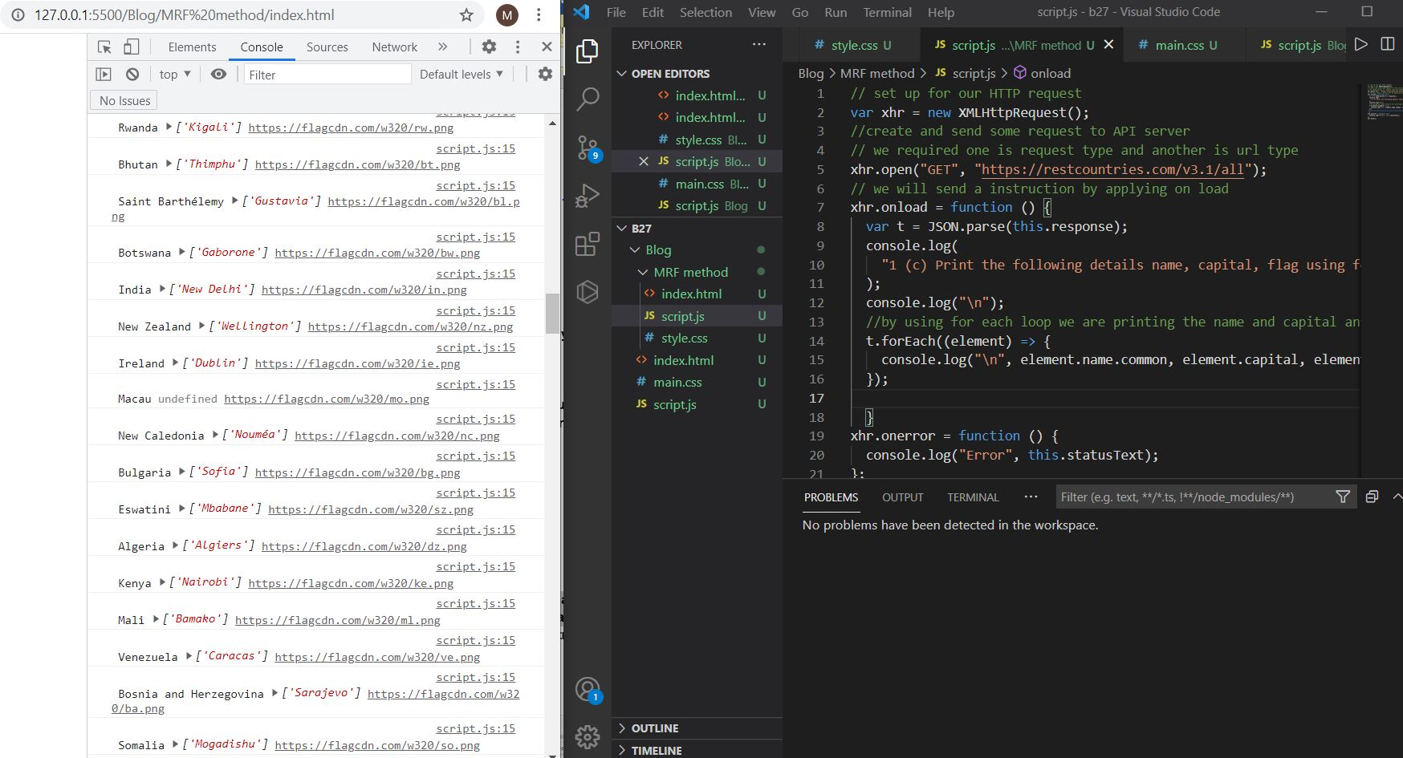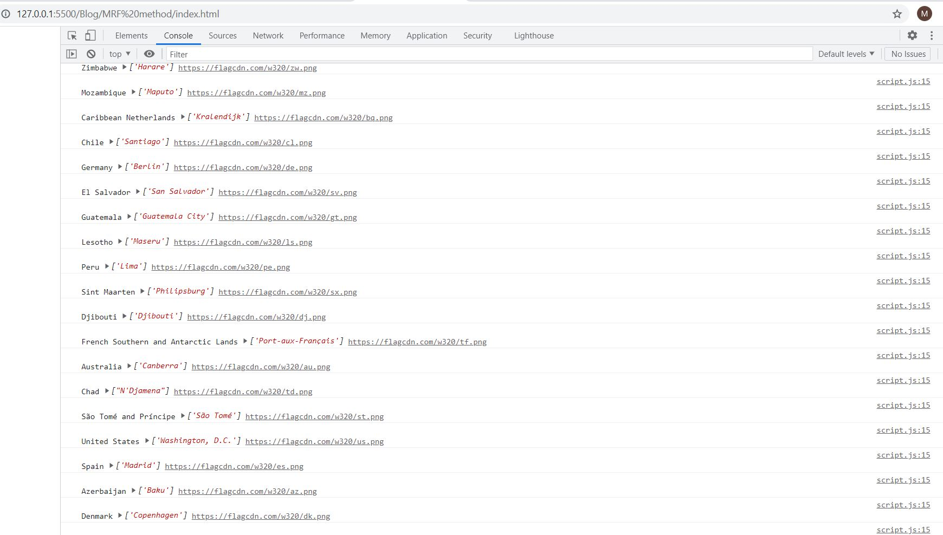

**d. Print the total population of countries using reduce function**

**// set up for our HTTP request**

**var xhr = new XMLHttpRequest();**

**//create and send some request to API server**

**// we required one is request type and another is url type**

**xhr.open("GET", "https://restcountries.com/v3.1/all");**

**// we will send a instruction by applying on load**

**xhr.onload = function () {**

**var t = JSON.parse(this.response);**

**console.log(**

**"1 (d) Printing the total population of countries using reduce function"**

**);**

**console.log("\n");**

**// first doing the mapping which countries having the population and after using reduce function doing the sum of total population.**

**console.log(t.map((x) => x.population).reduce((num1, num2) => num1 + num2));**

**}**

**xhr.onerror = function () {**

**console.log("Error", this.statusText);**

**};**

**xhr.send();**



**e. Print the country which uses US Dollars as currency**

**// set up for our HTTP request**

**var xhr = new XMLHttpRequest();**

**//create and send some request to API server**

**// we required one is request type and another is url type**

**xhr.open("GET", "https://restcountries.com/v3.1/all");**

**// we will send a instruction by applying on load**

**xhr.onload = function () {**

**var t = JSON.parse(this.response);**

**console.log(**

**"1 (e) Printing the countries which uses US Dollars as currency."**

**);**

**console.log("\n");**

**//byusing filter first doing the currencies.**

**t.filter((y) => {**

**// by using for in loop printing return true if i is equal to USD**

**for (let i in y.currencies) {**

**if (i === "USD") {**

**return true;**

**}**

**}**

**// by using mapping printing the countries names.**

**}).map((y) => console.log(y.name.common));**

**}**

**xhr.onerror = function () {**

**console.log("Error", this.statusText);**

**};**

**xhr.send();**

