**1, Fix the bugs in below snippet**

**2. Try the below one**

<html lang="en">

<head>

<title>Document guvi</title>

</head>

<body>

<p>Lorem ipsum dolor sit amet consectetur adipisicing elit</p>

<div>

Guvi Geek Network

</div>

</body>

</html>

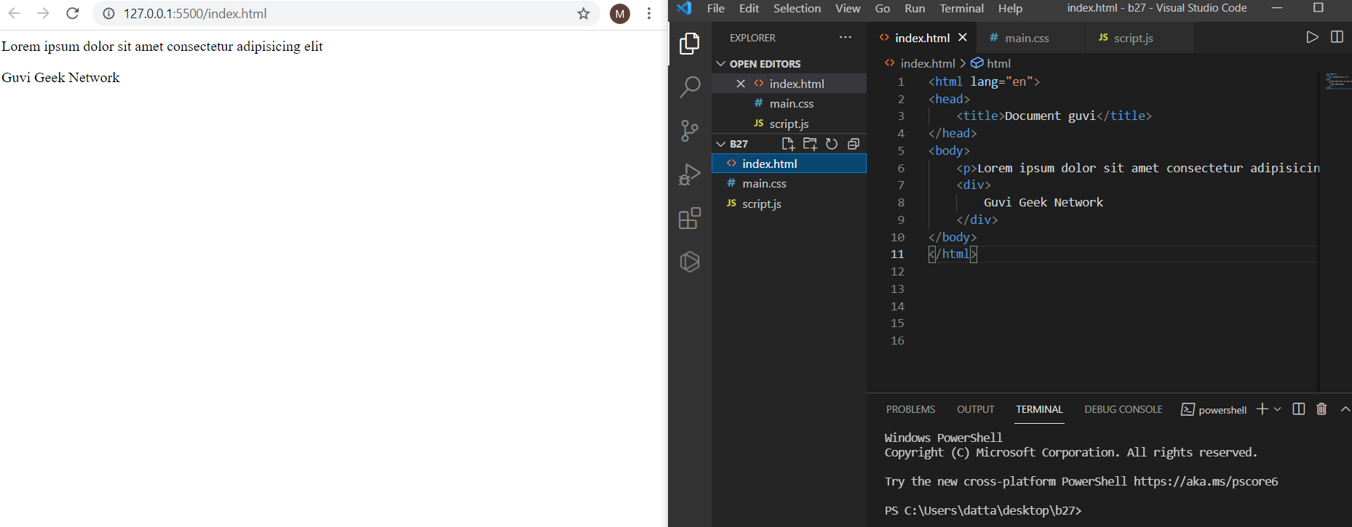

**3. Design a contact us form with all fields as required.**

<!DOCTYPE html>

<html lang="en">

<head>

<meta charset="UTF-8">

<meta http-equiv="X-UA-Compatible" content="IE=edge">

<meta name="viewport" content="width=device-width, initial-scale=1.0">

<title>Document</title>

</head>

<body>

<form action="#" Method="get">

<div class="container">

<h1>Contact Us Form</h1>

<p>Please fill in this form to Send contact us details.</p>

<hr>

<fieldset>

<legend>Contact Us</legend>

<label for="fname"><b>First Name</b></label></br>

<input type="text" id="fname" placeholder="Your name.." name="fname" required></br>

<label for="lname"><b>Last Name</b></label></br>

<input type="text" id="lname" placeholder="Your last name.." name="lname" required></br>

<label for="email"><b>Email Name</b></label></br>

<input type="email" placeholder="Type your email" name="email" required></br>

<label for="mobile"><b>Mobile Number</b></label></br>

<input type="number" placeholder="Type your mobile number" name="mobile" required></br>

<label for="altMobNo"><b>Alternate Mobile Number</b></label></br>

<input type="number" placeholder="Type your alternate mobile number" name="altMobNo" required></br>

<label for="address"><b>Address</b></label></br>

<input type="address" placeholder="Type your address" name="address" required></br></br>

<button type="submit" class="submit">submit</button>

</fieldset>

</div>

</form>

</body>

</html>

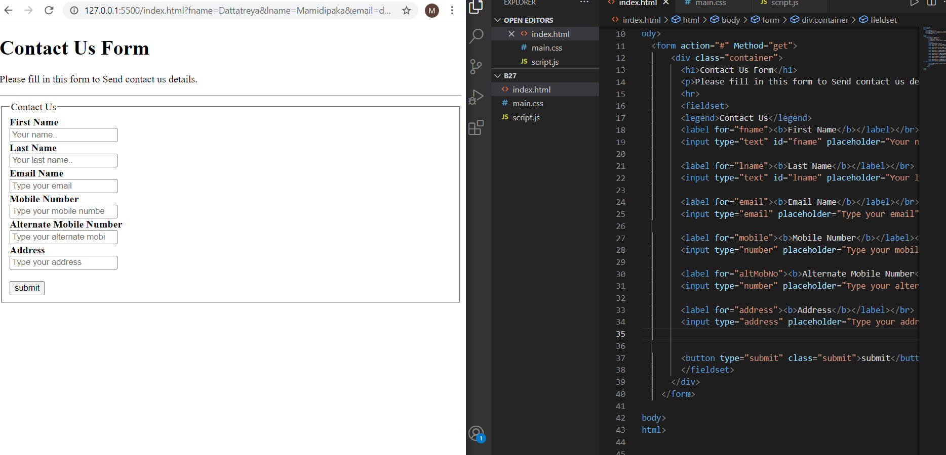

**4. Use certain HTML elements to display the following in a HTML page.**

<!DOCTYPE html>

<html lang="en">

<head>

<meta charset="UTF-8">

<meta http-equiv="X-UA-Compatible" content="IE=edge">

<meta name="viewport" content="width=device-width, initial-scale=1.0">

<title>Document</title>

</head>

<body>

<h2>Use certain HTML elements to display the following in a HTML page.</h2>

<ul>

<li>Programming Language</li>

<ul style="list-style-type:circle;">

<li>JavaScript</li>

<ol type = "a">

<li>Angular</li>

<li>React</li>

<li>Vue.js</li>

</ol>

</ul>

<ul style="list-style-type:circle;">

<li>Python</li>

<ol type = "a">

<li>Django Framework</li>

<li>Flask Framework</li>

</ol>

</ul>

<ul style="list-style-type:circle;">

<li>Java</li>

<ol type = "a">

<li>Spring</li>

<li>Maven</li>

<li>Hibernate</li>

</ol>

</ul>

<li>Database</li>

<ul style="list-style-type:circle;">

<li>MySQL</li>

<li>MongoDB</li>

<li>Cansandra</li>

</ul>

</ul>

</body>

</html>

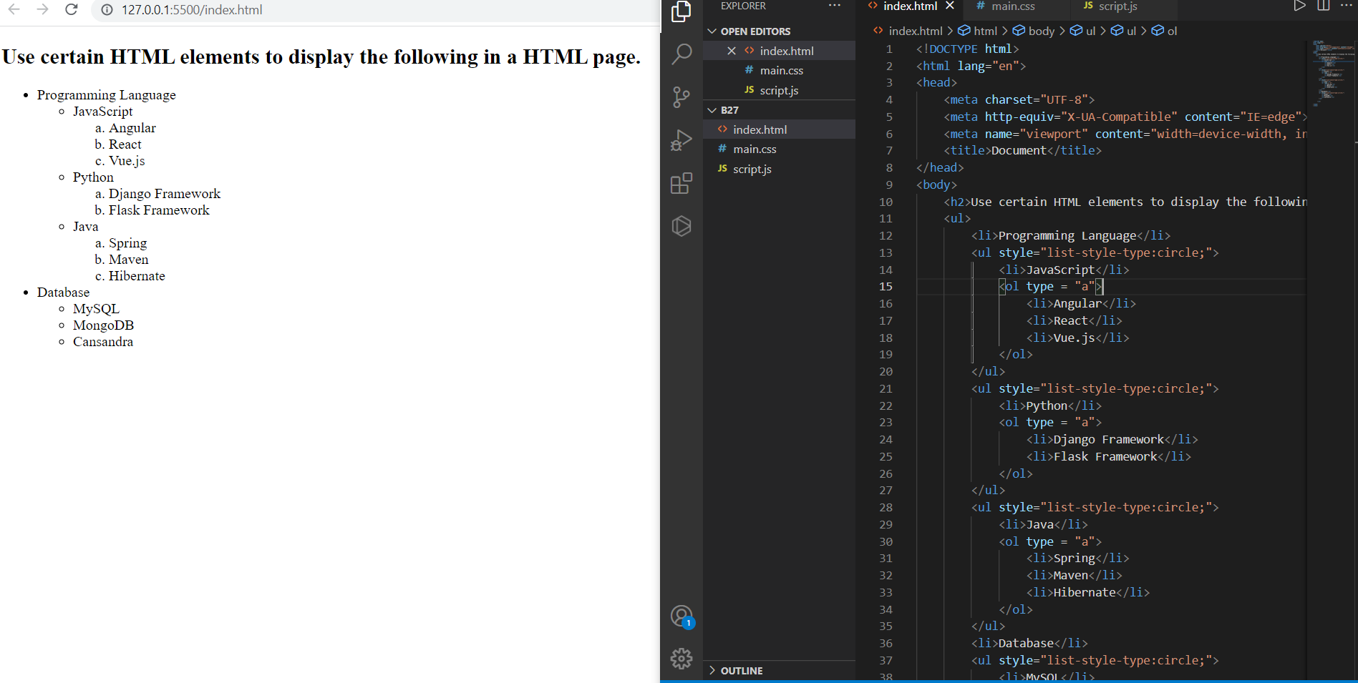

**5.Create an element that helps you to open the** [**https://google.com**](https://google.com/) **in separate new tab.**

<!DOCTYPE html>

<html lang="en">

<head>

<meta charset="UTF-8">

<meta http-equiv="X-UA-Compatible" content="IE=edge">

<meta name="viewport" content="width=device-width, initial-scale=1.0">

<title>Document</title>

</head>

<body>

<h1>The target attribute</h1>

<a href=" https://google.com" target="_blank">Visit Google</a>

<p>If you set the target attribute to "_blank", the link will open in a new browser window or a new tab.</p>

</body>

</html>

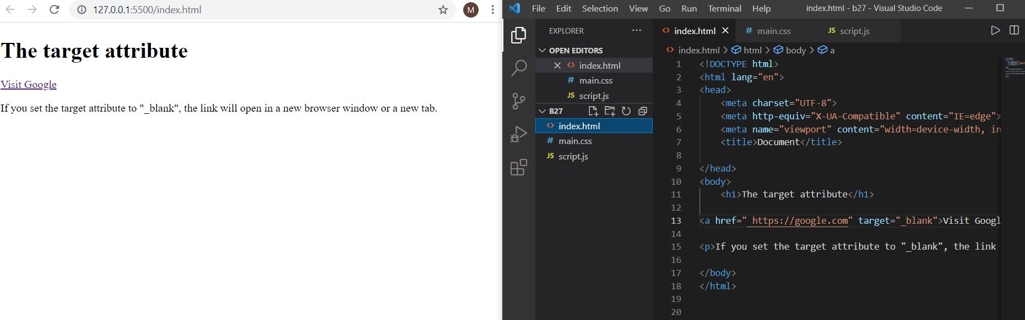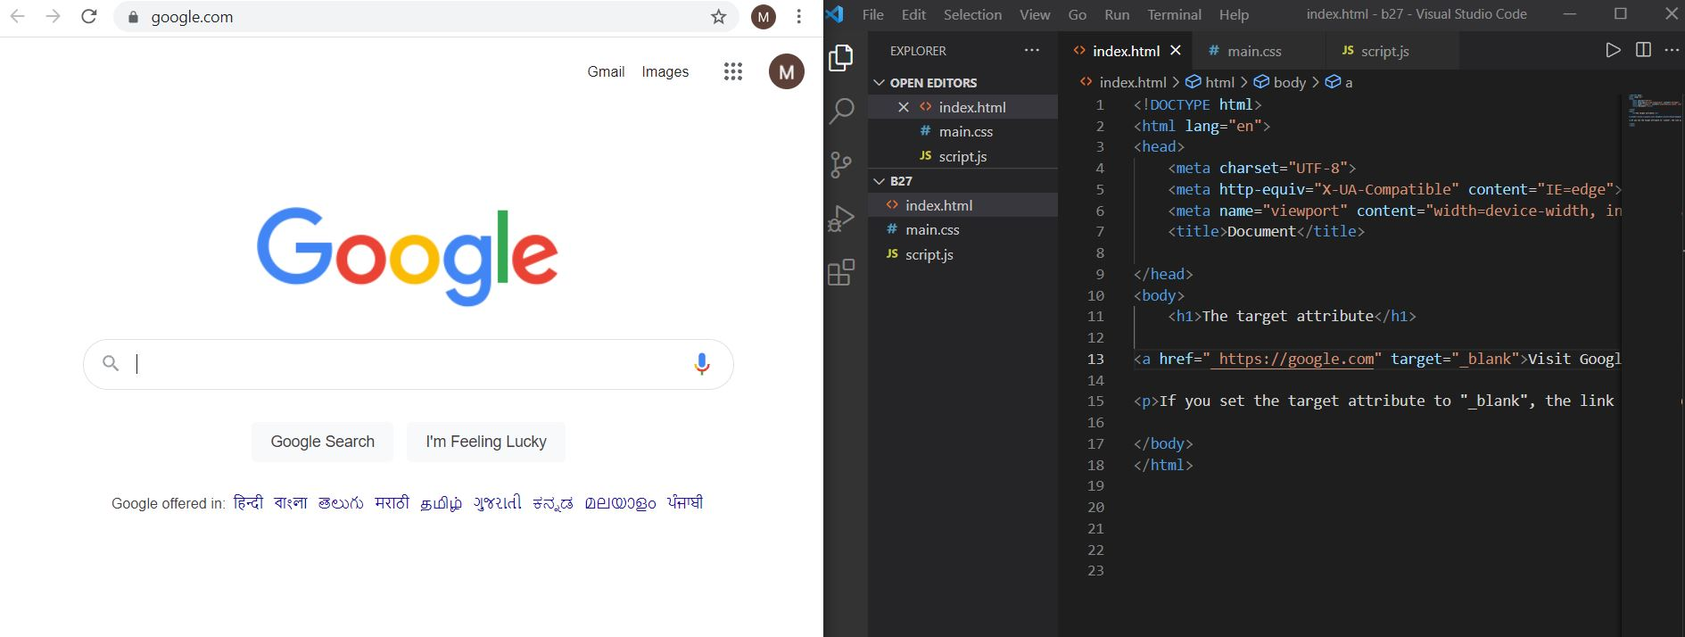

**6. In the form, add two radio buttons with grouping them for employee type(Salaried and own business)**

<!DOCTYPE html>

<html lang="en">

<head>

<meta charset="UTF-8">

<meta http-equiv="X-UA-Compatible" content="IE=edge">

<meta name="viewport" content="width=device-width, initial-scale=1.0">

<title>Form two radio buttons</title>

</head>

<body>

<form action="#" method="get">

<p>Employee type?</p>

<input type="radio" name="emptype" value="salaried"> Salaried</br>

<input type="radio" name="emptype" value="own business">Own business

<p><input type="submit" value="Submit"></p>

</form>

</body>

</html>

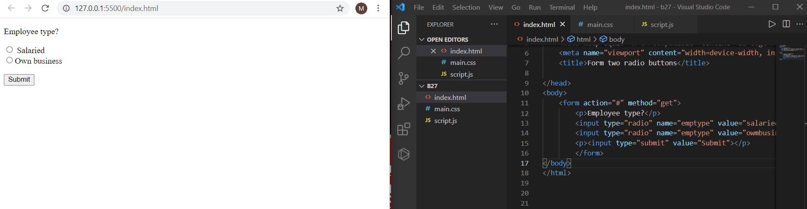

**7. Design form shown in the link** (<http://evc-cit.info/cit040/formguide/card_0.png>)

<!DOCTYPE html>

<html lang="en">

<head>

<meta charset="UTF-8">

<meta http-equiv="X-UA-Compatible" content="IE=edge">

<meta name="viewport" content="width=device-width, initial-scale=1.0">

<title>Document</title>

<style>

body

h2{

text-align: center;

background-color:red;

width: 96%;

color:white;

}

input[type=text1],[type=text2],[type=text]{

border: 3px solid;

border-top:0;

border-left:0;

border-right:0;

}

input[type=text2]{

width:85%

}

input[type=text1]{

width:40%

}

input[type=text]{

width:24.5%

}

fieldset{

border:3px solid black;

margin-right:70%;

}

</style>

</head>

<body>

<fieldset>

<h2>Yes! I want to subscribe to <em>Mag-O-Zine</em></h2>

<input type="text1" id="fname" name="fname">&emsp;<input type="text1" id="lname" name="lname"></br>

<label for="fname">First Name</label>&emsp;&emsp;&emsp;&emsp;&emsp;&emsp;&emsp;&nbsp;<label for="lname">Last Name</label></br>

<input type="text2" id="address" name="address"></br>

<label for="address">Address</label></br>

<input type="text" id="city" name="city">&emsp;&nbsp;<input type="text" id="city" name="city">&emsp;&nbsp;<input type="text" id="city" name="city"></br>

<label for="city">City</label>&emsp;&emsp;&emsp;&emsp;&emsp;&emsp;

<label for="state">State</label>&emsp;&emsp;&emsp;&emsp;&emsp;&ensp;&nbsp;

<label for="zip">Zip</label></br>

<p><b>Subscribe for:</b>

<label><input type="checkbox" checked="checked" name="1 year ($19.95)"> 1 year ($19.95)</label>

<label><input type="checkbox" name="2 year ($35.00)"> 2 year ($35.00)</label>

</p>

<p><b>Send me more information about:</b></p>

<label><input type="checkbox" checked="checked" name="computer-zine"><b>Computer-Zine</b></label></br>

<label><input type="checkbox" name="Fishing-Zine"><b>Fishing-Zine</b></label></br>

<label><input type="checkbox" checked="checked" name="cat-o-zine"><b>Cat-O-Zine</b></label></br>

</fieldset>

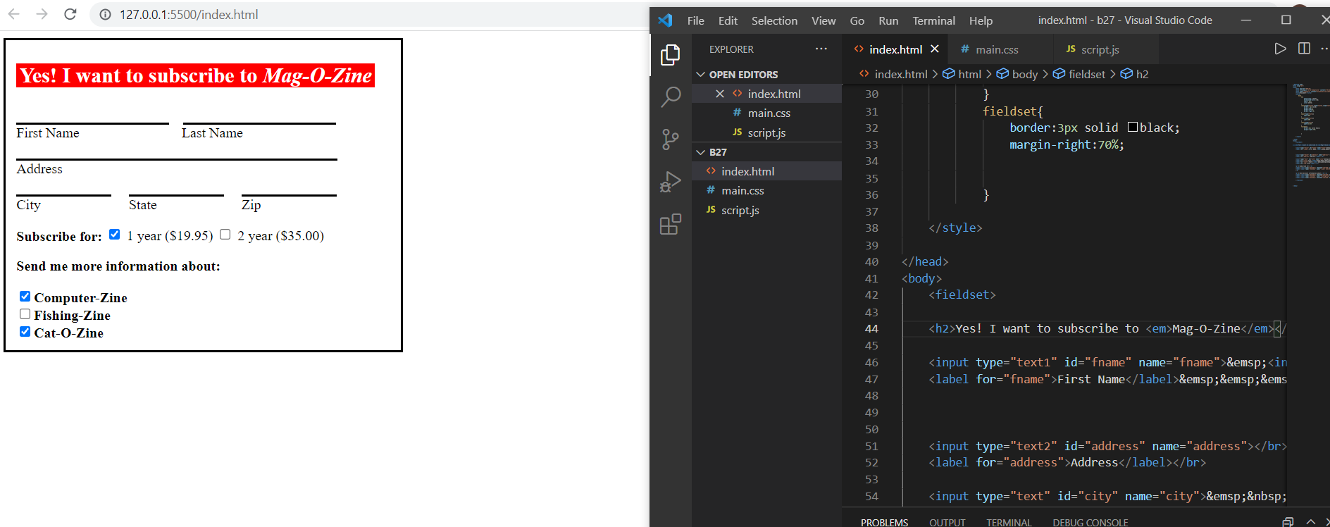

**8. Use the table tag to design given image Click here.**

<!DOCTYPE html>

<html lang="en">

<head>

<meta charset="UTF-8">

<meta http-equiv="X-UA-Compatible" content="IE=edge">

<meta name="viewport" content="width=device-width, initial-scale=1.0">

<title>Document</title>

</head>

<body>

<h4>Health Chart</h4>

<table border="" cellpadding="20" cellspacing="0">

<tr>

<th rowspan="2">State of Health</th>

<th colspan="2">Fasting Value</th>

<th>After Eating</th>

<tr>

<th>Minimum</th>

<th>Maximum</th>

<th>2 hours after Eating</th>

</tr>

</tr>

<tr>

<th>Healthy</th>

<td>70</td>

<td>100</td>

<td>Less than 140</td>

</tr>

<tr>

<th>Pre-Diabetes</th>

<td>101</td>

<td>126</td>

<td>140 to 200</td>

</tr>

<tr>

<th>Diabetes</th>

<td>More than 126</td>

<td>N/A</td>

<td>More than 200</td>

</tr>

</table>

</body>

</html>

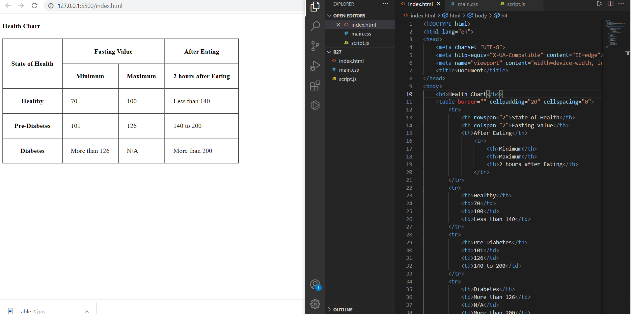

**9. Write HTML input tags snippet to show default values for all Form elements.**

<!DOCTYPE html>

<html lang="en">

<head>

<meta charset="UTF-8">

<meta http-equiv="X-UA-Compatible" content="IE=edge">

<meta name="viewport" content="width=device-width, initial-scale=1.0">

<title>Input element snippet</title>

</head>

<body>

<!-- Input element snippet -->

<form action="#" method="get">

<label for="fname">Firstname:</label></br>

<input type="text" id="fname" name="fname" value="Dattatreya"><br><br>

<input type="submit" value=submit>

</form>

</body>

</html>

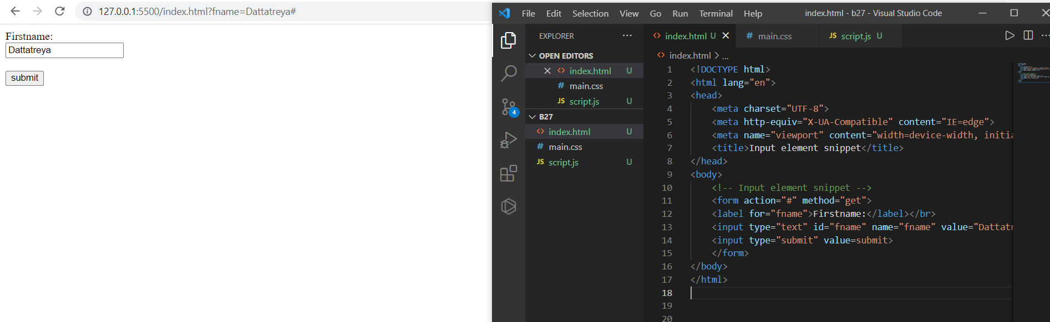

<!-- select element snippet -->

<h3>The select element</h3>

<p>The select element defines the drop down list.</p>

<form action="#" method="get">

<label for="proglang">Choose a programming language:</label>

<select id="proglang" name="programming_language">

<option value="python">Python</option>

<option value="javascript">JavaScript</option>

<option value="java">Java</option>

<option value="c++">C++</option>

</select><br><br>

<input type="submit" value=submit>

</form>

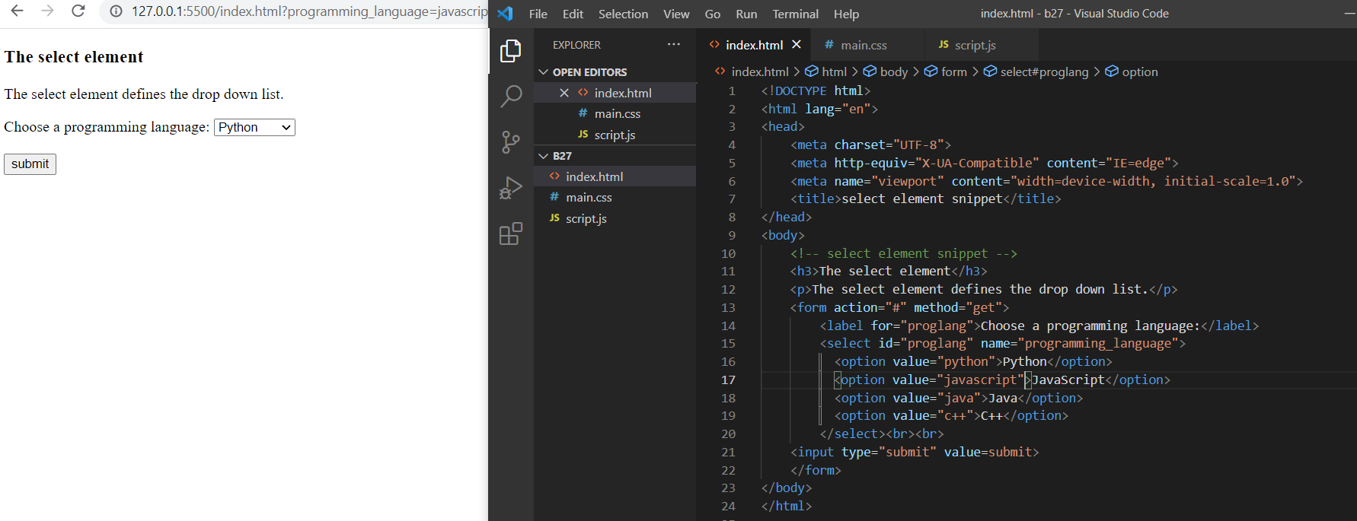

<!-- select element snippet -->

<h3>The select element</h3>

<p>The select element defines the drop down list.If we are not used selected attribute it automatically takes the first one if we give selected attribute it will select first that one.</p>

<form action="#" method="get">

<label for="proglang">Choose a programming language:</label>

<select id="proglang" name="programming_language">

<option value="python">Python</option>

<option value="javascript" selected>JavaScript</option>

<option value="java">Java</option>

<option value="c++">C++</option>

</select><br><br>

<input type="submit" value=submit>

</form>

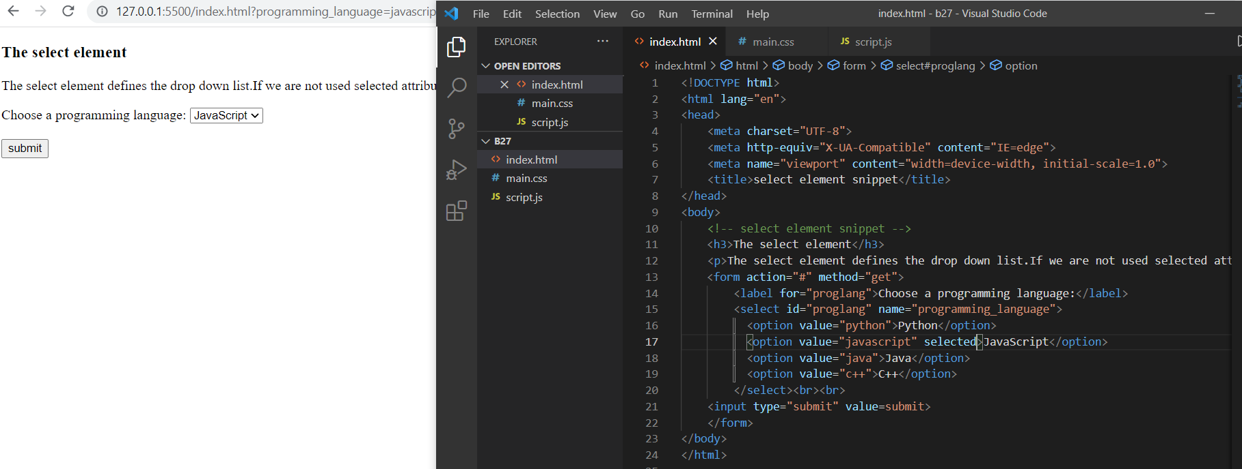

<!-- select element snippet-(visible) -->

<h3>Visible Option Values</h3>

<p>Use the size attribute to specify the number of visible values.</p>

<form action="#" method="get">

<label for="proglang">Choose a programming language:</label>

<select id="proglang" name="programming_language" size="2">

<option value="python">Python</option>

<option value="javascript">JavaScript</option>

<option value="java">Java</option>

<option value="c++">C++</option>

</select><br><br>

<input type="submit" value=submit>

</form>

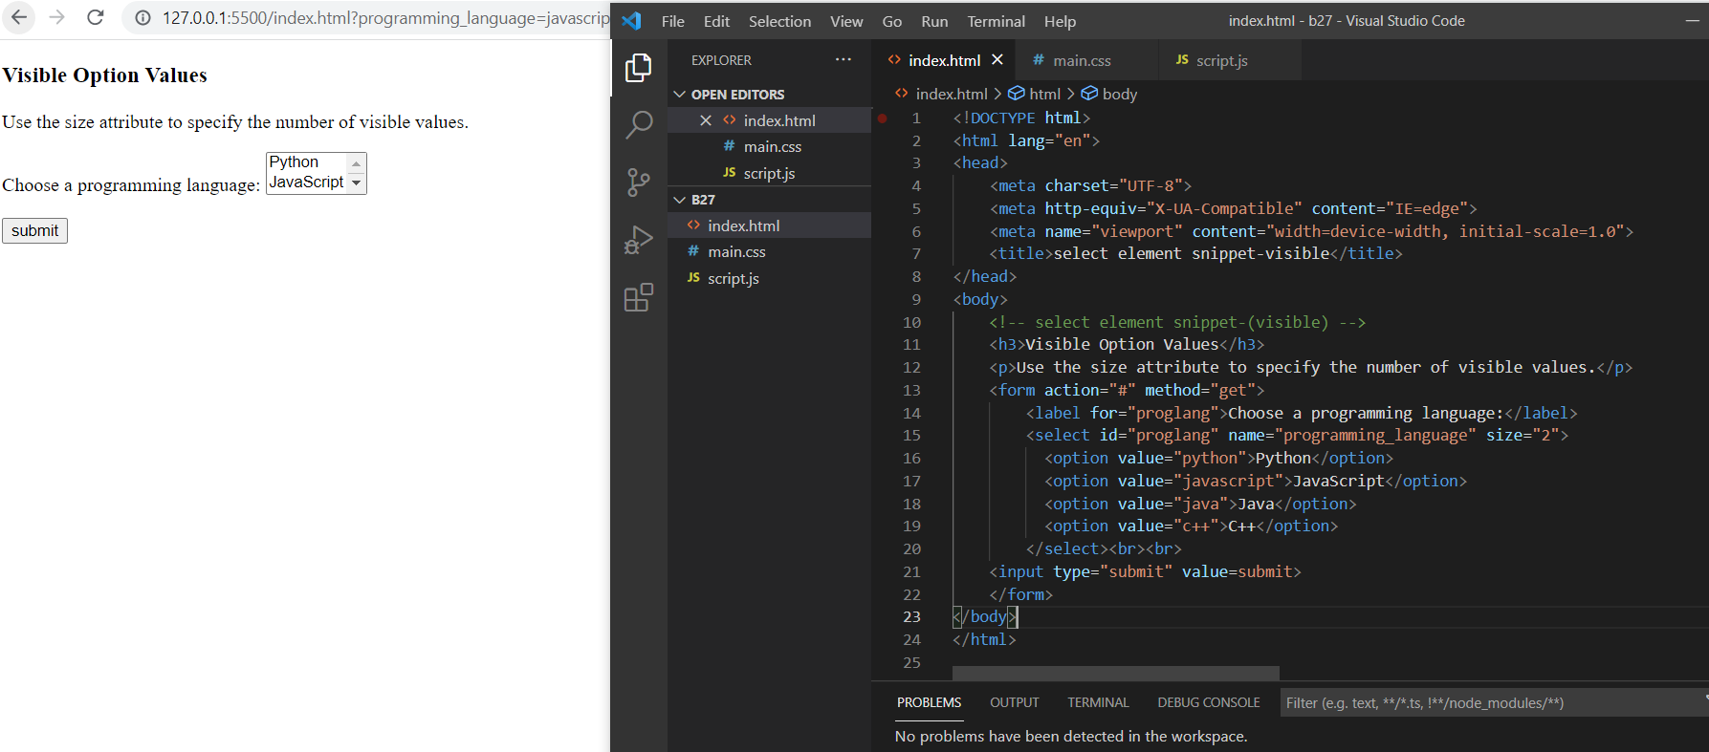

<!-- select element snippet-(multiple) -->

<h3>Allow Multiple Selections</h3>

<p>Use the multiple attribute to allow the user to select more than one value.</p>

<form action="#" method="get">

<label for="proglang">Choose a programming language:</label>

<select id="proglang" name="programming_language" size="4" multiple>

<option value="python">Python</option>

<option value="javascript">JavaScript</option>

<option value="java">Java</option>

<option value="c++">C++</option>

</select><br><br>

<input type="submit" value=submit>

</form>

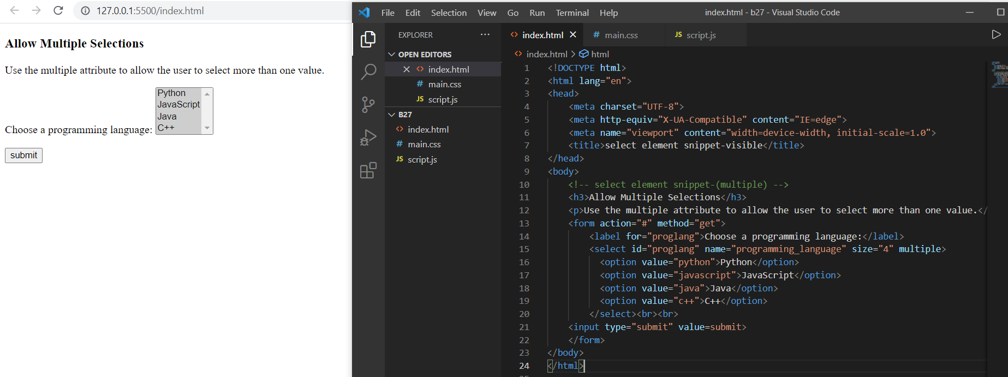

<!-- text area element snippet -->

<h2>Textarea</h2>

<p>The textarea element defines a multi-line input field.</p>

<form action="#" method="get">

<textarea name="message" rows="10" cols="20">The developer will develop his/her skills depending on the companies requirement and himself as well.</textarea>

<br><br>

<input type="submit" value=submit>

</form>

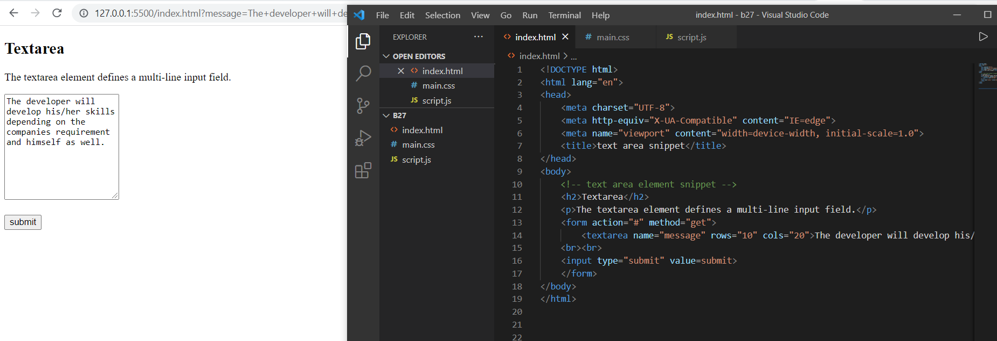

<!-- text area element snippet-(style:width,height) -->

<h2>Styling Textarea</h2>

<p>Use CSS to change the size of the textarea:</p>

<form action="#" method="get">

<textarea name="message" style="width:200px; height:500px;">The developer will develop his/her skills depending on the companies requirement and himself as well.</textarea>

<br><br>

<input type="submit" value=submit>

</form>

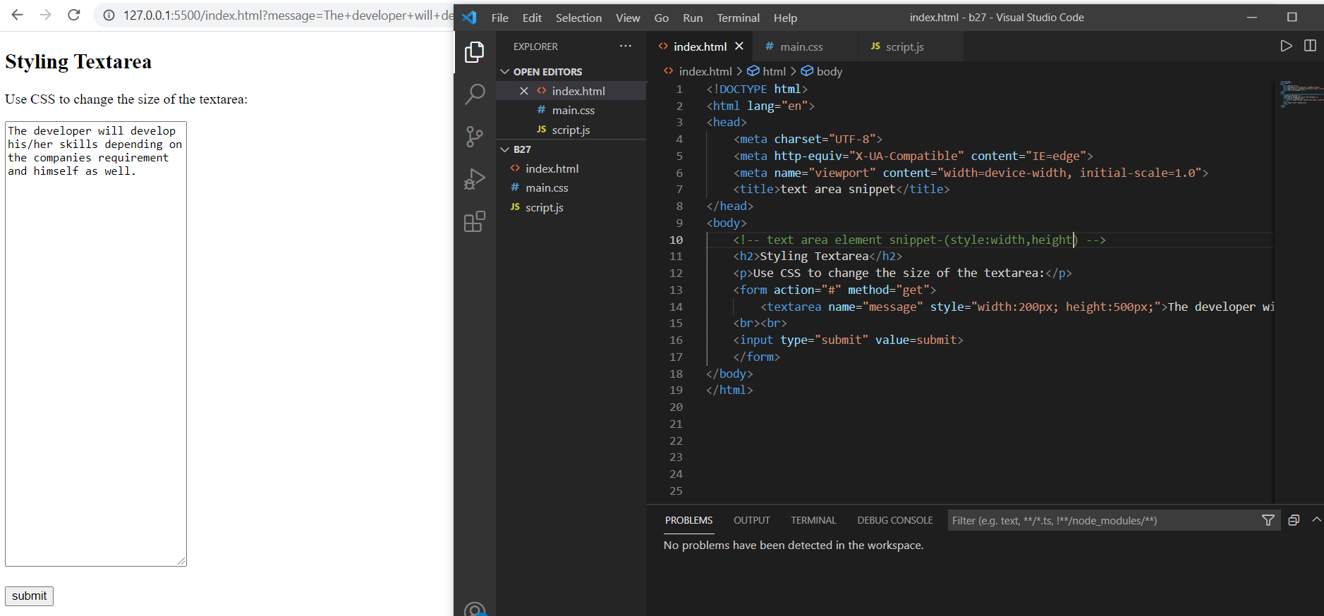

<!-- button element attribute -->

<h2>The button Element</h2>

<form action="#" method="get">

<button type="button" onclick="alert('Hello World!')">Click Me!</button>

</form>

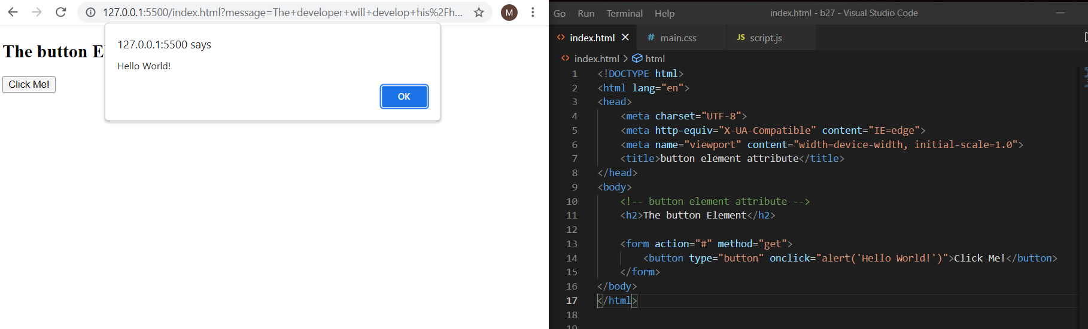

<!-- fieldset and legend elements -->

<h2>Grouping Form Data with Fieldset</h2>

<p>The fieldset element is used to group related data in a form, and the legend element defines a caption for the fieldset element.</p>

<form action="#" method="get">

<fieldset>

<legend>Person details:</legend>

<label for="fname">First name:</label><br>

<input type="text" id="fname" name="fname" value="Dattatreya"><br>

<label for="lname">Last name:</label><br>

<input type="text" id="lname" name="lname" value="Mamidipaka"><br><br>

<input type="submit" value="Submit">

</fieldset>

</form>

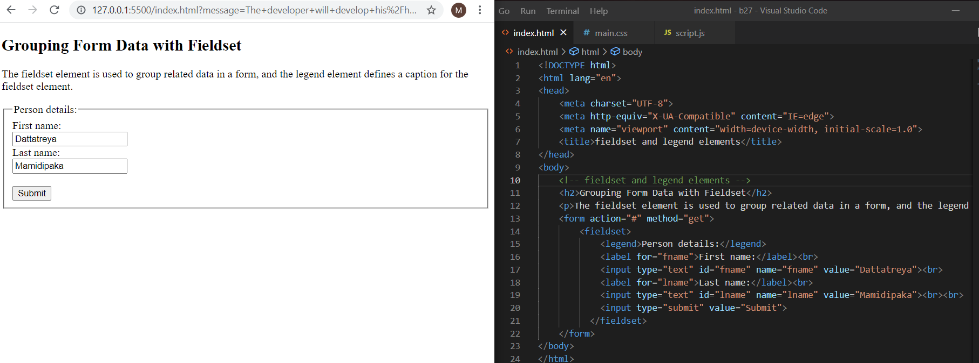

<!-- datalist elements -->

<h2>The datalist Element</h2>

<p>The datalist element specifies a list of pre-defined options for an input element.</p>

<form action="#" method="get">

<input list="proglang" name="programming language">

<datalist id="proglang">

<option value="python">

<option value="javascript">

<option value="java">

<option value="c++">

</datalist><br><br>

<input type="submit">

</form>

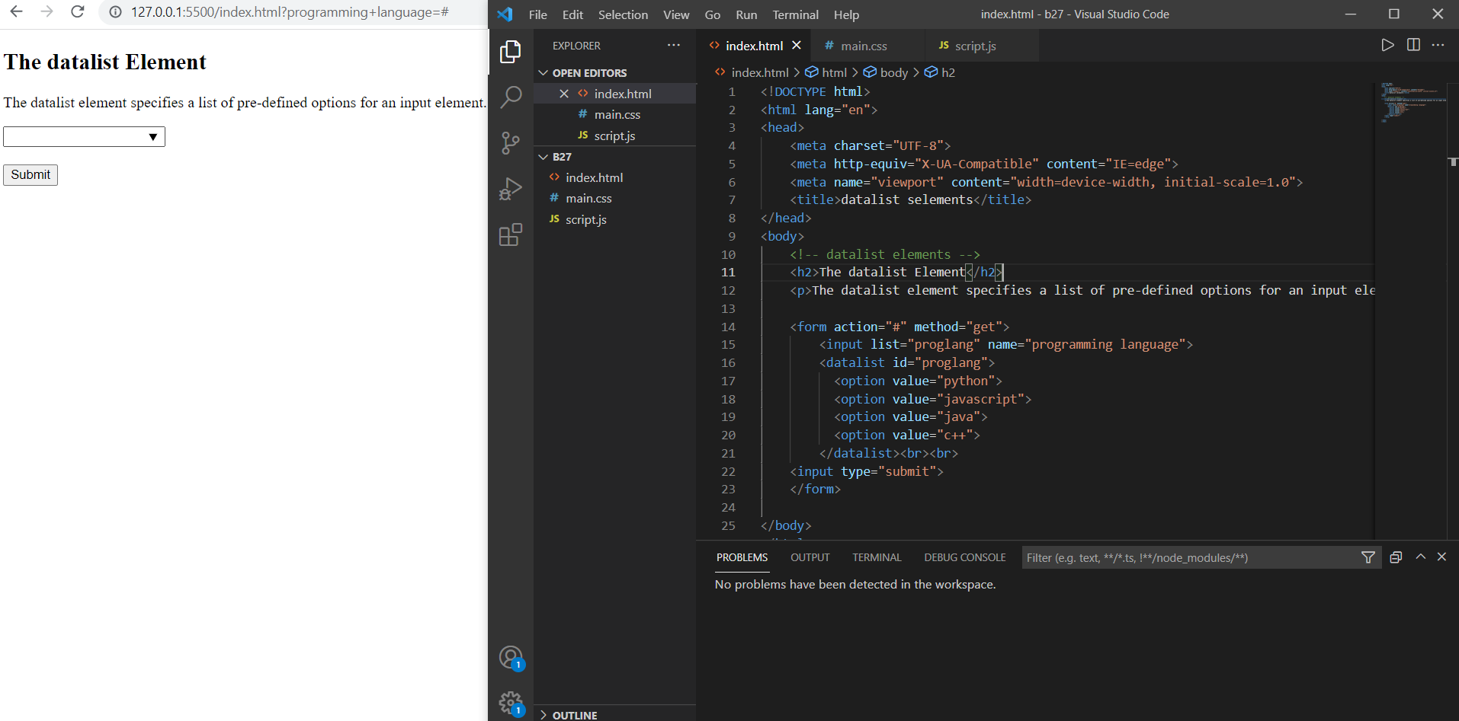

<!-- output element -->

<h2>The output Element</h2>

<p>The output element represents the result of a calculation.</p>

<form action="#" method="get">

<oninput="x.value=parseInt(a.value)+parseInt(b.value)">

0

<input type="range" id="a" name="a" value="50">

100 +

<input type="number" id="b" name="b" value="50">

=

<output name="x" for="a b"></output>

<br><br>

<input type="submit">

</form>

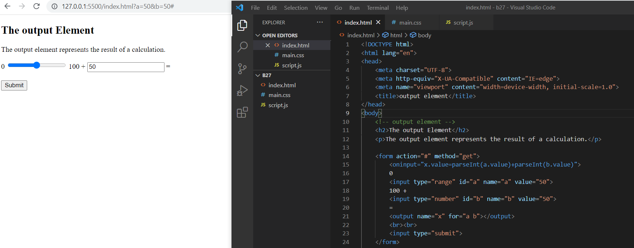

<form action="#" method="get">

<label for="cars">Choose a car:</label>

<select name="cars" id="cars">

<optgroup label="Swedish Cars">

<option value="volvo">Volvo</option>

<option value="saab">Saab</option>

</optgroup>

<optgroup label="German Cars">

<option value="mercedes">Mercedes</option>

<option value="audi">Audi</option>

</optgroup>

</select>

<br><br>

<input type="submit" value="Submit">

</form>

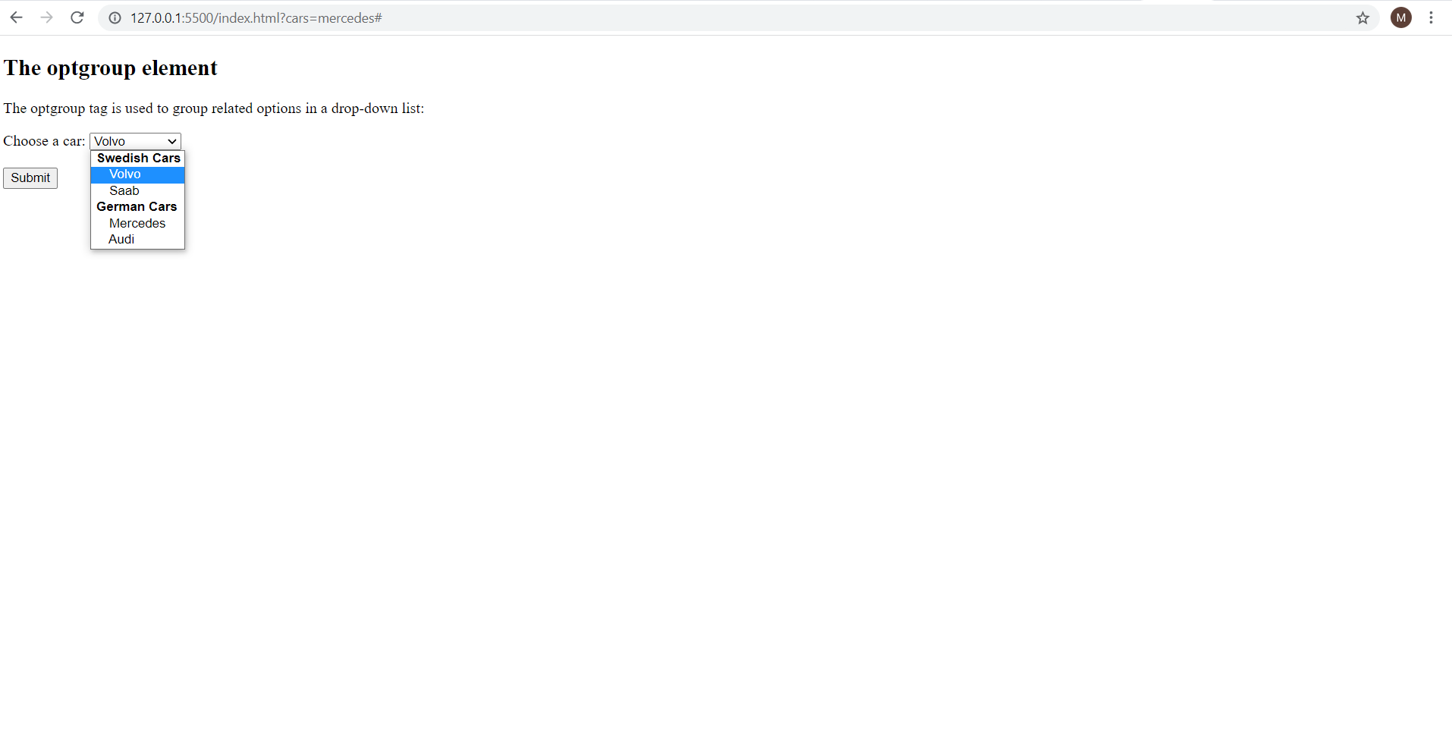

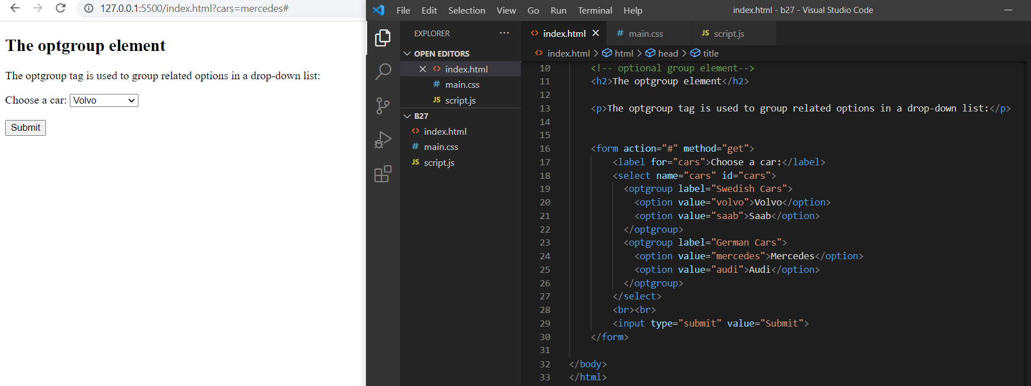

**10. In your, HTML page add the below line and Highlight it without using any CSS.**

* **"HTML & CSS is awesome"**

**index.html:**

<!DOCTYPE html>

<html lang="en">

<head>

<meta charset="UTF-8">

<meta http-equiv="X-UA-Compatible" content="IE=edge">

<meta name="viewport" content="width=device-width, initial-scale=1.0">

<title>Document</title>

<script src ="script.js" defer></script>

<style>

button{

color:chartreuse;

background-color:black

}

</style>

</head>

<body>

<button id="track">Highlight</button>

<p id="para">HTML & CSS is awesome</p>

</body>

</html>

**script.js:**

let button = document.getElementById("track");

button.addEventListener("mouseover", () => {});

let para = document.getElementById("para");

para.addEventListener("mouseover", () => {

para.style.backgroundColor = "chartreuse";

});

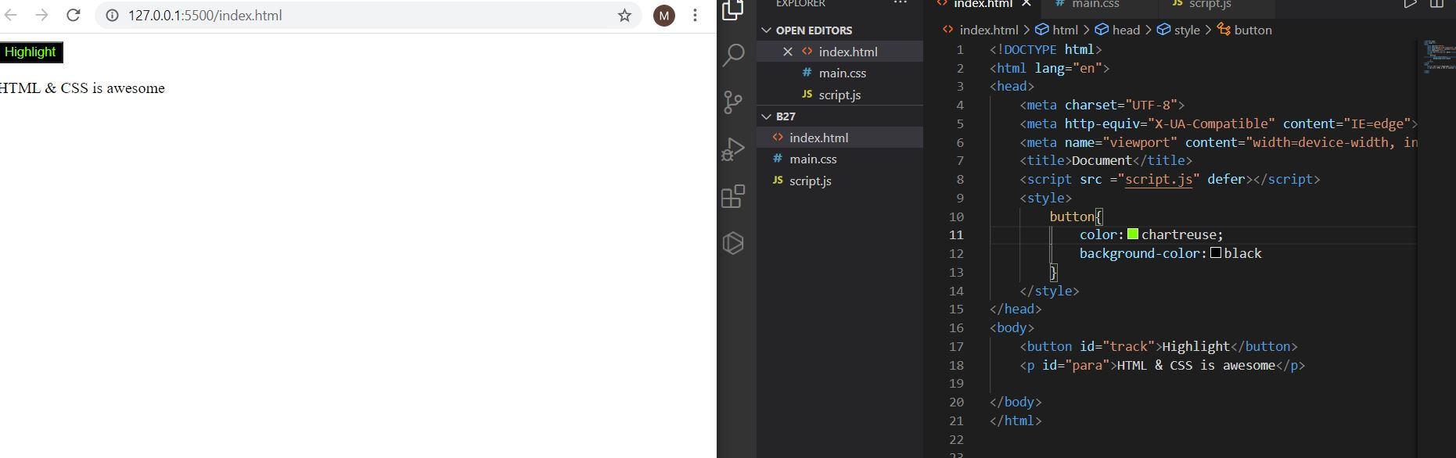

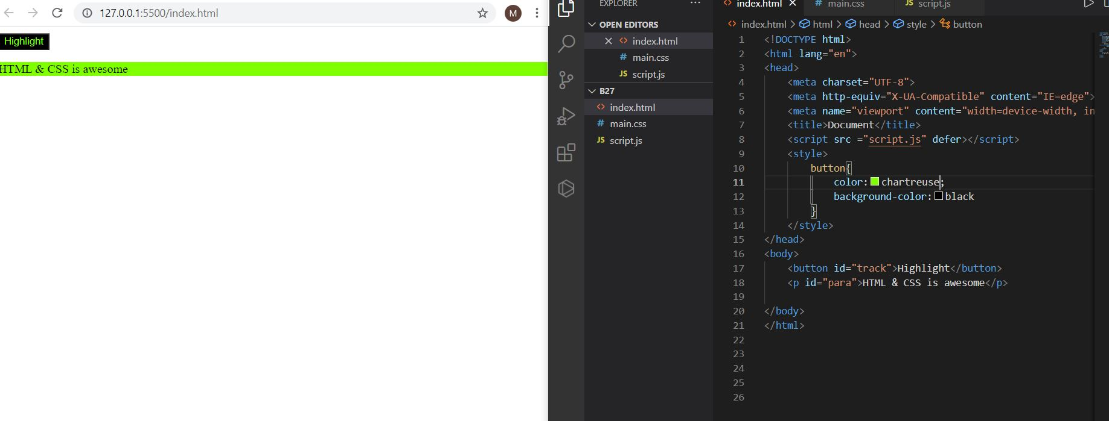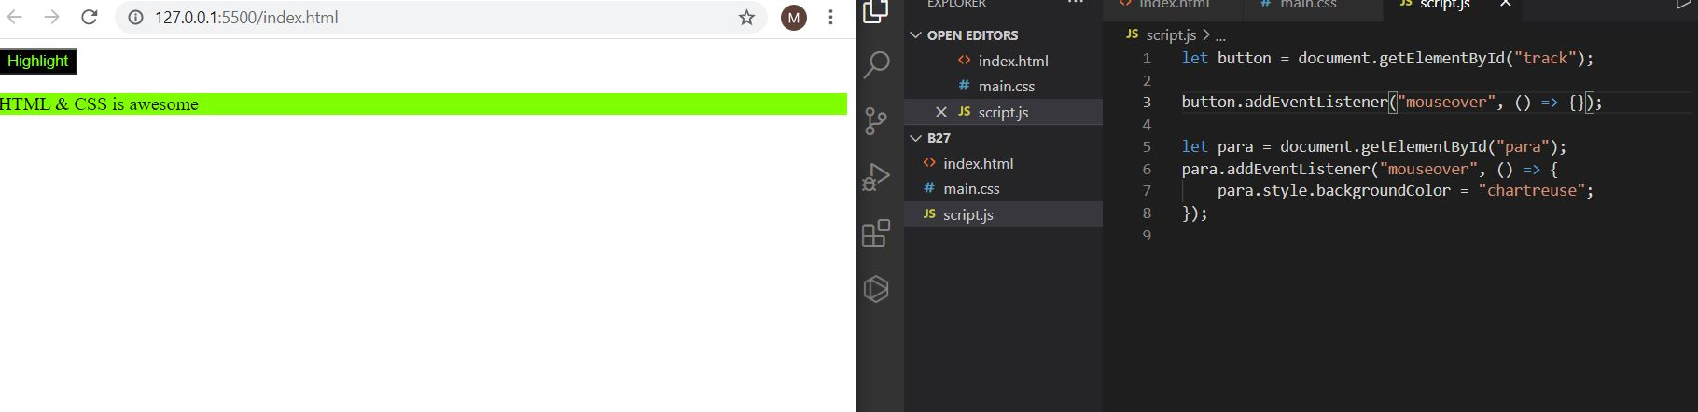

**11. Create an HTML page, which should contain all types of input elements.**

<!DOCTYPE html>

<html lang="en">

<head>

<meta charset="UTF-8" />

<meta http-equiv="X-UA-Compatible" content="IE=edge" />

<meta name="viewport" content="width=device-width, initial-scale=1.0" />

<title>Document</title>

</head>

<body>

<h2>Creating an html page with all input tags</h2>

<form action="#" method="get">

<fieldset>

<legend><b>Person details:</b></legend>

<label for="fname"><b>First name:</b></label>&emsp;&emsp;&emsp;&emsp;&emsp;&emsp;&emsp;&emsp;&ensp;&nbsp;

<label for="lname"><b>Last name:</b></label><br>

<input type="text" id="fname" name="fname" placeholder="First name">&emsp;&emsp;&emsp;

<input type="text" id="lname" name="lname" placeholder="Last name"><br>

<input type="hidden" id="custId" name="custId" value="96">

<label for="email"><b>Email Id:</b></label><br>

<input type="email" id="email" name="email" placeholder="Email"><br>

<label for="email"><b>Alternate Email Id:</b></label><br>

<input type="email" id="email" name="email" placeholder="Alt Email"><br>

<label for="birthday"><b>Date of birth:</b></label><br>

<input type="date" id="birthday" name="birthday"><br>

<label for="number"><b>Mobile number:</b></label><br />

<input type="number" id="number" name="number" placeholder="Mobile number"><br>

<label for="number"><b>Alternate Mobile no:</b></label><br />

<input type="number" id="number" name="number" placeholder="Mobile number"><br>

<label for="phone"><b>Landline number:</b></label><br>

<input type="tel" id="phone" name="phone" pattern="[0-9]{3}-[0-9]{2}-[0-9]{3}" placeholder="Landline number"><br>

<p><b>Choose Languages known:</b></p>

<input type="checkbox" id="english" name="english">

<label for="english">English</label><br>

<input type="checkbox" id="telugu" name="telugu">

<label for="telugu">Telugu</label><br>

<input type="checkbox" id="hindi" name="hindi">

<label for="hindi">Hindi</label>

<p><b>Choose your favourate Programming language</b></p>

<input type="radio" id="python" name="fav_language">

<label for="python">Python</label><br>

<input type="radio" id="java" name="fav_language">

<label for="java">Java</label><br>

<input type="radio" id="javascript" name="fav_language" value="JavaScript">

<label for="javascript">JavaScript</label><br><br>

<p><b>When you join GUVI Full stack development course?</b></p>

<label for="monyear">Month and year:</label>

<input type="month" id="monyear" name="monyear"><br><br>

<p><b>Strength of this course?</b></p>

<label for="members">Members (between 0 and 40):</label>

<input type="range" id="members" name="member" min="0" max="40"><br>

<p><b>Select at which the course will start at every saturday and sunday?</b></p>

<label for="appt">Select a time:</label>

<input type="time" id="appt" name="appt"><br>

<p><b>How namy weeks for this course?</b></p>

<label for="week">Select a weeks:</label>

<input type="week" id="week" name="week"><br>

<p><b>Add your webpage url?</b></p>

<label for="webpage">Webpage url:</label>

<input type="url" id="webpage" name="webpage"><br><br>

<label for="myfile"><b>Select your resume file:</b></label><br>

<input type="file" id="myfile" name="myfile"><br><br>

<input type="submit" value="Submit">

<input type="reset">

</fieldset>

</form>

</body>

