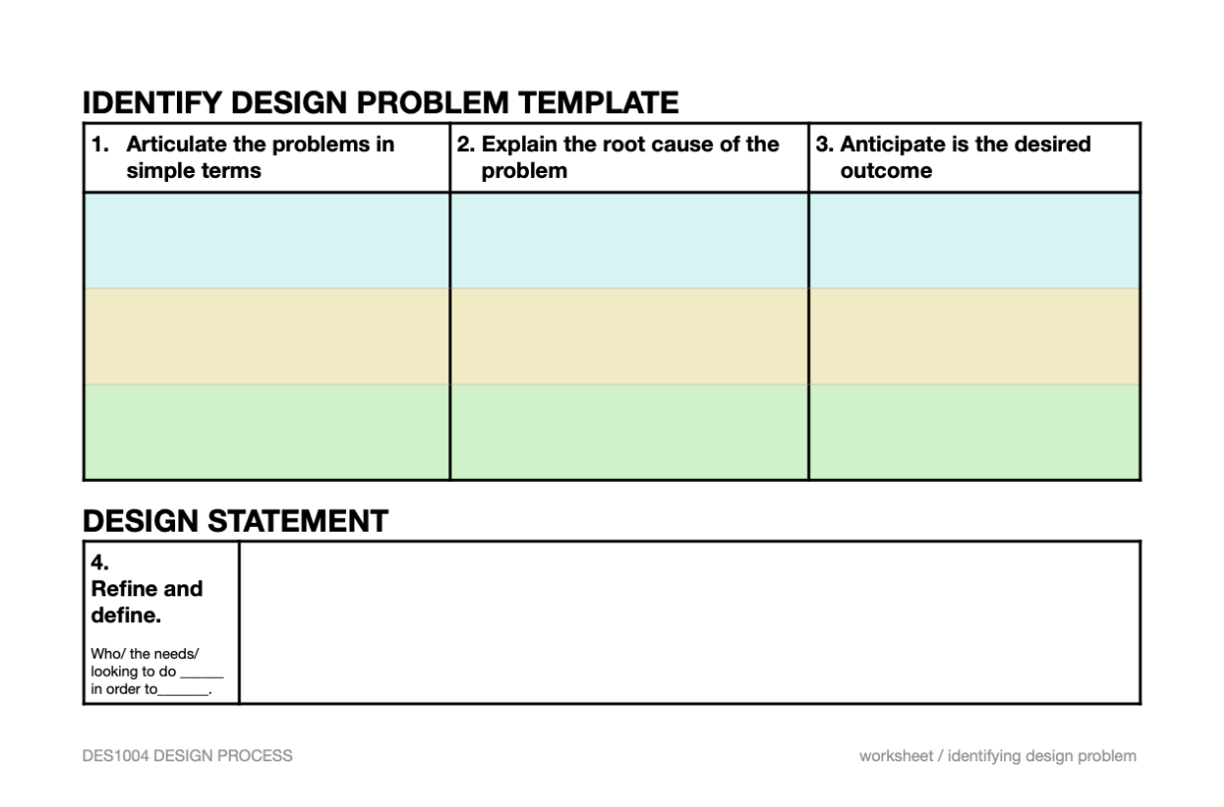
Make a sentence based on the sentence structure given:

