MONEY MANAGER

APPLICATION

*By*

*Nguyen Tien Dat – HE130826*

*Pham Tien Manh – HE130897*

Subject: PRM391

Lector: KienLT

Table of Contents

Table of Contents ii

Revision History iii

1. User Case Diagram 2

2 Detailed Design 6

2.1 Start Screen 6

2.2 Main Screen 6

2.3 Summary Report 6

2.4 Budget Management 6

2.5 Expense Management 6

2.6 Saving Management 6

2.7 List of Reports 6

2.8 Currency Exchange 6

2.9 Reset Data 6

3. Task Assignment 13

4. Database Design 17

# Use Case Diagram

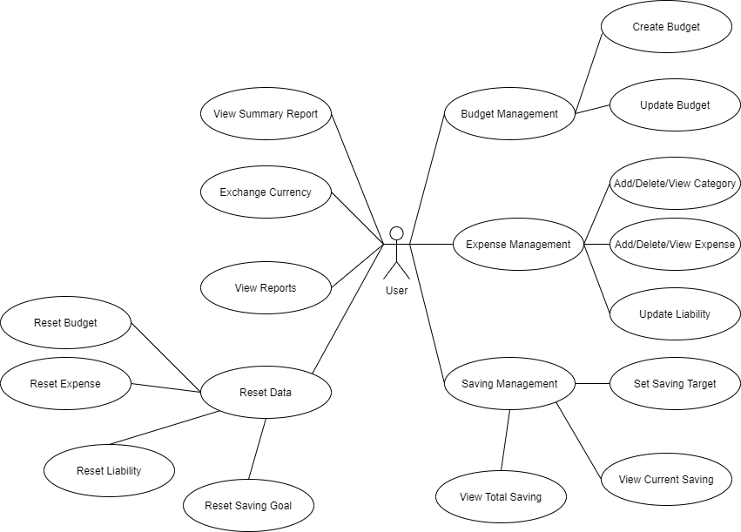

# Detailed Design

## Start Screen:

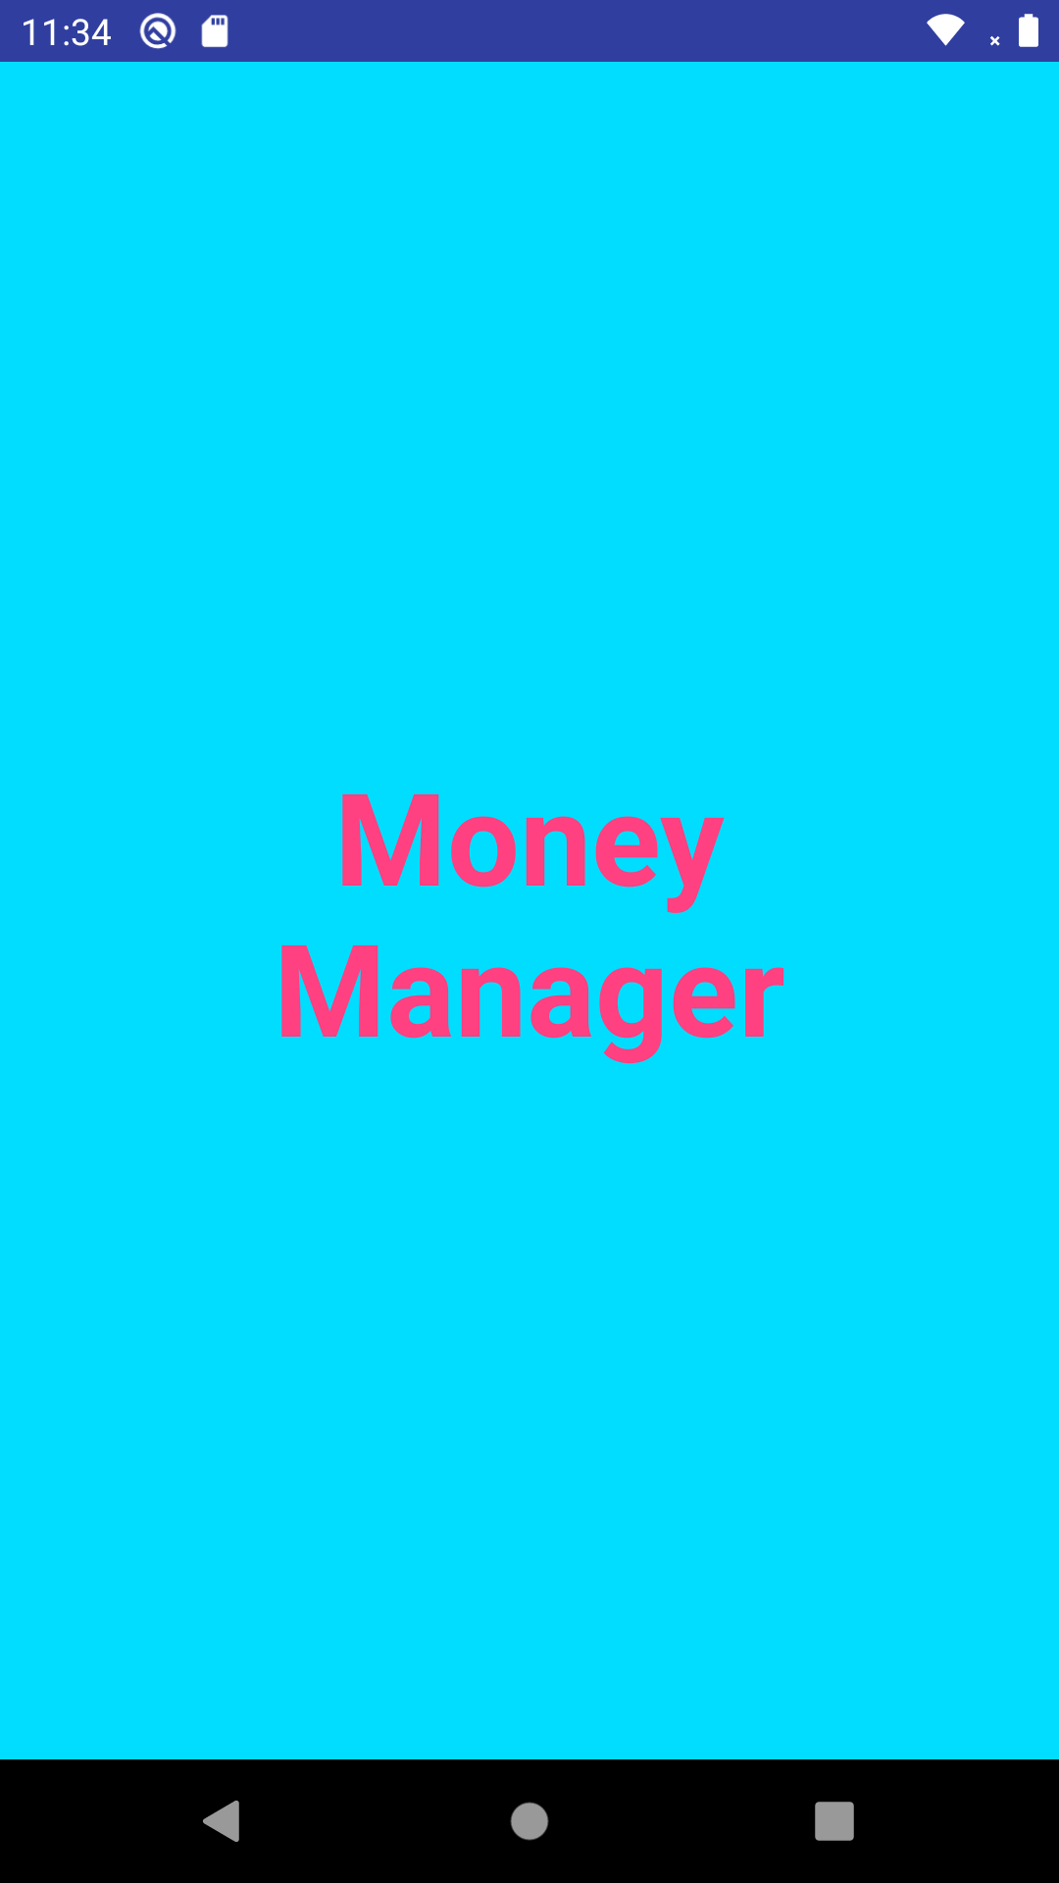

## Main Screen:

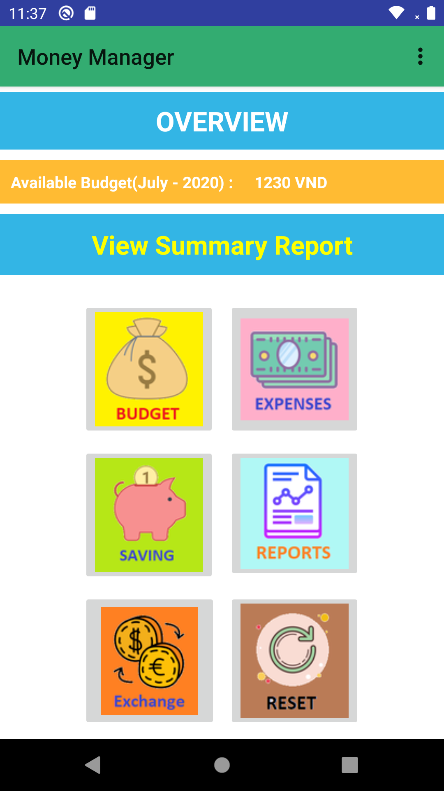

## Sumary Report:

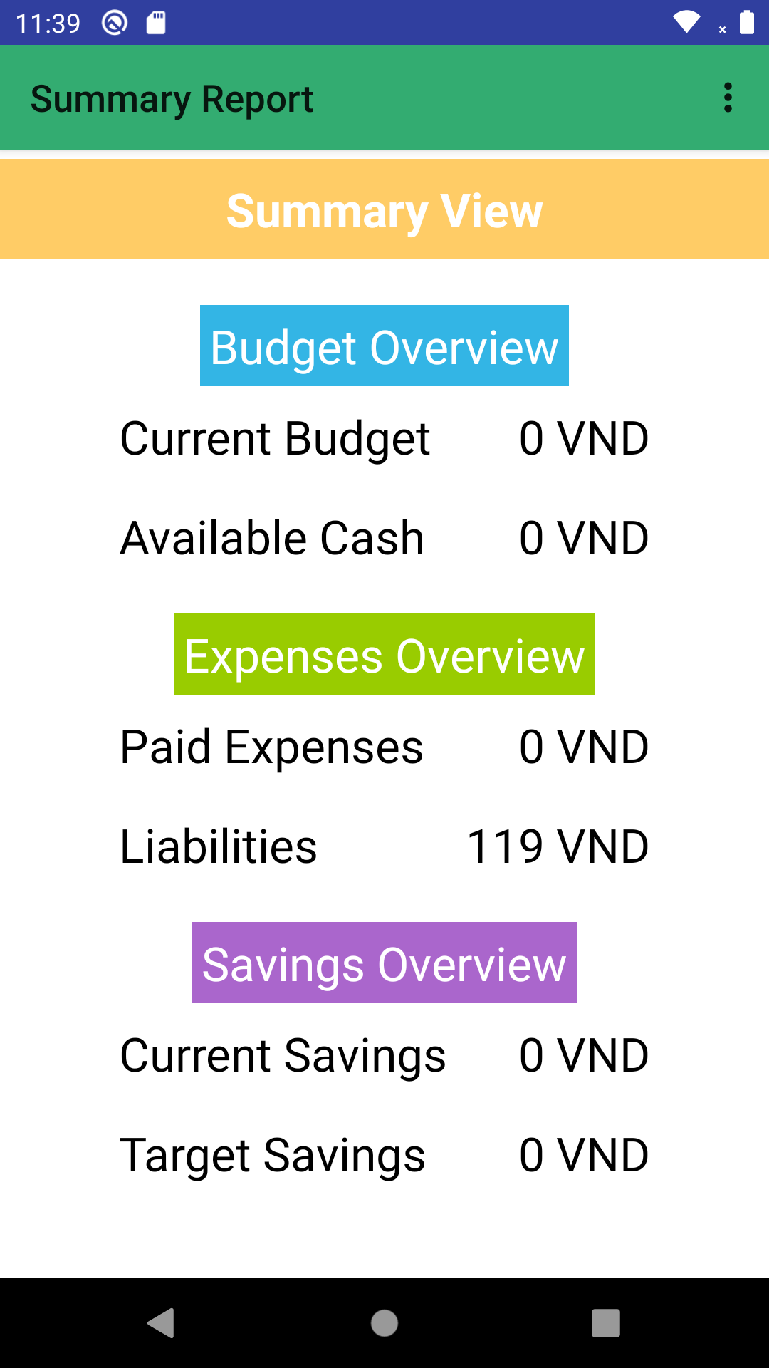

## Budget Management:

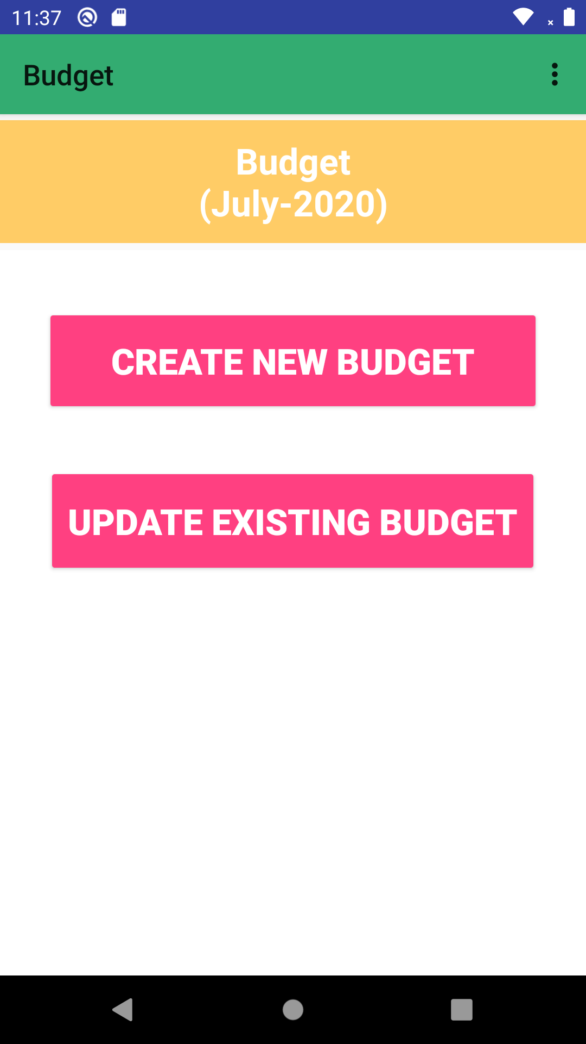

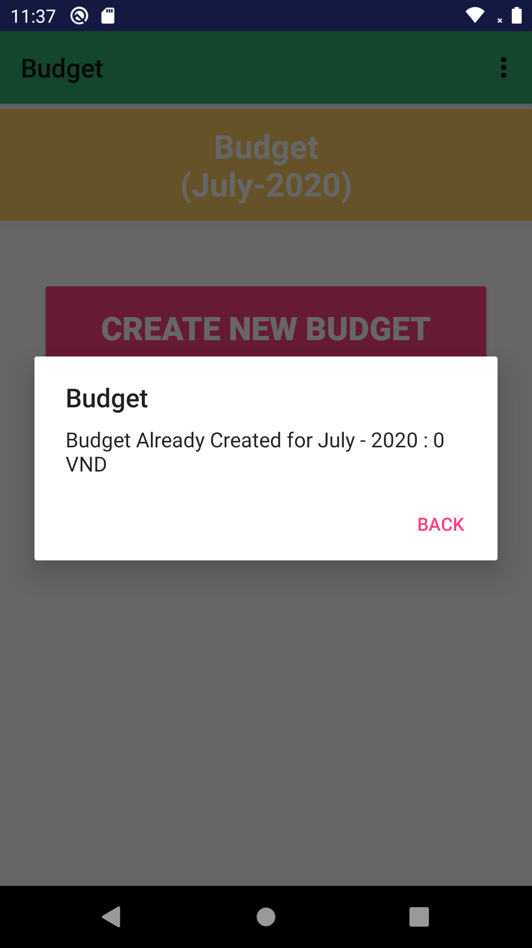

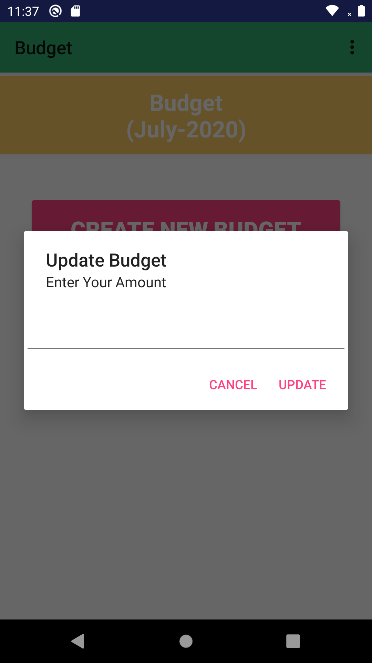

## Expense Management:

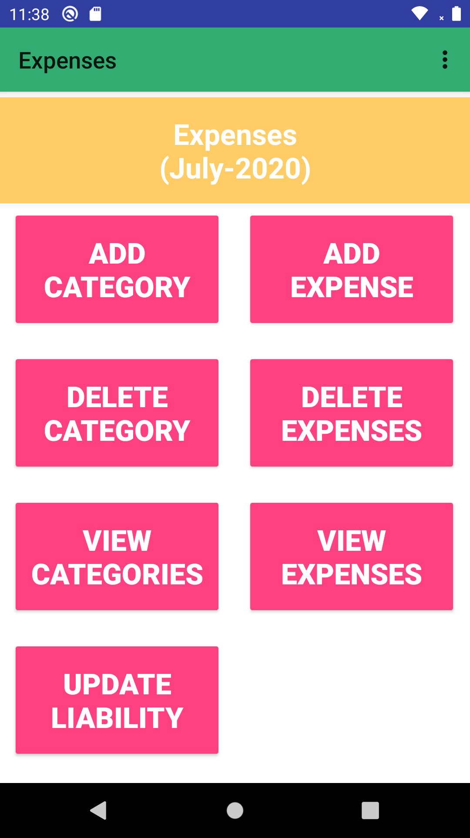

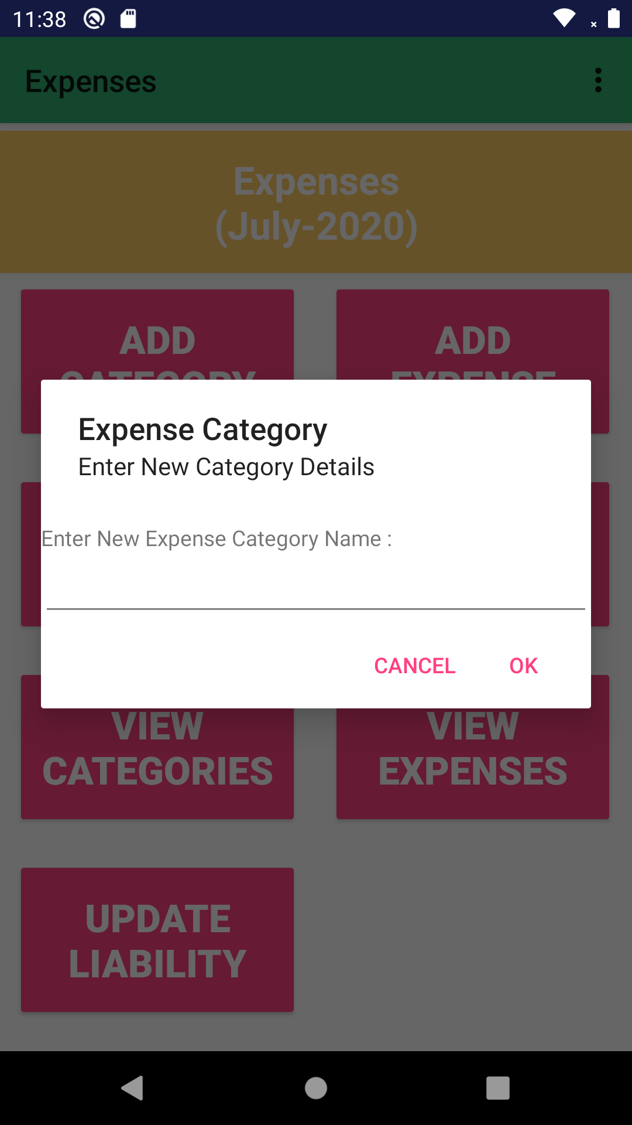

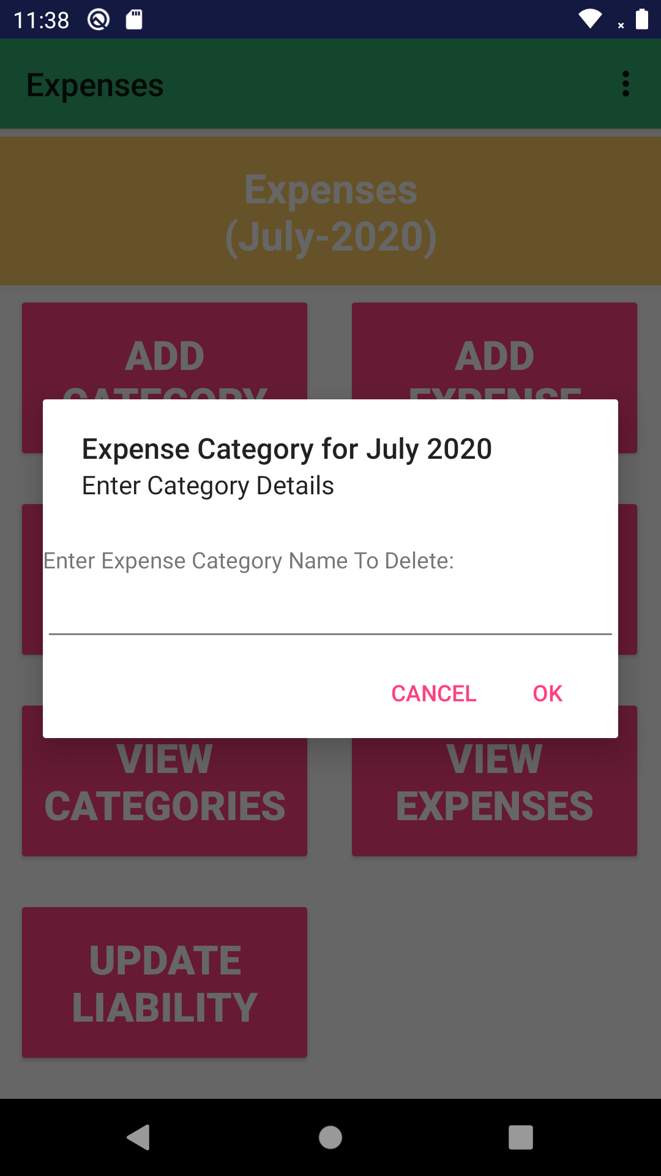

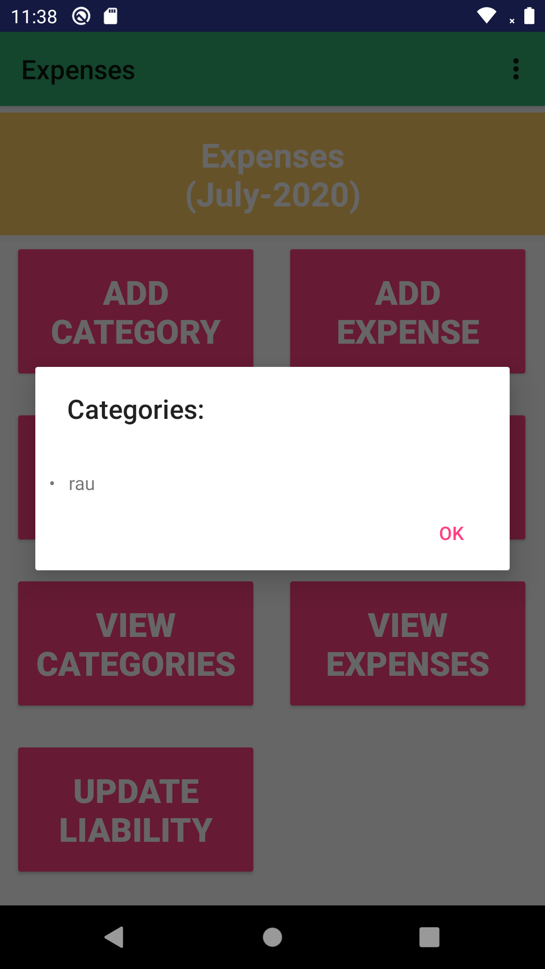

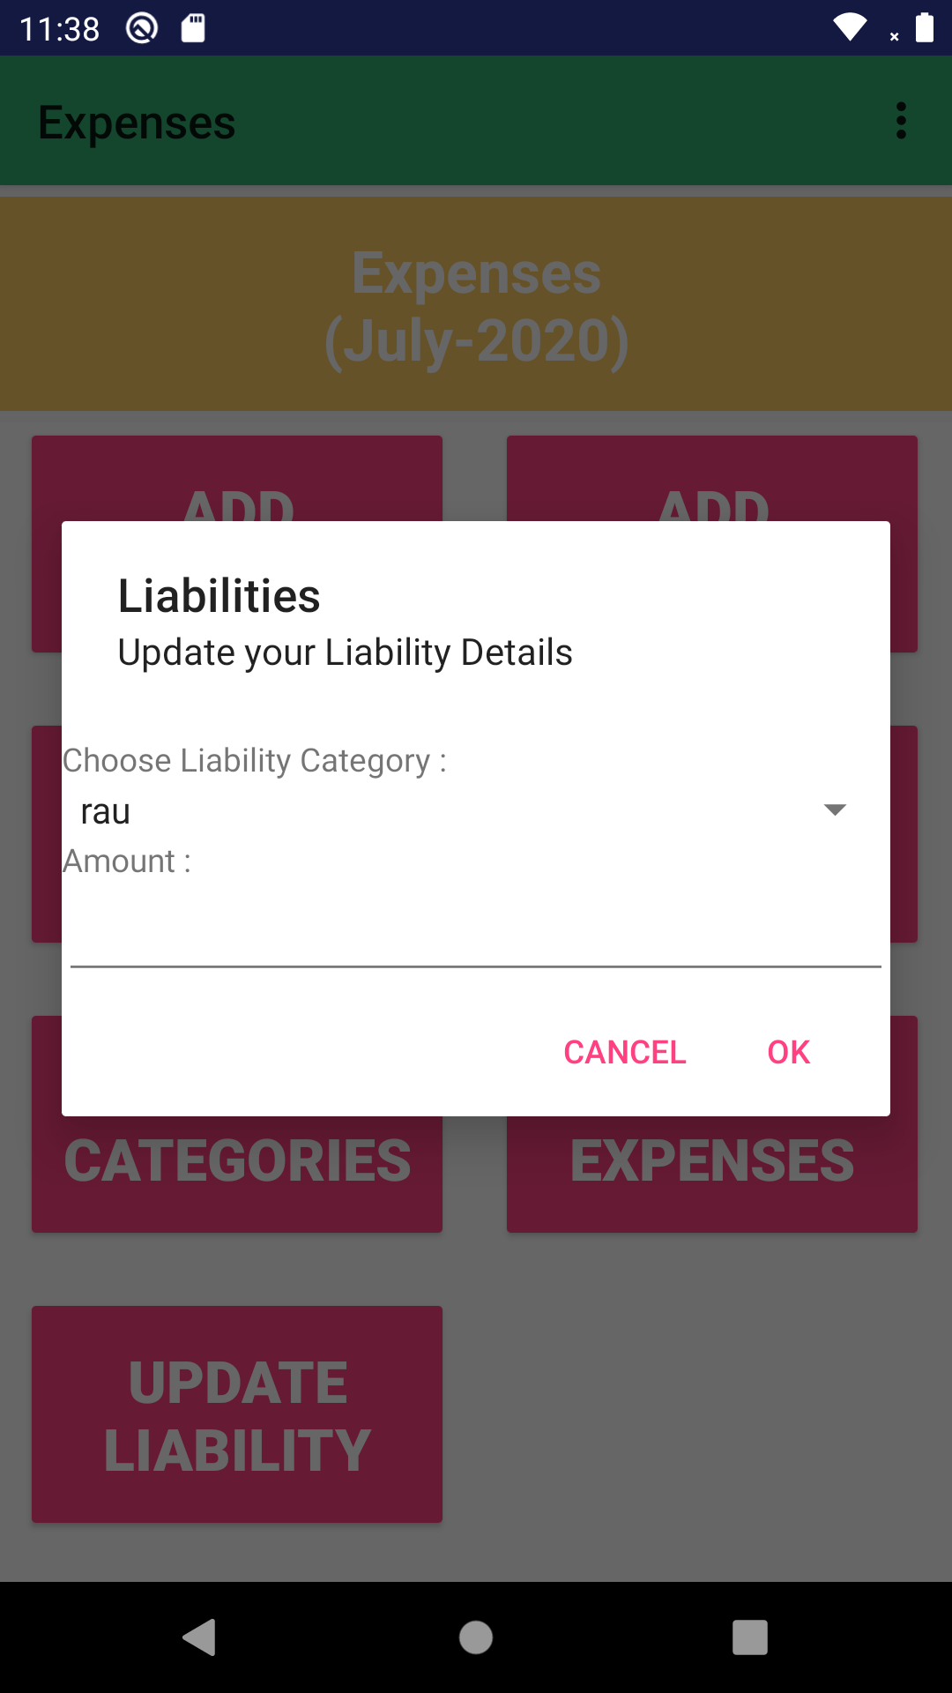

## Saving Management:

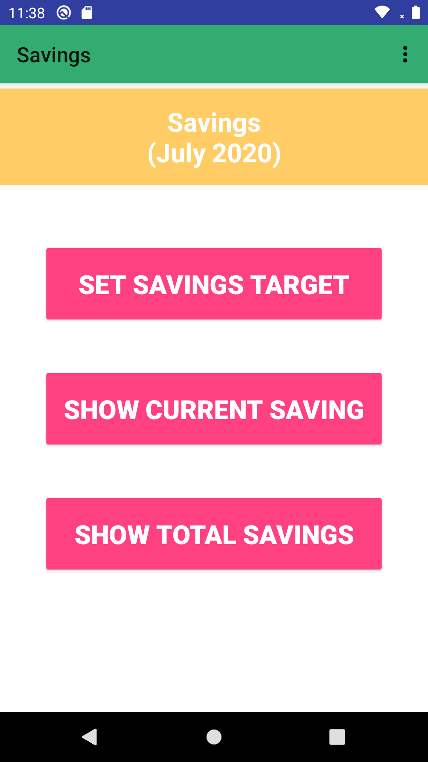

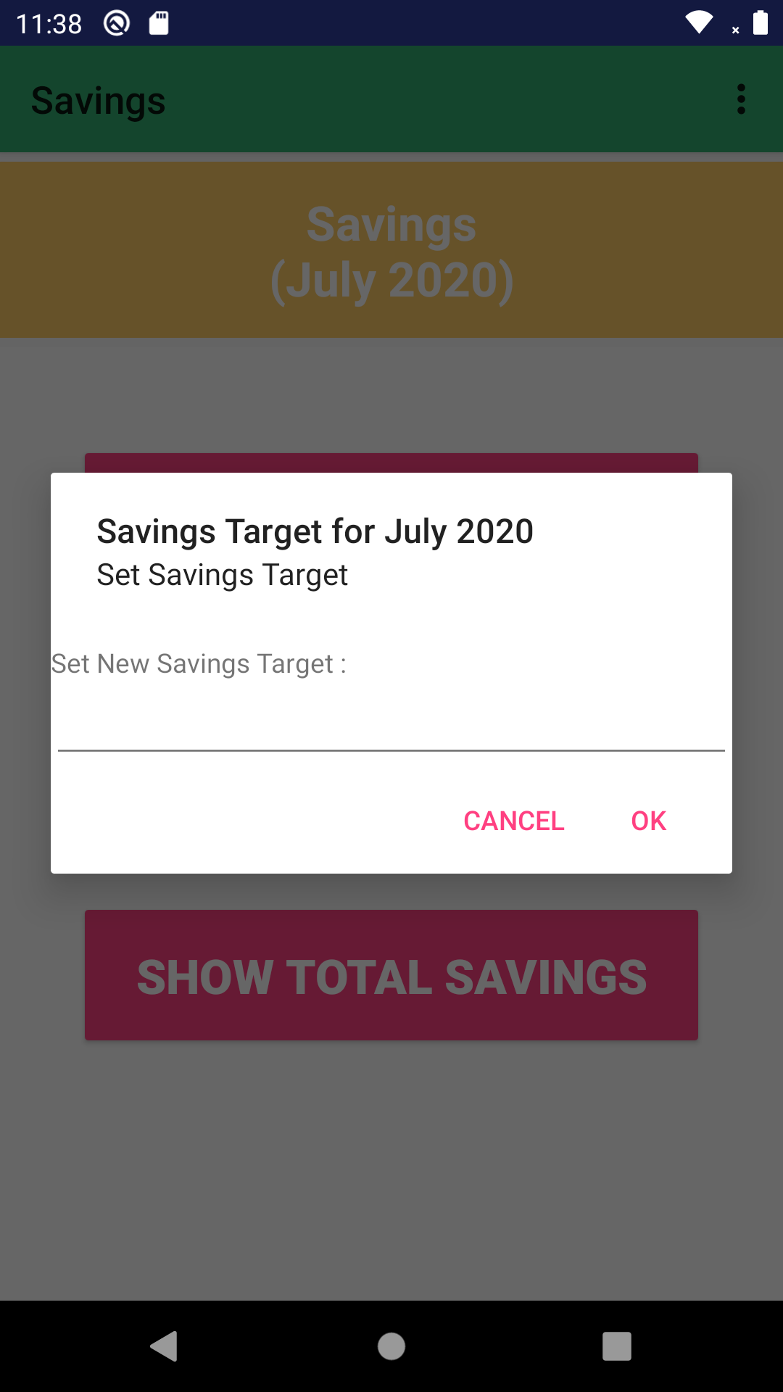

## List of Reports:

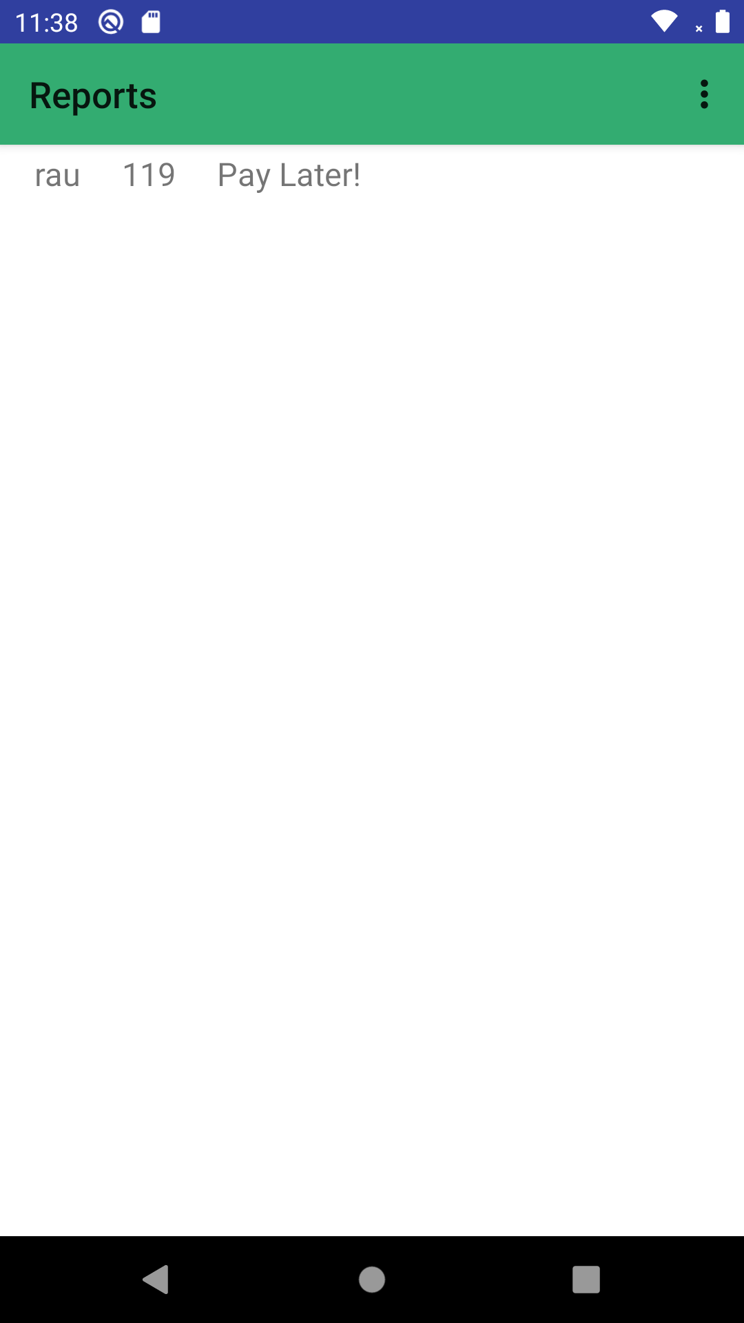

## Currency Exchange:

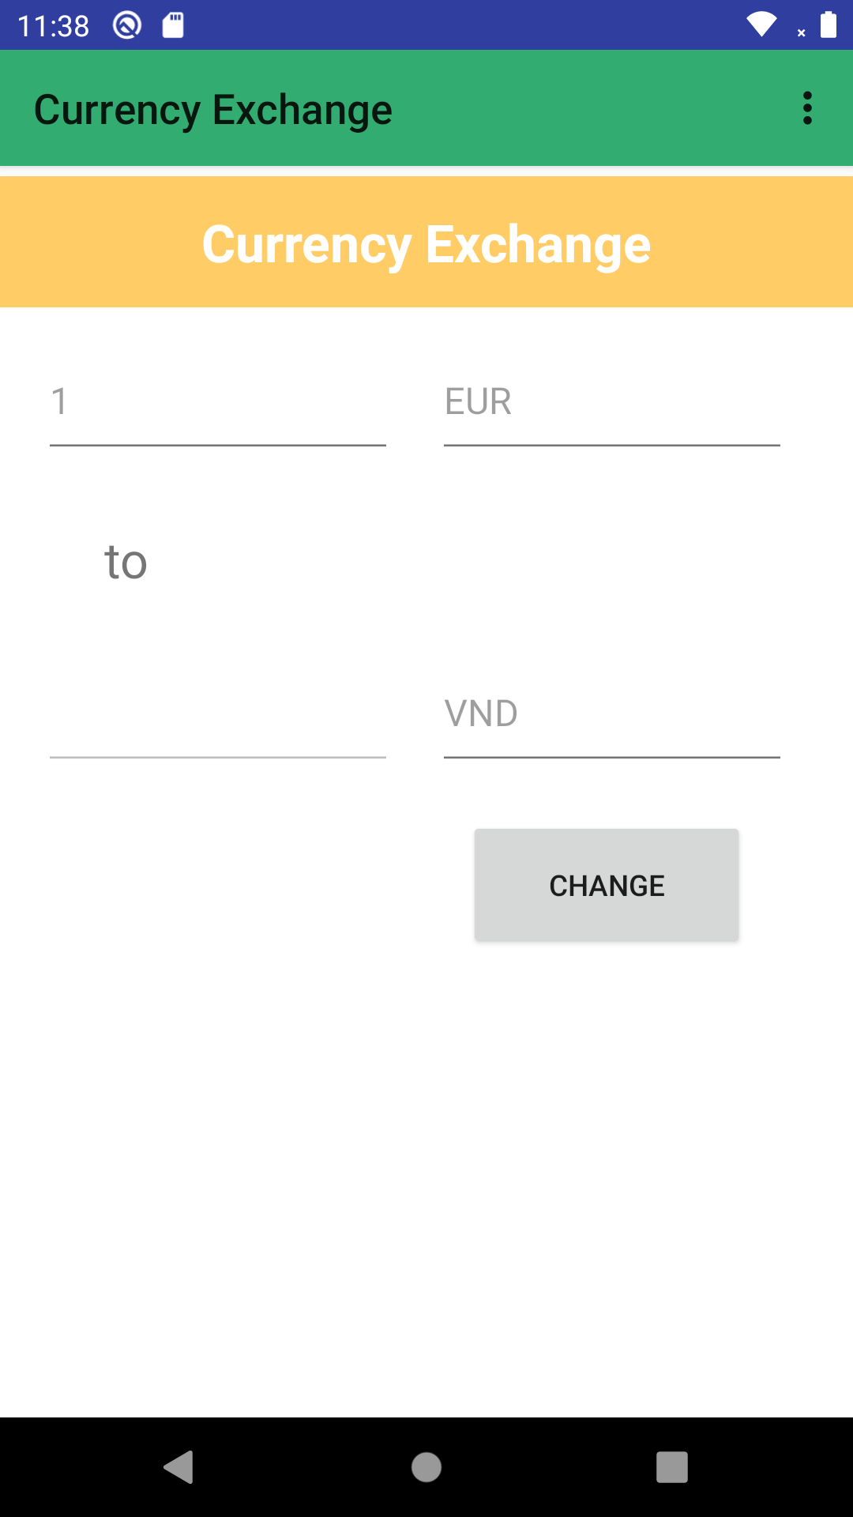

## Reset Data:

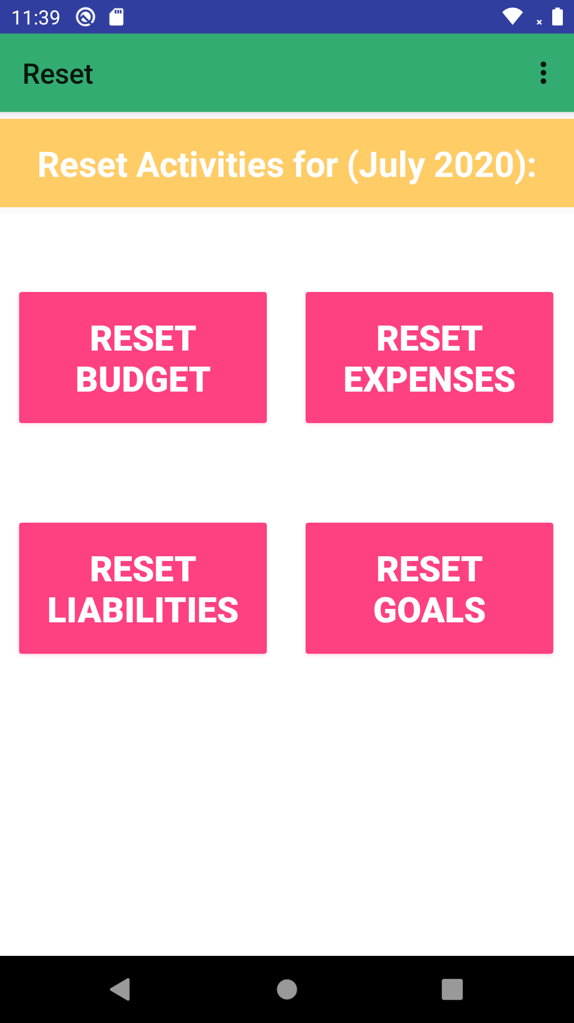

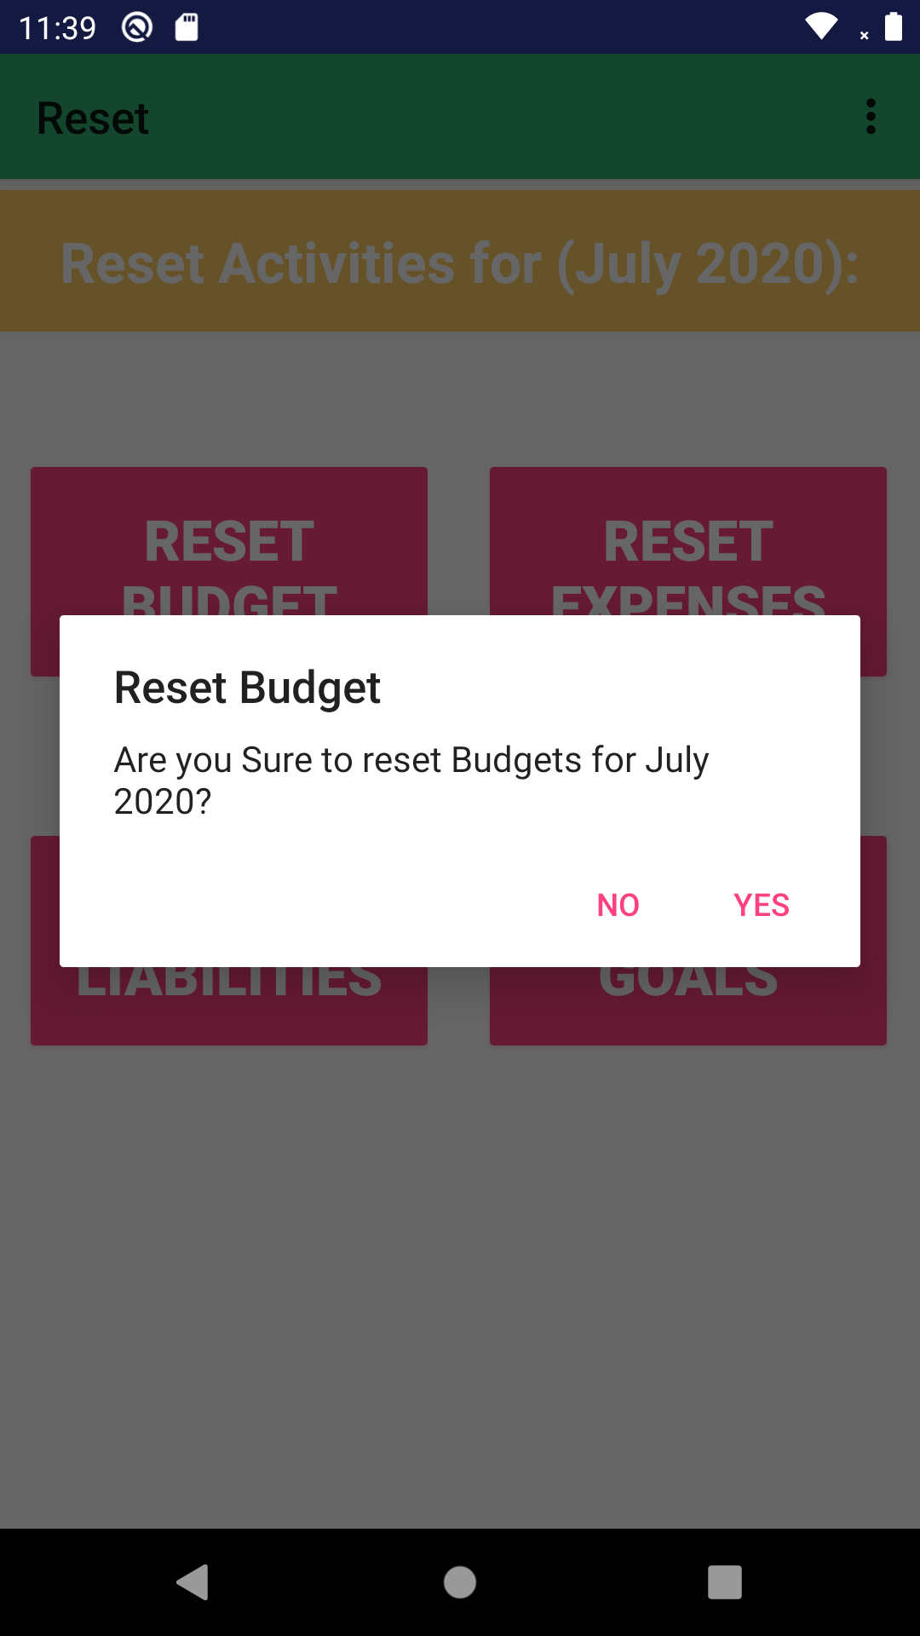

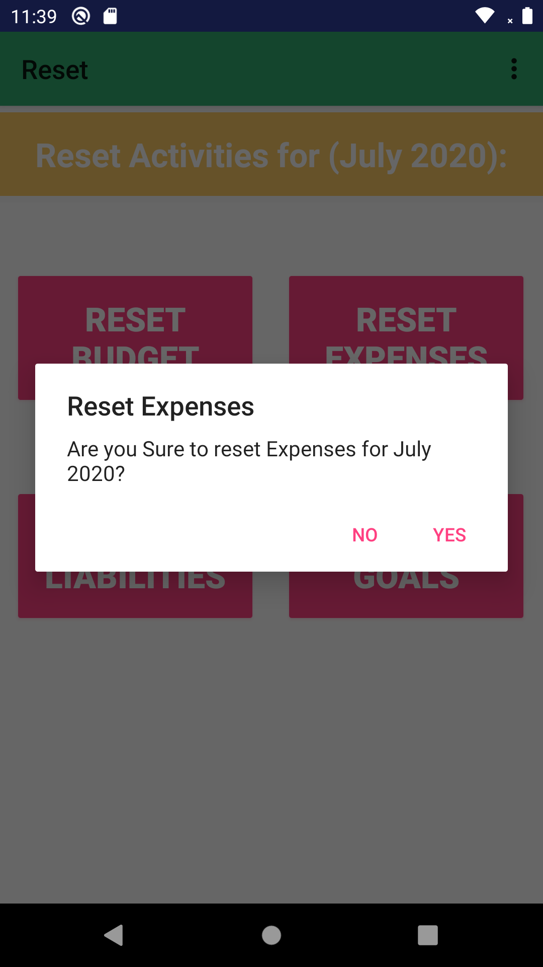

# Task Assignment

|  |  |
| --- | --- |
| Task | Assignee |
| Create UI | Nguyen Tien Dat |
| Coding Actitvity | Pham Tien Manh |
| Design Database | Nguyen Tien Dat |
| Writing Document | Nguyen Tien Dat |

# Database Design

