Ps5.writeup

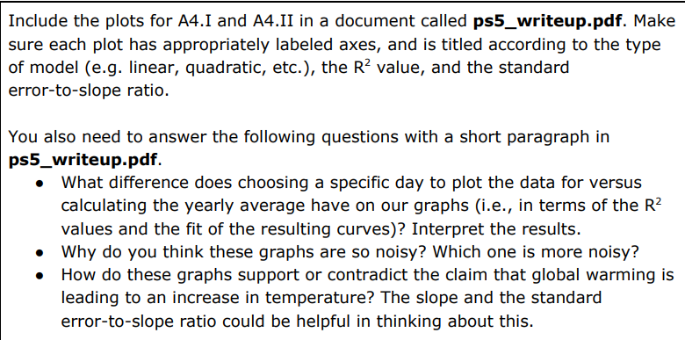

New York temp every Jan 10th | New York annual average temperature
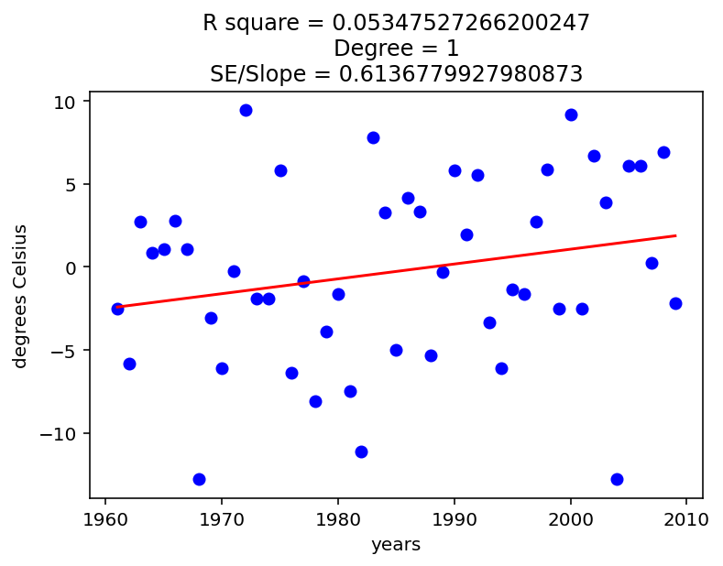 | 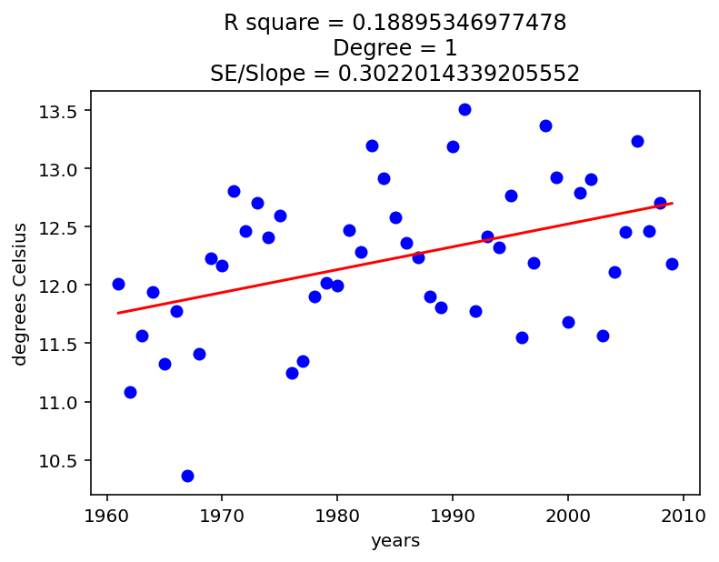

- Calculating the yearly average result in higher R² and lower SE/Slope (than choosing a specific day)
- These 2 graphs are noisy because city temperature depend on not only global average temperature but also the weather cycles, rain/storm, etc. Even if global average temperature rise, if at that year NY experience some extreme weather conditions, then NY’s temp will drop/rise abnormally
- NY’s temp every Jan 10th data are more noisy, because weather of a day depend more on random elements (weather cycle, rain, sun, etc), the annual one depend more on the average global temp (although still depend a lot on random elements)
- These 2 graph support the claim that global warming is leading to an increase in temperature. Even though the temperature each year vary, the line that best fits to the variable of NY’s temperature always go up (have the slope > 0) in all 2 case (annual average or 1 day), because:
  - The Standard Error/Slope of the annual average NY’s temp is about 30%, suggest that 95% Confidence interval of the actual annual average temperature line slope fluctuate between 41% to 159% of the NY’s temperature model line slope (the actual annual average temperature line always go up)
  - The NY Jan10th explanation similar with above

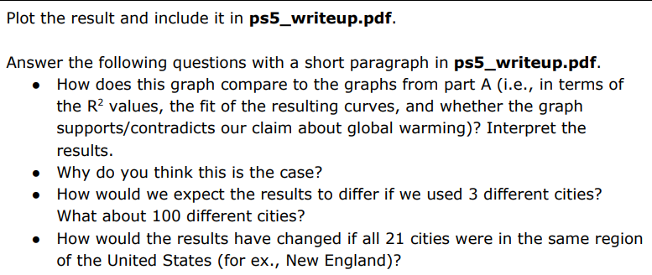
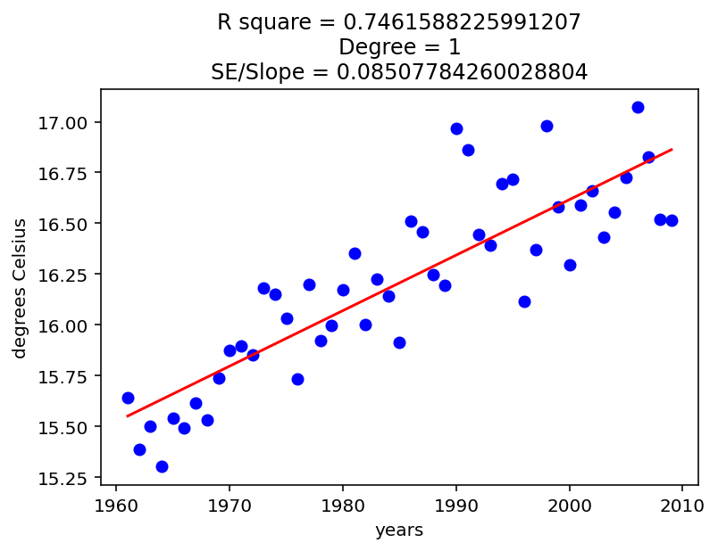
- R square increase significantly while the SE/Slope reduce
- The reason is when the sample size increase (more cities), the random elements’ influences reduce, and the data depends more on the global temperature trends (just like when I increased the sample size, from NY’s temperature in only 1 day each years to NY’s average annual temperature, R square increase and SE/Slope decrease)
- If we use only 3 different cities, the R square of the model will lower than R square of 21 cities’ model, but higher than only NY’s model. If we use 100 cities’ data, the model will have R square higher than both case (21 cites and only NY)
- If all 21 cites are from the same region, the R square will be lower than in different region, the data will be noisier. The reason is if all cities come from the same region, once local unexpected extreme weather condition occurs, all cities will be affected, which create a notable noise in the data, unlike the case when cities locate in different region, which local noise will only affect a few. Furthermore, if all cities are from the same region, the data will be less representative, only reflect the local weather trend rather than global temperature trend.

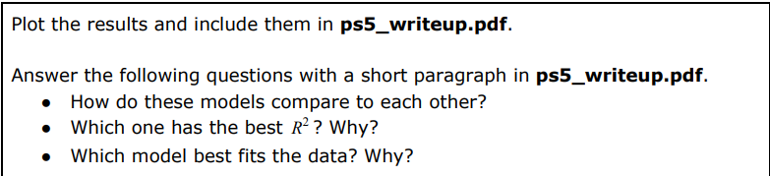
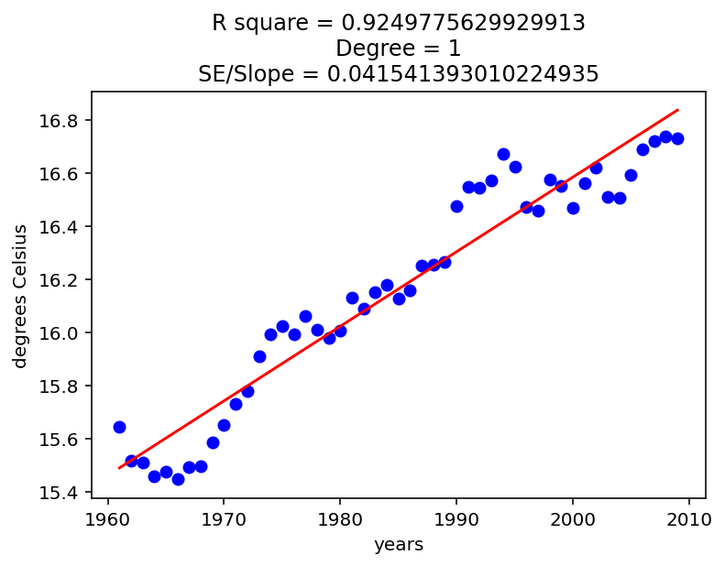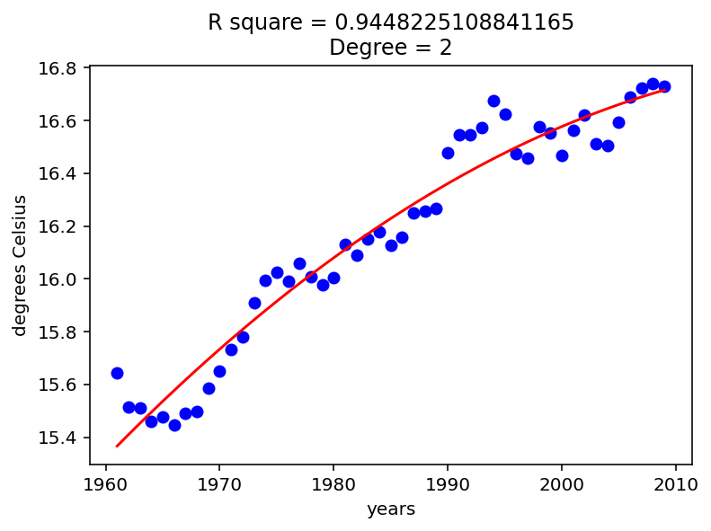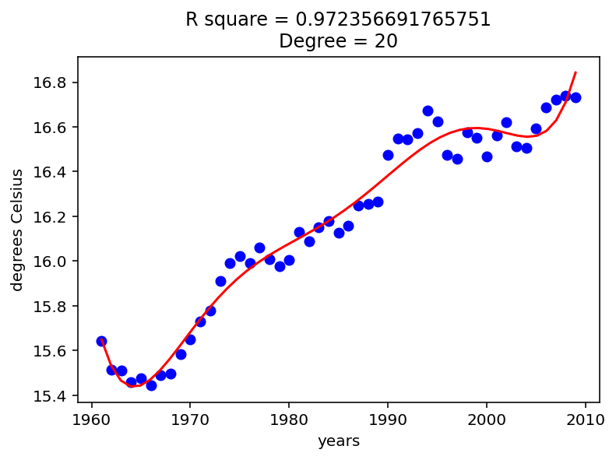
- The model fit the training data more as the degree of model increase
- 20 degree model has the best R² because the more the degree is, the more ‘variation’ the model can learn. For example, in the most extreme event, with model degree 20, even if the best model is degree 2 (the coefficient of the exponent term 20 is 0), the 20 degree model will only have R² equal to the degree 2 model and higher than that of degree 1 model, but if the best model that fit the data have higher degree, the degree 20 model R square will always higher than that of degree 1/2 model

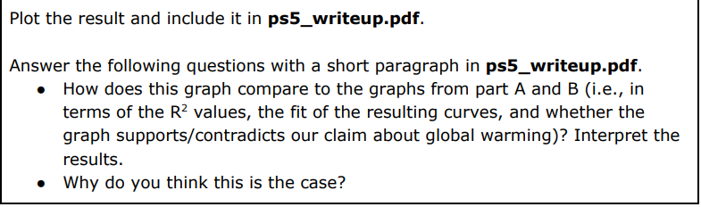
- The R square will be higher than the graphs from part A and B, the model will fit more to the data, and the graph support our claim about global warming.
- The reason is the moving average will make the extreme weather condition affect the model less, while the data is more variable (using data from 21 cities instead of only 1 in part A), which reduce the affection of random elements (which make the R square reduce and the SE/Slope increase, as extreme data point will be affected by the weight of the square expression, and the extreme data point will also make the model look less ‘reliable’ (se/slope reduce))

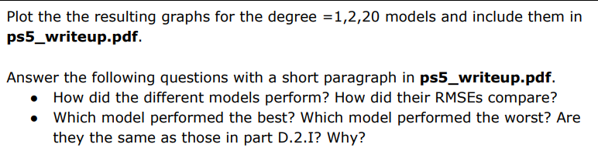
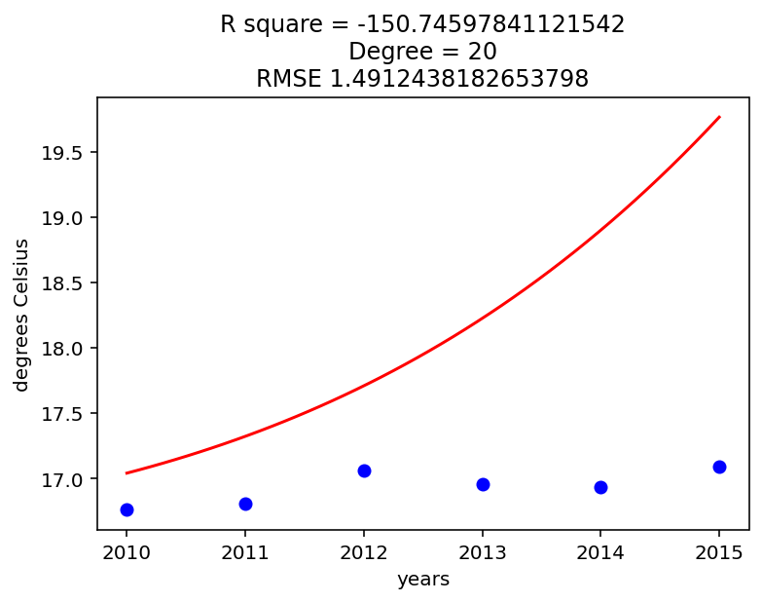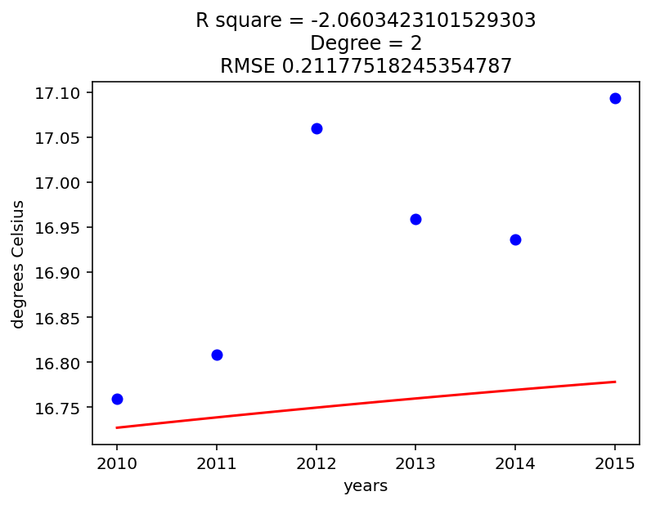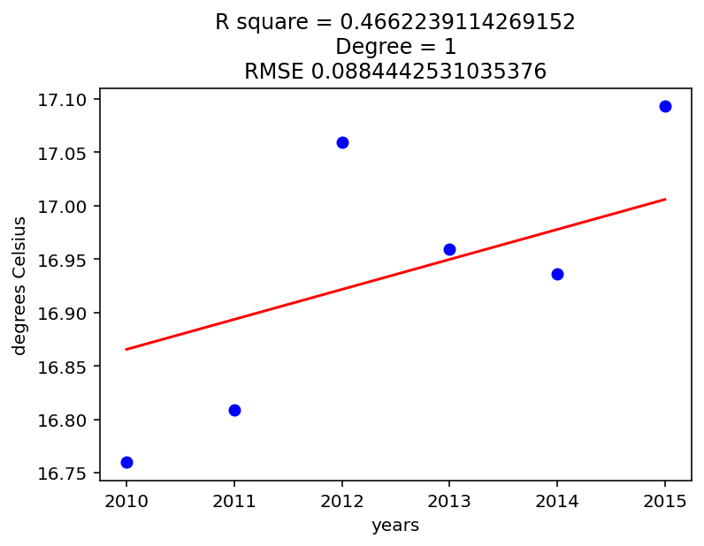
- Degree 1 model perform the best, and the model perform worse as it degree increase (the worst is degree 20 model). This show us an opposite trend compare with the model in part d.2.I
- The reason is while higher model can ‘learn’ the training data better, it will also learn the error, noise in the training data, and as the data change, the model lose it ability to predict data as the noise and error will no longer be the same as in the training data.
- If we use the mode generated by A.4.II data (annual NY’s temp), the prediction will be much worse, the rmse will soar much higher, especially with the degree 20 model. The reason is the data of NY does not represent the data of all 21 cities, as 21 cities located in a wide range of regions while NY’s data only represent the local trend (model bias).

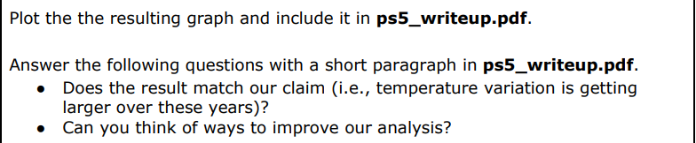
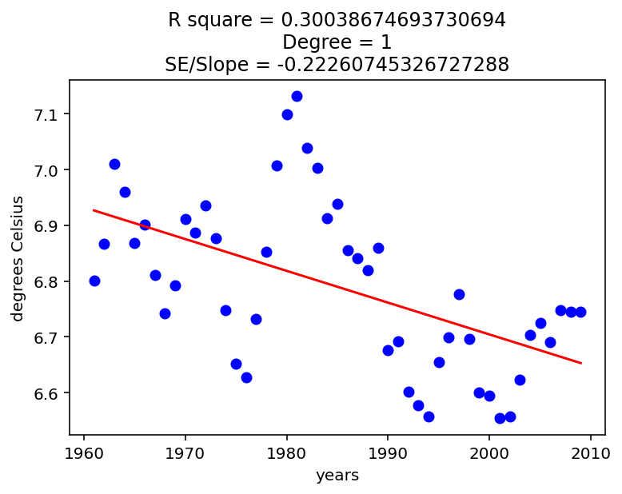
- No, it does not.
- Some way to improve the analysis:
  - Classify temperature data by season and compare the trends of season average temperature to reduce the variation in temperature between each season (May be summer/winter?)
  - Use the number of extreme temperature day instead of standard deviation, as the temperature difference between 2 seasons reduce faster than the increase in the number of extreme weather day.
  - Maybe we should increase the length of window_length to make the data smoother, less affected by extreme weather condition, as we can measure the number of extreme weather condition day by counting (so we do not need to ‘see’ the trend of extreme weather condition in the model metric). The model only needs to measure the temperature trend and its error while measuring the trend

