

Requirement & Design Specification

**Trade&Deal Hub System (TDUS)**

**Version: 1.0**

– Hanoi, August 2022 –

# Record of Changes

| **Version** | **Date** | **A* M, D** | **In charge** | **Change Description** |
| --- | --- | --- | --- | --- |
| V1.0 |  |  |  |  |
|  |  |  |  |  |
|  |  |  |  |  |
|  |  |  |  |  |
|  |  |  |  |  |
|  |  |  |  |  |
|  |  |  |  |  |
|  |  |  |  |  |
|  |  |  |  |  |
|  |  |  |  |  |
|  |  |  |  |  |
|  |  |  |  |  |

*A - Added M - Modified D - Deleted

Contents

Record of Changes 2

I. Overview 4

1. User Requirements 4

1.1 Actors 4

1.2 Use Cases 4

2. Overall Functionalities 9

2.1 Screens Flow 9

3. System High Level Design 10

3.1 Database Design 10

II. Requirement Specifications 10

1. Authentication 10

1.1 UC-2_Login System 10

1.2 UC-3_Logout System 12

1.3 UC-15_Delete User 14

1.4 UC_20_Forgot password 16

[1.5 UC-23: User registration  
a. Functional Description 18](#_sviq1lwhh2vd)

1.4 UC-27_ViewProfile 20

1.5 UC-28_ChangePassword: 22

1.6 UC-29_UpdateProfile: 24

1.7 UC-04_View_User_dasboard: 26

1.8 UC-05_Search User by Admin: 28

IV. Appendix 30

1. Assumptions & Dependencies 30

2. Limitations & Exclusions 30

3. Business Rules 30

# I. Overview

## 1. User Requirements

### 1.1 Actors

This Trade&Deal Hub System has 2 actors, including Admin and User, the Admin actor has the ability to manage the Trade&Deal Hub System, and the User actor has the role of using the Trade&Deal Hub System. The table below describes the actors interacting with the system and their respective descriptions.

| **#** | **Actor** | **Description** |
| --- | --- | --- |
| 1 | Admin | Administrators are privileged users with advanced access rights, manage user resources, and handle services from the user side. |
| 2 | User | A user is an individual who interacts with the system to use its features. Their main function is to use services, participate in buying and selling and manage their own resources. |
| 3 | Guest | Người bên ngoài truy cập vào trang web mà không cần xác minh, họ có thể xem những thông tin cơ bản của trang web mà không thực hiện được các dịch vụ của user. |

### 1.2 Use Cases

This section describes in detail the Use Cases that both admins and users will have in the Trade&DealHub System.

#### a. Diagram(s)

Figure bellow illustrate the use case diagrams for the Trade&DealHub system, divided by actor roles.

#### a.1 - Admin

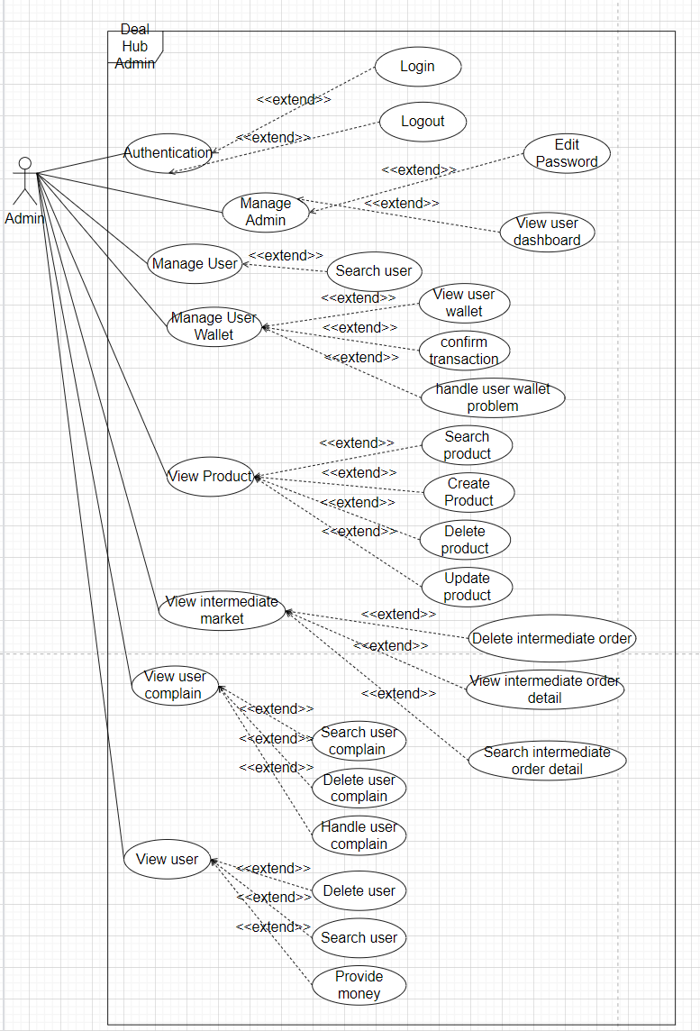

#### a.2 User

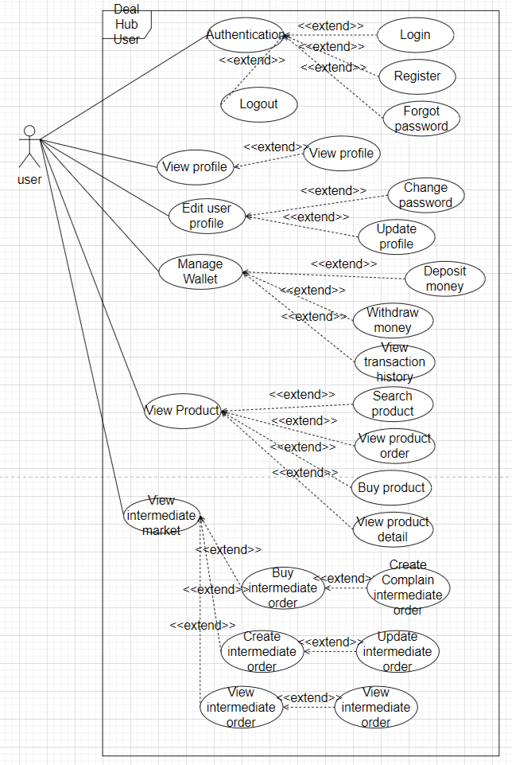

#### b. Descriptions

b1. Admin:

| **ID** | **Feature** | **Use Case** | **Use Case Description** |
| --- | --- | --- | --- |
| 01 | Authentication | Login | Login in to web |
| 02 | Authentication | Logout | LogOut of web |
| 03 | Manage Admin | Edit Password | Change admin password |
| 04 | Manage User | view user dashboard | view user dashboard |
| 05 | Manage User | search user | search user |
| 06 | Manage User | delete user | delete user |
| 07 | Manage User Wallet | View user wallet | Check user wallet money |
| 08 | Manage User Wallet | Confirm transaction | Confirm money transaction |
| 09 | Manage User Wallet | Handle user wallet problem | Resolve User Wallet Issue |
| 10 | View Product | Search Product | Can search new product |
| 11 | View Product | Create Product | Can create new product |
| 12 | View Product | Delete Product | The admin can delete product |
| 13 | View Product | Update Product | Can edit or update the information of a product |
| 14 | View intermediate market | Delete intermediate order | Delete intermediate order |
| 15 | View intermediate market | View intermediate order detail | View all intermediate order detail |
| 16 | View intermediate market | Search intermediate order detail | Check intermediate order in detail |
| 17 | View user complain | Search user complain | Watch user complain in detail |
| 18 | View user complain | Delete user complain | Delete complain in web |
| 19 | View user complain | Handle user complain | Check and handle complain by user |
| 20 | View user | Delete user | Delete user from web |
| 21 | View user | Search user | To find information about user |
| 22 | View user | Provide money | Provide an amount of money to the user |

b.2 User

| **ID** | **Feature** | **Use Case** | **Use Case Description** |
| --- | --- | --- | --- |
| 23 | Authentication | Register | Register an account on the website |
| 24 | Authentication | Login | Login in to account of web |
| 25 | Authentication | Forgot password | You forgot your password and the website asks you to register with gmail to retrieve your password |
| 26 | Authentication | LogOut | Log out of your account from the website |
| 27 | view profile | view profile | view profile of admin or user |
| 28 | Edit user profile | Change password | change user account password |
| 29 | Edit user profile | Update profile | Update profile |
| 30 | Manage Wallet | Deposit money | Deposit money into your account online |
| 31 | Manage Wallet | Withdraw money | Withdraw money from web account to bank account |
| 32 | Manage Wallet | View transaction history | View transaction history with withdrawals or deposits into your account's wallet |
| 33 | View Product | View Products in pages | View Products in website |
| 34 | View Product | View order product | Search for products available on the web |
| 35 | View Product | Withdrawal money | Withdrawal money to account |
| 36 | View Product | View History transaction | View all transaction and money |
| 37 | View Product detail | View Product detail | See product details: quantity, price,... |
| 38 | View Intermediate market | View product in Intermediate market | View product in Intermediate market |
| 39 | Create intermediary_order | View history intermerdiary_order | See the intermediary order created |
| 40 | Buy product in intermediary market | Buy product in intermediary market | Buy products available on the intermediary market |
| 41 | Create feedback | Create feedback about the product | Create feedback about the product |
| 42 | View intermediate order | View intermediate order | View intermediate order is available on the web |
| 43 | Update intermediate order | Update intermediate orde | Modify the information in the order |

## 2. Overall Functionalities

### 2.1 Screens Flow

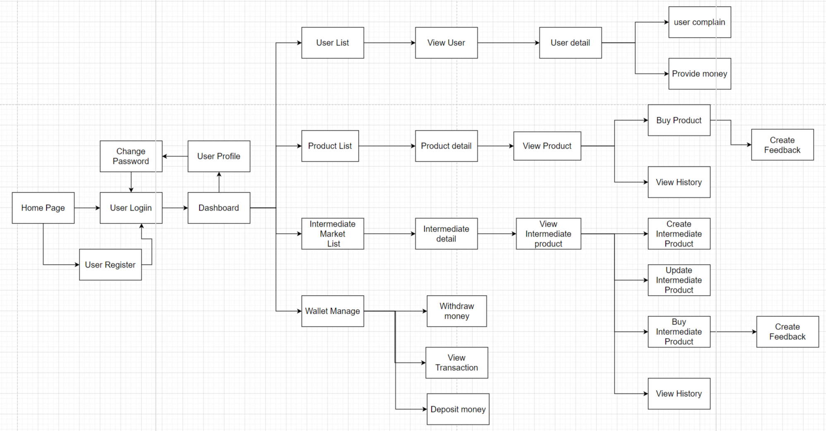

## 3. System High Level Design

### 3.1 Database Design

#### a. Database Schema

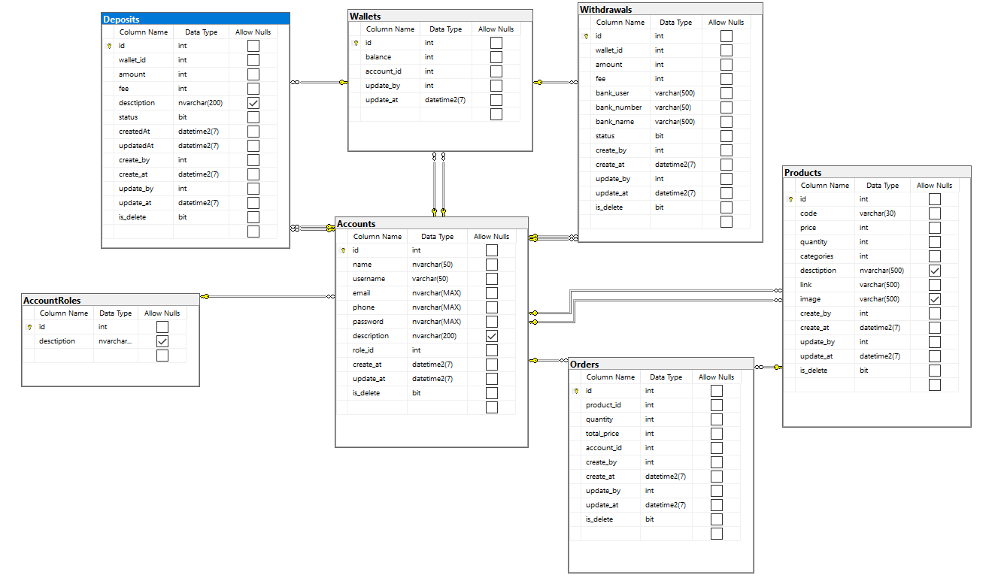

# II. Requirement Specifications

## 1. Authentication

### 1.1 UC-2_Login System

| UC ID and Name: | **UC-2_Login System** | | |
| --- | --- | --- | --- |
| Created By: | Hungnp | Date Created: | 20/01/2024 |
| Primary Actor: | Customer | Secondary Actors: | None |
| Trigger: | User clicks Login button from the page header, or  User accesses an authenticated feature (from a link or type the page URL directly into the address bar) | | |
| Description: | *As a user, I want to be able to log into the system so that I can use the system’s authenticated features and access my personalized account.* | | |
| Preconditions: | User account has been created & authorized | | |
| Postconditions: | · User logs in the system successfully  · The system tracked successful login into the Activity Log | | |
| Normal Flow | **1.0 Login System**  1. User accesses the User Login screen  2. User types in the login details or choo other login options  3. User clicks the Login button  4. System validates the login details  5. System allows user to access  6. System tracks user’s success login to the Activity Log  7. System accesses the Home Page (or the previous calling page if any) | | |
| Alternative Flows: | *none* | | |
| Exceptions: | ***2.0.E1 System can’t authenticate the user***  1. The Error Message screen is shown to the user  2. User clicks “Forgot Password?” link *=> change to UC-3_Reset Password*  3. User clicks “Register” link *=> change to UC-4_Register User Account* | | |
| Priority: | Must Have | | |
| Frequency of Use: |  | | |
| Business Rules: | BR-01, BR-02, BR-08 | | |
| Other Information: |  | | |
| Assumptions: |  | | |

#### 

### 1.2 UC-3_Logout System

| UC ID and Name: | **UC-2_Logout System** | | |
| --- | --- | --- | --- |
| Created By: | Hungnp | Date Created: | 20/01/2024 |
| Primary Actor: | admin/user | Secondary Actors: | None |
| Trigger: | User clicks Logout button from the page header | | |
| Description: | *As a admin/user, I want to be able to logout the system so that I can ending my current session* | | |
| Preconditions: | User account has been logout | | |
| Postconditions: | · Admin/user logout of the system successfully  · Admin/user session is invalidated | | |
| Normal Flow | **2.0 Logout System**  1. User clicks on the “Logout” button or link  2. System invalidated the admin/user’s session and redirects them to the UC-1_HomePage | | |
| Alternative Flows: | *none* | | |
| Exceptions: | ***2.0.E1 System can’t authenticate the user***  1. System is unable to process the logout request due to technical issue  2. System displays an error message to the user | | |
| Priority: | Must Have | | |
| Frequency of Use: |  | | |
| Business Rules: | BR-01 | | |
| Other Information: |  | | |
| Assumptions: |  | | |

### 1.3 UC-15_Delete User

| UC ID and Name: | **Delete User** | | | |
| --- | --- | --- | --- | --- |
| Created By: | HoangNDH | Date Created: | 20/J1n/2024 | |
| Primary Actor: | Admin | Secondary Actors: | |  |
| Trigger: | Admin wants to delete user account | | | |
| Description: | Admin wants to delete the user account and all related information. | | | |
| Preconditions: | Admin has successfully logged in and has the right to delete users. | | | |
| Postconditions: | The selected user has been removed from the system, and all related information has been deleted. | | | |
| Normal Flow | 1.Admin logs into the system with an account that has privileges to delete users.  2.Admin accesses the user management page or the user's personal information page.  3.Admin selects the option "Delete user."  4.The system displays a warning or confirmation to ensure the Admin does not accidentally delete the user.  5.Admin confirms the decision to delete the user.  6.The system deletes the user's account and all related information. | | | |
| Alternative Flows: | If Admin chooses to delete the user without confirmation, the system does not make any changes and displays a warning message. | | | |
| Exceptions: | **Exceptions:**  If there is an error during the user deletion process, the system will notify the specific error. | | | |
| Priority: | Must Have | | | |
| Frequency of Use: | Infrequent | | | |
| Business Rules: | BR-02, BR-09, BR-10 | | | |
| Other Information: | Once a user is deleted, they can no longer access the system. | | | |
| Assumptions: | Assume that admins have been trained and warned about the consequences of deleting users. | | | |

### 1.4 UC_20_Forgot password

| UC ID and Name: | **Forgot Password** | | | |
| --- | --- | --- | --- | --- |
| Created By: | HoangNDH | Date Created: | 20/J1n/2024 | |
| Primary Actor: | User | Secondary Actors: | | Admin |
| Trigger: | Click the "Forgot password" link on the login page | | | |
| Description: | User forgot password and wants to recover new password. | | | |
| Preconditions: | The user already has an account, but cannot log in due to forgotten password. | | | |
| Postconditions: | Users receive an email containing instructions and a link to reset their password. | | | |
| Normal Flow | 1.The user clicks the "Forgot password" link on the login page.  2.The system redirects the user to the password recovery page.  3.User enters registered email address.  4.The system sends an email containing a special link to the user's email address. | | | |
| Alternative Flows: | If the user doesn't remember their registered email address, they can choose another option, for example, enter a phone number. | | | |
| Exceptions: | **Exceptions:**  -If the email address is invalid or does not exist, the system will report an error.  -If there is an error when sending email, the system notifies the error and provides specific instructions. | | | |
| Priority: | Must Have | | | |
| Frequency of Use: | Infrequent | | | |
| Business Rules: | BR1 | | | |
| Other Information: | None | | | |
| Assumptions: | Assume that users have access to their registered email inbox to receive a password recovery link. | | | |

### 1.5 UC-23: User registration

| UC ID and Name: | **User Registration** | | | |
| --- | --- | --- | --- | --- |
| Created By: | VuPLN | Date Created: | 20/Jan/2024 | |
| Primary Actor: | User | Secondary Actors: | | System |
| Trigger: | User decides to register for the system. | | | |
| Description: | This use case describes the process of a user registering for the system, providing necessary information to create a new account. | | | |
| Preconditions: | None | | | |
| Postconditions: | User account is created successfully. | | | |
| Normal Flow | * User navigates to the registration page. * User enters required information: username, email, password. * User submits the registration form. * System validates the entered information. * System creates a new user account with the provided information. * System sends a confirmation email to the user. * User receives the confirmation email and clicks on the confirmation link. | | | |
| Alternative Flows: | If the username or email is already in use, the system notifies the user and prompts for unique credentials. | | | |
| Exceptions: | If the registration fails at any step, the system provides an error message to the user. | | | |
| Priority: | High, Must Have | | | |
| Frequency of Use: | Occasional | | | |
| Business Rules: | BR-01, BR-02, BR-08 | | | |
| Other Information: | Registration may include additional steps such as captcha verification to prevent automated registrations. | | | |
| Assumptions: | Users have access to a valid email address to receive the confirmation email.  Users are required to provide unique usernames and emails during registration. | | | |

**b.Business Rules:**

| **ID** | **Business Rule** | **Business Rule Description** |
| --- | --- | --- |
| BR-UR2 | Unique Email Addresses | Each user must register with a unique email address. The system will check the database to ensure that the provided email address is not already associated with an existing user account. |
| BR-UR7 | Terms of Service Agreement | Users must agree to the terms of service and privacy policy during the registration process. A checkbox or confirmation button will be provided to ensure users acknowledge and accept the terms. |

### 1.4 UC-27_ViewProfile

| UC ID and Name: | UC-27_ViewProfile: | | | |
| --- | --- | --- | --- | --- |
| Created By: | ChienNN | Date Created: | 20/J1n/2024 | |
| Primary Actor: | User | Secondary Actors: | | Admin |
| Trigger: | User clicks Name button from the home page header after login the website, or User accesses an authenticated feature (from a link or type the page URL directly into the address bar) | | | |
| Description: | As a user, I want to access my **Profile** page to see if my information is accurate | | | |
| Preconditions: | You must first successfully log in to your account | | | |
| Postconditions: | -User accesses the User Profile page successfully.  -The system tracks the user's access to the User Profile in the Activity Log. | | | |
| Normal Flow | **2.0 User Profile:**  1.User clicks on the "Profile" link in the page header.  2.System validates that the user is logged in (see 5.0.E1).  3.System displays the User Profile page with the user's personal information.  4.User views and manages their personal information on the User Profile page. | | | |
| Alternative Flows: | ***N/A*** | | | |
| Exceptions: | **Exceptions: User Not Logged In**  1.System detects that the user is not logged in.  2.The system redirects the user to the login screen.  3.User logs in (as described in UC-2_Login System).  4.Return to step 2 of the normal flow. | | | |
| Priority: | Must Have | | | |
| Frequency of Use: |  | | | |
| Business Rules: | BR-01 | | | |
| Other Information: | None | | | |
| Assumptions: | Assume that the majority of Patrons will regularly review and update their User Profile information for accuracy and relevance. | | | |

### 1.5 UC-28_ChangePassword:

| UC ID and Name: | **UC-28_ChangePassword** | | | |
| --- | --- | --- | --- | --- |
| Created By: | ChienNN | Date Created: | 20/Jan/2024 | |
| Primary Actor: | User | Secondary Actors: | | Admin |
| Trigger: | Users access the "Change Password" feature from the user profile or settings, indicating a desire to change the password. | | | |
| Description: | As a user, I want the ability to change my password for enhanced security and control over my account. | | | |
| Preconditions: | PRE-1. User is logged into the system.  PRE-2. User accounts have been created and authorized. | | | |
| Postconditions: | User's password is successfully updated in the system. | | | |
| Normal Flow | **2.0 Change Password:**  1.User navigates to the "Change Password" section within the user profile or settings.  2.System prompts the user to enter the current password and the desired new password.  3.User enters the current password and specifies a new password.  4.System validates the strength and security of the new password.  5.If the new password meets the security requirements, the system updates the password for the user. | | | |
| Alternative Flows: | ***N/A*** | | | |
| Exceptions: | **Exceptions: Weak Password**  -If the new password does not meet the security requirements, the system informs the user.  -User chooses a stronger password and repeats steps 3 to 5. | | | |
| Priority: | Must Have | | | |
| Frequency of Use: | Regular use, depending on the user's security preferences. | | | |
| Business Rules: | BR-01, BR-09 | | | |
| Other Information: | -Users shall receive guidance on creating strong passwords during the password change process.  -Password changes are immediately effective upon confirmation. | | | |
| Assumptions: | Assume that users will change their passwords periodically for security reasons. | | | |

### 1.6 UC-29_UpdateProfile:

| UC ID and Name: | UC-29_UpdateProfile | | | |
| --- | --- | --- | --- | --- |
| Created By: | ChienNN | Date Created: | 20/Jan/2024 | |
| Primary Actor: | User | Secondary Actors: | | Admin |
| Trigger: | Users access the "Update User Profile" feature from the user profile or settings, indicating a desire to update personal information. | | | |
| Description: | As a user, I want the ability to update my personal information to ensure accuracy and relevance in my user profile. | | | |
| Preconditions: | PRE-1. User is logged into the system.  PRE-2. User accounts have been created and authorized. | | | |
| Postconditions: | POST-1. User's personal information is successfully updated in the system. | | | |
| Normal Flow | **2.0 Update User Profile:**  1.User navigates to the "Update User Profile" section within the user profile or settings.  2.System displays the current user profile information, including but not limited to name, email, and contact details.  3.User reviews and, if desired, updates personal information.  4.User saves any changes made to the user profile.  5.System confirms the successful update and displays the updated user profile. | | | |
| Alternative Flows: | ***N/A*** | | | |
| Exceptions: | **Exceptions: Incomplete Profile Information**  If the user profile information is incomplete, the system prompts the user to complete the required fields.  2 a. User completes the required information and saves the changes.  2b. If the user chooses not to complete the required information, the system does not save the changes and informs the user. | | | |
| Priority: | Must Have | | | |
| Frequency of Use: | Regular use, depending on the user's need to update information. | | | |
| Business Rules: | BR-01, BR-09 | | | |
| Other Information: | The Manage Users section should display essential user information such as username, email, registration date, and account status. | | | |
| Assumptions: | Admins are assumed to be authenticated and authorized before accessing the Manage Users section. | | | |

### 1.7 UC-04_View_User_dasboard:

| UC ID and Name: | **UC-04_View_User_dasboard** | | | |
| --- | --- | --- | --- | --- |
| Created By: | ChienNN | Date Created: | 20/Jan/2024 | |
| Primary Actor: | Admin | Secondary Actors: | | None |
| Trigger: | Admin clicks "Manage Users" button from the admin dashboard, or Admin accesses the manage users section from a link or types the page URL directly into the address bar. | | | |
| Description: | As an admin, I want to be able to manage user accounts in the system, allowing me to view, edit, or deactivate user accounts as needed. | | | |
| Preconditions: | Admin account has been created and authorized. | | | |
| Postconditions: | Admin views and manages user accounts successfully. | | | |
| Normal Flow | **View_manager User:**  1.Admin accesses the Manage Users section from the admin dashboard.  2.System displays a list of user accounts with details such as username, email, and status.  3.Admin can click on a user account to view more details or perform actions.  4.Admin may choose to edit user details, deactivate a user account, or perform other administrative actions.  5.System saves the changes and updates user accounts accordingly.  6.Admin is redirected to the Manage Users section or the previous calling page if any. | | | |
| Alternative Flows: | ***N/A*** | | | |
| Exceptions: | **Exceptions: Admin encounters an error while trying to manage users**  An error message screen is shown to the admin.  Admin can choose to retry the action or return to the admin dashboard. | | | |
| Priority: | Must Have | | | |
| Frequency of Use: | regularly | | | |
| Business Rules: | BR-01, BR-09 | | | |
| Other Information: | Users shall receive guidance on completing required fields during the user profile update process.  User profile changes are immediately effective upon confirmation.. | | | |
| Assumptions: | Assume that users will regularly review and update their user profile information for accuracy and relevance. | | | |

### 

### 1.8 UC-05_Search User by Admin:

| UC ID and Name: | **UC-05_Search User by Admin** | | | |
| --- | --- | --- | --- | --- |
| Created By: | ChienNN | Date Created: | 20/Jan/2024 | |
| Primary Actor: | Admin | Secondary Actors: | | None |
| Trigger: | Admin initiates a search for a user from the admin dashboard or user management section. | | | |
| Description: | As an admin, I want to search for users within the system to view their details, make modifications, or perform other administrative actions. | | | |
| Preconditions: | Admin account has been created and authorized. | | | |
| Postconditions: | Admin successfully searches for and views user details. | | | |
| Normal Flow | **Search User by Admin**  1.Admin accesses the Admin Dashboard or the User Management section.  2.Admin initiates a user search by entering relevant criteria such as username, email, or other identifying information.  3.Admin clicks the "Search" button.  4.System retrieves and displays a list of users matching the search criteria, including essential user details.  5.Admin can click on a user to view more detailed information or perform administrative actions.  6.Admin is redirected to the User Search Results or the previous calling page if any. | | | |
| Alternative Flows: | ***N/A*** | | | |
| Exceptions: | **-19.E1 No Matching Users Found:**  +The system displays a message indicating that no users match the search criteria.  +Admin may refine the search criteria and retry or return to the admin dashboard.  **-19.0.E2 Invalid Search Criteria:**  +The system validates the search criteria and displays an error message if the input is invalid.  +Admin may correct the search criteria and retry. | | | |
| Priority: | quite necessary | | | |
| Frequency of Use: | regularly | | | |
| Business Rules: | BR-02, BR-09, BR-10 | | | |
| Other Information: | Admins may be provided with various search criteria fields, such as username, email, registration date, or other custom fields based on business requirements. | | | |
| Assumptions: | Admins are assumed to be accessing the user search functionality through a secure network connection to prevent unauthorized access or interception of sensitive information. | | | |

# IV. Appendix

## 1. Assumptions & Dependencies

AS-1: Users have access to internet-connected devices with modern web browsers to interact with the Online Shopping System.

AS-2: Customers will provide accurate and valid personal information during the registration and checkout process.

AS-3: The Online Shopping System relies on a secure payment gateway for processing financial transactions securely.

AS-4: Users are responsible for maintaining the confidentiality of their login credentials to ensure the security of their accounts.

AS-5: The system assumes that product information, pricing, and availability will be regularly updated to reflect the current state of the inventory.

AS-6: The success of the system is dependent on a stable and reliable hosting infrastructure to ensure continuous availability.

## 2. Limitations & Exclusions

## 3. Business Rules

The table below specifies the business rules in TDUS. These rules outline the relationship between the business objects and affect how the related features would be implemented in our system.

| **ID** | Category | **Rule Definition** |
| --- | --- | --- |
| BR-01 | Facts | Users must provide valid login information to access the system. |
| BR-02 | Constraints | For management activities, only administrators are allowed to log in. |
| BR-03 | Constraints | The system will check the validity of the data before accepting and storing. |
| BR-04 | Constraints | Response events are stored and associated with the corresponding user and product. |
| BR-05 | Constraints | The system records intermediate order information and updates order status. |
| BR-06 | Computation | Wallet balance is calculated based on deposit and withdrawal history. |
| BR-07 | Computation | Complaint management and handling system based on predefined rules. |
| BR-08 | Facts | All registration and login information must be confirmed before access is granted. |
| BR-09 | Constraints | Any other viewing and editing of personal information needs to be confirmed through access permission. |
| BR-10 | Facts | Every object, before performing any management activities, must be verified through the database. |

## 