TrafficTelligence: A Smart Traffic Volume Predictor

1. Abstract
Traffic congestion is an increasingly critical issue in urban environments worldwide. It contributes to delays in daily commuting, increased fuel consumption, pollution, stress, and reduced productivity. With the rapid expansion of cities and rising vehicle density, urban planners and transportation authorities face immense challenges in predicting and managing traffic flow efficiently. Addressing this challenge requires intelligent, data-driven systems capable of anticipating traffic trends in real time.
TrafficTelligence is an innovative, web-based predictive analytics application designed to address this exact need. It harnesses the power of machine learning, specifically Random Forest Regression, to analyze historical traffic data and forecast traffic volume based on a variety of influential features. These features include contextual data such as weather conditions (e.g., clouds, rain, snow), ambient temperature, holiday status, and temporal attributes like year, month, day, and precise time (hour, minute, second). By processing these inputs, the system generates accurate predictions that can support decision-making in traffic management systems.
The application's backend is built using Python and the Flask microframework, which facilitates seamless interaction between the user interface and the prediction model. The machine learning pipeline is implemented using pandas and scikit-learn, with proper preprocessing through label encoding and feature scaling to enhance model performance. The trained model and preprocessing tools are serialized using Pickle and deployed through a responsive Flask interface.
For ease of access and demonstration, TrafficTelligence is hosted on Replit, a cloud-based development and deployment environment. The platform allows users to interact with the system in real time through a clean, user-friendly web interface where they can input relevant data and instantly receive traffic volume predictions. This makes TrafficTelligence not only a powerful analytical tool but also an accessible prototype for real-world deployment in smart city ecosystems.

2. OBJECTIVES

1. Develop a Machine Learning Model to Predict Traffic Volume Based on Weather and Time-Related Features
The core objective of TrafficTelligence is to create a robust predictive model capable of estimating traffic volume using historical and contextual data. By analyzing patterns from a dataset that includes weather attributes (e.g., temperature, rainfall, snow, weather condition types like "Clouds" or "Clear") and temporal information (year, month, day, hours, minutes, seconds), the model learns correlations that influence road usage. A Random Forest Regression algorithm was chosen for its ability to handle nonlinear relationships and its resilience to overfitting, providing reliable traffic volume forecasts even in the presence of varied inputs.

2. Create a Web Application for Real-Time User Interaction and Traffic Prediction
To make the system interactive and accessible, the machine learning model is embedded in a Flask-based web application. This allows users to input data such as temperature, weather condition, holiday status, and the current time/date via a simple web form. When a user submits the form, the backend server processes the inputs, applies preprocessing, and passes the data to the trained model for prediction. The predicted traffic volume is then displayed instantly on the web interface, enabling real-time decision support.

3. Use Feature Engineering and Data Preprocessing Techniques to Improve Model Accuracy
Effective feature engineering is critical to improving the model’s performance. The raw dataset includes both numeric and categorical variables, some of which require transformation. For instance:
- Label Encoding is used to convert categorical fields like holiday and weather into numeric format suitable for model training.
- Feature Scaling with a StandardScaler is applied to numerical inputs such as temperature, rainfall, and snow, ensuring uniform distribution across features.
Missing values are intelligently handled using mean imputation (for numeric values) and default category assignment (for categorical ones). Time features are extracted from the date/time strings, allowing the model to learn from patterns across different times of the day or year.

4. Provide an Intuitive and Accessible Interface for Users to Input Relevant Data
The user interface is designed to be clean, responsive, and beginner-friendly. Built using HTML, CSS, and Jinja templates, the frontend guides users through a simple form where they can enter all required data points. Input fields are clearly labeled and validated to prevent errors. Upon submission, the site redirects to a results page that cleanly displays the predicted traffic volume, making the user experience seamless and informative even for non-technical audiences.

5. Facilitate Smart City Initiatives Through Data-Driven Traffic Insights
TrafficTelligence aligns with the vision of smart cities, where data plays a key role in enhancing urban mobility. By enabling accurate forecasting of traffic volumes, this application can help city planners, transportation authorities, and logistics firms make informed decisions about road usage, congestion management, and infrastructure planning. The system can also be extended to interface with live data feeds and IoT sensors, turning it into a real-time traffic analytics tool that supports adaptive traffic control systems and intelligent transportation strategies.

3. Technologies & Tools Used

Category | Technology
Programming Language | Python 3
Web Framework | Flask
Machine Learning | scikit-learn, RandomForestRegressor
Data Processing | pandas, NumPy
Model Serialization | Pickle, gzip
Web UI | HTML, CSS, Jinja2 Templates
Platform | Replit

4. System Architecture
The architecture of TrafficTelligence is modular, scalable, and designed to streamline the flow of data from user input to machine learning-based prediction output. Below is a breakdown of the five core components and how they interact:

1. User Interface (HTML/CSS/Jinja Templates)
The frontend interface serves as the first point of interaction for users. Developed using HTML, styled with CSS, and rendered dynamically with Jinja2 templates (Flask's templating engine), the UI is designed to be clean, intuitive, and responsive.
Users are presented with a form where they can enter:
- Weather condition (e.g., "Rain", "Clouds")
- Holiday status (e.g., "None", "New Year")
- Temperature, rainfall, and snowfall values
- Date and time (broken down into year, month, day, hours, minutes, and seconds)
This input form is located on the homepage and processed via POST requests to the backend server.

2. Flask Web Server (Backend Logic and Routing)
The Flask server acts as the application's core engine, handling:
- Routing: It defines endpoints like /, /predict, /about, /contact, etc.
- Request Handling: It processes form submissions using POST methods.
- Data Parsing: It extracts values from the input form and passes them through the necessary transformation pipeline.
- Error Handling: Catches exceptions and returns meaningful error messages to the user if needed.
The backend ensures seamless communication between the UI and the machine learning logic, maintaining the responsiveness of the application.

3. Preprocessing Tools (Encoders & Scalers)
Before the data is sent to the model for prediction, it undergoes preprocessing, which includes:
- Label Encoding: Converts categorical variables such as holiday and weather into numerical format using saved encoders (le_holiday.pkl, le_weather.pkl).
- Feature Scaling: Normalizes numerical data (temperature, rain, snow, etc.) using a saved StandardScaler object (scaler.pkl) to ensure consistent input for the machine learning model.
These tools are pre-trained during the model-building phase (ML_model.py) and saved as .pkl files. On application runtime, they are loaded into memory for real-time use.

4. Random Forest Model (Prediction Engine)
The core prediction engine is a trained Random Forest Regressor, a robust ensemble machine learning algorithm. It is trained offline using historical traffic data and saved in compressed format (model.pkl.gz) for faster loading and deployment.
During execution:
- The scaled and encoded feature vector is passed to the model.
- The model returns a numeric output representing predicted traffic volume for the given input conditions.
- The model has been trained using data split across time and contextual features to ensure generalizability.

5. Output Renderer (Result Display Page)
Once the prediction is made, the Flask app renders a result page (result.html) that displays the output to the user. This page:
- Clearly shows the predicted traffic volume in a formatted, readable message.
- Optionally includes links or navigation buttons for users to return to the home page or modify their input.
- Is designed to provide immediate feedback, enhancing user experience and trust in the system’s accuracy.

5. Modules Overview
The TrafficTelligence project is organized into well-structured modules, each of which plays a specific role in building, running, and serving the machine learning-based web application. Below is a detailed explanation of each module:

ML_model.py — Model Training and Preparation Script
This script is the backbone of the machine learning pipeline. It performs the following operations:
- Data Loading: Imports historical traffic data from a CSV file (traffic volume.csv).
- Data Cleaning: Fills missing values using mean imputation for numerical fields (like temp, rain, and snow) and assigns default values for categorical fields (weather, holiday).
- Feature Engineering:
  - Extracts time-based features by splitting date and time into year, month, day, hours, minutes, and seconds.
  - Applies Label Encoding to categorical features for machine learning compatibility.
- Preprocessing: Scales numeric inputs using StandardScaler for consistent feature magnitudes.
- Model Training: Trains a Random Forest Regressor, which is well-suited for regression problems involving both categorical and numeric data.
- Model Evaluation: Calculates performance metrics like R² score to evaluate model effectiveness.
- Model Saving: Stores the trained model (model.pkl.gz) and preprocessing tools (scaler.pkl, le_weather.pkl, le_holiday.pkl) for use during runtime.
This script only needs to be run once (or when retraining with new data).

app.py — Web Application Backend (Flask Server)
This file serves as the controller of the web application, built using the Flask framework. Its responsibilities include:
- Routing:
  - / – Home page with prediction form
  - /predict – Handles form submission and prediction
  - /about, /contact, /inspect – Additional informational pages
- Data Handling: Collects user input from HTML forms.
- Preprocessing at Runtime: Loads saved encoders and scaler from .pkl files and applies them to incoming user data.
- Prediction: Passes processed features to the trained ML model and retrieves the predicted traffic volume.
- Rendering: Returns the result via HTML templates for real-time user feedback.
- Error Handling: Ensures that any form submission or preprocessing errors are gracefully handled and displayed to the user.

templates/ — HTML Templates (Frontend UI)
This folder contains all the HTML files that define the structure of the web interface. Flask uses these templates with Jinja2, allowing dynamic rendering of variables (like predicted values or user inputs).
Key templates include:
- index.html: Homepage with the main input form
- result.html: Displays the predicted traffic volume
- about.html, contact.html, inspect.html: Additional static content pages
These templates make the application interactive and visually user-friendly.

static/ — Frontend Styling and Assets
This directory contains CSS files and static resources used to style the HTML pages. It ensures the UI is visually appealing and accessible across devices.
- style.css: The main stylesheet used to apply layout, color schemes, fonts, and responsive design principles.
You can also place images, JavaScript files, or additional stylesheets here.

🔹Pickle Files — Saved Preprocessing and Model Artifacts
These files are generated during the model training process (ML_model.py) and are loaded at runtime in the Flask app to ensure consistent transformation and prediction logic:
File Name | Purpose
model.pkl.gz | Compressed machine learning model trained on historical traffic data. Used for predicting new traffic volumes.
scaler.pkl | A StandardScaler object used to normalize numeric input features like temperature, rain, and snow.
le_holiday.pkl | LabelEncoder object used to convert the holiday string into numeric form.
le_weather.pkl | LabelEncoder object used to convert the weather string into numeric form.
By separating the training logic and runtime logic, the application becomes more efficient and production-ready.

6. Dataset Details

The dataset used in the TrafficTelligence project is a time-series dataset containing rich historical traffic volume information along with a variety of contextual features that influence traffic flow. It includes environmental attributes such as weather condition (categorical), temperature, rainfall, and snowfall (numerical), all of which play a significant role in driving behavior and congestion levels. Temporal data is also a key component, with original date and time fields being decomposed into granular features such as year, month, day, hour, minute, and second. This enables the model to capture patterns related to specific times of day, days of the week, or seasonal trends. The dataset also includes a categorical "holiday" feature that differentiates between public holidays and regular working days, further enhancing the model’s ability to identify traffic anomalies. The target variable for prediction is "traffic_volume," representing the number of vehicles at a given timestamp. To ensure data quality, missing values in numerical columns (temperature, rain, snow) are handled using mean imputation, while categorical fields like weather are filled with common default values (e.g., "Clouds") and holidays are marked as "None" if unspecified. This thorough preprocessing ensures the dataset is clean, consistent, and ready for training, enabling the machine learning model to generalize well and make accurate, real-world traffic predictions.

7. How to Run the Project
System Requirements
- Python 3 must be installed on your machine (version 3.6 or higher recommended).
- Install required Python libraries using pip:
- pip install flask pandas scikit-learn

To Train the Machine Learning Model
- Ensure the dataset file (traffic volume.csv) is present in the project directory.
- Run the training script:
- python ML_model.py
- This script will:
  - Load and preprocess the dataset (handle missing values, encode categories, scale features).
  - Train a Random Forest Regressor model.
  - Evaluate model performance using metrics like R² score.
  - Save the trained model and preprocessing tools as:
    - model.pkl.gz (model)
    - scaler.pkl (scaling tool)
    - le_weather.pkl and le_holiday.pkl (label encoders)

To Run the Web Application
- Make sure all .pkl files from the training step are present in the directory.
- Start the Flask web server using:
- python app.py
- The server will run locally and host the application on:
- http://localhost:5000

To Use the Application
- Open your browser and navigate to http://localhost:5000.
- Fill in the required input fields:
  - Weather condition
  - Holiday name
  - Temperature, rain, snow
  - Date and time values (year, month, day, hour, minute, second)
- Click Submit to get the predicted traffic volume.
- The result will be displayed on a separate page dynamically rendered by Flask.

8. Results and Evaluation
The Random Forest Regression model achieved a strong R² score during evaluation. The application accurately predicts traffic volume based on user-supplied input. It provides instant feedback on the predicted traffic volume, displayed in a user-friendly web interface.
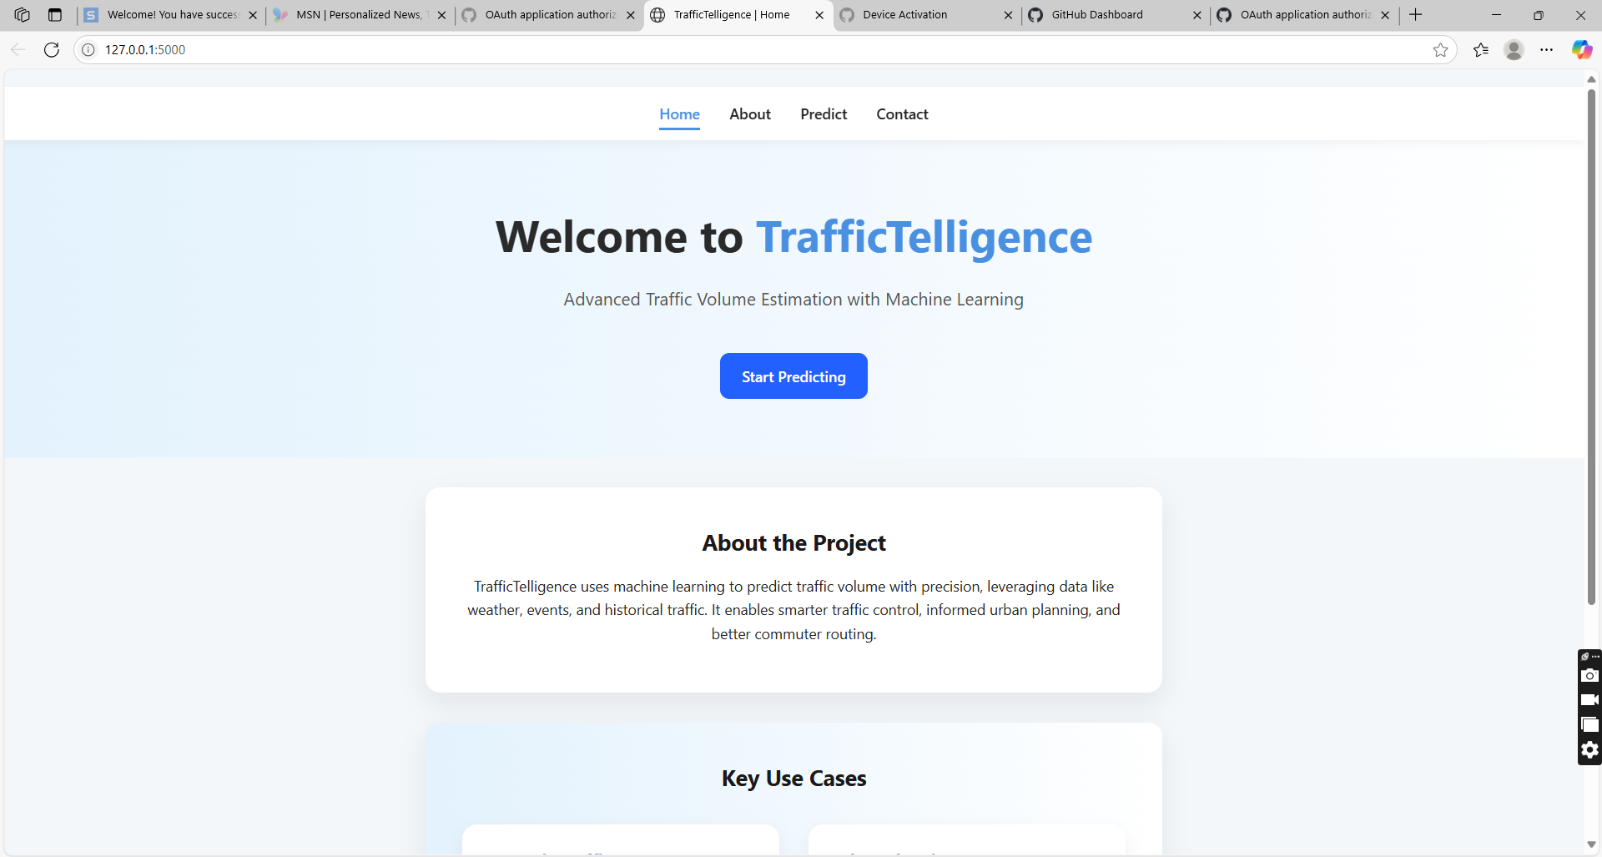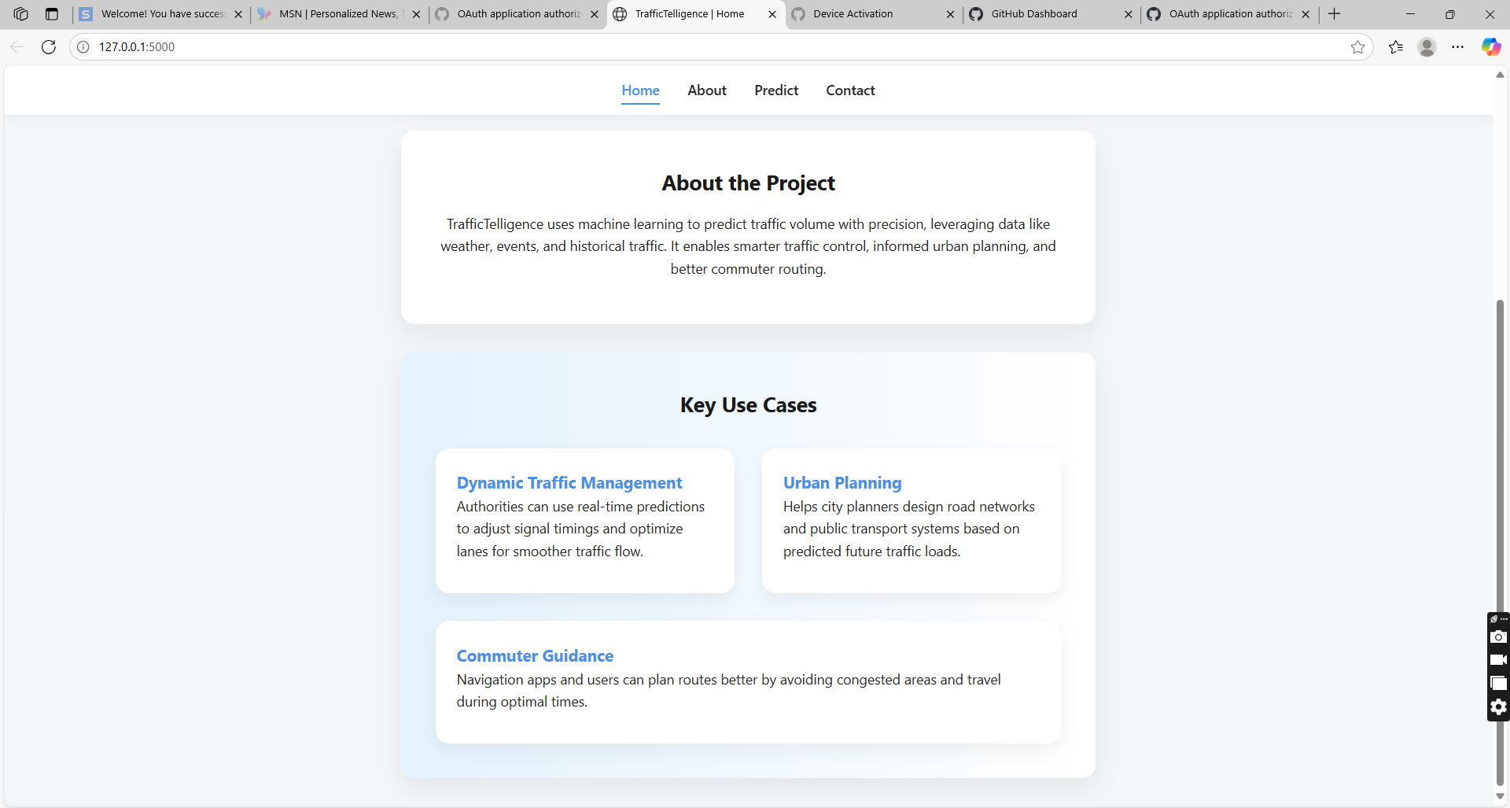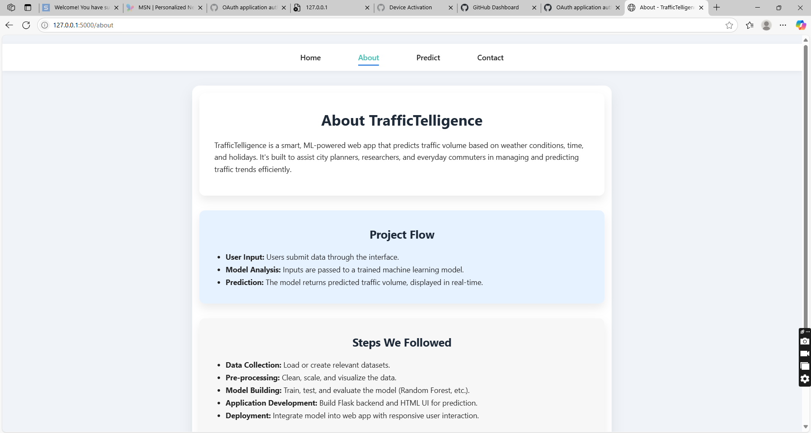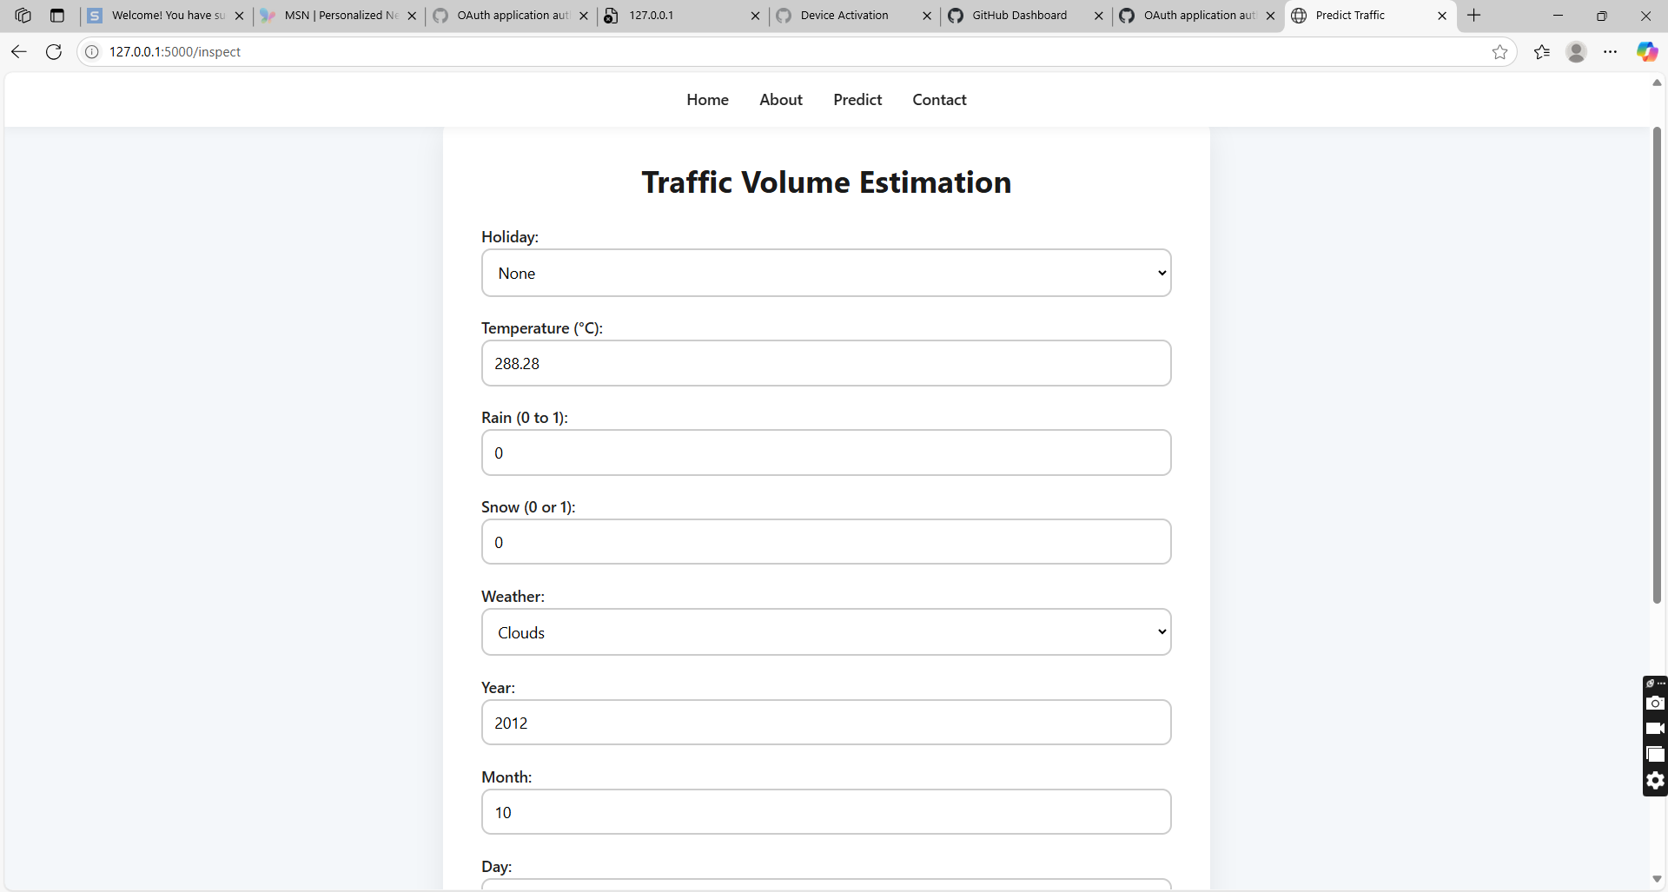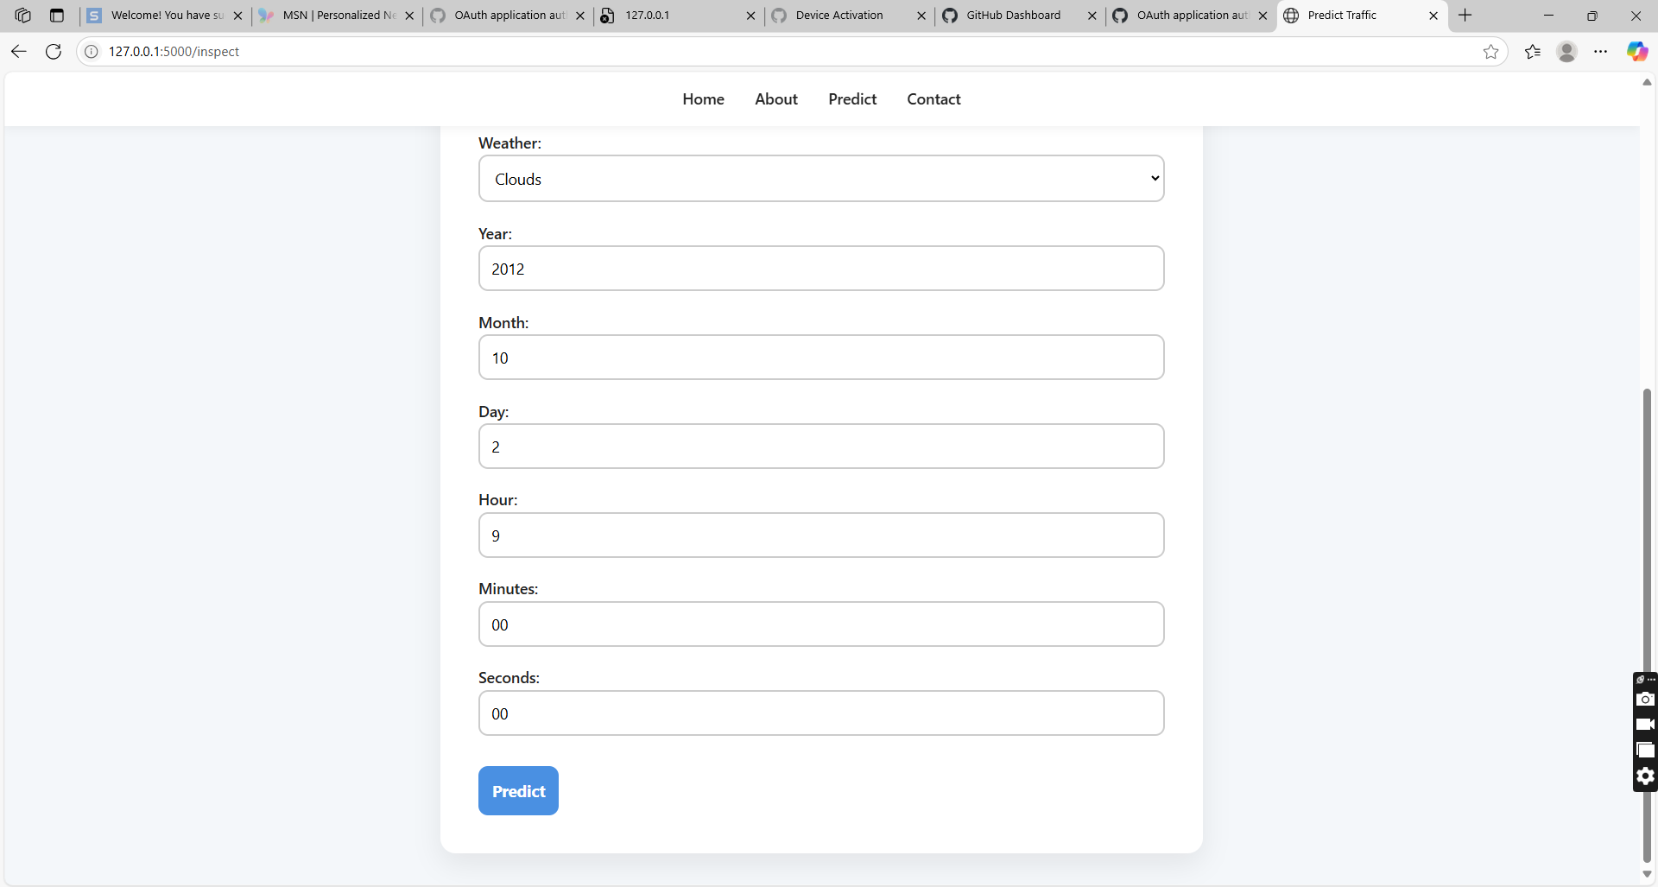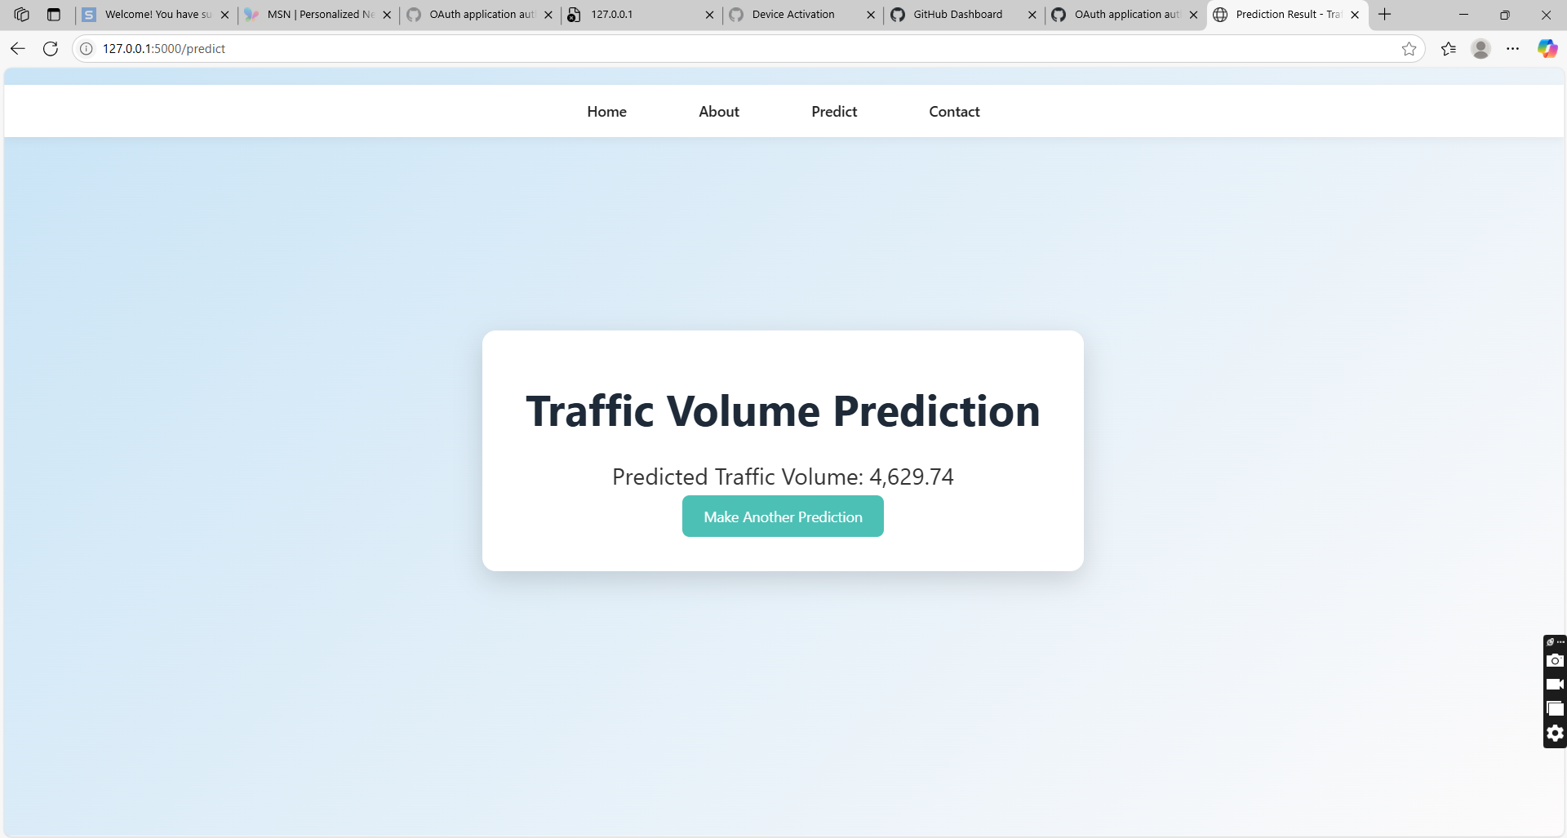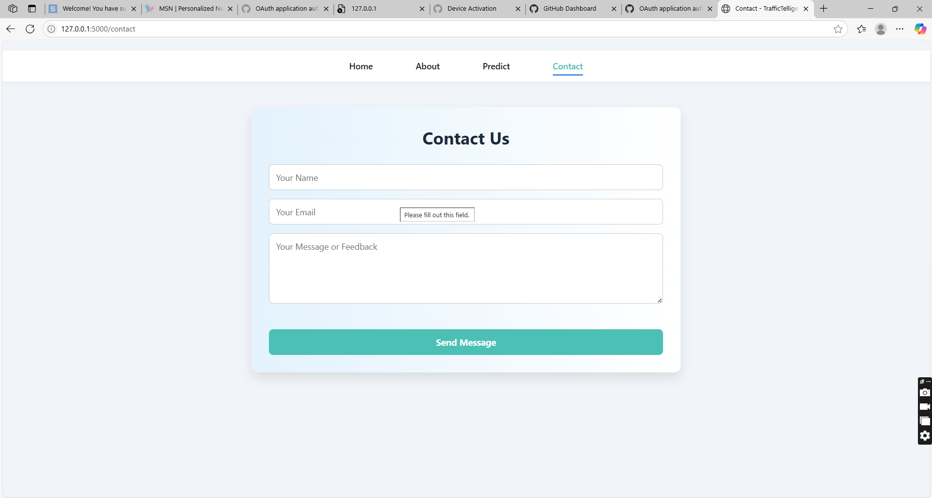

9. Future Enhancements
- Integrate live data feeds from traffic and weather APIs.
- Enhance UI with interactive charts and heatmaps.
- Improve model accuracy using deep learning or ensemble techniques.
- Add user login system and history tracking.
- Deploy on a public server or cloud for production usage.

10. Conclusion
TrafficTelligence is a successful integration of machine learning and web development for a real-world use case. It provides a robust and scalable solution to predict traffic volumes based on dynamic inputs. The modular code structure, ease of use, and open-source availability make it suitable for expansion into full-fledged traffic management systems in smart cities.

