DAA 7TH UNIT DETAILS
UNIT VII:
Branch and Bound: General method, applications - Travelling sales person problem,0/1 knapsack problem- LC Branch and Bound solution, FIFO Branch and Bound solution.

Important Questions for exam point of view:

- (a) Write FIFOBB algorithm for the 0/1 knapsack problem
(b) Explain the general method of Branch and Bound.

- Apply the Branch and Bound algorithm to solve the TSP, for the following cost matrix.

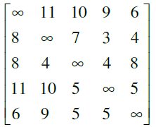

- (a) Explain how the traveling salesperson problem is solved by using LC Branch and Bound.
(b) Write the general algorithm for Branch and Bound.

- What is traveling sales person problem? Solve the following sales person problem instance using branch and bound.
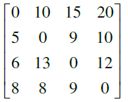
- (a) Draw the portion of the state space tree generated by FIFOBB using the variable tuple size for the knapsack instances, n = 5 (P1, P2, P5) = (10, 15, 6, 8, 4),
(w1, w2,..., w5) = (4, 6, 3, 4, 2) and M = 12.
(b) Write the control abstraction of LC search.

- a) What do you mean by bounding? Explain how these bound are useful in branch and bound methods.
b) Explain the principles of
i) FIFO branch and Bound
ii) LC Branch and Bound

7. a) Explain the method of reduction to solve TSP problem using Branch and Bound.
b) Explain the principles of FIFO Branch and Bound.

8. (a) Explain the principles of the following:
i) FIFO branch and Bound ii) LC Branch and Bound
(b)Draw the portion of the state space tree generated by LCBB for the knapsack instances: n=5, (P1, P2,… , P5) = (12,10,5,9,3), (w1, w2, ...,w5)=(3, 5, 2, 5, 3)
and M =12.
9. Explain the principles of
(a) Control Abstractions for LC – search
(b) Bounding
(c) FIFO branch and Bound
(d) LC Branch and Bound.

10. (a) Explain the following
(i) Control abstractions for LC – search (ii) Bounding
(b) Illustrate LCBB solution to solve the knapsack problem.

11. (a) Differentiate between Dynamic Knapsack and Branch and Bound Knapsack problem.
(b) Draw the portion of the state space tree generated by FIFOBB for the knapsack
instances: n=5, (P1, P2,… , P5) = (12,10,5,9,3), (w1, w2, ...,w5)=(3, 5, 2, 5, 3)
and M =12.
UNIT-VII
Branch & Bound
Branch & Bound (B & B) is general algorithm (or Systematic method) for finding optimal solution of various optimization problems, especially in discrete and combinatorial optimization.
- The B&B strategy is very similar to backtracking in that a state space tree is used to solve a problem.
- The differences are that the B&B method
  - Does not limit us to any particular way of traversing the tree.
  - It is used only for optimization problem
  - It is applicable to a wide variety of discrete combinatorial problem.
- B&B is rather general optimization technique that applies where the greedy method & dynamic programming fail.
- It is much slower, indeed (truly), it often (rapidly) leads to exponential time complexities in the worst case.
- The term B&B refers to all state space search methods in which all children of the “E-node” are generated before any other “live node” can become the “E-node”
  - Live node→ is a node that has been generated but whose children have not yet been generated.
  - E-node→is a live node whose children are currently being explored.
  - Dead node→ is a generated node that is not to be expanded or explored any further. All children of a dead node have already been expanded.
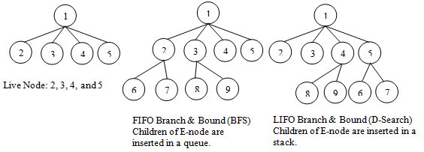
- Two graph search strategies, BFS & D-search (DFS) in which the exploration of a new node cannot begin until the node currently being explored is fully explored.
- Both BFS & D-search (DFS) generalized to B&B strategies.
  - BFS→like state space search will be called FIFO (First In First Out) search as the list of live nodes is “First-in-first-out” list (or queue).
  - D-search (DFS)→ Like state space search will be called LIFO (Last In First Out) search as the list of live nodes is a “last-in-first-out” list (or stack).
- In backtracking, bounding function are used to help avoid the generation of sub-trees that do not contain an answer node.
- We will use 3-types of search strategies in branch and bound
  - FIFO (First In First Out) search
  - LIFO (Last In First Out) search
  - LC (Least Count) search

FIFO B&B:
FIFO Branch & Bound is a BFS.
In this, children of E-Node (or Live nodes) are inserted in a queue.
Implementation of list of live nodes as a queue
  - Least()→ Removes the head of the Queue
  - Add()→ Adds the node to the end of the Queue
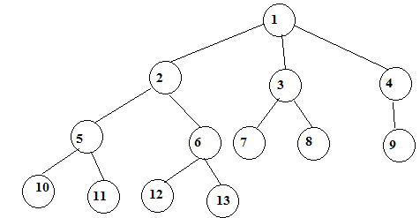

Assume that node ‘12’ is an answer node in FIFO search, 1st we take E-node has ‘1’
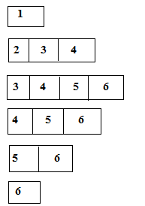

LIFO B&B:
LIFO Brach & Bound is a D-search (or DFS).
In this children of E-node (live nodes) are inserted in a stack
Implementation of List of live nodes as a stack
- Least()→ Removes the top of the stack
- ADD()→Adds the node to the top of the stack.
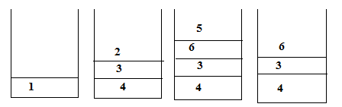
Least Cost (LC) Search:
The selection rule for the next E-node in FIFO or LIFO branch and bound is sometimes “blind”. i.e., the selection rule does not give any preference to a node that has a very good chance of getting the search to an answer node quickly.

The search for an answer node can often be speeded by using an “intelligent” ranking function. It is also called an approximate cost function “Ĉ”.
Expended node (E-node) is the live node with the best Ĉ value.
Branching: A set of solutions, which is represented by a node, can be partitioned into mutually (jointly or commonly) exclusive (special) sets. Each subset in the partition is represented by a child of the original node.
Lower bounding: An algorithm is available for calculating a lower bound on the cost of any solution in a given subset.

Each node X in the search tree is associated with a cost: Ĉ(X)
C=cost of reaching the current node, X(E-node) form the root + The cost of reaching an answer node form X.
Ĉ=g(X)+H(X).

Example:
8-puzzle
Cost function: Ĉ = g(x) +h(x)
where h(x) = the number of misplaced tiles
and g(x) = the number of moves so far
Assumption: move one tile in any direction cost 1.

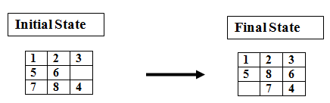
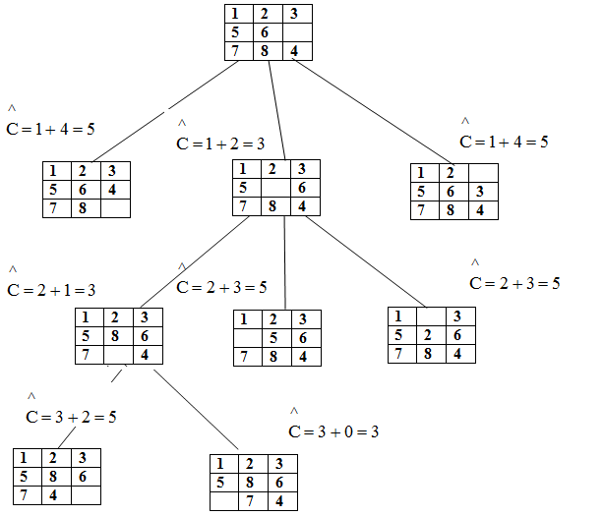

Note: In case of tie, choose the leftmost node.
Travelling Salesman Problem:
Def:- Find a tour of minimum cost starting from a node S going through other nodes only once and returning to the starting point S.
Time Conmlexity of TSP for Dynamic Programming algorithm is O(n²2^{n})
B&B algorithms for this problem, the worest case complexity will not be any better than O(n²2^{n}) but good bunding functions will enables these B&B algorithms to solve some problem instances in much less time than required by the dynamic programming alogrithm.
Let G=(V,E) be a directed graph defining an instances of TSP.
Let C_{ij}→ cost of edge <i, j>
C_{ij} =∞ if <i, j> ∉ E
|V|=n→ total number of vertices.
Assume that every tour starts & ends at vertex 1.
Solution Space S= {1, Π , 1 / Π is a permutation of (2, 3. 4. ----n) } then |S|=(n-1)!
The size of S reduced by restricting S
Sothat (1, i₁,i2,-----i_{n-1}, 1}∈ S iff <i_{j}, i_{j+1}>∈ E. O≤j≤n-1, i₀-i_{n}=1
S can be organized into “State space tree”.
Consider the following Example
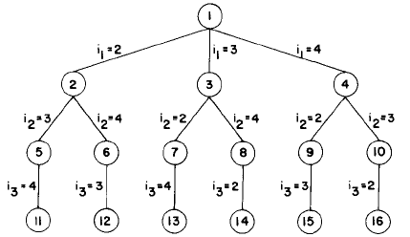
State space tree for the travelling salesperson problem with n=4 and i₀=i₄=1

The above diagram shows tree organization of a complete graph with |V|=4.
Each leaf node ‘L’ is a solution node and represents the tour defined by the path from the root to L.

Node 12 represents the tour.
i₀=1, i₁=2, i₂=4, i₃=3, i₄=1

Node 14 represents the tour.
i₀=1, i₁=3, i₂=4, i₃=2, i₄=1.
TSP is solved by using LC Branch & Bound:
To use LCBB to search the travelling salesperson “State space tree” first define a cost function C(.) and other 2 functions Ĉ(.) & u(.)
1
Such that Ĉ(r) ≤ C(r) ≤ u(r) → for all nodes r.
Cost C(.)→ is the solution node with least C(.) corresponds to a shortest tour in G.

C(A)={Length of tour defined by the path from root to A if A is leaf
Cost of a minimum-cost leaf in the sub-tree A, if A is not leaf }
1
From Ĉ(r) ≤ C(r) then Ĉ(r) → is the length of the path defined at node A.
From previous example the path defined at node 6 is i₀, i₁, i₂=1, 2, 4 & it consists edge of <1,2> & <2,4>
Abetter Ĉ(r) can be obtained by using the reduced cost matrix corresponding to G.
- A row (column) is said to be reduced iff it contains at least one zero & remaining entries are non negative.
- A matrix is reduced iff every row & column is reduced.

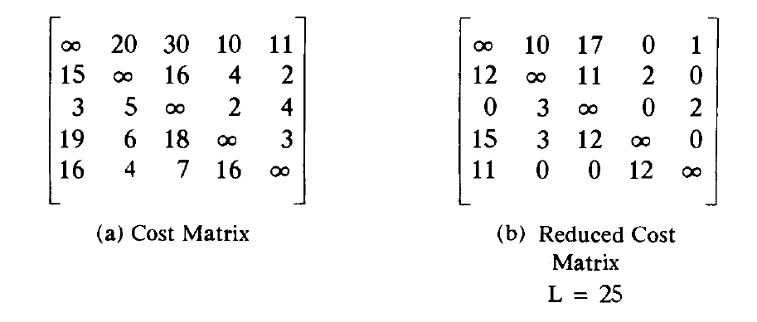
Given the following cost matrix:
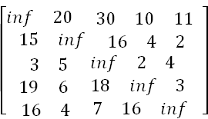

- The TSP starts from node 1: Node 1
  - Reduced Matrix: To get the lower bound of the path starting at node 1
Row # 1: reduce by 10 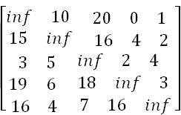 | Row #2: reduce 2  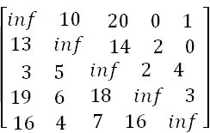 | Row #3: reduce by 2  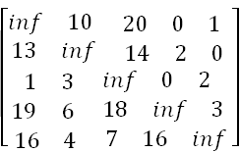
Row # 4: Reduce by 3:  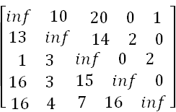 | Row # 5: Reduce by 4  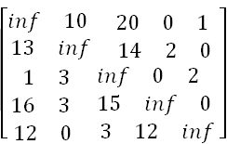 | Column 1: Reduce by 1  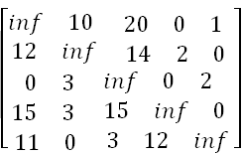
Column 2: It is reduced. | Column 3: Reduce by 3  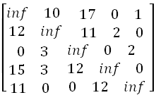 | Column 4: It is reduced.  Column 5: It is reduced.

The reduced cost is: RCL = 25
So the cost of node 1 is: Cost (1) = 25
The reduced matrix is:
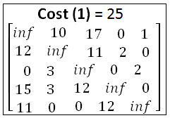

- Choose to go to vertex 2: Node 2
- Cost of edge <1,2> is: A(1,2) = 10
- Set row #1 = inf since we are choosing edge <1,2>
- Set column # 2 = inf since we are choosing edge <1,2>
- Set A(2,1) = inf
- The resulting cost matrix is:
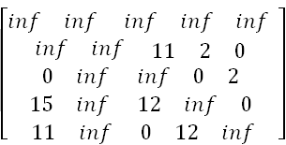
- The matrix is reduced:
- RCL = 0
- The cost of node 2 (Considering vertex 2 from vertex 1) is:
Cost(2) = cost(1) + A(1,2) = 25 + 10 = 35

- Choose to go to vertex 3: Node 3
- Cost of edge <1,3> is: A(1,3) = 17 (In the reduced matrix
- Set row #1 = inf since we are starting from node 1
- Set column # 3 = inf since we are choosing edge <1,3>
- Set A(3,1) = inf
- The resulting cost matrix is:
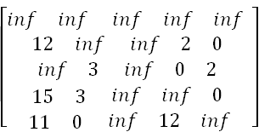

Reduce the matrix: Rows are reduced
The columns are reduced except for column # 1:
Reduce column 1 by 11:
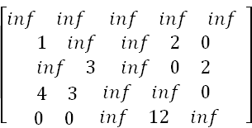
The lower bound is: RCL = 11
The cost of going through node 3 is:
cost(3) = cost(1) + RCL + A(1,3) = 25 + 11 + 17 = 53

- Choose to go to vertex 4: Node 4
Remember that the cost matrix is the one that was reduced at the starting vertex 1
Cost of edge <1,4> is: A(1,4) = 0
Set row #1 = inf since we are starting from node 1
Set column # 4 = inf since we are choosing edge <1,4>
Set A(4,1) = inf
The resulting cost matrix is:
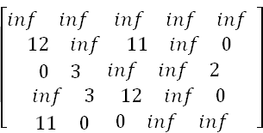

Reduce the matrix: Rows are reduced
Columns are reduced
The lower bound is: RCL = 0
The cost of going through node 4 is:
cost(4) = cost(1) + RCL + A(1,4) = 25 + 0 + 0 = 25

- Choose to go to vertex 5: Node 5
- Remember that the cost matrix is the one that was reduced at starting vertex 1
- Cost of edge <1,5> is: A(1,5) = 1
- Set row #1 = inf since we are starting from node 1
- Set column # 5 = inf since we are choosing edge <1,5>
- Set A(5,1) = inf
- The resulting cost matrix is:
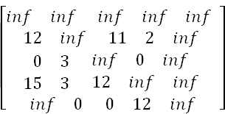

Reduce the matrix:
Reduce rows:
Reduce row #2: Reduce by 2
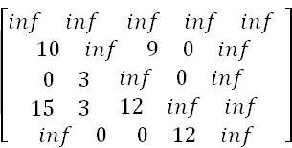

Reduce row #4: Reduce by 3
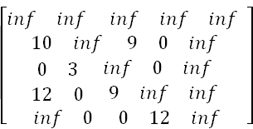
Columns are reduced
The lower bound is: RCL = 2 + 3 = 5
The cost of going through node 5 is:
cost(5) = cost(1) + RCL + A(1,5) = 25 + 5 + 1 = 31

In summary:
So the live nodes we have so far are:
    - 2: cost(2) = 35, path: 1->2
    - 3: cost(3) = 53, path: 1->3
    - 4: cost(4) = 25, path: 1->4
    - 5: cost(5) = 31, path: 1->5
Explore the node with the lowest cost: Node 4 has a cost of 25
Vertices to be explored from node 4: 2, 3, and 5
Now we are starting from the cost matrix at node 4 is:
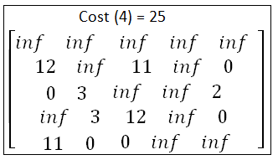
- Choose to go to vertex 2: Node 6 (path is 1->4->2)
Cost of edge <4,2> is: A(4,2) = 3
Set row #4 = inf since we are considering edge <4,2>
Set column # 2 = inf since we are considering edge <4,2>
Set A(2,1) = inf
The resulting cost matrix is:
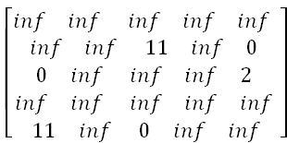

Reduce the matrix: Rows are reduced
Columns are reduced
The lower bound is: RCL = 0
The cost of going through node 2 is:
cost(6) = cost(4) + RCL + A(4,2) = 25 + 0 + 3 = 28

- Choose to go to vertex 3: Node 7 ( path is 1->4->3 )
Cost of edge <4,3> is: A(4,3) = 12
Set row #4 = inf since we are considering edge <4,3>
Set column # 3 = inf since we are considering edge <4,3>
Set A(3,1) = inf
The resulting cost matrix is:
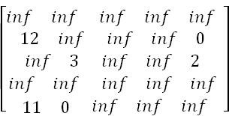

Reduce the matrix:
Reduce row #3: by 2:
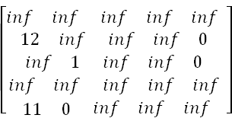
Reduce column # 1: by 11
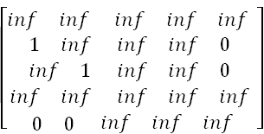
The lower bound is: RCL = 13
So the RCL of node 7 (Considering vertex 3 from vertex 4) is:
Cost(7) = cost(4) + RCL + A(4,3) = 25 + 13 + 12 = 50

- Choose to go to vertex 5: Node 8 ( path is 1->4->5 )
Cost of edge <4,5> is: A(4,5) = 0
Set row #4 = inf since we are considering edge <4,5>
Set column # 5 = inf since we are considering edge <4,5>
Set A(5,1) = inf
The resulting cost matrix is:
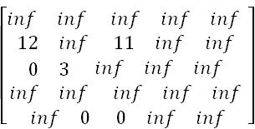

Reduce the matrix:
Reduced row 2: by 11
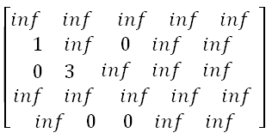
Columns are reduced
The lower bound is: RCL = 11
So the cost of node 8 (Considering vertex 5 from vertex 4) is:
Cost(8) = cost(4) + RCL + A(4,5) = 25 + 11 + 0 = 36

In summary: So the live nodes we have so far are:
    - 2: cost(2) = 35, path: 1->2
    - 3: cost(3) = 53, path: 1->3
    - 5: cost(5) = 31, path: 1->5
    - 6: cost(6) = 28, path: 1->4->2
    - 7: cost(7) = 50, path: 1->4->3
    - 8: cost(8) = 36, path: 1->4->5
  - Explore the node with the lowest cost: Node 6 has a cost of 28
  - Vertices to be explored from node 6: 3 and 5
  - Now we are starting from the cost matrix at node 6 is: 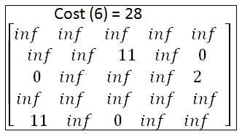

- Choose to go to vertex 3: Node 9 ( path is 1->4->2->3 )
Cost of edge <2,3> is: A(2,3) = 11
Set row #2 = inf since we are considering edge <2,3>
Set column # 3 = inf since we are considering edge <2,3>
Set A(3,1) = inf
The resulting cost matrix is:
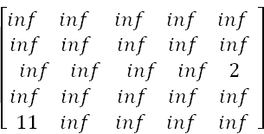

Reduce the matrix: Reduce row #3: by 2
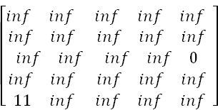
Reduce column # 1: by 11
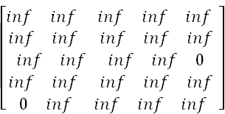
The lower bound is: RCL = 2 +11 = 13
So the cost of node 9 (Considering vertex 3 from vertex 2) is:
Cost(9) = cost(6) + RCL + A(2,3) = 28 + 13 + 11 = 52

  - Choose to go to vertex 5: Node 10 ( path is 1->4->2->5 )
Cost of edge <2,5> is: A(2,5) = 0
Set row #2 = inf since we are considering edge <2,3>
Set column # 3 = inf since we are considering edge <2,3>
Set A(5,1) = inf
The resulting cost matrix is:
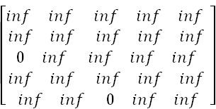
Reduce the matrix: Rows reduced
Columns reduced
The lower bound is: RCL = 0
So the cost of node 10 (Considering vertex 5 from vertex 2) is:
Cost(10) = cost(6) + RCL + A(2,3) = 28 + 0 + 0 = 28

In summary: So the live nodes we have so far are:
    - 2: cost(2) = 35, path: 1->2
    - 3: cost(3) = 53, path: 1->3
    - 5: cost(5) = 31, path: 1->5
    - 7: cost(7) = 50, path: 1->4->3
    - 8: cost(8) = 36, path: 1->4->5
    - 9: cost(9) = 52, path: 1->4->2->3
    - 10: cost(2) = 28, path: 1->4->2->5
- Explore the node with the lowest cost: Node 10 has a cost of 28
- Vertices to be explored from node 10: 3
- Now we are starting from the cost matrix at node 10 is:
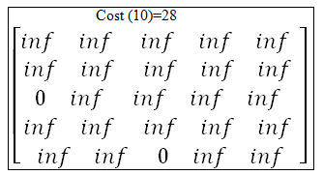

- Choose to go to vertex 3: Node 11 ( path is 1->4->2->5->3 )
Cost of edge <5,3> is: A(5,3) = 0
Set row #5 = inf since we are considering edge <5,3>
Set column # 3 = inf since we are considering edge <5,3>
Set A(3,1) = inf
The resulting cost matrix is:
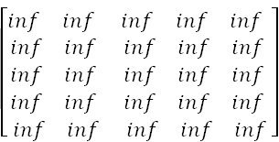

Reduce the matrix: Rows reduced
Columns reduced
The lower bound is: RCL = 0
So the cost of node 11 (Considering vertex 5 from vertex 3) is:
Cost(11) = cost(10) + RCL + A(5,3) = 28 + 0 + 0 = 28

State Space Tree:
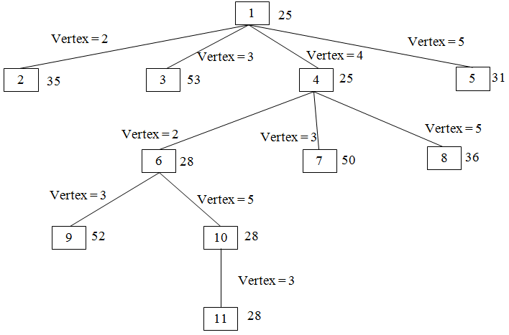
O/1 Knapsack Problem

What is Knapsack Problem: Knapsack problem is a problem in combinatorial optimization, Given a set of items, each with a mass & a value, determine the number of each item to include in a collection so that the total weight is less than or equal to a given limit & the total value is as large as possible.
O-1 Knapsack Problem can formulate as. Let there be n items, Z₁ to Z_{n} where Z_{i} has value P_{i} & weight w_{i}. The maximum weight that can carry in the bag is m.
All values and weights are non negative.
Maximize the sum of the values of the items in the knapsack, so that sum of the weights must be less than the knapsack’s capacity m.
The formula can be stated as
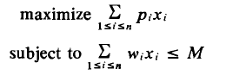
X_{i}=0 or 1 1 ≤ i ≤ n

To solve o/1 knapsack problem using B&B:
- Knapsack is a maximization problem
    - Replace the objective function by the function 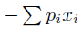to make it into a minimization problem
    - The modified knapsack problem is stated as
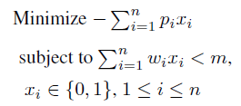
- Fixed tuple size solution space:
  - Every leaf node in state space tree represents an answer for which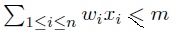 is an answer node; other leaf nodes are infeasible
  - For optimal solution, define
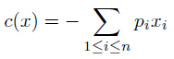 for every answer node x

- For infeasible leaf nodes,
- For non leaf nodes
c(x) = min{c(lchild(x)), c(rchild(x))}

- Define two functions cˆ(x) and u(x) such that for every node x,
cˆ(x) ≤ c(x) ≤ u(x)
- Computing cˆ(·) and u(·)

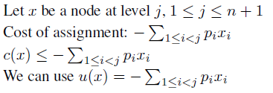

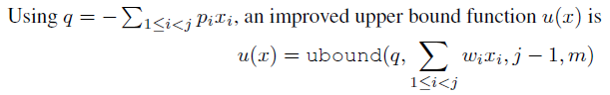

Algorithm ubound ( cp, cw, k, m )
{
// Input: cp: Current profit total
// Input: cw: Current weight total
// Input: k: Index of last removed item
// Input: m: Knapsack capacity
b=cp; c=cw;
for i:=k+1 to n do{
if(c+w[i] ≤ m) then {
c:=c+w[i]; b=b-p[i];
}
}
return b;
}

