Lab Report #1

Navigation and Intelligent Vehicles

Deniz Alp ATUN – 0552182 – [deniz.alp.atun@vub.be](mailto:deniz.alp.atun@vub.be)  
Siddheswar MUKHERJEE – 0554647 – [siddheswar.mukherjee@vub.be](mailto:siddheswar.mukherjee@vub.be)

Table of Contents

1 What Is Kalman Filter and How It Works? 1

2 Influence of Parameters to Kalman Filter Results 2

2.1 R and Filter Results 2

2.2 Q and Filter Results 3

2.3 P0 and Filter Results 3

2.4 Kalman Gain and What Information It Provides 3

3 Importance of ISE, MSE and Filter Covariance and Gain 4

# What Is Kalman Filter and How It Works?

Kalman Filter is a series of recursive operations that allows us to estimate a time dependent state which cannot be directly measured. This is done in two steps of equations; first one being **prediction equations** and second one being **correction equations**. In prediction equations, the initial value is used to estimate what next value is going to be called “a priori estimate”. After the prediction, second set of equations are used to correct the prediction with measurements resulting in a “a posteriori estimate”.

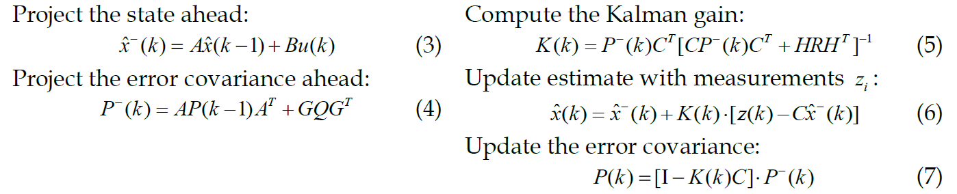

Figure 1 (3)-(4) are prediction equations (time update), (5) to (6) are correction equations (measurement update)  
These equations are provided in the lab pdf.

The measurements used to correct are stated as z(k), they provide some insight about whether our estimation is correct or not. In measurement model equation *z(k) = Cx(k)+Hv(k)* we can see that it is related to x(k) that is being predicted.

Since measurements and state to predict comes from real world, there exists noise that comes from observation. Kalman filter’s correction part takes this error into account and uses Gaussian Distribution as an assumed error in correction part.

# Influence of Parameters to Kalman Filter Results

Before delving further in the influence of Parameters, below is the reference image for values  
R = 0.01 , Q = 10-5, P0 = 0.01, x^0 = 0

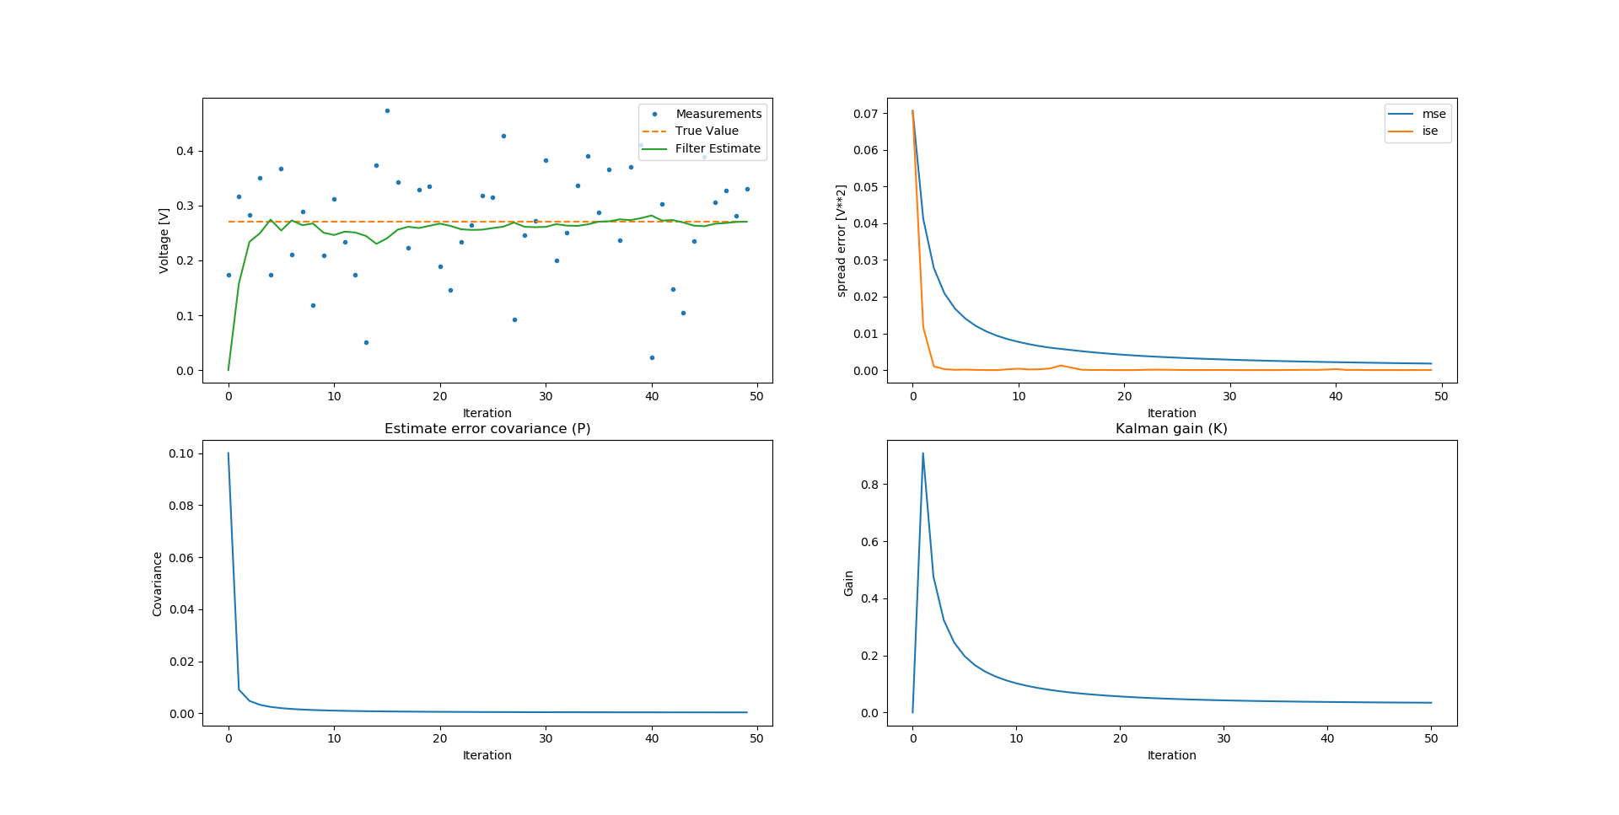

## R and Filter Results

R stands for measurement noise variance. Without using the python code, if measurements noise varies in a wide spectrum then it will make measurements less reliable for prediction. Thus we can assume if R increases, Kalman Filter will trust the given measurements less.

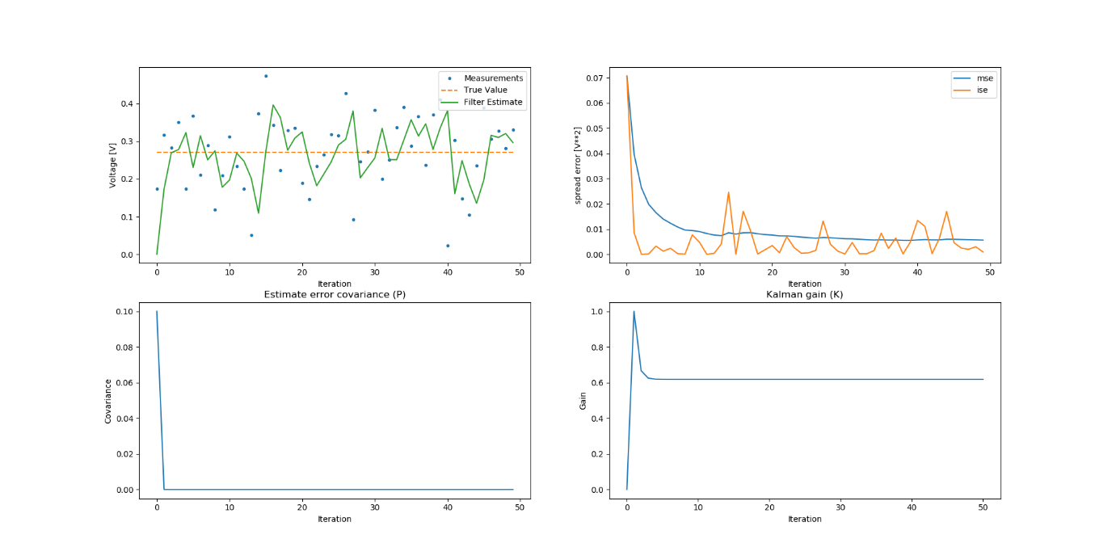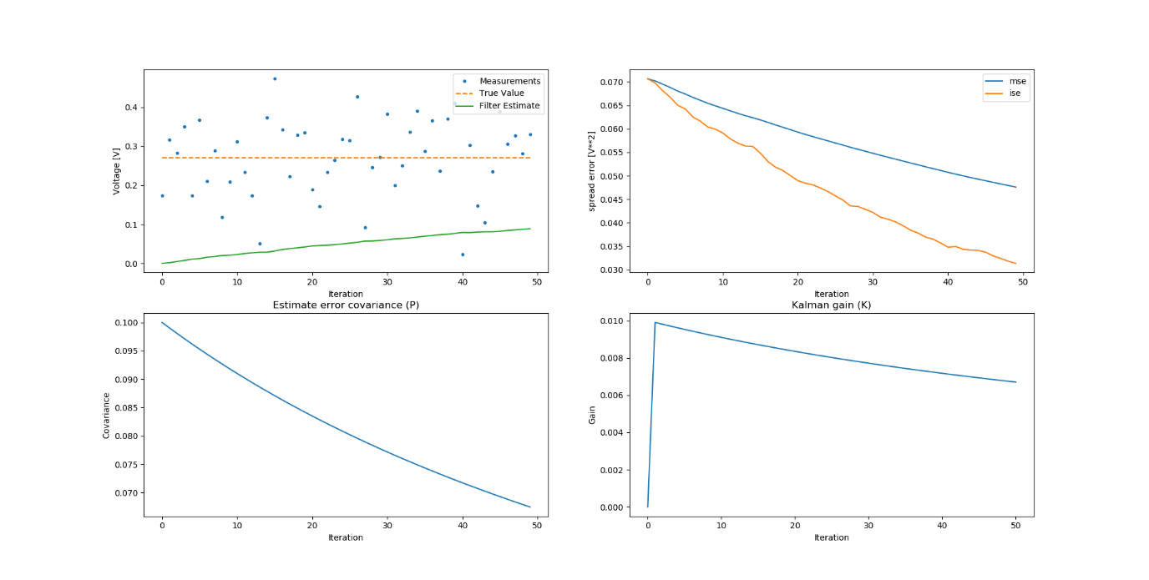

Figure 2 R increased

Figure 3 R decreased

The above statement holds true as below are observations from python code.  
Increase of R indicates that filters trust to the given measurements are weighted less. This causes the resulting graph to be more linear.  
Decrease of R indicates that the filters trust to the given measurements are weighted more. This causes the resulting graph to have spikes towards the measurements.

## Q and Filter Results

Q stands for process noise variance. Compared to R; it should be the opposite as process becomes noisy the results we obtain from the process will become less reliable. This in return causes the Kalman Filter to trust the measurements more and vice versa.

( Figures can be found in the attachment: Qdec1000 and Qinc1000)

Below is the confirmation of above hypothesis by changing values in python.  
Decrease of Q indicates that filters trust to the given measurements are weighted less. This causes the resulting graph to be more linear.  
Increase of Q indicates that the filters trust to the given measurements are weighted more. This causes the resulting graph to have spikes towards the measurements.

## P0 and Filter Results

Decrease of P0 indicates that filters trust to the given measurements are weighted less. This causes the resulting graph to be more linear.  
Increase of P0 indicates that the filters trust to the given measurements are weighted more. This causes the resulting graph to have spikes towards the measurements.

( Figures can be found in the attachment: P0is001, P0is1 and P0is0)

From testing; the boundary values are 0.1 and 0. Even if value 1 changes the results, the change on graph is very small and almost identical to 0.1. On the other hand, 0 as expected breaks the function of Kalman Filter and yields a result that is not close to the true value.

The reason for that is P0 is our initial prediction value. The closer our prediction is, the less work Kalman Filter has to do. That is why 0.1 and above do not effect the results that much since our initial value is 0.26578.

This brings up the question, since 1 and 0 are almost equally distant from 0.1 why setting P0 does not give error such as 0? The reason is 0 essentially removes equations (5) and (7), where values between 0 and 0.1 create more work for Kalman Filter to make correct estimations and values between 0.1 and above are corrected after first pass.

## Kalman Gain and What Information It Provides

Kalman gain is essential in correction steps, what it does is that it reduces the weight of an estimation for correcting purposes. The graph of Kalman Gain starts from 1 (if 0 is initial value for the list then 0) and reduces itself over iterations.

If limit of Kalman Gain is approaching 0, then it means that our results have lesser errors and we are reaching to a true value.

This also shows that if Kalman Gain does not approach 0; then Kalman Filter is trusting measurements more than the estimations.

# Importance of ISE, MSE and Filter Covariance and Gain

ISE indicates whether the Filter Result is weighted on measurements or not. When it is weighted on measurements, ISE graph is having a spiky result. The reason is that ISE measures the difference between estimation and real result, as Kalman Filter exists to create a balance between estimation and measurements when measurements are weighted and incorrect it causes sudden spikes.

MSE on the other hand calculates the difference between true value and estimation with history taken into account. Thus if the collection of estimations are closer to the collection of true values, the graph should give concave up decreasing curve.  
Difference in depth of concavity indicates if the difference is being reduced in a higher rate or not.

Filter Covariance indicates the quality of estimation, as it approaches to zero it means that the estimation is getting better and error between iterations is decreasing.  
The quality of estimation is not equivalent to accuracy of estimation, as we can observe from all the figures generated for header [2] most of the figures have a very sharp concave up decreasing curve. This means that our estimation procedure is working correctly and at every iteration the error is decreasing.

Kalman Gain is another important indicator where unlike covariance it indicates accuracy of estimation. As stated in the previous header [2], when Kalman Gain graph is approaching zero (concave up decreasing curve) it means that filter is reaching the true value.  
Another indicator is the curvature of curve. As curvature increases, the speed to estimate true value decreases.

One thing to note is ISE, MSE, Filter Covariance and Kalman Gain graphs/results only give a partial perspective of whether or not Filter Estimation is correct or not. Combining these partial results allows us to understand what part of the Filter Estimation is failing and why.