AI-FIRST
Transforming Horizon BCBS
Into a Predictive, Self-Healing, AI-Driven Enterprise

Submitted by:  IBM Consulting  Healthcare & Payer Delivery — ADMS Practice  Submitted to:  Horizon Blue Cross Blue Shield of New Jersey  Executive Leadership & Technology Office | Document Classification:  CONFIDENTIAL  Date:  April 2026  Reference:  IBM-HZN-AMS-RFP-2026-CAS

Powered by IBM AIOps · IBM Consulting Advantage · HIPAA Compliant · © 2026 IBM Corporation

Executive Summary
A Strategic Proposal for AI-Led Transformation of Application Management Services
"IBM is not proposing a technology project — IBM is proposing a transformation partnership that embeds AI-driven intelligence into the operating model of Horizon BCBS, enabling a future-ready enterprise that is faster, smarter, and more resilient than today."

The Moment  Horizon BCBS stands at a pivotal inflection point. With approximately 500 applications spanning enrollment, claims adjudication, member services, and data platforms, the organization faces mounting pressure to modernize operations, reduce administrative burden, and deliver measurably better member and provider experiences.  IBM proposes to shift from reactive, labor-intensive, and fragmented across towers to meet Horizon's growth objectives or competitive imperatives.  What IBM Proposes  IBM proposes a structured transition from reactive application support to a predictive, self-healing, and continuously improving AI-first operating model — delivered through IBM's proven Assets, Assistants, and Accelerators framework, and governed through an outcome-based accountability model.  Value Realization — What Will Be Monitored  Once live, CareOps360, specifically build and designed for Horizon, will surface real-time operational intelligence across all AMS towers through a single executive command center. The following metrics will be tracked and reported continuously to Horizon leadership:  - Active members under management and enrollment velocity  - Claims settled volume and adjudication cycle times  - Application availability and SLA attainment across 500+ applications  - Automation savings — YTD and cumulative cost avoidance  - Call Centre Average Speed of Answer and first-contact resolution  - Incident MTTR trends and AIOps-driven deflection rates  - Projected and realized annual AIOps savings versus committed baseline | Five Strategic Commitments  - AI-First Operating Model — AI embedded across every layer of AMS and QA lifecycle.  - Tech Arbitrage over Labor Arbitrage — Compressing cost through automation, not headcount.  - Outcome-Based Delivery — Committed SLAs tied to measurable business outcomes.  - Zero-Disruption Delivery — Risk-free phased transition protecting operational continuity.  - Continuous Innovation Engine — Horizon Transformation Office driving sustained value beyond steady state.  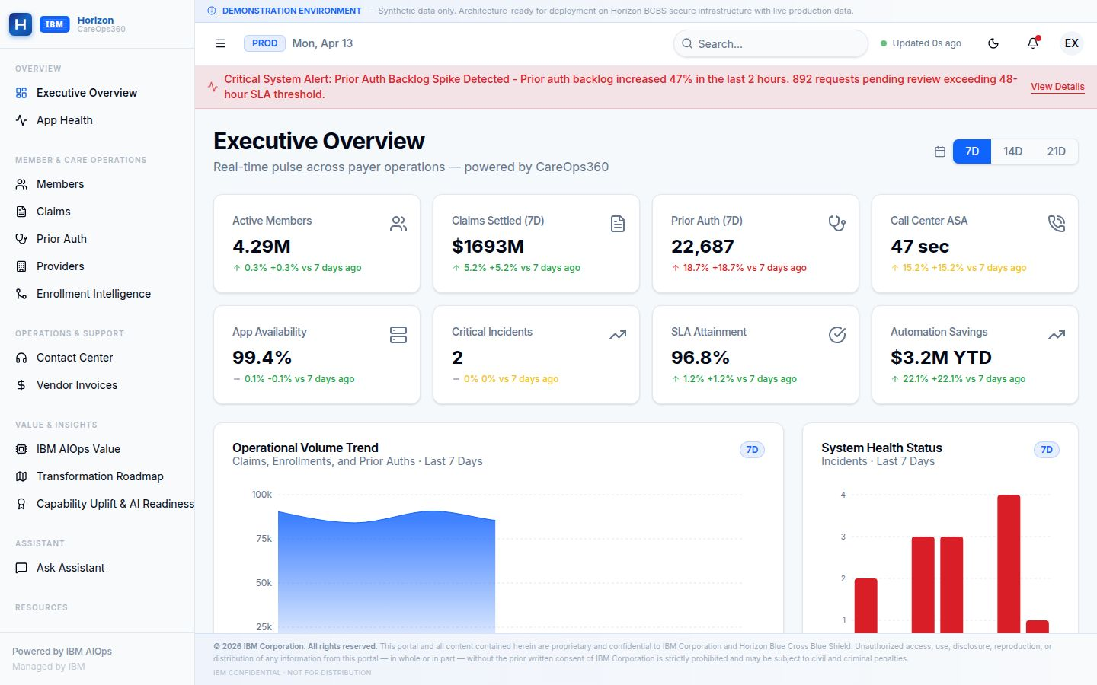  Figure 1: CareOps360 Executive Dashboard — platform overview (illustrative data shown; live metrics populated upon go-live)  All metrics will be baselined at contract commencement and tracked against IBM's committed outcome targets on a monthly governance cadence.
  IBM's Scale Behind This Proposal
  • 20,000+ AI & data practitioners globally
  • 81,000+ cloud & architecture experts
  • 40,000+ AI & analytics engagements
  • 15,000+ people across 40 global delivery centers
  • Leader in Enterprise Software Quality & Testing
  • Enterprise partnerships with AWS, Salesforce and IBM Technology
  • IBM’s client-0 success story which saved IBM ~3.4 B USD

The Transformation Imperative
Understanding Horizon's Strategic Objectives and IBM's Solution Design Rationale
What Horizon Needs  Horizon BCBS is seeking the right strategic partner to enhance and support its Application Development, Maintenance, Data, and Testing Services — with a clear focus on AI solutions and expertise native to the Horizon environment.  Service Transformation Goals  - High-quality services delivered through AI and automation to obtain operational efficiencies.  - Realization of a product-oriented operating model.  - Focused automation — especially in testing and quality engineering.  - AI tools to drive Agile application modernization across the portfolio.  - Consultative support applying deep healthcare payer best practices.  Cost Structure Expectations  Horizon expects structural cost reduction — not just efficiency gains. The fixed baseline model signals a clear expectation: year-over-year productivity improvements and cost takeout driven by automation and AI, not rate arbitrage. | Factors That Shaped IBM's Solution  - End-to-End Integrated Delivery: A unified operating model across Application Maintenance, Development, Testing, and Data — reducing fragmentation and improving accountability across the full lifecycle.  - AI at the Core: Not bolted on. AI is embedded in triage, root cause analysis, resolution, test automation, and continuous validation — from the first day of delivery.  - Transition Without Disruption: IBM's phased transition approach maintains seamless service continuity while progressively modernising the underlying operating model.  - Open, Elastic Architecture: Plug-and-play architecture allows IBM to deploy on Horizon's existing AWS stack or any cloud ecosystem — avoiding lock-in and enabling flexibility.
  IBM's solution shifts Horizon from reactive incident
  management to predictive, autonomous operations

Figure 1: Current vs. Target — Automation Coverage by Domain
Incident Triage |  | 45%
Test Execution |  |  | 38%
Root Cause Analysis |  |  | 22%
Change Risk Scoring |  |  | 18%
Deployment Validation |  |  | 15%
Estimated baseline automation coverage across AMS domains (current state). IBM's proposal targets 80%+ automation across all domains within 12 months.

CareOps360 Command Center
IBM's Executive Operations Platform for Real-Time AMS Visibility at Horizon
What Is CareOps360?  CareOps360 is IBM's production-grade executive operations platform purpose-built for the Horizon BCBS engagement. It delivers real-time operational intelligence across all AMS towers — enrollment, claims, applications, infrastructure, and quality — through a single, unified command centre accessible to Horizon's executive and operational leadership. The platform is architecture-ready for live production data and is currently deployed in a production-equivalent environment.  Built on IBM's AIOps observability framework, CareOps360 surfaces predictive insights, SLA performance, enrollment intelligence, digital front door metrics, and transformation roadmap progress — eliminating the need for manual reporting aggregation.  Dashboards Delivered  - Executive Overview — Cross-tower operational pulse with 8 real-time KPI tiles.  - Application Health — 500+ app inventory, incident register, availability trends.  - Claims Operations — Daily volume, adjudication queue, denial analytics.  - Prior Authorization — Backlog, review SLA, procedure-level approval rates.  - Enrollment Intelligence — AI-assisted intake, pipeline health, surge detection.  - Member Services — Contact centre, chatbot containment, digital adoption.  - IBM AIOps Value — Automation savings, shift-left rate, self-heal event tracking.  - Transformation Roadmap — 60-initiative portfolio with phase and risk status.  - Capability Uplift — Workforce certification, automation coverage, AI readiness. | Metrics Monitored via CareOps360  Figure 2: CareOps360 Executive Overview — eight operational KPIs spanning members, claims, prior auth, infrastructure, SLA, and automation savings. Platform shown in production-equivalent environment; metrics are illustrative.
  Metric Domain | What Will Be Tracked
  Application Ops | Availability, MTTR, incident volume by severity
  Claims | Volume, adjudication rate, TAT, denial drivers
  Prior Auth | Backlog, review SLA, auto-approval rate
  Enrollment | Time-to-good, auto-match rate, queue health
  Member Services | ASA, FCR, chatbot containment, digital adoption
  AIOps Value | Savings YTD, shift-left rate, self-heal events
  Transformation | Phase progress, milestone risk, initiative velocity
  Access & Security
  • Role-based access: IBM and Horizon executives
  • Token-authenticated sessions with inactivity timeout
  • HIPAA-compliant — no PHI data in the command center
  • Architecture-ready for production data integration

AIOps & Agentic AI Operations
From Reactive Incident Management to Autonomous, Self-Healing Operations
IBM's Agentic AI framework shifts Horizon from reactive incident handling to proactive, AI-driven real-time diagnosis and autonomous resolution

The Agentic AI Architecture  IBM's AIOps framework is built on a multi-agent architecture where specialised AI agents handle distinct responsibilities across the incident lifecycle — from detection through resolution and continuous learning.  Agent Roles  - Help Desk Agent: Delivers context-aware guidance and automated actions to help users auto-resolve issues before ticket creation.  - Triage Agent: Prioritises tickets based on impact, urgency, and historical patterns — eliminating manual queue management.  - Root Cause Analysis Agent: Correlates signals across 140+ monitoring sources to identify root cause within minutes.  - Resolution Agent: Suggests or executes remediation steps based on runbooks and past resolutions.  - Runbook Generation Agent: Auto-generates and updates runbooks from resolved incidents — compounding operational knowledge over time.  - Continuous Learning Agent: Feeds production telemetry back into all agents, ensuring progressive improvement with every incident cycle. | Value Realization  Built for Horizon's AWS Stack  - Agent Layer: AWS AgentCore & Bedrock  - Model Layer: AWS Bedrock with native Guardrails  - Vector Store: AWS OpenSearch + PostgreSQL  - Integrations: ServiceNow · Dynatrace · CloudWatch · OpenShift  - IBM ContextForge for institutional knowledge management
  Metric | With AIOps
  MTTR (Mean Time to Resolve) | < 1.8 hrs
  Alert Noise per Shift | > 60% Reduced
  P3/P4 Auto-Resolution | > 74%
  Change Failure Rate | 40% Reduction
  System Availability | 99.95%
  Ops Manual Triage Hours | ~30% Reduction
  ✓ Horizon’s ARB Approval Secured
  Architecture Review Board
  ✓ Horizon’s GenAI Board Approved

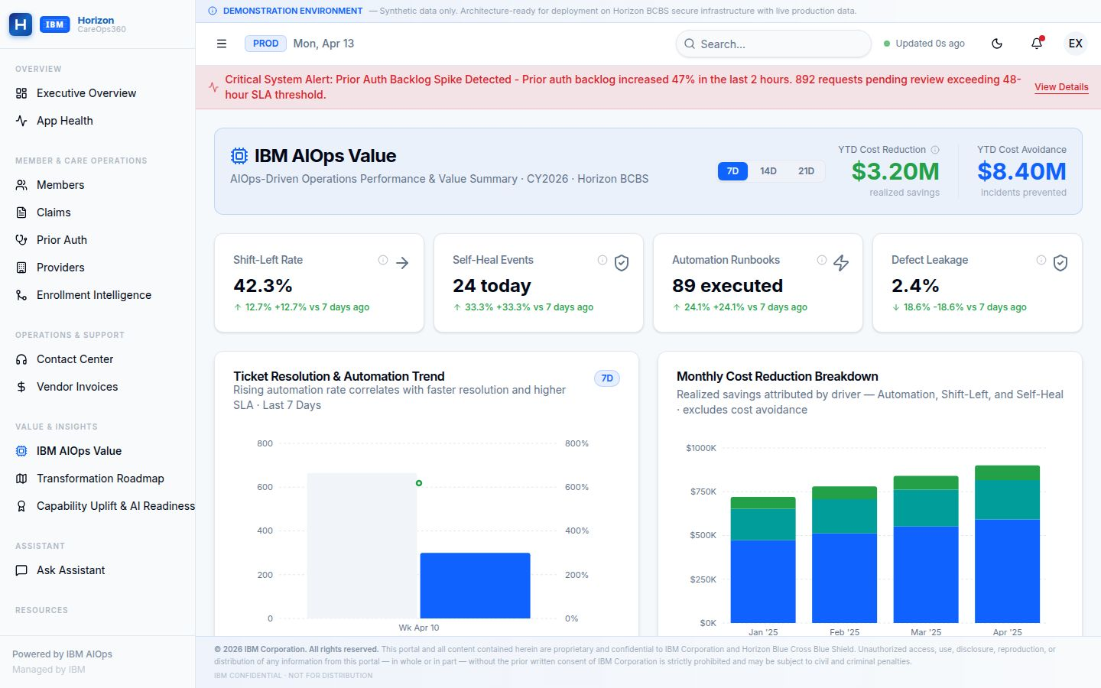
Figure 4: IBM AIOps Value Dashboard — automation savings, shift-left rate, self-heal events, and monthly cost reduction trend by driver. Metrics are illustrative; live values tracked upon go-live.
Platform Modernization
ICOE Modernization, Mainframe Migration & Application Rationalization
Integration Modernization  IBM's Integration Modernization program restructures IBM's delivery organization to align with Horizon's evolving platform landscape — introducing DevSecOps pipelines, product-centric engineering squads, and shared services for API management, identity, and data integration.  ICOE Deliverables  - Dedicated engineering squads aligned to Horizon product and platform domains.  - DevSecOps pipelines replacing manual release management processes.  - Integration Simplification roadmap — reducing point-to-point complexity.  - Document Generation Modernization (HLGS upgrade roadmap).  - Observability and SRE practices for proactive system health management.  Application Rationalization  IBM will conduct a structured assessment of Horizon's ~500 application portfolio using the Texture and other IBM assets and accelerators like ICCA— identifying candidates for decommission, consolidation, cloud migration, or AI-augmented modernization. | Mainframe Modernization Roadmap  Horizon's mainframe hosts critical batch processing, eligibility logic, and financial settlement. IBM's strategy executes phased migration preserving continuity:
  Workstream | Approach | Timeline
  Eligibility Processing | API-wrap → Cloud rehost | Q2–Q4 2026
  COBOL → Java Pilot | AI-assisted code conversion | Q3 2026
  Unified Payments | AWS modernization | Q3 2026
  Claims Engine | Parallel-run cutover | Q1–Q2 2027
  Member Data Services | Event-driven migration | Q4 2026+
  Technical Debt Governance
  • All stacks maintained to n-2 versions
  • Architecture Review Board (IBM + Horizon)
  • Rollback gates at every migration phase
  • Zero-disruption contractual commitment

~500  Applications Assessed | COBOL→Java  AI-Assisted Conversion | n-1  Stack Version Governance | Zero  Disruption Commitment

Quality Engineering & AI-Augmented Development
Measurable Quality at Every Milestone — Improved with Every Release
Self-Improving Quality Framework  IBM's Quality Engineering model embeds measurable validation checkpoints across every stage of development and production — creating a closed-loop feedback system within the CI/CD pipeline. Production insights, defect analytics, and automation metrics continuously refine testing strategies, enabling sustained defect reduction, faster recovery, and progressive quality improvement over time.  Quality Controls  - End-to-end traceability and release readiness visibility.  - Defect leakage, density, and stability metrics (MTTR).  - Automation coverage with KPI-driven governance.  - AI-driven defect insights and regression optimisation.  - Production telemetry feeding back into test strategy.  Intelligent Test Automation  IBM's Generative AI capabilities enable self-generating test cases, automated test maintenance, and continuous validation integration — dramatically reducing the cost and time associated with regression testing across Horizon's complex, multi-system portfolio. | AI-Augmented Development Model  IBM transforms Horizon's engineering model from a traditional project-centric approach to a modern, product-centric engineering organisation — powered by IBM Consulting Advantage accelerators and the BUILD ONCE, BENEFIT (BOB) framework of reusable enterprise assets.  AI-Assisted Development  - Generative AI tools accelerate code generation, review, documentation, and optimisation.  - Reduces developer toil and elevates focus to high-value engineering.  - IBM Consulting Advantage accelerators compress time-to-value.  DevSecOps Integration  - Security embedded "left" into CI/CD pipelines.  - Automated vulnerability scanning at every stage.  - Compliance gates and policy enforcement from commit to production.
  Target: 80% test automation coverage across
  Horizon's application portfolio within 12 months
  of full deployment.

Figure 5: Quality KPI Improvement Targets — 12-Month Programme
Test Automation Coverage |  | 80%
Defect Escape Rate Reduction |  |  | 65%
Regression Cycle Time Cut |  |  | 70%
Test Maintenance Effort Reduced |  |  | 55%
Production Incident Rate |  |  | 40%
IBM's quality engineering targets for Horizon's AMS portfolio at 12-month programme maturity.

Phased Transformation Roadmap
A Structured, Compounding Journey from Stabilization to Autonomous Operations
IBM's proposed transformation follows a structured, phased approach — delivering quick wins in the immediate term while building the foundation for long-term enterprise transformation. Each phase builds on the last, compounding value across the portfolio.

Phase 0 — Foundation  0–8 Weeks | Phase 1 — Ignite  1–3 Months | Phase 2 — Scale  3–6 Months | Phase 3 — Optimise  6–12 Months
› Command Center assessment & blueprint  › ICOE architecture definition  › Quote to Cart KPI alignment roadmap  › AIOps baseline measurement  › Risk-free transition planning | › Integration Simplification & ICOE Modernization Roadmap  › Document Generation modernization (HLGS)  › Initial AIOps and monitoring deployment  › Test automation framework initiation  › Innovation Council formation | › Unified Payments & Mainframe modernization  › COBOL → Java modernization pilot  › AI-assisted Dev + Intelligent QA rollout  › Digital Front Door Phase 2–3 delivery  › Agentic AI incident triage live | › Agentic AI for full incident autonomy  › Quote to Cart full production launch  › Claims adjudication parallel-run initiated  › GenAI development lifecycle integrated  › Predictive capacity management live

Phase 4 — Transform (12–24 Months)  - Full autonomous operations for P3/P4 incidents.  - Mainframe eligibility processing on AWS — production.  - AI personalization engine live (DFD Phase 4).  - COBOL → Java migration complete for pilot workstream.  - Enterprise-wide observability platform fully deployed.  - Claims adjudication cutover initiated.  Roadmap Metrics Tracked in CareOps360  - Total initiatives in portfolio: 60 across 4 domains (Payer, Clinical, Digital, Enterprise).  - Active / In-Flight initiatives tracked against quarterly milestones.  - At-risk initiatives flagged for executive escalation within 48 hours.  - Dependency maps surfaced to prevent cascade delays.  Transformation Portfolio at a Glance  • 60 total initiatives across 3 delivery years  • 25 Year 1 initiatives — Technical Debt, Digital, Payer  • 15 Active / In-Flight as of programme launch  • 9 Completed milestones in foundation phase  • 2 At-Risk initiatives under executive monitoring | Governance at Every Phase  - Executive Steering Committee: Quarterly IBM VP + Horizon CIO/COO review.  - Programme Management Office: Monthly health reporting and risk register.  - Delivery Operations Reviews: Bi-weekly SLA and incident trends.  - Financial Governance: Monthly actuals vs. committed model.  - Innovation Council: Quarterly idea pipeline and prioritisation.  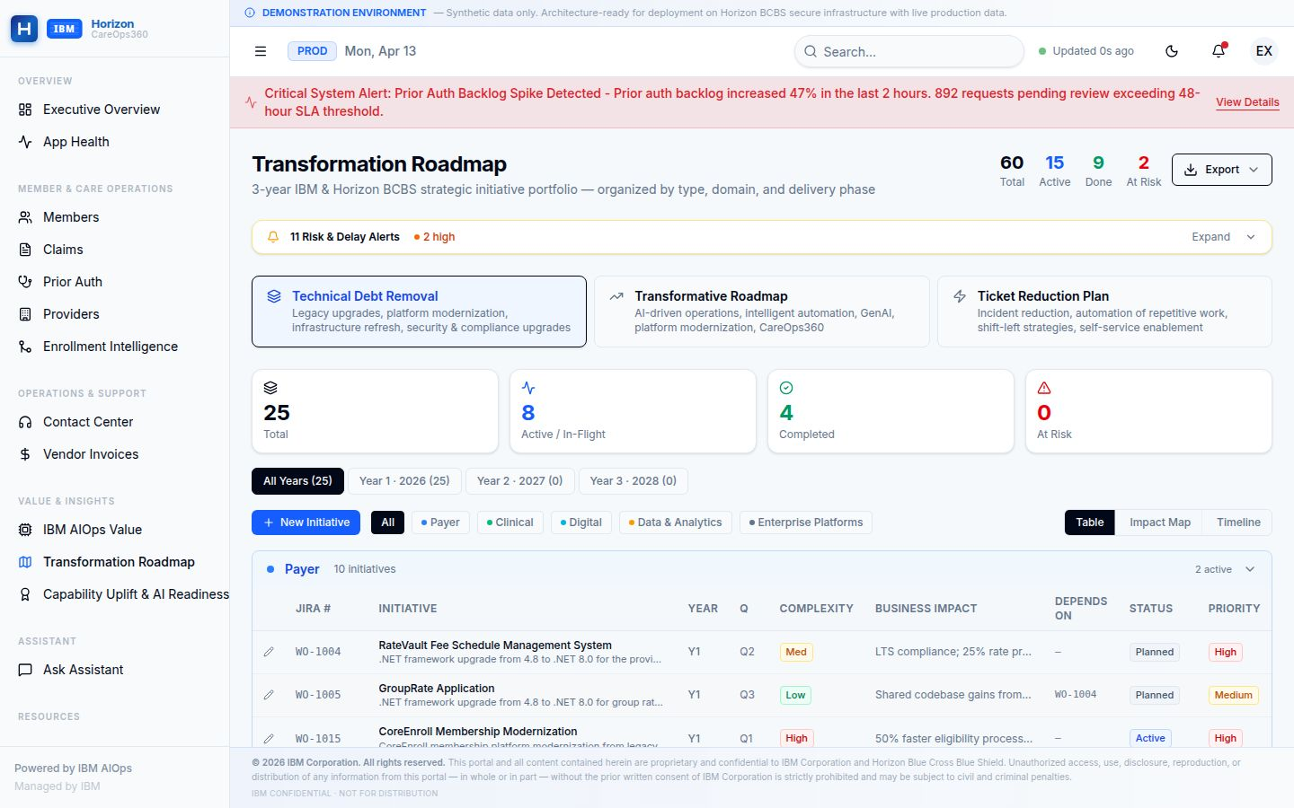  Figure 5: CareOps360 Transformation Roadmap —initiative portfolio tracked by type, domain, phase, and risk status. Live milestone and dependency tracking available on go-live.

Claims & Prior Authorization Operations
AI-Augmented Adjudication, Backlog Management, and Denial Reduction at Scale
Claims and prior authorization are among Horizon's highest-volume, highest-risk operational domains. IBM embeds AI-driven intelligence to accelerate adjudication, reduce denials, and eliminate manual backlog management — at enterprise scale.

Claims Operations Intelligence  IBM's CareOps360 platform surfaces real-time visibility into the claims lifecycle — from receipt through adjudication, settlement, and denial management. Operational leads and executives can identify queue bottlenecks, denial spikes, and auto-adjudication performance degradation in real time, without waiting for next-day reporting.  What IBM Will Deliver  - AI-enhanced auto-adjudication rules engine — reducing manual adjudication rates from baseline.  - Denial pattern analytics — identifying root causes across procedure, eligibility, and coordination of benefits failure modes.  - Real-time claims dashboard: volume by line of business, TAT trending, denial driver breakdown.  - SLA-bound adjudication commitments: average turnaround time reduction target to be agreed at contract.  Claims Metrics That Will Be Tracked  - Claims received daily — volume trend and year-over-year comparison.  - Claims in adjudication — queue depth and aging by payer class.  - Auto-adjudication rate — target improvement trajectory over programme life.  - Denial rate by denial code — top-5 denial reasons tracked monthly.  - Average turnaround days — actuals vs. SLA commitment. | Prior Authorization: AI-Assisted Review  Prior authorization is a significant operational and member experience pressure point. Horizon's current backlog and review cycle times create friction for providers and members alike. IBM will deploy AI-assisted review tooling to triage and prioritise requests, identify auto-approvable cases, and flag clinically complex cases for expedited human review.  Prior Auth Metrics That Will Be Tracked  Target: 100% of urgent prior auth requests resolved within regulatory SLA. AI-assisted triage to reduce average review time by 30%+ within 12 months.  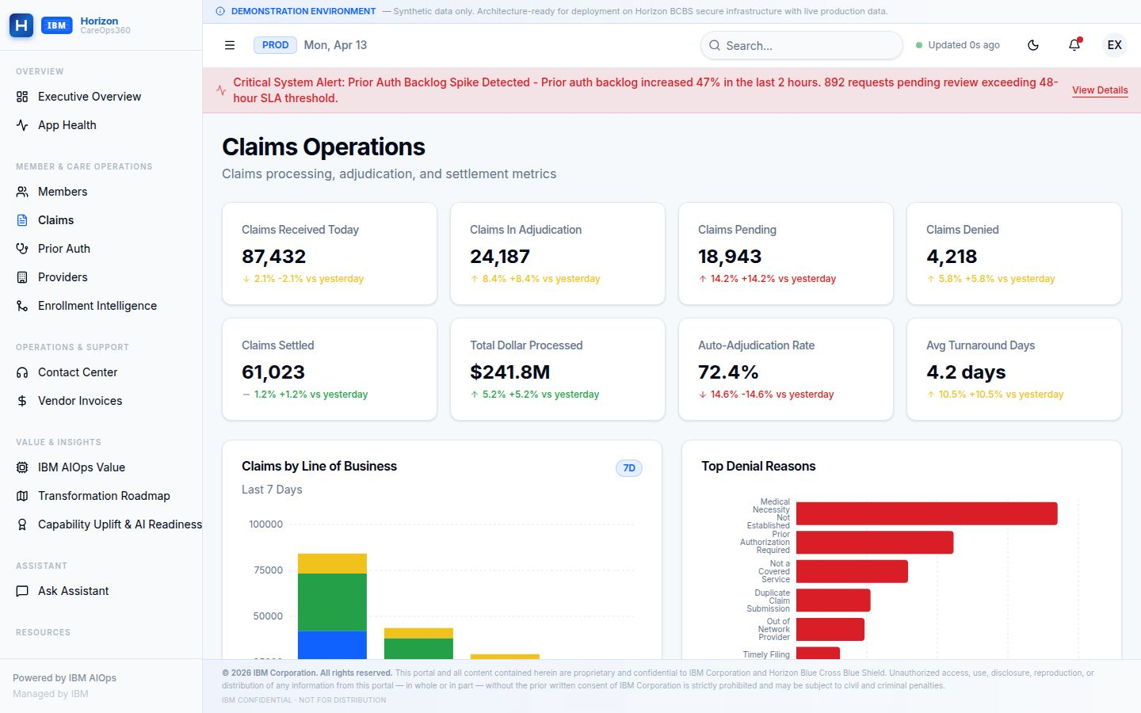
  Metric | Target Direction
  Requests Received Daily | Trend monitored weekly
  Average Review Hours | Reduction target (baseline to agreed)
  Urgent Request SLA | 100% within 72-hr regulatory SLA
  Backlog Size | Reduction tracked monthly
  Auto-Approval Rate (low-risk) | Increase target: >40% by Month 12
  Top Procedure Approval Rates | Category-level variance monitoring

Figure 6: CareOps360 Claims Operations Dashboard — daily volume, adjudication queue, settlement metrics, auto-adjudication rate, and top denial reasons. Illustrative data shown; live metrics populated on go-live.
Enrollment Intelligence & AI-Assisted Intake
From Manual Queue Management to Autonomous, Predictive Enrollment Operations
The Enrollment Challenge at Horizon  Horizon's enrollment pipeline processes tens of thousands of records across individual, group, and government segments — with high volumes during open enrollment periods creating significant operational risk. Manual validation, eligibility matching, and exception handling consume substantial operational capacity and introduce SLA risk when not actively monitored.  IBM's Enrollment Intelligence solution transforms this from a reactive, queue-management function into a proactive, AI-augmented enrollment operations capability — with real-time visibility into pipeline health, SLA compliance, and AI remediation rates.  What IBM Will Deliver  - End-to-end enrollment pipeline monitoring: intake, validation, AI remediation, and syndication.  - Auto-match rate improvement: AI-assisted eligibility matching reduces manual intervention volumes.  - Surge detection and capacity modelling: predictive alerts for open enrollment demand spikes.  - SLA breach alerting: real-time flag when queue health degrades beyond threshold.  - Compliance & audit trail: full record-level traceability for regulatory examination.  Enrollment Metrics That Will Be Tracked  - Time-to-good (intake to validated record) — reduction target agreed at contract baseline.  - Auto-match rate — AI eligibility matching accuracy, tracked monthly.  - Manual intervention rate — percentage of records requiring human review.  - Records in queue — real-time queue depth with aging breakdown.  - SLA compliance rate — percentage of records processed within agreed SLA.  - Failed records — hard failure volume and root cause trend. | Enrollment Intelligence Hub  CareOps360's Enrollment Intelligence Hub provides a unified, multi-tab view of the enrollment lifecycle — from Operations Overview and Intake & Validation through to AI Remediation, Syndication, Reconciliation, and Compliance & Audit. The hub includes an embedded Operations Copilot for real-time queue health summaries and priority recommendations.  Surge Protection  • Predictive surge detection alerts leadership ahead  • Capacity modelling integrated with workforce planning  • Auto-escalation on queue depth threshold breach  • Open enrollment operational command center built in  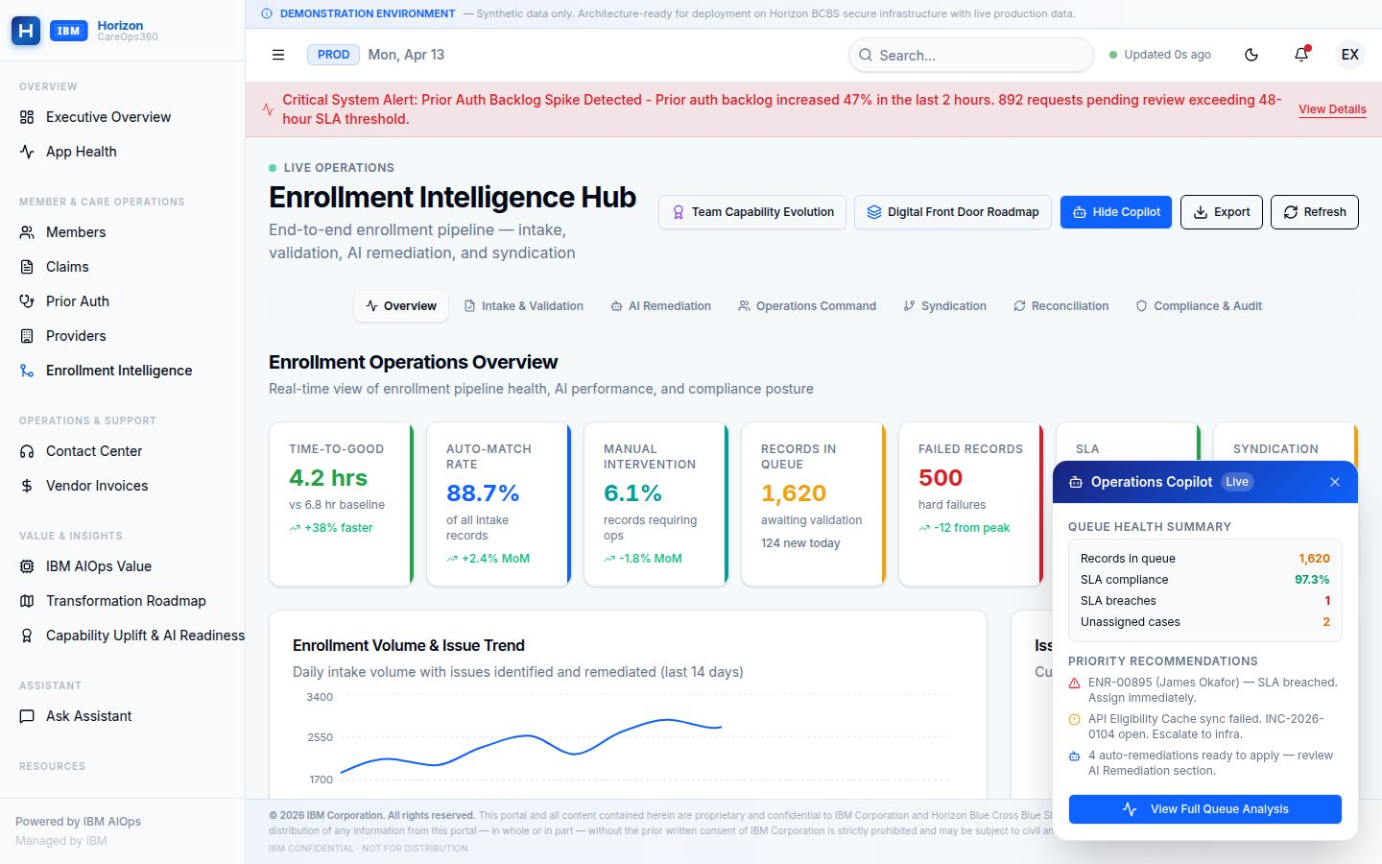
  Hub Tab | Purpose
  Overview | Pipeline health, KPI summary, SLA status
  Intake & Validation | Record-level validation status and error patterns
  AI Remediation | Auto-fix rate, remediation type breakdown
  Operations Command | Queue management and intervention workflow
  Syndication | Downstream system feed status and reconciliation
  Compliance & Audit | Regulatory traceability and exception log

Figure 7: CareOps360 Enrollment Intelligence Hub — pipeline health KPIs, auto-match rate, manual intervention tracking, queue depth, and AI Remediation overview. Illustrative data; live metrics upon go-live.

Member Services & Contact Center Intelligence
Reducing Contact Volume, Elevating Digital Experience, and Measuring Every Interaction
IBM's approach to member services transforms the contact centre from a cost centre to a digital engagement command post — where AI containment, self-service, and agent augmentation work together to reduce call volume, improve FCR, and increase member satisfaction.

The Member Experience Opportunity  Contact center performance is a direct signal of operational quality across the enterprise. High call volumes, elevated abandonment rates, and low first-call resolution typically reflect process failures upstream — in enrollment, claims, prior auth, and provider services — that force members to call. IBM addresses this systemically, not just at the contact center surface.  What IBM Will Deliver  - AI-powered chatbot and IVR containment: increasing self-service resolution to reduce agent handle time.  - Agent Assist tooling: surfacing relevant member context, prior interactions, and suggested resolution paths in real time.  - Digital adoption acceleration: driving members to portal and mobile for routine transactions.  - Contact reason analytics: identifying and feeding back upstream root causes driving call volume.  - FCR improvement programme: structured analysis of repeat contacts and intervention design.  Member Services Metrics That Will Be Tracked  - Calls received daily — volume trend and driver breakdown by call reason.  - Average Speed of Answer (ASA) — target reduction from baseline.  - Abandonment rate — threshold monitored in real time.  - First Call Resolution (FCR) — target improvement trajectory.  - Chatbot containment rate — self-service automation coverage.  - Digital adoption rate — percentage of members using digital channels for routine transactions. | Contact Center KPI Targets  Digital Channel Strategy  IBM's Digital Front Door investment directly reduces contact volume by enabling members to complete plan comparison, enrollment changes, claims status lookup, prior auth status, and ID card requests entirely within digital channels — reducing broker and call-center dependency for Horizon's most frequent transaction types.  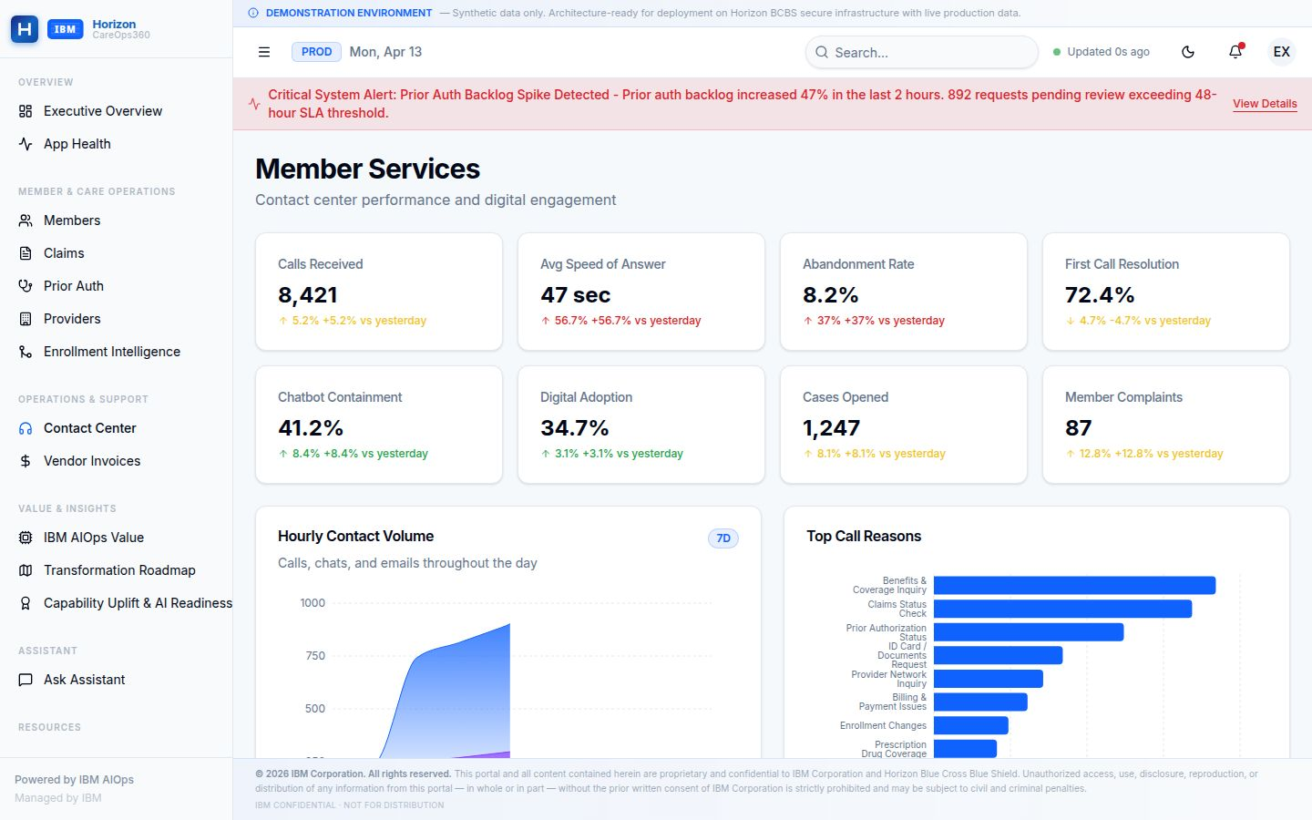  Figure 8: CareOps360 Member Services Dashboard — calls, ASA, abandonment rate, FCR, chatbot containment, digital adoption, and top call reasons by category. Illustrative data; live metrics upon go-live.
  Contact Reason Feedback Loop
  • Top call reasons surfaced daily in CareOps360
  • Root cause analysis drives upstream process fixes
  • Agent Assist reduces handle time per contact
  • Monthly member satisfaction trend tracked

Capability Uplift & AI Readiness
How IBM's Delivery Capability Directly Enables Horizon's Transformation Outcomes
A Workforce Built for AI-First Delivery  IBM's transformation proposal is backed by a deeply credentialled, continuously upskilling delivery team that brings AI and automation expertise directly into Horizon's operating environment. Capability investment is not a separate training programme — it is embedded into every phase of delivery, with certifications, automation coverage, and AI-readiness metrics tracked in CareOps360.  IBM is evolving the Horizon delivery model from traditional operations to AI-augmented and autonomous operations. Certified AI and ML resources are expanding significantly, automation coverage is scaling across all workflows, and delivery staff are being redeployed from manual tasks to higher-value advisory and engineering roles — directly enabling measurable transformation outcomes.  The Strategic Capability Narrative  IBM's people strategy for Horizon is threefold: certify deep expertise in AI, healthcare, and IBM platforms; automate the repeatable so people focus on the complex; and redeploy freed capacity toward the strategic programmes that matter most — Digital Front Door, Quote to Cart, ICOE Modernization, and Mainframe Modernization.  Capability Metrics That Will Be Tracked  - Total certified professionals on the Horizon engagement — headcount and credential breakdown.  - AI/ML certifications: target growth trajectory month-over-month.  - Automation coverage: percentage of delivery processes with automation applied.  - Workforce AI-enabled percentage: share of team using AI tooling in daily delivery.  - FTE productivity gain: reduction in manual effort per unit of delivery output.  - Auto-remediation readiness: target capability milestone for self-healing operations. | Capability Dashboard  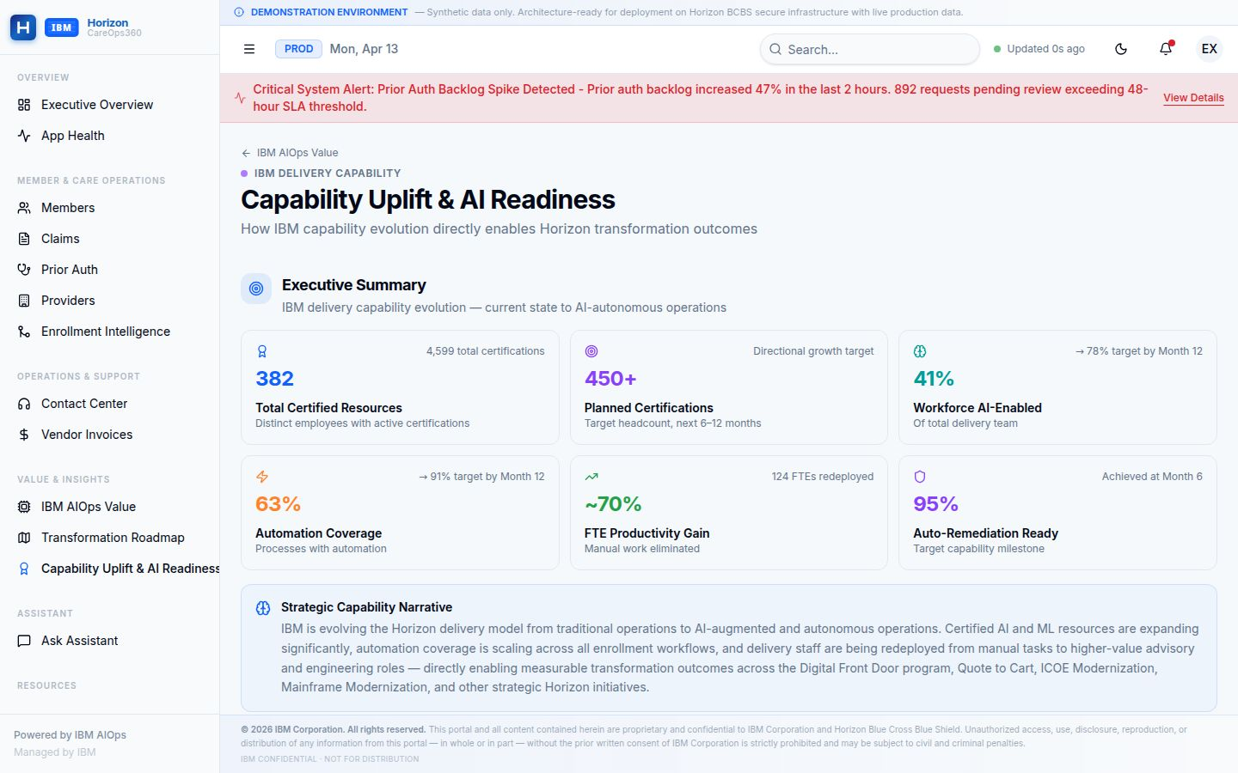  Figure 9: CareOps360 Capability Uplift Dashboard — certified resources, planned certifications, automation coverage, workforce AI-enablement, productivity gain, and auto-remediation readiness. Illustrative data; live metrics upon go-live.
  Capability Area | Metric Tracked | Target
  AI / ML Certifications | Certified professionals | Growth to plan
  Planned Certifications | Next 6–12 month pipeline | Headcount target
  Workforce AI-Enabled | % using AI daily | 78% by Month 12
  Automation Coverage | % processes automated | 91% by Month 12
  FTE Productivity Gain | Manual effort eliminated | Target agreed
  Auto-Remediation Ready | Self-heal milestone | Achieved Month 6
  IBM Certification Domains at Horizon
  • AI / Machine Learning — model deployment, AIOps, LLM operations
  • Healthcare & Payer — BCBS models, CMS compliance, HIPAA
  • IBM Platform — consulting advantage, cloud architecture, hybrid cloud
  • Cloud Engineering — AWS, OpenShift, DevSecOps, SRE

Why IBM as Your Transformation Partner
Scale, Depth, and Skin in the Game
IBM is the only partner that brings together AI-first operating platform capability, Horizon’s institutional knowledge, deep healthcare payer domain expertise, proven global delivery scale, and a willingness to share outcome risk through an outcome-based engagement model.

Enterprise Transformation, Not Just IT  IBM's proposal delivers unified transformation across Operations, Development, and Quality Engineering — not siloed initiatives that optimise one tower while creating drag in another.  IBM's delivery philosophy — AI-Embedded Operations, Scalable Architecture, and Outcome-Based Engagement — ensures that every IBM investment compounds Horizon's capability, not IBM's margin.  What Differentiates IBM  - Skin in the game: Outcome-based engagement with IBM's full capability depth behind every phase — IBM's success is tied to Horizon's outcomes.  - AI at depth, not at surface: IBM's Agentic AI, Generative AI, and AIOps capabilities are production-proven across healthcare and financial services — not proof-of-concept.  - The BOB Framework: IBM's BUILD ONCE, BENEFIT reusable asset library compresses implementation time and reduces per-solution cost across the portfolio.  - Innovation Council: IBM commits a structured quarterly innovation process — governed, prioritised, business-case-backed innovation at Horizon's direction. | IBM's Global Delivery Strength  Healthcare Payer Pedigree  IBM brings deep healthcare payer expertise — including BCBS operating models, CMS regulatory compliance, HIPAA data governance, enrollment lifecycle management, and claims adjudication platform knowledge — directly into Horizon's delivery team from Day 1.
  20K+  AI Practitioners | 81K+  Cloud Experts
  40K+  AI Engagements | 15K+  Global Centres
  Key References
  • Partner of the Year 2023 — Enterprise AI delivery
  • Leader in Enterprise Software Quality & Testing
  • Proven BCBS engagement track record
  • CMS & HIPAA compliance expertise

IBM's Modernization Investment with Horizon
Co-Investing in Digital Front Door, Quote to Cart, Mainframe Modernization, and ICOE — As a True Partnership
"IBM will invest alongside Horizon in the modernization programs that define the next decade of Horizon's competitiveness. These are not service-delivery engagements — they are strategic co-investments where IBM brings capital, capability, and commitment to shared outcomes."

Digital Front Door — IBM as Co-Builder  The Digital Front Door is Horizon's most visible member-facing transformation program. IBM will not merely provide delivery resources — IBM will co-design, co-build, and co-operate the unified digital engagement layer that gives Horizon members a seamless, AI-enhanced experience from plan discovery through care navigation.  This is a programme where IBM brings its healthcare digital accelerators, member experience design patterns, and proven BCBS digital transformation playbook — reducing time to market, compressing risk, and ensuring Horizon is not starting from a blank page.  Quote to Cart — Compressing the Purchase Cycle  Quote to Cart is Horizon's highest near-term ROI digital initiative. IBM will co-invest in the design and delivery of a fully digital plan comparison, selection, and payment flow that enables prospective and renewing members to transact entirely within a digital channel — compressing the sales cycle from days to minutes and directly reducing broker dependency for straightforward purchases. | Mainframe Modernization — IBM as a partner with AWS  Horizon's mainframe infrastructure is mission-critical — hosting eligibility processing, claims engine logic, financial settlement, and benefit adjudication. IBM understands that modernizing this estate is not merely a technical program — it is a strategic risk management exercise that must be executed with surgical precision.  IBM proposes a phased, parallel-run migration approach — wrapping mainframe workloads with modern APIs before cloud rehosting, running parallel environments until transaction equivalence is validated, and only cutting over when all stakeholders have confidence. IBM brings AI-assisted COBOL-to-Java conversion tooling that compresses the code conversion timeline by 40–60% compared to manual approaches.  ICOE Modernization — IBM as Architecture Partner  The Integration Centre of Excellence Modernization is IBM's commitment to restructure the delivery organisation to match Horizon's evolving platform landscape. This means product-centric engineering squads, DevSecOps pipelines, API management simplification, and observability-first SRE practices — all delivered as a sustained organisational evolution, not a one-time project.
  IBM's commitment: Every modernization investment IBM makes at Horizon compounds Horizon's long-term competitive capability — not IBM's dependency. The goal is a Horizon that operates better, faster, and smarter with every program completed.

 | ICA and AIOps  AI-Infused Delivery | 60+  Modernization Initiatives | Zero  Disruption Commitment

Recommended Next Steps
From Proposal to Partnership — IBM's Proposed Engagement Path
Immediate Actions (2–4 Weeks)  - Schedule Executive Alignment Session — IBM VP + Horizon CIO/COO to confirm transformation vision and programme scope.  - Conduct Command Center Walkthrough — Live demonstration of CareOps360 platform with Horizon's operational and technology leadership.  - Initiate Contract Finalisation — Confirm outcome-based SLA schedule and investment model.  - Begin Phase 0 Foundation Assessment — IBM AMS team on-site to conduct application portfolio and AIOps baseline assessment.  Phase 0 Commitments (Weeks 1–8)  - Week 1–2: IBM transition team mobilised; AIOps instrumentation begins across priority applications.  - Week 3–4: ICOE architecture definition workshop; Quote to Cart KPI alignment roadmap delivered.  - Week 5–6: Phase 1 Ignite plan presented to Steering Committee.  - Week 7–8: Innovation Council inaugural session — first idea pipeline scoped. | What IBM Needs from Horizon  - Executive sponsorship confirmed with a named Horizon program owner.  - Access to application inventory, current SLA performance data, and AMS tooling estate.  - Introduction to Horizon's technology and operations leadership teams.  - Agreement on data governance and security protocols for CareOps360 production integration.  Appendix: Workforce Certification  As of April 2026, IBM's delivery team at Horizon carries 382 certified professionals across 4,599 certifications spanning AI/ML (307), Healthcare (342), IBM Products (338), and Cloud (250) domains. This credentialled workforce directly enables the AI-first delivery model described in this proposal.
  IBM is ready to begin. With your confirmation, Phase 0 can mobilise within 5 business days.

A Strategic Partnership for Enterprise Transformation
IBM is committed to Horizon's success — not as a vendor, but as a transformation partner with shared stakes in every outcome.

© 2026 IBM Corporation · IBM-HZN-AMS-RFP-2026-CAS · Confidential — Executive Use Only · All figures based on IBM programme data and industry benchmarks.

