AI-FIRST
Transforming Horizon BCBS
Into a Predictive, Self-Healing, AI-Driven Enterprise

Submitted by:  IBM Consulting  Healthcare & Payer Delivery — AMS Practice  Submitted to:  Horizon Blue Cross Blue Shield of New Jersey  Executive Leadership & Technology Office | Document Classification:  CONFIDENTIAL  Date:  April 2026  Reference:  IBM-HZN-AMS-RFP-2026-CAS

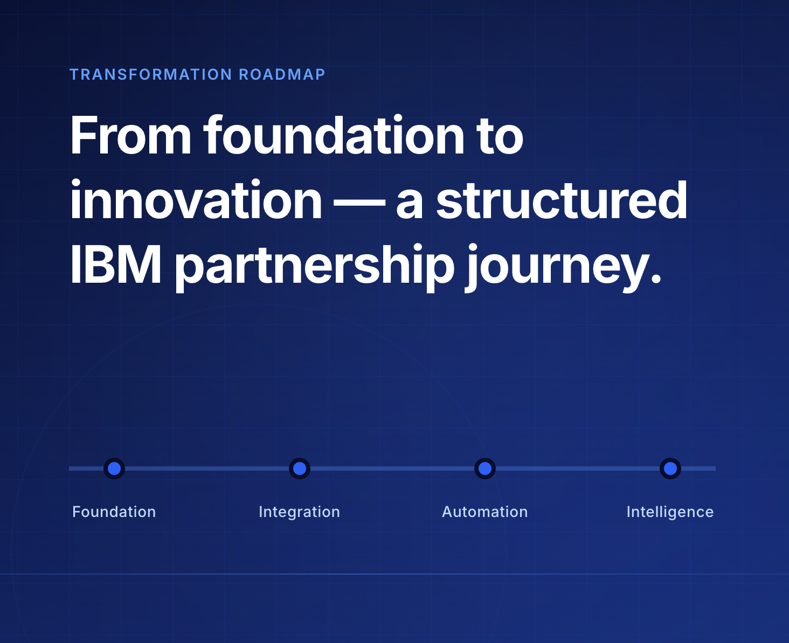

Powered by IBM AIOps · IBM Consulting Advantage · HIPAA Compliant · © 2026 IBM Corporation

Table of Contents
IBM × Horizon BCBS — AI-First Transformation Proposal, April 2026
01 | Executive Summary  AI-Led Transformation of AMS
02 | The Transformation Imperative  Horizon's Strategic Objectives & IBM's Design Rationale
03 | CareOps360 Command Center  IBM's Executive Operations Platform for Real-Time Visibility
04 | AIOps & Agentic AI Operations  From Reactive to Autonomous, Self-Healing Operations
05 | Platform Modernization  Integration Modernization, Mainframe Migration & App Rationalization
06 | Quality Engineering  Measurable Quality at Every Milestone
07 | Phased Transformation Roadmap  Stabilization to Autonomous Operations
08 | Claims & Prior Authorization  AI-Augmented Adjudication at Scale
09 | Enrollment Intelligence  AI-Assisted Intake and Surge Management
10 | Staff Enablement and AI Readiness  Workforce Enablement and Automation Maturity
11 | Transformation Opportunities  Digital Front Door, Mainframe Modernization & ICOE Partnership
12 | Next Steps & Call to Action  Mobilizing the Partnership
13 | Why IBM as Your Transformation Partner  Scale, Depth, and Skin in the Game
A | Appendix A — Program Initiative Register  60 Initiatives: Upgrade, Ticket Reduction & Transformation

Executive Summary
A Strategic Proposal for AI-Led Transformation of Application Management Services
"IBM is not proposing a technology project — IBM is proposing a transformation partnership that embeds AI-driven intelligence into the operating model of Horizon BCBS, enabling a future-ready enterprise that is faster, smarter, and more resilient than today."

The Moment  Horizon BCBS stands at a pivotal inflection point. With approximately 1000 applications spanning enrollment, claims adjudication, member services, and data platforms, the organization faces mounting pressure to modernize operations, reduce administrative burden, and deliver measurably better member and provider experiences.  The incumbent delivery model — reactive, labor-intensive, and fragmented across towers — is no longer sufficient to meet Horizon's growth objectives or competitive imperatives.  What IBM Proposes  IBM proposes a structured transition from reactive application support to a predictive, self-healing, and continuously improving AI-first operating model — delivered through IBM's proven Assets, Assistants, and Accelerators framework, and governed through an outcome-based accountability model.  Value Realization — What Will Be Monitored  Once live, CareOps360 will surface real-time operational intelligence across all AMS towers through a single executive command center. The following metrics will be tracked and reported continuously to Horizon leadership:  - Active members under management and enrollment velocity  - Claims settled volume and adjudication cycle times  - Application availability and SLA attainment across 1000+ applications  - Automation savings — YTD and cumulative cost avoidance  - Call Center Average Speed of Answer and first-contact resolution | 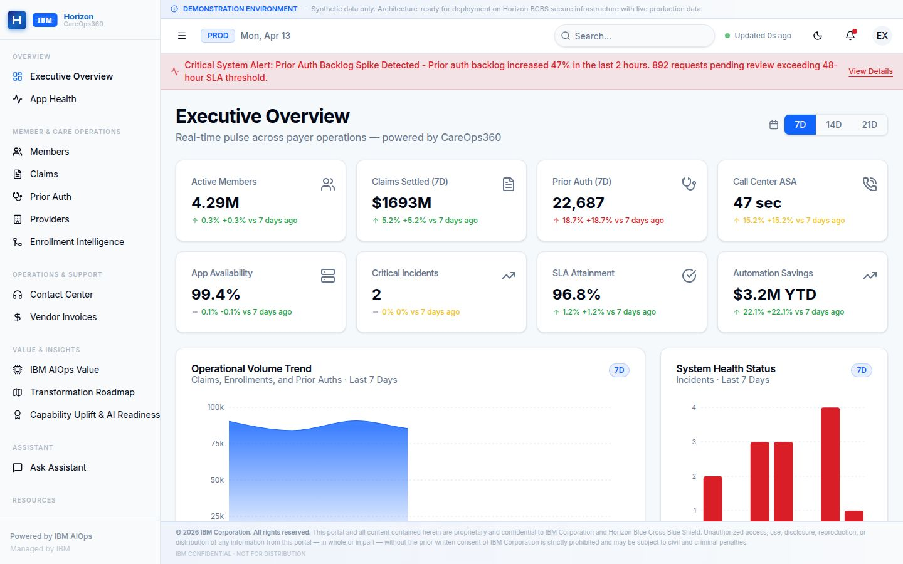  Figure 1: CareOps360 Executive Dashboard — platform overview (illustrative data shown; live metrics populated upon go-live)  Five Strategic Commitments  - AI-First Operating Model — AI embedded across every layer of AMS and QA lifecycle.  - Tech Arbitrage over Labor Arbitrage — Compressing cost through automation, not headcount.  - Outcome-Based Delivery — Committed SLAs tied to measurable business outcomes.  - Zero-Disruption Delivery — Risk-free phased transition protecting operational continuity.  - Continuous Innovation Engine — Horizon Transformation Office driving sustained value beyond steady state.
  IBM's Scale Behind This Proposal
  • 20,000+ AI & data practitioners globally
  • 81,000+ cloud & architecture experts
  • 40,000+ AI & analytics engagements
  • 15,000+ people across 40 global delivery centers
  • Leader in Enterprise Software Quality & Testing
  • Enterprise partnerships with AWS, Salesforce and IBM Technology
  • IBM's client-0 success story which saved IBM ~3.4B USD

~1000  Applications in Scope | Day -1  Efficiencies and Cost Reduction | 24×7  Global AIOps Coverage | AI-First  Operating Model Commitment
The Transformation Imperative
Understanding Horizon's Strategic Objectives and IBM's Solution Design Rationale
What Horizon Needs  Horizon BCBS is seeking the right strategic partner to enhance and support its Application Development, Maintenance, Data, and Testing Services — with a clear focus on AI solutions and expertise native to the Horizon environment.  Service Transformation Goals  - High-quality services delivered through AI and automation to obtain operational efficiencies.  - Realization of a product-oriented operating model.  - Focused automation — especially in testing and quality engineering.  - AI tools to drive Agile application modernization across the portfolio.  - Consultative support applying deep healthcare payer best practices.  Cost Structure Expectations  Horizon expects structural cost reduction — not just efficiency gains. The fixed baseline model signals a clear expectation: year-over-year productivity improvements and cost takeout driven by automation and AI, not rate arbitrage. | Factors That Shaped IBM's Solution  - End-to-End Integrated Delivery: A unified operating model across Application Maintenance, Development, Testing, and Data — reducing fragmentation and improving accountability across the full lifecycle.  - AI at the Core: Not bolted on. AI is embedded in triage, root cause analysis, resolution, test automation, and continuous validation — from the first day of delivery.  - Transition Without Disruption: IBM's phased transition approach maintains seamless service continuity while progressively modernizing the underlying operating model.  - Open, Elastic Architecture: Plug-and-play architecture allows IBM to deploy on Horizon's existing AWS stack or any cloud ecosystem — avoiding lock-in and enabling flexibility.
  IBM's solution shifts Horizon from reactive
  incident management to predictive,
  autonomous operations
Current State vs. IBM Target — Key Operational Metrics (Complete list will be in SOW)
Operational Metric | Estimated Current State | IBM 12-Month Target | Direction
Test Automation Coverage | ~25% | 80%+ | ↑ +3x
MTTR (Mean Time to Resolve) | > 4 hours | < 1.8 hours | ↓ 55%
Defect Escape to Production | High / Untracked | 65% Reduction | ↓ Best-in-class
Incident P3/P4 Auto-Resolution | < 10% | > 74% | ↑ 7x
Regression Cycle Time | Multi-day manual | 70% Faster | ↓ Automated
Alert Noise per Shift | Unfiltered high | > 60% Reduced | ↓ AI-filtered
Enrollment Error Ticket Rate | High / Reactive | ~110 tickets/month saved | ↓ Zero-touch
System Availability (AMS) | ~99.7% | 99.9% | ↑ AI-ops

All current-state estimates are directional and will be formally baselined during SOW phase. IBM's committed targets will be contractually agreed at program commencement. See Appendix A for the complete 60-initiative program portfolio.
CareOps360 Command Center
IBM's Executive Operations Platform for Real-Time AMS Visibility at Horizon
What Is CareOps360?  CareOps360 is IBM's production-grade executive operations platform purpose-built for the Horizon BCBS engagement. It delivers real-time operational intelligence across all AMS towers — enrollment, claims, applications, infrastructure, and quality — through a single, unified command center accessible to Horizon's executive and operational leadership. The platform is architecture-ready for live production data and is currently deployed in a production-equivalent environment.  Built on IBM's AIOps observability framework, CareOps360 surfaces predictive insights, SLA performance, enrollment intelligence, digital front door metrics, and transformation roadmap progress — eliminating the need for manual reporting aggregation.  Dashboards Delivered  - Executive Overview — Cross-tower operational pulse with 8 real-time KPI tiles.  - Application Health — 1000+ app inventory, incident register, availability trends.  - Claims Operations — Daily volume, adjudication queue, denial analytics.  - Prior Authorization — Backlog, review SLA, procedure-level approval rates.  - Enrollment Intelligence — AI-assisted intake, pipeline health, surge detection.  - Member Services — Contact center, chatbot containment, digital adoption.  - IBM AIOps Value — Automation savings, shift-left rate, self-heal event tracking.  - Transformation Roadmap — 60-initiative portfolio with phase and risk status.  - Capability Uplift — Workforce certification, automation coverage, AI readiness.  Portal Credentials (Demo Environment)  - URL: https://careops360-ibm.com/  - Horizon Executive: exec@horizon.com  - Password: Horizon&IBM2026  - Note: Demo mode only — no live PHI or  production data, Command center is ready to be deployed | Metrics Monitored via CareOps360  Figure 2: CareOps360 Executive Overview — eight operational KPIs spanning members, claims, prior auth, infrastructure, SLA, and automation savings. Platform shown in production-equivalent environment; metrics are illustrative.
  Access & Security
  • Role-based access: IBM and Horizon executives
  • Token-authenticated sessions with inactivity timeout
  • HIPAA-compliant — no PHI data in the command center
  • Architecture-ready for production data integration
  Metric Domain | What Will Be Tracked
  Application Ops | Availability, MTTR, incident volume by severity
  Claims | Volume, adjudication rate, TAT, denial drivers
  Prior Auth | Backlog, review SLA, auto-approval rate
  Enrollment | Time-to-good, auto-match rate, queue health
  Member Services | ASA, FCR, chatbot containment, digital adoption
  AIOps Value | Savings YTD, shift-left rate, self-heal events
  Transformation | Phase progress, milestone risk, initiative velocity
AIOps & Agentic AI Operations
From Reactive Incident Management to Autonomous, Self-Healing Operations
IBM's Agentic AI framework shifts Horizon from reactive incident handling to proactive, AI-driven real-time diagnosis and autonomous resolution

The Agentic AI Architecture  IBM's AIOps framework is built on a multi-agent architecture where specialized AI agents handle distinct responsibilities across the incident lifecycle — from detection through resolution and continuous learning.  Agent Roles  - Help Desk Agent: Delivers context-aware guidance and automated actions to help users auto-resolve issues before ticket creation.  - Triage Agent: Prioritizes tickets based on impact, urgency, and historical patterns — eliminating manual queue management.  - Root Cause Analysis Agent: Correlates signals across 140+ monitoring sources to identify root cause within minutes.  - Resolution Agent: Suggests or executes remediation steps based on runbooks and past resolutions.  - Runbook Generation Agent: Auto-generates and updates runbooks from resolved incidents — compounding operational knowledge over time.  - Continuous Learning Agent: Feeds production telemetry back into all agents, ensuring progressive improvement with every incident cycle. | Value Realization  Built for Horizon's AWS Stack  - Agent Layer: AWS AgentCore & Bedrock  - Model Layer: AWS Bedrock with native Guardrails  - Vector Store: ElasticSearch + PostgreSQL  - Integrations: ServiceNow · CloudWatch · OpenShift  - Splunk and Horizon’s Anomaly Framework  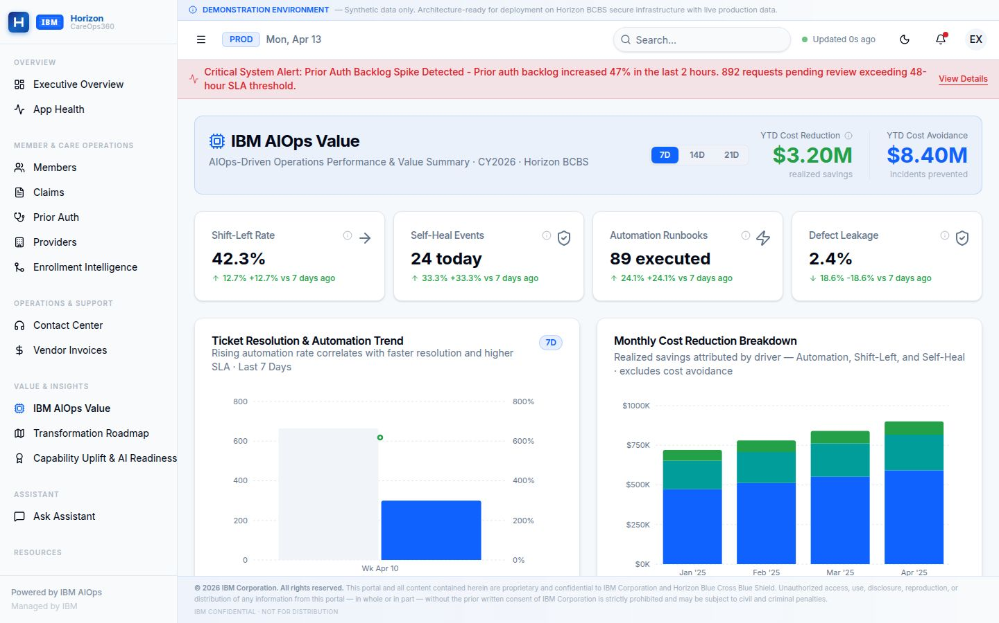
  ✓ Horizon’s ARB Approval  Architecture Review Board  ✓ Horizon’s GenAI Board Approved | ✓ Horizon's GenAI Board Approved  Horizon GenAI Governance
  Metric | With AIOps
  MTTR (Mean Time to Resolve) | < 1.8 hrs
  Alert Noise per Shift | > 60% Reduced
  P3/P4 Auto-Resolution | > 74%
  Change Failure Rate | 40% Reduction
  System Availability | 99.95%
  Ops Manual Triage Hours | ~30% Reduction

Figure 4: IBM AIOps Value Dashboard — automation savings, shift-left rate, self-heal events, and monthly cost reduction trend by driver. Metrics are illustrative; live values tracked upon go-live.

Platform Modernization
Integration Modernization, Mainframe Migration & Application Rationalization; Ideation, design, and business case creation are covered as part of Transformation Office responsibilities.
Integration Modernization — Real-Time, Cloud-Native  IBM's Integration Modernization program transforms Horizon's data exchange backbone from point-to-point batch processes to a cloud-native, event-driven, real-time integration architecture — enabling claims, eligibility, provider, and member data to flow continuously across systems without overnight lag.  From Batch to Real-Time Streaming  - MOM API-First Hub (HLGN-1053): Transform Horizon's Messaging-Oriented Middleware from point-to-point topology to an API-first enterprise integration hub — enabling real-time, event-driven partner data exchange across claims, eligibility, and provider domains.  - Event Streaming Architecture: Replace batch ETL with Apache Kafka-based event streaming on AWS MSK — delivering sub-second data freshness across enrollment, claims, and provider systems.  - API Gateway Consolidation: Unified API gateway via AWS API Gateway + IBM API Connect — replacing 70+ point-to-point integrations with governed, observable, versioned APIs.  - ODM Cloud-Native (HLGN-1054): Migrate IBM ODM Decision Center from on-premises to containerized cloud environment, enabling real-time business rule evaluation and business-user-configurable workflows.  Application Rationalization  IBM will conduct a structured assessment of Horizon's ~1000 application portfolio using Texture and other IBM assets and accelerators like ICCA — identifying candidates for decommission consolidation, cloud migration, or AI-augmented modernization. | Mainframe Modernization Roadmap  Horizon's mainframe hosts critical batch processing, eligibility logic, and financial settlement. IBM's strategy executes phased migration preserving continuity:
  Workstream | Approach | Timeline
  Eligibility Processing | API-wrap → Cloud rehosts | Q2–Q4 2026
  COBOL → Java Pilot | AI-assisted code conversion | Q3 2026
  Unified Payments | AWS modernization | Q3 2026
  Claims Engine | Parallel-run cutover | Q1–Q2 2027
  Member Data Services | Event-driven migration | Q4 2026+
  Technical Debt Governance — n-1/n-2 Version Standard
  • IBM commits to maintaining all Horizon stacks at n-1
  (one version behind latest LTS) — balancing security currency
  with stability
  • Quarterly version review cadence: IBM + Horizon ARB jointly
  assess all frameworks, runtimes, and vendor platforms
  • Upgrade backlog surfaced in CareOps360 Transformation
  Roadmap — every pending upgrade tracked with risk, owner, and
  deadline
  • n-1 compliance report delivered monthly to Horizon CTO:
  highlights stacks at EOL risk, CVE exposure, and upgrade progress
  • Priority-1 CVEs receive emergency patch within 72 hours
  regardless of n-1 cadence
  • Rollback gates at every upgrade phase — no production
  cutover without parallel validation
  • 2026 Year 1: 25 platform upgrades in flight (Angular 17, .NET 8,
  ODM 9.2, SAP BO 4.3)

~1000  Applications Assessed | COBOL → Java  AI-Assisted Conversion | n-1/2  Stack Version Governance | Zero  Disruption Commitment

Quality Engineering & AI-Augmented Development
Measurable Quality at Every Milestone — Improved with Every Release
Self-Improving Quality Framework  IBM's Quality Engineering model embeds measurable validation checkpoints across every stage of development and production — creating a closed-loop feedback system within the CI/CD pipeline. Production insights, defect analytics, and automation metrics continuously refine testing strategies, enabling sustained defect reduction, faster recovery, and progressive quality improvement over time.  Quality Controls  - End-to-end traceability and release readiness visibility.  - Defect leakage, density, and stability metrics (MTTR).  - Automation coverage with KPI-driven governance.  - AI-driven defect insights and regression optimization.  - Production telemetry feeding back into test strategy.  Intelligent Test Automation  IBM's Generative AI capabilities enable self-generating test cases, automated test maintenance, and continuous validation integration — dramatically reducing the cost and time associated with regression testing across Horizon's complex, multi-system portfolio. | AI-Augmented Development Model  IBM transforms Horizon's engineering model from a traditional project-centric approach to a modern, product-centric engineering organization — powered by IBM Consulting Advantage accelerators reusable enterprise assets.  AI-Assisted Development  - Generative AI tools accelerate code generation, review, documentation, and optimization.  - Reduces developer toil and elevates focus to high-value engineering.  - IBM Consulting Advantage accelerators compress time-to-value.  DevSecOps Integration  - Security embedded "left" into CI/CD pipelines.  - Automated vulnerability scanning at every stage.  - Compliance gates and policy enforcement from commit to production.
  Target: 80% test automation coverage across Horizon's application portfolio within 12 months of full deployment.

Figure 5: Quality Engineering — Before & After IBM Transformation
Quality Metric | Current State | 6-Month Target | 12-Month Target | Method
Test Automation Coverage | ~25% | 55% | 80%+ | GenAI self-generating tests
Defect Escape to Production | High / tracked manually | 40% reduction | 65% reduction | AI defect prediction
Regression Cycle Time | Multi-day manual | 50% faster | 70% faster | Intelligent test selection
Mean Time to Detect (MTTD) | > 2 hours | < 30 min | < 15 min | AIOps + telemetry feedback
AI-Generated Test Cases | < 5% | 40%+ | > 70% | IBM Consulting Advantage
Production Incident Rate | Baseline | 20% reduction | 40% reduction | Shift-left quality gates
Critical Defect Leakage | Measured quarterly | Monthly SLA | Zero-leakage SLA | End-to-end traceability
Figure 5: IBM Quality Engineering targets across Horizon's AMS portfolio — current state vs. 6- and 12-month programme milestones. All targets will be formally baselined and committed at contract commencement.
Phased Transformation Roadmap
A Structured, Compounding Journey from Stabilization to Autonomous Operations
IBM's proposed transformation follows a structured, phased approach — delivering quick wins in the immediate term while building the foundation for long-term enterprise transformation. Each phase builds on the last, compounding value across the portfolio. See Appendix A for detail of the initiatives

Phase 0 — Foundation  0–8 Weeks | Phase 1 — Ignite  1–3 Months | Phase 2 — Scale  3–6 Months | Phase 3 — Optimize  6–12 Months
› Command Center blueprint and operationalization  › ICOE architecture definition  › Quote to Card KPI alignment roadmap  › AIOps baseline measurement  › Risk-free transition planning  › AI-assisted Dev + Intelligent QA rollout | › Integration Simplification & ICOE Modernization Roadmap  › Document Generation modernization (HLGS)  › Initial AIOps and monitoring deployment on production  › Test automation framework initiation  › Innovation Council formation  › GenAI development lifecycle integrated | › Unified Payments & Mainframe modernization Initiated  › COBOL → Java modernization pilot  › Digital Front Door blueprint  › Agentic AI incident triage live | › Agentic AI for full incident autonomy  › Claims adjudication parallel run initiated  › Predictive capacity management live

Phase 4 — Transform (12–24 Months) *  - Full autonomous operations for P3/P4 incidents.  - Mainframe eligibility processing decommissioned  - Member Enrollment front door Operationalized  - COBOL → Java migration complete for most workstream  - Enterprise-wide observability platform fully deployed.  *Requires Horizon’s Involvement and Investment  Roadmap Metrics Tracked in CareOps360  - Total initiatives in portfolio: 60 across 4 domains (Payer, Clinical, Digital, Enterprise).  - Active / In-Flight initiatives tracked against quarterly milestones.  - At-risk initiatives flagged for executive escalation within 48 hours. | Governance at Every Phase  - Executive Steering Committee: Quarterly IBM VP + Horizon CIO/COO review.  - Program Management Office: Monthly health reporting and risk register.  - Delivery Operations Reviews: Bi-weekly SLA and incident trends.  - Financial Governance: Monthly actuals vs. committed model.  - Innovation Council: Quarterly idea pipeline and prioritization.
  Transformation Portfolio at a Glance
  • 60 total initiatives across 3 delivery years
  • 25 Year 1 initiatives — Technical Debt, Digital, Payer
  • 15 Active / In-Flight as of program launch
  • 9 Completed milestones in foundation phase
  • 2 At-Risk initiatives under executive monitoring
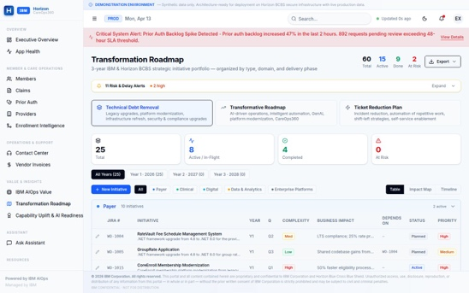
Figure 5: CareOps360 Transformation Roadmap — 60-initiative portfolio tracked by type, domain, phase, and risk status. Live milestone and dependency tracking available on go-live.
Claims & Prior Authorization Operations
AI-Augmented Adjudication, Backlog Management, and Denial Reduction at Scale
Claims and prior authorization are among Horizon's highest-volume, highest-risk operational domains. IBM embeds AI-driven intelligence to accelerate adjudication, reduce denials, and eliminate manual backlog management — at enterprise scale.

Claims Operations Intelligence  IBM's CareOps360 platform surfaces real-time visibility into the claims lifecycle — from receipt through adjudication, settlement, and denial management. Operational leads and executives can identify queue bottlenecks, denial spikes, and auto-adjudication performance degradation in real time, without waiting for next-day reporting.  What IBM Will Deliver  - AI-enhanced auto-adjudication rules engine — reducing manual adjudication rates from baseline.  - Denial pattern analytics — identifying root causes across procedure, eligibility, and coordination of benefits failure modes.  - Real-time claims dashboard: volume by line of business, TAT trending, denial driver breakdown.  - SLA-bound adjudication commitments: average turnaround time reduction target to be agreed at contract.  Claims Metrics That Will Be Tracked  - Claims received daily — volume trend and year-over-year comparison.  - Claims in adjudication — queue depth and aging by payer class.  - Auto-adjudication rate — target improvement trajectory over program life.  - Denial rate by denial code — top-5 denial reasons tracked monthly.  - Average turnaround days — actuals vs. SLA commitment.  Figure 6: CareOps360 Claims Operations Dashboard — daily volume, adjudication queue, settlement metrics, auto-adjudication rate, and top denial reasons. Illustrative data shown; live metrics populated on go-live. | Prior Authorization: AI-Assisted Review  Prior authorization is a significant operational and member experience pressure point. Horizon's current backlog and review cycle times create friction for providers and members alike. IBM will deploy AI-assisted review tooling to triage and prioritise requests, identify auto-approvable cases, and flag clinically complex cases for expedited human review.  Prior Auth Metrics That Will Be Tracked  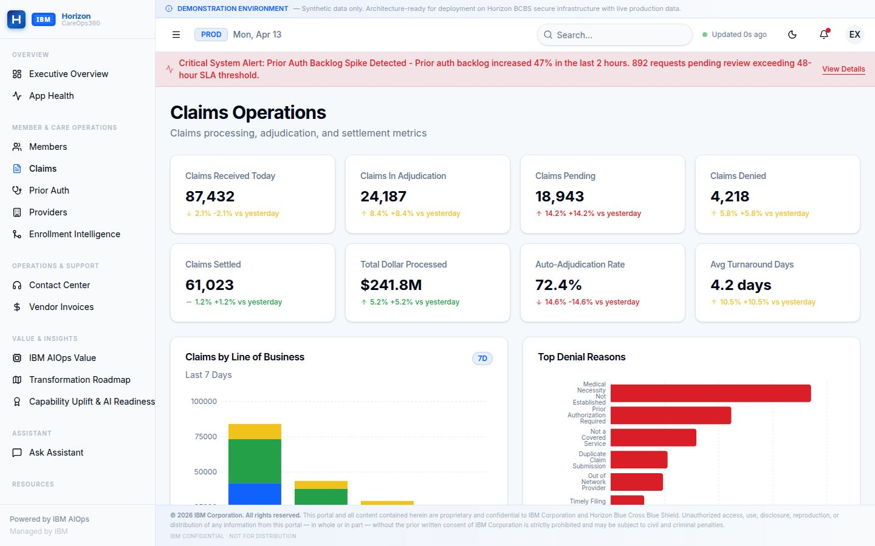
  Metric | Target Direction
  Requests Received Daily | Trend monitored weekly
  Average Review Hours | Reduction target (baseline to agreed)
  Urgent Request SLA | 100% within 72-hr regulatory SLA
  Backlog Size | Reduction tracked monthly
  Auto-Approval Rate (low-risk) | Increase target: >40% by Month 12
  Top Procedure Approval Rates | Category-level variance monitoring
  Target: 100% of urgent prior auth requests resolved within regulatory SLA. AI-assisted triage to reduce average review time by 30%+ within 12 months.

Horizon Health Enrollment Exchange (HHEE)Intelligence & AI-Assisted Intake
Multi-Channel Chaos to Canonical, Autonomous Agentic Enrollment Operations; Ideation, and business case creation are covered as part of Transformation Office responsibilities.
The Enrollment Challenge at Horizon  Horizon's enrollment pipeline processes tens of thousands of records across individual, group, commercial and government segments with high volumes during open enrollment periods creating significant operational risk. Each intake channel has a unique format or version of an 834, meaning validation runs against hundreds of rules, identity resolution occurs too late in the pipeline and syndication to downstream targets is managed reactively.  HHEE transforms this from a reactive, queue-management batch function into a proactive, real-time, AI-augmented enrollment operations capability with real-time visibility into pipeline health, SLA compliance, and AI remediation rates. Every channel, every format, every rule, and every downstream target unified under one operating model.  What HHEE Delivers - Core Capabilities  - Canonical 834 Transformation: All channels converted to Horizon 834 canonical format at intake; one format and quality standard, eliminating downstream incompatibilities.  - Real-Time Validation: Validation fires at intake, not post-processing, errors caught in minutes not hours, with companion guide ingestion and rule hierarchy management built in.  - Shift-Left Member Mastering: COB resolved and HUMI assigned earlier in the pipeline; improving auto-match rate and reducing rework.  - Agentic Remediation: Majority of exceptions auto resolved with confidence scoring, Root Cause Analysis (RCA) generation and HUMI escalation for the remainder, reducing manual intervention volumes measurably.  Enrollment Metrics That Will Be Tracked  - Time-to-good (intake to validated record): Reduction target agreed at contract baseline.  - Auto-match rate: AI eligibility matching accuracy, tracked monthly.  - Manual intervention rate: Percentage of records requiring human review.  - Records in queue: Real-time queue depth with aging breakdown. | Horizon Health Enrollment Exchange Hub  Provides a unified, multi-tab view of the enrollment lifecycle from Trading Partner intake through Processing Pipeline, Command Center, Work Management, Syndication & Reconciliation, Rules Engine, and Compliance & Audit. An embedded Operations Copilot delivers real-time pipeline and queue health summaries, prioritized interventions and recommendations. The HHEE integrates with the larger CareOps360's Hub to deliver a unified, multi-tab view of the enterprise operations experience.  Surge Protection and Command Center  - Surge detection alerts leadership ahead of demand spikes  - Capacity modelling with workforce planning and SLA forecasting  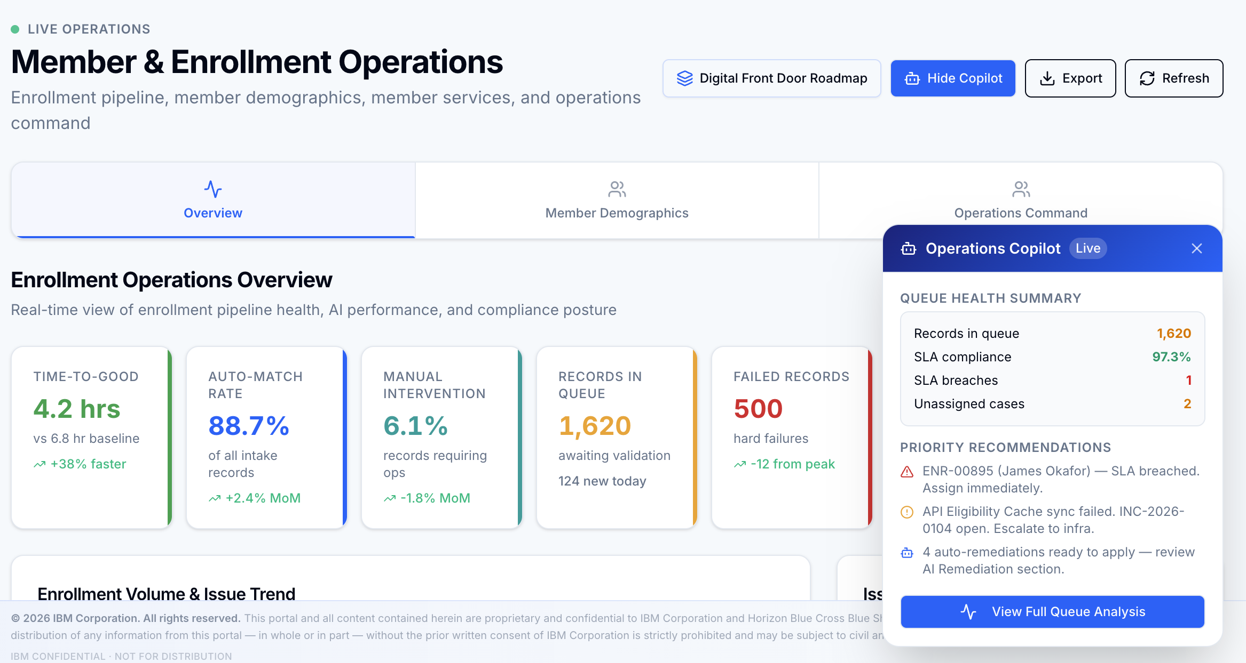  Figure 7: The HHEE integrates with the CareOps360 Enrollment Intelligence Hub in support of overall operations management. Illustrative data: live metrics upon go-live
  HHEE Hub | Purpose
  Trading Partner Hub | Channel partner intake configuration and management
  Processing Pipeline | End-to-end record flow: intake → validation → mastering → syndication
  Work Management | Queue management, exception triage, and intervention workflow
  Rules Engine Admin | Companion guide ingestion, rule hierarchy management, version control
  Operations Command Center | HHEE control tower, SLA forecasting, incident replay, routing health, Ops Copilot, agentically enabled
  Syndication & Reconciliation | Downstream system feed status and reconciliation
  Compliance & Audit | Regulatory traceability, exception log, full record-level audit trail

Staff Enablement & AI Readiness
How IBM's Delivery Capability Directly Enables Horizon's Transformation Outcomes
A Workforce Built for AI-First Delivery  IBM's transformation proposal is backed by a deeply credentialled, continuously upskilling delivery team that brings AI and automation expertise directly into Horizon's operating environment. Capability investment is not a separate training program — it is embedded into every phase of delivery, with certifications, automation coverage, and AI-readiness metrics tracked in CareOps360.  IBM is evolving the Horizon delivery model from traditional operations to AI-augmented and autonomous operations. Certified AI and ML resources are expanding significantly, automation coverage is scaling across all workflows, and delivery staff are being redeployed from manual tasks to higher-value advisory and engineering roles — directly enabling measurable transformation outcomes.  The Strategic Capability Narrative  IBM's people strategy for Horizon is threefold: certify deep expertise in AI, healthcare, and IBM platforms; automate the repeatable so people focus on the complex; and redeploy freed capacity toward the strategic programmes that matter most — Digital Front Door, Quote to Card, ICOE Modernization, and Mainframe Modernization.  Capability Metrics That Will Be Tracked  - Total certified professionals on the Horizon engagement — headcount and credential breakdown.  - AI/ML certifications: target growth trajectory month-over-month.  - Automation coverage: percentage of delivery processes with automation applied.  - Workforce AI-enabled percentage: share of team using AI tooling in daily delivery.  - FTE productivity gain: reduction in manual effort per unit of delivery output.  - Auto-remediation readiness: target capability milestone for self-healing operations. | Capability Dashboard  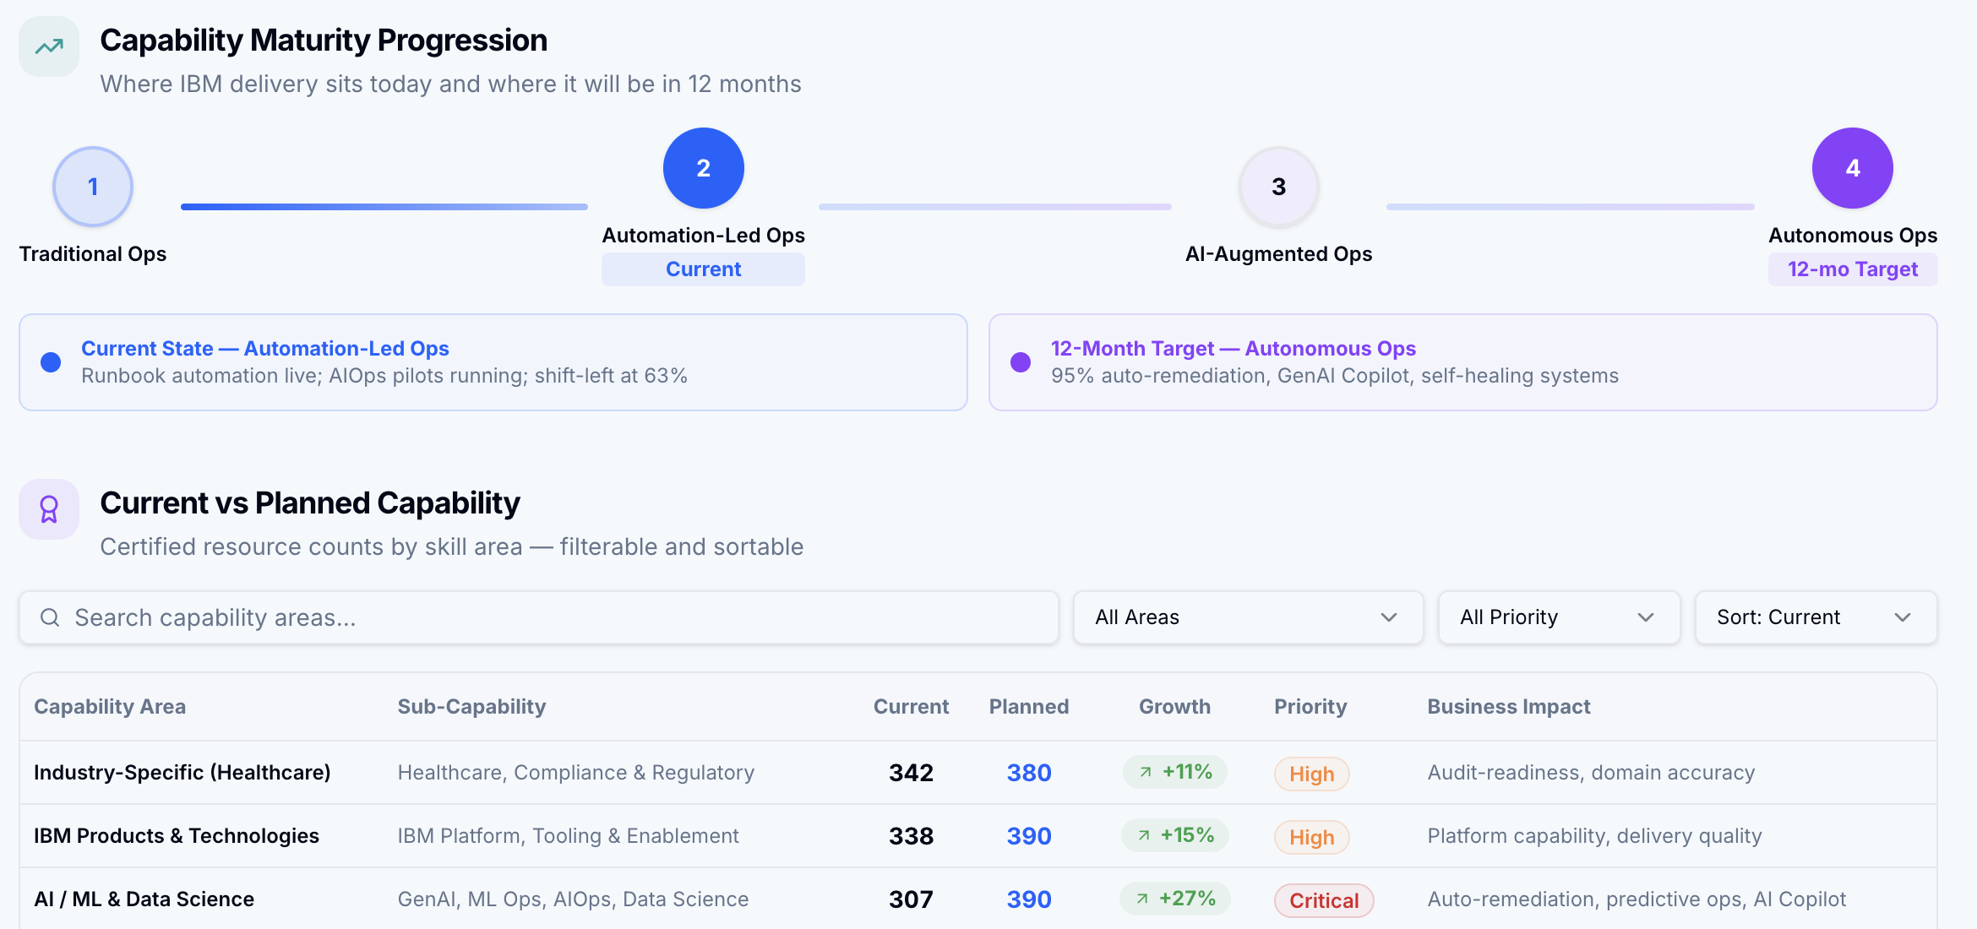  Figure 9: CareOps360 Capability Uplift Dashboard — certified resources, planned certifications, automation coverage, workforce AI-enablement, productivity gain, and auto-remediation readiness. Illustrative data: live metrics upon go-live.
  IBM Certification Domains at Horizon
  • AI / Machine Learning — model deployment, AIOps, LLM operations
  • Healthcare & Payer — BCBS models, CMS compliance, HIPAA
  • IBM Platform — consulting advantage, cloud architecture, hybrid cloud
  • Cloud Engineering — AWS, OpenShift, DevSecOps, SRE
  Capability Area | Metric Tracked | Target
  AI / ML Certifications | Certified professionals | Growth to plan
  Planned Certifications | Next 6–12-month pipeline | Headcount target
  Workforce AI-Enabled | % using AI daily | 78% by Month 12
  Automation Coverage | % processes automated | 91% by Month 12
  FTE Productivity Gain | Manual effort eliminated | Target agreed
  Auto-Remediation Ready | Self-heal milestone | Achieved Month 6

Transformation Opportunities
Co-create Digital Front Door, Quote to Card, Mainframe Modernization, and ICOE; Ideation, and business case creation are covered as part of Transformation Office responsibilities.
"IBM will invest alongside Horizon in the modernization programs that define the next decade of Horizon's competitiveness. These are not service-delivery engagements — they are strategic co-investments where IBM brings capital, capability, and commitment to shared outcomes."

Digital Front Door — IBM as Co-Builder  The Digital Front Door is Horizon's most visible member-facing transformation program. IBM will not merely provide delivery resources — IBM will co-design, co-build, and co-operate the unified digital engagement layer that gives Horizon members a seamless, AI-enhanced experience from plan discovery through care navigation.  This is a program where IBM brings its healthcare digital accelerators, member experience design patterns, and proven BCBS digital transformation playbook — reducing time to market, compressing risk, and ensuring Horizon is not starting from a blank page.  Quote to Card — Compressing the Purchase Cycle  Quote to Card is Horizon's highest near-term ROI digital initiative. IBM will co-invest in the design and delivery of a fully digital plan comparison, selection, and payment flow that enables prospective and renewing members to transact entirely within a digital channel — compressing the sales cycle from more than 4 months to weeks and directly reducing broker dependency for straightforward purchases.  Horizon's member, broker, and sales operations run on an 18-year-old, heavily customized Sales Cloud that faces forced API retirements already scheduled by Salesforce. This results in a process that takes 2–3x longer than the industry benchmark and is not amenable for seamless mobile access, AI activation and standard upgrades leading to market share erosion.  IBM proposes a self-funding, two-year roadmap expected to return $38–50M annually and gives Horizon's people back the time to do the work that wins business. |  | Mainframe Modernization — IBM as a Partner with AWS  Horizon's mainframe infrastructure is mission-critical — hosting eligibility processing, claims engine logic, financial settlement, and benefit adjudication. IBM understands that modernizing this estate is not merely a technical program — it is a strategic risk management exercise that must be executed with surgical precision.  IBM proposes a phased, parallel-run migration approach — wrapping mainframe workloads with modern APIs before cloud rehosting, running parallel environments until transaction equivalence is validated, and only cutting over when all stakeholders have confidence. IBM brings AI-assisted COBOL-to-Java conversion tooling that compresses the code conversion timeline by 40–60% compared to manual approaches.  ICOE Modernization — IBM as Architecture Partner  The current integration landscape is complex and costly, driven by heavy reliance on Informatica, fragmented integration patterns, and high customization effort for vendor feeds—leading to slow data delivery and limited agility. IBM solution is to modernize to a Databricks-centric, event-driven architecture with standardized data contracts and AI-assisted automation, enabling real-time data flow, reducing manual effort, and significantly improving scalability, speed, and cost efficiency
  IBM's commitment: Every modernization investment IBM makes at Horizon compounds Horizon's long-term competitive capability — not IBM's dependency. The goal is a Horizon that operates better, faster, and smarter with every program completed.
ICA + AIOps  AI-Infused Delivery | 60+  Modernization Initiatives |  | Zero  Disruption Commitment
Why IBM as Your Transformation Partner
Scale, Depth, and Skin in the Game
IBM is the only partner that brings together AI-first operating platform capability, Horizon's institutional knowledge, deep healthcare payer domain expertise, proven global delivery scale, and a willingness to share outcome risk through an outcome-based engagement model.

Enterprise Transformation, Not Just IT  IBM's proposal delivers unified transformation across Operations, Development, and Quality Engineering — not siloed initiatives that optimize one tower while creating drag in another.  IBM's delivery philosophy — AI-Embedded Operations, Scalable Architecture, and Outcome-Based Engagement — ensures that every IBM investment compounds Horizon's capability, not IBM's margin.  What Differentiates IBM  - Skin in the game: Outcome-based engagement with IBM's full capability depth behind every phase — IBM's success is tied to Horizon's outcomes.  - AI at depth, not at surface: IBM's Agentic AI, Generative AI, and AIOps capabilities are production-proven across healthcare and financial services — not proof-of-concept.  - IBM Consulting Advantage: Horizon will realize accelerated value through IBM Consulting’s portfolio of 6,500+ assets and accelerators, strategic initiatives such as BOB.  - Transformation Office: IBM commits a structured quarterly innovation process — governed, prioritized, business-case-backed innovation at Horizon's direction. | IBM's Global Delivery Strength  Healthcare Payer Pedigree  IBM brings deep healthcare payer expertise — including BCBS operating models, CMS regulatory compliance, HIPAA data governance, enrollment lifecycle management, and claims adjudication platform knowledge — directly into Horizon's delivery team from Day 1.
  20K+  AI Practitioners | 81K+  Cloud Experts
  40K+  AI Engagements | 15K+  Global Centers
  Key References
  • AWS Partner of the Year 2025 — Enterprise AI delivery
  • Leader in Enterprise Software Quality & Testing
  • Proven BCBS engagement track record
  • CMS & HIPAA compliance expertise
In 2025 and 2026, Gartner named IBM as a Leader across seven data and AI-related Gartner Magic Quadrants. We believe this reflects IBM’s ability to execute consistently across every layer of the AI lifecycle—not just in one area.
Data and AI-related Magic Quadrants that name IBM a Leader:
- 2025 Magic Quadrant for Data Science and Machine Learning
- 2025 Magic Quadrant for AI Application Development Platforms
- 2025 Magic Quadrant for Cloud Database Management Systems
- 2026 Magic Quadrant for Data and Analytics Governance.
- 2025 Magic Quadrant for Data Integration Tools
- 2025 Magic Quadrant for Metadata Management Solutions
- 2026 Magic Quadrant for Augmented Data Quality

Recommended Next Steps
From Proposal to Partnership — IBM's Proposed Engagement Path
Immediate Actions (2–4 Weeks)  - Schedule Executive Alignment Session — IBM VP + Horizon CIO/COO to confirm transformation vision and program scope.  - Conduct Command Center Walkthrough — Live demonstration of CareOps360, AIOps, ICA , Project BOB with Horizon's operational and technology leadership.  - Initiate Contract Finalization — Confirm outcome-based SLA schedule and investment model.  - Begin Phase 0 Foundation Assessment — IBM AMS team on-site to conduct application portfolio and AIOps baseline assessment.  Phase 0 Commitments (Weeks 1–12)  - Week 1–2: IBM transition team mobilized; AIOps instrumentation begins across priority applications.  - Week 3–4: ICOE architecture definition workshop; Quote to Card KPI alignment roadmap delivered.  - Week 5–6: Phase 1 Ignite plan presented to Steering Committee.  - Week 7–8: Transformation Office inaugural session — first idea pipeline scoped  - Week 8–12: AIOPs platform live on production | What IBM Needs from Horizon  - Executive sponsorship confirmed with a named Horizon program owner.  - Access to application inventory, current SLA performance data, and AMS tooling estate.  - ARB and Gen AI Board Review  - Agreement on data governance and security protocols for CareOps360 production integration.  Appendix: Workforce Certification  As of April 2026, IBM's delivery team at Horizon carries 382 certified professionals AI/ML (307), Healthcare (342), IBM Products (338), and Cloud (250) domains. This credentialled workforce directly enables the AI-first delivery model described in this proposal.
  IBM is ready to begin. With your confirmation, Phase 0 can mobilize within 5 business days.

A Strategic Partnership for Enterprise Transformation
IBM is committed to Horizon's success — not as a vendor, but as a transformation partner with shared stakes in every outcome.

© 2026 IBM Corporation · IBM-HZN-AMS-RFP-2026-CAS · Confidential — Executive Use Only · All figures based on IBM program data and industry benchmarks.

Appendix A — Program Initiative Register
60 Initiatives Across Upgrade, Ticket Reduction & Transformation — April 2026 Baseline
This register is sourced from the Horizon program roadmap (April 2026). All initiatives are tracked live in CareOps360's Transformation Roadmap dashboard — with phase, status, owner, and risk updated in real time. See Appendix reference in Section 02.

25  Platform Upgrades | 19  Ticket Reductions | 16  Transformation Program | 60  Total Initiatives

Section 1 — Platform & Framework Upgrades (n-1 Compliance) (25)
ID | Domain | Product / Application | Status | Expected Outcome
HLGN-1001 | Enterprise Platforms | IBM ODM | Active | 40% improvement in rules processing speed; AI-assisted decision support
HLGN-1002 | Digital | WAM SSO | Active | Enhanced security posture, modern UI for 3,200+ internal users
HLGN-1003 | Enterprise Platforms | Internal Cloud Apps (×8) | Completed | Standardized Angular 17 baseline; eliminated CVE-2022-25869 vulnerability class
HLGN-1004 | Payer | Fee Schedule Repository | Planned | LTS compliance; 25% fee processing performance gain
HLGN-1005 | Payer | GroupFee Application | Planned | Shared codebase benefits; 20% lower group fee maintenance cost
HLGN-1006 | Enterprise Platforms | NAR Windows Platform | Completed | EOL server risk eliminated; security posture hardened
HLGN-1007 | Clinical | CareRadius Angular Frontend | Active | Modern UI components, improved page load, enhanced maintainability
HLGN-1008 | Clinical | CareRadius VB6 Legacy | Planned | VB6 runtime eliminated; 60% reduction in legacy-related incident tickets
HLGN-1009 | Clinical | CareRadius SAP BO | Active | Improved report performance, new visualizations, renewed vendor support
HLGN-1010 | Digital | Communication Services | Active | Enhanced member notifications, improved mobile responsiveness
HLGN-1011 | Enterprise Platforms | Doc Portal | Planned | Modern document management; 30% improved search/retrieval performance
HLGN-1012 | Enterprise Platforms | Horizon ECM | Planned | Improved content workflow; modern security standards compliance
HLGN-1013 | Data & Analytics | Cognos BI | Completed | AI-assisted insights, improved cloud connectivity and dashboard performance
HLGN-1014 | Data & Analytics | Tableau Analytics | Completed | Pulse AI analytics integration, improved extract performance
HLGN-1015 | Payer | Membership System | Active | 50% processing time reduction; real-time eligibility verification
HLGN-1016 | Data & Analytics | MPD Mainframe Extracts | Planned | Near real-time data; batch windows reduced from 6hrs to 45min
HLGN-1017 | Payer | Route Code Eligibility | Planned | Real-time eligibility routing; reduced manual intervention
HLGN-1018 | Payer | EDI Eligibility Data Store | Planned | Expanded trading partner support; eligibility disputes reduced 25%
HLGN-1019 | Digital | Consumer Data Management | Planned | Improved self-service capabilities; modern accessibility standards (WCAG)
HLGN-1020 | Payer | Personal Representative Mgmt | Planned | Platform support through 2029; improved performance; security compliance
HLGN-1021 | Payer | NASCO | Planned | Enhanced NASCO feature set; improved SLA compliance; HIPAA 2024 readiness
HLGN-1022 | Payer | Legacy Finance Platform | Planned | Unsupported .NET 3.5 eliminated; 35% improvement in financial processing
HLGN-1023 | Payer | Universal Payment System | Active | PCI DSS 4.0 compliance; improved payment reliability and audit trail
HLGN-1024 | Enterprise Platforms | Image Plus | Active | Improved document processing speed; enhanced OCR accuracy; vendor renewal
HLGN-1025 | Payer | Financial Reporting Suite | Planned | Unified technology stack; 20% lower maintenance cost

Section 2 — Ticket Reduction Initiatives (Automation & Quality Improvement) (19)

Jira ID | Domain | Product / Application | Status | Expected Outcome
HLGN-1026 | Payer | IDR System | Completed | ~120 monthly tickets eliminated; 100% automation of SSN randomization updates
HLGN-1027 | Payer | HMU | Active | ~85 monthly data discrepancy tickets eliminated via timestamp fix
HLGN-1028 | Payer | Billing Portal | Active | ~200 monthly tickets reduced; 2-day SLA improvement for billing resolution
HLGN-1029 | Data & Analytics | Data Load Pipeline | Completed | 60% reduction in data load anomaly tickets across 12 reporting systems
HLGN-1030 | Payer | Claims Audit Engine | Active | ~150 monthly audit exception tickets eliminated via automated reconciliation
HLGN-1031 | Enterprise Platforms | API Management | Active | ~75 monthly API support tickets reduced; improved developer self-service
HLGN-1032 | Enterprise Platforms | File Processing Service | Completed | ~60 monthly operations tickets eliminated; 4-hour batch window reduction
HLGN-1033 | Digital | Broker Sales Portal | Planned | ~90 monthly portal tickets reduced for complex subgroup configurations
HLGN-1034 | Payer | Member Enrollment System | Planned | ~110 monthly enrollment error tickets reduced; 15% clean submission improvement
HLGN-1035 | Enterprise Platforms | ChatOps Platform | Planned | ~130 monthly incident tickets consolidated; MTTR reduced by 40%
HLGN-1036 | Clinical | Authorization Integration | Active | ~95 monthly authorization error tickets prevented via partner validation
HLGN-1037 | Payer | Member Data Hub | At Risk | ~180 monthly member discrepancy tickets — MDM governance (recovery plan active)
HLGN-1038 | Payer | MPV Processing | Completed | ~70 monthly reprocessing tickets eliminated; 78% reduction sustained in production
HLGN-1039 | Digital | Survey Platform | Planned | ~45 monthly survey tickets proactively resolved via ELK monitoring alerts
HLGN-1040 | Payer | Membership Workflow Engine | Planned | ~65 monthly DB update delay tickets eliminated via queue management improvements
HLGN-1041 | Digital | IVR Platform | Planned | ~55 monthly IVR configuration tickets eliminated; real-time plan data in IVR
HLGN-1042 | Payer | Premium Rating Engine | At Risk | ~80 monthly rating mismatch tickets — vendor data quality (recovery plan active)
HLGN-1043 | Payer | Claims Adjudication | Completed | ~100 monthly escalation tickets reduced; 20% improvement in first-contact resolution
HLGN-1044 | Digital | Broker Management Portal | Planned | ~90 monthly manual broker update tickets via broker self-service portal launch

Section 3 — Strategic Transformation Program (16)

Jira ID | Domain | Product / Application | Status | Expected Outcome
HLGN-1045 | Payer | SHBS-UPS | Planned | MS Access dependency eliminated; multi-user access; full audit trail compliance
HLGN-1046 | Enterprise Platforms | CareOps360 | Active | 90% reduction in executive reporting cycle time; real-time operational decision support
HLGN-1047 | Enterprise Platforms | IBM BAW | Active | 80% reduction in manual workflow handling time; full audit trail for regulated processes
HLGN-1048 | Payer | IKA | Planned | Straight-through processing for 95% of eligibility; manual intervention near zero
HLGN-1049 | Payer | HVCPS | Planned | 99.9% payment calculation accuracy; auto-reconciliation eliminating manual review
HLGN-1050 | Data & Analytics | OnDemand | Planned | Report delivery from 48hrs to real-time self-service; 80% IT reporting ticket reduction
HLGN-1051 | Digital | HLGS Document Generation | Planned | 40% letter generation cost reduction; multi-channel delivery; real-time composition
HLGN-1052 | Provider | IPA | Planned | Provider audit cycle 30→10 days; 60% manual effort reduction; provider satisfaction up
HLGN-1053 | Enterprise Platforms | MOM Integration Hub | Planned | API-first hub replacing batch; real-time event streaming; 50% integration cost reduction
HLGN-1054 | Enterprise Platforms | IBM ODM Cloud-Native | Planned | Business-user-configurable rules; IT rule-change tickets → zero; sub-second evaluation
HLGN-1055 | Payer | SBC Compliance Automation | Planned | 100% ERISA/ACA SBC compliance; automated generation and distribution across all plans
HLGN-1056 | Digital | Smartcomm Cloud Platform | Planned | 50% document production cost reduction; omni-channel delivery; centralized brand control
HLGN-1057 | Data & Analytics | Enterprise BI (Power BI) | Planned | 40% analytics licensing cost reduction; single platform for 1,200+ business users
HLGN-1058 | Provider | CAGUI Pharmacy Crosswalk | Planned | 70% manual crosswalk effort reduced; automated alignment across 15,000+ provider contracts
HLGN-1059 | Clinical | Prior Auth AI Engine | Planned | 85% auto-approval rate; auth cycle 3 days→4 hours; $4.2M annual cost avoidance
HLGN-1060 | Digital | GenAI Member Engagement | Planned | 25% engagement improvement; 18% care gap closure; 30% contact center deflection

Source: Horizon BCBS Program Roadmap — horizon-roadmap-all-2026-04-10. All status, timelines, and outcomes are per April 2026 baseline. IBM committed delivery targets are formally agreed at contract commencement. At-Risk initiatives have active recovery plans in place.

