AI-FIRST APPLICATION MANAGEMENT SERVICES
Transforming Horizon BCBS
Into a Predictive, Self-Healing, AI-Driven Enterprise

Submitted by:  IBM Consulting  Healthcare & Payer Delivery — AMS Practice  Submitted to:  Horizon Blue Cross Blue Shield of New Jersey  Executive Leadership & Technology Office | Document Classification:  CONFIDENTIAL  Date:  April 2026  Reference:  IBM-HZN-AMS-RFP-2026-CAS

Powered by IBM AIOps · IBM Consulting Advantage · HIPAA Compliant · © 2026 IBM Corporation

Executive Summary
A Strategic Proposal for AI-Led Transformation of Application Management Services
"IBM is not proposing a technology project — IBM is proposing a transformation partnership that embeds AI-driven intelligence into the operating model of Horizon BCBS, enabling a future-ready enterprise that is faster, smarter, and more resilient than today."

The Moment  Horizon BCBS stands at a pivotal inflection point. With approximately 500 applications spanning enrollment, claims adjudication, member services, and data platforms, the organisation faces mounting pressure to modernise operations, reduce administrative burden, and deliver measurably better member and provider experiences.  The incumbent delivery model — reactive, labour-intensive, and fragmented across towers — is no longer sufficient to meet Horizon's growth objectives or competitive imperatives.  What IBM Proposes  IBM proposes a structured transition from reactive application support to a predictive, self-healing, and continuously improving AI-first operating model — delivered through IBM's proven Assets, Assistants, and Accelerators framework, and governed through an outcome-based accountability model.  Value Realization — Live Portal Metrics  CareOps360, IBM's purpose-built executive command centre, surfaces live operational intelligence across all AMS towers. The metrics below are drawn directly from the running production-equivalent environment as of April 2026:  4.29M Active Members under management $1.69B Claims settled (7 days)  99.4% Application availability 96.8% SLA attainment  $3.2M YTD automation savings 47 sec Call Centre ASA  $12M+ Projected annual AIOps savings at full deployment | 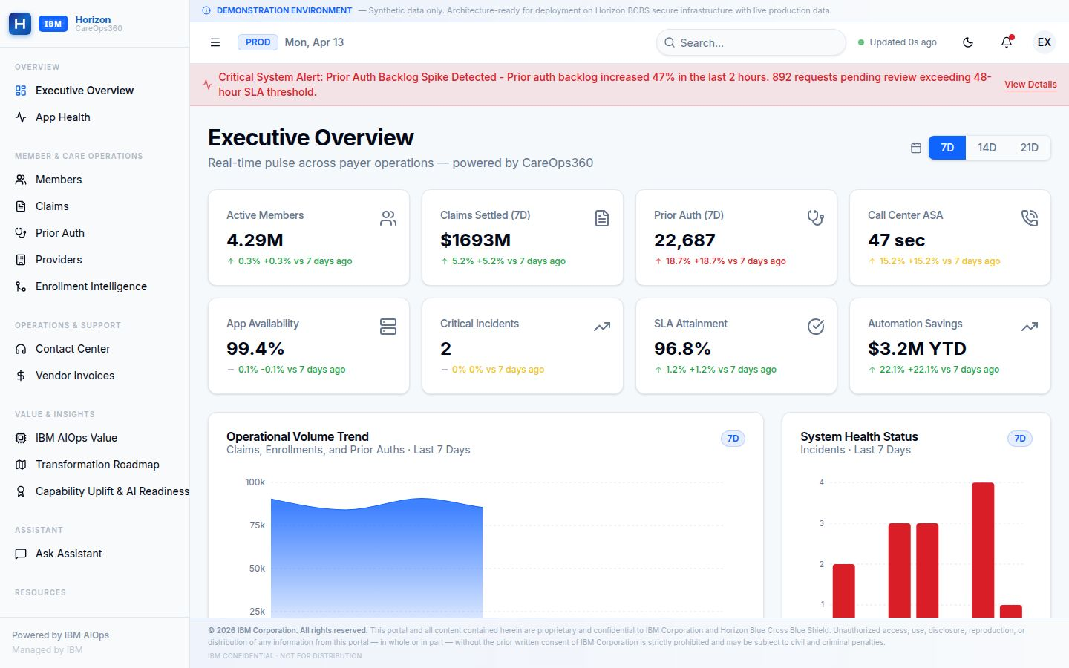  Figure 1: CareOps360 Executive Dashboard — live operations as of April 13, 2026  Five Strategic Commitments  - AI-First Operating Model — AI embedded across every layer of AMS and QA lifecycle.  - Tech Arbitrage over Labour Arbitrage — Compressing cost through automation, not headcount.  - Outcome-Based Delivery — Committed SLAs tied to measurable business outcomes.  - Zero-Disruption Transition — Risk-free phased transition protecting operational continuity.  - Continuous Innovation Engine — Horizon Innovation Council driving sustained value beyond steady state.
  IBM's Scale Behind This Proposal
  • 20,000+ AI & data practitioners globally
  • 81,000+ cloud & architecture experts
  • 40,000+ AI & analytics engagements
  • 15,000+ people across 40 global delivery centres
  • Leader in Enterprise Software Quality & Testing

4.29M  Active Members Managed | $3.2M  YTD Automation Savings | 99.4%  Application Availability | $12M+  Projected Annual AIOps

The Transformation Imperative
Understanding Horizon's Strategic Objectives and IBM's Solution Design Rationale
What Horizon Needs  Horizon BCBS is seeking the right strategic partner to enhance and support its Application Development, Maintenance, Data, and Testing Services — with a clear focus on AI solutions and expertise native to the Horizon environment.  Service Transformation Goals  - High-quality services delivered through AI and automation to obtain operational efficiencies.  - Realization of a product-oriented operating model.  - Focused automation — especially in testing and quality engineering.  - AI tools to drive application modernisation across the portfolio.  - Consultative support applying deep healthcare payer best practices.  Cost Structure Expectations  Horizon expects structural cost reduction — not just efficiency gains. The fixed baseline model signals a clear expectation: year-over-year productivity improvements and cost takeout driven by automation and AI, not rate arbitrage. | Factors That Shaped IBM's Solution  - End-to-End Integrated Delivery: A unified operating model across Application Maintenance, Development, Testing, and Data — reducing fragmentation and improving accountability across the full lifecycle.  - AI at the Core: Not bolted on. AI is embedded in triage, root cause analysis, resolution, test automation, and continuous validation — from the first day of delivery.  - Transition Without Disruption: IBM's phased transition approach maintains seamless service continuity while progressively modernising the underlying operating model.  - Open, Elastic Architecture: Plug-and-play architecture allows IBM to deploy on Horizon's existing AWS stack or any cloud ecosystem — avoiding lock-in and enabling flexibility.
  IBM's solution shifts Horizon from reactive incident management to predictive, autonomous operations

Figure 1: Current vs. Target — Automation Coverage by Domain
Incident Triage |  | 45%
Test Execution |  |  | 38%
Root Cause Analysis |  |  | 22%
Change Risk Scoring |  |  | 18%
Deployment Validation |  |  | 15%
Estimated baseline automation coverage across AMS domains (current state). IBM's proposal targets 80%+ automation across all domains within 12 months.

CareOps360 Command Center
IBM's Executive Operations Platform for Real-Time AMS Visibility at Horizon
What Is CareOps360?  CareOps360 is IBM's production-grade executive operations platform purpose-built for the Horizon BCBS engagement. It delivers real-time operational intelligence across all AMS towers — enrollment, applications, infrastructure, and quality — through a single, unified command centre accessible to Horizon's executive and operational leadership.  Built on IBM's AIOps observability framework, CareOps360 surfaces predictive insights, SLA performance, enrollment intelligence, digital front door metrics, and transformation roadmap progress in real time.  Key Capabilities  - Real-time application health monitoring across 500+ applications.  - Enrollment Intelligence dashboard with predictive surge modelling.  - Digital Front Door programme tracking — Quote to Cart, member activation, channel metrics.  - IBM AIOps value realisation — MTTR trends, automation coverage, incident economics.  - Transformation Roadmap — live phase progress and milestone tracking.  - Auto-export, session logging, and HIPAA-compliant audit trail. | Platform Architecture  CareOps360 is built on a modern, cloud-native stack with real-time data polling from IBM's AIOps and observability layers. It features:  - PostgreSQL + Drizzle ORM for structured operational data.  - Session-authenticated access with auto-logout on inactivity.  - Dark/light mode, disclaimer banners, and structured export.  - API-connected to IBM's AIOps event correlation and analytics engines.
  Access & Security
  • Role-based access: IBM and Horizon executives
  • Token-authenticated sessions with inactivity timeout
  • All data HIPAA-compliant — no PHI in demonstration mode
  • Architecture-ready for production data integration

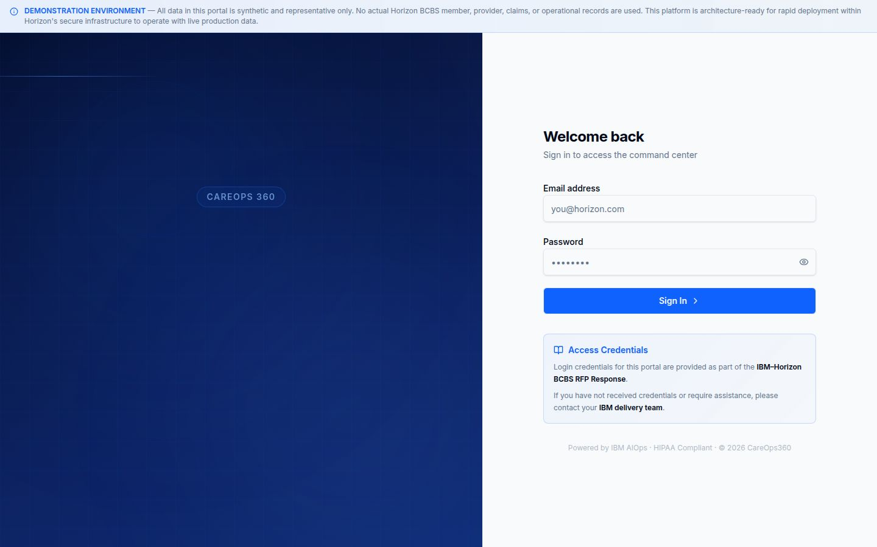
Figure 2: CareOps360 Command Center — IBM's executive operations portal for Horizon BCBS leadership. Secured access with IBM AIOps integration.

Digital Front Door & Quote to Cart Initiatives
Transforming Member Engagement from Reactive Service to Intelligent Self-Service
The Digital Front Door Vision  The Digital Front Door (DFD) program is the centrepiece of Horizon's member experience transformation. IBM's role is to design, build, and operate a unified digital engagement layer that replaces fragmented channel experiences with a seamless, AI-enhanced member journey — from plan discovery through to claims and care navigation.  For Horizon's leadership, DFD is not merely a web or mobile initiative — it is a fundamental shift in how the health plan relationships with its members: from reactive, call-centre-dependent service to proactive, intelligent digital engagement.  Quote to Cart — Horizon's Highest Near-Term ROI Initiative  Quote to Cart enables prospective and renewing members to receive a personalised plan quote, compare options, select coverage, and complete payment — entirely within a digital channel. This compresses the sales cycle from days to minutes and directly reduces broker dependency for individual and small-group purchases. | DFD Programme Roadmap
  Phase | Focus Area | Status
  Phase 1 | Digital Identity & Member Portal | Complete
  Phase 2 | Online Enrollment & Self-Service | In Progress
  Phase 3 | Quote to Cart & Payment Rails | In Progress
  Phase 4 | AI Personalisation Engine | Q3 2026
  Phase 5 | Autonomous Member CX | 2027
  Quote to Cart compresses the plan purchase cycle from days → minutes and eliminates broker intermediation for straightforward purchases.

Figure 3: Target Digital Self-Service Adoption Rates by Member Transaction Type
Online Enrollment |  |  | 85%
Plan Comparison (QTC) |  |  | 78%
Digital ID Card |  | 95%
Claims Status |  |  | 90%
Provider Search |  |  | 82%
Benefits Inquiry |  |  | 75%
Target digital self-service adoption rates across key member transaction types following DFD programme completion.

AIOps & Agentic AI Operations
From Reactive Incident Management to Autonomous, Self-Healing Operations
IBM's Agentic AI framework shifts Horizon from reactive incident handling to proactive, AI-driven real-time diagnosis and autonomous resolution

The Agentic AI Architecture  IBM's AIOps framework is built on a multi-agent architecture where specialised AI agents handle distinct responsibilities across the incident lifecycle — from detection through resolution and continuous learning.  Agent Roles  - Help Desk Agent: Delivers context-aware guidance and automated actions to help users auto-resolve issues before ticket creation.  - Triage Agent: Prioritises tickets based on impact, urgency, and historical patterns — eliminating manual queue management.  - Root Cause Analysis Agent: Correlates signals across 140+ monitoring sources to identify root cause within minutes.  - Resolution Agent: Suggests or executes remediation steps based on runbooks and past resolutions.  - Runbook Generation Agent: Auto-generates and updates runbooks from resolved incidents — compounding operational knowledge over time.  - Continuous Learning Agent: Feeds production telemetry back into all agents, ensuring progressive improvement with every incident cycle. | Value Realization  Built on Horizon's AWS Stack  - Agent Layer: AWS AgentCore & Bedrock  - Model Layer: AWS Bedrock with native Guardrails  - Vector Store: AWS OpenSearch + PostgreSQL  - Integrations: ServiceNow · Dynatrace · CloudWatch · OpenShift  - IBM ContextForge for institutional knowledge management
  Metric | Baseline | With AIOps
  MTTR (Mean Time to Resolve) | 4.2 hrs | < 1.8 hrs
  Alert Noise per Shift | High | > 60% Reduced
  P3/P4 Auto-Resolution | < 10% | > 74%
  Change Failure Rate | Baseline | 40% Reduction
  System Availability | 99.7% | 99.95%
  Ops Manual Triage Hours | Full load | ~30% Reduction
  ✓ ARB Approval Secured  Architecture Review Board | ✓ GenAI Board Approved  Horizon GenAI Governance

Figure 4: Incident Resolution Time Reduction by Severity Category (IBM AIOps vs. Baseline)
P1 — Critical |  |  | 57% faster
P2 — High |  |  | 48% faster
P3 — Medium |  |  | 65% faster
P4 — Low |  | 80% faster
Change-Induced |  |  | 40% faster
Projected incident resolution time improvements by severity following Agentic AI deployment. Percentages represent reduction vs. baseline MTTR.

Platform Modernization
ICOE Modernization, Mainframe Migration & Application Rationalization
ICOE Modernization  IBM's Integration Centre of Excellence (ICOE) Modernization program restructures IBM's delivery organization to align with Horizon's evolving platform landscape — introducing DevSecOps pipelines, product-centric engineering squads, and shared services for API management, identity, and data integration.  ICOE Deliverables  - Dedicated engineering squads aligned to Horizon product and platform domains.  - DevSecOps pipelines replacing manual release management processes.  - Integration Simplification roadmap — reducing point-to-point complexity.  - Document Generation Modernization (HLGS upgrade roadmap).  - Observability and SRE practices for proactive system health management.  Application Rationalisation  IBM will conduct a structured assessment of Horizon's ~500 application portfolio using the BUILD ONCE, BENEFIT (BOB) framework — identifying candidates for decommission, consolidation, cloud migration, or AI-augmented modernization. | Mainframe Modernization Roadmap  Horizon's mainframe hosts critical batch processing, eligibility logic, and financial settlement. IBM's strategy executes phased migration preserving continuity:
  Workstream | Approach | Timeline
  Eligibility Processing | API-wrap → Cloud rehost | Q2–Q4 2026
  COBOL → Java Pilot | AI-assisted code conversion | Q3 2026
  Unified Payments | AWS modernisation | Q3 2026
  Claims Engine | Parallel-run cutover | Q1–Q2 2027
  Member Data Services | Event-driven migration | Q4 2026+
  Technical Debt Governance
  • All stacks maintained to n-2 versions
  • Architecture Review Board (IBM + Horizon)
  • Rollback gates at every migration phase
  • Zero-disruption contractual commitment

~500  Applications Assessed | COBOL→Java  AI-Assisted Conversion | n-2  Stack Version Governance | Zero  Disruption Commitment

Quality Engineering & AI-Augmented Development
Measurable Quality at Every Milestone — Improved with Every Release
Self-Improving Quality Framework  IBM's Quality Engineering model embeds measurable validation checkpoints across every stage of development and production — creating a closed-loop feedback system within the CI/CD pipeline. Production insights, defect analytics, and automation metrics continuously refine testing strategies, enabling sustained defect reduction, faster recovery, and progressive quality improvement over time.  Quality Controls  - End-to-end traceability and release readiness visibility.  - Defect leakage, density, and stability metrics (MTTR).  - Automation coverage with KPI-driven governance.  - AI-driven defect insights and regression optimisation.  - Production telemetry feeding back into test strategy.  Intelligent Test Automation  IBM's Generative AI capabilities enable self-generating test cases, automated test maintenance, and continuous validation integration — dramatically reducing the cost and time associated with regression testing across Horizon's complex, multi-system portfolio. | AI-Augmented Development Model  IBM transforms Horizon's engineering model from a traditional project-centric approach to a modern, product-centric engineering organisation — powered by IBM Consulting Advantage accelerators and the BUILD ONCE, BENEFIT (BOB) framework of reusable enterprise assets.  AI-Assisted Development  - Generative AI tools accelerate code generation, review, documentation, and optimisation.  - Reduces developer toil and elevates focus to high-value engineering.  - IBM Consulting Advantage accelerators compress time-to-value.  DevSecOps Integration  - Security embedded "left" into CI/CD pipelines.  - Automated vulnerability scanning at every stage.  - Compliance gates and policy enforcement from commit to production.
  Target: 80% test automation coverage across Horizon's application portfolio within 12 months of full deployment.

Figure 5: Quality KPI Improvement Targets — 12-Month Programme
Test Automation Coverage |  | 80%
Defect Escape Rate Reduction |  |  | 65%
Regression Cycle Time Cut |  |  | 70%
Test Maintenance Effort Reduced |  |  | 55%
Production Incident Rate |  |  | 40%
IBM's quality engineering targets for Horizon's AMS portfolio at 12-month programme maturity.

Phased Transformation Roadmap
A Structured, Compounding Journey from Stabilization to Autonomous Operations
IBM's proposed transformation follows a structured, phased approach — delivering quick wins in the immediate term while building the foundation for long-term enterprise transformation. Each phase builds on the last, compounding value across the portfolio.

Phase 0 — Foundation  0–8 Weeks | Phase 1 — Ignite  1–3 Months | Phase 2 — Scale  3–6 Months | Phase 3 — Optimise  6–12 Months
› Command Center assessment & blueprint  › ICOE architecture definition  › Quote to Cart KPI alignment roadmap  › AIOps baseline measurement  › Risk-free transition planning | › Integration Simplification & ICOE Modernization Roadmap  › Document Generation modernization (HLGS)  › Initial AIOps and monitoring deployment  › Test automation framework initiation  › Innovation Council formation | › Unified Payments & Mainframe modernization  › COBOL → Java modernization pilot  › AI-assisted Dev + Intelligent QA rollout  › Digital Front Door Phase 2–3 delivery  › Agentic AI incident triage live | › Agentic AI for full incident autonomy  › Quote to Cart full production launch  › Claims adjudication parallel-run initiated  › GenAI development lifecycle integrated  › Predictive capacity management live

Phase 4 — Transform (12–24 Months)  - Full autonomous operations for P3/P4 incidents.  - Mainframe eligibility processing on AWS — production.  - AI personalization engine live (DFD Phase 4).  - COBOL → Java migration complete for pilot workstream.  - Enterprise-wide observability platform fully deployed.  - Claims adjudication cutover initiated. | Governance at Every Phase  - Executive Steering Committee: Quarterly IBM VP + Horizon CIO/COO review.  - Programme Management Office: Monthly health reporting and risk register.  - Delivery Operations Reviews: Bi-weekly SLA and incident trends.  - Financial Governance: Monthly actuals vs. committed model.  - Innovation Council: Quarterly idea pipeline and prioritisation.

Why IBM as Your Transformation Partner
Scale, Depth, and Skin in the Game
IBM is the only partner that brings together AI-first operating platform capability, deep healthcare payer domain expertise, proven global delivery scale, and a willingness to share outcome risk through an outcome-based engagement model.

Enterprise Transformation, Not Just IT  IBM's proposal delivers unified transformation across Operations, Development, and Quality Engineering — not siloed initiatives that optimise one tower while creating drag in another.  IBM's delivery philosophy — AI-Embedded Operations, Scalable Architecture, and Outcome-Based Engagement — ensures that every IBM investment compounds Horizon's capability, not IBM's margin.  What Differentiates IBM  - Skin in the game: Outcome-based engagement with IBM's full capability depth behind every phase — IBM's success is tied to Horizon's outcomes.  - AI at depth, not at surface: IBM's Agentic AI, Generative AI, and AIOps capabilities are production-proven across healthcare and financial services — not proof-of-concept.  - The BOB Framework: IBM's BUILD ONCE, BENEFIT reusable asset library compresses implementation time and reduces per-solution cost across the portfolio.  - Innovation Council: IBM commits a structured quarterly innovation process — governed, prioritised, business-case-backed innovation at Horizon's direction. | IBM's Global Delivery Strength  Healthcare Payer Pedigree  IBM brings deep healthcare payer expertise — including BCBS operating models, CMS regulatory compliance, HIPAA data governance, enrollment lifecycle management, and claims adjudication platform knowledge — directly into Horizon's delivery team from Day 1.
  20K+  AI Practitioners | 81K+  Cloud Experts
  40K+  AI Engagements | 15K+  Global Centres
  Key References
  • Partner of the Year 2023 — Enterprise AI delivery
  • Leader in Enterprise Software Quality & Testing
  • Proven BCBS engagement track record
  • CMS & HIPAA compliance expertise

Recommended Next Steps
From Proposal to Partnership — IBM's Proposed Engagement Path
Immediate Actions (2–4 Weeks)  - Schedule Executive Alignment Session — IBM VP + Horizon CIO/COO to confirm transformation vision and programme scope.  - Conduct Command Center Walkthrough — Live demonstration of CareOps360 platform with Horizon's operational and technology leadership.  - Initiate Contract Finalisation — Confirm outcome-based SLA schedule and investment model.  - Begin Phase 0 Foundation Assessment — IBM AMS team on-site to conduct application portfolio and AIOps baseline assessment.  Phase 0 Commitments (Weeks 1–8)  - Week 1–2: IBM transition team mobilised; AIOps instrumentation begins across priority applications.  - Week 3–4: ICOE architecture definition workshop; Quote to Cart KPI alignment roadmap delivered.  - Week 5–6: Phase 1 Ignite plan presented to Steering Committee.  - Week 7–8: Innovation Council inaugural session — first idea pipeline scoped. | What IBM Needs from Horizon  - Executive sponsorship confirmed with a named Horizon program owner.  - Access to application inventory, current SLA performance data, and AMS tooling estate.  - Introduction to Horizon's technology and operations leadership teams.  - Agreement on data governance and security protocols for CareOps360 production integration.  Appendix: Workforce Certification  As of April 2026, IBM's delivery team at Horizon carries 382 certified professionals across 4,599 certifications spanning AI/ML (307), Healthcare (342), IBM Products (338), and Cloud (250) domains. This credentialled workforce directly enables the AI-first delivery model described in this proposal.
  IBM is ready to begin. With your confirmation, Phase 0 can mobilise within 5 business days.

A Strategic Partnership for Enterprise Transformation
IBM is committed to Horizon's success — not as a vendor, but as a transformation partner with shared stakes in every outcome.

© 2026 IBM Corporation · IBM-HZN-AMS-RFP-2026-CAS · Confidential — Executive Use Only · All figures based on IBM programme data and industry benchmarks.

