LAVA: A Lightweight Benchmarking Framework for Robust and Real-Time Deepfake Voice Detection
Quoc Hung NGUYEN*^{[0000-0002-6363-0160]}, Khac Anh Tuan PHAN^{1[0009-0006-5164-465X]}, Phuong Chinh NGUYEN^{2[0009-0007-6080-9644]}, Thanh Dat LAI^{3[0009-0002-3962-960X]}, Tan Khiem NGUYEN^{4[0009-0003-2085-6252]}, and Thanh Dat TRUONG^{5[0009-0006-6562-3956]}
University of Economics Ho Chi Minh City (UEH), Ho Chi Minh City, Viet Nam
Corresponding author: hungngq@ueh.edu.vn
Abstract. Deepfake-voice detectors are often compared across incompatible partitions, score conventions, preprocessing, and timing boundaries. LAVA is a registry-based framework that evaluates heterogeneous detectors through common integrity, score, robustness, and runtime contracts while preserving native architectures. We evaluate four LAVA-trained Mel-sequence models MobileNetV3Small-LSTM, ShuffleNetV2-LSTM, MnasNet-A1-LSTM, and EfficientNet-B0-LSTM and externally pretrained RawNet2 and AASIST references. SHA-256 grouping quarantined 30 byte-identical cross-label files and produced a checksum-group-disjoint manifest; clean evaluation used all 2,737 test recordings. ShuffleNetV2 achieved the best clean result (F1 0.9824, AUC 0.9929, EER 1.46%), whereas MobileNetV3 had the lowest single-thread CPU end-to-end latency (43.8 ms); ShuffleNet required 62.5 ms (RTF 0.0208). A fixed stratified 100-recording diagnostic evaluated seeded noise, four codec round trips, and simulated replay. Noise was the principal weakness; ShuffleNet’s mean F1 degradation across nine conditions was 0.1623. The exploratory Pareto set contained MobileNetV3, ShuffleNetV2, and AASIST. Heterogeneous training provenance and input contracts preclude an architecture-only ranking, and the evidence does not establish full-test robustness, physical replay, unseen-domain, edge-device, streaming, or multi-seed performance.
Keywords: Deepfake voice detection, audio anti-spoofing, lightweight deep learning, robustness, real-time factor, Pareto analysis.
- Introduction
Synthetic and converted speech threaten speaker verification and human decision making. ASVspoof established shared logical- and physical-access protocols [1], [2], [3], [4], [5], while WaveFake broadened public generated-audio resources [6]. Yet reported performance remains difficult to compare when detectors use opposite class orders, incompatible durations, different preprocessing, or inconsistent runtime boundaries. Byte-identical files crossing data splits create a separate leakage risk.
LAVA is concerned with the evaluation interface rather than making each detector use a single architecture. It retains the original computation of Mel-sequence, raw waveform, recurrent and graph attention models while unifying artifact verification, P(FAKE), integrity test, saved output, stress inputs, timing and aggregations. Current data includes four locally trained lightweight artifacts and two pretrained artifacts; clean evaluation is full testing, while robustness is diagnostic.We ask: Three main research questions (RQs) are answered in this paper:
- RQ1: How competitive are lightweight temporal CNNs against the two references under one clean protocol?
- RQ2: How does performance change under the executed noise, codec, and simulated-replay conditions?
- RQ3: which detectors are non-dominated when EER, robustness degradation, and end-to-end RTF are considered jointly?
Contributions are: (i)
Table 1: Effective placement of sample work. P indicates partial coverage
Work | Robust | Efficiency | Cross-domain | Main relation/limitation
ASVspoof [1], [2], [3], [4] | P | - | P | Standard protocols; no unifying LAVA runtime
RawNet2/AASIST [9], [10] | P | P | - | References external to this study
SSL anti-spoofing [17], [18] | P | - | P | Family of future larger detectors
Cross-domain studies [19], [20], [22], [24] | Yes | P | Yes | Encourage limited scope
LAVA | Yes | Yes | - | Six detectors; unified contract; no invisible set
- Related Work
Reproducible anti-spoofing methodologies were set forth by ASVspoof and t-DCF [1], [2], [3], [4], [5]; while WaveFake and survey works illustrate additional synthesis methods and detection frameworks. RawNet2 models waveforms directly, whereas AASIST integrates spectral and temporal graph attention [9], [10], [11]; LCNN and SincNet illustrate complementary time-frequency and learned-filter approaches [12], [13].
Self-supervised encoders such as wav2vec 2.0, HuBERT, and WavLM offer transferable representations [14], [15], [16], including anti-spoofing and calibrated cross-domain variants [17], [18]. Uniform re-evaluation, attack-agnostic data, explicit domain-shift studies, non-semantic representations, and multilingual benchmarks nevertheless show persistent generalization gaps [19], [20], [21], [22], [23], [24]. LAVA therefore does not infer unseen-domain performance from in-domain accuracy.
MobileNet, ShuffleNet, EfficientNet, and MnasNet pursue efficiency through distinct search and scaling principles [25], [26], [27], [28], [29], [30]. Their published vision or phone measurements are not evidence of LAVA audio runtime. Table I positions the current contribution: robustness, resource measurement, integrity, and heterogeneous score semantics are evaluated jointly, while training provenance remains explicit.
- METHODOLOGY
  - LAVA Framework and Experimental Protocol
LAVA separates canonical data and integrity (D), registered detectors (M), executed conditions (C), measurements (E), and analyses (A). The registry declares framework, input, duration, artifacts, threshold, and provenance; adapters retain native computation but expose loading, bounded scores, parameter count, and size. The clean and stress runners enter sample-by-sample scores prior to doing the statistics and graphics, avoiding planned experiments from showing up as results. Figure 1 illustrates the six-detector border.
The six-model benchmark was assembled incrementally. Existing five-model per-sample results remained authoritative; only ShuffleNet inference and efficiency were executed after its artifact became available. Analyses whose mathematical result depends on detector count agreement, error overlap, pairwise tests, master tables, and Pareto dominance were then recomputed from stored outputs. This procedure retained the earlier five-model directory as experiment history and avoided silently changing its scores.
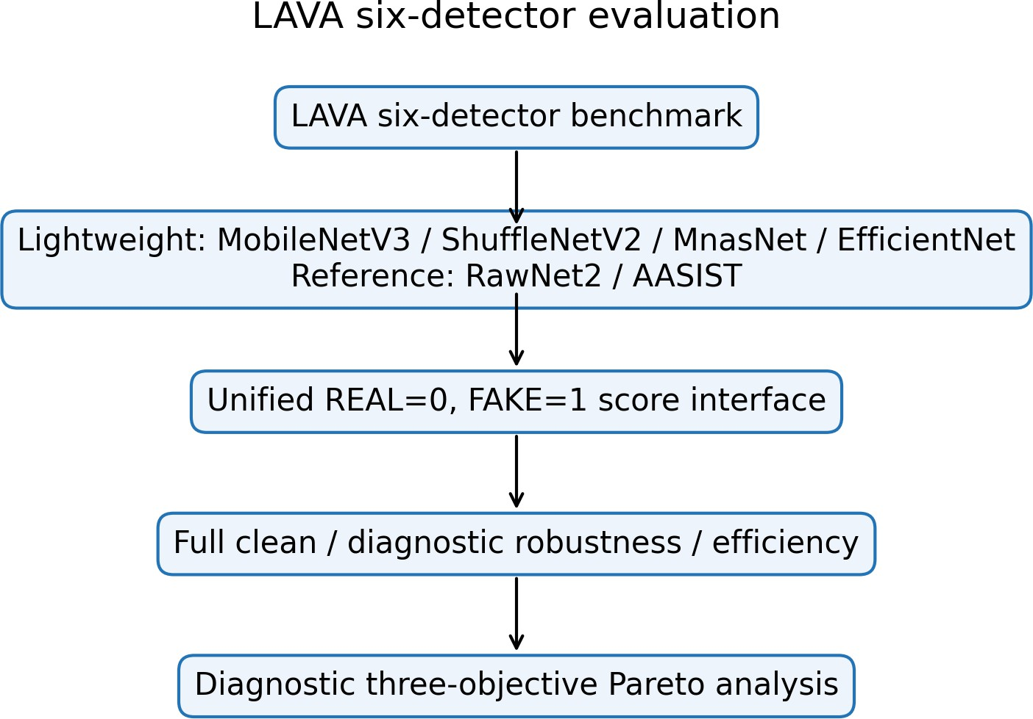
Fig. 1. Six native detectors connected to the unified LAVA evaluation boundary
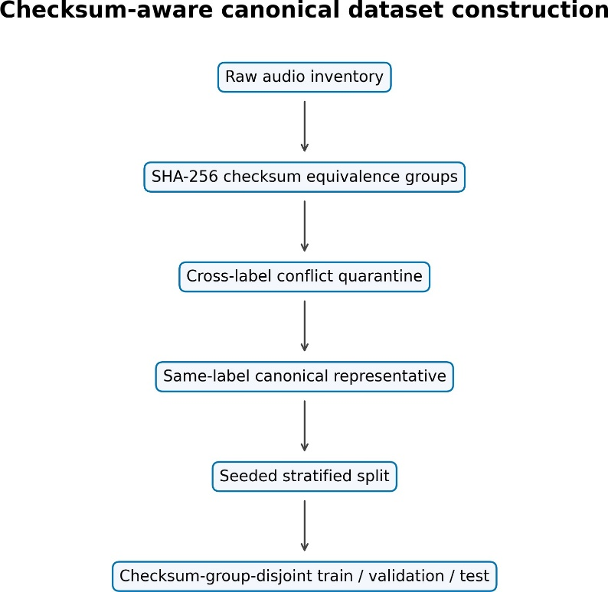
Fig. 2. SHA-256 conflict quarantine, canonicalization, and disjoint splitting.
  - Dataset Integrity and Canonical Split
The internal binary collection has no speaker, source, generator, parent-recording, or dataset identifiers; LAVA therefore claims neither speaker, source, generator, nor cross-dataset independence. It scanned 18,722 files (10,550 REAL, 8,172 FAKE), found 435 duplicate groups and 476 redundant files, and quarantined all 30 files in 14 cross-label checksum groups. Within a same-label group, the lexicographically first path is canonical. The retained 18,232 recordings comprise 10,493 REAL and 7,739 FAKE, split with seed 42 into 12,762/2,733/2,737 train/validation/test samples. The supported claim is checksum-group-disjoint only. For h(x) = SHA256(x) and split group sets G_{s},
$$x_{i}∼x_{j}⇔h\left(x_{i}\right)=h\left(x_{j}\right), G_{tr}∩G_{va}=G_{tr}∩G_{te}=G_{va}∩G_{te}=∅.$$
The manifest hash is:
8b55591d58d3658b8cafe0e77b6ebdedbaa67be2e339730a7276fe9b10958df9.
Figure 2 and Table II record the implemented policy once.
Table 2: Canonical manifest and split inventory
Inventory | Count | Split | Count
Scanned / retained | 18,722 / 18,232 | Train | 12,762
Retained REAL / FAKE | 10,493 / 7,739 | Validation | 2,733
Duplicate groups / redundant | 435 / 476 | Test | 2,737
Cross-label groups / files | 14 / 30 | Independence | checksum groups

  - Standardized Audio Preprocessing
Lightweight inputs are decoded, channel-averaged, polyphase-resampled to 22,050 Hz, and padded/truncated to 3.0 s. Six chronological 0.5-s segments use a Hann STFT (N = 2048, hop 512), 128 HTK-style Mel filters spanning 20–8,000 Hz, relative dB mapping clipped to 80 dB, [0, 255] scaling, bilinear 224 × 224 resizing, and RGB replication. For segment t
$$X_{t}\left(m,k\right)=\sum_{n=0}^{N-1}{x_{t}}\left[n+mH\right]w\left[n\right]e^{-j2πkn/N}, S_{t}^{mel}\left(m,r\right)=\sum_{k}{{\left|X_{t}\left(m,k\right)\right|}^{2}}H_{r}\left(k\right)$$
  - Evaluated Detector Architectures
For the lightweight family, shared segment encoder fθ produces six embeddings, an LSTM with 128 units aggregates them, and a 64-unit ReLU layer plus dropout 0.4 feeds a sigmoid:
$p_{fake}=σ\left(W_{2}{\text{Dropout}}_{.4}\left(\text{ReLU}\left(W_{1}\text{LSTM}\left(f_{θ}\left(X_{1:6}\right)\right)+b_{1}\right)\right)+b_{2}\right).$ (3)
MobileNetV3 uses inverted residual and squeeze–excitation blocks; ShuffleNetV2 uses channel split/shuffle; MnasNet provides platform-searched inverted residual stages; EfficientNet-B0 uses compound scaling and MBConv blocks. RawNet2 retains its Sinc-style front end, residual blocks, attention, GRU, and classifier; AASIST retains spectral–temporal heterogeneous graph attention and readout. Figure 3 combines the common lightweight path with the unequal provenance that must qualify comparisons.
  - Training, Artifact Provenance, and Score Semanticn
MobileNet and EfficientNet use ImageNet initialization; EfficientNet’s deployment is explicitly the best warm-up checkpoint, not a completed fine-tuning lifecycle. MnasNet and ShuffleNet were trained jointly with their recurrent heads from scratch; all 49 and 56 BatchNormalization layers, respectively, were trainable from epoch 1. RawNet2 and AASIST were not trained by:

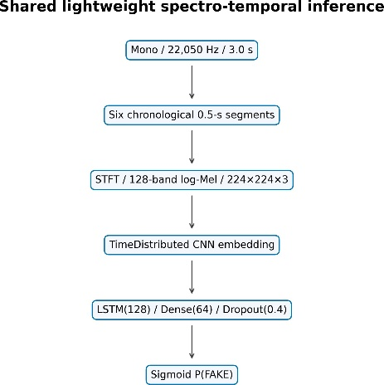(a)Mel-sequence temporalpath

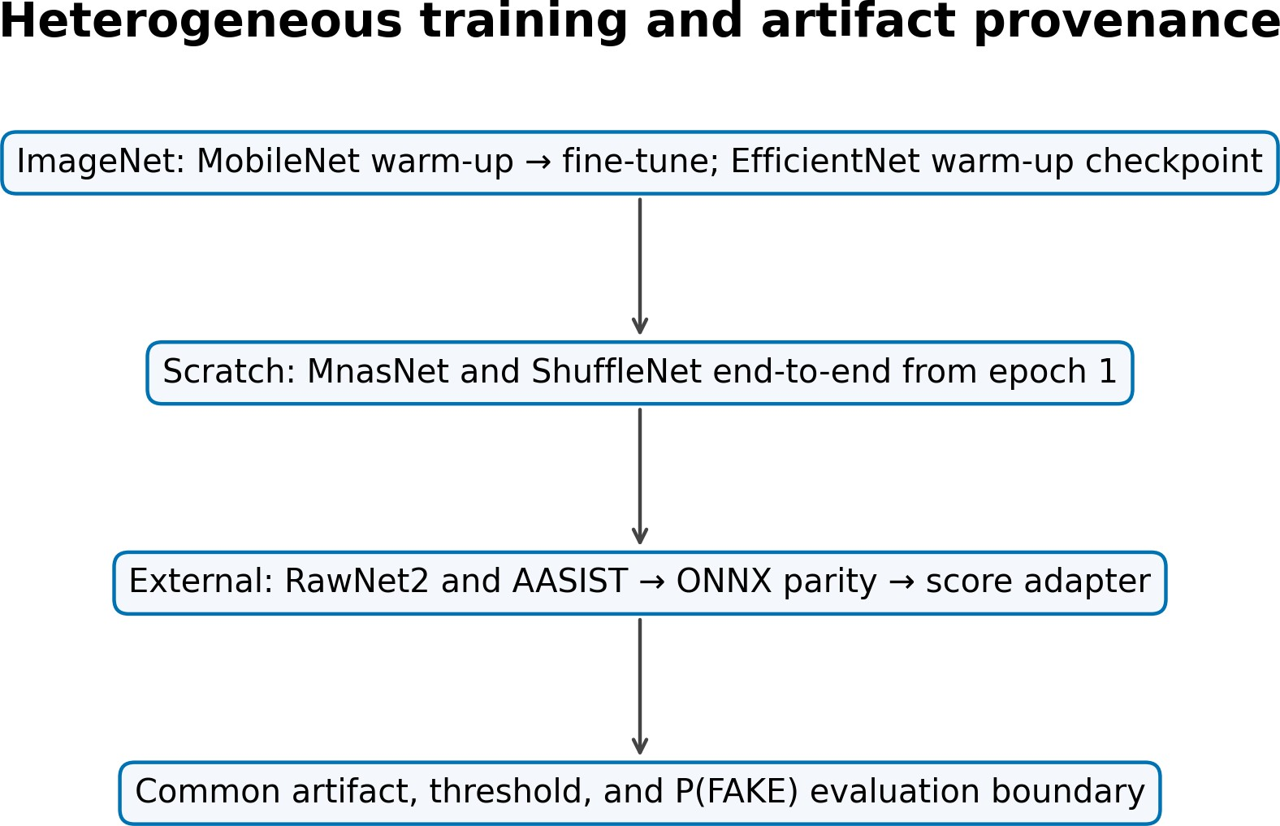
(b)Artifactprovenance
Fig. 3. Architecture and provenance: the evaluation contract is shared, training is not.
Table 3: Detector specification, provenance, and deployed threshold.
Detector | Input | Temporal core | Params | Initialization/artifact provenance | τ
MobileNetV3-LSTM | Mel, 3.0 s | LSTM(128) | 1,308,401 | ImageNet; warm-up + partial fine-tune | .82
ShuffleNetV2-LSTM | Mel, 3.0 s | LSTM(128) | 1,868,441 | scratch; full end-to-end, best epoch 16/28 | .12
MnasNet-A1-LSTM | Mel, 3.0 s | LSTM(128) | 3,369,255 | scratch; full end-to-end, best epoch 27/39 | .90
EfficientNet-B0-LSTM | Mel, 3.0 s | LSTM(128) | 4,779,300 | ImageNet; best warm-up epoch 47 | .90
RawNet2 | waveform, 4.04 s | GRU | 17,621,410 | external reference; ONNX export | .50
AASIST | waveform, 4.04 s | graph readout | 297,866 | external reference; ONNX export | .50

LAVA: strict PyTorch loading followed by ONNX export gave maximum native/export score differences of 4.11 × 10⁻⁶ and 5.96 × 10⁻⁸ on six real tensors. This verifies conversion, not identical training or publication-pipeline equivalence.

MobileNet followed frozen-backbone warm-up and lower-rate partial fine-tuning with BatchNormalization frozen. EfficientNet’s selected warm-up checkpoint is epoch 47 (validation loss 0.1698). MnasNet used Adam from 10⁻⁴, stopped at epoch 39, and restored epoch 27. ShuffleNet used Adam from 3 × 10⁻⁴, stopped at epoch 28, and restored epoch 16; its backbone and all BatchNormalization layers remained trainable.

LAVA fixes REAL=0 and FAKE=1; every adapter returns p = P (FAKE) and
$$\overset{ˆ}{y}=1\left[p≥τ\right], τ^{*}=\arg{\max_{τ}{F}}1_{val}\left(τ\right).$$
The four low-weight thresholds in Table III are validation-only. No calibration on external references. Defaults on those are 0.5, uncalibrated. Labels do not influence threshold choice or weighting. Score values are not claims of calibrated real-world probability.
  - Clean and Robustness Evaluation
The clean analysis makes use of all 2,737 testing samples (1,575 REAL, 1,162 FAKE). Accuracy, classwise and macro F1, ROC-AUC from raw scores, and linearly interpolated EER are reported. With FAKE positive,
$$P=\frac{TP}{TP+FP}, R=\frac{TP}{TP+FN}, F1=\frac{2PR}{P+R}; FAR=\frac{FP}{FP+TN},$$
$$FRR=\frac{FN}{FN+TP}, EER≃\frac{FAR+FRR}{2}.$$
The EER implementation sorts distinct raw-score thresholds, forms FAR and FRR, finds the first sign change of FAR − FRR, and linearly interpolates the crossing; if no sign change occurs, it uses the minimum absolute gap. Confusion counts use the stored deployed threshold and are therefore operating-point dependent, whereas ROC-AUC and EER characterize score ordering. Macro-F1 gives equal weight to REAL and FAKE and supplements the positive-class F1 used during lightweight threshold selection. Robustness uses a preselected stratified subset of 100 test recordings (58 REAL, 42 FAKE; seed 42), and each baseline uses those same IDs. Four seeded AWGN levels (20, 10, 5, 0 dB) use sample-identity-derived seeds. FFmpeg round trips cover MP3 128/64 kb/s, Opus 64 kb/s, and AAC 96 kb/s. Simulated replay applies taps at 0/17/43/89 ms with gains 1/.45/.25/.12, normalization by 1.82, and a causal fourth-order 100–3,800-Hz band-pass. It is not physical replay. For nine conditions,
$$ΔF1_{k}=F1_{clean}-F1_{k}, \overline{ΔF1}=\frac{1}{9}\sum_{k=1}^{9}{Δ}F1_{k}.$$
Negative degradation means improvement on this small subset and is not automatically robustness. Full-test stress, physical replay, and unseen evaluation are respectively NOT_RUN, NOT_AVAILABLE, and NOT_AVAILABLE.
Noise power is derived from each clean signal’s measured power, and the first 16 hexadecimal characters of its SHA-256 identity determine its random seed. Stress waveforms are materialized once and shared by every adapter. Codec audio is converted to PCM16, encoded, decoded, and re-entered through the ordinary model path; the codec-library version was not sealed and is therefore NOT_MEASURED. These controls isolate detector differences from independently sampled or re-encoded perturbations.
  - Clean and Robustness Evaluation
Each artifact runs float32, batch one, one backend thread, and no accelerator in a sequential isolated process on the same Windows AMD64 desktop CPU. Ten warm-ups precede 50 timed repetitions. Measurements separate preprocessing, model-only, and end-to-end time and include P95, load time, throughput, and whole-process RSS. The commercial CPU name and installed RAM were not recorded. For N clips,
$$Q=\frac{N}{T_{total}}, RTF=\frac{T_{processing}}{T_{audio}}.$$
RTF below one demonstrates faster-than-duration offline processing, not causal streaming or edge deployment.
The runner reports preprocessing and model-only time in addition to end-to-end mean, P95, throughput, load time, and RSS sampled every 20 ms. Interpreter start-up and graph tracing are excluded from warm timing. Keras parameter counts include non-trainable BatchNormalization state, whereas native PyTorch reference counts exclude buffers; serialized size and executed latency therefore remain separate reported quantities.
The six full-test score files are joined by sample ID. Model A dominates B iff
$$f_{i}\left(A\right)≤f_{i}\left(B\right)∀i \text{and} ∃j:f_{j}\left(A\right)<f_{j}\left(B\right).$$
Both the clean scopes and the diagnostic scopes have been purposefully distinguished by filename, summaries, and language. Full-test EER appears in clean performance and bootstrap reporting; subset EER is used only in the diagnostic Pareto vector because the corresponding robustness coordinate uses the same 100 IDs. Mixing full-test EER with subset degradation would produce a numerically valid but scope-inconsistent frontier. Likewise, the 100-sample clean baseline is never substituted for the 2,737-sample clean table. This scope discipline is part of the benchmark contract, not merely a reporting convention.
Table 4: Clean performance on all 2,737 canonical test recordings
Model | F1-Score | Prec. | Rec. | F1 | Macro-F1 | AUC | EER
MobileNetV3 | .9766 | .9741 | .9707 | .9724 | .9761 | .9911 | .0250
ShuffleNetV2 | .9850 | .9795 | .9854 | .9824 | .9847 | .9929 | .0146
MnasNet-A1 | .9697 | .9599 | .9690 | .9645 | .9690 | .9886 | .0310
EfficientNet-B0 | .9635 | .9724 | .9406 | .9563 | .9624 | .9877 | .0400
RawNet2 ext. | .4936 | .4380 | .6807 | .5330 | .4900 | .5178 | .4813
AASIST ext. | .5513 | .4758 | .5585 | .5139 | .5487 | .5597 | .4463

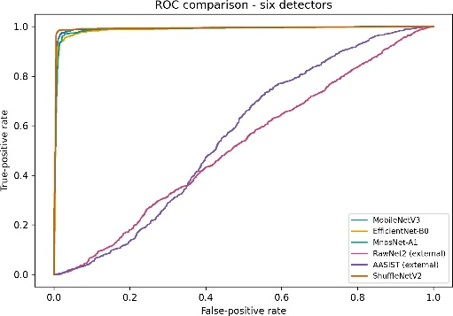
- ROC
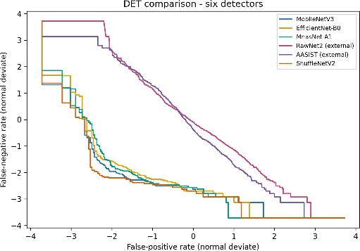
- DET/EER

Fig. 4. Threshold-independent clean discriminationon the full test split
- Results and Discussion
  - RQ1 - Clean Detection Performance
All six artifacts passed load, finite bounded-score, hash, and adapter checks. Table IV reports the full canonical test. ShuffleNet led every aggregate (F1 0.9824, macro-F1 0.9847, AUC 0.9929, EER 0.0146) with 24 false positives and 17 false negatives. MobileNet ranked second on F1 and AUC, followed by MnasNet and the available EfficientNet warm-up checkpoint. RawNet2 and AASIST were near chance under this dataset/adapter contract. This is not an architecture-only ranking because provenance, duration, representation, threshold calibration, and training differ.
Class-wise counts refine the aggregate view. MobileNet produced 30 false positives and 34 false negatives. MnasNet traded more false positives (47) for fewer false negatives (36), whereas EfficientNet’s 31/69 split shows that its principal error was missed FAKE speech at the validation-selected threshold. RawNet2 generated 1,015 false positives and 371 false negatives; AASIST generated 715 and 513. These reference outcomes are consistent with score/domain mismatch and uncalibrated default thresholds, but the present evidence cannot attribute them to one cause.
The associated REAL/FAKE F1 values were 0.9797/0.9724 for MobileNet, 0.9870/0.9824 for ShuffleNet, 0.9736/0.9645 for MnasNet, and 0.9686/0.9563 for EfficientNet. The reference values were 0.4469/0.5330 for RawNet2 and 0.5834/0.5139 for AASIST. Reporting both classes prevents the positive-class F1 from hiding RawNet2’s asymmetric tendency to label REAL recordings as FAKE. Confusion counts and class-wise values remain reproducible from the full score CSV rather than a normalized image.
Raw-score ROC and DET views in Fig. 4 separate threshold-independent discrimination from deployed decisions. The four lightweight curves are strong; the reference curves are close to diagonal. Bootstrap intervals overlap among some lightweight systems, so close AUC values are not presented as universal ranks.
Artifact checks also constrain interpretation of this gap. ShuffleNet’s TensorFlow 2.15 conversion reproduced source scores within 1.75 × 10⁻¹⁰ and matched the canonical training-manifest hash. The reference ONNX exports matched their native checkpoints within the tolerances reported in Section III-E, making gross serialization or class-index reversal unlikely.
Nevertheless, validation-calibrated lightweight thresholds and uncalibrated reference thresholds affect confusion metrics, while domain and preprocessing shifts affect both thresholded and raw-score measures. The results therefore support a statement about the deployed artifacts under LAVA, not about the maximum attainable RawNet2 or AASIST performance after retraining or calibration..
  - RQ2 – Robustness under Practical Distortions
Table V and Fig. 5 summarize the matched diagnostic. AWGN was the largest weakness for every high-performing lightweight system: mean noise degradation ranged from 0.3555 for ShuffleNet to 0.8053 for EfficientNet and accelerated at 5 and 0 dB.
Table 5: Diagnostic F1 degradation on the fixed 100-recording subset; lower is better
Model | Clean F1 | Noise ∆ | Codec ∆ | Replay ∆ | Mean (9)
MobileNetV3 | .9756 | .6722 | .0095 | .0620 | .3099
ShuffleNetV2 | .9756 | .3555 | .0032 | .0256 | .1623
MnasNet-A1 | .9756 | .6119 | .0233 | .1489 | .2989
EfficientNet-B0 | .9630 | .8053 | .0000 | .0641 | .3650
RawNet2 ext. | .5660 | .5077 | −.0007 | −.0109 | .2241
AASIST ext. | .5060 | −.0660 | −.0074 | −.0682 | −.0402

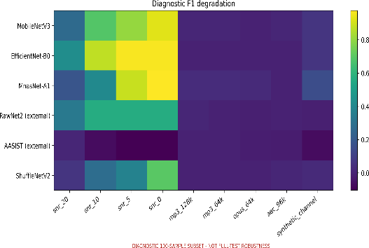(a) Nine-condition degradation
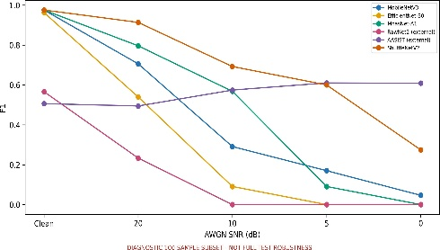 (b) AWGN F1 trajectory
Fig. 5. Diagnostic robustness; all models reuse identical stressed recordings.
Codec changes were small for the tested settings (0.0000–0.0233 across lightweight models). Under simulated replay, ShuffleNet retained F1 0.9500 (∆F1 0.0256), compared with degradations 0.0620/0.0641/0.1489 for MobileNet/EfficientNet/MnasNet. Negative reference deltas arise from low baselines and score redistribution; they do not establish superior robustness.
These outcomes answer RQ2 only for the executed subset and transformations. Codec stability cannot be generalized beyond four round trips, replay is not physical, and no unseen corpus exists.
Across all nine conditions, the lightweight mean degradations were 0.1623 (ShuffleNet), 0.2989 (MnasNet), 0.3099 (MobileNet), and 0.3650 (EfficientNet). AASIST’s value of −0.0402 is mathematically lower but accompanies clean-subset F1 0.5060; it illustrates why degradation must be paired with absolute performance. RawNet2 likewise improved slightly under the codec/replay transforms but retained subset-clean F1 0.5660. The diagnostic design supports failure-mode discovery and controlled cross-model comparison, not population-level robustness confidence intervals.
  - Computational Efficiency
Under the common single-thread CPU protocol (Table VI), MobileNet had the lowest latency and RTF; ShuffleNet was second among TensorFlow detectors. AASIST combined the smallest artifact with the largest latency, whereas RawNet2 combined the largest parameter count with moderate latency. Parameters and serialized size therefore did not predict runtime. RSS is whole-process memory, not model-only tensor allocation.
Table 6: Measured float32 batch-one desktop-CPU efficiency (10 warm-ups, 50 runs).
Model | Params | MiB | RSS | E2E ms | P95 ms | clips/s | RTF
MobileNetV3 | 1.31M | 5.64 | 554.6 | 43.81 | 52.12 | 22.83 | .0146
ShuffleNetV2 | 1.87M | 7.74 | 501.8 | 62.52 | 75.37 | 15.99 | .0208
MnasNet-A1 | 3.37M | 13.43 | 566.0 | 117.00 | 138.96 | 8.55 | .0390
EfficientNet-B0 | 4.78M | 18.96 | 651.2 | 175.85 | 196.11 | 5.69 | .0586
RawNet2 ext. | 17.62M | 67.65 | 249.5 | 96.54 | 102.62 | 10.36 | .0239
AASIST ext. | .30M | 1.61 | 442.5 | 362.91 | 398.45 | 2.76 | .0899

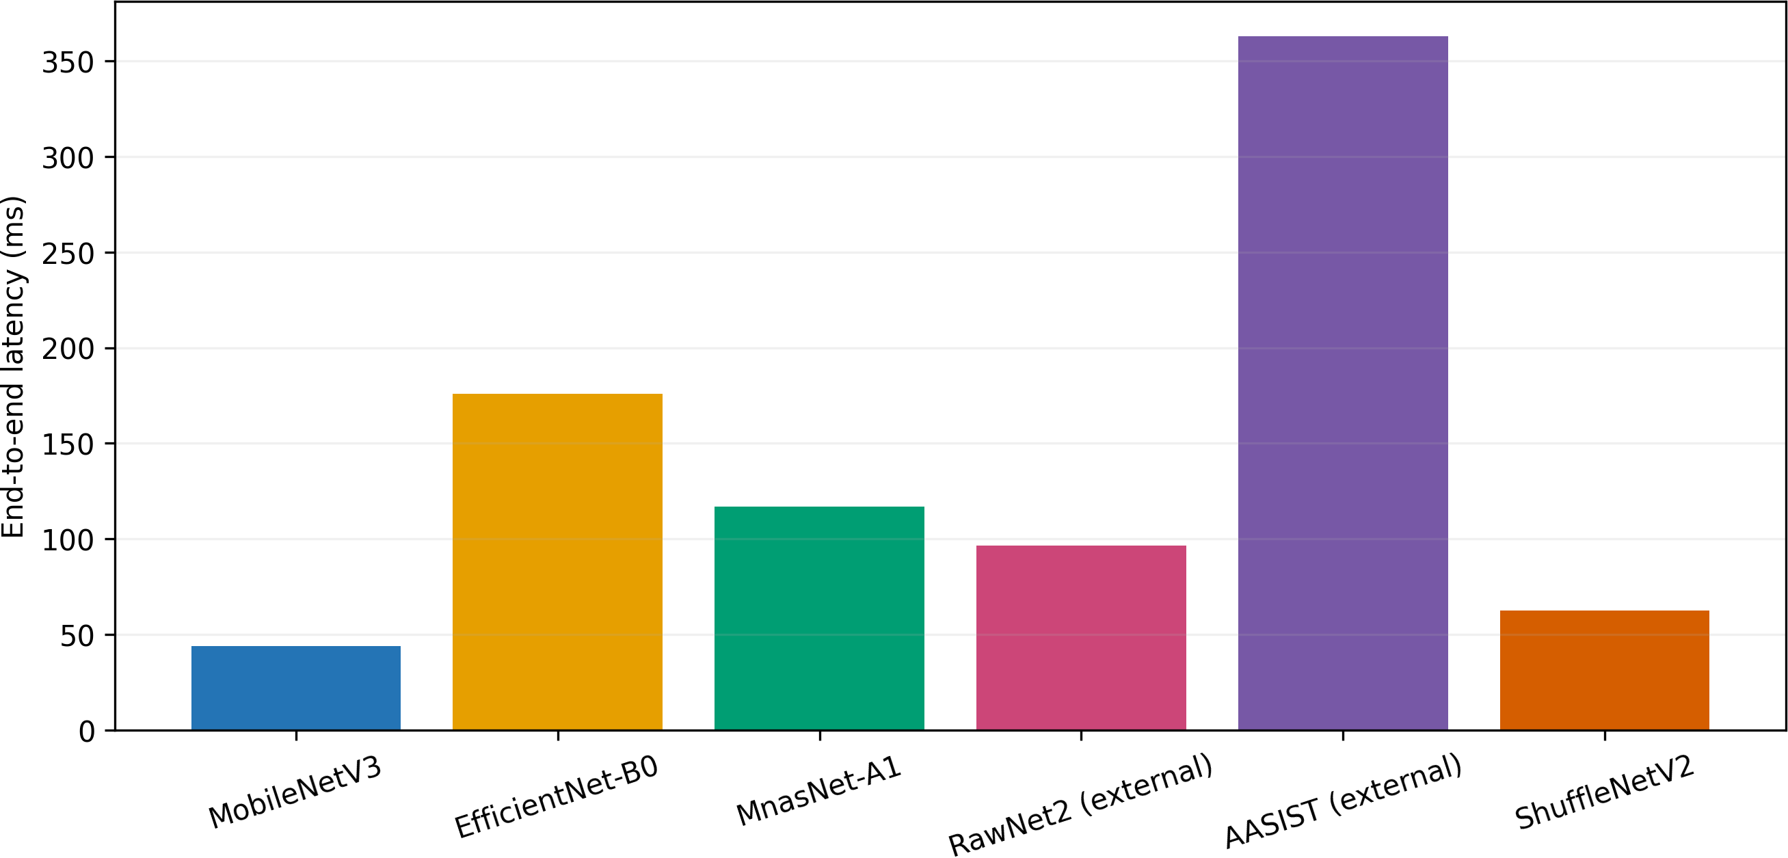
(a) End-to-end latency
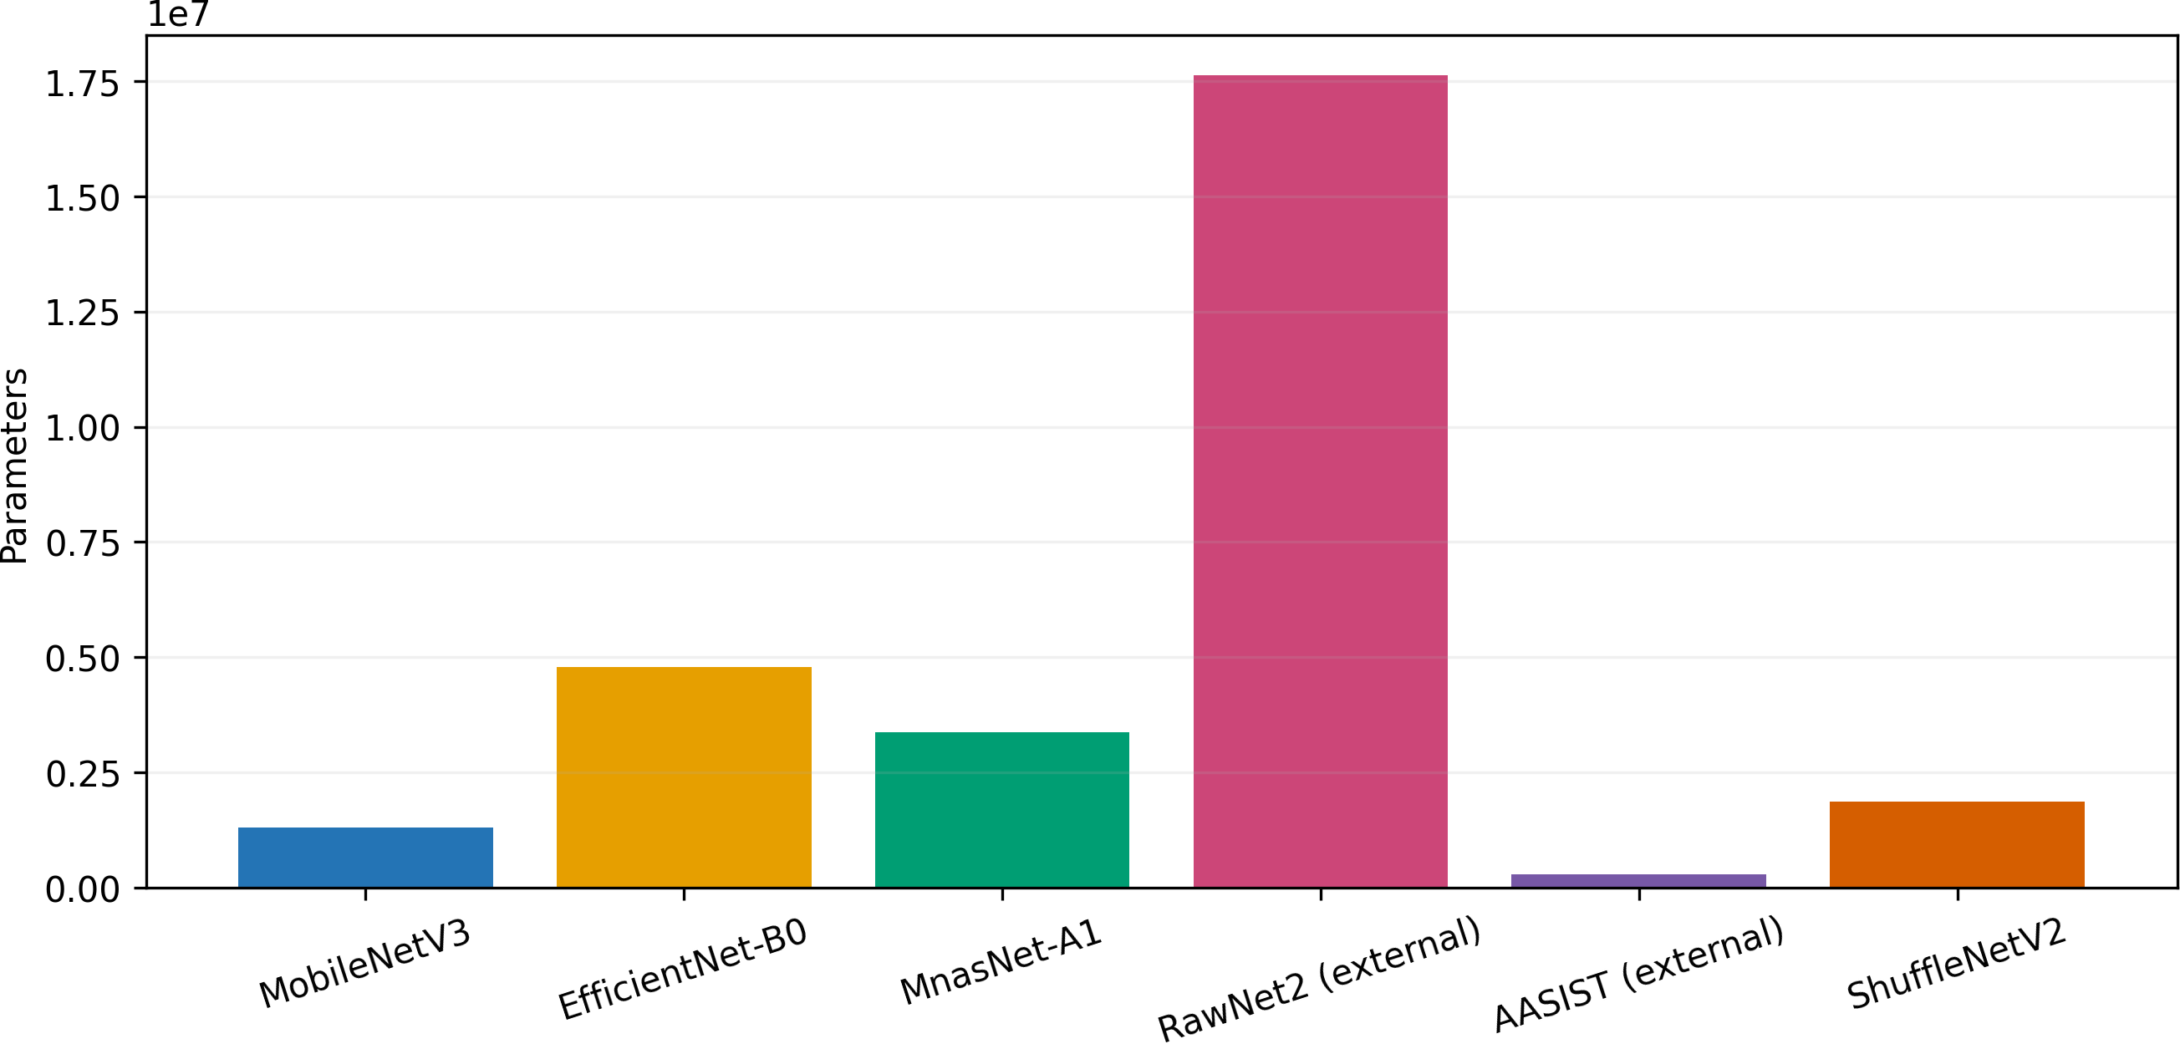
(b) Parameter count
Fig. 6. Runtime and complexity are related but not interchangeable.
Table 7: Exploratory three-objective Pareto result on the diagnostic scope.
Model | Subset EER | Mean ∆F1 | RTF | Frontier
MobileNetV3 | .0476 | .3099 | .0146 | Yes
ShuffleNetV2 | .0476 | .1623 | .0208 | Yes
MnasNet-A1 | .0476 | .2989 | .0390 | No
EfficientNet-B0 | .0476 | .3650 | .0586 | No
RawNet2 ext. | .4138 | .2241 | .0239 | No
AASIST ext. | .3810 | −.0402 | .0899 | Yes

  - RQ3 – Pareto Trade-Offs
The non-dominated diagnostic set is MobileNet, ShuffleNet, and AASIST (Table VII, Fig. 7). MobileNet supplies the lowest RTF; ShuffleNet combines the same subset EER with lower degradation at a modest latency cost. AASIST remains non-dominated only because negative degradation from a weak clean AASIST continues to be non-dominated since the negative degradation due to a poor clean baseline occurs at the extreme coordinate. Frontier membership is not a scalar ranking. ShuffleNet dominates MnasNet and RawNet2; MobileNet dominates EfficientNet.
  - Error, Agreement, and Statistical Evidence
All six detectors were correct on 911 clean samples and wrong on 10. The four lightweight models were unanimously correct while both references were wrong on 785 samples; the reverse occurred on three. ShuffleNet agreed with Mo-bileNet/EfficientNet/MnasNet on 0.979/0.970/0.977 of decisions, but with RawNet2/AASIST on 0.494/0.559; agreement does not imply correctness.
Full-test 95% bootstrap intervals for ShuffleNet were [0.9768, 0.9875] for F1, [0.9894, 0.9960] for AUC, and [0.0103, 0.0207] for EER. In the 15-pair McNemar family, ShuffleNet differed from MobileNet after Holm correction (padj = 0.0096) and more strongly from EfficientNet and MnasNet. MobileNet–MnasNet (padj = 0.1060) and EfficientNet–MnasNet (padj = 0.1180) were not significant at 0.05; every lightweight–reference comparison was significant. Complete six-model intervals, paired F1 differences, adjusted p-values, agreement, and error matrices remain in supplementary artifacts.
For completeness, the corresponding F1 intervals were [0.9654,0.9788] for MobileNet, [0.9573,0.9717] for MnasNet, [0.9477,0.9651] for EfficientNet, [0.5150,0.5489] for RawNet2, and [0.4928,0.5349] for AASIST. AUC intervals were [0.9871,0.9947], [0.9842,0.9923], [0.9833,0.9917], [0.4944,0.5395], and [0.5377,0.5815], respectively. These intervals quantify finite-test sampling conditional on the existing checkpoints; they cannot measure training-seed variation.
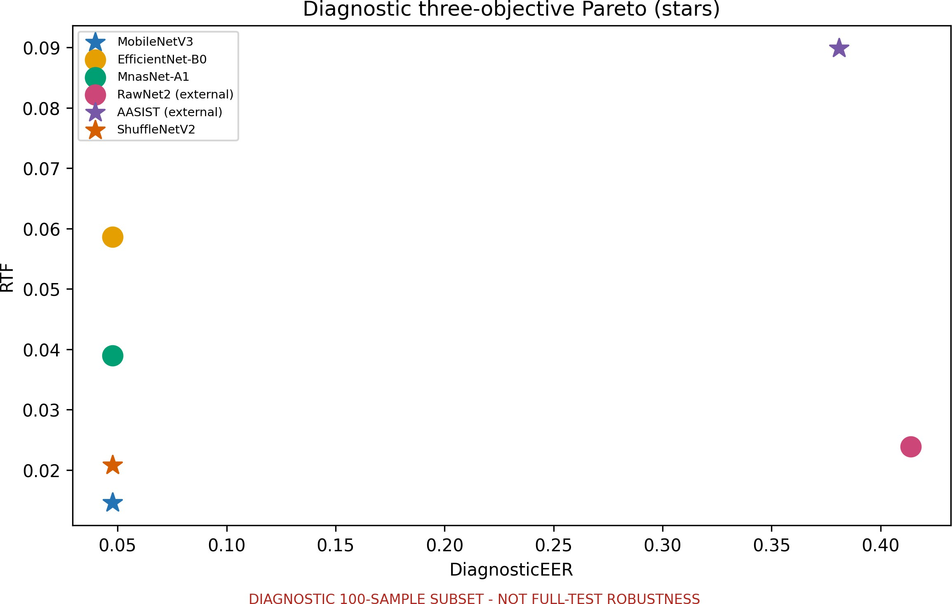
Fig. 7. EER–RTF projection; stars mark the three-objective diagnostic frontier
EER intervals were [0.0178,0.0311] for MobileNet, [0.0250,0.0379] for MnasNet, [0.0311,0.0482] for EfficientNet, [0.4616,0.5016] for RawNet2, and [0.4279,0.4660] for AASIST. Pairwise F1-difference intervals for ShuffleNet minus MobileNet/EfficientNet/MnasNet were [0.0036,0.0166], [0.0182,0.0339], and [0.0116,0.0247]. Their corresponding discordant correctness counts (ShuffleNet wrong/right) were 17/40, 12/71, and 10/52. The direction and paired evidence agree with the clean table, while the non-significant MobileNet–MnasNet and EfficientNet–MnasNet comparisons discourage over-ordering the middle lightweight systems..
From a deployment perspective, MobileNet and ShuffleNet define the most practically attractive measured region: both combine high clean discrimination with sub-0.021 RTF, while ShuffleNet provides better clean and diagnostic robustness outcomes at a modest latency cost. EfficientNet’s larger artifact and higher latency do not improve clean quality in its available warm-up state. MnasNet remains competitive in detection but is dominated in the current diagnostic objectives. The reference systems remain scientifically useful as heterogeneous stress tests for the adapter and score contract even though their absolute clean results are weak. These conclusions should be revisited after validation calibration of the references, multi-seed lightweight training, and target-hardware measurement.
  - Direct Answers to the Research Questions
- RQ1: The four locally trained lightweight artifacts outperform the two external references under this clean contract, with ShuffleNet strongest in detection and MobileNet fast-est.
- RQ2: Codec and simulated-replay changes were modest relative to low-SNR white noise, but evidence is limited to 100 matched samples.
- RQ3: MobileNet, ShuffleNet, and AASIST are non-dominated in the diagnostic space; AASIST’s membership reflects a negative degradation coordinate rather than strong absolute detection. These findings characterize artifacts under LAVA, not universal-ly superior architectures.
- Conclusion and limitations
The study mixes ImageNet transfer (MobileNet/EfficientNet), scratch optimization (ShuffleNet/MnasNet), and external RawNet2/AASIST checkpoints, so evaluation consistency is not identical training. Missing speaker/source/generator identifiers permit only checksum-group-disjoint claims. Robustness uses 100 samples; replay is simulated; no unseen corpus, physical replay, codec-version seal, or probability calibration exists. Runtime was measured on one desktop CPU rather than an edge target, and single checkpoints plus test-set bootstrap do not replace multi-seed training. Future work should first execute full-test stresses and a metadata-rich external corpus, then measure physical replay and target hardware before quantization or streaming studies.
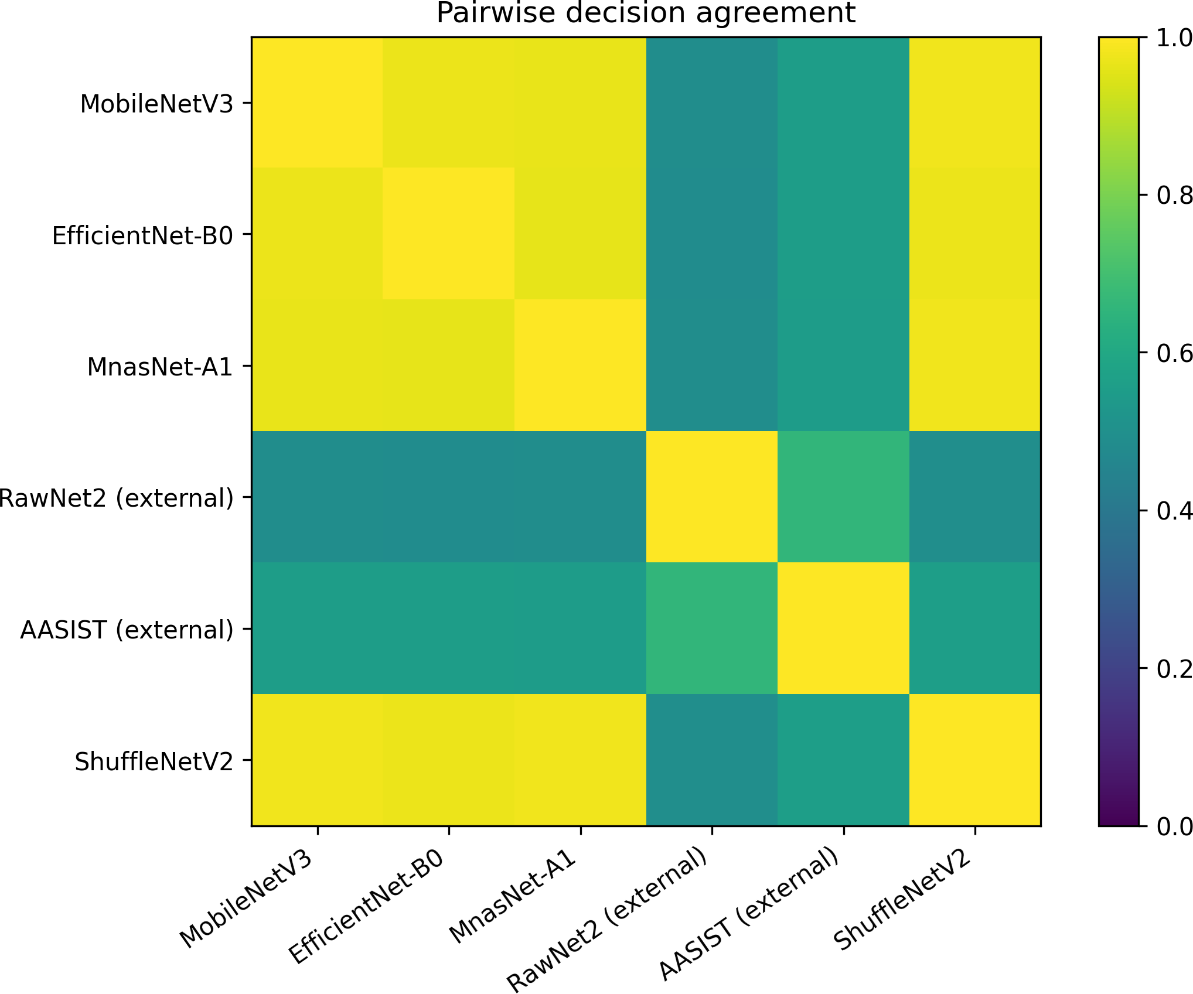
Fig. 8. Pairwise agreement on identical full-test sample IDs; agreement is not accuracy.
LAVA provides an evidence-traceable interface for six architecturally heterogeneous voice anti-spoofing artifacts. On 2,737 clean test recordings, ShuffleNetV2-LSTM delivered the best F1/AUC/EER, while MobileNetV3Small-LSTM minimized latency and RTF. The diagnostic stresses identify low-SNR noise as the principal weakness, and multi-objective analysis retains MobileNet, ShuffleNet, and AASIST for different trade-offs. These results support reproducible deployment-oriented comparison and faster-than-duration offline inference, not unseen-domain, physical-replay, streaming, or edge-device validation.

Acknowledgement
This research was supported by the University of Economics Ho Chi Minh City (UEH), Vietnam.

References
- Z. Wu, T. Kinnunen, N. Evans, J. Yamagishi, C. Hanilci, M. Sahidullah, and A. Sizov, “ASVspoof 2015: The first automatic speaker verification spoofing and countermeasures challenge,” in Interspeech, 2015, pp. 2037–2041.
- T. Kinnunen, M. Sahidullah, H. Delgado, M. Todisco, N. Evans, J. Yamagishi, and K. A. Lee, “The ASVspoof 2017 challenge: Assessing the limits of replay spoofing attack detection,” in Interspeech, 2017, pp. 2–6.
- M. Todisco, X. Wang, V. Vestman, M. Sahidullah, H. Delgado, A. Nautsch, J. Yamagishi, N. Evans, T. Kinnunen, and K. A. Lee, “ASVspoof 2019: Future horizons in spoofed and fake audio detection,” in Interspeech, 2019, pp. 1008–1012.
- J. Yamagishi, X. Wang, M. Todisco, M. Sahidullah, J. Patino, A. Nautsch, X. Liu, K. A. Lee, T. Kinnunen, N. Evans, and H. Delgado, “ASVspoof 2021: Accelerating progress in spoofed and deepfake speech detection,” in ASVspoof 2021 Workshop, 2021, pp. 47–54.
- T. Kinnunen, K. A. Lee, H. Delgado, N. Evans, M. Todisco, M. Sahidullah, J. Yamagishi, and D. A. Reynolds, “t-DCF: A detection cost function for the tandem assessment of spoofing countermeasures and automatic speaker verification,” in Odyssey, 2018, pp. 312–319.
- J. Frank and L. Sch"onherr, “Wavefake: A data set to facilitate audio deepfake detection,” in NeurIPS Datasets and Benchmarks, 2021. [Online].
Available: https://arxiv.org/abs/2111.02813
- J. Yi, C. Tao, R. Fu, X. Yan, C. Wang, T. Zhang, X. Zhang, Y. Zhao, Y. Ren, L. Xu et al., “Audio deepfake detection: A survey,” arXiv preprint arXiv:2308.14970, 2023. [Online]. Available: https://arxiv.org/abs/2308.14970
- M. Li, Y. Ahmadiadli, and X.-P. Zhang, “A survey on speech deepfake detection,” arXiv preprint arXiv:2404.13914, 2024. [Online]. Available: https://arxiv.org/abs/2404.13914
- H. Tak, J. Patino, M. Todisco, A. Nautsch, N. Evans, and A. Larcher, “End-to-end anti-spoofing with RawNet2,” in ICASSP, 2021, pp. 6369–6373.
- J.-w. Jung, H.-S. Heo, H. Tak, H.-j. Shim, J. S. Chung, B.-J. Lee, H.-J. Yu, and N. Evans, “AASIST: Audio anti-spoofing using integrated spectro-temporal graph attention networks,” in ICASSP, 2022, pp. 6367–6371.
- P. Velickovic, G. Cucurull, A. Casanova, A. Romero, P. Lio, and Y. Bengio, “Graph attention networks,” in International Conference on Learning Representations, 2018. [Online]. Available: https://openreview.net/forum?id=rJXMpikCZ

- Z. Wu, R. K. Das, J. Yang, and H. Li, “Light convolutional neural network with feature genuinization for detection of synthetic speech attacks,” in Interspeech, 2020, pp. 1101–1105.
- M. Ravanelli and Y. Bengio, “Speaker recognition from raw waveform with SincNet,” in IEEE Spoken Language Technology Workshop, 2018, pp. 1021–1028.
- A. Baevski, Y. Zhou, A. Mohamed, and M. Auli, “wav2vec 2.0: A framework for self-supervised learning of speech representations,” in NeurIPS, vol. 33, 2020, pp. 12 449–12 460. [Online]. Available: https://proceedings.neurips.cc/paper/2020/hash/92d1e1eb1cd6f9fba3227870bb6d7f07-Abstract.html
- W.-N. Hsu, B. Bolte, Y.-H. H. Tsai, K. Lakhotia, R. Salakhutdinov, and A. Mohamed, “HuBERT: Self-supervised speech representation learning by masked prediction of hidden units,” IEEE/ACM Transactions on Audio, Speech, and Language Processing, vol. 29, pp. 3451–3460, 2021.
- S. Chen, C. Wang, Z. Chen, Y. Wu, S. Liu, Z. Chen, J. Li, N. Kanda, T. Yoshioka, X. Xiao et al., “WavLM: Large-scale self-supervised pre-training for full stack speech processing,” IEEE Journal of Selected Topics in Signal Processing, vol. 16, no. 6, pp. 1505–1518, 2022.
- H. Tak, M. Todisco, X. Wang, J.-w. Jung, J. Yamagishi, and N. Evans, “Automatic speaker verification spoofing and deepfake detection using wav2vec
2.0 and data augmentation,” in Odyssey, 2022, pp. 112–119.
- O. Pascu, A. Stan, D. Oneata, E. Oneata, and H. Cucu, “Towards generalisable and calibrated audio deepfake detection with self-supervised representations,” in Interspeech, 2024, pp. 4828–4832.
- N. M. Muller, P. Czempin, F. Dieckmann, A. Froghyar, and K. Bottinger, “Does audio deepfake detection generalize?” in Interspeech, 2022, pp. 2783–2787.
- P. Kawa, M. Plata, and P. Syga, “Attack agnostic dataset: Towards generalization and stabilization of audio deepfake detection,” in Interspeech, 2022, pp. 4023–4027.
- N. M. Muller, N. Evans, H. Tak, P. Sperl, and K. Bottinger, “Harder or different? understanding generalization of audio deepfake detection,” in Interspeech, 2024, pp. 2705–2709.
- Y. Li, M. Zhang, M. Ren, X. Qiao, M. Ma, D. Wei, and H. Yang, “Cross-domain audio deepfake detection: Dataset and analysis,” in EMNLP, 2024, pp. 4977–4983.
- A. Das, Y. El Kheir, C. Franzreb, T. Herzig, T. Polzehl, and S. Moller, “Generalizable audio spoofing detection using non-semantic representations,” in Interspeech, 2025, pp. 4553–4557.
- I.-P. Ciobanu, A.-I. Hiji, N. C. Ristea, P. Irofti, C. Rusu, and R. T. Ionescu, “XMAD-Bench: Cross-domain multilingual audio deepfake benchmark,” in Findings of EACL, 2026, pp. 3109–3120.
- M. Sandler, A. Howard, M. Zhu, A. Zhmoginov, and L.-C. Chen, “MobileNetV2: Inverted residuals and linear bottlenecks,” in CVPR, 2018, pp. 4510–4520.
- A. Howard, M. Sandler, G. Chu, L.-C. Chen, B. Chen, M. Tan, W. Wang, Y. Zhu, R. Pang, V. Vasudevan, Q. V. Le, and H. Adam, “Searching for MobileNetV3,” in ICCV, 2019, pp. 1314–1324.
- X. Zhang, X. Zhou, M. Lin, and J. Sun, “ShuffleNet: An extremely efficient convolutional neural network for mobile devices,” in CVPR, 2018, pp. 6848–6856.
- N. Ma, X. Zhang, H.-T. Zheng, and J. Sun, “ShuffleNet V2: Practical guidelines for efficient cnn architecture design,” in ECCV, 2018, pp. 116–131.
- M. Tan and Q. V. Le, “EfficientNet: Rethinking model scaling for convolutional neural networks,” in ICML, ser. PMLR, vol. 97, 2019, pp. 6105–6114. [Online]. Available: https://proceedings.mlr.press/v97/tan19a.html
- M. Tan, B. Chen, R. Pang, V. Vasudevan, M. Sandler, A. Howard, and Q. V. Le, “MnasNet: Platform-aware neural architecture search for mobile,” in CVPR, 2019, pp. 2820–2828.
- B. McFee, C. Raffel, D. Liang, D. P. W. Ellis, M. McVicar, E. Battenberg, and O. Nieto, “librosa: Audio and music signal analysis in python,” in Proceedings of the 14th Python in Science Conference, 2015, pp. 18–25.
- B. Efron, “Bootstrap methods: Another look at the jackknife,” The Annals of Statistics, vol. 7, no. 1, pp. 1–26, 1979.
- Q. McNemar, “Note on the sampling error of the difference between correlated proportions or percentages,” Psychometrika, vol. 12, no. 2, pp. 153–157, 1947.
- S. Holm, “A simple sequentially rejective multiple test procedure,” Scandinavian Journal of Statistics, vol. 6, no. 2, pp. 65–70, 1979. [Online]. Available: https://www.jstor.org/stable/4615733

