LAVA: A Lightweight Benchmarking Framework for Robust and Efficient Deepfake Voice Detection
Quoc Hung NGUYEN*^{[0000-0002-6363-0160]}, Khac Anh Tuan PHAN^{1[0009-0006-5164-465X]}, Phuong Chinh NGUYEN^{2[0009-0007-6080-9644]}, Thanh Dat LAI^{3[0009-0002-3962-960X]}, Tan Khiem NGUYEN^{4[0009-0003-2085-6252]}, and Thanh Dat TRUONG^{5[0009-0006-6562-3956]}
University of Economics Ho Chi Minh City (UEH), Ho Chi Minh City, Viet Nam
Corresponding author: hungngq@ueh.edu.vn
Abstract. Deepfake voice detectors are difficult to compare across incompatible data partitions, score conventions, calibration, preprocessing, and timing. LAVA applies common artifact-integrity, P(FAKE), robustness, and runtime contracts while preserving native computation. We evaluate four locally trained Mel-sequence artifacts and externally pretrained RawNet2 and AASIST reference artifacts, whose training and calibration provenance differs. SHA-256 grouping quarantined 30 cross-label files and produced a checksum-group-disjoint manifest; clean evaluation used all 2,737 test recordings. ShuffleNetV2 achieved the highest AUC (0.9929) and lowest EER (1.46%); its threshold-specific F1 was 0.9824. On one single-thread desktop CPU, MobileNetV3 had the lowest end-to-end latency (43.81 ms; RTF 0.0146), while ShuffleNetV2 required 62.52 ms (RTF 0.0208). A fixed stratified 100-recording diagnostic evaluated seeded AWGN, four codec round trips, and simulated replay. Low-SNR noise was the main observed weakness, and ShuffleNetV2 retained the highest mean stressed F1 (0.8133). Using diagnostic-subset EER, mean stressed F1, and end-to-end RTF, the corrected exploratory Pareto frontier contains MobileNetV3 and ShuffleNetV2. These findings support deployment-oriented offline comparison, but do not establish full-test robustness, unseen-corpus generalization, physical-replay robustness, streaming, edge-device performance, or multi-seed stability.
Keywords: Deepfake voice detection, audio anti-spoofing, lightweight deep learning, robustness, computational efficiency, Pareto analysis.
- Introduction
Synthetic and converted speech pose risks to speaker verification and human decision-making. Despite rapid progress in deepfake voice detection [1], [2] and shared evaluation resources such as ASVspoof and WaveFake [3], [4], comparisons remain difficult because studies differ in data partitions, label conventions, input duration, preprocessing, calibration, and runtime boundaries. Byte-identical recordings across data splits introduce an additional integrity concern.
LAVA provides a common evaluation interface for heterogeneous deployed artifacts without imposing a shared architecture or training protocol. It preserves both Mel-sequence and raw-waveform pipelines while standardizing artifact checks, P(FAKE) semantics, data integrity, stress conditions, stored outputs, and timing. Four lightweight artifacts were trained locally, whereas RawNet2 and AASIST are externally pretrained reference artifacts. Clean performance is evaluated on the full test set, robustness on a fixed diagnostic subset, and efficiency on one desktop CPU; therefore, the evidence does not establish streaming or edge-device operation. The study addresses:
RQ1: How do deployed artifacts compare on clean AUC and EER, and how should threshold-dependent metrics be interpreted under heterogeneous training and calibration? RQ2: How does absolute performance change under the executed noise, codec, and simulated-replay conditions on the fixed diagnostic subset? RQ3: Which artifacts are non-dominated across diagnostic-subset EER, mean stressed F1, and end-to-end RTF?
Corresponding to RQ1–RQ3, LAVA contributes: (1) checksum-group-disjoint, artifact-traceable clean evaluation emphasizing AUC/EER and provenance limitations; (2) matched diagnostic evaluation of noise, compression, and simulated replay using absolute stressed performance and aggregate failure-pattern analysis; and (3) a desktop-CPU efficiency protocol with corrected three-objective Pareto analysis for scenario-specific, deployment-oriented recommendations.
- Related Work
Deepfake detection and benchmark protocols. ASVspoof established shared logical-access, physical-access, and deepfake tasks covering EER/t-DCF, unknown attacks, replay, and later channel/compression variation [3], [5]. WaveFake supplies multi-generator synthetic speech; representative detectors include raw-waveform and graph-attention systems [4], [9].
Robustness, replay, and unseen-data generalization. Strong in-domain discrimination need not transfer to unseen generators, datasets, or recording domains [13], [16]. Replay evidence is also protocol-dependent: physical-access evaluation and simulation are not interchangeable, so claims must identify the distortion, subset, and replay mode [5].
Computational efficiency and deployment-oriented evaluation. Efficient CNN families were designed under resource constraints, but their vision/mobile measurements do not establish audio-pipeline latency, throughput, memory, or real-time factor [17], [22]. Such evidence requires explicit preprocessing, hardware, batch-size, warm-up, and timing boundaries.
Table 1. Scope explicitly reported by representative studies. Yes = evaluated; Sim. = simulated replay; – = not reported. Unseen includes held-out attacks, generators, or domains; ASVspoof replay entries denote physical-access protocols, whereas LAVA uses simulation only.
Study | Noise | Compression | Replay | Unseen Data | Latency/RTF | Edge
ASVspoof 2019 [3] | – | – | Yes | Yes | – | –
WaveFake [4] | – | – | – | – | – | –
ASVspoof 2021 [5] | – | Yes | Yes | Yes | – | –
RawNet2 / AASIST [7], [9] | – | – | – | Yes | – | –
Generalization studies [12]–[16] | – | – | – | Yes | – | –
LAVA (this work) | Yes | Yes | Sim. | – | Yes | –
Research gap. The surveyed studies report clean discrimination, robustness/generalization, or efficiency under different protocols and boundaries, complicating deployment-oriented comparison of heterogeneous artifacts. LAVA addresses this measurement and traceability problem through a common evaluation contract, without claiming unseen-corpus or edge-device validation.
- Methodology
  - LAVA Framework and Experimental Protocol
LAVA separates canonical data and integrity (D), registered detectors (M), executed conditions (C), measurements (E), and analyses (A). The registry records framework, input, duration, artifact, threshold, and provenance; adapters preserve native computation while exposing loading, bounded scores, parameter count, and size. Runners derive statistics and figures from sample-level outputs while keeping planned and executed conditions distinct. Figures 1 and 2 show the evaluation boundary and checksum-aware data construction.

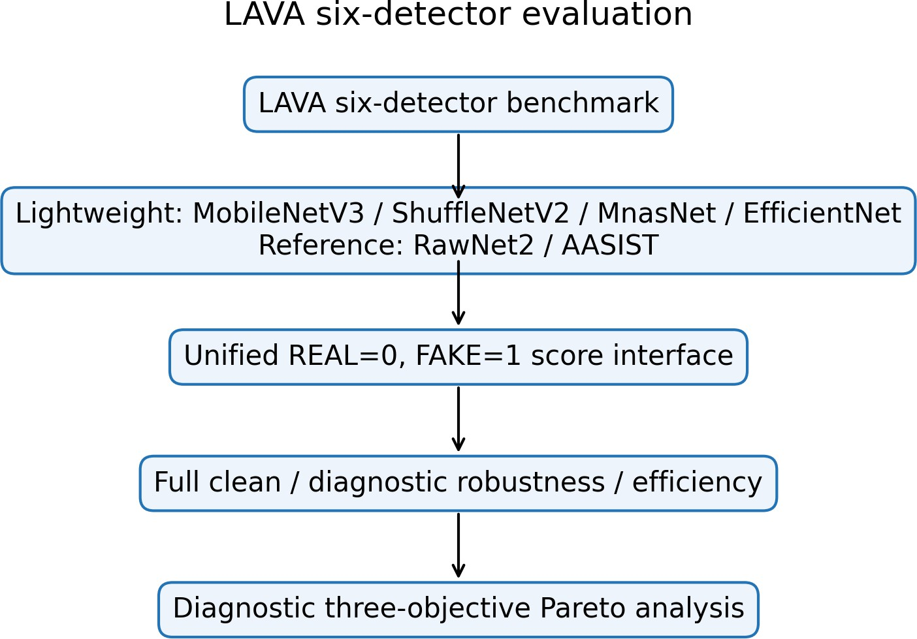
Fig. 1. Six native detectors connected to the unified LAVA evaluation boundary
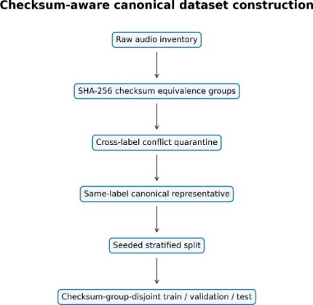
Fig. 2. SHA-256 conflict quarantine, canonicalization, and disjoint splitting.

  - Dataset Integrity and Canonical Split
The internal binary collection lacks speaker, source, generator, parent-recording, and dataset identifiers; the split therefore establishes neither speaker, source, generator, parent-recording, nor cross-dataset independence. LAVA scanned 18,722 files (10,550 REAL, 8,172 FAKE), found 435 duplicate groups and 476 redundant files, and quarantined all 30 files in 14 cross-label checksum groups. Within a same-label group, the lexicographically first path is canonical. The retained 18,232 recordings comprise 10,493 REAL and 7,739 FAKE, split with seed 42 into 12,762/2,733/2,737 train/validation/test recordings (Table 2). The supported split property is checksum-group-disjoint. For h(x) = SHA256(x) and split group sets Gs,
$$x_{i}∼x_{j}⇔h\left(x_{i}\right)=h\left(x_{j}\right), G_{tr}∩G_{va}=G_{tr}∩G_{te}=G_{va}∩G_{te}=∅.$$
The manifest hash is:
8b55591d58d3658b8cafe0e77b6ebdedbaa67be2e339730a7276fe9b10958df9.
Table 2. Canonical manifest and split inventory
Inventory | Count | Split | Count
Scanned / retained | 18,722 / 18,232 | Train | 12,762
Retained REAL / FAKE | 10,493 / 7,739 | Validation | 2,733
Duplicate groups / redundant | 435 / 476 | Test | 2,737
Cross-label groups / files | 14 / 30 | Split property | checksum-group-disjoint

  - Standardized Audio Preprocessing
Lightweight inputs are decoded, channel-averaged, polyphase-resampled to 22,050 Hz, and padded/truncated to 3.0 s. Six chronological 0.5-s segments use a Hann STFT (N = 2048, hop 512), 128 HTK-style Mel filters spanning 20–8,000 Hz, relative dB mapping clipped to 80 dB, [0, 255] scaling, bilinear 224 × 224 resizing, and RGB replication [15]. For segment t
$$X_{t}\left(m,k\right)=\sum_{n=0}^{N-1}{x_{t}}\left[n+mH\right]w\left[n\right]e^{-j2πkn/N}, S_{t}^{mel}\left(m,r\right)=\sum_{k}{{\left|X_{t}\left(m,k\right)\right|}^{2}}H_{r}\left(k\right)$$
  - Evaluated Detector Architectures
For the lightweight family, shared segment encoder fθ produces six embeddings, an LSTM with 128 units aggregates them, and a 64-unit ReLU layer plus dropout 0.4 feeds a sigmoid:
$$p_{fake}=σ\left(W_{2}{\text{Dropout}}_{.4}\left(\text{ReLU}\left(W_{1}\text{LSTM}\left(f_{θ}\left(X_{1:6}\right)\right)+b_{1}\right)\right)+b_{2}\right).$$
  - Training Artifact Provenance and Score Semantics
MobileNet and EfficientNet use ImageNet initialization; EfficientNet is the best warm-up checkpoint, not a completed fine-tuning result. MnasNet and ShuffleNet were trained from scratch with their recurrent heads and trainable BatchNormalization layers. RawNet2 and AASIST are externally pretrained reference artifacts and were not trained under the local protocol (Figure 3).

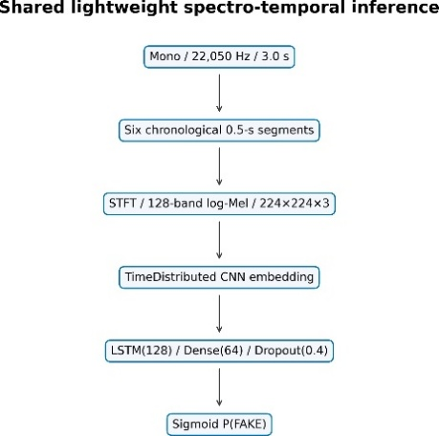
(a) Mel-sequence temporal path

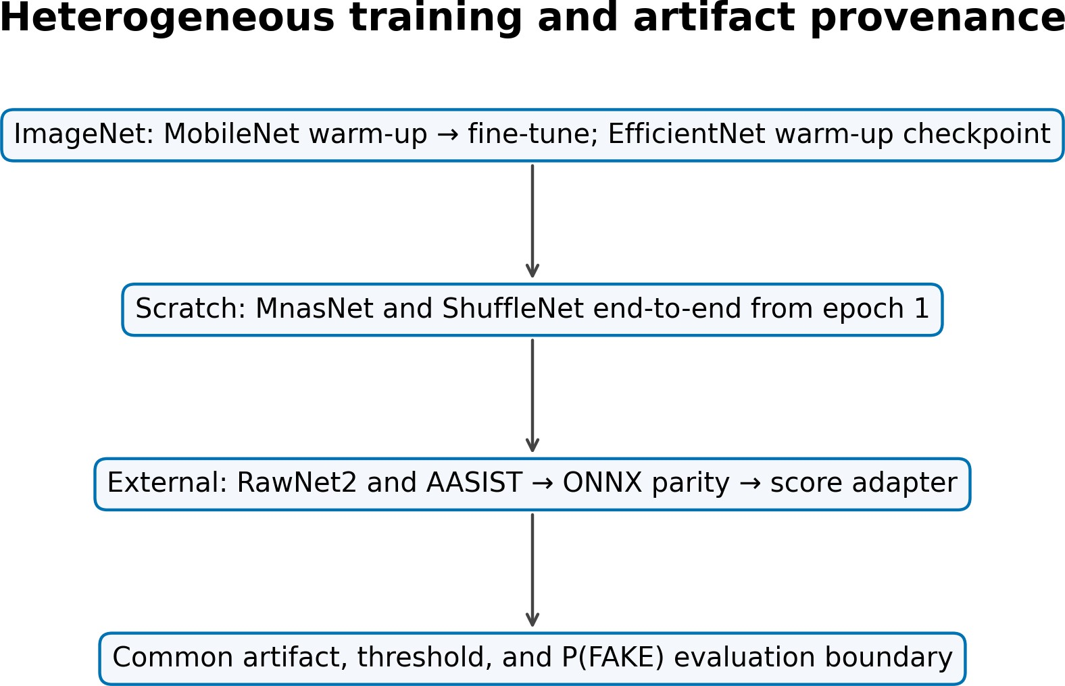
(b) Artifact provenance
Fig. 3. Architecture and provenance: the evaluation contract is shared, training is not.
Table 3. Detector specification, provenance, and deployed threshold
Detector | Input | Temporal core | Params | Initialization/artifact provenance | τ
MobileNetV3-LSTM [17] | Mel, 3.0 s | LSTM(128) | 1,308,401 | ImageNet; warm-up + partial fine-tune | .82
ShuffleNetV2-LSTM [18] | Mel, 3.0 s | LSTM(128) | 1,868,441 | scratch; full end-to-end, best epoch 16/28 | .12
MnasNet-A1-LSTM [21] | Mel, 3.0 s | LSTM(128) | 3,369,255 | scratch; full end-to-end, best epoch 27/39 | .90
EfficientNet-B0-LSTM warm-up [22] | Mel, 3.0 s | LSTM(128) | 4,779,300 | ImageNet; best warm-up epoch 47 | .90
RawNet2 [7] | waveform, 4.04 s | GRU | 17,621,410 | external reference; ONNX export | .50
AASIST [9], [24] | waveform, 4.04 s | graph readout | 297,866 | external reference; ONNX export | .50
RawNet2 and AASIST were strictly loaded in PyTorch and exported to ONNX. Maximum native/export score differences were 4.11 × 10−6 and 5.96 × 10−8 on six real tensors. This verifies conversion, not equal training or publication-pipeline equivalence.
LAVA fixes REAL=0 and FAKE=1; every adapter returns p = P(FAKE) and applies the detector threshold listed in Table 3.
$$\overset{ˆ}{y}=1\left[p≥τ\right], τ^{*}=\arg{\max_{τ}{F}}1_{val}\left(τ\right).$$
The four lightweight thresholds in Table 3 are validation-only. The external reference artifacts use the uncalibrated default threshold of 0.5. Labels do not influence threshold selection or weighting, and scores are not interpreted as calibrated real-world probabilities.
  - Clean and Robustness Evaluation
Clean evaluation uses all 2,737 test recordings (1,575 REAL, 1,162 FAKE). Accuracy, precision, recall, F1, macro-F1, ROC-AUC from raw scores, and linearly interpolated EER are reported. With FAKE positive,
$$P=\frac{TP}{TP+FP}, R=\frac{TP}{TP+FN}, F1=\frac{2PR}{P+R}; FAR=\frac{FP}{FP+TN},$$
$$FRR=\frac{FN}{FN+TP}, EER≃\frac{FAR+FRR}{2}.$$
Robustness is a fixed 100-recording diagnostic evaluation (58 REAL, 42 FAKE; seed 42), and every artifact uses the same recordings. Four seeded AWGN levels (20, 10, 5, 0 dB) use sample-identity-derived seeds. FFmpeg round trips cover MP3 128/64 kb/s, Opus 64 kb/s, and AAC 96 kb/s. Simulated replay applies taps at 0/17/43/89 ms with gains 1/.45/.25/.12, normalization by 1.82, and a causal fourth-order 100-3,800-Hz band-pass; it is not physical replay. For nine conditions,
$$Δ{F1}_{k}={F1}_{clean}-{F1}_{k}, {\overline{F1}}_{stress}=\frac{1}{9}\sum_{k=1}^{9}{{F1}_{k}}.$$
Negative degradation denotes improvement relative to a low diagnostic-subset baseline and is not evidence of robustness. Full-test stress evaluation was not run; physical replay and unseen-corpus evaluations are not available.
  - Computational Efficiency Evaluation
Each artifact runs float32, batch one, one backend thread, and no accelerator in a sequential isolated process. Ten warm-ups precede 50 timed repetitions. Measurements separate preprocessing, model-only, and end-to-end time and include P95, load time, throughput, and whole-process RSS. The stored platform signature matches the measurement host identified as an AMD Ryzen 9 8940HX (16 cores, 32 logical processors) with 15.28 GiB usable RAM, running 64-bit Windows 11 Pro build 26200. TensorFlow 2.15 executes the lightweight models and ONNX Runtime 1.17.3 executes the external references. For N clips,
$$Q=\frac{N}{T_{total}}, RTF=\frac{T_{processing}}{T_{audio}}.$$
An RTF below one indicates faster-than-duration offline processing on this host; it does not establish causal streaming or edge-device deployment.
The corrected diagnostic Pareto analysis minimizes diagnostic-subset EER, maximizes mean stressed F1 across the nine executed conditions, and minimizes end-to-end RTF. The objective vector below negates mean stressed F1 so that all three components are minimized. Model A dominates model B when every component is no worse and at least one is strictly better:
$$g(m)=({EER}_{diag}(m),-{\overline{F1}}_{stress}(m),RTF(m)).$$
$$g_{i}(A)≤g_{i}(B) ∀i, and ∃j:g_{j}(A)<g_{j}(B).$$
Table 4: Clean performance on all 2,737 canonical test recordings. Accuracy, precision, recall, F1, and macro-F1 use each artifact's deployed threshold; AUC and EER are threshold-independent.
Model | Accuracy | Precision | Recall | F1 | Macro-F1 | AUC | EER
MobileNetV3 | .9766 | .9741 | .9707 | .9724 | .9761 | .9911 | .0250
ShuffleNetV2 | .9850 | .9795 | .9854 | .9824 | .9847 | .9929 | .0146
MnasNet-A1 | .9697 | .9599 | .9690 | .9645 | .9690 | .9886 | .0310
EffNet-B0 warm-up | .9635 | .9724 | .9406 | .9563 | .9624 | .9877 | .0400
RawNet2 ext. | .4936 | .4380 | .6807 | .5330 | .4900 | .5178 | .4813
AASIST ext. | .5513 | .4758 | .5585 | .5139 | .5487 | .5597 | .4463

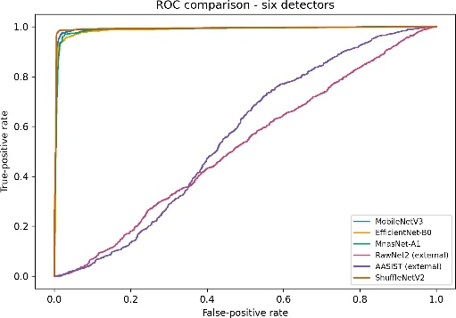
- ROC
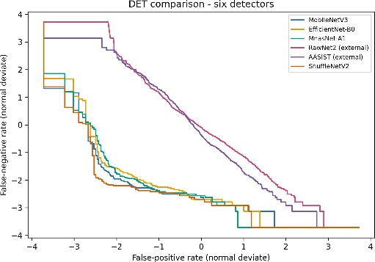
- DET/EER
Fig. 4. Threshold-independent clean discrimination on the full test split
- Results and Discussion
  - RQ1 Clean Detection Performance
All six artifacts passed load, finite bounded-score, hash, and adapter checks. AUC and EER provide the primary comparison in Table 4 and Figure 4: ShuffleNetV2 achieved the highest AUC (0.9929) and lowest EER (0.0146), followed by MobileNetV3 (AUC 0.9911; EER 0.0250), MnasNet-A1, and the available EfficientNet-B0 warm-up checkpoint. The current RawNet2 and AASIST reference artifacts operated near chance under this dataset, adapter, and score contract. Accuracy, precision, recall, F1, and macro-F1 describe performance only at each deployed threshold.
This deployed-artifact comparison is not a controlled architecture study. The locally trained lightweight artifacts and external RawNet2/AASIST checkpoints differ in training data, initialization, duration, representation, loader details, and threshold calibration. The results do not show that the RawNet2 or AASIST architectures are inferior and do not estimate their maximum attainable performance after retraining or calibration.
  - RQ2 Robustness under Executed Distortions
On the fixed 100-recording diagnostic subset, AWGN was the largest observed weakness for the four high-performing lightweight artifacts. Mean noise degradation ranged from 0.3555 for ShuffleNetV2 to 0.8053 for the available EfficientNet-B0 warm-up checkpoint and increased sharply at 5 and 0 dB. Table 5 and Figure 5 report only these diagnostic conditions.
Table 5: Fixed 100-recording diagnostic robustness. Clean F1 and EER use the diagnostic subset; ΔF1 is clean minus stressed performance.
Model | Clean F1 | Diagnostic EER | Noise ΔF1 | Codec ΔF1 | Replay ΔF1 | Mean stressed F1
MobileNetV3 | .9756 | .0476 | .6722 | .0095 | .0620 | .6657
ShuffleNetV2 | .9756 | .0476 | .3555 | .0032 | .0256 | .8133
MnasNet-A1 | .9756 | .0476 | .6119 | .0233 | .1489 | .6767
EffNet-B0 warm-up | .9630 | .0476 | .8053 | .0000 | .0641 | .5980
RawNet2 ext. | .5660 | .4138 | .5077 | −.0007 | −.0109 | .3419
AASIST ext. | .5060 | .3810 | −.0660 | −.0074 | −.0682 | .5462

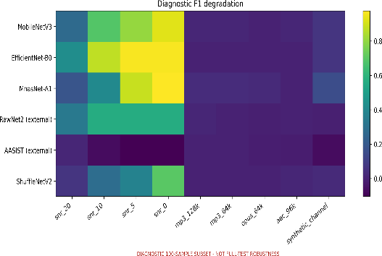(a) Nine-condition degradation
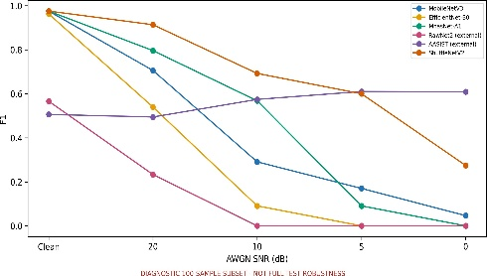 (b) AWGN F1 trajectory
Fig. 5. Diagnostic robustness; all models reuse identical stressed recordings.
On the fixed diagnostic subset, codec effects were small for the lightweight artifacts (mean ΔF1: 0.0000–0.0233). Under simulated replay, ShuffleNetV2 retained F1 = 0.9500 (ΔF1 = 0.0256), versus ΔF1 values of 0.0620, 0.0641, and 0.1489 for MobileNetV3, the available EfficientNet-B0 warm-up checkpoint, and MnasNet-A1. Negative deltas for the external artifacts reflect score redistribution around weak baselines, not general robustness.
Aggregate failure-pattern analysis. On the fixed diagnostic subset, low-SNR AWGN produced the largest aggregate degradation; codec effects were limited, while simulated replay affected MnasNet-A1 most and ShuffleNetV2 least. These patterns establish neither causality nor general robustness. Without paired clean/stressed scores, sample-level prediction flips cannot be identified.
  - Computational Efficiency
Under the single-thread desktop-CPU protocol in Table 6, MobileNetV3 had the lowest end-to-end latency and RTF; ShuffleNetV2 ranked second among locally trained artifacts. The available EfficientNet-B0 warm-up checkpoint was the slowest Mel-sequence artifact. AASIST paired the smallest file with the largest latency, whereas RawNet2 paired the most parameters with moderate latency; size therefore did not predict runtime. RSS is whole-process memory.
Table 6: Float32 batch-one desktop-CPU efficiency on AMD Ryzen 9 8940HX (10 warm-ups, 50 timed runs). RSS is whole-process memory.
Model | Params | Size (MiB) | RSS (MiB) | Model ms | E2E ms | P95 ms | clips/s | RTF
MobileNetV3 | 1.31M | 5.64 | 554.6 | 30.07 | 43.81 | 52.12 | 22.83 | .0146
ShuffleNetV2 | 1.87M | 7.74 | 501.8 | 48.05 | 62.52 | 75.37 | 15.99 | .0208
MnasNet-A1 | 3.37M | 13.43 | 566.0 | 95.25 | 117.00 | 138.96 | 8.55 | .0390
EffNet-B0 warm-up | 4.78M | 18.96 | 651.2 | 168.36 | 175.85 | 196.11 | 5.69 | .0586
RawNet2 ext. | 17.62M | 67.65 | 249.5 | 95.10 | 96.54 | 102.62 | 10.36 | .0239
AASIST ext. | 0.30M | 1.61 | 442.5 | 359.61 | 362.91 | 398.45 | 2.76 | .0899
  - RQ3 Exploratory Pareto Trade-offs
Under the evaluated objectives, Figure 6 identifies MobileNetV3 and ShuffleNetV2 as non-dominated artifacts. MobileNetV3 has the lowest RTF (0.0146). ShuffleNetV2 combines diagnostic-subset EER = 0.0476, the highest mean stressed F1 (0.8133), and RTF = 0.0208; it dominates the other four artifacts in this diagnostic analysis. The frontier is exploratory because robustness uses 100 recordings and runtime one desktop host; it does not identify a universal optimum.
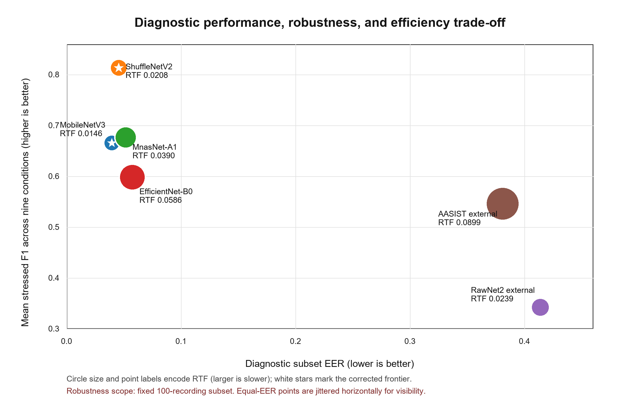
Fig. 6. Corrected diagnostic Pareto space: diagnostic-subset EER, mean stressed F1, and end-to-end RTF. Stars mark MobileNetV3 and ShuffleNetV2; equal-EER points are jittered horizontally only for visibility.
- Discussion and Conclusion
Evidence is limited by heterogeneous training and calibration, a fixed 100-recording robustness diagnostic, simulated rather than physical replay, and runtime measurements on one desktop CPU. The dataset lacks metadata needed to establish speaker, source, generator, parent-recording, or cross-dataset independence. No unseen-corpus, edge-device, causal-streaming, or multi-seed evaluation was conducted; RSS represents whole-process memory, EfficientNet-B0 is represented only by its available warm-up checkpoint, and paired scores for sample-level flip analysis are unavailable.
Recommendations are scenario-, artifact-, and platform-specific. Under the evaluated objectives, ShuffleNetV2 provides the strongest measured balance across clean discrimination, diagnostic stressed F1, and RTF. MobileNetV3 is the non-dominated choice when latency is prioritized on the measured host. These findings are not universal architecture rankings or an optimal-model claim.
Overall, LAVA provides an evidence-traceable evaluation of six heterogeneous voice anti-spoofing artifacts. Under the evaluated objectives, the exploratory non-dominated set comprises MobileNetV3 and ShuffleNetV2, while low-SNR noise is the principal observed weakness on the fixed diagnostic subset. Future work should retain paired per-recording scores, extend robustness evaluation to the full test set, and evaluate unseen corpora, physical replay, streaming, and target edge hardware [15], [16]. The current evidence supports deployment-oriented offline comparison, but not comprehensive generalization, streaming, or edge-device validation.

Acknowledgement
This research was supported by the University of Economics Ho Chi Minh City (UEH), Vietnam.

References
[1] J. Yi, C. Wang, J. Tao, X. Zhang, C. Y. Zhang, and Y. Zhao, “Audio deepfake detection: A survey,” arXiv preprint arXiv:2308.14970, 2023.
[2] M. Li, Y. Ahmadiadli, and X. P. Zhang, “A survey on speech deepfake detection,” arXiv preprint arXiv:2404.13914, 2024.
[3] M. Todisco, X. Wang, V. Vestman, M. Sahidullah, H. Delgado, A. Nautsch, J. Yamagishi, N. Evans, T. Kinnunen, and K. A. Lee, "ASVspoof2019: Future horizons in spoofed and fake audio detection." pp. 1008-1012.
[4] J. Frank, and L. Schönherr, “WaveFake: A data set to facilitate audio deepfake detection,” NeurIPS Datasets and Benchmarks, 2021.
[5] J. Yamagishi, X. Wang, M. Todisco, M. Sahidullah, J. Patino, A. Nautsch, X. Liu, K. A. Lee, T. Kinnunen, N. Evans, and H. Delgado, "ASVspoof 2021: Accelerating progress in spoofed and deepfake speech detection." pp. 47-54.
[6] T. Kinnunen, K. A. Lee, H. Delgado, N. Evans, M. Todisco, M. Sahidullah, J. Yamagishi, and D. A. Reynolds, "t-DCF: A detection cost function for the tandem assessment of spoofing countermeasures and automatic speaker verification." pp. 312-319.
[7] H. Tak, J. Patino, M. Todisco, A. Nautsch, N. Evans, and A. Larcher, "End-to-end anti-spoofing with RawNet2." pp. 6369-6373.
[8] M. Ravanelli, and Y. Bengio, "Speaker recognition from raw waveform with SincNet." pp. 1021-1028.
[9] J. w. Jung, H. S. Heo, H. Tak, H. j. Shim, J. S. Chung, B. J. Lee, H. J. Yu, and N. Evans, "AASIST: Audio anti-spoofing using integrated spectro-temporal graph attention networks." pp. 6367-6371.
[10] H. Tak, M. Todisco, X. Wang, J. w. Jung, J. Yamagishi, and N. Evans, "Automatic speaker verification spoofing and deepfake detection using wav2vec 2.0 and data augmentation." pp. 112-119.
[11] Z. Wu, R. K. Das, J. Yang, and H. Li, "Light convolutional neural network with feature genuinization for detection of synthetic speech attacks." pp. 1101-1105.
[12] O. Pascu, A. Stan, D. Oneata, E. Oneata, and H. Cucu, "Towards generalisable and calibrated audio deepfake detection with self-supervised representations." pp. 4828-4832.
[13] N. M. Müller, P. Czempin, F. Dieckmann, A. Froghyar, and K. Böttinger, "Does audio deepfake detection generalize?." pp. 2783-2787.
[14] P. Kawa, M. Plata, and P. Syga, "Attack agnostic dataset: Towards generalization and stabilization of audio deepfake detection." pp. 4023-4027.
[15] N. M. Müller, N. Evans, H. Tak, P. Sperl, and K. Böttinger, "Harder or different? understanding generalization of audio deepfake detection." pp. 2705-2709.
[16] Y. Li, M. Zhang, M. Ren, X. Qiao, M. Ma, D. Wei, and H. Yang, "Cross-domain audio deepfake detection: Dataset and analysis." pp. 4977-4983.
[17] A. Howard, M. Sandler, G. Chu, L. C. Chen, B. Chen, M. Tan, W. Wang, Y. Zhu, R. Pang, V. Vasudevan, Q. V. Le, and H. Adam, "Searching for MobileNetV3." pp. 1314-1324.
[18] N. Ma, X. Zhang, H. T. Zheng, and J. Sun, "ShuffleNet V2: Practical guidelines for efficient CNN architecture design." pp. 116-131.
[19] M. Sandler, A. Howard, M. Zhu, A. Zhmoginov, and L. C. Chen, "MobileNetV2: Inverted residuals and linear bottlenecks." pp. 4510-4520.
[20] X. Zhang, X. Zhou, M. Lin, and J. Sun, "ShuffleNet: An extremely efficient convolutional neural network for mobile devices." pp. 6848-6856.
[21] M. Tan, B. Chen, R. Pang, V. Vasudevan, M. Sandler, A. Howard, and Q. V. Le, "MnasNet: Platform-aware neural architecture search for mobile." pp. 2820-2828.
[22] M. Tan, and Q. V. Le, “EfficientNet: Rethinking model scaling for convolutional neural networks,” ICML, vol. 97, pp. 6105-6114, 2019.
[23] B. McFee, C. Raffel, D. Liang, D. P. W. Ellis, M. McVicar, E. Battenberg, and O. Nieto, "librosa: Audio and music signal analysis in Python." pp. 18-25.
[24] P. Veličković, G. Cucurull, A. Casanova, A. Romero, P. Liò, and Y. Bengio, "Graph attention networks."

