LAVA: A Lightweight Benchmarking Framework for Robust and Efficient Deepfake Voice Detection
Quoc Hung NGUYEN*^{[0000-0002-6363-0160]}, Khac Anh Tuan PHAN^{1[0009-0006-5164-465X]}, Phuong Chinh NGUYEN^{2[0009-0007-6080-9644]}, Thanh Dat LAI^{3[0009-0002-3962-960X]}, Tan Khiem NGUYEN^{4[0009-0003-2085-6252]}, and Thanh Dat TRUONG^{5[0009-0006-6562-3956]}
University of Economics Ho Chi Minh City (UEH), Ho Chi Minh City, Viet Nam
Corresponding author: hungngq@ueh.edu.vn
Abstract. Deepfake voice detectors are difficult to compare across incompatible data partitions, score conventions, calibration, preprocessing, and timing. LAVA applies common artifact-integrity, P(FAKE), robustness, and runtime contracts while preserving native computation. We evaluate four locally trained Mel-sequence artifacts and externally pretrained RawNet2 and AASIST reference artifacts, whose training and calibration provenance differs. SHA-256 grouping quarantined 30 cross-label files and produced a checksum-group-disjoint manifest; clean evaluation used all 2,737 test recordings. ShuffleNetV2 achieved the highest AUC (0.9929) and lowest EER (1.46%); its threshold-specific F1 was 0.9824. On one single-thread desktop CPU, MobileNetV3 had the lowest end-to-end latency (43.81 ms; RTF 0.0146), while ShuffleNetV2 required 62.52 ms (RTF 0.0208). A fixed stratified 100-recording diagnostic evaluated seeded AWGN, four codec round trips, and simulated replay. Low-SNR noise was the main observed weakness, and ShuffleNetV2 retained the highest mean stressed F1 (0.8133). Using diagnostic-subset EER, mean stressed F1, and end-to-end RTF, the corrected exploratory Pareto frontier contains MobileNetV3 and ShuffleNetV2. These findings support deployment-oriented offline comparison, but do not establish full-test robustness, unseen-corpus generalization, physical-replay robustness, streaming, edge-device performance, or multi-seed stability.
Keywords: Deepfake voice detection, audio anti-spoofing, lightweight deep learning, robustness, computational efficiency, Pareto analysis.
- Introduction
Synthetic and converted speech pose risks to speaker verification and human decision-making. Despite rapid progress in deepfake voice detection [1], [2] and shared evaluation resources such as ASVspoof and WaveFake [3], [4], comparisons remain difficult because studies differ in data partitions, label conventions, input duration, preprocessing, calibration, and runtime boundaries. Byte-identical recordings across data splits introduce an additional integrity concern.
LAVA provides a common evaluation interface for heterogeneous deployed artifacts without imposing a shared architecture or training protocol. It preserves both Mel-sequence and raw-waveform pipelines while standardizing artifact checks, P(FAKE) semantics, data integrity, stress conditions, stored outputs, and timing. Four lightweight artifacts were trained locally, whereas RawNet2 and AASIST are externally pretrained reference artifacts. Clean performance is evaluated on the full test set, robustness on a fixed diagnostic subset, and efficiency on one desktop CPU; therefore, the evidence does not establish streaming or edge-device operation. The study addresses:
RQ1: How do deployed artifacts compare on clean AUC and EER, and how should threshold-dependent metrics be interpreted under heterogeneous training and calibration? RQ2: How does absolute performance change under the executed noise, codec, and simulated-replay conditions on the fixed diagnostic subset? RQ3: Which artifacts are non-dominated across diagnostic-subset EER, mean stressed F1, and end-to-end RTF?
Corresponding to RQ1–RQ3, LAVA contributes: (1) checksum-group-disjoint, artifact-traceable clean evaluation emphasizing AUC/EER and provenance limitations; (2) matched diagnostic evaluation of noise, compression, and simulated replay using absolute stressed performance and aggregate failure-pattern analysis; and (3) a desktop-CPU efficiency protocol with corrected three-objective Pareto analysis for scenario-specific, deployment-oriented recommendations.
Table 1. Representative-study coverage. P = partial or indirect; Sim. = simulated replay; - = not evaluated or not reported.
Study | Noise | Compression | Replay | Unseen Data | Latency/RTF | Edge
ASVspoof 2019 [1] | - | - | Yes | P | - | -
WaveFake [2] | - | - | - | P | - | -
ASVspoof 2021 [5] | P | P | Yes | P | - | -
RawNet2 [7] | - | - | - | P | - | -
AASIST [8] | - | - | - | P | - | -
wav2vec 2.0 aug. [9] | P | - | - | P | - | -
Pascu et al. [10] | - | - | - | Yes | - | -
Müller et al. [11] | - | - | - | Yes | - | -
Attack Agnostic [12] | - | - | - | Yes | - | -
LAVA (this work) | Yes | Yes | Sim. | - | Yes | -
- Related Work
ASVspoof 2019 and 2021 established shared logical-access, physical-access, and deepfake evaluation protocols, including replay and channel variation [3], [5], [6], while WaveFake broadened publicly available synthesized-speech resources [4]. Representative detection approaches include raw-waveform models such as SincNet and RawNet2 [7], [8], the spectro-temporal graph-attention architecture AASIST [9], and wav2vec 2.0 and LCNN-based systems using complementary representations and augmentation strategies [10], [11].
Studies of unseen attacks and datasets show that strong in-domain performance does not necessarily transfer across sources [12], [13], [14], [15], [16]. Meanwhile, efficient backbones such as MobileNet, ShuffleNet, EfficientNet, and MnasNet were developed under resource constraints [17], [18], [19], [20], [21], [22] but their published image- or phone-based measurements do not establish audio latency for the pipelines evaluated here.
As summarized in Table 1, prior work generally addresses only subsets of clean detection, corruption robustness, replay, unseen-data evaluation, and computational efficiency. Few studies integrate these dimensions within a single artifact-traceable evaluation contract. LAVA addresses this measurement-integration gap for six deployed artifacts without claiming unseen-corpus generalization or edge-device validation.
- Methodology
  - LAVA Framework and Experimental Protocol
LAVA separates canonical data and integrity (D), registered detectors (M), executed conditions (C), measurements (E), and analyses (A). The registry records framework, input, duration, artifact, threshold, and provenance; adapters preserve native computation while exposing loading, bounded scores, parameter count, and size. Runners derive statistics and figures from sample-level outputs while keeping planned and executed conditions distinct. Figures 1 and 2 show the evaluation boundary and checksum-aware data construction.

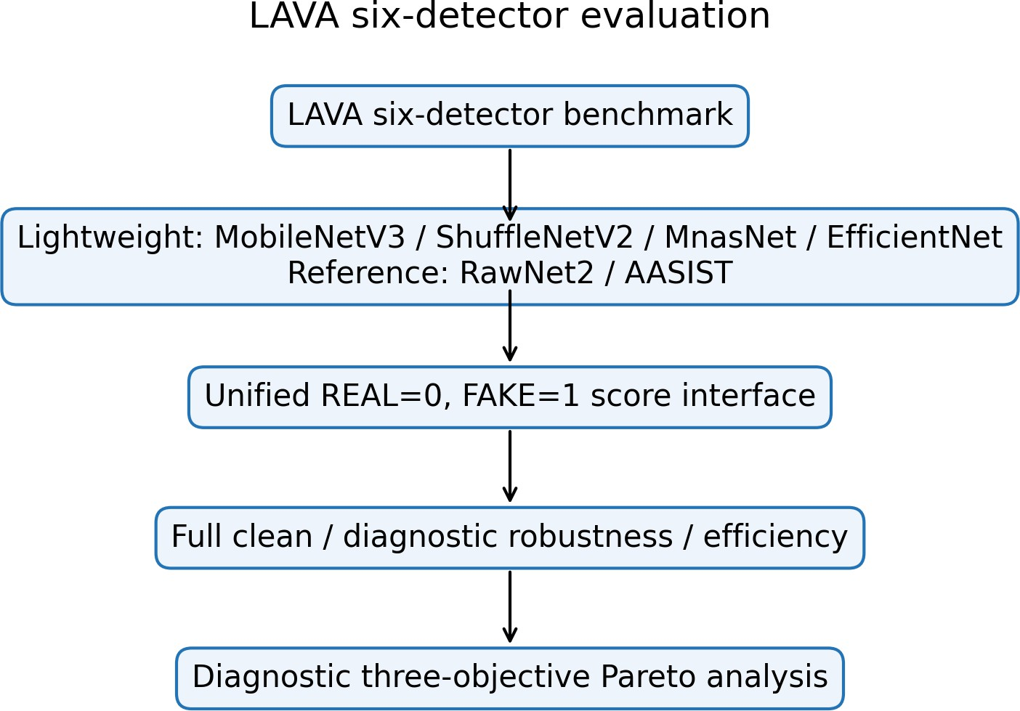
Fig. 1. Six native detectors connected to the unified LAVA evaluation boundary
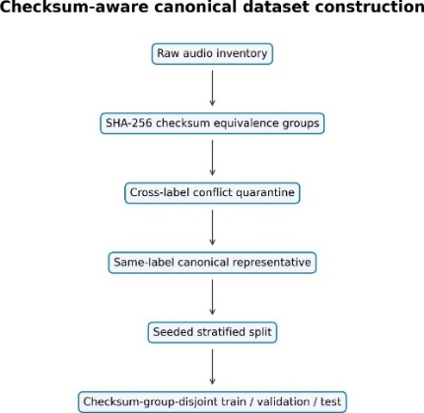
Fig. 2. SHA-256 conflict quarantine, canonicalization, and disjoint splitting.

  - Dataset Integrity and Canonical Split
The internal binary collection lacks speaker, source, generator, parent-recording, and dataset identifiers; the split therefore establishes neither speaker, source, generator, parent-recording, nor cross-dataset independence. LAVA scanned 18,722 files (10,550 REAL, 8,172 FAKE), found 435 duplicate groups and 476 redundant files, and quarantined all 30 files in 14 cross-label checksum groups. Within a same-label group, the lexicographically first path is canonical. The retained 18,232 recordings comprise 10,493 REAL and 7,739 FAKE, split with seed 42 into 12,762/2,733/2,737 train/validation/test recordings (Table 2). The supported split property is checksum-group-disjoint. For h(x) = SHA256(x) and split group sets Gs,
$$x_{i}∼x_{j}⇔h\left(x_{i}\right)=h\left(x_{j}\right), G_{tr}∩G_{va}=G_{tr}∩G_{te}=G_{va}∩G_{te}=∅.$$
The manifest hash is:
8b55591d58d3658b8cafe0e77b6ebdedbaa67be2e339730a7276fe9b10958df9.
Table 2. Canonical manifest and split inventory
Inventory | Count | Split | Count
Scanned / retained | 18,722 / 18,232 | Train | 12,762
Retained REAL / FAKE | 10,493 / 7,739 | Validation | 2,733
Duplicate groups / redundant | 435 / 476 | Test | 2,737
Cross-label groups / files | 14 / 30 | Split property | checksum-group-disjoint

  - Standardized Audio Preprocessing
Lightweight inputs are decoded, channel-averaged, polyphase-resampled to 22,050 Hz, and padded/truncated to 3.0 s. Six chronological 0.5-s segments use a Hann STFT (N = 2048, hop 512), 128 HTK-style Mel filters spanning 20–8,000 Hz, relative dB mapping clipped to 80 dB, [0, 255] scaling, bilinear 224 × 224 resizing, and RGB replication [15]. For segment t
$$X_{t}\left(m,k\right)=\sum_{n=0}^{N-1}{x_{t}}\left[n+mH\right]w\left[n\right]e^{-j2πkn/N}, S_{t}^{mel}\left(m,r\right)=\sum_{k}{{\left|X_{t}\left(m,k\right)\right|}^{2}}H_{r}\left(k\right)$$
  - Evaluated Detector Architectures
For the lightweight family, shared segment encoder fθ produces six embeddings, an LSTM with 128 units aggregates them, and a 64-unit ReLU layer plus dropout 0.4 feeds a sigmoid:
$$p_{fake}=σ\left(W_{2}{\text{Dropout}}_{.4}\left(\text{ReLU}\left(W_{1}\text{LSTM}\left(f_{θ}\left(X_{1:6}\right)\right)+b_{1}\right)\right)+b_{2}\right).$$
  - Training Artifact Provenance and Score Semantics
MobileNet and EfficientNet use ImageNet initialization; EfficientNet is the best warm-up checkpoint, not a completed fine-tuning result. MnasNet and ShuffleNet were trained from scratch with their recurrent heads and trainable BatchNormalization layers. RawNet2 and AASIST are externally pretrained reference artifacts and were not trained under the local protocol (Figure 3).

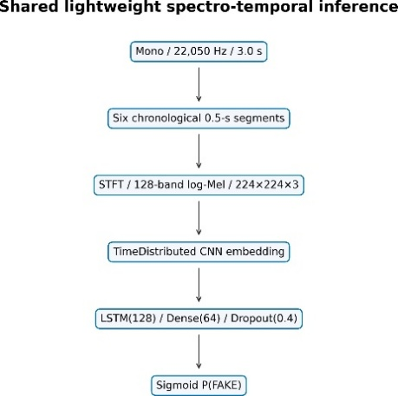
(a) Mel-sequence temporal path

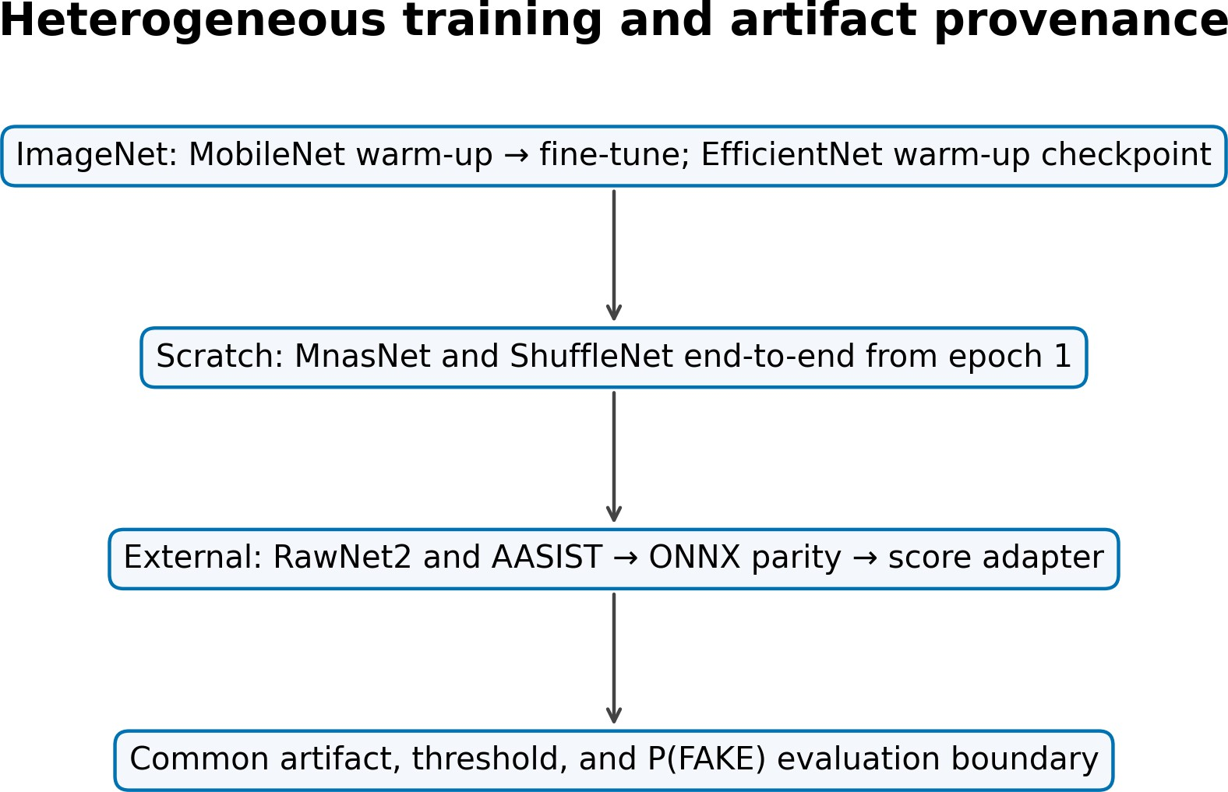
(b) Artifact provenance
Fig. 3. Architecture and provenance: the evaluation contract is shared, training is not.
Table 3. Detector specification, provenance, and deployed threshold
Detector | Input | Temporal core | Params | Initialization/artifact provenance | τ
MobileNetV3-LSTM [20], [23] | Mel, 3.0 s | LSTM(128) | 1,308,401 | ImageNet; warm-up + partial fine-tune | .82
ShuffleNetV2-LSTM [21], [19] | Mel, 3.0 s | LSTM(128) | 1,868,441 | scratch; full end-to-end, best epoch 16/28 | .12
MnasNet-A1-LSTM [22] | Mel, 3.0 s | LSTM(128) | 3,369,255 | scratch; full end-to-end, best epoch 27/39 | .90
EfficientNet-B0-LSTM [24] | Mel, 3.0 s | LSTM(128) | 4,779,300 | ImageNet; best warm-up epoch 47 | .90
RawNet2 [7] | waveform, 4.04 s | GRU | 17,621,410 | external reference; ONNX export | .50
AASIST [10], [16] | waveform, 4.04 s | graph readout | 297,866 | external reference; ONNX export | .50
RawNet2 and AASIST were strictly loaded in PyTorch and exported to ONNX. Maximum native/export score differences were 4.11 × 10−6 and 5.96 × 10−8 on six real tensors. This verifies conversion, not equal training or publication-pipeline equivalence.
LAVA fixes REAL=0 and FAKE=1; every adapter returns p = P(FAKE) and applies the detector threshold listed in Table 3.
$$\overset{ˆ}{y}=1\left[p≥τ\right], τ^{*}=\arg{\max_{τ}{F}}1_{val}\left(τ\right).$$
The four lightweight thresholds in Table 3 are validation-only. The external reference artifacts use the uncalibrated default threshold of 0.5. Labels do not influence threshold selection or weighting, and scores are not interpreted as calibrated real-world probabilities.
  - Clean and Robustness Evaluation
Clean evaluation uses all 2,737 test recordings (1,575 REAL, 1,162 FAKE). Accuracy, precision, recall, F1, macro-F1, ROC-AUC from raw scores, and linearly interpolated EER are reported. With FAKE positive,
$$P=\frac{TP}{TP+FP}, R=\frac{TP}{TP+FN}, F1=\frac{2PR}{P+R}; FAR=\frac{FP}{FP+TN},$$
$$FRR=\frac{FN}{FN+TP}, EER≃\frac{FAR+FRR}{2}.$$
Robustness is a fixed 100-recording diagnostic evaluation (58 REAL, 42 FAKE; seed 42), and every artifact uses the same recordings. Four seeded AWGN levels (20, 10, 5, 0 dB) use sample-identity-derived seeds. FFmpeg round trips cover MP3 128/64 kb/s, Opus 64 kb/s, and AAC 96 kb/s. Simulated replay applies taps at 0/17/43/89 ms with gains 1/.45/.25/.12, normalization by 1.82, and a causal fourth-order 100-3,800-Hz band-pass; it is not physical replay. For nine conditions,
$$Δ{F1}_{k}={F1}_{clean}-{F1}_{k}, {\overline{F1}}_{stress}=\frac{1}{9}\sum_{k=1}^{9}{{F1}_{k}}.$$
Negative degradation denotes improvement relative to a low diagnostic-subset baseline and is not evidence of robustness. Full-test stress evaluation was not run; physical replay and unseen-corpus evaluations are not available.
  - Computational Efficiency Evaluation
Each artifact runs float32, batch one, one backend thread, and no accelerator in a sequential isolated process. Ten warm-ups precede 50 timed repetitions. Measurements separate preprocessing, model-only, and end-to-end time and include P95, load time, throughput, and whole-process RSS. The stored platform signature matches the measurement host identified as an AMD Ryzen 9 8940HX (16 cores, 32 logical processors) with 15.28 GiB usable RAM, running 64-bit Windows 11 Pro build 26200. TensorFlow 2.15 executes the lightweight models and ONNX Runtime 1.17.3 executes the external references. For N clips,
$$Q=\frac{N}{T_{total}}, RTF=\frac{T_{processing}}{T_{audio}}.$$
An RTF below one indicates faster-than-duration offline processing on this host; it does not establish causal streaming or edge-device deployment.
The corrected diagnostic Pareto analysis minimizes diagnostic-subset EER, maximizes mean stressed F1 across the nine executed conditions, and minimizes end-to-end RTF. The objective vector below negates mean stressed F1 so that all three components are minimized. Model A dominates model B when every component is no worse and at least one is strictly better:
$$g(m)=({EER}_{diag}(m),-{\overline{F1}}_{stress}(m),RTF(m)).$$
$$g_{i}(A)≤g_{i}(B) ∀i, and ∃j:g_{j}(A)<g_{j}(B).$$
Table 4: Clean performance on all 2,737 canonical test recordings. Accuracy, precision, recall, F1, and macro-F1 use each artifact's deployed threshold; AUC and EER are threshold-independent.
Model | Accuracy | Precision | Recall | F1 | Macro-F1 | AUC | EER
MobileNetV3 | .9766 | .9741 | .9707 | .9724 | .9761 | .9911 | .0250
ShuffleNetV2 | .9850 | .9795 | .9854 | .9824 | .9847 | .9929 | .0146
MnasNet-A1 | .9697 | .9599 | .9690 | .9645 | .9690 | .9886 | .0310
EfficientNet-B0 | .9635 | .9724 | .9406 | .9563 | .9624 | .9877 | .0400
RawNet2 ext. | .4936 | .4380 | .6807 | .5330 | .4900 | .5178 | .4813
AASIST ext. | .5513 | .4758 | .5585 | .5139 | .5487 | .5597 | .4463

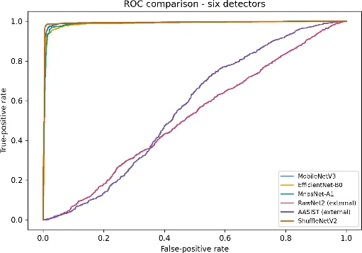
- ROC
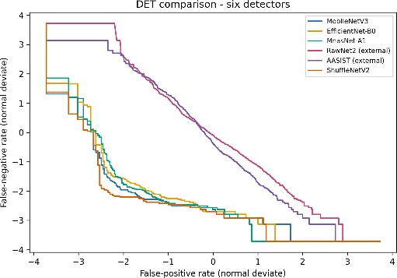
- DET/EER
Fig. 4. Threshold-independent clean discrimination on the full test split
- Results and Discussion
  - RQ1 Clean Detection Performance
All six artifacts passed load, finite bounded-score, hash, and adapter checks. AUC and EER provide the primary comparison in Table 4 and Figure 4: ShuffleNetV2 achieved the highest AUC (0.9929) and lowest EER (0.0146), followed by MobileNetV3 (AUC 0.9911; EER 0.0250), MnasNet-A1, and the available EfficientNet-B0 warm-up checkpoint. The current RawNet2 and AASIST reference artifacts operated near chance under this dataset, adapter, and score contract. Accuracy, precision, recall, F1, and macro-F1 describe performance only at each deployed threshold.
This deployed-artifact comparison is not a controlled architecture study. The locally trained lightweight artifacts and external RawNet2/AASIST checkpoints differ in training data, initialization, duration, representation, loader details, and threshold calibration. The results do not show that the RawNet2 or AASIST architectures are inferior and do not estimate their maximum attainable performance after retraining or calibration.
  - RQ2 Robustness under Executed Distortions
On the fixed 100-recording diagnostic subset, AWGN was the largest observed weakness for the four high-performing lightweight artifacts. Mean noise degradation ranged from 0.3555 for ShuffleNetV2 to 0.8053 for EfficientNet-B0 and increased sharply at 5 and 0 dB. Table 5 reports diagnostic-subset EER and mean absolute stressed F1; Figure 5 shows the condition-level patterns.
Table 5: Fixed 100-recording diagnostic robustness. Clean F1 and EER use the diagnostic subset; ΔF1 is clean minus stressed performance.
Model | Clean F1 | Diagnostic EER | Noise ΔF1 | Codec ΔF1 | Replay ΔF1 | Mean stressed F1
MobileNetV3 | .9756 | .0476 | .6722 | .0095 | .0620 | .6657
ShuffleNetV2 | .9756 | .0476 | .3555 | .0032 | .0256 | .8133
MnasNet-A1 | .9756 | .0476 | .6119 | .0233 | .1489 | .6767
EfficientNet-B0 | .9630 | .0476 | .8053 | .0000 | .0641 | .5980
RawNet2 ext. | .5660 | .4138 | .5077 | −.0007 | −.0109 | .3419
AASIST ext. | .5060 | .3810 | −.0660 | −.0074 | −.0682 | .5462

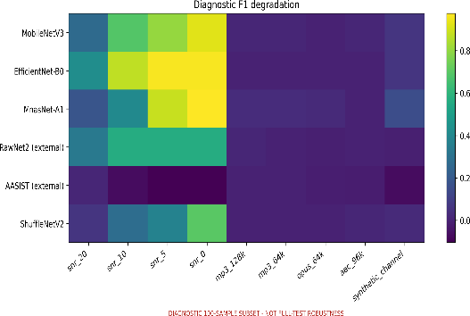(a) Nine-condition degradation
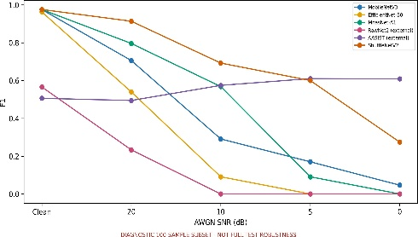 (b) AWGN F1 trajectory
Fig. 5. Diagnostic robustness; all models reuse identical stressed recordings.
Codec effects were small for the lightweight artifacts at the tested settings (mean ΔF1: 0.0000–0.0233). Under simulated replay, ShuffleNetV2 retained an F1 of 0.9500 (ΔF1 = 0.0256), compared with ΔF1 values of 0.0620, 0.0641, and 0.1489 for MobileNetV3, EfficientNet-B0, and MnasNet-A1, respectively. Negative deltas for the external reference artifacts reflect score redistribution around weak baselines rather than superior robustness.
Aggregate failure-pattern analysis. The condition-level results indicate that low-SNR AWGN was the main weakness: mean noise ΔF1 ranged from 0.3555 for ShuffleNetV2 to 0.8053 for EfficientNet-B0, with MobileNetV3 and MnasNet-A1 reaching 0.6722 and 0.6119. Codec effects remained limited, while simulated replay affected MnasNet-A1 most and ShuffleNetV2 least, possibly because of different sensitivities to band limitation and delayed echoes. These evidence-bounded interpretations apply only to the fixed diagnostic subset and do not establish causality. Because paired clean/stressed scores are unavailable, sample-level prediction flips cannot be identified.
  - Computational Efficiency
Under the common single-thread desktop-CPU protocol in Table 6, MobileNetV3 had the lowest end-to-end latency and RTF; ShuffleNetV2 was second among the locally trained artifacts. AASIST combined the smallest serialized artifact with the largest latency, while RawNet2 combined the largest parameter count with moderate latency. Parameter count and artifact size therefore did not predict runtime. RSS denotes whole-process memory, not model-only allocation.
Table 6: Float32 batch-one desktop-CPU efficiency on AMD Ryzen 9 8940HX (10 warm-ups, 50 timed runs). RSS is whole-process memory.
Model | Params | Size (MiB) | RSS (MiB) | Model ms | E2E ms | P95 ms | clips/s | RTF
MobileNetV3 | 1.31M | 5.64 | 554.6 | 30.07 | 43.81 | 52.12 | 22.83 | .0146
ShuffleNetV2 | 1.87M | 7.74 | 501.8 | 48.05 | 62.52 | 75.37 | 15.99 | .0208
MnasNet-A1 | 3.37M | 13.43 | 566.0 | 95.25 | 117.00 | 138.96 | 8.55 | .0390
EfficientNet-B0 | 4.78M | 18.96 | 651.2 | 168.36 | 175.85 | 196.11 | 5.69 | .0586
RawNet2 ext. | 17.62M | 67.65 | 249.5 | 95.10 | 96.54 | 102.62 | 10.36 | .0239
AASIST ext. | 0.30M | 1.61 | 442.5 | 359.61 | 362.91 | 398.45 | 2.76 | .0899
  - RQ3 Corrected Pareto Trade-offs
Figure 6 visualizes the corrected exploratory frontier containing MobileNetV3 and ShuffleNetV2. MobileNetV3 is non-dominated because it has the lowest measured RTF (0.0146). ShuffleNetV2 shares the diagnostic-subset EER of 0.0476 with the four lightweight artifacts, has the highest mean stressed F1 (0.8133), and retains a low RTF (0.0208); it dominates MnasNet-A1, EfficientNet-B0, RawNet2, and AASIST under these objectives. AASIST is no longer on the corrected frontier. This result is exploratory because robustness uses 100 recordings and efficiency was measured on one desktop host.
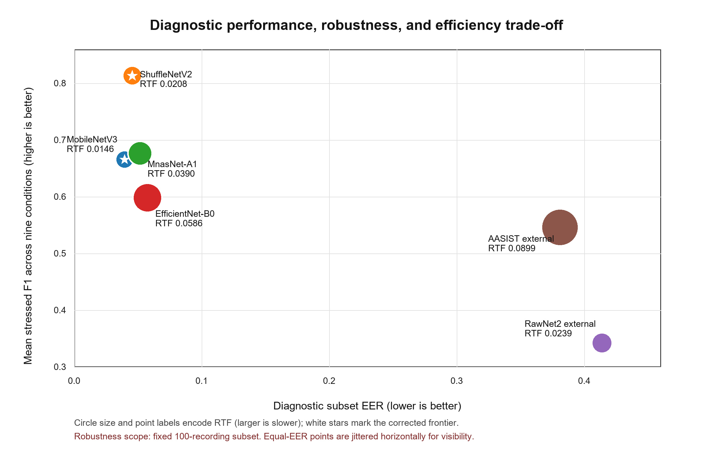
Fig. 6. Corrected diagnostic Pareto space: diagnostic-subset EER, mean stressed F1, and end-to-end RTF. Stars mark MobileNetV3 and ShuffleNetV2; equal-EER points are jittered horizontally only for visibility.
- Discussion and Conclusion
Evidence is limited by heterogeneous training and calibration, a fixed 100-recording robustness subset, simulated rather than physical replay, and runtime measurements on one desktop CPU. The dataset lacks metadata needed to establish speaker, source, generator, parent-recording, or cross-dataset independence. No unseen-corpus, edge-device, causal-streaming, or multi-seed evaluation was conducted; RSS represents whole-process memory, EfficientNet-B0 is a warm-up checkpoint, and paired scores for sample-level flip analysis are unavailable.
Recommendations are therefore artifact- and platform-specific. ShuffleNetV2 is preferred when prioritizing predictive performance or balancing clean discrimination, diagnostic robustness, and efficiency because it achieved the highest clean AUC, lowest clean EER, highest mean stressed F1, and remained on the corrected frontier with an RTF of 0.0208. MobileNetV3 is preferred for latency- or resource-sensitive use because it achieved the lowest end-to-end latency and RTF on the measured host. These findings do not constitute universal architecture rankings.
Overall, LAVA provides an evidence-traceable evaluation of six heterogeneous voice anti-spoofing artifacts. The corrected exploratory frontier comprises MobileNetV3 and ShuffleNetV2, while low-SNR noise remains the principal weakness under the evaluated diagnostic conditions. Future work should retain paired per-recording scores, extend robustness evaluation to the full test set, and evaluate unseen corpora, physical replay, streaming, and target edge hardware [15], [16]. Thus, the current evidence supports deployment-oriented offline comparison, but not comprehensive generalization, streaming, or edge-device validation.

Acknowledgement
This research was supported by the University of Economics Ho Chi Minh City (UEH), Vietnam.

References

[1] J. Yi, C. Wang, J. Tao, X. Zhang, C. Y. Zhang, and Y. Zhao, “Audio deepfake detection: A survey,” arXiv preprint arXiv:2308.14970, 2023.
[2] M. Li, Y. Ahmadiadli, and X. P. Zhang, “A survey on speech deepfake detection,” arXiv preprint arXiv:2404.13914, 2024.
[3] M. Todisco, X. Wang, V. Vestman, M. Sahidullah, H. Delgado, A. Nautsch, J. Yamagishi, N. Evans, T. Kinnunen, and K. A. Lee, "ASVspoof2019: Future horizons in spoofed and fake audio detection." pp. 1008-1012.
[4] J. Frank, and L. Schönherr, “WaveFake: A data set to facilitate audio deepfake detection,” NeurIPS Datasets and Benchmarks, 2021.
[5] J. Yamagishi, X. Wang, M. Todisco, M. Sahidullah, J. Patino, A. Nautsch, X. Liu, K. A. Lee, T. Kinnunen, N. Evans, and H. Delgado, "ASVspoof 2021: Accelerating progress in spoofed and deepfake speech detection." pp. 47-54.
[6] T. Kinnunen, K. A. Lee, H. Delgado, N. Evans, M. Todisco, M. Sahidullah, J. Yamagishi, and D. A. Reynolds, "t-DCF: A detection cost function for the tandem assessment of spoofing countermeasures and automatic speaker verification." pp. 312-319.
[7] H. Tak, J. Patino, M. Todisco, A. Nautsch, N. Evans, and A. Larcher, "End-to-end anti-spoofing with RawNet2." pp. 6369-6373.
[8] M. Ravanelli, and Y. Bengio, "Speaker recognition from raw waveform with SincNet." pp. 1021-1028.
[9] J. w. Jung, H. S. Heo, H. Tak, H. j. Shim, J. S. Chung, B. J. Lee, H. J. Yu, and N. Evans, "AASIST: Audio anti-spoofing using integrated spectro-temporal graph attention networks." pp. 6367-6371.
[10] H. Tak, M. Todisco, X. Wang, J. w. Jung, J. Yamagishi, and N. Evans, "Automatic speaker verification spoofing and deepfake detection using wav2vec 2.0 and data augmentation." pp. 112-119.
[11] Z. Wu, R. K. Das, J. Yang, and H. Li, "Light convolutional neural network with feature genuinization for detection of synthetic speech attacks." pp. 1101-1105.
[12] O. Pascu, A. Stan, D. Oneata, E. Oneata, and H. Cucu, "Towards generalisable and calibrated audio deepfake detection with self-supervised representations." pp. 4828-4832.
[13] N. M. Müller, P. Czempin, F. Dieckmann, A. Froghyar, and K. Böttinger, "Does audio deepfake detection generalize?." pp. 2783-2787.
[14] P. Kawa, M. Plata, and P. Syga, "Attack agnostic dataset: Towards generalization and stabilization of audio deepfake detection." pp. 4023-4027.
[15] N. M. Müller, N. Evans, H. Tak, P. Sperl, and K. Böttinger, "Harder or different? understanding generalization of audio deepfake detection." pp. 2705-2709.
[16] Y. Li, M. Zhang, M. Ren, X. Qiao, M. Ma, D. Wei, and H. Yang, "Cross-domain audio deepfake detection: Dataset and analysis." pp. 4977-4983.
[17] A. Howard, M. Sandler, G. Chu, L. C. Chen, B. Chen, M. Tan, W. Wang, Y. Zhu, R. Pang, V. Vasudevan, Q. V. Le, and H. Adam, "Searching for MobileNetV3." pp. 1314-1324.
[18] N. Ma, X. Zhang, H. T. Zheng, and J. Sun, "ShuffleNet V2: Practical guidelines for efficient CNN architecture design." pp. 116-131.
[19] M. Sandler, A. Howard, M. Zhu, A. Zhmoginov, and L. C. Chen, "MobileNetV2: Inverted residuals and linear bottlenecks." pp. 4510-4520.
[20] X. Zhang, X. Zhou, M. Lin, and J. Sun, "ShuffleNet: An extremely efficient convolutional neural network for mobile devices." pp. 6848-6856.
[21] M. Tan, B. Chen, R. Pang, V. Vasudevan, M. Sandler, A. Howard, and Q. V. Le, "MnasNet: Platform-aware neural architecture search for mobile." pp. 2820-2828.
[22] M. Tan, and Q. V. Le, “EfficientNet: Rethinking model scaling for convolutional neural networks,” ICML, vol. 97, pp. 6105-6114, 2019.
[23] B. McFee, C. Raffel, D. Liang, D. P. W. Ellis, M. McVicar, E. Battenberg, and O. Nieto, "librosa: Audio and music signal analysis in Python." pp. 18-25.
[24] P. Veličković, G. Cucurull, A. Casanova, A. Romero, P. Liò, and Y. Bengio, "Graph attention networks."

