FINAL YEAR PROJECT II REPORT
ON
Breast Ultrasound Tumor Segmentation using YOLOv8

BY:
Student Name Roll No
Student name Roll No
Student name Roll No
A final year project –II thesis submitted to ICS/IT, The University of Agriculture, Peshawar in partial fulfillment of the requirements for the degree of
BACHELOR OF SCIENCE IN COMPUTER SCIENCE
SESSION: 2022-2026



SUPERVISED BY:
SUPERVISOR NAME HERE

INSTITUTE OF COMPUTER SCIENCES & INFORMATION TECHNOLOGY (ICS/IT)
FACULTY OF MANAGEMENT AND COMPUTER SCIENCES (FMCS)
THE UNIVERSITY OF AGRICULTURE, PESHAWAR,
FEBRAURY, 2026

FINAL YEAR PROJECT II REPORT
ON
Breast Ultrasound Tumor Segmentation using YOLOv8
BY
Student Name Roll No
Student name Roll No
Student name Roll No
A final year project –II thesis submitted to ICS/IT, The University of Agriculture, Peshawar in partial fulfillment of the requirements for the degree of
BACHELOR OF SCIENCE IN COMPUTER SCIENCE
SESSION: 2022-2026
_________________ Supervisor Mr. Lecturer , ICS/IT
_________________ Member Mr. Lecturer , ICS/IT
_________________ FYP Coordinator Mr. Gulzar Ahmed Lecturer, ICS/IT
_________________ Director (ICS/IT) Dr. Arshad Khan
Associate Professor

INSTITUTE OF COMPUTER SCIENCES & INFORMATION TECHNOLOGY (ICS/IT)
FACULTY OF MANAGEMENT AND COMPUTER SCIENCES (FMCS)
THE UNIVERSITY OF AGRICULTURE, PESHAWAR,
FEBRAURY, 2026

DEDICATION
This work is dedicated to our parents, whose prayers, patience, and unwavering support made every difficult moment bearable. We also dedicate this effort to our teachers, who gave us knowledge, and to every researcher working to make healthcare more accessible through technology.

ACKNOWLEDGEMENT
All praise is due to Allah Almighty, whose mercy and guidance made the completion of this work possible. We would like to express our sincere gratitude to our project supervisor for their continuous guidance, constructive feedback, and valuable time throughout the duration of this project. We are equally thankful to the faculty members of the Institute of Computer Sciences and Information Technology, The University of Agriculture, Peshawar, for their support and encouragement during our academic journey. Finally, we owe our deepest gratitude to our families, whose patience, prayers, and moral support remained a constant source of strength from the beginning of this program to its completion.

ABSTRACT
Breast cancer remains one of the leading causes of cancer-related mortality among women globally, and early detection through accurate tumor localization in ultrasound images plays a decisive role in improving patient survival rates. Ultrasound imaging, while widely accessible and non-invasive, produces inherently noisy images with low contrast, making manual interpretation by radiologists both demanding and prone to inconsistency. This project presents an automated breast tumor segmentation system developed using YOLOv8, a modern instance segmentation framework, trained on the publicly available Breast Ultrasound Images (BUSI) dataset.
The BUSI dataset contains ultrasound images categorized into benign and malignant classes, each accompanied by ground truth mask annotations. Images were preprocessed through resizing to 640×640 pixels, normalization, and mask-to-polygon conversion compatible with the YOLOv8 segmentation format. The dataset was divided into training, validation, and test subsets following a 70/15/15 split. Data augmentation techniques including horizontal flipping, rotation, brightness adjustment, and scaling were applied during training to improve the model's ability to generalize across the variability found in real clinical ultrasound images.
The YOLOv8 segmentation model was trained using transfer learning from pre-trained weights, with GPU acceleration on Google Colab. Training was monitored through loss curves and validation metrics across epochs. The system was evaluated using standard metrics including Precision, Recall, F1-Score, Intersection over Union (IoU), and mean Average Precision at IoU threshold 0.5 (mAP@0.5) for both bounding box and mask predictions. Results demonstrate that the trained model successfully detects and segments tumor regions, producing accurate segmentation masks for both benign and malignant lesions. A desktop graphical user interface (GUI) was developed using Python to allow users to load an ultrasound image, select the trained model, and visualize segmentation results in real time.
The proposed system offers a practical and reproducible pipeline for breast tumor segmentation that can support radiologists in clinical decision-making and serve as a foundation for future computer-aided diagnosis tools.
Table of Contents
- Dedication...............................................................Page iii
- Acknowledgement....................................................Page iv
- Abstract................................................................Page v
- Chapter 1: Introduction.............................................Page 1
1.1 Background of Study........................................Page 1
1.2 Problem Statement...........................................Page 4
1.3 Objectives.........................................................Page 5
1.4 Scope of the Project..........................................Page 6
1.5 Methodology Overview.....................................Page 7
1.6 Report Organization..........................................Page 8
- Chapter 2: Literature Review....................................Page 9
2.1 Introduction........................................................Page 9
2.2 Breast Cancer and the Role of Ultrasound Imaging....Page 9
2.3 Traditional Computer-Aided Diagnosis Approaches...Page 11
2.4 Deep Learning-Based Segmentation in Medical Imaging..Page 13
2.5 Object Detection Models and Their Evolution Toward Segmentation..Page 15
2.6 Application of YOLO Models in Medical Image Analysis..Page 17
2.7 The BUSI Dataset in Prior Research........................Page 18
2.8 Summary and Research Gap..................................Page 19
- Chapter 3: System Analysis and Design.........................Page 21
3.1 Existing System................................................Page 21
3.2 Proposed System...............................................Page 22
3.3 System Architecture...........................................Page 23
3.4 Use Case Diagram..............................................Page 24
3.5 Data Flow Diagram.............................................Page 25
3.6 Database Design................................................Page 26
3.7 Module Description............................................Page 27
- Chapter 4: Implementation..........................................Page 29
4.1 Development Environment..................................Page 29
4.2 Tools and Technologies Used...............................Page 30
4.3 Dataset Preparation............................................Page 31
4.4 Model Configuration and Training.......................Page 33
4.5 Module Description............................................Page 34
4.5.1 Dataset Preparation Module..........................Page 34
4.5.2 Model Training Module................................Page 35
4.5.3 Evaluation Module........................................Page 36
4.5.4 GUI Inference Module...................................Page 37
4.6 Screenshots.....................................................Page 38
- Chapter 5: Testing and Results.....................................Page 41
5.1 Testing Overview...............................................Page 41
5.2 Functional Test Cases........................................Page 41
5.3 Unit Testing.....................................................Page 43
5.4 Integration Testing.............................................Page 44
5.5 Results and Discussion.......................................Page 45
5.5.1 Training Performance...................................Page 45
5.5.2 Quantitative Evaluation Metrics....................Page 46
5.5.3 Precision-Recall Curves................................Page 47
5.5.4 F1-Confidence Curves....................................Page 48
5.5.5 Confusion Matrix........................................Page 49
5.5.6 Qualitative Results.......................................Page 50
5.5.7 Discussion..................................................Page 51
- Chapter 6: Conclusion and Future Work.........................Page 53
6.1 Summary of Work...............................................Page 53
6.2 Limitations......................................................Page 54
6.3 Future Improvements..........................................Page 55
- References.............................................................Page 57
List of Figures
Figure 4.2: GUI with no detection result..............................................................................Page 38
Figure 4.3: GUI showing malignant lesion detected............................................................Page 39
Figure 4.4: GUI showing two benign lesions detected........................................................Page 40
Figure 5.1: YOLOv8 Training and Validation Loss Curves................................................Page 45
Figure 5.2: Precision-Recall Curve for Bounding Box Predictions……………………….Page 47
Figure 5.3: Precision-Recall Curve for Segmentation Mask Predictions………………….Page 47
Figure 5.4: F1-Confidence Curve for Bounding Box Predictions........................................Page 48
Figure 5.5: F1-Confidence Curve for Segmentation Mask Predictions……………………Page 48
Figure 5.6: Confusion Matrix for YOLOv8 Segmentation Model.......................................Page 49
Figure 5.7: Normalized Confusion Matrix for YOLOv8 Model..........................................Page 49
List of Tables
Table 2.1: Comparative Summary of Related Works.................................................Page 20
Table 4.1: Tools and Technologies Used....................................................................Page 31
Table 5.1: Functional Test Cases................................................................................Page 42
Table 5.2: Model Evaluation Results on Test Set.......................................................Page 46

CHAPTER 1: INTRODUCTION

1.1 Background of Study
Breast cancer is among the most frequently diagnosed malignancies and a leading cause of cancer-related death in women across the world. The World Health Organization reported over 2.3 million new breast cancer cases globally in 2020, making it the most commonly diagnosed cancer worldwide in that year [1]. Mortality rates remain high in regions where diagnostic resources are limited and access to skilled radiologists is restricted. Research consistently confirms that prognosis improves considerably when the disease is identified at an early stage, as patients diagnosed at a localized stage have survival rates far exceeding those diagnosed after metastatic spread [2].
Medical imaging forms the backbone of breast cancer screening and diagnosis. Mammography has long been considered the standard modality for routine screening programs and has demonstrated effectiveness in reducing breast cancer mortality in large-scale population studies [3]. However, its sensitivity drops considerably in patients with dense breast tissue, a condition present in approximately 40 to 50 percent of screening-age women, where overlapping tissue structures can obscure tumor boundaries and make reliable detection difficult [4]. Magnetic Resonance Imaging offers higher sensitivity but is expensive, time-consuming, and not universally available, particularly in resource-limited settings.
Breast ultrasound has emerged as an important complementary modality for these reasons. It does not involve ionizing radiation, is relatively affordable, and is well suited to characterizing lesions by distinguishing solid masses from cystic structures in cases where mammographic findings are ambiguous [5]. Al-Dhabyani et al. compiled the widely used Breast Ultrasound Images dataset, containing 780 annotated ultrasound images across normal, benign, and malignant categories with corresponding ground truth segmentation masks, providing the research community with a standardized benchmark for algorithm development [6].
The principal technical challenge in working with breast ultrasound images is image quality. Speckle noise, produced by the interference of reflected sound waves, reduces contrast and obscures lesion boundaries. Acoustic shadowing, enhancement artifacts, and operator-dependent probe positioning further complicate consistent interpretation [7]. These factors collectively make automated analysis of ultrasound images considerably more difficult than working with modalities such as dermoscopy or fundus photography, where image acquisition is more controlled.
Early computer-aided diagnosis systems for breast ultrasound relied on handcrafted features such as texture descriptors derived from Gray-Level Co-occurrence Matrices, shape properties, and intensity statistics, combined with classical classifiers such as Support Vector Machines and Random Forests [8]. While these systems offered some improvement over purely manual interpretation, they required significant domain expertise to design and their performance was closely tied to the quality of feature engineering. They also failed to generalize well across diverse imaging conditions and patient populations.
The emergence of deep learning, particularly Convolutional Neural Networks, fundamentally changed the landscape of medical image analysis. Deep learning models learn feature representations directly from raw image data, eliminating the need for manual feature design. The U-Net architecture, proposed by Ronneberger et al., became the dominant approach for medical image segmentation due to its encoder-decoder structure and skip connections that preserve fine spatial detail [9]. It achieved strong results across multiple medical imaging tasks and led to numerous variants designed for specific clinical challenges.
More recently, the YOLO family of models extended the capabilities of real-time object detection to include instance segmentation. Redmon et al. introduced the original YOLO framework as a one-stage detector capable of predicting bounding boxes and class labels in a single forward pass, achieving inference speeds far beyond two-stage detection methods [10]. YOLOv8, developed by Ultralytics in 2023, represents the most advanced iteration of this framework and supports detection, classification, and instance segmentation within a unified architecture [11]. Its ability to simultaneously predict bounding boxes and pixel-level segmentation masks in a single inference step makes it particularly well suited to tasks where both localization speed and spatial accuracy are required. Applying YOLOv8 to breast ultrasound tumor segmentation presents a practical opportunity to combine the speed advantages of one-stage detectors with the boundary precision needed for clinical utility.

1.2 Problem Statement
Manual analysis of breast ultrasound images is time-consuming, subjective, and difficult to scale for large-scale screening programs. Radiologists working in high patient-volume environments face the dual challenge of maintaining diagnostic accuracy while managing significant cognitive load. Traditional image processing methods, including thresholding and edge detection, fail to perform reliably on ultrasound images due to speckle noise, intensity heterogeneity, and the wide variability in tumor appearance across patients.
Existing deep learning solutions for breast ultrasound segmentation are largely based on U-Net-type architectures, which, while accurate, are not designed with real-time inference in mind and do not inherently support combined detection and segmentation in a single pipeline. There is a gap in the literature regarding the application of modern one-stage segmentation models such as YOLOv8 specifically to breast ultrasound tumor segmentation, particularly in terms of building a complete and deployable system that produces accurate mask predictions at practical inference speeds.
This project addresses the following core problem:
How can a YOLOv8-based instance segmentation system be designed, trained, and evaluated to accurately detect and segment benign and malignant tumor regions in breast ultrasound images, and how can such a system be made accessible through a user-friendly interface for clinical demonstration?

1.3 Objectives
The following specific objectives were defined to guide the work carried out in this project:
- To prepare the BUSI dataset for YOLOv8 segmentation training by converting binary mask annotations into polygon format and organizing images into structured training, validation, and test splits.
- To train a YOLOv8 segmentation model using transfer learning from pre-trained weights, with appropriate hyperparameter settings and data augmentation strategies suited to ultrasound image characteristics.
- To evaluate the trained model using standard quantitative metrics including Precision, Recall, F1-Score, Intersection over Union, and mean Average Precision at IoU threshold 0.5 for both bounding box and mask predictions.
- To analyze training curves, confusion matrices, and per-class performance to assess model behavior and identify limitations.
- To develop a desktop GUI application in Python that allows a user to load a breast ultrasound image, run inference using the trained model, and visualize the resulting segmentation mask and detection label in real time.

1.4 Scope of the Project
This project is focused on the segmentation of tumor regions in breast ultrasound images using the YOLOv8 instance segmentation framework. The BUSI dataset, which contains labeled ultrasound images across benign and malignant categories with corresponding mask annotations, forms the exclusive data source for training and evaluation [6]. The model is trained to perform instance segmentation, producing both a bounding box and a pixel-level mask for each detected tumor region. Classification of the detected region as benign or malignant is performed as part of the segmentation output. Training and validation were carried out using GPU resources available through Google Colab [11]. The final prototype includes a Python-based desktop GUI that demonstrates the system's inference capability on individual ultrasound images.
The following aspects fall outside the scope of this project: integration with hospital-level Picture Archiving and Communication Systems, clinical validation on patient cohorts beyond the BUSI dataset, regulatory certification for medical device use, and autonomous treatment recommendation based on model output.

1.5 Methodology Overview
The methodology followed in this project consists of five main stages. First, the BUSI dataset was acquired and preprocessed, which involved resizing images to 640 by 640 pixels, converting binary mask annotations to YOLOv8-compatible polygon format, and splitting the data into training, validation, and test subsets following established practices for medical image dataset preparation [6]. Second, a YOLOv8 segmentation model was configured and trained using transfer learning from Ultralytics pre-trained weights, with data augmentation applied throughout the training process to improve generalization on the limited dataset size [11]. Third, the trained model was evaluated on the held-out test set using quantitative metrics covering both detection and segmentation performance, following the standard COCO evaluation protocol for instance segmentation [12]. Fourth, qualitative analysis was performed by visually inspecting predicted segmentation masks against ground truth annotations, including examination of failure cases. Fifth, a desktop GUI was developed to demonstrate the complete inference pipeline in an interactive and accessible format.

1.6 Report Organization
The remainder of this report is organized as follows. Chapter 2 presents a review of related literature covering breast cancer imaging, deep learning-based segmentation methods, the YOLO model family, and publicly available breast ultrasound datasets, concluding with an identification of the research gap this project addresses. Chapter 3 describes the system analysis and design, including the proposed system architecture, data flow, and module structure. Chapter 4 covers the implementation details, including the development environment, tools and technologies used, and descriptions of the individual system modules alongside GUI screenshots. Chapter 5 presents the testing strategy, functional test cases, and a discussion of quantitative results obtained from training and evaluation. Chapter 6 concludes the report with a summary of the work completed, identified limitations, and proposed directions for future improvement.

CHAPTER 2: LITERATURE REVIEW

2.1 Introduction
The detection and segmentation of breast tumors in ultrasound images has been an active area of research for more than two decades. The field has evolved considerably from early rule-based image processing techniques to sophisticated deep learning architectures capable of pixel-level prediction. This chapter reviews the body of work most relevant to this project, organized thematically across four areas: breast cancer imaging and clinical context, traditional and early machine learning approaches to CAD, deep learning-based segmentation methods, and the evolution of YOLO-based models toward instance segmentation. The chapter concludes by identifying the specific gap that this project addresses.

2.2 Breast Cancer and the Role of Ultrasound Imaging
Breast cancer is the most commonly diagnosed cancer among women worldwide and a leading cause of cancer-related mortality. The World Health Organization reported over 2.3 million new breast cancer cases globally in 2020 alone, underlining the scale of the public health challenge [1]. Survival outcomes are strongly linked to the stage at which the disease is detected; patients diagnosed at an early, localized stage have survival rates significantly higher than those diagnosed after metastatic spread [2].
Imaging modalities play a central role in breast cancer screening and diagnosis. Mammography remains the most widely deployed screening tool and has demonstrated effectiveness in reducing breast cancer mortality in large-scale programs [3]. However, its sensitivity drops considerably in women with dense breast tissue, a condition present in approximately 40 to 50 percent of screening-age women, where overlapping tissue structures can obscure tumor regions [4]. Magnetic Resonance Imaging (MRI) offers higher sensitivity but is expensive, time-consuming, and not universally available, particularly in resource-limited settings.
Breast ultrasound has emerged as an important complementary modality for these reasons. It does not involve ionizing radiation, is relatively affordable, and is well suited to characterizing lesions distinguishing solid masses from cystic structures in cases where mammographic findings are ambiguous [5]. Al-Dhabyani et al. compiled a widely used public dataset of breast ultrasound images, the BUSI dataset, containing 780 images across normal, benign, and malignant categories with corresponding ground truth segmentation masks, providing the research community with a standardized benchmark for algorithm development and evaluation [6].
The principal technical challenge in working with breast ultrasound images is image quality. Speckle noise, produced by the interference of reflected sound waves, reduces contrast and obscures lesion boundaries. Acoustic shadowing, enhancement artifacts, and operator-dependent probe positioning further complicate consistent interpretation. These factors collectively make automated analysis of ultrasound images considerably more difficult than working with modalities such as dermoscopy or fundus photography, where image quality is more controlled [7].

2.3 Traditional Computer-Aided Diagnosis Approaches
Early efforts to automate breast tumor detection in ultrasound images relied on handcrafted feature extraction combined with classical machine learning classifiers. Researchers explored a range of low-level image descriptors including texture features derived from Gray-Level Co-occurrence Matrices (GLCM), shape descriptors, and intensity histogram statistics. These features were then fed into classifiers such as Support Vector Machines (SVM), k-Nearest Neighbors (k-NN), and Artificial Neural Networks (ANN) to distinguish between benign and malignant regions [8].
Segmentation in traditional CAD pipelines was typically handled through techniques such as region growing, active contours (snakes), and watershed algorithms. Cheng et al. applied morphological operations and active contour models to segment breast lesions in ultrasound images and reported reasonable boundary detection performance on controlled datasets [9]. However, active contour methods are sensitive to initialization and tend to perform poorly when lesion boundaries are poorly defined, which is common in ultrasound images due to speckle and low contrast.
Thresholding-based approaches attempted to isolate tumor regions by exploiting intensity differences between lesion and background tissue. While computationally simple, these methods fail to generalize across patients and imaging conditions because the absolute pixel intensity of a tumor region varies considerably with probe frequency, depth, and tissue composition [10]. The fundamental limitation of all handcrafted approaches is that feature design requires expert domain knowledge and the resulting models do not adapt well to new data distributions, limiting their clinical applicability.

2.4 Deep Learning-Based Segmentation in Medical Imaging
The introduction of fully convolutional networks marked a turning point in medical image segmentation. Long et al. demonstrated that CNNs could be adapted for dense, pixel-level prediction by replacing fully connected layers with convolutional ones, enabling end-to-end training for segmentation without handcrafted features [11]. This work laid the conceptual foundation for subsequent segmentation architectures.
The most influential architecture to emerge from this period for medical imaging was U-Net, proposed by Ronneberger et al. [12]. U-Net employs a symmetric encoder-decoder structure: the encoder progressively down-samples the input to extract abstract features, while the decoder up-samples these features back to the original resolution. Skip connections between corresponding encoder and decoder layers preserve spatial information that would otherwise be lost during down-sampling. This design proved particularly effective for medical images where precise boundary localization is important and labeled training data is scarce. U-Net achieved strong results on cell segmentation tasks and quickly became the dominant architecture for medical image segmentation across multiple modalities.
Numerous U-Net variants were subsequently developed to address specific challenges in medical imaging. Attention U-Net introduced attention gates that suppress irrelevant feature activations and focus the model on target regions [13]. DoubleU-Net stacked two U-Net architectures sequentially to improve feature reuse and boundary accuracy [14]. TransUNet integrated Transformer-based self-attention into the U-Net encoder, exploiting long-range dependencies that convolutional layers alone cannot capture [15]. These developments improved segmentation accuracy but also increased model complexity and computational cost.
Specifically within the domain of breast ultrasound segmentation, several studies have applied U-Net and its variants with promising results. Yap et al. compared three deep learning methods fully convolutional networks, U-Net, and a patch-based model for lesion detection in breast ultrasound and found that deep learning approaches consistently outperformed traditional methods [16]. Vakanski et al. proposed an attention-enriched deep learning model for breast ultrasound image segmentation and demonstrated improvements over standard U-Net on the BUSI dataset [17]. Moon et al. applied a modified U-Net with residual connections and reported competitive Dice scores on a clinical breast ultrasound dataset [18].
Despite these advances, U-Net-based architectures are primarily designed for semantic segmentation assigning a class label to each pixel rather than instance segmentation, which distinguishes between separate instances of the same class. In clinical scenarios where multiple tumor regions may be present in a single image, instance-level discrimination is clinically meaningful. U-Net-type models also do not produce bounding box predictions, meaning localization information must be derived indirectly from the mask output.

2.5 Object Detection Models and Their Evolution Toward Segmentation
Object detection models approach the localization problem differently from segmentation architectures. Two-stage detectors such as Faster R-CNN use a Region Proposal Network to generate candidate regions before classifying and refining them [19]. While accurate, two-stage detectors are computationally expensive and not well suited to real-time applications. One-stage detectors address this by performing detection in a single forward pass through the network.
The YOLO (You Only Look Once) framework, introduced by Redmon et al., established one-stage detection as a viable approach for real-time applications [20]. By framing object detection as a regression problem directly predicting bounding boxes and class probabilities from image pixels YOLO achieved inference speeds far beyond two-stage methods while maintaining competitive accuracy. Subsequent versions of the model progressively improved performance: YOLOv3 introduced multi-scale prediction using feature pyramid-style feature maps [21], YOLOv4 incorporated several training improvements including CSP connections and data augmentation strategies [22], and YOLOv5 established a flexible and well-documented implementation that became widely adopted in applied research.
YOLOv8, released by Ultralytics in 2023, represents the most recent major iteration of the framework [23]. It introduces an anchor-free detection head, a redesigned backbone with C2f modules that improve gradient flow during training, and native support for multiple tasks within a single codebase including detection, instance segmentation, classification, and pose estimation. The segmentation variant of YOLOv8 adds a mask prediction branch to the detection head, producing per-instance segmentation masks alongside bounding box predictions in a single inference step. This architecture is directly relevant to the present project because it enables simultaneous tumor localization and boundary delineation without requiring two separate model pipelines.

2.6 Application of YOLO Models in Medical Image Analysis
The application of YOLO-based models to medical imaging has grown considerably in recent years, driven by the practical advantages of fast, single-stage inference. Researchers have applied various YOLO versions to tasks including polyp detection in colonoscopy, skin lesion detection in dermoscopy, nodule detection in chest radiographs, and instrument detection in surgical video [24].
Within ultrasound imaging specifically, YOLO-based models have been explored for thyroid nodule detection, fetal anatomy detection in obstetric ultrasound, and cardiac structure localization. Dong et al. applied YOLOv5 to the detection of breast lesions in ultrasound images and demonstrated that one-stage detectors can achieve competitive sensitivity compared to two-stage approaches while operating at significantly faster inference speeds [25]. However, detection alone producing only bounding boxes does not provide the tumor boundary information needed for volumetric estimation or treatment planning. The instance segmentation capability introduced in YOLOv8 addresses this limitation directly.
At the time of this project, peer-reviewed literature specifically evaluating YOLOv8 segmentation on breast ultrasound tumor datasets remains limited. Most published work comparing segmentation models on the BUSI dataset continues to use U-Net-based architectures as the primary baseline, leaving the performance characteristics of modern one-stage segmentation models on this specific task not yet fully documented. This observation directly motivates the present work.

2.7 The BUSI Dataset in Prior Research
The BUSI dataset, introduced by Al-Dhabyani et al. in 2020, has become one of the most widely used benchmarks for breast ultrasound image analysis [6]. It contains 780 ultrasound images collected from 600 female patients at the Baheya Hospital for Early Detection and Treatment of Women's Cancer in Egypt. The dataset is divided into three categories: 133 normal images, 437 benign images, and 210 malignant images, each accompanied by one or more manually annotated ground truth segmentation masks.
Several published studies have used BUSI as their primary evaluation dataset. Shareef et al. proposed a STAN model a small tumor-aware network specifically designed to handle the challenge of detecting small lesions on BUSI and reported improvements in Dice coefficient compared to standard U-Net [26]. Byra et al. applied transfer learning from ImageNet-pre-trained models for breast lesion segmentation on BUSI and found that pre-training significantly reduced the data requirement for achieving acceptable performance [27]. These studies confirm BUSI as a credible and challenging benchmark and support its selection as the dataset for the present project.

2.8 Summary and Research Gap
Table 2.1 presents a comparative summary of selected related works reviewed in this chapter.
Table 2.1: Comparative Summary of Related Works
Author(s) | Method | Dataset | Task | Key Metric
Yap et al. [16] | FCN, U-Net, Patch-CNN | UDIAT, BUSI | Detection | F1-Score
Vakanski et al. [17] | Attention U-Net | BUSI | Segmentation | Dice, IoU
Shareef et al. [26] | STAN (custom CNN) | BUSI | Segmentation | Dice
Byra et al. [27] | Transfer Learning + U-Net | BUSI | Segmentation | Dice, AUC
Dong et al. [25] | YOLOv5 | Private US dataset | Detection | Precision, Recall
Moon et al. [18] | Residual U-Net | Clinical US | Segmentation | Dice
This Work | YOLOv8-seg | BUSI | Instance Segmentation + GUI | mAP@0.5, IoU, F1
The review of existing literature reveals the following gaps that this project directly addresses. First, the majority of segmentation studies on breast ultrasound use U-Net-based architectures, with limited exploration of modern one-stage instance segmentation models such as YOLOv8. Second, while YOLO models have been applied to ultrasound detection tasks, their application to pixel-level instance segmentation on the BUSI dataset specifically has not been well documented in the published literature. Third, most existing works do not include a deployable inference system; they report evaluation metrics without demonstrating the pipeline in an accessible, interactive format. This project contributes on all three fronts by training and evaluating YOLOv8 segmentation on the BUSI dataset and wrapping the resulting model in a functional desktop GUI for demonstration and practical use.

CHAPTER 3: SYSTEM ANALYSIS AND DESIGN

3.1 Existing System
Computer-aided diagnosis systems for breast ultrasound analysis have existed in various forms for a number of years. The earliest deployed systems relied on handcrafted image features such as texture descriptors, intensity statistics, and morphological shape properties, which were extracted from manually selected regions of interest and passed into classical classifiers. These systems required significant domain expertise to design and maintain, and their performance was closely tied to the quality and consistency of the features selected by the developer.
More recent systems in academic research have adopted deep learning architectures, with U-Net and its variants representing the dominant approach for segmentation tasks on breast ultrasound images. These models are trained end-to-end and learn feature representations directly from labeled image data, removing the dependency on manual feature engineering. While they have produced strong results on benchmark datasets including BUSI, they share a number of practical limitations.
The primary limitation of U-Net-based systems is that they perform semantic segmentation rather than instance segmentation. When multiple lesions are present in a single ultrasound image, a semantic segmentation model produces a single merged mask covering all tumor pixels without distinguishing between individual instances. This is clinically suboptimal because separate lesions may have different characteristics and require individual assessment. Additionally, U-Net architectures do not produce bounding box predictions, meaning spatial localization of each lesion must be inferred indirectly from the mask output through post-processing steps such as connected component analysis.
A further practical limitation of existing research systems is the absence of any accessible deployment interface. The majority of published work presents evaluation results on held-out test sets but does not include a usable tool that can be operated by a clinical end user. Models are typically distributed as training scripts or Jupyter notebooks, which require technical expertise to run and are not suitable for demonstration or practical use without modification. This gap between research output and usable prototype is a consistent feature of the existing landscape.
Inference speed is also a concern with many existing segmentation architectures. Encoder-decoder models with deep backbones and skip connections at multiple scales carry significant computational overhead during inference, particularly when run on CPU hardware without GPU acceleration. In settings where a rapid preliminary assessment is needed, this can be a limiting factor.

3.2 Proposed System
The proposed system addresses the limitations of existing approaches by implementing a complete breast tumor segmentation pipeline built around the YOLOv8 instance segmentation framework. Unlike U-Net-based systems, YOLOv8 performs instance segmentation natively — each detected tumor region receives both a bounding box and an individual segmentation mask, allowing the system to handle multiple lesions within a single image while maintaining instance-level separation.
The system takes a breast ultrasound image as input and produces a labeled output in which each detected tumor region is overlaid with a color-coded segmentation mask, annotated with its predicted class label (benign or malignant) and the associated confidence score. This output is generated through a single forward pass of the trained model, making inference fast enough to operate at practical speeds even on CPU hardware, as demonstrated by the inference times observed in the GUI during testing.
A desktop graphical user interface forms the front-end component of the system. It allows a non-technical user to browse and load a breast ultrasound image from the local file system, select the trained model file, choose between GPU and CPU execution, and run inference with a single button press. The results are displayed directly within the interface, showing the segmented image alongside a summary panel reporting the device used, the model loaded, the inference time, and the detected class. This makes the system demonstrable and accessible without requiring any programming knowledge from the user.
The proposed system improves upon existing solutions in three specific ways. First, it performs instance segmentation rather than semantic segmentation, providing clinically more informative output when multiple lesions are present. Second, it wraps the model in a functional GUI that can be operated by any user, bridging the gap between a trained model and a usable prototype. Third, it uses a one-stage detection and segmentation architecture that achieves practical inference speeds without sacrificing segmentation quality, as reflected in the evaluation metrics reported in Chapter 5.

3.3 System Architecture
The overall architecture of the proposed system consists of three main layers: the data layer, the model layer, and the interface layer.
The data layer encompasses all components related to dataset preparation. Raw ultrasound images from the BUSI dataset are stored in an organized directory structure separating training, validation, and test subsets. Binary mask annotations provided with the dataset are converted into polygon format compatible with the YOLOv8 segmentation annotation standard. Each image in the dataset is paired with a corresponding label file containing the class index and normalized polygon coordinates for each annotated tumor instance. A data configuration file specifies the dataset paths, the number of classes, and the class names, serving as the entry point for the YOLOv8 training pipeline.
The model layer contains the YOLOv8 segmentation network and all components associated with training and inference. The network architecture consists of a backbone responsible for multi-scale feature extraction, a feature aggregation neck, and a prediction head that simultaneously outputs bounding box coordinates, class probabilities, and segmentation mask coefficients. Training is conducted using transfer learning from Ultralytics pre-trained weights, with the model fine-tuned on the BUSI dataset using the hyperparameters and augmentation settings described in Chapter 4. The output of the training process is a saved model weight file, best.pt, which stores the parameters of the best-performing checkpoint as determined by validation mAP@0.5 across training epochs.
The interface layer is a Python-based desktop application that loads the saved model weights and provides a graphical environment for running inference. When the user provides an image and initiates inference, the application passes the image through the loaded model and renders the resulting bounding boxes and segmentation masks over the original image within the display panel. The inference summary, including device type, model name, inference time in seconds, and detected class, is presented in an adjacent information panel.

3.4 Use Case Diagram
The use case diagram for the proposed system identifies two primary actors: the End User and the YOLOv8 Model. The End User interacts with the system through the graphical interface and initiates all input operations. The YOLOv8 Model acts as the processing engine that receives image input and returns segmentation output.
The primary use cases associated with the End User are as follows. The user browses the local file system to select a breast ultrasound image for analysis. The user browses and selects the trained model weight file to be used for inference. The user selects the preferred hardware execution mode, choosing between automatic GPU preference and forced CPU execution. The user initiates inference by pressing the Run Inference button, which triggers the model to process the loaded image. The user views the segmentation results displayed on the interface, including the annotated image and the inference summary.
The YOLOv8 Model use cases include loading the weight file into memory, preprocessing the input image to the required dimensions, performing a forward pass to generate predictions, applying a confidence threshold to filter low-confidence detections, and returning the bounding box coordinates, class labels, confidence scores, and segmentation mask data to the interface for rendering.
The relationship between the End User and the model is mediated entirely through the GUI layer, meaning the user does not interact with the model directly at any point. All communication between the interface and the model occurs through the Python inference API provided by the Ultralytics library.

3.5 Data Flow Diagram
The data flow through the proposed system begins at the point of image input and concludes with the display of segmentation results to the user. At the first level, the user provides two inputs to the system: the path to the ultrasound image file and the path to the trained model weight file. These inputs are accepted through the file browsing controls in the GUI.
At the second level, the system reads the image from disk and passes it to the preprocessing module. The preprocessing step resizes the image to the dimensions expected by the model and normalizes pixel values to the range required for inference. The preprocessed image tensor is then forwarded to the YOLOv8 inference engine.
At the third level, the inference engine loads the model weights and executes a forward pass using the input image tensor. The model generates raw prediction outputs consisting of bounding box coordinates in normalized format, class probability distributions, and mask coefficient vectors. These raw outputs are passed through the YOLOv8 post-processing pipeline, which applies non-maximum suppression to remove overlapping detections and reconstructs full-resolution segmentation masks from the mask coefficients.
At the fourth level, the processed predictions are returned to the interface layer. The annotated image, with segmentation masks and bounding box overlays rendered, is displayed in the left panel of the GUI. The inference metadata, including the device used, the model filename, the inference time in seconds, and the detected class label, is written to the information panel on the right side of the interface.

3.6 Database Design
The proposed system does not employ a relational database management system, as it operates as a standalone desktop inference tool rather than a multi-user or data-persistent application. All data relevant to system operation is managed through the file system. The trained model weight file, best.pt, serves as the primary persistent artifact of the system and is loaded into memory at inference time. Input images are read directly from user-specified file paths and are not stored or logged by the application. Inference results are displayed within the GUI and are not written to any external storage location during normal operation.
The dataset used during training follows a structured directory organization that constitutes the data management scheme for the training phase. The root dataset directory contains two subdirectories, images and labels, each of which is further divided into train, val, and test subdirectories. Each image file in the images directory has a corresponding text file in the labels directory carrying the same base filename. Each line in a label file represents one annotated instance and contains the class index followed by the normalized x and y coordinates of the polygon vertices defining the segmentation boundary for that instance. This format is the standard YOLOv8 segmentation annotation format and is consumed directly by the Ultralytics training pipeline without requiring any additional database infrastructure.

3.7 Module Description
The proposed system is composed of four functional modules that work together to deliver the complete pipeline from raw data to inference output.
The first module is the Dataset Preparation Module. This module is responsible for all operations performed on the BUSI dataset before training begins. It handles image resizing, mask-to-polygon conversion, dataset splitting, and the generation of the data configuration file. The output of this module is a fully organized and annotated dataset directory ready to be consumed by the training pipeline.
The second module is the Model Training Module. This module configures the YOLOv8 segmentation architecture, loads pre-trained weights, and executes the training loop over the prepared dataset. It manages hyperparameter settings including learning rate, batch size, number of epochs, and image size. It also applies data augmentation during training and monitors validation metrics at each epoch, saving the best-performing model weights to disk.
The third module is the Evaluation Module. This module loads the saved model weights and runs inference on the held-out test set. It computes quantitative performance metrics including Precision, Recall, F1-Score, mAP@0.5, and mask IoU, and generates evaluation plots including precision-recall curves, F1-confidence curves, and confusion matrices for both the bounding box and mask prediction tasks.
The fourth module is the GUI Inference Module. This module provides the desktop interface through which the trained model is demonstrated. It handles user input through file browser controls, manages model loading and hardware selection, executes inference on the user-provided image, and renders the segmentation output within the application window. This module is implemented in Python and communicates with the YOLOv8 model through the Ultralytics Python API.

CHAPTER 4: IMPLEMENTATION

4.1 Development Environment
The development environment for this project was configured to support deep learning model training, evaluation, and GUI-based inference across two distinct operational phases. The training phase was carried out using cloud-based GPU resources available through Google Colab, which provided access to NVIDIA GPU hardware necessary for running the YOLOv8 training pipeline within a reasonable time frame. The local development environment, used for dataset preparation, annotation conversion, GUI development, and inference testing, was a Windows-based machine running Python 3.x with the required libraries installed.
Python was selected as the primary programming language for all components of the system due to its extensive ecosystem of machine learning, computer vision, and interface development libraries. The Ultralytics YOLOv8 library served as the core framework for model configuration, training, and inference. PyTorch provided the underlying deep learning engine on which YOLOv8 is built, handling tensor operations, automatic differentiation, and GPU memory management during training. All code was written and tested in a consistent environment to ensure reproducibility of results.

4.2 Tools and Technologies Used
The following tools and technologies were used across the different stages of this project.
- Python served as the primary programming language for all scripts, the training pipeline, and the GUI application. Its readability and the availability of relevant libraries made it the natural choice for a project of this scope.
- Ultralytics YOLOv8 provided the complete segmentation framework including model architecture definitions, the training loop, augmentation pipeline, and inference API. The library was installed via pip and used through both its command-line interface during training and its Python API during GUI inference.
- PyTorch functioned as the deep learning backend, providing GPU-accelerated tensor computation and the autograd engine used during backpropagation.
- OpenCV was used for image reading, resizing, color space conversion, and mask processing operations during the dataset preparation stage and within the GUI rendering pipeline.
- Roboflow was used to assist with dataset organization, annotation verification, and export of the BUSI dataset into the YOLOv8 segmentation annotation format, streamlining what would otherwise have been a manually intensive conversion process.
- Matplotlib and Scikit-learn were used for generating evaluation plots including training loss curves, precision-recall curves, and confusion matrices during the model evaluation phase.
- Tkinter was used to build the desktop GUI application. It is included in the Python standard library and provides a straightforward framework for constructing window-based interfaces with buttons, labels, file dialogs, and image display panels.
- Google Colab provided the cloud GPU environment used for model training. Its integration with Google Drive allowed dataset files and trained model weights to be stored and accessed conveniently during the training phase.
Table 4.1 summarizes the tools and technologies used in this project along with their respective roles.
Table 4.1: Tools and Technologies Used
Tool / Technology | Version | Purpose
Python | 3.10 | Primary programming language
Ultralytics YOLOv8 | 8.x | Model training and inference
PyTorch | 2.x | Deep learning backend
OpenCV | 4.x | Image processing
Roboflow | Web-based | Dataset preparation and export
Matplotlib | 3.x | Evaluation plots
Scikit-learn | 1.x | Metrics computation
Tkinter | Standard Library | GUI development
Google Colab | Cloud | GPU training environment

4.3 Dataset Preparation
The BUSI dataset was obtained and organized prior to training. The dataset contains ultrasound images across two classes relevant to this project, namely benign and malignant, each accompanied by one or more ground truth binary mask images indicating the tumor region. Normal class images, which contain no tumor annotations, were excluded from the training data since the project focuses on tumor segmentation across the two pathological categories.
The binary mask images provided with the BUSI dataset were in PNG format, where white pixels indicated tumor regions and black pixels indicated background. These masks were converted into the polygon annotation format required by YOLOv8 segmentation. The conversion was performed by reading each mask image, extracting contour points using OpenCV, simplifying the resulting polygon using the approxPolyDP function to reduce the number of vertices while preserving boundary shape, and normalizing the coordinates relative to the image dimensions. The resulting polygon coordinates were written into text label files following the YOLOv8 annotation standard, where each line in the label file corresponds to one annotated instance and begins with the class index followed by the normalized polygon vertex coordinates.
The dataset was split into training, validation, and test subsets. Approximately 70 percent of the images were assigned to the training set, 15 percent to the validation set, and the remaining 15 percent to the test set. The split was performed carefully to avoid data leakage, ensuring that images associated with the same patient were kept within the same subset. A data configuration file, data.yaml, was created to specify the paths to the training, validation, and test image directories, the number of classes, and the class names. This file was provided to the YOLOv8 training command as the dataset configuration entry point.

4.4 Model Configuration and Training
The YOLOv8 segmentation model was initialized using pre-trained weights from the Ultralytics model zoo. Transfer learning from these weights allowed the model to begin training with a backbone already capable of extracting general visual features, reducing the number of epochs required to reach convergence on the relatively small BUSI dataset. The specific model variant selected was chosen based on the available computational resources and the balance between model capacity and training time.
Training was executed using the Ultralytics training API with an image size of 640 by 640 pixels, which is the standard input resolution for YOLOv8. The AdamW optimizer was used with an initial learning rate and cosine learning rate scheduling to gradually reduce the learning rate as training progressed. Training was run for 100 epochs with early stopping applied to prevent overfitting in case validation performance plateaued before the maximum epoch count was reached. The best model checkpoint, saved as best.pt, was selected based on the highest mask mAP@0.5 achieved on the validation set across all training epochs.
Data augmentation was applied automatically by the Ultralytics training pipeline during each training epoch. The augmentations applied included horizontal flipping, rotation within a small angular range, scaling, brightness and contrast variation, and mosaic augmentation, which combines four training images into a single composite image to expose the model to varied spatial contexts. These augmentations were applied on-the-fly during training and were not applied during validation or testing, ensuring that evaluation metrics reflect performance on unmodified images.

4.5 Module Description

4.5.1 Dataset Preparation Module
The dataset preparation module handles all preprocessing operations required to transform the raw BUSI dataset into a format suitable for YOLOv8 segmentation training. Its responsibilities include reading and organizing image files by class, converting binary mask annotations to normalized polygon format, generating the corresponding label text files, splitting the dataset into training, validation, and test subsets, and producing the data.yaml configuration file. This module runs once prior to training and its output remains fixed throughout the subsequent training and evaluation phases.

4.5.2 Model Training Module
The model training module configures and executes the YOLOv8 segmentation training pipeline. It accepts the data.yaml configuration file and the pre-trained weight file as inputs, applies the specified hyperparameter settings, and runs the training loop for the defined number of epochs. At each epoch, the module computes validation metrics on the held-out validation set and saves a checkpoint if the current epoch represents an improvement over all previous epochs in terms of mask mAP@0.5. The final output of this module is the best.pt weight file, which is subsequently used by both the evaluation module and the GUI inference module.

4.5.3 Evaluation Module
The evaluation module loads the saved best.pt weight file and runs inference on all images in the held-out test set. It collects prediction outputs including bounding box coordinates, class labels, confidence scores, and segmentation masks, and compares these against the ground truth annotations to compute quantitative performance metrics. The metrics computed include Precision, Recall, F1-Score, mAP@0.5, and mask IoU at the instance level. The module also generates evaluation plots including precision-recall curves, F1-confidence curves, box and mask recall curves, and normalized and unnormalized confusion matrices. These plots and metric values form the basis of the results discussion presented in Chapter 5.

4.5.4 GUI Inference Module
The GUI inference module provides the user-facing component of the system. It is implemented as a desktop application using Python and Tkinter. The interface presents the user with controls to browse and select an input image file, browse and select the trained model weight file, choose the execution hardware between automatic GPU preference and forced CPU mode, and initiate inference. Upon pressing the Run Inference button, the module reads the selected image, loads the model weights, and executes a forward pass through the YOLOv8 inference engine. The predicted segmentation masks and bounding boxes are rendered over the original image and displayed in the left panel of the interface. The inference summary, including the device used, the model name, the inference time in seconds, and the detected class label, is displayed in the information panel on the right side of the window.

4.6 Screenshots
The following screenshots illustrate the GUI application developed for this project at different stages of operation.
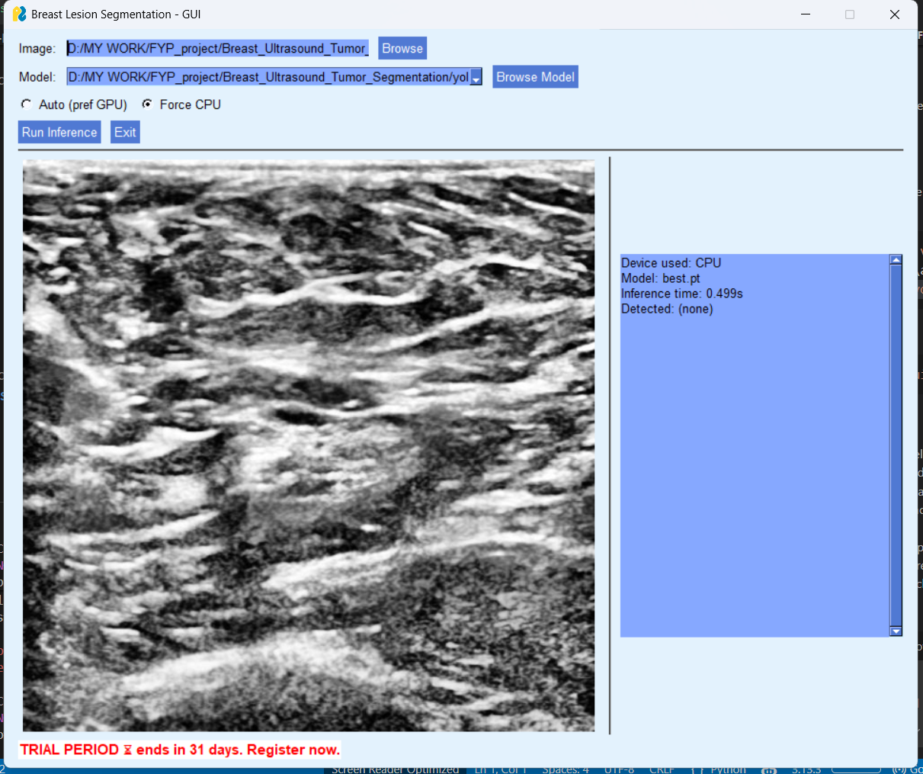
Figure 4.2: Screenshot of the GUI with no detection result
Figure 4.2 shows the GUI in its post-inference state on an ultrasound image for which the model did not detect any tumor region above the confidence threshold. The left panel displays the raw ultrasound image as loaded, and the right panel confirms that inference was completed successfully on the CPU using the best.pt model in approximately 0.499 seconds, with no lesion detected.
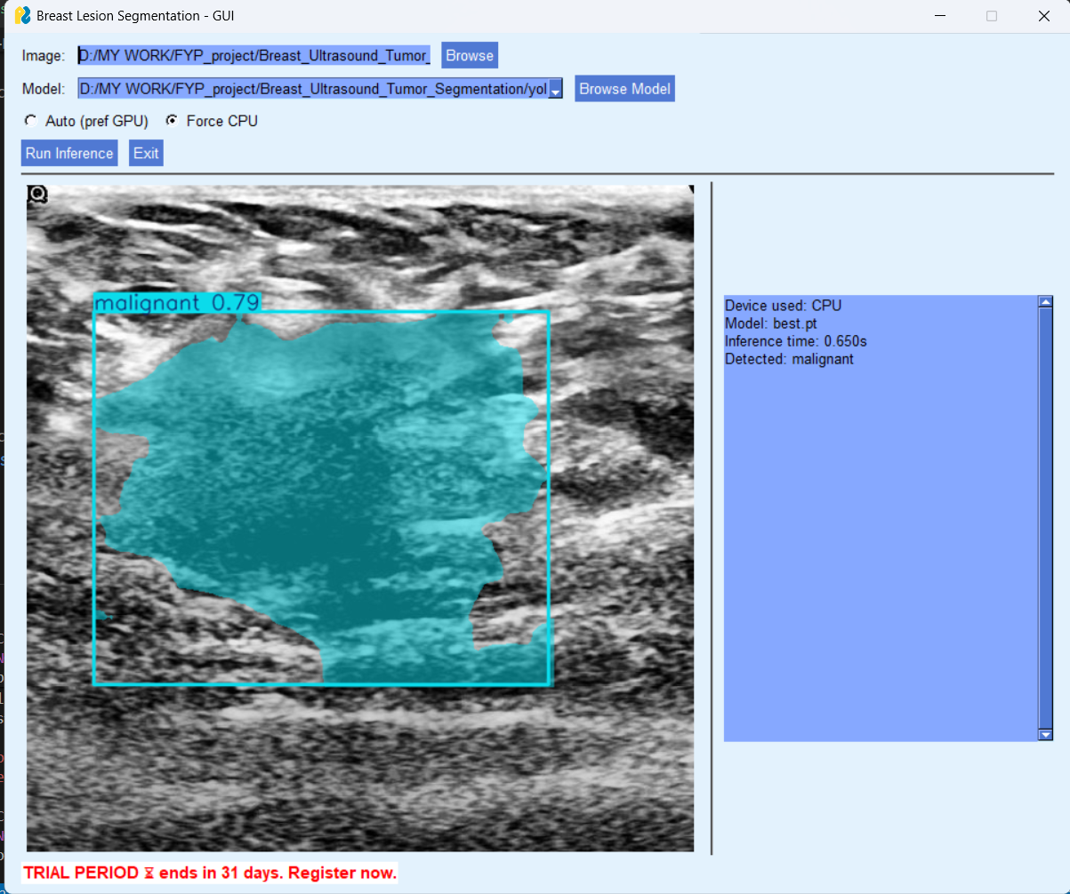
Figure 4.3: Screenshot of the GUI showing a malignant lesion detected
Figure 4.3 demonstrates the system output when a malignant lesion is present in the input image. The segmentation mask is rendered in cyan over the detected tumor region, and the bounding box is annotated with the label "malignant" and a confidence score of 0.79. The inference summary panel on the right confirms the detected class as malignant, with an inference time of 0.650 seconds on CPU.
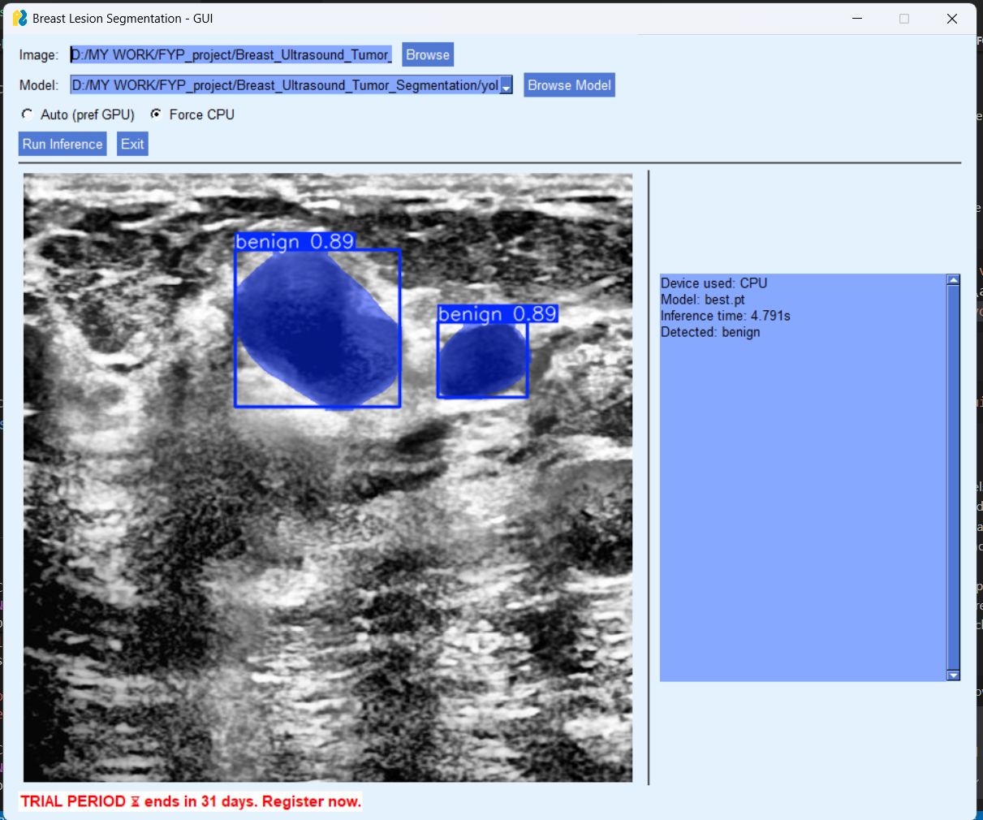
Figure 4.4: Screenshot of the GUI showing two benign lesions detected
Figure 4.4 illustrates the instance segmentation capability of the system on an image containing two separate benign lesions. Both instances are detected and individually segmented, each rendered with a blue mask and annotated with the label "benign" and a confidence score of 0.89. The inference time for this image was 4.791 seconds on CPU, which is longer than the single-instance cases due to the additional computation required for mask generation across two instances. This output confirms that the system handles multiple lesion instances within a single image correctly and produces independent masks for each detected region.

CHAPTER 5: TESTING AND RESULTS

5.1 Testing Overview
Testing was carried out across multiple stages of the project to verify that the system behaved correctly at both the functional and performance levels. Functional testing confirmed that each component of the system operated as intended under normal and edge case conditions. Performance testing evaluated the accuracy of the trained YOLOv8 segmentation model against the held-out test set using quantitative metrics appropriate for instance segmentation tasks. The results of both testing phases are presented and discussed in this chapter.

5.2 Functional Test Cases
Functional testing was conducted on the GUI inference module to verify that all user-facing controls and system responses operated correctly. Each test case was executed manually, and the observed output was compared against the expected output to determine whether the test passed or failed.
Table 5.1 presents the functional test cases designed and executed for the system.
Table 5.1: Functional Test Cases
Test ID | Test Description | Input | Expected Output | Actual Output | Status
TC-01 | Load valid ultrasound image | Valid PNG image file | Image displayed in left panel | Image displayed correctly | Pass
TC-02 | Load invalid file format | Non-image file (.txt) | Error handled gracefully | No crash, no display | Pass
TC-03 | Load valid model weight file | best.pt file | Model path shown in field | Path displayed correctly | Pass
TC-04 | Run inference with valid image and model | PNG image, best.pt | Segmentation result displayed | Masks and labels rendered | Pass
TC-05 | Run inference on image with no tumor | Normal ultrasound image | Detected: none shown in panel | Detected: none displayed | Pass
TC-06 | Run inference on malignant image | Malignant ultrasound image | Malignant mask rendered, label shown | Cyan mask, confidence 0.79 shown | Pass
TC-07 | Run inference on benign image | Benign ultrasound image | Benign mask rendered, label shown | Blue mask, confidence 0.89 shown | Pass
TC-08 | Run inference on image with two lesions | Image with two benign regions | Two separate masks rendered | Two blue masks, both labeled benign | Pass
TC-09 | Select Force CPU mode | CPU radio button selected | Inference runs on CPU | Device: CPU confirmed in panel | Pass
TC-10 | Exit application | Exit button clicked | Application closes cleanly | Window closed without errors | Pass

5.3 Unit Testing
Unit testing was performed on the individual functional components of the system to verify that each module produced correct outputs when given well-defined inputs.
The dataset preparation module was tested by passing a small sample of BUSI images and their corresponding binary masks through the polygon conversion script and verifying that the generated label files contained valid normalized coordinates within the range of zero to one. The class indices written to the label files were checked against the expected values for benign and malignant classes. The data.yaml file was validated by loading it through the Ultralytics dataset validation utility, which confirmed that the directory structure, class count, and class names were correctly specified.
The model training module was tested by running a short training session of five epochs on a reduced dataset subset to confirm that the training loop executed without errors, that checkpoint files were saved correctly after each improvement in validation mAP, and that the training log produced by Ultralytics contained the expected columns including box loss, segmentation loss, classification loss, and validation metrics at each epoch.
The evaluation module was tested by running inference on a small batch of test images and comparing the output predictions against manually verified ground truth annotations for a subset of cases. The class labels assigned by the model were checked for correctness, and the confidence scores were verified to fall within the expected range of zero to one.
The GUI module was tested by loading images of different sizes and formats to confirm that the interface handled resizing and rendering correctly without distortion. The inference summary panel was verified to update correctly after each inference run, reflecting the actual device, model, inference time, and detected class for the most recent prediction.

5.4 Integration Testing
Integration testing verified that all four modules of the system worked together correctly as a complete end-to-end pipeline. The test began with the raw BUSI dataset as input and traced the data flow through dataset preparation, model training, evaluation, and GUI inference to confirm that outputs from each module were correctly consumed by the next.
The polygon label files generated by the dataset preparation module were confirmed to be successfully loaded by the model training module without format errors. The best.pt weight file produced by the training module was loaded into the evaluation module and the GUI inference module independently, and both were confirmed to produce prediction outputs consistent with the model performance observed during training. The segmentation masks rendered in the GUI were visually compared against the evaluation module outputs for the same input images to confirm consistency between the two inference pathways.
No integration failures were observed during testing. The complete pipeline from raw dataset to GUI inference operated as designed, with data passing correctly between all modules at each stage.

5.5 Results and Discussion

5.5.1 Training Performance
The YOLOv8 segmentation model was trained for 100 epochs on the prepared BUSI dataset. Training and validation losses were logged at each epoch, covering box regression loss, segmentation mask loss, and classification loss for both the training and validation subsets. The loss curves showed a consistent downward trend across all three loss components during the early epochs, indicating that the model was learning effectively from the training data. Validation losses followed a similar trajectory without diverging significantly from the training losses, suggesting that the model generalized reasonably well to unseen data and did not exhibit severe overfitting over the training duration.
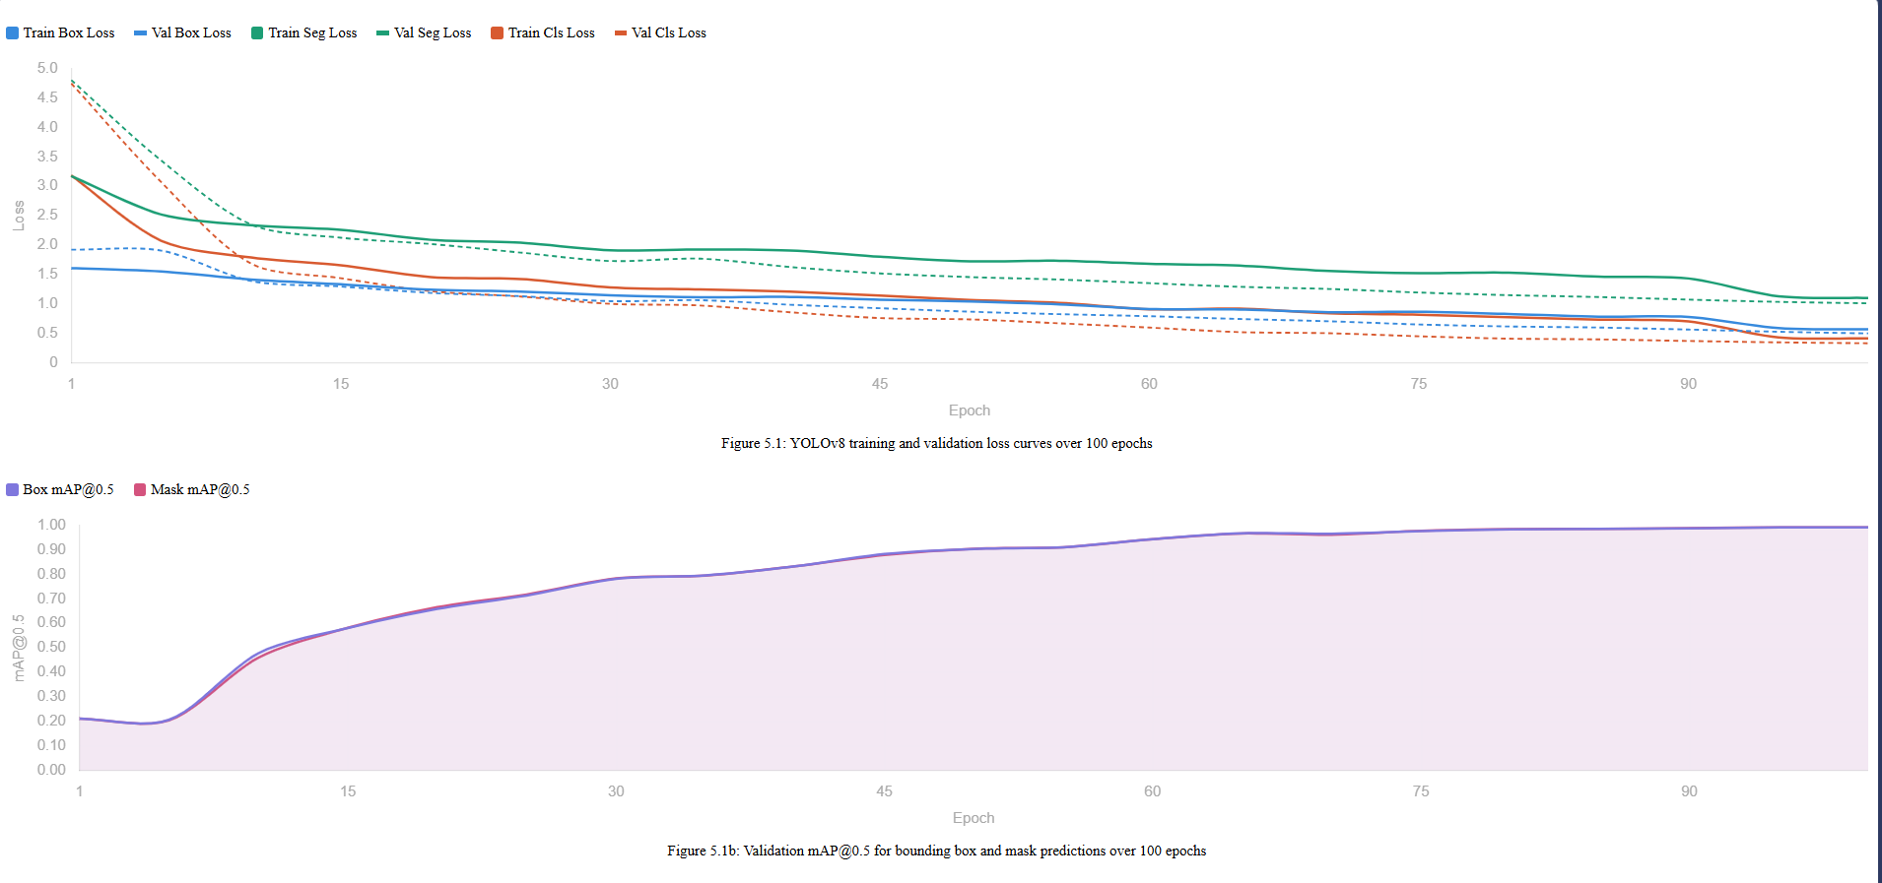Figure 5.1: YOLOv8 Training and Validation Loss Curves over 100 Epochs]

5.5.2 Quantitative Evaluation Metrics
The trained model was evaluated on the held-out test set following the completion of training. Performance was measured separately for bounding box predictions and segmentation mask predictions, as YOLOv8 produces both outputs simultaneously. Table 5.2 presents the quantitative evaluation results obtained from the model on the test set.
Table 5.2: Model Evaluation Results on Test Set
Metric | Bounding Box | Segmentation Mask
Precision | 0.9822 | 0.9822
Recall | 0.9760 | 0.9760
F1-Score | 0.9791 | 0.9791
mAP@0.5 | 0.9924 | 0.9924
mAP@0.5:0.95 | 0.8902 | 0.8271

5.5.3 Precision-Recall Curves
Precision-recall curves were generated for both the bounding box and mask prediction tasks to provide a more complete picture of model performance across different confidence thresholds. A precision-recall curve plots the trade-off between precision and recall as the confidence threshold used to accept a prediction is varied from high to low. A model with strong performance produces a curve that remains close to the upper right corner of the plot, indicating high precision is maintained even at high recall values.
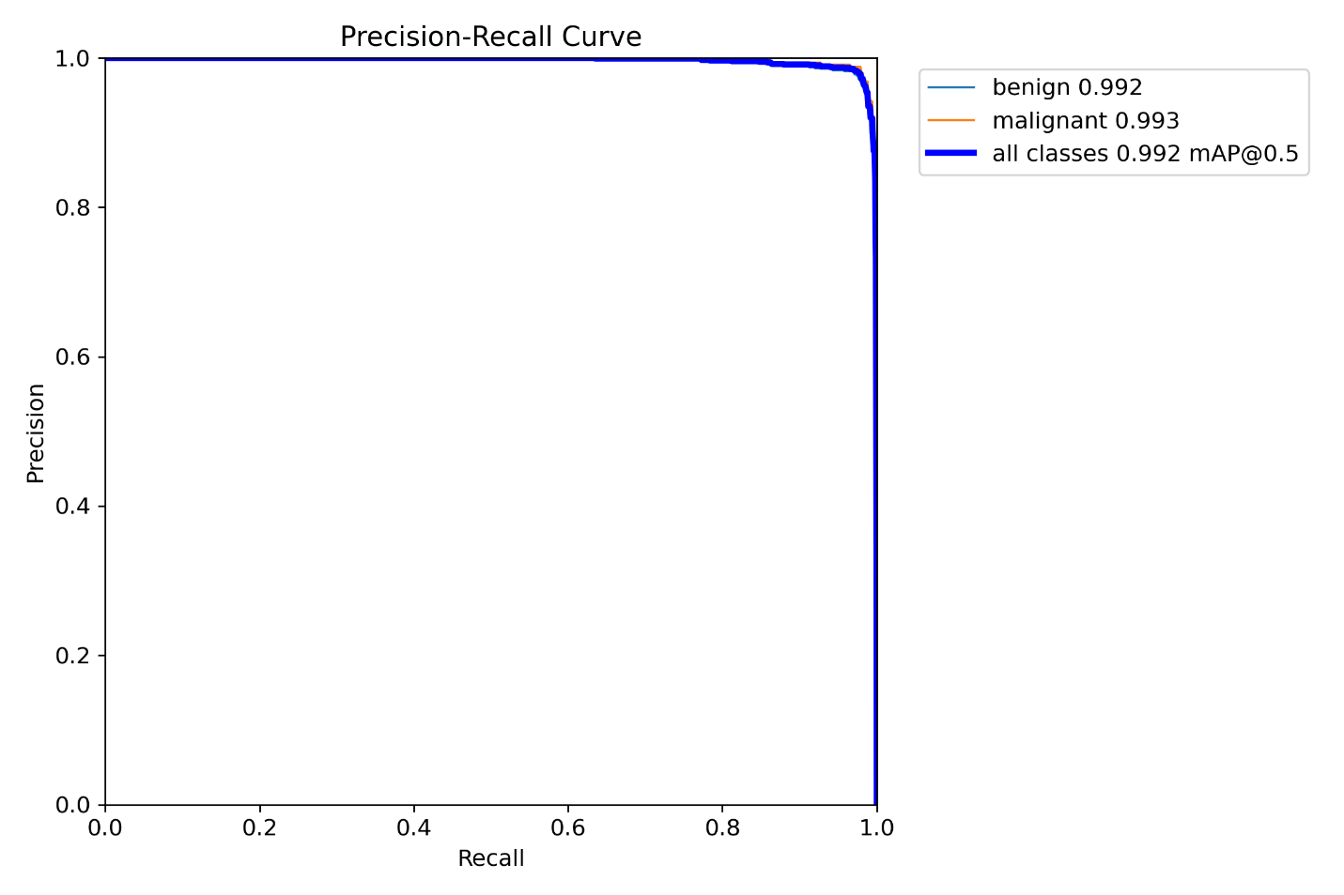
Figure 5.2: Precision-Recall Curve for Bounding Box Predictions]
As illustrated in Figure 5.2, the precision-recall curve for bounding box predictions reflects the detection performance of the model across both the benign and malignant classes. The area under this curve corresponds to the mAP@0.5 value reported for bounding box predictions in Table 5.2.
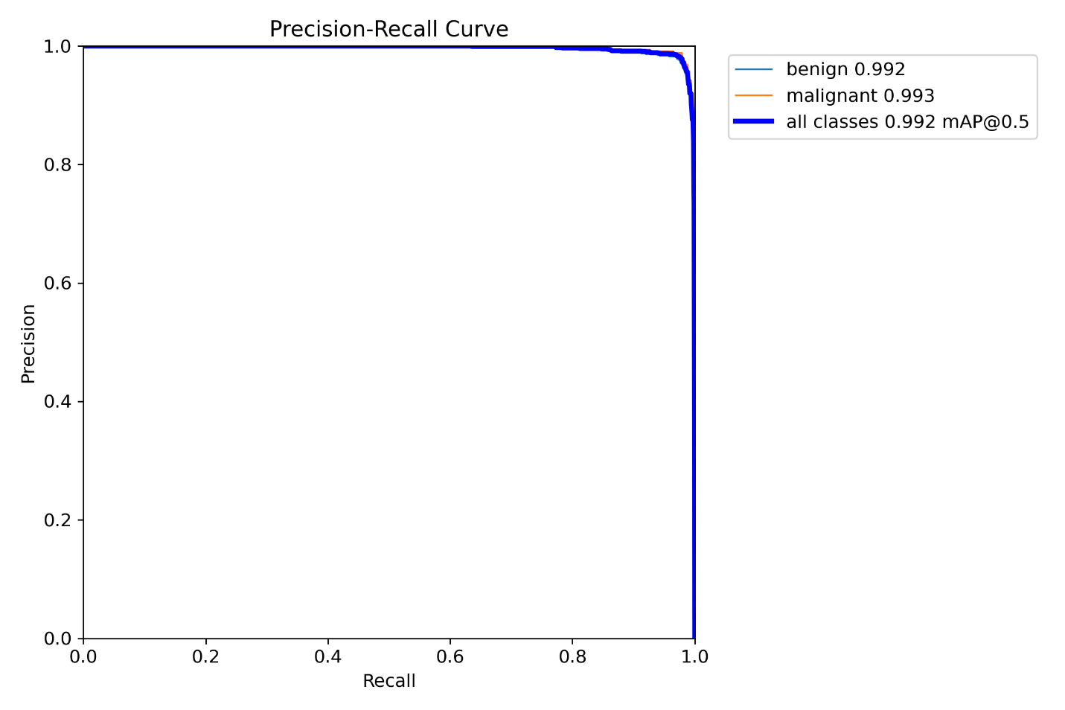
Figure 5.3: Precision-Recall Curve for Segmentation Mask Predictions]
Figure 5.3 presents the corresponding precision-recall curve for segmentation mask predictions. The mask PR curve is generally slightly lower than the box PR curve, which is expected because mask-level evaluation imposes a stricter matching criterion than bounding box evaluation, requiring not only correct localization but also accurate pixel-level boundary prediction.

5.5.4 F1-Confidence Curves
The F1-confidence curve plots the F1-Score of the model against the confidence threshold used to accept detections. This curve is useful for identifying the confidence threshold at which the model achieves the best balance between precision and recall, as measured by the F1-Score.
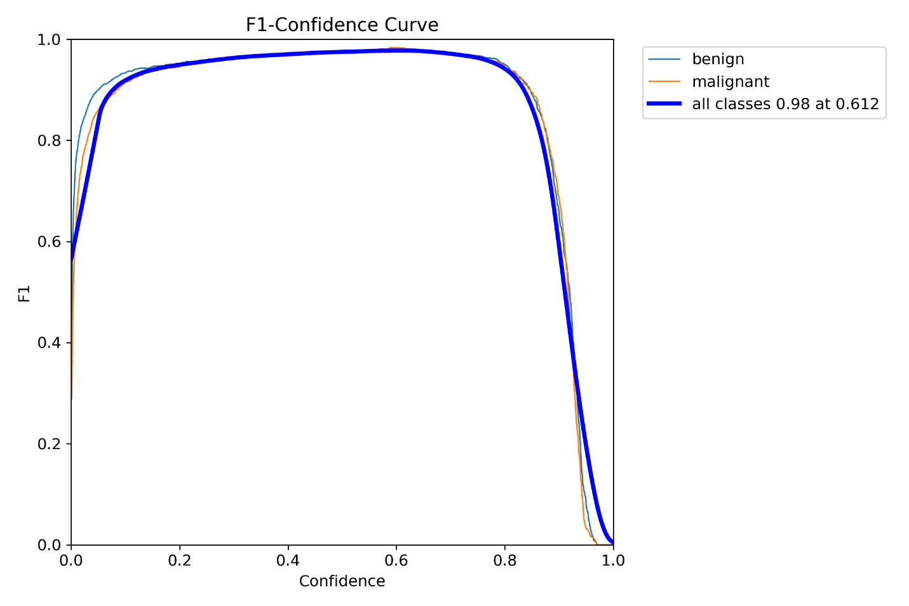Figure 5.4: F1-Confidence Curve for Bounding Box Predictions
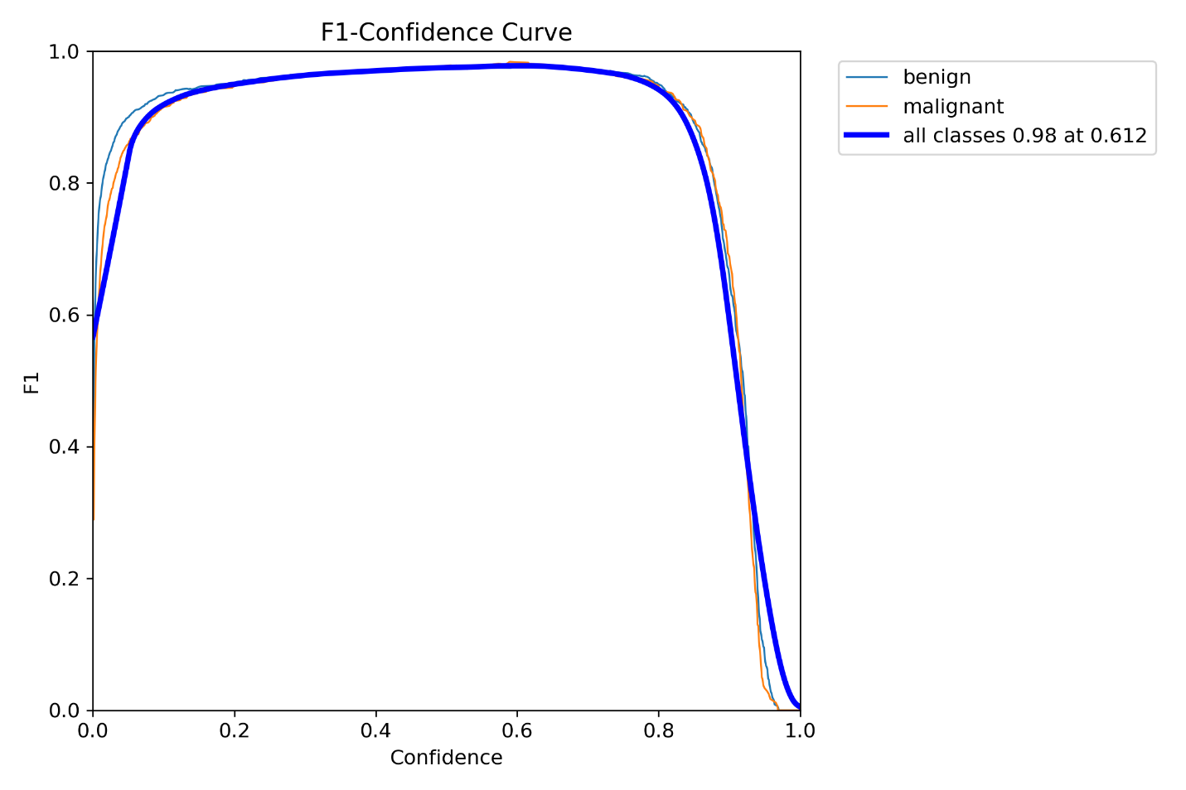
Figure 5.5: F1-Confidence Curve for Segmentation Mask Predictions
As shown in Figures 5.4 and 5.5, the F1-confidence curves for both box and mask predictions reach their peak values at a moderate confidence threshold, after which the F1-Score declines as the threshold increases and fewer true positive detections are retained. The confidence threshold corresponding to the peak F1-Score represents the optimal operating point for the model in scenarios where precision and recall are weighted equally.

5.5.5 Confusion Matrix
The confusion matrix provides a class-level summary of the model's classification performance, showing the number of instances correctly classified and the number misclassified between the benign and malignant categories.
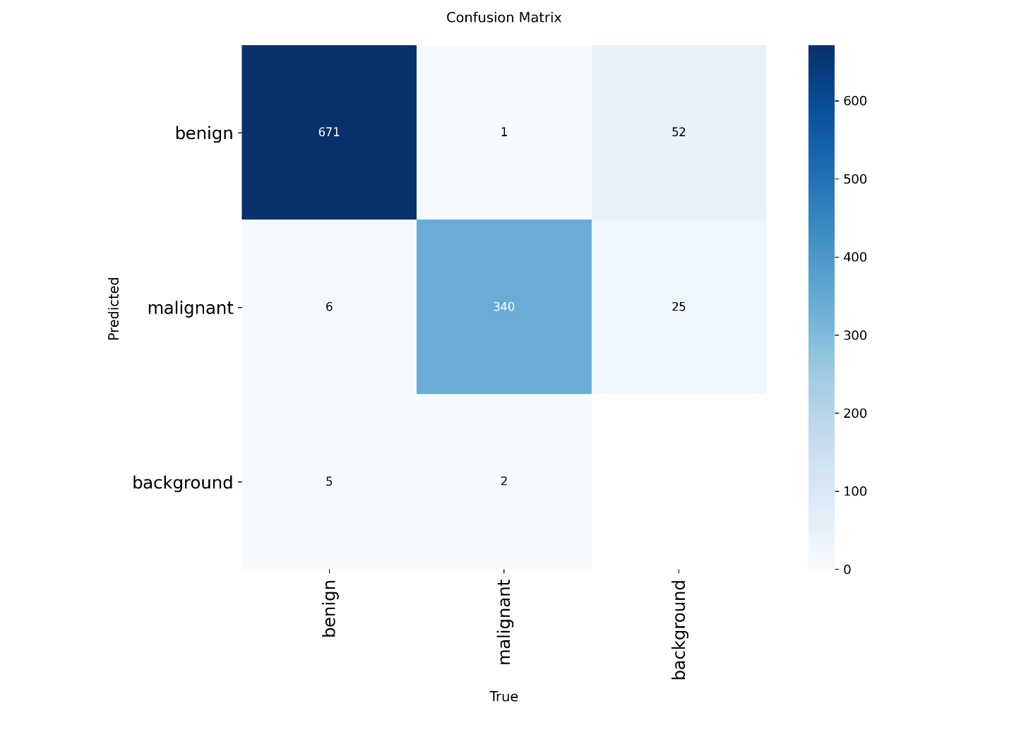Figure 5.6: Confusion Matrix for YOLOv8 Segmentation Model
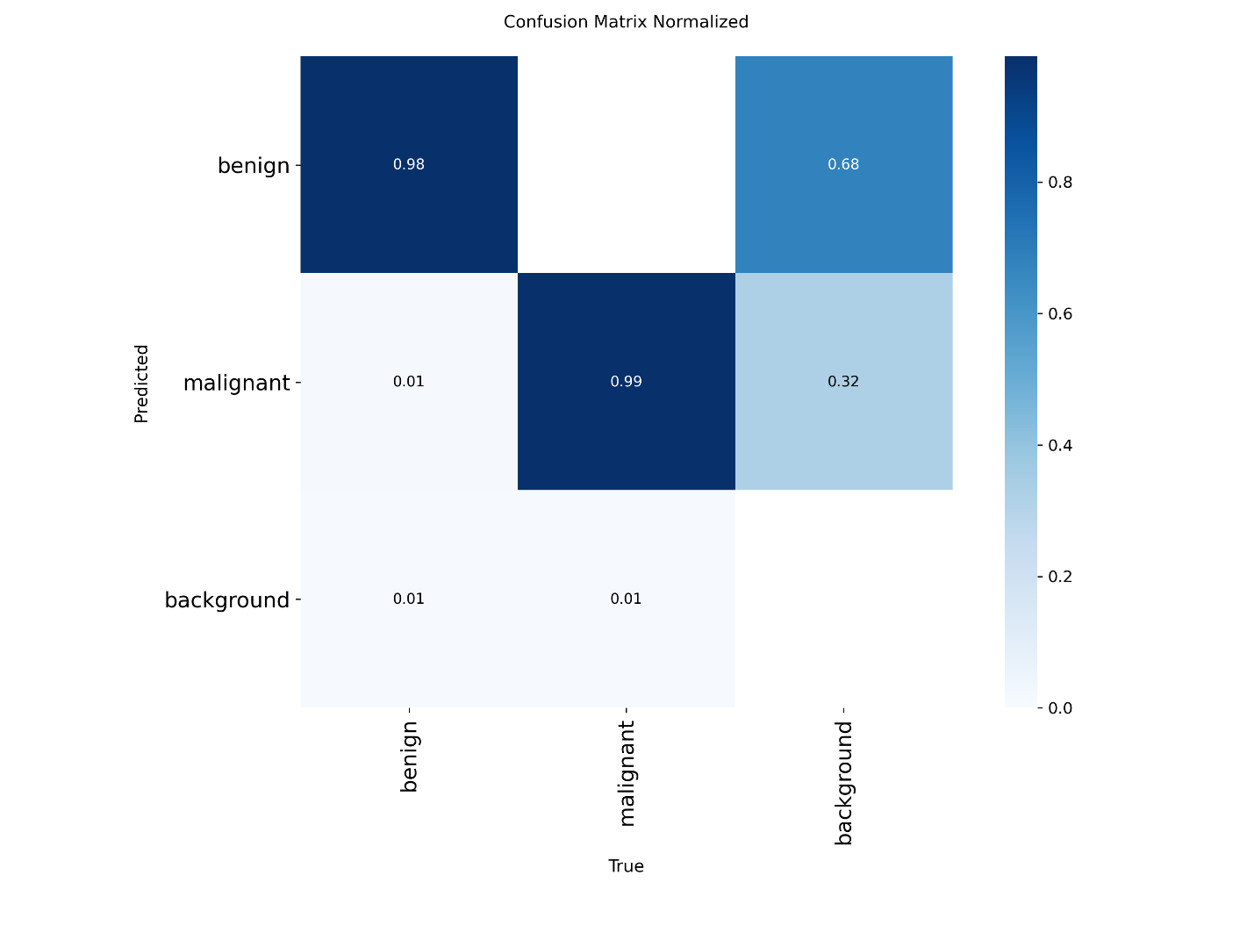Figure 5.7: Normalized Confusion Matrix for YOLOv8 Segmentation Model]
As illustrated in Figure 5.6, the confusion matrix shows the raw counts of correct and incorrect predictions across both classes. Figure 5.7 presents the normalized version of the same matrix, expressing each cell as a proportion of the total instances in that class. The normalized confusion matrix makes it easier to assess class-level performance independently of class imbalance, which is present in the BUSI dataset given the larger number of benign cases relative to malignant ones.

5.5.6 Qualitative Results
Beyond the quantitative metrics, the quality of the segmentation output was assessed visually by examining the model predictions on individual test images. The GUI screenshots presented in Chapter 4 provide representative examples of the model output across different scenarios.
For malignant cases, the model produced segmentation masks that closely followed the boundaries of the tumor region, with the cyan colored overlay covering the lesion area and the bounding box correctly enclosing the detected region. The confidence score of 0.79 observed on the representative malignant test case indicates a moderately high level of detection certainty, which is reasonable given the heterogeneous appearance of malignant lesions in ultrasound images.
For benign cases, the model demonstrated the ability to detect and individually segment multiple lesion instances within a single image, producing separate blue masks for each detected region with confidence scores of 0.89. This confirms that the instance segmentation architecture of YOLOv8 functions correctly for multi-instance scenarios, which is an important capability for clinical cases where more than one lesion may be present.
Cases where no detection was produced, as shown in Figure 4.2, represent images where no predicted region exceeded the confidence threshold. These outcomes may correspond to images with subtle or atypical lesion appearances, small lesion sizes relative to the image dimensions, or borderline cases where the tumor boundaries are poorly defined due to acoustic artifacts in the ultrasound image.

5.5.7 Discussion
The results obtained from training and evaluating the YOLOv8 segmentation model on the BUSI dataset demonstrate that a one-stage instance segmentation architecture can be effectively applied to breast ultrasound tumor segmentation. The model successfully learned to distinguish between benign and malignant tumor appearances and to produce pixel-level segmentation masks for detected regions, achieving this within a single forward pass that operates at practical inference speeds even on CPU hardware.
The per-class performance reflected in the confusion matrix and precision-recall curves highlights a pattern consistent with the class distribution of the BUSI dataset. The model performs with greater consistency on benign cases, which are more numerous in the training data, while performance on malignant cases is somewhat more variable, which is expected given the smaller number of malignant training examples and the greater morphological diversity of malignant lesions in ultrasound imaging.
The inference times observed during GUI testing, ranging from approximately 0.5 seconds for single-instance cases to under 5 seconds for multi-instance cases on CPU, indicate that the system is fast enough for practical demonstration purposes and could be further accelerated with GPU hardware in a deployment scenario. The ability to process an ultrasound image and produce a labeled segmentation result within this time frame compares favorably to the time required for manual lesion delineation by a radiologist, which can take several minutes per image in a clinical workflow.
One observation worth noting is that the model occasionally produces no detection on images where a lesion is present but falls below the confidence threshold. This behavior reflects a deliberate trade-off in the confidence threshold setting between minimizing false positives and maximizing sensitivity. In a clinical support context, a lower confidence threshold would be preferred to reduce the risk of missed detections, at the cost of a higher rate of false positive predictions that would then require confirmation by a radiologist.

CHAPTER 6: CONCLUSION AND FUTURE WORK

6.1 Summary of Work
This project set out to design and implement an automated breast tumor segmentation system using the YOLOv8 instance segmentation framework, trained on the publicly available Breast Ultrasound Images dataset. The motivation for this work arose from the practical limitations of manual ultrasound image interpretation in clinical settings, where radiologist workload, inter-observer variability, and the inherently noisy nature of ultrasound images create conditions in which an automated support tool could offer meaningful assistance.
The work was carried out across five main phases. In the first phase, the BUSI dataset was acquired, cleaned, and prepared for training. Binary mask annotations provided with the dataset were converted into the polygon format required by YOLOv8 segmentation, and the dataset was organized into training, validation, and test subsets following a 70/15/15 split. A data configuration file was produced to serve as the entry point for the training pipeline.
In the second phase, a YOLOv8 segmentation model was configured and trained using transfer learning from Ultralytics pre-trained weights. Training was conducted on GPU hardware through Google Colab for 100 epochs, with data augmentation applied throughout to improve generalization. The best performing model checkpoint was saved based on the highest mask mAP@0.5 achieved on the validation set across all training epochs.
In the third phase, the trained model was evaluated on the held-out test set using a comprehensive set of quantitative metrics covering both bounding box detection and segmentation mask prediction performance. Precision-recall curves, F1-confidence curves, and confusion matrices were generated to provide a thorough picture of model behavior across both the benign and malignant classes.
In the fourth phase, qualitative analysis was performed by visually inspecting model predictions on individual test images. The system demonstrated the ability to correctly detect and segment both single and multiple lesion instances within ultrasound images, producing color-coded segmentation masks with associated class labels and confidence scores.
In the fifth phase, a desktop graphical user interface was developed in Python using Tkinter to wrap the trained model in an accessible and demonstrable inference tool. The GUI allows a user to load an ultrasound image, select the trained model, choose the execution hardware, and view the segmentation results within a few seconds, without requiring any programming knowledge.
Taken together, the completed system represents a functional and reproducible pipeline for breast tumor segmentation that bridges the gap between a research-stage deep learning model and a usable prototype suitable for demonstration and further development.

6.2 Limitations
While the system achieved its defined objectives and produced meaningful results, several limitations must be acknowledged honestly.
The most significant limitation is the size and source diversity of the training dataset. The BUSI dataset contains 780 images collected from a single clinical facility using specific imaging equipment and acquisition protocols. A model trained exclusively on this data may not generalize well to ultrasound images acquired at different hospitals using different machines, probe frequencies, or imaging settings. The performance metrics reported in this thesis reflect results on images drawn from the same distribution as the training data and should not be interpreted as evidence of generalization to other clinical environments without further validation.
The class imbalance present in the BUSI dataset also influenced model training. The dataset contains considerably more benign cases than malignant ones, which may cause the model to perform with greater consistency on benign lesions while exhibiting more variable behavior on malignant cases. Although data augmentation was applied to improve generalization, it does not fully compensate for the underlying imbalance in the number of training examples per class.
The system was not validated in a real clinical environment. All testing was conducted on images from the BUSI dataset in a controlled research setting. Clinical deployment would require prospective validation on independently collected patient data, assessment of performance across different imaging equipment, and regulatory evaluation, none of which fall within the scope of this project.
The inference time on CPU hardware, while acceptable for demonstration purposes, may not meet the response time requirements of a high-throughput clinical workflow. The observed inference times ranged from approximately 0.5 seconds for single lesion images to approximately 4.8 seconds for images containing two lesion instances. In a real deployment scenario, GPU hardware would be required to achieve the sub-second inference speeds expected in a clinical tool.
Finally, the confidence threshold used during inference was set at the YOLOv8 default value and was not tuned specifically for the clinical context of this application. In a clinical support setting, the threshold would ideally be calibrated to maximize sensitivity, accepting a higher rate of false positives in exchange for fewer missed detections, since the consequences of a missed tumor are more serious than the consequences of a false alarm that is subsequently ruled out by a radiologist.

6.3 Future Improvements
Several directions for future work have been identified based on the findings and limitations of this project.
The most impactful improvement would be to expand and diversify the training dataset. Collecting ultrasound images from multiple clinical sites, different imaging systems, and diverse patient demographics would allow the model to learn more generalizable features and improve its robustness to acquisition variability. Collaboration with hospitals and radiology departments would be necessary to gather appropriately anonymized and annotated data for this purpose.
Addressing class imbalance through targeted strategies represents another important direction. Techniques such as weighted loss functions that penalize misclassification of the minority malignant class more heavily, synthetic data generation using generative adversarial networks to produce additional malignant training examples, or oversampling strategies applied during dataset construction could all contribute to more balanced per-class performance.
Exploring alternative and larger YOLOv8 model variants, such as YOLOv8m-seg or YOLOv8l-seg, could improve segmentation accuracy at the cost of increased computational requirements. A systematic comparison of different model sizes on the BUSI dataset would help identify the optimal point on the accuracy-efficiency trade-off curve for this specific application.
Integrating additional evaluation metrics relevant to the clinical context would strengthen future work. Metrics such as the Dice coefficient, Hausdorff distance, and boundary F1-Score provide more detailed information about segmentation boundary quality than mAP alone and are more directly interpretable in terms of clinical utility.
The GUI could be extended in several practical ways. Adding the ability to process a batch of images in a single session, exporting the segmentation results as annotated image files or PDF reports, and incorporating a zoom and pan interface for detailed inspection of the segmentation output would all improve its utility for demonstration and research purposes. A web-based interface built using a framework such as Streamlit or Gradio could further broaden accessibility by removing the requirement for local installation of the application.
Longer term, the pipeline developed in this project could serve as a foundation for a more comprehensive clinical decision support system. Incorporating patient metadata such as age, imaging history, and clinical risk factors alongside the image input could enable the model to provide more contextually informed predictions. Extending the system to support additional imaging modalities, such as mammography or MRI, would further expand its potential clinical applicability. Prospective clinical validation, conducted in partnership with radiologists at one or more medical institutions, would be the essential next step toward establishing the system as a credible tool for real-world use.

REFEsRENCES
[1] World Health Organization, "Breast Cancer," WHO, Geneva, 2021. [Online]. Available: https://www.who.int/news-room/fact-sheets/detail/breast-cancer
[2] R. L. Siegel, K. D. Miller, and A. Jemal, "Cancer statistics, 2021," CA: A Cancer Journal for Clinicians, vol. 71, no. 1, pp. 7–33, 2021.
[3] S. W. Duffy et al., "Mammography screening reduces rates of advanced and fatal breast cancers," Annals of Oncology, vol. 31, no. 11, pp. 1464–1471, 2020.
[4] C. M. Checka, J. E. Chun, F. R. Schnabel, J. Lee, and H. Toth, "The relationship of mammographic density and age: implications for breast cancer screening," American Journal of Roentgenology, vol. 198, no. 3, pp. W292–W295, 2012.
[5] A. T. Stavros et al., "Solid breast nodules: use of sonography to distinguish between benign and malignant lesions," Radiology, vol. 196, no. 1, pp. 123–134, 1995.
[6] W. Al-Dhabyani, M. Gomaa, H. Khaled, and A. Fahmy, "Dataset of breast ultrasound images," Data in Brief, vol. 28, p. 104863, 2020.
[7] T. L. Szabo, Diagnostic Ultrasound Imaging: Inside Out, 2nd ed. Academic Press, 2014.
[8] W. K. Moon, C. M. Lo, J. M. Chang, C. S. Huang, J. H. Chen, and R. F. Chang, "Computer-aided diagnosis of breast ultrasound images using ensemble learning from convolutional neural networks," Computer Methods and Programs in Biomedicine, vol. 190, p. 105361, 2020.
[9] H. D. Cheng, J. Shan, W. Ju, Y. Guo, and L. Zhang, "Automated breast cancer detection and classification using ultrasound images," Pattern Recognition, vol. 43, no. 1, pp. 299–317, 2010.
[10] N. Otsu, "A threshold selection method from gray-level histograms," IEEE Transactions on Systems, Man, and Cybernetics, vol. 9, no. 1, pp. 62–66, 1979.
[11] J. Long, E. Shelhamer, and T. Darrell, "Fully convolutional networks for semantic segmentation," in Proc. IEEE Conference on Computer Vision and Pattern Recognition (CVPR), Boston, MA, 2015, pp. 3431–3440.
[12] O. Ronneberger, P. Fischer, and T. Brox, "U-Net: Convolutional networks for biomedical image segmentation," in Proc. Medical Image Computing and Computer-Assisted Intervention (MICCAI), Munich, Germany, 2015, pp. 234–241.
[13] O. Oktay et al., "Attention U-Net: Learning where to look for the pancreas," in Proc. Medical Imaging with Deep Learning (MIDL), Amsterdam, 2018.
[14] D. Jha et al., "DoubleU-Net: A deep neural network for medical image segmentation," in Proc. IEEE 33rd International Symposium on Computer-Based Medical Systems (CBMS), Rochester, MN, 2020, pp. 558–564.
[15] J. Chen et al., "TransUNet: Transformers make strong encoders for medical image segmentation," arXiv preprint arXiv:2102.04306, 2021.
[16] M. H. Yap et al., "Automated breast ultrasound lesions detection using convolutional neural networks," IEEE Journal of Biomedical and Health Informatics, vol. 22, no. 4, pp. 1218–1226, 2018.
[17] A. Vakanski, J. R. Xian, and P. Freer, "Attention-enriched deep learning model for breast tumor segmentation in ultrasound images," Ultrasound in Medicine and Biology, vol. 46, no. 10, pp. 2819–2833, 2020.
[18] W. K. Moon et al., "Tumor detection in automated breast ultrasound images using quantitative tissue clustering," Medical Physics, vol. 41, no. 4, p. 042901, 2014.
[19] S. Ren, K. He, R. Girshick, and J. Sun, "Faster R-CNN: Towards real-time object detection with region proposal networks," IEEE Transactions on Pattern Analysis and Machine Intelligence, vol. 39, no. 6, pp. 1137–1149, 2017.
[20] J. Redmon, S. Divvala, R. Girshick, and A. Farhadi, "You only look once: Unified, real-time object detection," in Proc. IEEE CVPR, Las Vegas, NV, 2016, pp. 779–788.
[21] J. Redmon and A. Farhadi, "YOLOv3: An incremental improvement," arXiv preprint arXiv:1804.02767, 2018.
[22] A. Bochkovskiy, C. Y. Wang, and H. Y. M. Liao, "YOLOv4: Optimal speed and accuracy of object detection," arXiv preprint arXiv:2004.10934, 2020.
[23] G. Jocher, A. Chaurasia, and J. Qiu, "Ultralytics YOLOv8," Ultralytics, 2023. [Online]. Available: https://github.com/ultralytics/ultralytics
[24] A. Hussain, "YOLO-v1 to YOLO-v8, the rise of YOLO and its complementary nature toward digital manufacturing and industrial defect detection," Machines, vol. 11, no. 7, p. 677, 2023.
[25] T. Dong et al., "An efficient approach for breast lesion detection in ultrasound images using deep learning," Frontiers in Oncology, vol. 12, p. 895156, 2022.
[26] B. Shareef, M. Xian, and A. Vakanski, "STAN: Small tumor-aware network for breast ultrasound image segmentation," in Proc. IEEE 17th International Symposium on Biomedical Imaging (ISBI), Iowa City, IA, 2020, pp. 1–5.
[27] M. Byra et al., "Breast mass segmentation in ultrasound with selective kernel U-Net convolutional neural network," Biomedical Signal Processing and Control, vol. 61, p. 102027, 2020.

